Service Design connecting elderly with internet-based communications

Gifty Thomas
Design and Innovation
Jamia Millia Islamia, Okhla
Delhi, 110025, India
jiff707@gmail.com
Shubhmoy Halder
Design and Innovation
Jamia Millia Islamia, Okhla
Delhi, 110025, India
subhomoy24@gmail.com
Deepshikha
Design and Innovation
Jamia Millia Islamia, Okhla
Delhi, 110025, India
emaildeepshikhajha@gmail.com

ABSTRACT
The prevalence of internet and smartphone usage has significantly impacted the way people communicate, with online technologies like emails, instant messaging etc. However, older generations may be unfamiliar with these newer forms of communication, leading to a generation gap. As the elderly population continues to grow, it's important to consider how to design products and services that bridge this gap. This paper has following objectives - To design an artefact that can help close the intergenerational gap, To evaluate this artefact, To assess and adapt the techniques used in designing the service. The adoption of technology by older adults is influenced by their personal characteristics, such as prior experience and context, as well as the features of the technology itself. While designing technology that is adapted to the needs of older users is important, it is not sufficient to guarantee adoption. To ensure that the technology is suitable for the user, it is necessary to involve them in the design process through participatory design. Building an appropriate context for adoption also plays a crucial role in increasing the chances of acceptance and adoption of technology, such as providing access to support. The perceived usefulness of technology influences elderly technological adoption. It is promising that the users in the study understood the purpose of the device and perceived its benefits. However, it can be challenging for them to perceive benefits despite understanding the usefulness of the technology. The pictures at the centre of the device and service helped the elderly understand the device's use. It appears that the device's simplicity and lack of complexity helped the elderly overcome their fear of technology, despite academic claim that high anxiety is a significant barrier to technological adoption. Participatory Design helped to meet the ergonomic guidelines, with the exception of the pop-up menu bar. However, the biggest lesson learned from the tests was that service design tools were applied without adaptation for elderly users. The study can help tremendously in the ongoing trend of IOT based communication services and help elderly to be able to take part actively.

Keywords — User-centric, Geriatric, User experience, Service Design, Communication

INTRODUCTION

The UN reports that the ageing of society is a global phenomenon and by 2050, the world will have more individuals over 60 years old than those under 15, marking an unprecedented reversal in the proportion of the population. Simultaneously, there is a shift in our lifestyle with over 3.2 billion internet users and 3.65 billion mobile phone users, resulting in a mobile penetration of 51% of the global population, according to the International Telecommunications Union. However, only 8% of internet users are aged 55 or older, indicating that despite the ageing population's proportion, they are excluded from internet-based communication tools. Although younger generations may be more technology-literate in the future, the ageing process may still cause issues with using technology and product design. Technology has traditionally been designed for certain demographics, leading to the exclusion of the elderly from western culture's communication practices and feelings of loneliness and isolation. Thus, it is crucial to develop products and services accessible to the elderly to bridge the communication gap and include them in society's technological advancements. This issue is important because being excluded from technology often means being excluded from society. For instance, while older generations would print out photos to share with family and friends, modern digital cameras and smartphones make it easier to take and share pictures, but also make them inaccessible to those who lack technology or internet access. The service proposed in this research consists of a connected device designed to help elderly individuals reconnect with technology, and a platform (website/app) to which the device is linked. While there has been limited research on designing technology for intergenerational needs, this is an opportunity to contribute to this area of research. The main focus of this Research is to explore how to design an inclusive technology-based system for the elderly that enables them to access internet communication and reconnect with the rest of society. Additionally, the research will address how to evaluate the technology and its adoption possibilities.
The authors will also consider whether designing a service to reconnect older and younger generations is different from designing other services, and whether existing service design methodologies can be applied to this particular service. The objective of this research is to explore how to design a technology, such as a product or service, that can help the elderly reconnect with technology and society. In addition to designing the technology, the Research also aims to examine how to evaluate its effectiveness and test its adoption by older users. Furthermore, the suitability of Service Design methodologies for designing technology and services for older users will be examined. If these methodologies are not suitable, the Research will explore alternative techniques that can be adapted for this specific group of users.

LITERATURE STUDY

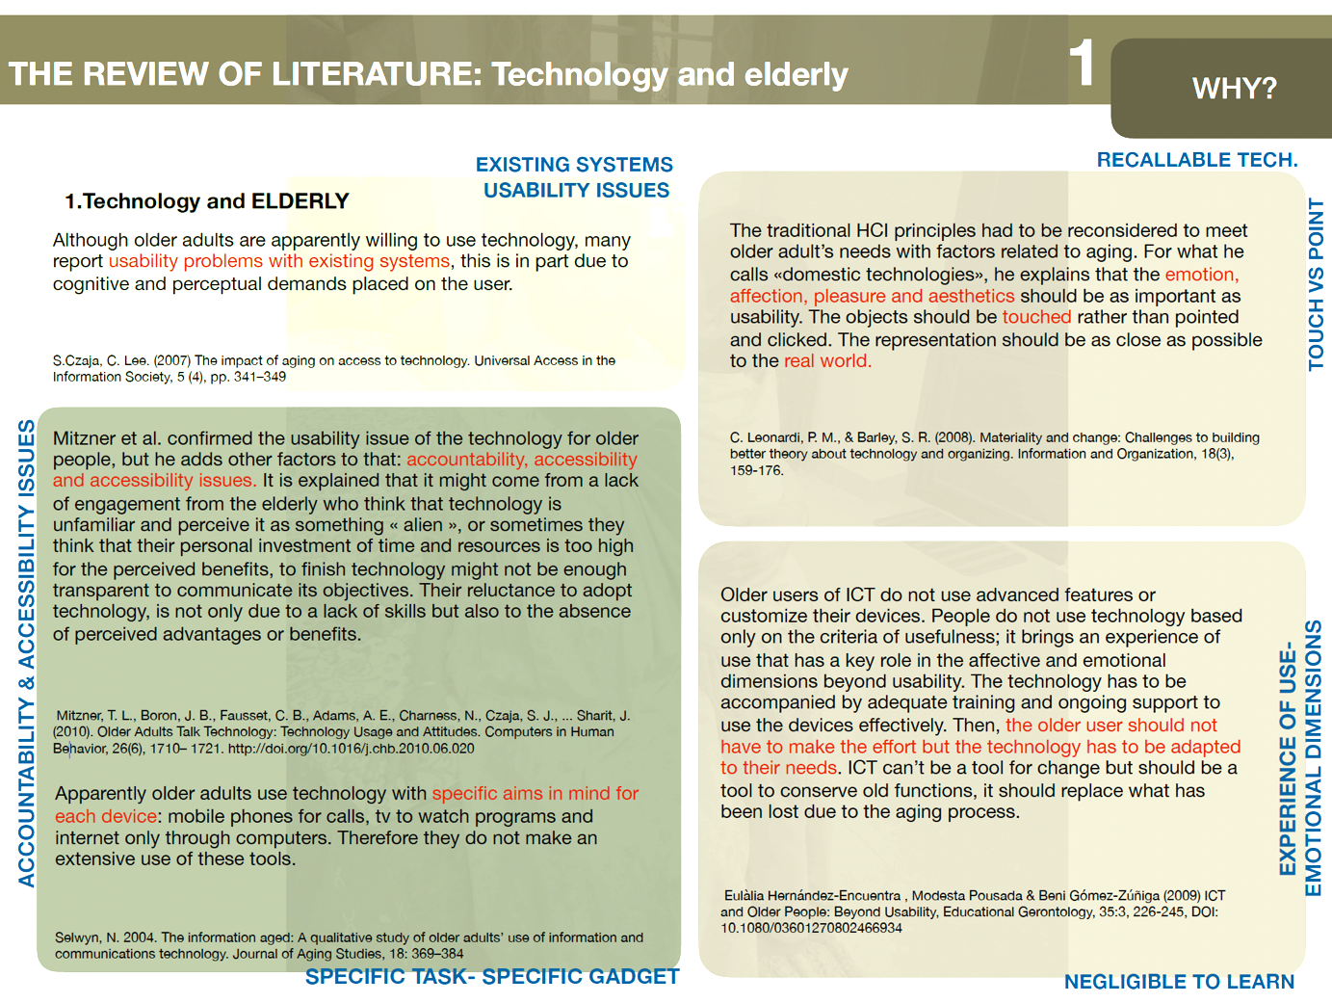
Figure 1: Literature summarized as chart

Figure 1-2 summarise literature study. The World Wide Web Consortium (W3C) has synthesised its recommendations for designing Interfaces for the elderly based on guidelines and research in the field. These recommendations include using a sans serif font, a minimum text size of 12pt, greater text spacing, high contrast, avoiding drop-down menus, limiting information overload, avoiding large blocks of bold or underlined text, avoiding fluorescent colours, using static menus, and avoiding pop-up windows. While there are not many precise guidelines that apply specifically to older users, the W3C recommendations are condensed and precise, and the guidelines from Czaja & Lee (2007) provide more details. Since the interface of the Vesta-Tab was designed by including the elderly in the interface design rather than adhering to these guidelines, it will be interesting to test if the evaluations of the outcomes and results comply with the different criteria mentioned above. The World Wide Web Consortium (W3C) has developed recommendations for designing interfaces for the elderly. These recommendations are based on guidelines and research in the field. They include using a sans serif font, a minimum text size of 12pt, greater text spacing, high contrast, avoiding drop-down menus, limiting information overload, avoiding large blocks of bold or underlined text, avoiding fluorescent colours, using static menus, and avoiding pop-up windows. The W3C recommendations are condensed and precise, but more detailed guidelines are available from Czaja & Lee. The interface of the-Tab was designed with the input of elderly users, rather than adhering to these guidelines.
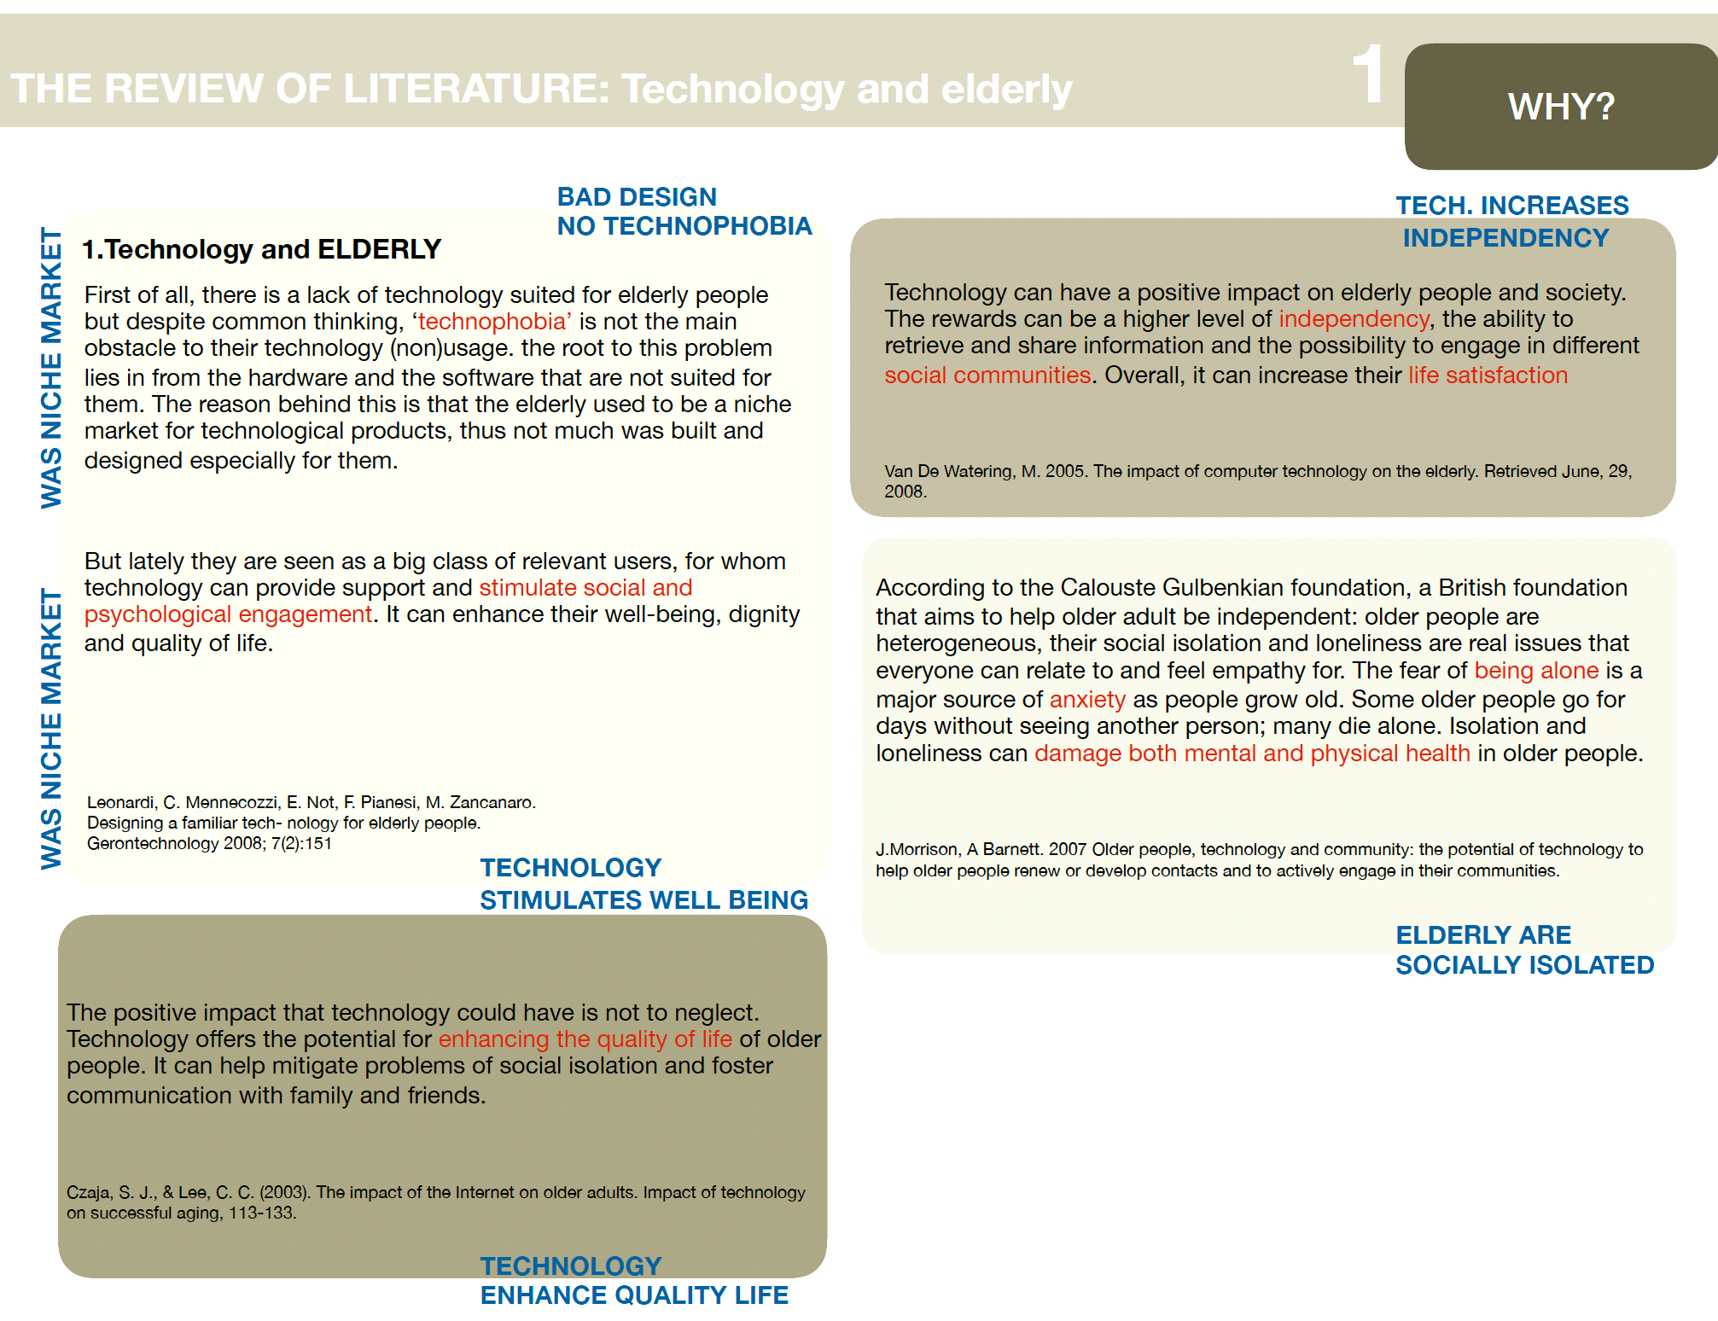
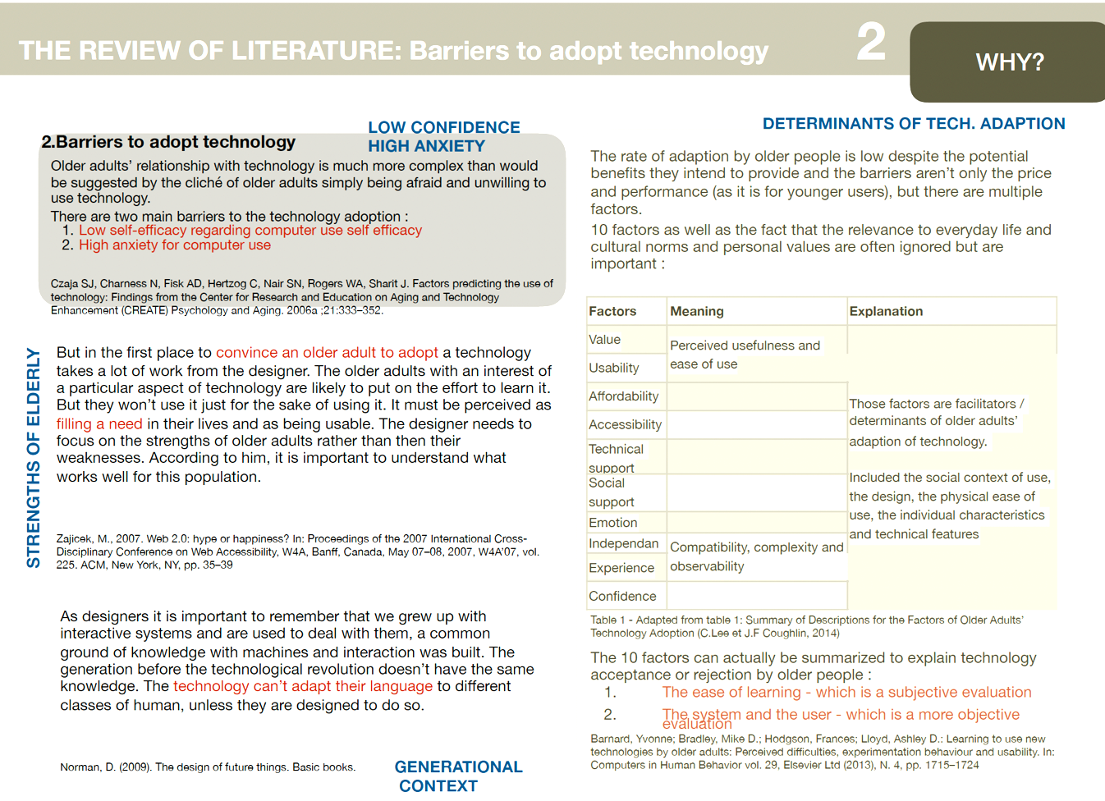
Figure 2: Literature summarized as chart

DESIGN CRITERIA

Now are some of the concrete design criteria that need to be taken into account when designing a technology for elderly, there are not a lot of them, the two oldest ones are those : 1. - Use a Sans Serif font (such as Arial or Helvetica), this is consistent with the findings of R. Morrel and K. Echt, 1997 2. - Use dark type on a light color (« negative contrasts »), emphasising on high contrast, (R. Ellis and S. Kurniawan, 2000) In 2007, Czaja and Lee have come out with these 17 guidelines (that are sometimes more precise than the criteria above, Figure 3):
Figure 3: Design criteria

SERVICE DESIGN AND ELDERLY

During the "exploration" phase, it's crucial to gain a deep understanding of the problem and the customer's perspective. The Value Proposition Canvas can be helpful in visualising the customer's needs and designing a service that meets those needs. In the "creation" phase, exploring various possibilities through scenario design and co-creation is recommended. The "reflection" phase involves testing ideas through prototypes, and the "implementation" phase requires a clear understanding of the process, which can be illustrated through service blueprints and the Business Model Canvas. While co-creation and user-centred design are effective methods for service design, designing a product or service for elderly people requires a special approach. However, there is currently no specific method in the literature for designing a service for this demographic. This research aims to fill this gap by exploring how service design can be applied to older users and whether any changes need to be made to the existing methodologies. Overall, although some research has been conducted on the use of technology by older people and factors affecting technology adoption, there is still a need for further clarification in this area. While the W3 consortium has developed HCI guidelines, there is nothing in the literature on how to apply service design specifically to elderly users. This research aims to address this gap in the literature.

Many of the Service Design methods that are typically used may not be appropriate for designing services for the elderly (Figure 4). Service Design is centred around human needs and interactions, but older adults may have limitations in attention and working memory that make it difficult to use certain approaches, such as scenario-based design, which require cognitive flexibility. This presents a challenge for designers, as they need to adapt their methods to accommodate these limitations. For example, when testing a scenario, it's important to use a real picture of the user's family to make it easier for them to engage with the scenario. To address these challenges, a set of adapted service design techniques has been developed that are specifically adapted for use with older adults. These techniques have been developed through trial and error during the project described in this Research, and they can be easily implemented for any service design project aimed at older adults. By contextualising all tests and prototypes to the user's life and situation, designers can create services that are more accessible and effective for this user group.

Figure 4: Tool adaptation for Service Design

USER STUDY INSIGHTS

During the interviews with 30 young generation aged 15-29 year olds, it was found that 65% of the young people have relationships with their elderly relatives, while 20% have occasional contact and 15% have no contact at all. A third of the participants communicate with their elders more than once a week, another third less than once a week, and the remaining third at a much lower frequency. Most of them prefer to visit or call their relatives, while a minority use text messaging, internet messaging apps, or letters/cards. More than half of those studied said that the current means of communication are unsuitable to keep in touch with their elderly relatives, citing reasons such as complexity, lack of interest, or the elderly not being connected. Young people prefer calls, videoconferencing, visits, and letters to communicate with their elders, and half of them would use new means of communication if their relatives were "connected." However, some expressed skepticism that the elderly would be willing or able to adapt to new technologies or not. The essential features of a device for inter-generational communication were identified as voice recording, audio and video messages, an alert option, and the ability to share pictures. 65% of the young people interviewed have relationships with their elders, 20% others have some relations but rarely while the remaining 15% have no relationship with the elderly of their family at all. One-third of the people asked, told that they had communications more than once a week, another third said less than once a week and the last third said that their communications to a much lower frequency. Most of them (more than 80%) go to visit them or call them. While a minority use text messaging, internet (whatsapp) or letters / cards, especially postal cards.
More than half of those surveyed said that the current communication means are unsuitable to keep in touch with their older relatives. Quote: "With my parents yes, with my grandparents no. " Reasons why? "Too complicated for them but in a few years" older people "will be comfortable with ICT’s" "Too complex (and sometimes dangerous) for their technological knowledge" "They have never learned to use" "Technological breakthrough inter-generation" "Lack of interest from them. " "Because they are not connected as the young people are" "As requested by my grandmother, she prefers the good old visiting than this useless mobile or computer" "Currently inadequate and too complicated for the elderly. "
Some other points noted - More willingness on their part to relearn something. Physical function decline, the social bond is reduced, the direct presence is the best. They would not be able and would not want to learn to use new things. Young people do NOT want to communicate with their older relatives through social networks. They prefer: • Calls • Videoconference • Visits (more) • Letters. Half the people studied would use new means of communication if their older relatives were ‘connected’. Even if someone said ‘they don’t understand anything’. Even if it's easy to use, the world connected would have a negative effect on them and they won’t be willing to even try’’ The essential features of such a device are for them include - • Voice recorder • Audio messages / videos • An ‘ALERT’option • Picture

30 Individuals between 50 and 70 years old studied in Dlehi and Kerala reported having close relationships with their children and grandchildren, with communication occurring more than twice a week. Communication methods varied widely, ranging from phones to letters and cards, with a preference for in-person contact. Despite this, internet-based communication such as Skype and email have become more prevalent than traditional phone calls. Technology is considered useful for staying in touch, especially when urgent decisions need to be made. However, some elderly individuals may not be able to use phones. Social networks are not commonly used by respondents and are not preferred for communication. The prospect of a device to facilitate communication with the elderly was met with interest, with respondents emphasising the importance of simplicity, directness, and ease of use, as well as readability. Three-quarters of respondents believe that videoconferencing would be the most useful feature for communicating with elderly individuals, with a minority citing messages, photos, and voice messages as important. Figure 5 depicts summary.

Figure 5: Summary of study conducted

Few conclusions drawn were - Younger users would be the content creators for -Tab. Middle generation (50-70 years old) would buy the device for their elderly parents. Both generations would share content on the application/website. Many expressed concerns about elderly anxiety towards technology. Device being easy to use was emphasized. Both generations were against service using their social media data. Half of those surveyed would use service if their older relatives had the device. Interest in pre-ordering the device was expressed. Pictures, texts, and video conferences were identified as important features. Engineers involved in project were unable to implement video conferencing. Decision was made to include video conferencing in some parts of the project. Video conferencing was seen as a must-have feature for customers.

Based on the visits to the different living places in Delhi and Kerala, it was observed that a majority of the elderly had access to a television, either in their own homes or in their old age homes (although sometimes not in their own rooms, but in a common living area). They were all able to use the remote control to change channels and adjust the volume. Messages/Pictures sent by family members, especially children and grandchildren, were received and kept as mementos. Additionally, picture frames were a common feature in all the living places, with many pictures displayed in their rooms and living rooms. It was noted that the kitchen area had fewer pictures, and the elderly spent most of their time in their own rooms or living rooms, where they read books, news or watched TV. Majority of the elderly have access to television. TV is either in their own homes or in old age homes. Many may not have TV in their own room. Elderly can use remote control to change channels and adjust volume. Pictures from family members are received and kept as mementos. Picture frames are a common feature in all living places 1 Older people feel like outsider because they do not have access to technology Ask them if it is the way they feel - Yes, they see that other people connect through cell phones, internet and so on and do not feel included in those communication means. The device should be a mobile tablet Go to see the elderly with a mockup and see their reaction Yes, it is better for them to have something in their hands so that they can adapt it to see it depending on if they wear glasses or have sight issues. There should be a wireless charging system. Asking the elderly and showing them different options - Yes, it is better. The charging system has to be adapted to every older user. They chose their favorite form. Choice of logos - Test different options Some logos are more meaningful to them. It might be a good solution to be able to personalize the choice of logos. Size and font of the text. The size of the text was readable by the older users. They are going to adopt the device Give some elderly the device and see if and how much they use it Has not been tested yet. The notification should be a LED rather than a noise. Many pictures displayed in their rooms and living rooms. Kitchen area has fewer pictures. Elderly spend most of their time in their own rooms or living rooms • They read books, or watch TV in these areas.

VALUE PROPOSITION CANVAS AND BUSINESS MODEL

To gain a deeper understanding of the two customer segments (family and older users), a Value Proposition Canvas was utilized (Figure 6-7), The canvas was used to design and test the value proposition that was envisioned, setting problem statement, testing them, and making iterations based on the results. The value proposition created for the "family" segment is presented below, although the parents and children are combined as a simplification, while in reality, there are differences between these two groups. Parents experience more emotional pain or gain from the service that enables them to communicate more with their parents, while the children also benefit. Both groups are referred to as "family" because they create content for the elderly to see. A use-case scenario is provided on the following page to illustrate the customers' jobs and how they can benefit from the service.

To better understand the needs and desires of their potential customers, the designers used the Value Proposition Canvas, a tool developed by A. Osterwalder and his team in 2015. The canvas helped them create and test hypotheses about the value proposition for their product. One customer segment identified was "the family," which included both parents and children. While there is a difference in emotional pain/ gain between the two groups, they were grouped together as they are the ones who create content for the elderly. To illustrate how the service could benefit their customers, a use-case scenario featuring Catherine, a 50-year-old working mother with a mother in a care home, was created. Catherine and her family often feel guilty about not visiting their grandmother enough, and her daughter's inability to drive makes it difficult to visit. The proposed solution was an application that allows them to send messages and photos to an elderly-friendly device, which they can control remotely. While they initially thought of integrating it with other applications and printing goodies from the pictures, customer testing showed that these features were not desirable. The pain reliever for the family is that they would feel less guilty about not visiting as often, while the gain creator is that they can easily connect with her and increase their presence in her mind, making her less scared and giving her good conversation topics with her friends at the care home.

Value Proposition Canvas was used to understand potential customer needs and desires • Canvas aided in creating and testing hypotheses about the value proposition for the product • "The family" was identified as a customer segment that includes parents and children • Emotional pain/gain was different for parents and children, but they were grouped together as they create content for the elderly • A use-case scenario featuring Catherine, a working mother with a mother in a care home, was created to illustrate the service's benefits • The proposed solution was an application that allows for messaging and photo-sharing with an elderly friendly device that can be controlled remotely • Integrating with other applications and printing goodies from pictures were initially considered but not desired by customers • Pain reliever for the family is less guilt over not visiting as often • Gain creator is increased connection with the elderly loved one and decreased fear, providing good conversation topics for them and their friends in the care home.

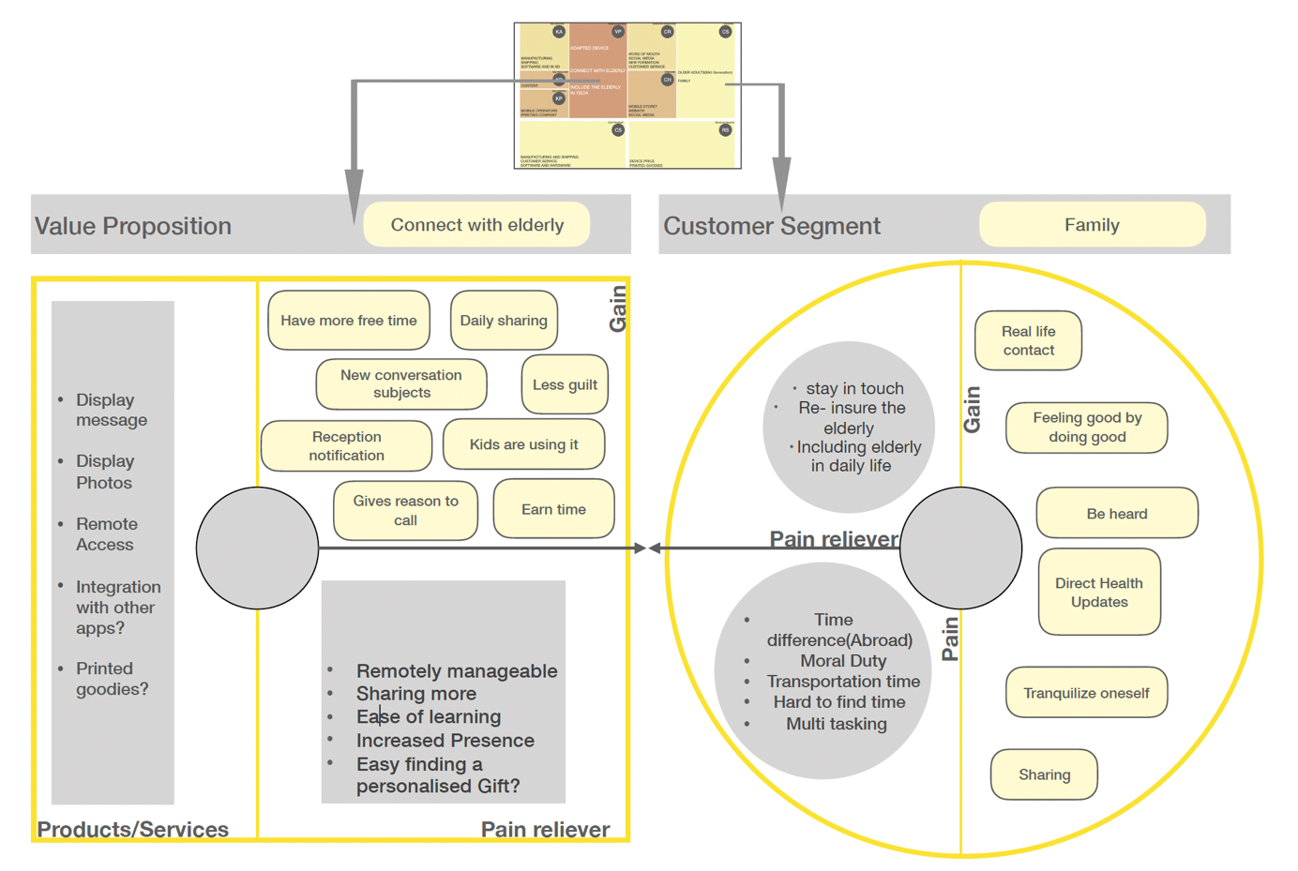
Figure 6: Value proposition canvas for other than elderly

The following is the Value Proposition Canvas for elderly individuals, which includes a proposal for a device that enables them to receive content from their loved ones. To illustrate this proposal, we will use service design techniques and provide a persona and scenario of an older adult.

Figure 7: Value proposition canvas for the elderly

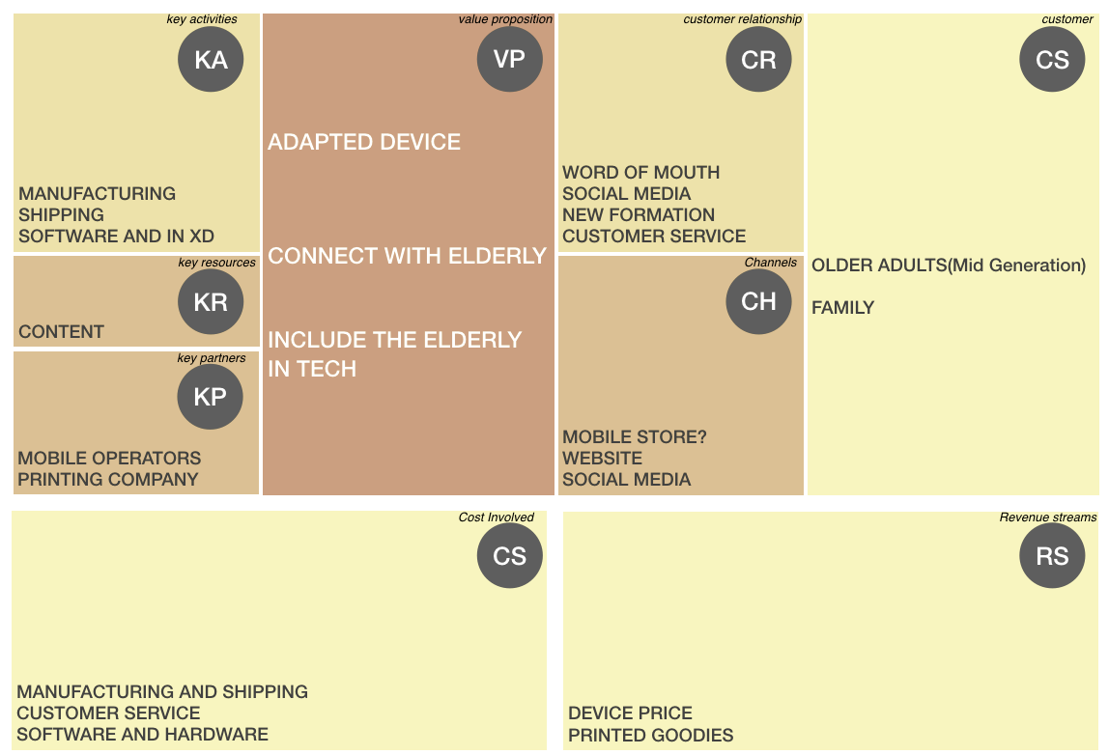
Figure 8: Business Model Canvas - TAB SERVICE

The service that has been described in this Research has the potential to be turned into a viable business. This can be demonstrated through the use of a Business Model Canvas (Figure 8). The Business Model Canvas presented in this Research illustrates a double-sided business model with two distinct customer segments. On one side are the elderly who use the physical device, and on the other side are their family members who use the free application or website to send pictures and messages. The four building blocks on the right side of the canvas - Value Proposition, Customer Relationships, Channels, and Customer Segments - are the core activities that Service Design aims to address and together form a significant part of the service experience's touchpoint, particularly the channels and customer relationships. To ensure a sustainable business, it is crucial to have higher revenues than costs. However, the revenue source for this service is unconventional since the elderly are not the ones buying the device. Based on interviews with the elderly, it was found that they are not likely to purchase the device themselves since they may not appreciate its value. The elderly living in the Résidence les Trémières were entirely taken care of, and none of them managed their own budgets. As a result, the family members not only create content but also pay for the device. Nonetheless, the elderly stated that they would use the "Vesta-Tab" if given as a gift but would not buy it themselves. The business model canvas effectively demonstrates the two customer segments, with only one generating revenue. In addition, providing support and training is critical to the customer relationship and increasing the device's potential adoption. As highlighted, elderly users should be assisted in the right context and at any time they need it since they may lack knowledge in this area. Providing classes to teach them how to use the device is a significant advantage in the customer relationship. Furthermore, a good support service should be established in case a problem occurs since this type of customer is unlikely to reach out through social media or website channels. Business Model Canvas shows double-sided business model with two customer segments. Elderly use physical device, family members use app/website to communicate with them. Four building blocks on the right side (Value Proposition, Customer Relationships, Channels, Customer Segments) are core activities for Service Design. Sustainable business requires higher revenues than costs. Elderly are unlikely to purchase device themselves, family members pay for it and create content. Two customer segments are effectively demonstrated in canvas, with only one generating revenue. Support and training for elderly users is critical for customer relationship and adoption. Classes to teach device usage and good support service are significant advantages.

DESIGN OF TAB FOR ELDERLY

In this section, an overview of the entire Tab service is provided. It begins by outlining the problem that the service aims to address. Then, the artefact is described in detail, including its technical specifications and visual aspects. Additionally, the interfaces of both the device and the mobile application are presented. Finally, a summary of all the functionalities offered by the service is provided.
As outlined earlier the solution is aimed to address the societal problem of older adults being excluded from modern communication tools. Younger generations have adapted to using various tools and applications that require an internet connection for communication, which can be challenging for older adults who are unfamiliar with these technologies. This leads to their exclusion from society, as explained by K. Moffat in 2013. However, the solution cannot involve modifying the way younger generations communicate. Instead, the product provides an adapted means for older adults to connect with younger generations without having to learn new technology. This device features designs and interfaces specifically tailored to older adults' needs and is easy for them to use. When a younger family member sends a message or picture, the older adult receives a LED notification and can view the content by simply touching the screen. Additionally, they can view saved pictures through a slideshow feature. All functionalities of the solution are optimised for older adults' ease of use.

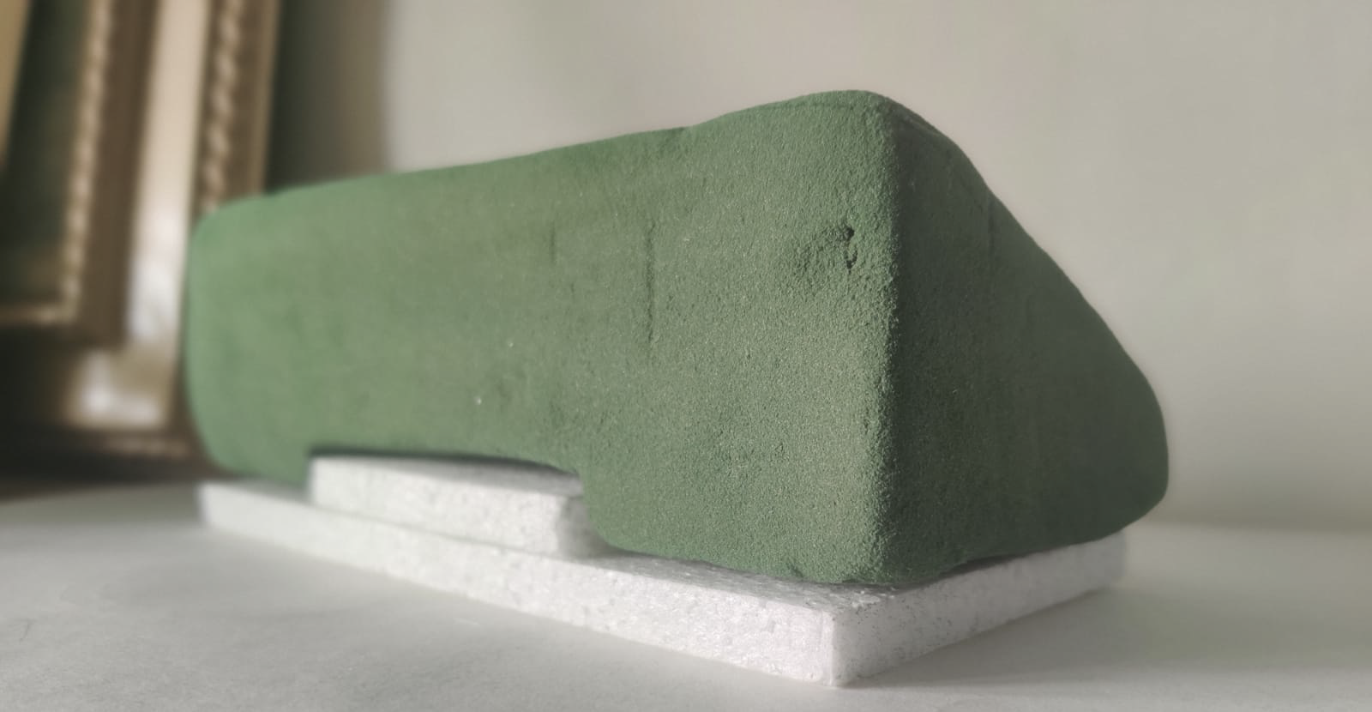
Figure 9: Foam mockup

As outlined in the methodology, the participatory design approach involved engaging with older adults multiple times throughout the process. It was found that the most effective way to obtain feedback from the elderly was by presenting them with a physical mockup (Figure 9-10). This was because it became apparent that responses related to something tangible were much more valuable than answers to abstract questions, which older adults found difficult to relate to. Participatory design approach used in the study. Engaged with older adults multiple times. Feedback from seniors obtained through physical mockups. Responses related to tangible objects were more valuable than abstract questions. Older adults found abstract questions difficult to relate to.

Figure 10: Picture of the mockup in its context

After finalising the shell design, it became necessary to consult the elderly once again. This was prompted by a conversation with a nurse who raised concerns about the charging wire. To address this issue, the team considered implementing an induction charging system. I consulted with older adults to assess which design they found most user-friendly and easy to operate. They used images and Foam mockups to simulate the action of placing the device on the charging station. However, their initial assumptions about the preferred shape of the charging system were proven wrong, as it was found that the elderly preferred a rectangular shape on which the device could "slide" rather than an oval shape. Here are the different options that were presented to the elderly (Figure 11).

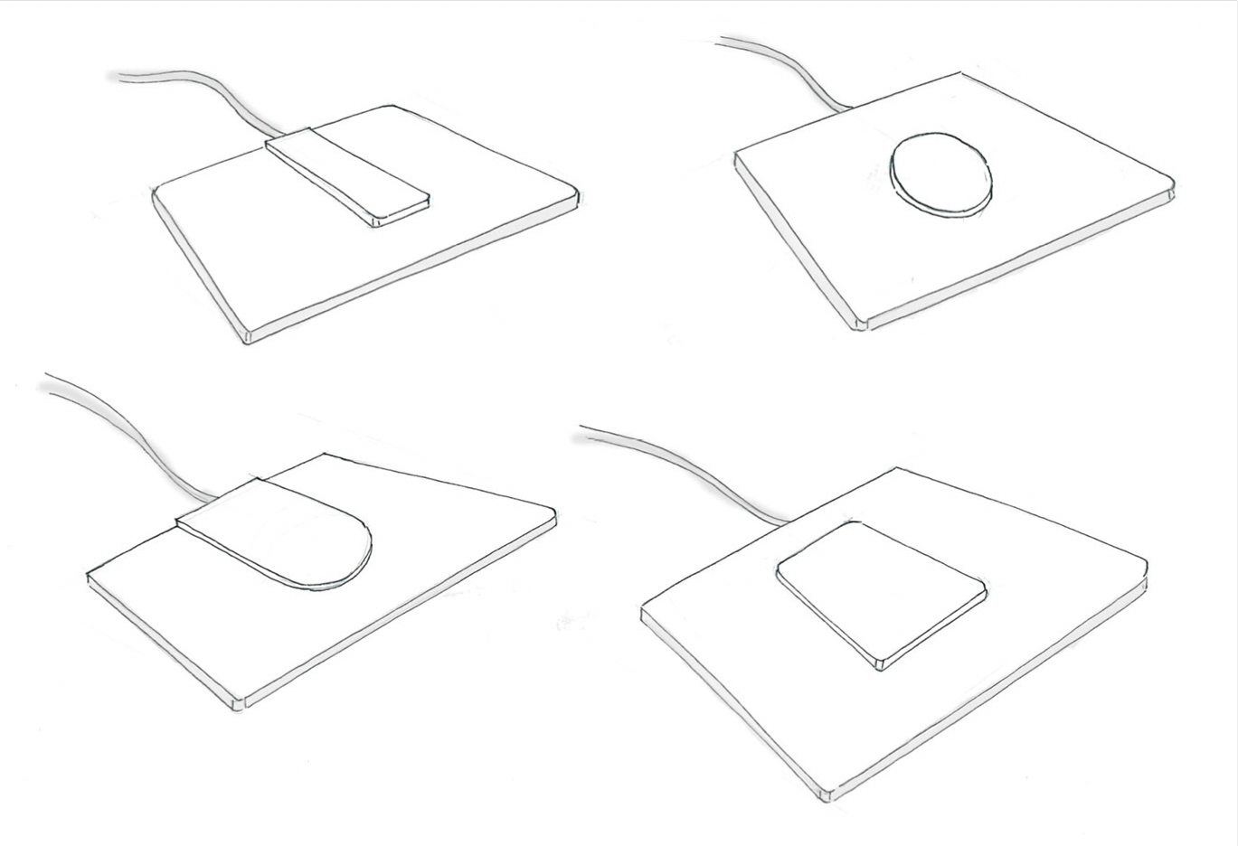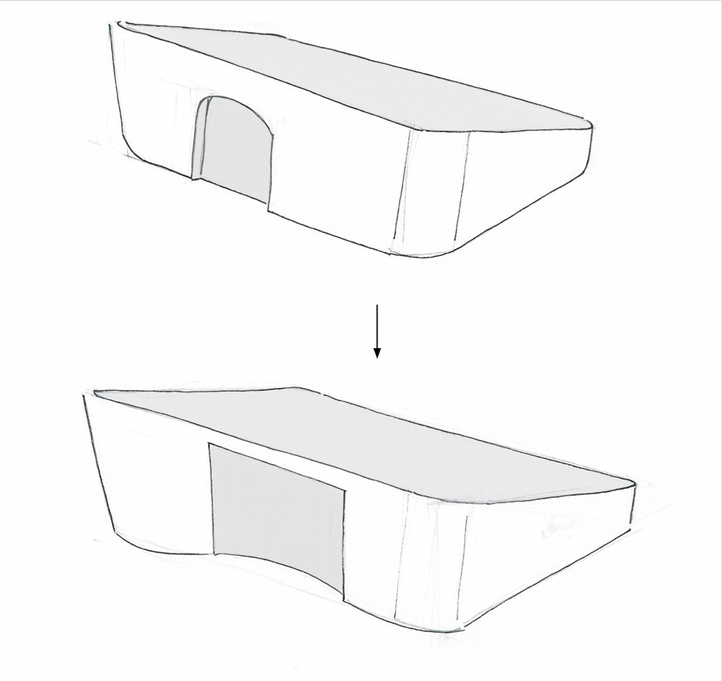
Figure 11: Drafts of the different charging systems

After considering the constraints and conducting various tests to analyse the desired features and value proposition of the "Tab," the final product was developed as a touchscreen device that primarily connects to a mobile application and also to a computer (Figure 12). The device features a capacitive touchscreen, which is more suitable for older users than resistive screens. The device can be charged wirelessly through an induction charging station. Users can send pictures and messages to the "Tab" from the mobile application or website. When a new picture or message is received, a LED notification appears on the top middle of the device. To view the picture or message, the elderly user simply touches the screen. If there is no notification or new content to display, touching the screen will activate the device's "display" mode, in which all pictures stored on the device will be displayed one after the other.
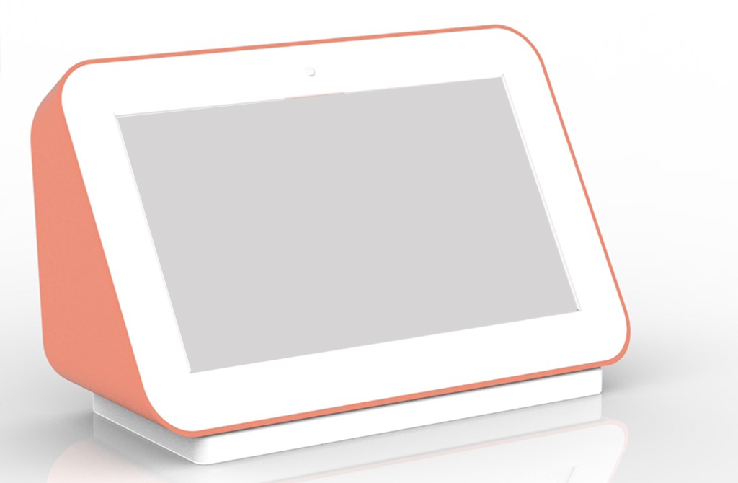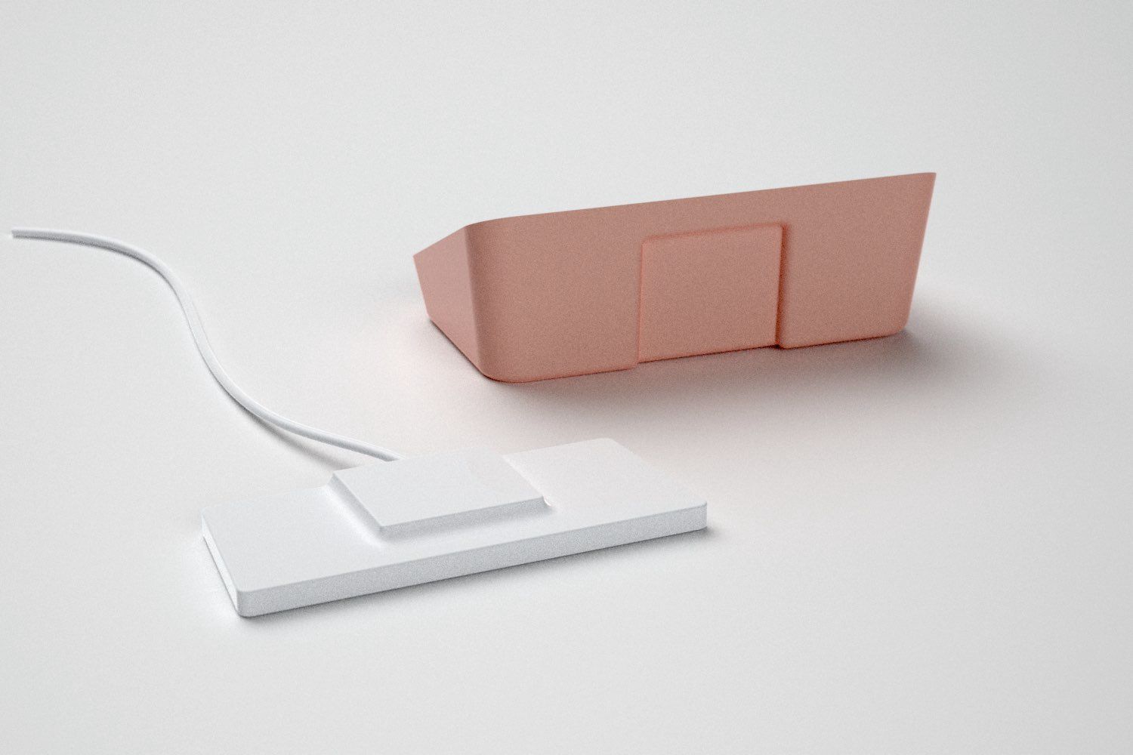
Figure 12: Tab and mobile App

Before proceeding with the scenario presented on this page before, it is a prerequisite that the user has already added the tablet of their elderly relative to their application. Once this is done, the user can choose to configure specific settings for this person. For example, setting a reminder for their birthday or setting a reminder to send a message if they haven't sent anything in two weeks. Now, let's move on to the scenario (Figure 13, 14). The user begins by taking a photo directly from the application:
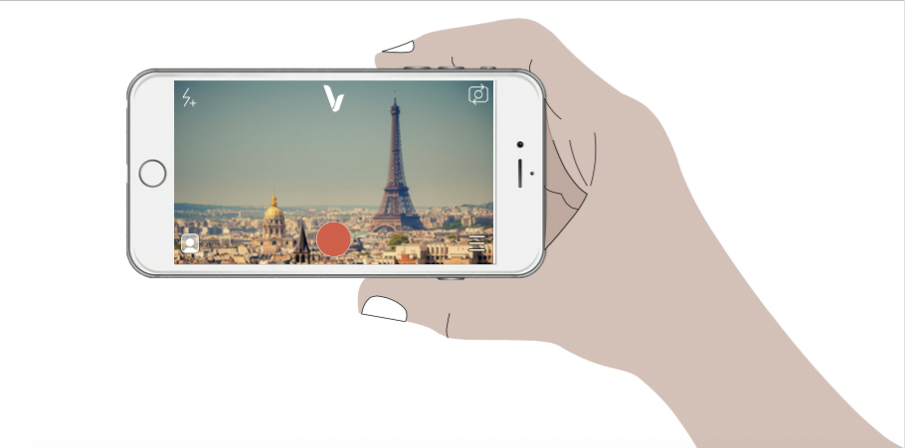
Figure 13: Young user taking a photo from the-App and Elderly receiving a photo on the-Tab

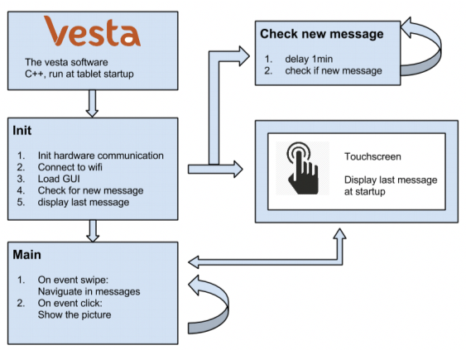
Figure 14: Actions - starting and touching the device and structure of the interfaces of the application

The following diagram provides an overview of the different screens in the interface. The design process involved observing the tasks that elderly people would want to perform with the device, resulting in a "task model." This was used to derive an "abstract model" which led to the final interface presented here. The "video" mode interface is not included as it was deemed too difficult to implement and could not be tested with foam mockups. The diagram shows a tree structure of the different interfaces of the Tab, with each number representing an interface that will be explained.
When the user interacts with the device's touchscreen for the first time, there are two possible scenarios: Either they have received a notification indicating that they have received a new picture, or there is no new picture, and the device will be put in "display mode," where pictures are displayed and automatically switch. In the case of the display mode, the screen will look like this (Figure 15-16):

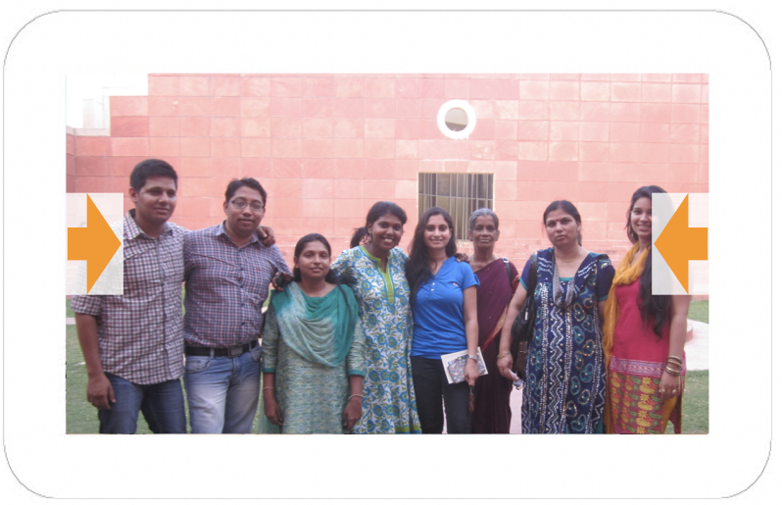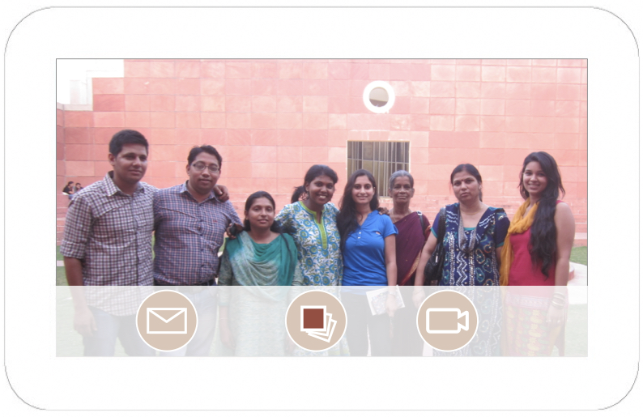
Figure 15: Interface 1- Picture without the menu, gallery, sliding between pictures; Figure 16: Interface 2 - Picture with the menu (arrow has been clicked)

Here is the structure of the application that enables families to send pictures and texts to the Tab (Figure 17). While using a website is also an option, given the widespread use of mobile devices, having a mobile application is deemed essential for users. 1. The application begins with a welcome screen, followed by a reminder that pictures should be taken horizontally. 2. To send pictures and texts on the tablet, the family needs to download an application. 3. The application can also be accessed via a website, but a mobile application is preferred. 4. The first screen of the application is a welcoming screen. 5. Users are prompted to take a picture horizontally since it is the most frequent task. 6. On the right side (#1) of the screen, users can take a picture, add text, and choose a receiver from their contact list. 7. On the left side (#2) of the screen, users can browse their contacts, access their phone's picture gallery, choose a picture, add a message, and send it. 8. In the middle of the left side (#3) of the screen, users can add contacts and set reminders to send pictures. 9. Users can adjust settings for the contact's tab (#4), such as brightness, volume (for future video conferences), and battery level.

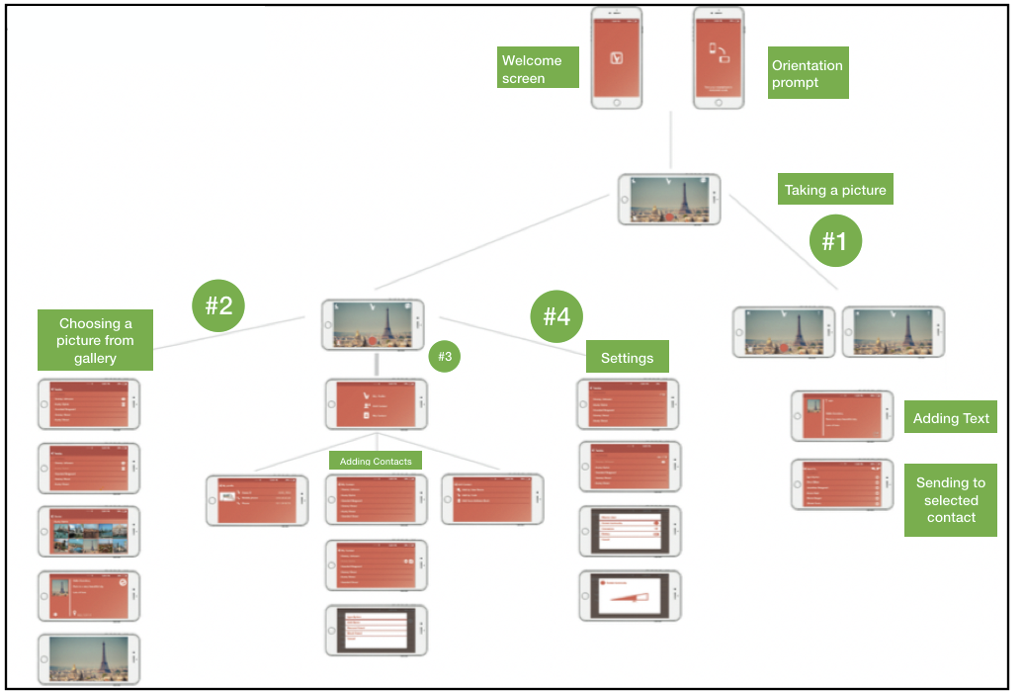
Figure 17: Structure of the application

SUMMARY

Testing with elderly people is challenging compared to other user categories. Contextualisation is necessary to make the tests easier, and sometimes their ability to hear and understand can be compromised due to ageing. There is a lack of understanding of the elderly as consumers and users. Some service design techniques cannot be applied in the same way with elderly users as with younger users. Communication with family is crucial for elderly users, but they do not perceive the monetary value of the product and would not pay for it. There is a lack of technology for the elderly, and none of the existing technologies have been widely adopted by elderly users in India. Elderly users may feel a bit apprehensive when facing technology, but they do not experience high anxiety when supported through the activity, which contrasts with C. Szaja 2007 research. Participatory design resulted in an interface that was mostly compliant with the criteria proposed by W3C and other relevant theories. Most of the test conclusions align with the literature, particularly with the idea that the perceived usefulness of technology influences elderly technological adoption. It is promising that the users in the study understood the purpose of the device and perceived its benefits. However, it can be challenging for them to perceive benefits, as discussed in section 3.2, despite understanding the usefulness of the technology. The pictures at the centre of the device and service helped the elderly understand the device's use. It appears that the device's simplicity and lack of complexity helped the elderly overcome their fear of technology, despite Czaja and Lee's claim that high anxiety is a significant barrier to technological adoption. Participatory Design helped to meet the ergonomic guidelines, with the exception of the pop-up menu bar. However, the biggest lesson learned from the tests was that service design tools were applied without adaptation for elderly users.
The development of technologies specifically designed for the elderly is severely lacking. During the search for potential competition for the service being designed, it became apparent that there are very few alternative solutions available. Some connected photo-frames exist, but they have not been successful in the market. "Hubert" is another application that simplifies the home screen on android devices, but it is not specifically designed for the elderly. Devices that focus on the safety and health of the elderly, such as the Tab Safe for medication compliance, exist, but the majority of technologies are designed for the mass market and are not adapted to the needs of the elderly, as discussed in this research. The best technology for the elderly would be high-tech devices that feel familiar and low-tech, such as a TV screen that is touch-enabled or a pen that virtualises handwritten text for communication. The lack of technology designed for the elderly is due to the fact that this customer segment is not well understood. However, using service design tools could help to develop valuable services that benefit the elderly and society as a whole. Service design is a rapidly evolving field, and there is a lack of clear principles and best practices, particularly when adapting tools for use with the elderly. The proposed adaptation of service design tools in this Research is a starting point that requires further research to create more precise and effective tools to develop better technological and non-technological services for the elderly.

REFERENCES

[1] S.Czaja, C. Lee. (2007) The impact of aging on access to technology. Universal Access in the Information Society, 5 (4), pp. 341–349
[2] Mitzner, T. L., Boron, J. B., Fausset, C. B., Adams, A. E., Charness, N., Czaja, S. J., ... Sharit, J. (2010). Older Adults Talk Technology: Technology Usage and Attitudes. Computers in Human Behavior, 26(6), 1710– 1721. http://doi.org/10.1016/j.chb.2010.06.020
[3] Selwyn, N. 2004. The information aged: A qualitative study of older adults’ use of information and communications technology. Journal of Aging Studies, 18: 369–384
[4] C. Leonardi, P. M., & Barley, S. R. (2008). Materiality and change: Challenges to building better theory about technology and organizing. Information and Organization, 18(3), 159-176.
[5] Eulàlia Hernández-Encuentra , Modesta Pousada & Beni Gómez-Zúñiga (2009) ICT and Older People: Beyond Usability, Educational Gerontology, 35:3, 226-245, DOI: 10.1080/03601270802466934
[6] Leonardi, C. Mennecozzi, E. Not, F. Pianesi, M. Zancanaro. Designing a familiar tech- nology for elderly people. Gerontechnology 2008; 7(2):151
[7] Czaja, S. J., & Lee, C. C. (2003). The impact of the Internet on older adults. Impact of technology on successful aging, 113-133.
[8] Van De Watering, M. 2005. The impact of computer technology on the elderly. Retrieved June, 29, 2008.
[9] J.Morrison, A Barnett. 2007 Older people, technology and community: the potential of technology to help older people renew or develop contacts and to actively engage in their communities.
[10] Czaja SJ, Charness N, Fisk AD, Hertzog C, Nair SN, Rogers WA, Sharit J. Factors predicting the use of technology: Findings from the Center for Research and Education on Aging and Technology Enhancement (CREATE) Psychology and Aging. 2006a ;21:333–352.
[11] Zajicek, M., 2007. Web 2.0: hype or happiness? In: Proceedings of the 2007 International Cross- Disciplinary Conference on Web Accessibility, W4A, Banff, Canada, May 07–08, 2007, W4A’07, vol. 225. ACM, New York, NY, pp. 35–39
[12] Norman, D. (2009). The design of future things. Basic books.
[13] Barnard, Yvonne; Bradley, Mike D.; Hodgson, Frances; Lloyd, Ashley D.: Learning to use new technologies by older adults: Perceived difficulties, experimentation behaviour and usability. In: Computers in Human Behavior vol. 29, Elsevier Ltd (2013), N. 4, pp. 1715–1724

