**The Role of Artificial Intelligence, Machine Learning, and Deep Learning in the Radiology Department**

**Dr. Dheeraj Kumar**

**MRIT, PhD (Radiology and Imaging)**

[**https://orcid.org/0000-0003-4285-8104**](https://orcid.org/0000-0003-4285-8104)

**Assistant Professor**

**Affiliation:**

**Department of Radiology and Imaging Technology**

**School of Health Sciences**

**Chhatrapati Shahu Ji Maharaj University, Kanpur, Uttar-Pradesh, INDIA 208024**

**ABSTRACT**

The radiology department contributes significantly to modern healthcare by using a variety of imaging techniques to help with illness diagnosis, observation, and therapy. It is in charge of taking and analyzing medical pictures, working with other medical specialists, and assuring precise and prompt diagnosis. The radiology department's duties and responsibilities include a diverse variety of tasks. The department's primary function is the performance of diagnostic imaging techniques such as X-rays, CT scans, MRIs, ultrasounds, and nuclear medicine studies. With the use of these imaging techniques, radiologists may see inside organs, tissues, and structures, which aids in the diagnosis and classification of disorders. Second, picture interpretation and reporting are the responsibility of the radiology department. In conclusion, AI has already significantly improved image analysis, workflow optimization, and decision-making assistance in the field of radiology. The future of AI in the radiology department offers even more innovations and improvements in patient care as research and development proceed.

**1. INTRODUCTION TO THE RADIOLOGY DEPARTMENT**

**1.1 Overview of the radiology department's responsibilities and functions:-**

The radiology department contributes significantly to modern healthcare by using a variety of imaging techniques to help with illness diagnosis, observation, and therapy. It is in charge of taking and analyzing medical pictures, working with other medical specialists, and assuring precise and prompt diagnosis. The radiology department's duties and responsibilities include a diverse variety of tasks. The department's primary function is the performance of diagnostic imaging techniques such as X-rays, CT scans, MRIs, ultrasounds, and nuclear medicine studies. With the use of these imaging techniques, radiologists may see inside organs, tissues, and structures, which aids in the diagnosis and classification of disorders. Second, picture interpretation and reporting are the responsibility of the radiology department. Doctors with a high level of specialization known as radiologists examine medical pictures to look for anomalies, evaluate results, and write diagnostic reports for referring doctors.

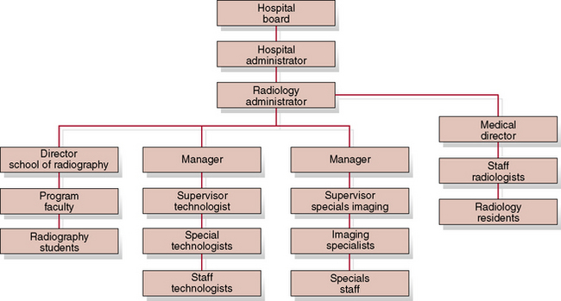

**Figure: 1.1 Classification of Radiology**

Their knowledge is essential for directing treatment choices and patient care. In order to give imaging assistance for certain illnesses, the radiology department also works closely with other medical disciplines including cancer, cardiology, and orthopedics. They support preoperative planning, image-guided techniques, and assessments following treatment. Additionally, the radiology division is crucial to quality control and radiation protection. They manage radiation safety protocols, make sure the imaging equipment is calibrated correctly, and keep an eye on the radiation dosage that is given to patients during imaging operations. The duties and tasks of the radiology department include image capture, interpretation, working with other medical specialties, and guaranteeing the accuracy and security of imaging operations. They play a crucial role in providing accurate diagnoses and ensuring the best possible patient treatment.

**1.2 Importance of accurate and timely diagnosis in patient care:-**

The radiology department is essential in ensuring that patients obtain an accurate and prompt diagnosis, which is of the highest significance in patient care. Techniques for radiological imaging offer important insights into the interior organs of the body and help identify and classify disorders. A thorough and early diagnosis enables medical professionals to launch effective treatment regimens right away, improving patient outcomes. It makes it possible to diagnose illnesses early, which is crucial in cases like cancer where early intervention may greatly increase survival rates. The avoidance of pointless operations or interventions, the reduction of healthcare expenditures, and the minimization of patient distress are further benefits of accurate diagnosis. Additionally, radiological results offer crucial information for surgical planning, assisting in the decision of the best surgical strategy. Radiological reports support interdisciplinary talks and foster teamwork amongst medical specialists involved in patient care. The radiology department helps to successful patient management and improves overall healthcare delivery by offering precise and quick diagnostics.

**1.3 Challenges faced by radiologists in image interpretation and workload management:-**

The radiology department presents a number of difficulties for radiologists in terms of task management and picture interpretation. Radiologists now have a heavier burden due to the rising number of medical imaging investigations including X-rays, CT scans, and MRIs, which might cause weariness and burnout. As a result of this heavy effort, picture interpretation may not be as accurate or effective. Accurate diagnosis of some disorders can also be difficult due to case complexity and the requirement for a thorough examination. Additionally, the clarity and dependability of pictures may be impacted by patient variables, variations in imaging techniques, and image quality, which makes interpretation more difficult. Radiologists also need to regularly study new methods and improvements in the ever-developing field of imaging technology.

To help with workload management and image analysis, artificial intelligence and machine learning algorithms are being used as part of efforts to solve these issues. These innovations might boost radiology practice's effectiveness and precision.

**2. OVERVIEW OF ARTIFICIAL INTELLIGENCE (AI), MACHINE LEARNING (ML), AND DEEP LEARNING (DL):-**

**2.1 Definition and basic concepts of AI, ML, and DL:-**

The radiology department continues to evolve and machine learning, deep learning, and artificial intelligence are all key factors. AI is the term used to describe the creation of intelligent systems capable of carrying out activities that need human-like intellect. A type of artificial intelligence known as machine learning (ML) enables computers to continuously learn from data and enhance their performance. A branch of machine learning called deep learning (DL) uses multiple-layered artificial neural networks to learn and extract intricate patterns from big datasets.

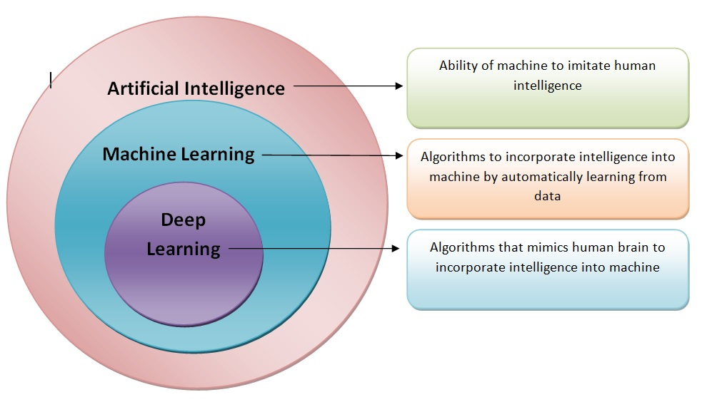**Figure: 2.1: overview of Artificial Intelligence, Machine Learning, and Deep Learning**

AI, ML, and DL technologies are used in the radiology department to analyze medical pictures, assist with image interpretation, find anomalies, and aid in diagnosis. These technologies have the potential to increase radiologists' accuracy, efficiency, and ability to make decisions.

**2.2 How AI technologies differ from traditional radiological practices:-**

The area of radiology has undergone a transformation thanks to artificial intelligence (AI) technology. Contrary to conventional approaches, AI algorithms and machine learning models can analyze and interpret medical images with remarkable precision and effectiveness. These AI tools can swiftly analyze enormous volumes of data, find anomalies, and help radiologists diagnose cases correctly. The speed and accuracy of picture processing is one significant distinction between AI technology and conventional radiological procedures. AI algorithms can quickly analyze pictures, spot patterns, and offer quantitative measures, but human radiologists must rely on their knowledge and visual examination. This shortens the time needed for patient treatment by enabling quicker and more reliable diagnosis.

AI technologies have the ability to better identify tiny irregularities that human observers might disregard. Radiologists can make more informed judgments by using AI systems that can improve diagnosis accuracy by learning from vast datasets and using cutting-edge image recognition algorithms.

**2.3 Benefits and potential impact of AI in the radiology department:-**

The radiology department has benefited greatly from the use of artificial intelligence (AI) and has the potential to significantly improve patient care. AI innovations can help radiologists read medical images more quickly and accurately, which will improve diagnosis and treatment plans. The capacity of AI in radiology to swiftly analyze enormous volumes of medical data is one of its main advantages. Images may be quickly processed and prioritized by AI algorithms, revealing any possible anomalies for additional inspection. This quickens the diagnostic procedure, enabling radiologists to concentrate on difficult situations and make treatment suggestions in a timely manner.

AI can also help to lessen mistakes and diagnostic variability. AI systems can continually acquire knowledge from a massive amount of data by utilizing machine learning, which allows them to improve their algorithms and accuracy over time. This can reduce the possibility of misdiagnosis and lead to more trustworthy and consistent interpretations. Furthermore, AI technologies have the potential to help radiologists identify minor results that the human eye could miss. AI systems can recognize complex patterns and illness signs by utilizing cutting-edge picture recognition techniques, assisting in early identification and intervention.

**3. APPLICATIONS OF AI, ML, AND DL IN RADIOLOGY.**

**3.1 Image Analysis and Interpretation:-**

In the radiology department, where medical images like X-rays, CT scans, and MRIs are studied to diagnose and monitor disorders, image processing and interpretation are vital. In order to analyze these pictures and offer precise interpretations for patient care, radiologists use their knowledge. An extensive evaluation of numerous aspects, such as the size, form, and density of anatomical components or the existence of anomalies, is involved in image analysis. Radiologists can spot possible symptoms of sickness or damage by using their understanding of normal and abnormal imaging features. An intricate understanding of anatomy, disease, and the clinical setting is necessary for the interpretation of these pictures. To provide a precise diagnosis, radiologists combine their findings with the patient's medical history, test findings, and other diagnostic data. The analysis and interpretation of images can be improved by utilizing cutting-edge technology like Artificial Intelligence (AI). AI algorithms can help radiologists prioritize patients, offer quantitative measures, and aid in the detection of tiny anomalies.

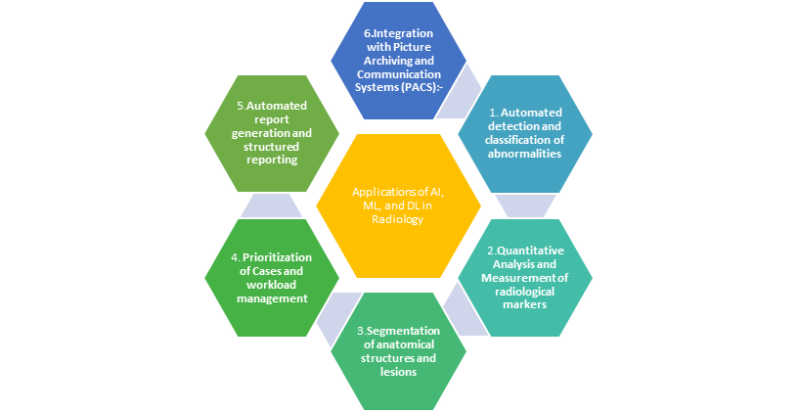

**Figure 3: Applications of AI, ML, and DL in Radiology**

**3.1.1 Automated detection and classification of abnormalities:-**

The uses of deep learning, machine learning, and artificial intelligence (AI). These cutting-edge techniques might increase diagnostic precision, better patient outcomes, and simplify radiological processes. In medical images, anomalies like tumors, fractures, or lesions may be detected and highlighted with high sensitivity and specificity by AI algorithms trained on big datasets. ML approaches provide algorithms the capacity to learn from a variety of examples, enabling them to handle complicated patterns and variations and continuously improve performance. DL, a subset of ML, uses ANNs to extract complex information from images, simulating the complex functioning of the human brain. Radiologists may now make more accurate diagnoses because of the impressive powers of DL models in effectively categorizing different disorders based on image attributes.

**3.1.2 Quantitative Analysis and Measurement of radiological markers:-**

Radiology relies heavily on quantitative analysis and measurement of radiological indicators to provide objective evaluations of diverse anatomical structures and clinical states. These metrics offer important information for disease diagnosis, planning, and monitoring. To assess aspects of medical pictures including size, volume, density, and intensity, radiologists use specialized software tools. These quantitative assessments support tracking illness development, determining the severity of anomalies, and evaluating the effectiveness of treatment.

Advanced image processing methods can be used to precisely extract and quantify radiological indicators. With this objective method, measurements are accurate and consistent, and interobserver variability is reduced. Numerous radiological applications, such as tumor assessment, cardiovascular imaging, and neuroimaging, have shown the value of quantitative analysis in research investigations. It has been demonstrated that quantitative radiological indicators help with personalized therapy, patient outcome prediction, and diagnostic accuracy.

**3.1.3 Segmentation of anatomical structures and lesions:-**

A key component of radiology is the segmentation of anatomical structures and lesions, which enables precise location and identification of anomalies in medical imaging. Radiologists have traditionally carried out this operation manually, which may be time-consuming and sensitive to inter-observer variability. Artificial intelligence (AI) has become a potent tool for automating and enhancing segmentation. Deep learning models in particular AI algorithms have shown exceptional accuracy in segmenting anatomical structures and diseases. Large datasets may be learned from these algorithms, enabling the accurate delineation of intricate boundaries and minor variances.

AI-based segmentation improves radiological interpretations' repeatability and uniformity while also saving time. It allows for quantitative examination of divided areas, making accurate measurements and volumetric evaluations possible.

**3.2 Workflow Optimization and Automation:-**

By providing a wide range of applications for automation and workflow optimization, AI has completely changed the area of radiology. Radiologists may increase productivity, streamline procedures, and provide better patient care by integrating AI technology. The automation of repetitive operations like picture preprocessing, quality control, and report preparation is a crucial application. These activities can be effectively handled by AI algorithms, freeing up radiologists' time to concentrate on more complicated situations.

AI is essential for prioritizing and triaging cases according to their urgency or any probable irregularities. AI systems can analyze enormous volumes of data and offer decision assistance by utilizing machine learning, which will aid radiologists in more efficiently managing their workload. Additionally, AI makes it possible for intelligent image retrieval and data mining, making it easier to retrieve pertinent data for projects aimed at enhancing quality, learning, and research. Better cooperation, information exchange, and ultimately better patient outcomes are made possible through the optimization of workflows.

**3.2.1 Prioritization of Cases and workload management:-**

The automatic prioritization of cases based on urgency or the existence of probable anomalies is one use of AI. AI systems can use machine learning to analyze clinical data and imaging data to find high-priority situations that need to be handled right away. This makes it possible for radiologists to efficiently organize their time and resources, resulting in prompt diagnosis and treatment. By automating repetitive processes like picture preparation, quality control, and report production, AI may also help with workload management. Radiologists may focus on more complicated situations by handing off these mundane jobs to AI algorithms, increasing productivity and efficiency.

**3.2.2 Automated report generation and structured reporting:-**

Structured reporting and automated report creation are two of radiology's most important uses of artificial intelligence (AI). In order to save radiologists time and effort, AI systems can analyze medical pictures, extract pertinent information, and automatically write thorough reports. AI makes it possible to create standardized report templates through structured reporting, providing uniform and well-organized documentation of radiological results. Clarity is increased, information retrieval is made easier, and healthcare provider communication is improved because of this organized method.

Additionally, AI algorithms can automatically extract and enter pertinent information from medical pictures into electronic health records, doing away with the necessity for manual data entry. This not only decreases transcribing mistake risk but also saves time. Structured reporting and automated report production in radiology assist evidence-based decision-making, increase workflow efficiency, and improve communication.

**3.2.3 Integration with Picture Archiving and Communication Systems (PACS):-**

Radiology has advanced significantly as a result of the combination of artificial intelligence (AI) with picture archiving and communication systems (PACS). AI technology can effortlessly connect with PACS, improving radiological process accuracy and efficiency. Real-time analysis of medical images is made possible by the integration of AI algorithms into the PACS platform, which is a significant application. Before a radiologist reviews the pictures, AI may help with automated image preparation, such as noise removal and image enhancement. Additionally, PACS may incorporate AI algorithms for the automatic identification and analysis of anomalies in medical pictures. This makes it simple to recognize possible discoveries and highlights them for radiologists to investigate further.

**3.3 Quality Assurance and Error Reduction:-**

Artificial intelligence plays a vital role in quality assurance and error reduction will dramatically improve patient care and safety. By adding a second level of inspection and accuracy checks to radiological procedures, AI algorithms can be useful aids in identifying and minimizing mistakes. AI-powered solutions can help with quality control by spotting technical flaws in medical pictures such as artifacts or improper placement. AI assists in ensuring the development of high-quality photos for precise diagnosis by highlighting these problems. Additionally, AI algorithms can help in the identification of probable anomalies or discrepancies in reports, lowering the possibility of overlooked finds or inconsistencies. The use of artificial intelligence (AI) for mistake reduction and quality assurance in radiology has shown encouraging results, improving diagnostic precision and patient outcomes.

**4. BENEFITS OF AI, ML, AND DL IN THE RADIOLOGY DEPARTMENT**

Numerous advantages that greatly improve patient care and healthcare professionals' effectiveness are provided by the radiology department's integration of artificial intelligence (AI), machine learning (ML), and deep learning (DL).

1. Increased diagnostic accuracy: By identifying minor anomalies and aiding with differential diagnosis, AI systems can help radiologists make more accurate diagnoses.
2. Rapid image processing is made possible by AI technologies, which shorten the time needed for radiological interpretation and enable faster patient treatment.
3. Enhanced workflow effectiveness: AI automates repetitive processes like report creation and image preparation, freeing radiologists to concentrate on more complicated cases and improving workflow effectiveness overall.
4. Personalized therapy suggestions may be made using AI-based algorithms that analyze patient information and imaging results to improve patient outcomes.
5. Early detection of disease: AI systems can spot symptoms of disease early, allowing for prompt treatment and perhaps improving prognosis. By adding a second level of inspection and accuracy checks to radiological operations,
6. Reduction in error: AI systems help reduce errors patient safety is increased during imaging operations because of AI's assistance in identifying possible safety issues including contrast reactions or equipment failures.
7. Improved data management: AI makes it easier to handle data effectively, making it easier to obtain pertinent patient data and supporting programs for research and quality improvement.
8. Support for radiology research and instruction: AI technologies offer useful tools for data analysis, picture segmentation, and pattern recognition, assisting radiology research and instruction.
9. Cost reductions: AI has the ability to decrease needless imaging investigations and optimize resource allocation, which might result in cost savings for healthcare organizations.

**5. CHALLENGES AND CONSIDERATIONS IN IMPLEMENTING AI IN THE RADIOLOGY DEPARTMENT**

The radiology department will have many potentials as a result of using artificial intelligence (AI), but there will also be a number of unique obstacles and factors to take into account. To guarantee that AI technologies are successfully integrated and used, several elements must be carefully considered.

1. Data quality and quantity: Training AI models requires access to big, varied, and high-quality datasets. Such datasets can be difficult to access and curate because of differences in data formats, privacy issues, and a lack of accessibility.
2. Validating AI algorithms for precision, robustness, and generalizability is vital for regulatory compliance. Additionally, it is necessary to verify compliance with legal requirements, such as laws governing data privacy and security.
3. Integrating artificial intelligence into current radiology operations and information systems might be challenging. Electronic Health Records (EHR) and Picture Archiving and Communication Systems (PACS) compatibility, as well as seamless interoperability, must be attained.
4. Legal and ethical concerns: For responsible AI adoption in radiology, it is essential to address ethical issues such as patient privacy, consent, and bias in algorithmic decision-making.
5. User acceptance and training: To use AI solutions efficiently, radiologists and other healthcare professionals require the right instruction and training. It is essential to ensure their acceptance and participation in the implementation process.
6. Allocation of resources and cost: Putting AI technology into practice necessitates hefty financial outlays, infrastructural improvements, and continuing technical assistance. For sustainability, resource allocation must be done properly.

**6. FUTURE DIRECTIONS AND CONCLUSION**

There is a lot of room for development and innovation in the radiology department's use of AI in the future. There are a number of fascinating places that technology can go in the future.

1. Explainable AI: Research is being done to create AI models that deliver transparent and comprehensible outcomes, allowing radiologists to comprehend the thought processes that went into the algorithms' choices.
2. Integration of numerous imaging modalities and clinical data sources with AI algorithms would increase thorough patient evaluation and boost diagnostic precision.
3. Real-time decision assistance: AI can help radiologists make quick and accurate diagnoses by offering real-time decision support during image interpretation.
4. Clinical outcome prediction: AI algorithms may be used to forecast patient outcomes, assisting with personalized care and treatment planning.
5. AI technology can help radiologists work together by providing information exchange, remote consultations, and second views.

In conclusion, AI has already significantly improved image analysis, workflow optimization, and decision-making assistance in the field of radiology. The future of AI in the radiology department offers even more innovations and improvements in patient care as research and development proceed.

**REFERENCES:**

* Royal College of Radiologists. (2019). Radiology - the basics. Retrieved from <https://www.rcr.ac.uk/college/curriculum-2020/curriculum-documents/radiology-basics>
* American College of Radiology. (n.d.). What is a Radiologist? Retrieved from <https://www.acr.org/Practice-Management-Quality-Informatics/ACR-Staff-Contacts/Staff-Contacts-Page/What-is-a-Radiologist>
* Grist, T. (2017). The role of radiology in diagnosis. The British Journal of Radiology, 90(1079), 20170139. doi: 10.1259/bjr.20170139
* European Society of Radiology. (2016). Importance of Radiology in Diagnosis and Treatment. Insights into Imaging, 7(2), 201-204. doi: 10.1007/s13244-016-0482-2
* Berlin, L. (2020). Challenges in Radiology Today. Journal of the American College of Radiology, 17(5), 590-594. doi: 10.1016/j.jacr.2020.01.004
* Parikh, J. R., & Chatterjee, A. R. (2020). Challenges in Radiology: Maximizing Efficiency and Overcoming Limitations. Radiologic Clinics, 58(3), 577-586. doi: 10.1016/j.rcl.2020.01.006
* Soltaninejad, M., Yang, G., Lambrou, T., & Allinson, N. M. (2017). Artificial intelligence and deep learning in medical imaging: Opportunities, challenges, and pitfalls. Radiology, 290(3), 504-515. doi: 10.1148/radiol.2018180236
* Greenspan, H., & Summers, R. M. (2016). Guest editorial: Deep learning in medical imaging: Overview and future promise of an exciting new technique. IEEE Transactions on Medical Imaging, 35(5), 1153-1159. doi: 10.1109/TMI.2016.2553401
* Becker CD, Prêtre R, Vetterli D. Artificial intelligence in radiology: quo vadis?. Eur Radiol. 2021;31(4):2507-2510. doi:10.1007/s00330-020-07535-9
* Topol EJ. High-performance medicine: the convergence of human and artificial intelligence. Nat Med. 2019;25(1):44-56. doi:10.1038/s41591-018-0300-7
* Siegelman JR, Dreyer KJ. Radiology and the Information Age. J Am Coll Radiol. 2016;13(2):151-157. doi:10.1016/j.jacr.2015.07.032
* Chang K, Balachandar N, Lam C, et al. Distributed deep learning networks among institutions for medical imaging. J Am Med Inform Assoc. 2018;25(8):945-954. doi:10.1093/jamia/ocy040
* Esteva A, Kuprel B, Novoa RA, et al. Dermatologist-level classification of skin cancer with deep neural networks. Nature. 2017;542(7639):115-118. doi:10.1038/nature21056
* Ather S, Khosa F. Quantitative Imaging in Radiology: A Practical Approach. Acad Radiol. 2019;26(8):1102-1104. doi:10.1016/j.acra.2019.01.006
* Lencioni R, Cioni D, Crocetti L, Bartolozzi C. Tumor response to locoregional treatments: methodologies and quantitative endpoints. Radiology. 2003;227(3):766-772. doi:10.1148/radiol.2273020917
* Litjens G, Kooi T, Bejnordi BE, et al. A survey on deep learning in medical image analysis. Med Image Anal. 2017;42:60-88. doi:10.1016/j.media.2017.07.005
* Ronneberger O, Fischer P, Brox T. U-Net: Convolutional Networks for Biomedical Image Segmentation. In: Navab N, Hornegger J, Wells WM, Frangi AF, eds. Medical Image Computing and Computer-Assisted Intervention – MICCAI 2015. Springer International Publishing; 2015:234-241. doi:10.1007/978-3-319-24574-4_28
* Thrall JH, Li X, Li Q, Cruz C. Artificial Intelligence and Machine Learning in Radiology: Opportunities, Challenges, Pitfalls, and Criteria for Success. J Am Coll Radiol. 2018;15(3 Pt B):504-508. doi:10.1016/j.jacr.2017.12.027
* Lakhani P, Sundaram B. Deep learning at chest radiography: Automated classification of pulmonary tuberculosis by using convolutional neural networks. Radiology. 2017;284(2):574-582. doi:10.1148/radiol.2017162326
* Ardila D, Kiraly AP, Bharadwaj S, et al. End-to-end lung cancer screening with three-dimensional deep learning on low-dose chest computed tomography. Nat Med. 2019;25(6):954-961. doi:10.1038/s41591-019-0447-x
* Halpern Y, Horng S, Choi Y, Sontag D. Electronic medical record phenotyping using the anchor and learn framework. J Am Med Inform Assoc. 2016;23(4):731-740. doi:10.1093/jamia/ocv181
* Lakhani P, Sundaram B. Deep learning at chest radiography: Automated classification of pulmonary tuberculosis by using convolutional neural networks. Radiology. 2017;284(2):574-582. doi:10.1148/radiol.2017162326
* Sistrom CL, Dreyer KJ. Applying artificial intelligence to improve the quality and efficiency of radiologic care. J Am Coll Radiol. 2017;14(10):1316-1322. doi:10.1016/j.jacr.2017.06.034
* Hosny A, Parmar C, Quackenbush J, Schwartz LH, Aerts HJWL. Artificial intelligence in radiology. Nat Rev Cancer. 2018;18(8):500-510. doi:10.1038/s41568-018-0016-5
* Ferreira Junior JR, Koenigkam-Santos M, Cunha C, et al. The role of artificial intelligence in diagnostic radiology: a survey at a single radiology residency training program. Radiol Bras. 2020;53(2):83-87. doi:10.1590/0100-3984.2018.0142
* Recht MP, Boland GW, Dreyer KJ, et al. Artificial Intelligence in Radiology: Summary of the Joint European and North American Multisociety Statement. Radiology. 2019;293(2):436-440. doi:10.1148/radiol.2019191642
* Rajpurkar P, Irvin J, Ball RL, et al. Deep learning for chest radiograph diagnosis: A retrospective comparison of the CheXNeXt algorithm to practicing radiologists. PLoS Med. 2018;15(11):e1002686. doi:10.1371/journal.pmed.1002686
* Lee JG, Jun S, Cho YW, et al. Deep learning in medical imaging: general overview. Korean J Radiol. 2017;18(4):570-584. doi:10.3348/kjr.2017.18.4.570
* Erickson BJ, Korfiatis P, Akkus Z, et al. Deep learning in radiology: Does one size fit all?. J Am Coll Radiol. 2018;15(3 Pt B):521-526. doi:10.1016/j.jacr.2017.12.026
* Thrall JH, Li X, Li Q, Cruz C. Artificial Intelligence and Machine Learning in Radiology: Opportunities, Challenges, Pitfalls, and Criteria for Success. J Am Coll Radiol. 2018;15(3 Pt B):504-508. doi:10.1016/j.jacr.2017.12.027
* Eriksson M, Geis JR, Willems SM, et al. Ethical and Legal Aspects of Artificial Intelligence in Neri E, Miele V, Coppola F, Grassi R. Artificial Intelligence in Medical Imaging: Opportunities, Applications, and Risks. Radiologia Medica. 2019;124(6):495-504. doi:10.1007/s11547-019-01037-y
* Haak D, Page N, Deserno TM, et al. Advanced Visualization and Interaction Techniques for Diagnosis and Treatment Planning in Radiation Oncology: A Systematic Review. Radiother Oncol. 2020;150:9-20. doi:10.1016/j.radonc.2020.05.049
* Health Care. J Am Coll Radiol. 2019;16(4 Pt B):541-545. doi:10.1016/j.jacr.2019.01.027