Review of Data Science in Business Intelligence and a Future View
Dr.G.Babu
Assistant Professor
Directorate of Online Education
SRM Institute of Science and Technology (SRMIST), Kattankulathur
Mail: babug2@srmist.edu.in

Abstract:
Business intelligence is a collection of procedures, systems, and strategies that rework unprocessed facts into insightful expertise that motivates worthwhile enterprise endeavors. It is a set of sources and packages for changing facts into understanding and expertise that may be used. BI influences the organization's tactical, organizational, and operational enterprise selections. It encourages using beyond statistics to sell evidence-primarily based totally selections above preconceptions and intuition. Data evaluation is done via way of means of BI gear, which additionally produces reports, overviews, dashboards, maps, graphs, and charts to offer customers complete statistics on the character of the enterprise. Organizational tactical, strategically important, and operational company selections are all without delay suffering from enterprise intelligence. It promotes rational selections grounded in ancient statistics rather than conjecture and intuition. To provide customers granular enterprise intelligence, enterprise intelligence gear examines facts and bring reports, summaries, dashboards, maps, graphs, and charts. Businesses invest time, money, and sources in enterprise intelligence primarily because it lets them maintain a better eye on and look into current purchaser buy patterns. Business intelligence is volumetric in nature and consequently involves monitoring the consequences of key overall performance indicators. The begin of facts technology and the hard aggregate of enterprise expertise, statistics technology, and facts analytics capabilities required. Data technology's purpose is to expand new or up-to-date computational theories that could extract treasured statistics from the great quantities of facts being accumulated at a growing pace. It similarly seeks to offer a multidisciplinary evaluation of the studies issues and improvements in this area concerning facts evaluation.
Keywords: Data science, Key performance indicator, Business intelligence

I. Introduction and Rationale of a Business Intelligence
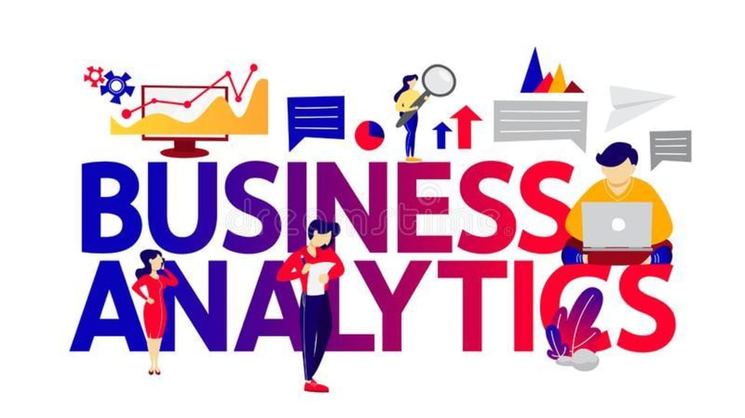
A vast amount of information has been accumulated throughout human history. For thousands of years, information has been preserved. Data is now an essential component of social interactions as well a history, politics, science, economics, and corporate organizations. Social media platforms like Facebook, Twitter, and Instagram, where users regularly create a massive flood of diverse types of information (music, photographs, text, etc.), are blatant examples of this tendency [1]. Government, scientific, and technical laboratory data, as well as data pertaining to space exploration, are now accessible to the general public for usage and review. In the case of the 260 terabytes of human genetic information published by the 1000 Genomes Project [2, 3] is one example. More than 20 terabytes of data are accessible to the general public at sites like Internet Archive [4, 5] and ClueWeb09 [6]. In order to provide users with deep understanding about the nature of the business, BI tools analyze data and produce reports, summaries, dashboards, maps, graphs, and charts. Numerous enterprises and open-source programs recognize that Big Data Analytics will have a visual component in the future and are creating new platforms for interaction and financing this research.

BI Important

- Measurement: Establishing KPI (Key Performance Indicators) according to past data
- Define and establish standards for various procedures.
- By employing BI systems, businesses can notice issues that need to be resolved to identify trends in the marketplace.
- BI aids in the visualisation of data, which boosts the overall accuracy of the data and the clarity of decision-making.
- Small and medium-sized businesses can also employ BI systems. (Small and Medium Enterprises)
How Business Intelligence systems are implemented?
Here are the steps:
Step 1) Extracting raw data from business databases. The data may be dispersed among various different systems.
Step 2) The data is cleaned and transformed into the data warehouse. Data cubes are created by linking the table.
Step 3) The user of the BI system can ask questions, request ad hoc reports, or perform any other analysis.
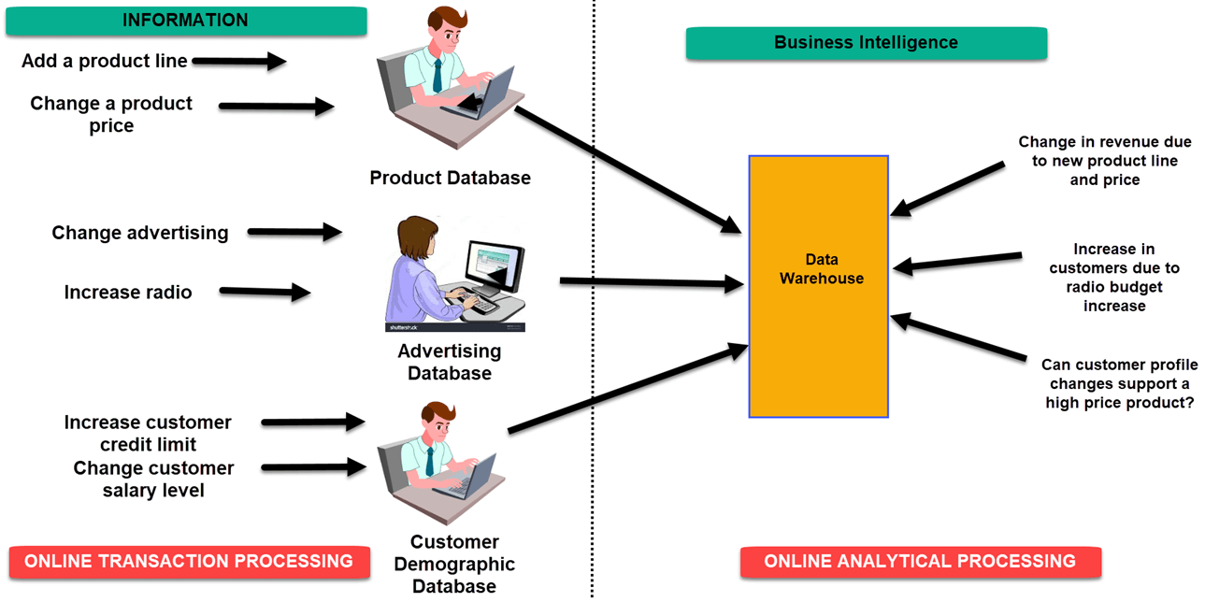

Figure 1 Examples of Business Intelligence System

Advantages of Business Intelligence
Here are some of the advantages of using Business Intelligence System:

A. Increase productivity
Businesses can generate reports with just one click using a BI program, saving an enormous amount of time and resources. In addition, it allows workers to fulfill their duties with greater efficiency.
B. To boost visibility
BI also helps to improve the visibility of these processes and makes it possible to identify any areas which need attention.
C. Fix Accountability
The organization's performance in relation to its established goals must be controlled by someone, and the BI system assigns responsibility and ownership to that person.[5]
D. It streamlines business processes:
The complexity of business procedures is eliminated through BI. By providing approaches like benchmarking, computer modeling, predictive analysis, and others, it also simplifies analytics.

II. Data Science : an overview
For the purpose of solving a business problem and produce meaningful insights, companies hire data engineers to acquire, clean, organize, and evaluate huge amounts of data. As a result, data scientists explore huge data on on an ongoing basis to discover trends, establish projections, and develop hypothesis that businesses use to arrive at decisions about their procedures, target markets, or goods. We live in a world that's full of data. Nevertheless, how are companies genuinely utilizing data in every day activities?You'll discover the skills that you'll require to succeed as a data scientist as well as more information about how businesses employ data science in this Chapter[8].

Impact of data science in business

Data science integration into the company's operations can greatly enhance productivity, decision-making, and product development. It can lower or completely eliminate the risk of fraud and error while assisting you in increasing productivity and customer service. Data scientists could help your business automate time-consuming processes to free up human labour for more crucial tasks. Consider these key benefits that data science provides for organisations.

Making better business decisions

Businesses can use risk analysis data and strategies to make smart business decisions. Higher-ups might benefit from the collection and analysis of data within the company by providing objective backing for difficult business decisions..

Measuring performance

Businesses may use data science to analyze performance through data collecting and then use patterns and empirical evidence to assist them in coming up with solutions.

providing data to internal finances. In order to help you make educated decisions about your spending plan, money, and budget, the organization may also utilize data science to create predictions, provide financial reports, and analyze economic trends. A clear image of the state of internal finances will enable completely optimized income creation.

Developing better products

A corporation may contact its target audiences, determine what those audiences appreciate, and then tailor its goods to that audience by using data analysis, which can employ a data-driven strategy to produce verifiable and evidence-based figures.

Increasing efficiency
By gathering information from operational activities in the workplace, a company can test and measure alternative approaches and receive feedback. Data can assist the company in growing and taking on new workloads by increasing the efficiency of routine tasks and work volume[12]. By obtaining industrial data, businesses may increase production and address inefficiencies. By gathering a lot of data from industrial machinery, one can increase output and boost production efficiency..

III Differences Between Data Science and Business Analytics
Business analytics and data science are covered in this chapter. Data collection, modeling, and insight collecting are all aspects of data science and business analytics. The distinction between the two is that business-specific issues like cost, profit, etc. are the focus of business analytics. Data science, on the other hand, provides answers to issues like how geography, seasonality, and client preferences affect the organization. Data Science is, in essence, a broader subset of the two. Data science uses technology, algorithm development, and data to address a variety of challenges. Artificial intelligence and machine learning have recently gained popularity and are poised to advance data science[12]. Business analytics, on the other hand, is the statistical analysis of corporate data to produce insights and solutions. Business Data science demands coding skills, whereas business analytics does not. Business analytics is a subset of data science. A data scientist can therefore perform business analytics, but not the other way around.
- Business analytics cannot compete with data science, which is a luxury. To understand how a firm operates and acquire insights, business analytics are necessary.
- Business analytics is crucial in helping management make important choices, but the findings of data science analysis cannot be employed in the company's day-to-day decision-making.
- Data science does not provide a straightforward solution. Most of the queries are broad in nature. However, business analytics provides extremely particular, mostly financial, business-related answers.
- Data Science can address issues that Business Analytics cannot, but the other way around.
- Business Analytics mostly employs structured data, whereas Data Science uses both structured and unstructured data.
- Compared to business analytics, which is currently developing slowly, data science has the potential to advance rapidly, particularly with the emergence of machine learning and artificial intelligence.
- In contrast to business analysts, data scientists seldom see inaccurate data.
- Unlike business analytics, data science heavily rely on the availability of data.
- Investing in data science is expensive, compared to business analytics, which is less expensive.
- Business analytics is less expensive to invest in than data science, and vice versa.
- The data of today may be analysed using data science. Data has multiplied and diversified into a wide range of data. Data scientists are well-suited to handle this since they have the necessary expertise. However, business analysts do not have this.

Data technology for business decision-making may very well be a reality. It is the pillar of business foundations in the era of statistics. Its programmes go beyond just extending insights. The gathered information helps to increase effectiveness. Repurposing data for creating client profiles that can be (re)centered for marketing campaigns and logo creation is a common living instance of this.Decision-makers have no trouble identifying the crossover benefits of information technology, which include but are not limited to the following::
• Fraud detection
• Financial chance management
• Cyberattack mitigation
• Industrial mechanization and management
• Advance caution structures for IT teams
In addition to being a valuable asset, data serves as a universal medium of exchange. With its assistance, a company's capabilities, including its organisational supply chains, stocks, distribution networks, customer service, and marketing channels, may all be optimised. This active method seeks to reduce capital expenditures by viewing revenues from an outcome-oriented perspective.Some of the direct benefits of data science for firms include higher ROIs, better sales, enhanced processes, faster turnaround times for items, and greater customer involvement and pleasure.A strong data synthesis may aid in quantification of results and offer a clearer picture of what works and what doesn't. It's not a good idea to start money-making projects impulsively. Instead, they must adhere to the quantitative data that shows cost savings, business process optimisation, and time-saving techniques.A good data synthesis may help quantify findings and provide a clearer picture of what works and what doesn't. Money-spinning efforts shouldn't be launched on a whim. Instead, they ought to follow the numerical data that illustrates cost reductions, business process optimization, and procedures that save time. Although the previously mentioned hallmark qualities are common to everyone, precise value adds vary depending on the business. Data can show the appropriate target market for startups and businesses with a consumer-facing frontend. Marketing departments may use campaign performance data to churn hot leads and boost conversion rates, which will result in improved sales.

IV How Does Data Science and Analytics Work?
Data science is not magical in any way. There are several parts in the process, starting with asking the correct questions and ending with effectively presenting the study' findings and applying data analytics to corporate decision-making. Below is an explanation of this process: 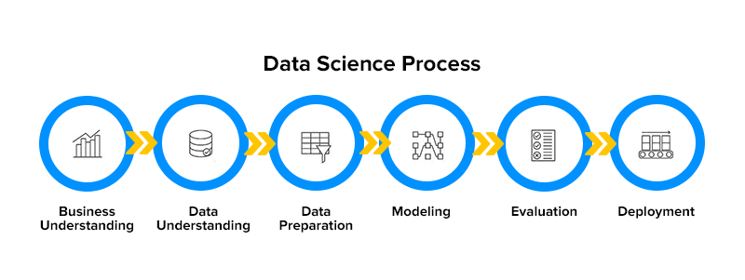

Figure 2 Data Science and Analytics Work Process

1. Asking the right questions

Even though it might seem simple, data science requires the correct questions in order to get meaningful findings. For instance, you won't receive the intended outcome if your query, "What kind of customers are good for our business," is too unclear. You may ensure that you acquire the needed answers by using data scientists' assistance in improved question framing.

2. Getting the right data

Once you have the right questions, a data scientist can help determine how to collect the required data for analysis. In some cases, you will already be having the data and in others, you may need to seek out new data sources.

3. Cleaning the data

One of the most crucial steps in the data science process is data cleansing. By correcting or deleting the data points that are faulty, erroneous, or incomplete, you prepare datasets for analysis at this stage.

4. Analyzing the data

At this stage—the heart of the data science process—you can finally begin to analyse the prepared datasets and build models. Since data analysis is an iterative process, certain settings might need to be changed as you go.

5. Comprehending the results

Following the completion of the data analysis process, the data scientist presents the information to the stakeholders using a variety of data visualisation approaches and decides how it may be used to enhance business results.

V.Industrial Applications of Data Science

Anomaly Detection

Data sets that contain outliers or violate the norms of a data cluster are considered anomalies. This is a crucial application since even the smallest data deviations might have catastrophic effects.

Pattern Recognition

Making a product offering that is pertinent to the customer's purchasing habits is essential to a company's existential interest. After carefully sorting through enormous data and doing trend analysis, these patterns can be created. An essential technique for figuring out seasonal highs and lows is pattern identification. Applications of pattern recognition using data science include risk management, computer vision, stock trading, natural language processing, and speech recognition.[3]

Predictive Modeling

Always choose flexibility and nimbleness above rigidity and nonconformity. In a similar spirit, formula-driven training sets are topped off with predictive modelling. Predictive modelling is not a new concept and has been around for a while, it should be noted. Data science, however, improves it by adding deep learning and machine learning. In business, predictive analytics helps close the gaps. It is used, for instance, in industrial manufacturing to reduce equipment breakdown.

Recommendation Engines
Don’t we love personalization for our favorite products?

Brands may achieve high customer satisfaction ratings with the help of recommendation engines. They aid company analysts in imagining how marketing campaigns need to be planned in order to give a suitable offer to the consumer at the most advantageous moment. This aids in retaining customers. Companies that use data science and machine learning to provide clients with hyper-personalized experiences include Netflix and Amazon[9].

Classification & Categorization
Working through structured data is rather simple. But developments in deep learning and artificial neural networks have allowed teams to manage unstructured data sets be it images, text, multimedia files, or textual documents. Through this use of data science for small business applications[11] as well as legacy corporations, the macroeconomic ecosystem is benefitting at large.

Sentiment & Behavioral Analysis

Structured data may be processed easily. However, advances in artificial neural networks and deep learning have made it possible for teams to manage unstructured data collections, including text, photos, multimedia files, and text documents. The macroeconomic ecosystem as a whole benefits from the use of data science for small business applications[11] as well as legacy enterprises.

Conversational Systems

A discussion of conversational AI-powered interfaces is essential to any comprehensive guide to data analytics. These days, technologies that can automate boring, repetitive operations are included in the building tools for business data science applications[5].

These operations rely heavily on human interaction. The personnel can be reassigned to more productive tasks by providing automation for such recurrent KRAs. Conversational systems include intelligent agents, voice-activated messenger bots, and text-to-speech user interfaces. This essay will explain how automation will affect the nature of labour in the future.

Autonomous Systems

Machine learning is a discipline that enables AI programmes to learn from their errors and retrain themselves accordingly. Data science applications for business verticals have proliferated as a result of ML's contribution to this sector. In the continuous shapeshifts in IoT and bot development, it has a direct say.

In mechanised warehouses, the majority of operations are being handled by self-supervising robots. Autonomous vehicles are becoming a reality. A self-sufficient future is developing sooner rather than later owing to data analytics for company owners.

VI. Data Science Use Cases
Our creativity is the only restriction on the uses of data science for large and small organisations. This technology's capabilities and reach are expanding to support large-scale industries.[8]
Entertainment: Data science methods are being used by over-the-top streaming services like Netflix to analyse the sentiment of its users. By serving viewers material based on their choices, this promotes hyper-personalization experiences and a greater customer retention rate.
Financial Services: Customer portfolios undergo a rigorous examination using training models in order to root out forgeries and fraudulent transactions, manage risks, and spot possible opportunities for upselling items.
Healthcare: This industry is experimenting with a variety of AI-related strategies, some of which are described in this article. The fact that there is a widespread agreement to use computer vision in an effort to discover sickness signs that may elude human observation gives insight into how data science and analytics affect corporate decision-making.
The algorithms concept reviewing millions of patient records for pertinent signals is supported by the fact that AI and ML are raising the hopes of medical practitioners to identify life-threatening illnesses at an early stage.
Manufacturing: The widespread faith in the technology to optimise supply chains, anticipate equipment failures, and expedite distribution is evidence of the commercial use of data science for business executives.To learn more about how big data is utilized in manufacturing, read this article.
Retail: Major retailers utilise data science and analytics to manage supply chains, optimise inventories, and design outcome-driven remarketing campaigns. To learn why your retail organisation should increase its data analytics expenditures, read this article.
Logistics: With the help of data science technologies, shipments and delivery routes are optimised to ensure that consumers throughout the world receive their goods on time.
Travel: AI, ML, and other subsets of data science are well-ingrained inside the commercial side of firms in the travel sector, from passenger loads to aeroplane routes and customised ticketing platforms.
VII. Conclusion
Data science is beneficial to every organization in every industry, from hiring new hires and new applications to assisting senior staff with better decision-making. Data science is now a core subject that connects many other fields, such as mathematics, statistics, mathematical techniques, logical thinking, artificial intelligence, and machine learning applications. All of these factors can be utilized to access and effectively use the data from various businesses or organizations. Based on the interests and satisfaction of their clients, businesses can grow thanks to the wise decisions that come from this effective use of data. The data from various businesses or organizations may be accessed through all of these variables and used in efficient ways.
References
[1]. Russell, Stuart J., and Peter Norvig. Artificial intelligence: a modern approach. Malaysia; Pearson Education Limited,, 2016.
[2]. Nilsson, Nils J. Principles of artificial intelligence. Morgan Kaufmann, 2014. 3.
[3] Bell, Jason. Machine learning: hands-on for developers and technical professionals. John Wiley & Sons, 2020.
[4] Van Der Aalst, Wil. "Data science in action." Process mining. Springer, Berlin, Heidelberg, 2016. 3-23.
[5]. Dhar, Vasant. "Data science and prediction." Communications of the ACM 56.12 (2013): 64-73.
[6]. Hazen, Benjamin T., et al. "Data quality for data science, predictive analytics, and big data in supply chain management: An introduction to the problem and suggestions for research and applications." International Journal of Production Economics 154 (2014): 72-80.
[7]. Wimmer, Hayden, and Loreen Marie Powell. "A comparison of open source tools for data science." Journal of Information Systems Ap]plied Research 9.2 (2016): 4.
[8]. Islam, Mohaiminul. "Data Analysis: Types, Process, Methods, Techniques and Tools." International Journal on Data Science and Technology 6.1 (2020): 10.
[9]. Nicolae, Bogdan, et al. "Park, Yoonho. Leveraging Adaptive I/O to Optimize Collective Data Shuffling Patterns for Big Data Analytics. IEEE TRANSACTIONS ON PARALLEL AND DISTRIBUTED SYSTEMS. PP (99) pp: 1-13." (2020). 1
[10]. Abas, Zuraida Abal, et al. "Analytics: A Review Of Current Trends, Future Application And Challenges." Journal of Advanced Computer Technology. PP 3560 (2020): 3565.
[11] Rani, Bindu, and Shri Kant. "An Approach Toward Integration of Big Data into Decision Making Process." New Paradigm in Decision Science and Management. Springer, Singapore, 2020. 207-215.
[12]. Bejjam, Suvarnamukhi & Seshashayee, M.. (2018). Big Data Concepts and Techniques in Data Processing. International Journal of Computer Sciences and Engineering. 6. 712-714.

