Renewable energy sources
Mamta Chahar², Manisha Ruhela^{1*}, and Sarita Khaturia¹
¹Department of Chemistry , School of Liberal Arts and Sciences, Mody University of Science and Technology, Lakshmangarh, Sikar 332311, Rajasthan, India.
²Department of Chemistry (Applied Sciences), Institute of engineering & Technology, NIMS University, Jaipur, Rajasthan, India
manisharuhela570@gmail.com
mamtachahariitd@gmail.com
saritarajkhatri@gmail.com

Table of contents

1. Abstract
2. Introduction
3. The types of renewable energy sources
4. Future of renewable energy sources
5. The benefits of utilizing renewable energy
6. Facts about renewable energy
7. Conclusions
1. Abstract
Renewable energy sources (RES), which harness energy from natural processes to meet the world's expanding energy needs, are currently replacing traditional energy sources. The amount of conventional energy available is finite and decreasing. On the other hand, the natural world is constantly producing new renewable energy sources. The main RES sources include biomass, hydroelectricity, geothermal energy, solar energy, and wind energy. Many countries throughout the world have adopted the use of RES in an effort to achieve energy independence. Without social acceptance, no new technology linked with them can be successfully adopted; as a result, whether or not RES is embraced by citizens is vital.
Keywords: Renewable energy sources, solar, wind, hydroelectricity, geothermal and biomass energy
2. Introduction:
A renewable energy source is one that never runs out or is depleted, such as the sun. Renewable energy sources are commonly included when discussing "alternative energy" [1-3]. It implies to alternatives to the most widely used non-sustainable sources of energy, such coal. Renewable natural resources or processes are used to produce renewable energy, also referred to as clean energy. For example, regardless of whether their accessibility is reliant upon the time and climate, daylight and wind proceed to sparkle and blow. While utilizing the force of nature has for some time been utilized for transportation, lighting, warming, and different purposes, sustainable power is habitually considered of as a moderately late innovation. Wind has been utilized to drive ships across the seas and power grain factories. The light warmed the day and helped with lighting fires that endured into the night. In any case, during the most recent 500 years or more, individuals have become increasingly more dependent on dirtier, more reasonable energy sources like coal and explored gas.
3. The types of renewable energy sources
Currently, the most generally utilized sustainable power sources are:
- Solar power
- Wind power
- Water power
- Tidal power
- Geothermal power
- Fuel from biomass

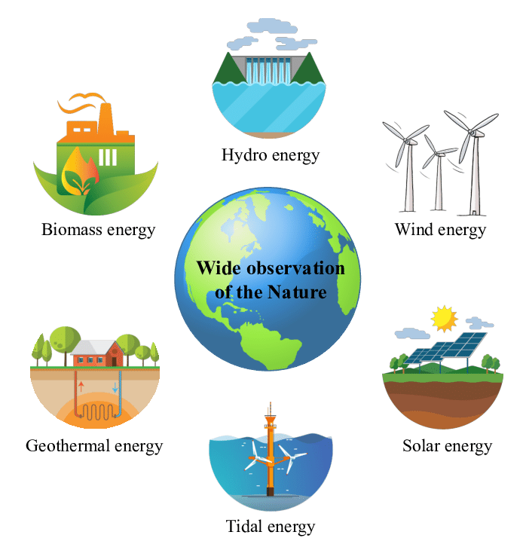

Figure 1: Various renewable energy sources

1. Solar power: One of the most copious and promptly accessible energy sources on our planet is daylight. The amount of sun powered energy that arrives at the outer layer of the globe in a solitary hour surpasses the planet's entire yearly energy needs. The amount of sun based energy we can use shifts relying upon the hour of day, the time of the year, as well as our geographic area, regardless of the way that it might seem like the ideal sustainable power source. Sun powered energy [4, 5] is turning into an increasingly more typical choice to supplement your energy use in the UK.
Working: Silicon cells layer, a glass covering unit, a metal casing, and wire associations for energy stream from the phones make up a sunlight based charger. In spite of not being a metal, silicon is a decent channel. It empowers the change of sun powered energy into valuable energy through assimilation. At the point when daylight hits a silicon cell, it makes the cells move, what begins an electric flow to stream. The photovoltaic impact, a general term for how sunlight powered chargers work, is depicted by the initiation.Edmond Becquerel made the finding in 1839. This result is the basis for the scientific theory of solar energy electricity production. Semiconductors are substances that can produce an electric current when exposed to sunlight.
The entire process entails:
- Solar radiation absorbed by the silicon cell
- This photovoltaic solar cell reacts to the radiation and causes the electrons to move. Electric current starts to flow as a result of this.
- Direct current (DC) electricity is transported via cables to a solar inverter. DC is changed into alternating current (AC) in the converter. It is a widely used type of electricity in the US.
Thin-film photovoltaic solar modules make up around 5% of all solar modules on the market today. They don't make a panel out of many cells, but rather have at least one semiconductor on the surface of a single substrate. For a very long time, crystalline silicon has been more effective at converting solar radiation into electricity than thin-film photovoltaic technology. However, they are less expensive to build, and the technology is rising in popularity in the US. Additionally, the use of multi-junction cells is more effective than the use of conventional solar cells. They use more solar power. These cells have numerous layers rather than relying just on one semiconductor, such as silicon. Each layer has a semiconductor element that responds to a particular region of the light spectrum. Although using technology is expensive, it will probably become more commercially viable in the next years.

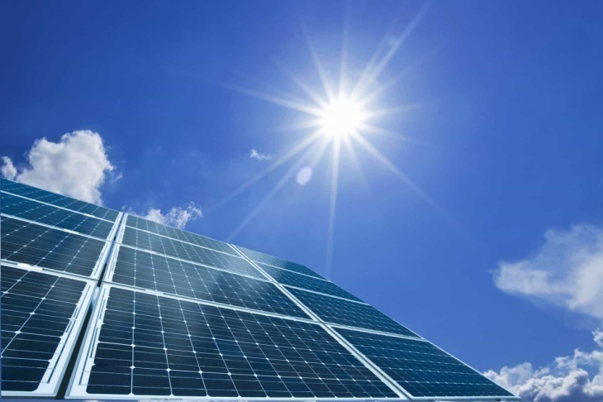

Figure 2: Solar energy
2. Wind energy: A plentiful wellspring of sustainable power is wind. With wind power offering increasingly more to the Public Network, wind ranches are turning into a more normal sight in the UK. To create power from wind energy, turbines power generators, which in this way supply capacity to the Public Matrix. Despite the fact that there exist techniques for "off-lattice" or family power, few out of every odd property can oblige a private breeze turbine.
Working: The method of catching breeze energy [6-8] and changing it into helpful mechanical and electrical power is known as wind power. Today, turbines — essentially immense windmills — give most of the breeze energy utilized. The breeze turns a few of the turbine's cutting edges, which look like propellers, around the rotor. The generator, which pivots to deliver power, is associated with the rotor by a primary shaft. Daylight produces varieties in surface temperature, and these varieties in surface temperatures make warm air rise and produce winds. In this manner, one of the elements of sunlight based power is to catch the energy from these breezes. The magnificence of wind power is that it comes from the breeze, which is a basically boundless and limitless asset. Wind energy creates fundamentally less contamination and fossil fuel byproducts than energy that is energized by petroleum derivatives.

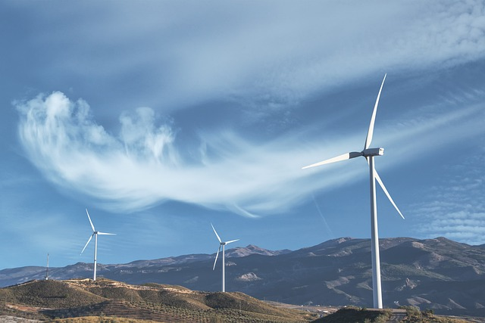

Figure 3: Wind energy
3. Hydro power: It is one of the most financially settled wellsprings of environmentally friendly power. A major supply can be used to make a managed progression of water that will drive a turbine, creating power, by raising a dam or boundary. The capacity to store power for use during seasons of pinnacle request makes this energy source frequently more dependable than sunlight based or wind power (particularly assuming it's flowing instead of stream based). Like breeze energy, hydro can periodically be savvier as a business energy source (contingent upon the sort and contrasted with different wellsprings of energy), however it can likewise be used for homegrown, "off-network," producing. It is a huge sustainable power source that is as of now used to create power all around the world is hydroelectric power (HEP) [9-11]. It utilizes the basic standards of material science. Water falling under serious strain has a great deal of motor energy. The turbines in a HEP station are turned by the streaming water. The generator changes the mechanical energy of the turbines into electrical energy through attractive acceptance.
Working: Hydroelectric Power Station is a technique for turning generator turbines by utilizing dam water that is tumbling from a level. The public matrix framework is provided with the electrically created mechanical energy.
Three primary parts make up a hydroelectric power plant.
• The dam that produces the water head is the first. High-speed water tumbling from the dam's base gives the turbines active energy to turn.
• The supply is the subsequent component. The region behind the dam where water is held is known as the water repository. The supply's water level is higher than that of the rest of the dam's development. The supply's water level decides how much potential energy it contains. The expected energy of water increments with level.
• The third component is the power plant, which creates power and is wired into the framework.

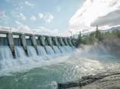

Figure 4: Hydro power energy

4. Tidal energy
This is one more type of hydro energy that utilizes two times day to day flowing flows to drive turbine generators. Albeit flowing stream not at all like some other hydro energy sources isn't steady, it is exceptionally unsurprising and can hence make up for the periods when the tide momentum is low. Tides are a typical event. They are vulnerable to estimating long stretches of time ahead of time. Along these lines, the energy created by the gigantic water development might be caught and changed into a valuable sort of energy. Flowing energy [12-14] can possibly give power later on regardless of whether it isn't presently usually utilized. Flowing energy has battled contrasted with other environmentally friendly power sources in light of its generally significant expense and shortage of building locales. In any case, flowing energy age seems to have a promising future since late innovation headways recommend that the monetary and ecological expenses can be diminished to levels that are serious.
Working:
Tidal Energy Generator: Tidal energy is the energy derived from the rise and fall of tides.Dams or tidal barrages are built to block off a small seaport. Whenever the sea level rises, water pours through the dam. The turbine blades that are mounted at the dam opening are moved as a result. As a result, electricity is produced.

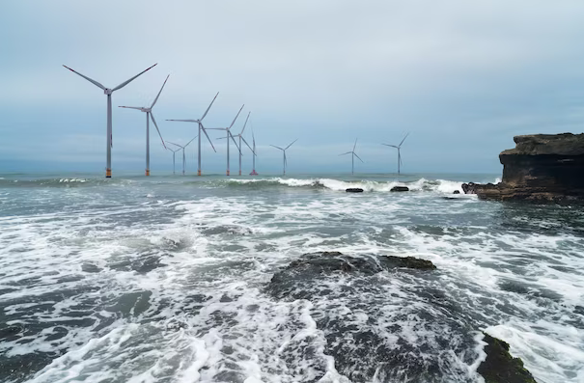
Figure 5: Tidal energy

5. Geothermal energy
Geothermal energy can be used to straightforwardly warm homes or to create power by using the normal intensity that exists underneath the world's surface. Geothermal energy is of minor significance in the UK contrasted with countries like Iceland, where geothermal intensity is impressively more uninhibitedly accessible, notwithstanding the way that it outfits a power that is simply underneath our feet. Environmentally friendly power got from the World's center is known as geothermal energy [15-18]. It starts from heat delivered during the planet's underlying creation and the radioactive rot of components.
Working: In the world's center, rocks and fluids contain this nuclear power. Nuclear power is consistently moved from the planet's inside to its surface because of the distinction in temperature between the world's center and its surface. A portion of the stone in the World's center melts at temperatures over 4000°C to create hot, liquid rocks known as magma. Considering that the mantle is lighter than the hidden stone, these warms additionally drive some of it to convect vertically and act plastically. The stone and water in the hull of the Earth can get as hot as 370°C. From superficial right down to a few miles beneath, nuclear power is available in the stones and liquids.

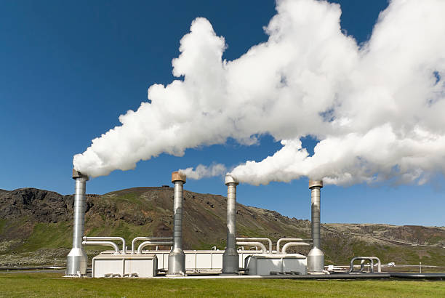

Figure 6: Geothermal energy

6. Biomass Energy
In this cycle, strong fuel made from plant assets is changed into power. Albeit the center of biomass is the consuming of natural materials to make power, this interaction is presently cleaner and more energy-effective. Biomass makes power at an essentially lower monetary and ecological expense by turning home, modern, and rural waste into strong, fluid, and gas fuel. Since individuals initially began warming their homes and preparing their feasts by consuming wood, biomass has been utilized. The biggest biomass energy source accessible today is still wood. Food crops, verdant and woody plants, ranger service or horticultural squanders, oil-rich green growth, and the natural piece of metropolitan and modern squanders are a few additional sources. Indeed, even landfill exhaust, which are basically made out of methane, the chief gas in flammable gas, can be utilized as a biomass energy source. Energizes, power, and different products that would regularly be produced using non-renewable energy sources can be subbed with biomass.
Working: Since it includes solar energy, biomass [19-22] is a renewable source of energy. In its simplest form, biomass is an organic material derived from plants and animals. Through the process of photosynthesis, chlorophyll in plants receives solar energy by transforming groundwater and atmospheric carbon dioxide into carbohydrates. The energy that these plants absorbed from the sun is released when they are burned into the air. This renewable energy source is boundless as long as biomass is generated. Plants, crop waste, wood chips, corn, and other sorts of rubbish are examples of biomass.
Thus, the captured solar energy is released when these plants and animals burn, reverting to carbon dioxide and water. This means that since we can always grow more plants and crops and because trash will always exist, biomass is a renewable source of energy.
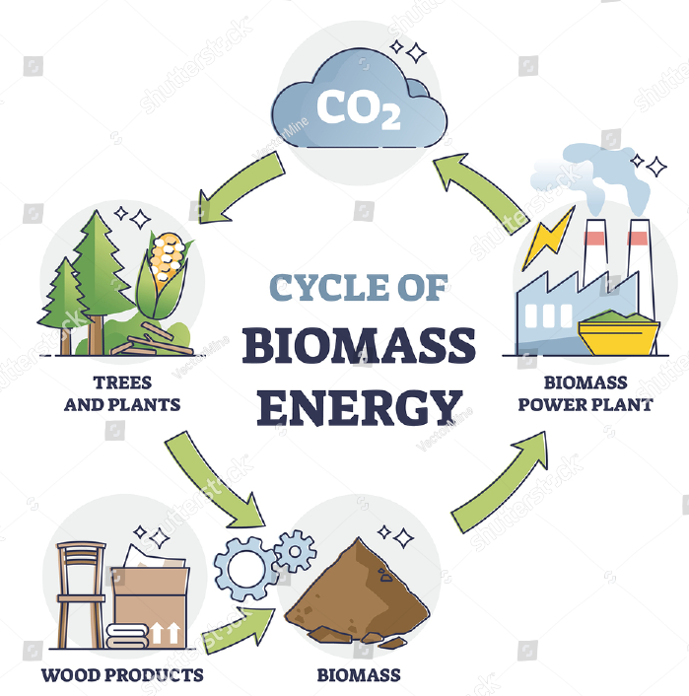

Figure 7: Biomass Energy

4. Future of renewable energy sources
The interest for energy to control our homes, organizations, and networks develops alongside the worldwide populace. Keeping a manageable energy level and forestalling environmental change need development and extension of sustainable power sources. The Global Energy Organization (IEA) predicts that by 2024, 30% of the world's power would come from inexhaustible sources, up from the ongoing 26% offer. The IEA's chief, Fatih Birol, expressed that "environmentally friendly power is at a basic point at the present time." The UK accomplished a pristine unbelievable environmentally friendly power achievement in 2020. It is guessed that as power request ascends from here on out, the quantity of environmentally friendly power sources will continue to develop. This will bring about lower sustainable power costs, which is phenomenal for the climate and conservative for us.
5. The benefits of utilizing renewable energy in a household environment are compelling:
- Minimize your energy expenditures: Once the costs of establishing a renewable energy system have been covered, you can minimize your reliance on the National Grid and your energy prices. A great gas boiler substitute is air source heat pumps.
- Receive payment for the electricity you produce: The Feed-in Tariff program of the UK government compensates you for the electricity you produce, even if you use it.
- Refinance your electricity with the grid: You can get extra money from the Feed-in Tariff program if you are producing enough energy to export an excess back into the National Grid.
- Drive an electric vehicle: Did you know that our EV rates are renewable in addition to being cost-effective? View our electric vehicle pricing.
- Minimizing carbon footprint: Carbon dioxide and other dangerous pollutants are not released into the atmosphere while using green, renewable energy sources. The Solar panels page of the Energy Saving Trust states that a typical solar PV system might save 1.5 to 2 tonnes of carbon annually.
6. Facts about renewable energy
• By 2020, sun powered PV might supply 5% of world interest, and by 2030, it might supply up to 9%.
• Our energy prerequisites can be fulfilled by 95% sustainable power constantly 2050.
• Value Waterhouse Cooper extends that by 2050, Africa will be completely subject to sustainable power.
• The expense of sun based PV boards has diminished by 95% during the past 40 years.
• As per a US research, sustainable power produces three fold the number of occupations as non-renewable energy sources.
• Interest in environmentally friendly power presently surpasses that in non-renewable energy sources. The market for environmentally friendly power is currently worth more than $250 billion.

7. Conclusion
By subbing environmentally friendly power hotspots for petroleum products in the transportation and power age ventures, CO2 discharges could be diminished. It is fundamental to create and advance sustainable power supply innovations as well as interest for sustainable power since there are a few unwanted and irreversible externalities in the age of ordinary energy. To bring down the expense of creation per unit, more power ought to be produced from sustainable power sources. Various factors, for example, populace development, energy costs, climate, and innovation, influence how much energy is consumed.

References

1. Zhao, J., Patwary, A. K., Qayyum, A., Alharthi, M., Bashir, F., Mohsin, M., ... & Abbas, Q. (2022). The determinants of renewable energy sources for the fueling of green and sustainable economy. Energy, 238, 122029.
2. Kebede, A. A., Kalogiannis, T., Van Mierlo, J., & Berecibar, M. (2022). A comprehensive review of stationary energy storage devices for large scale renewable energy sources grid integration. Renewable and Sustainable Energy Reviews, 159, 112213.
3. Sher, F., Curnick, O., & Azizan, M. T. (2021). Sustainable conversion of renewable energy sources. Sustainability, 13(5), 2940.
4. Esmaeili Shayan, M., Esmaeili Shayan, S., & Nazari, A. (2021). Possibility of supplying energy to border villages by solar energy sources. Energy Equipment and Systems, 9(3), 279-289.
5. Heffron, R., Halbrügge, S., Körner, M. F., Obeng-Darko, N. A., Sumarno, T., Wagner, J., & Weibelzahl, M. (2021). Justice in solar energy development. Solar Energy, 218, 68-75.
6. Sadorsky, P. (2021). Wind energy for sustainable development: Driving factors and future outlook. Journal of Cleaner Production, 289, 125779.
7. Msigwa, G., Ighalo, J. O., & Yap, P. S. (2022). Considerations on environmental, economic, and energy impacts of wind energy generation: Projections towards sustainability initiatives. Science of The Total Environment, 849, 157755.
8. Zhao, X., Nashalian, A., Ock, I. W., Popoli, S., Xu, J., Yin, J., ... & Chen, J. (2022). A Soft Magnetoelastic Generator for Wind‐Energy Harvesting. Advanced Materials, 34(38), 2204238.
9. Chang, L., Lu, Q., Ali, S., & Mohsin, M. (2022). How does hydropower energy asymmetrically affect environmental quality? Evidence from quantile-based econometric estimation. Sustainable Energy Technologies and Assessments, 53, 102564.
10. Gemechu, E., & Kumar, A. (2022). A review of how life cycle assessment has been used to assess the environmental impacts of hydropower energy. Renewable and Sustainable Energy Reviews, 167, 112684.
11. Ugwu, C. O., Ozor, P. A., & Mbohwa, C. (2022). Small hydropower as a source of clean and local energy in Nigeria: Prospects and challenges. Fuel Communications, 10, 100046.
12. Chowdhury, M. S., Rahman, K. S., Selvanathan, V., Nuthammachot, N., Suklueng, M., Mostafaeipour, A., ... & Techato, K. (2021). Current trends and prospects of tidal energy technology. Environment, development and sustainability, 23, 8179-8194.
13. Shetty, C., & Priyam, A. (2022). A review on tidal energy technologies. Materials Today: Proceedings, 56, 2774-2779.
14. Duman, S., Akbel, M., & Kahraman, H. T. (2021). Development of the multi-objective adaptive guided differential evolution and optimization of the MO-ACOPF for wind/PV/tidal energy sources. Applied Soft Computing, 112, 107814.
15. Fridleifsson, I. B. (2003). Status of geothermal energy amongst the world's energy sources. Geothermics, 32(4-6), 379-388.
16. Fridleifsson, I. B. (2001). Geothermal energy for the benefit of the people. Renewable and sustainable energy reviews, 5(3), 299-312.
17. Stefansson, V. (2000, May). The renewability of geothermal energy. In Proceedings of the World Geothermal Congress 2000 (pp. 883-888).
18. Dickson, M. H., & Fanelli, M. (2013). Geothermal energy: utilization and technology.
19. Balat, M., & Ayar, G. (2005). Biomass energy in the world, use of biomass and potential trends. Energy sources, 27(10), 931-940.
20. Chuah, T. G., Wan Azlina, A. G. K., Robiah, Y., & Omar, R. (2006). Biomass as the renewable energy sources in Malaysia: an overview. International Journal of Green Energy, 3(3), 323-346.
21. Güney, T., & Kantar, K. (2020). Biomass energy consumption and sustainable development. International Journal of Sustainable Development & World Ecology, 27(8), 762-767.
22. Balat, M. (2009). Global status of biomass energy use. Energy Sources, Part A, 31(13), 1160-1173.

