BIODEGRADATION OF HEAVY METALS BY MICROORGANISMS
*Priyam Kumari, Vishal Kumar Singh, Rupa Verma
MSc Biotechnology, University Department of Botany, Ranchi University Ranchi, Jharkhand, India.
Corresponding author: idealpriyamsinha@gmail.com*,
ABSTRACT
Heavy metal pollution of soil and water, which may lead to cancer and impede plant development, has significantly increased in recent years. Examples of such heavy metals include arsenic, mercury, lead, chromium, nickel, etc. Bioremediation of heavy metals depends on microbes. Through genetic engineering, it is possible to produce microbes that have been genetically altered to potentially reduce numerous types of polycyclic hydrocarbons (PAHs). Flavobacterium, Pseudomonas, Bacillus, Arthrobacter, Corynebacterium, Mycobacterium, Methanogens, Aspergilus niger, are some microbial species that help in bioremediation of heavy metals, which is quite effective and promotes sustainable development. In addition to these, microbes aid in bioaugmentation, and some can raise soil fertility. Through a process called bioremediation, harmful polymers are converted into less harmful ones by microorganisms using them as a source of energy. Because of the Earth's fast degradation, an emergency scenario exists. One of these problems is contamination from heavy metals. The success of their strategy also depends on its effectiveness as a tool for the cleanup of polluted soils. The process of using microbiological methods to convert complicated polymers into less dangerous structures is known as biodegradation, and it is used by them as a source of energy. Bioremediation technology is still in its infancy and has to draw a distinction between what it claims to do and what really occurs. As a consequence of the aging processes, dead biomass can equally be obtained from contemporary sources.
KEYWORDS: - Bioremediation, Bioaugmentation, Flavobacterium, Pseudomonas, Arthrobacter, Corynebacterium, Mycobacterium, Methanogens, Aspergilus niger.

INTRODUCTION
The only environment that supports a range of microflora and fauna is soil, which provides higher plants with both mechanical and nutritional support. Industries including textile, leather, paper, electroplating, chrome plating, petroleum refining, paint, and fabrication employ heavy metals extensively. These businesses seriously contaminate the environment by discharging significant amounts of hazardous waste and untreated effluents. Soil, water, and air are contaminated as a result of the organic pollutants that are present, deposited, and persistent in the environment.[1]
Metals released into water bodies undergo chemical change, which has a more negative human health and environmental impact. Heavy metal soil pollution is a serious environmental issue that has a big effect on the ecosystem. In addition to bioaccumulating in tissues and being biomagnified along with the trophic levels, heavy metals are non-biodegradable and bioaccumulated. Heavy metals can leak into the environment as a result of volcanic eruptions and bedrock weathering. The kind of heavy metals released from the rock substratum relies on its composition as well as additional elements including the climate, soil's natural characteristics, soil chemistry, and other human activities occurring in the area.[2]
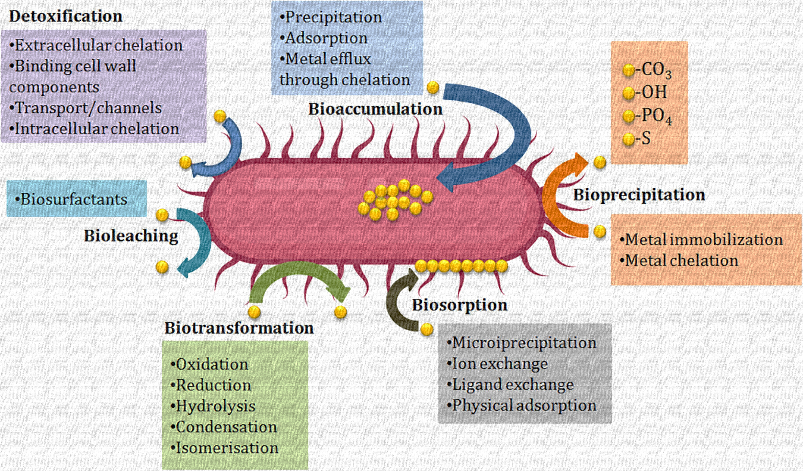

Figure 1: The main causes, consequences, and trophic levels of heavy metal exposure.[52]
As a result of their presence in the soil, heavy metals pose a risk to human health and are known to go up the food chain through plants. Due to anthropogenic activity, many heavy metals including cadmium, nickel, chromium, lead, arsenic, and mercury are released into the environment. Even in tiny amounts, these heavy metals are harmful to both plant and animals. There are several innovative technologies being created nowadays that have an emphasis on eliminating pollutants rather than using the traditional method of disposal. Figure 2. depicts many categories of heavy metal sources.
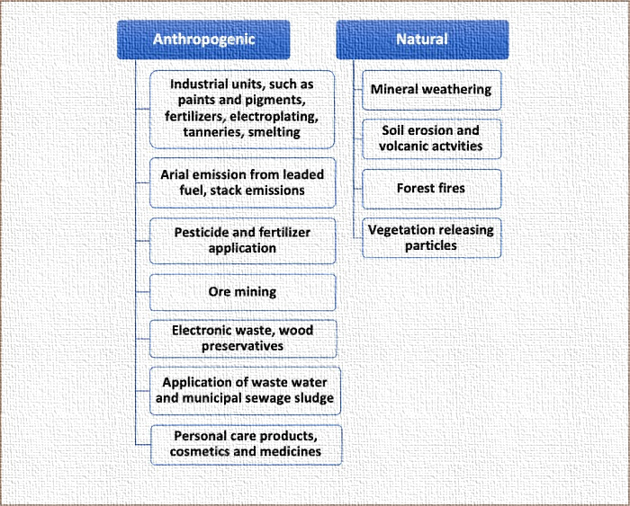Figure 2: Sources of heavy metals.[2]
Several wastewater technologies were applied on a target scale to reduce the concentration of hazardous chemicals in wastewater from a higher level to a lower one. The contaminated soil has been cleaned up via physical, chemical, photochemical, and microbiological degrading processes. These methods are more damaging to the environment and have limits when it comes to completely eliminating soil hydrocarbon pollution. One of the best methods for cleaning heavy metal-polluted soil is biological treatment, which uses the soil's natural microbes to convert the heavy metals into harmless compounds. Metal-polluted soil can be cleaned up using chemical, physical, and biological techniques.
HEAVY METAL REMEDIATION
Heavy metal remediation in polluted ecosystems, such as soil and water, has been done in recent years using a variety of technologies and methodologies. These techniques include physicochemical and biological ones, the latter of which may be further divided into in-situ and ex-situ bioremediation.
A. Physicochemical Methods
Processes that seek to eliminate heavy metals from any polluted environment are a part of physicochemical approaches. They can be used as metal or metal-containing particulate matter. This remediation can be carried out using physical and chemical processes like ion exchange, precipitation, reverse osmosis, evaporative recovery, solvent extraction, filtration, chemical oxidation, chemical leaching, electrokinetic, landfilling, electrochemical treatment, electrodialysis, ultrafiltration, solvent extraction, chemical precipitation, chemical reduction, and isolation (mechanical) separation of metals. These techniques do, however, need a lot of solvents and might result in inadequate metal removal as well as the formation of hazardous waste. In addition to being laborious and expensive, they also typically damage the soil and have harmful environmental effects. Consequently, these approaches are constrained by their high prices, high energy needs, poor performance, erratic metal ion removal, and production of hazardous sludge. [3-7]
B. Biological Methods
A variety of techniques are used to remove or degrade heavy metals through biological activity. These techniques are collectively known as biological remediation or biodegradation. These biological processes, which can be utilized to remove heavy metals, can either be anaerobic or aerobic (involving the presence of oxygen). In the process of biodegradation, the contaminated environment is biologically broken down under certain circumstances to concentrations that are below the regulatory bodies' set limits. [8-12]
*Figure 3, provides a quick summary of the various bioremediation approaches for various pollutants.
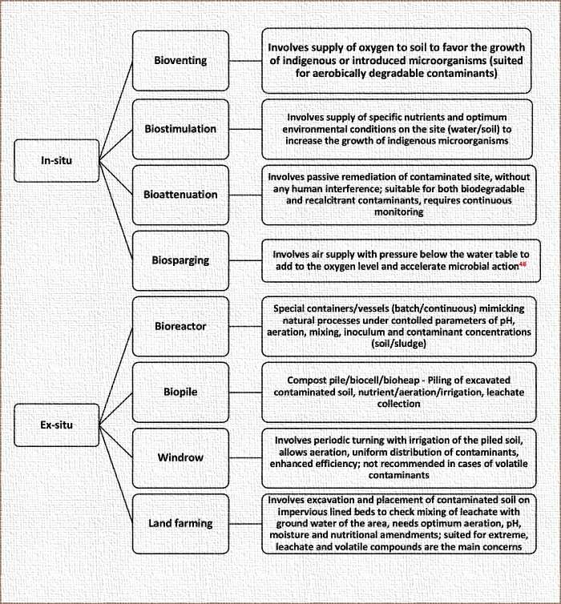Figure 3: Methods for different pollutants using different types of bioremediations.[13]

Table 1: Types of bioremediations.[14]
STRATEGY | DEGRADATION | ORGANISM
In situ bioremediation | Biotransformation | Bacterioremediation
Bioventing
Biosparging
Biostimulation
Bioaugmentation
Phytoremediation
Ex-situ bioremediation | Biodegradation | Mycoremediation
Land farming
Composting
Biopiles
Bioreactors
Others | Mineralization | Phytoremediation  Compost bioremediation

IN SITU BIOREMEDIATION
While the soil is still on the site, in situ bioremediation techniques remediate the pollution. The employment of these specific techniques depends on a variety of variables, including the extent of the contamination, the characteristics of the chemicals involved, the concentration of the pollutants, and the amount of time needed to accomplish the bioremediation. Due to its cost-effectiveness and the need for fewer items to be moved, this procedure is typically advised. Intrinsic and designed in situ bioremediation are two subtypes of in situ bioremediation that are occasionally used to categorize it. There are many different forms, but the most common ones include phytoremediation, bioventing, sparging, biostimulation, and bioaugmentation. [15-18]
Bioventing - The most popular in situ approach is called "venting," which involves supplying filthy soil with air and nutrients to encourage the growth of bacteria. Pollutants must biodegrade before they may be vented into the atmosphere, which necessitates a small airflow and low oxygen levels. It is possible to model the in-situ biodegradation of simple hydrocarbons in the soil, indicating that the contamination is widespread below the soil's surface. The inability to aerate superficial pollution and the difficulty in supplying oxygen to polluted soil restrict the effectiveness of venting.[19]
Biosparging - The process known as "sparging" involves injecting high-pressure air beneath the water table to increase groundwater oxygen levels and speed up the bacterial bioremediation of pollutants. To ensure the effective removal of soil pollutants despite any adverse circumstances, both venting and bio-sparging procedures have been used concurrently. Biosparging can also combine soil and groundwater, combined with soil under the water table and inside the capillary fringe, to lower the concentration of dissolved oil compounds in groundwater. It is a simple, affordable technique with lots of versatility.
The process of bioremediation is initiated by biostimulation, which promotes bacterial growth. In order to promote microbial activity and speed the breakdown of pollutants or toxic compounds into carbon sources or sources of nitrogen and phosphorus, improved nutrients and necessary chemicals are first provided to the polluted soil. Microorganisms that are among the earliest recyclers in nature include bacteria and fungi. Microorganisms' ability to transform chemical waste into energy and useful resources suggests important biological processes that are more efficient and environmentally benign.
Bioaugmentation - In bioaugmentation, there are specific locations where microorganisms are needed to remove the pollutants. They can quickly clean up the place because they can outcompete local microbes. It has been documented that bioaugmentation may eliminate hazardous substances from ecosystems including soil and water. However, a number of restrictions have also been noted. For instance, it has been found that abiotic and biotic stressors cause the number of exogenous microbes to decline when they are added to a contaminated environment. They develop because of inadequate growth resources, such as substrates, temperature fluctuations, and pH, as well as competition between imported and native microorganisms.[20]
Phytoremediation - A developing method called phytoremediation makes use of plants to clean up soil and water pollutants. It may be a viable option in the future and has a potential utility in the biodegradation of organic pollutants. Sites with shallow pollutants are suited for this method. Nevertheless, several studies have highlighted a number of this technology's drawbacks, including pollution concentration, toxicity, bioavailability, plant type, and stress tolerance.
EX SITU BIOREMEDIATION
Ex-situ bioremediation refers to the process of treating and excavating soil before putting it back where it came from. When contaminated material is removed, it can either be treated on-site or off-site, which is frequently a quicker way to decontaminate the region. There are two types of ex-situ bioremediation: solid phase systems and slurry phase systems. Composting, piles, bioreactors, and land farming are among the most crucial methods.
Land farming - Land farming is a straightforward procedure that entails excavating polluted soil over a prepared plot with intermittent tilling until pollutants are destroyed by microorganisms, with the technique being restricted to the treatment of a small portion of soil. Particularly when applied to soil that has been polluted with petroleum, the approach is simple and very successful. The approach can only be used to treat a small (10–35 cm) area of top soil.[21]
Composting - Composting is a process that requires mixing contaminated soil with non-hazardous organic agricultural wastes to encourage the growth of a large number of microorganisms at higher temperatures (40–65°C). The technique is used on a mixture of excavated soils and biosolids (wood chips, animal waste, and vegetal waste) that have been polluted with organic compounds (pesticides and petroleum hydrocarbons).[21]
Biopiles - Biopiles are a combination of composting and conventional farming. Different microorganisms (aerobic and anaerobic) can thrive in enriched habitats created by biopiles. The aqueous reactors, which are pumped up from a specific site, represent an ex-situ treatment of a polluted environment. It entails applying specialized designed technologies to bioremediate a polluted environment. For the treatment of surface pollutants, engineered cells are created to control the physical losses of the pollutants through leaching, which is subsequently followed by volatilization. Biopiling is regarded as a practical, economical method for polluted soils.
Bioreactors - A bioreactor is a container that is utilized once an external environment has been optimized and in which a biological reaction takes place. To produce a high output of bioremediation, the system may contain enzymes, tissues, microbes, and animal and plant cells. Since the target environment is simpler to manage, regulate, and anticipate in bioreactor systems than in other systems, biodegradation is often higher in bioreactor systems. Despite the benefits of reactor systems, it has been discovered that the polluted environment (such as soil) requires physical extraction of the contaminant before it can be handled by a bioreactor.[15]
BIOSORPTION AND BIOACCUMULATION
The use of biosorption and bioaccumulation as heavy metal cleanup procedures alternatives seems promising. The phrase "bioaccumulation" describes the uptake of contaminants by living biomass or cells, including the active/metabolism-dependent uptake of heavy metals. Using living biomass for cleanup may not be a viable option due to the extremely toxic metals that can accumulate in cells and interfere with metabolic processes, resulting in cell death. Dead biomass (biosorption) is flexible to changing environmental conditions and does not require a growth or nutritional medium, yet it is not impacted by toxicity. Up until equilibrium is reached, heavy metals are adsorbed passively (without requiring any energy expenditure; independent of metabolism) on the surface. Therefore, biosorption is preferable to active absorption or bioaccumulation since it is metabolism independent; nonetheless, it is highly reliant on the kind of biomass or biosorbent and pollutants involved. Microbial biomasses of fungus, algae, or yeast have been used for in-situ procedures to bioremediate because of these benefits. There have also been reports of heavy metal bioremediation using genetically engineered microbes and heavy metal nanoparticles produced by bacteria.
Intracellular sequestration is the term for the accumulation of metal ions inside the cells of microorganisms. Because of surface interactions, heavy metal ions become complex and are then carried inside of the cell. Extracellular sequestration is defined as the concentration of metal ions in the periplasm or their complexation into insoluble precipitates. Cadmium precipitation in Klebsiella planticola and Pseudomonas aeruginosa has been documented. [22-28,33]

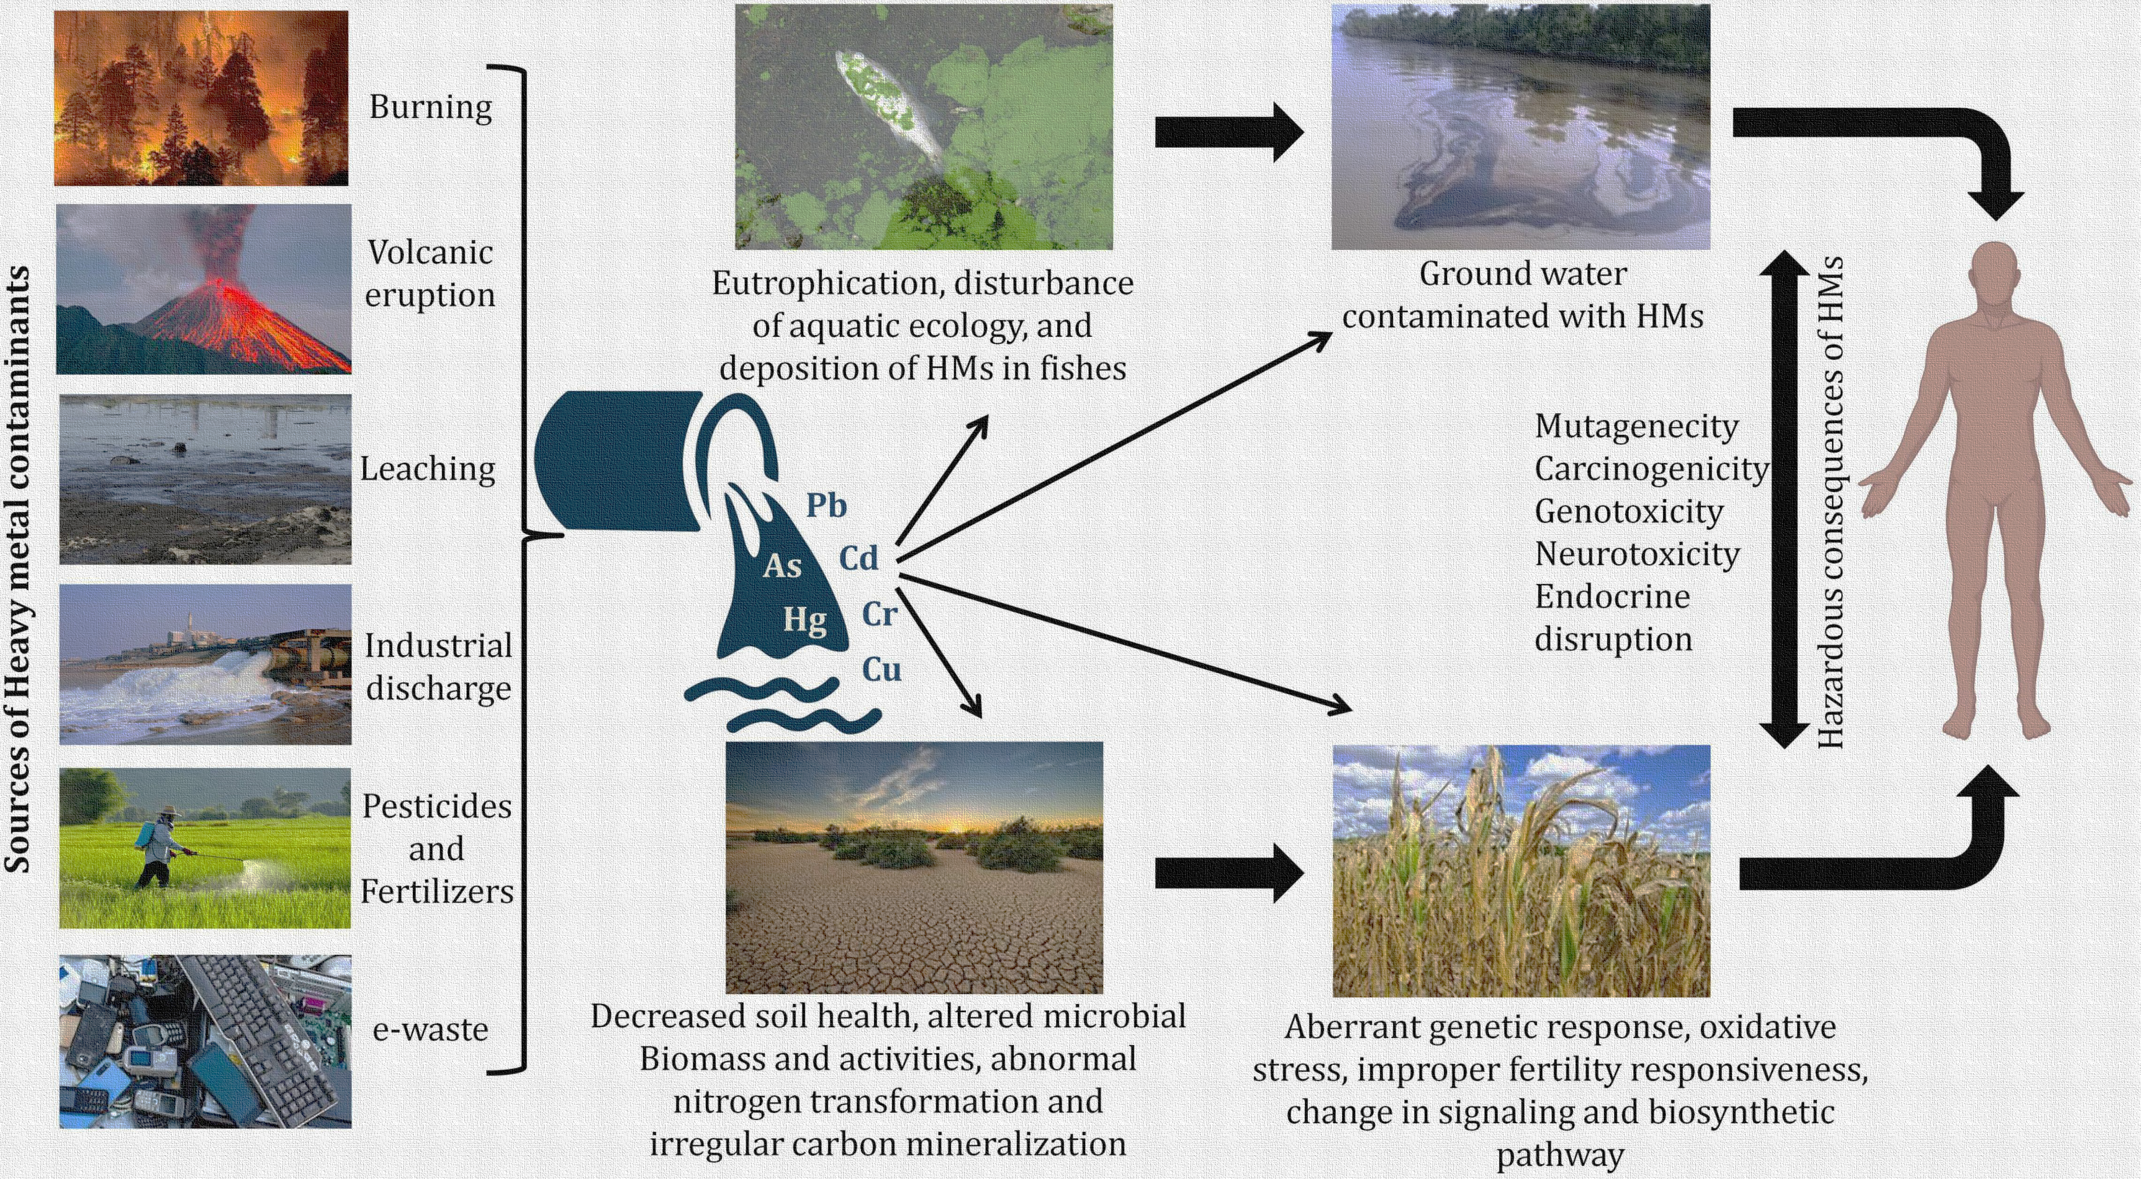

Figure 4: Environmental cleanup of heavy metals using microbes.[52]
Since microbes are nature's original recyclers, many different species can be employed for bioremediation. They may also convert chemicals into sources of energy and raw materials for their own growth, creating a biological process that is both inexpensive and environmentally beneficial. Heavy metals are becoming a serious global environmental issue as a result of their extensive industrial use. Due to industrial activity and fuel consumption, toxic heavy metals accumulate via the food chain, posing a threat to the environment and human health. Mercury, silver, lead, cadmium, and arsenic are some examples of heavy metals that have hazardous effects on living cells. Many different kinds of bacteria have genes in their DNA that make them resistant to various cations and oxyanions of heavy metals. In order to deal with the absorption of heavy metal ions, bacteria go through a variety of different methods. These processes include complexation, biosorption, trapping, efflux, reduction, and precipitation. As a result, microorganisms can be a potential, limitless resource for brand-new environmental biotechnologies. In bioremediation, harmful compounds to the environment or human health are detoxified or degraded using naturally occurring microbes. The microorganisms can either be separated from other resources at the contaminated location or utilized locally. The following examples are only a few of the microorganisms that are engaged in biodegradation as stated in Table 2: Acinetobacter, Actinobactera, Alcaligenes, Arthrobacter, Bacillins, Beijerinckia, Flavobacterium, Methylosinus, Mycobacterium, Mycococcus, Nitrosomonas, Nocardia, Xanthobacter, Penicillium, Phanerochaete, Pseudomonas, Rhizoctonia, Trametes, and Serratia. While most bioremediation procedures are carried out in aerobic environments, operating a system in anaerobic ones may allow microorganisms to break down otherwise resistant substances. During the process of growing, aerobic organisms require oxygen. Cellular respiration refers to these ongoing processes that employ oxygen to oxidize energy-producing substances like fatty acids from oil. Pseudomonas, Sphingomonas, Rhodococcus, Alcaligenes, and Mycobacterium are a few examples of aerobic degradative bacteria. In addition to hydrocarbon compounds, microorganisms may be employed to break down hazardous substances like insecticides. Numerous bacteria use the pollutant as a source of carbon and energy for their metabolism. In contrast to aerobic bacteria, anaerobic bacteria have a metabolism that is not dependent on oxygen. Additionally, biphenyls, chloroform, and dechlorination have all been bioremediation using anaerobic bacteria. Fungi may also be able to break down a wide spectrum of harmful or persistent environmental contaminants. There are many different kinds of substrates available, including maize cobs, straws, and dust. the aerobic bacteria that multiply by using methane as a source of carbon and energy. This aerobic breakdown, which is being started with the enzyme methane monooxygenase, will be effective against a variety of compounds. [29-51]
Table 2: Heavy metal distribution in environment and microorganisms involved in biodegradation.[14]
Heavy metal | Distribution | Microorganism | Reference
As | Soil, volcanic eruption | Sporosarcina ginsengisoli | [31-32]
Cd | Soil, sedimentary rocks, water | Bacillus sp.  Klebsiella planticola | [33-35]
Cr | All environments | Bacillus cereus strain XMCr-6  Bacillus cereus  Pseudomonas putida  Enterobacter cloacae B2-DHA  Bacillus subtilis | [36-39]
Pb | Soil | Rhodobacter sphaeroides  Leclercia adecarboxylata  Kocuria flava | [40]
Hg | Water, soil, and air | Bacillus sp. strain CSB_B078  Klebsiella pneumoniae isolate  Enterobacter sp. strain 08  Acinetobacterseohaensis strain | [41]
Cu | Earth's crust, oceans, lakes, and rivers | Kocuria flava | [42]
Zn | Surface water, soil, and rock | Pseudomonas putida | [43-44]
Ni | Air, soil, sediments, and water | Desulfovibrio desulfuricans  Bacillus licheniformis | [45-46]
Co | Air, soil, and water | Bacillus sp.  Rhodopseudomonas palustris | [34, 47,48]
As: arsenic; Cd: cadmium; Cr: chromium; Pb: lead; Hg: mercury; Cu: copper; Zn: zinc; Ni: nickel; Co: cobalt.
WHAT AFFECTS BIOREMEDIATION?
Microorganisms might have natural and monetary limits with regards to weighty metal evacuation. The decision of a suitable bioremediation ought to consider various boundaries. The level of biodegradation relies fundamentally upon various elements. Most importantly, supplements in the sullied climate including nitrogen, phosphate, sulfur, iron, and potassium can advance and support vigorous microbial turn of events, cell digestion, and microorganism expansion. These supplements act as the structure blocks of life and help in the development of the compounds expected by microorganisms to corrupt poisons. Second, it's conceivable that the expense of remediation will be essential to the continuation of bioremediation, consequently it ought to be reasonable to be attainable monetarily. Thirdly, the sort of contaminations — whether they are dangerous or harmless, natural or inorganic, weighty metals, polycyclic sweet-smelling hydrocarbons, pesticides, or chlorinated solvents — may affect the cycle. Strong, semisolid, fluid, or unpredictable poisons, for instance, could unfavorably affect the interaction. Taking into account that it might affect the adequacy of bioremediation, the sort of debased district is additionally urgent. Fourth, the bioremediation interaction is impacted by physicochemical factors like pH, temperature, and others. Since it influences microbial development and, thusly, the evacuation of toxins, picking all that scope of these boundaries can likewise essentially affect the speed and measure of biodegradation. Five, natural development and powerful bioremediation are both exceptionally subject to dampness content (water). 6th, various microorganisms that can biodegrade any sort of foreign substance, including E. crassipes and L. Hofmeister, as well as chlorobacteria, corynebacteria, acinetobacter, mycobacteria, streptomyces, bacilli, and other amphibian plants, can likewise separate turbidity and compound homegrown wastewater. Seventh, both high-impact and anaerobic bioremediation might utilize oxygen, which is generally utilized for the early decay of hydrocarbons in dirtied areas. [ 15-18]
ADVANTAGES AND LIMITATIONS
Many scientists employ bioremediation, a straightforward procedure, to remediate waste from polluted areas like soil. The bacteria that break down the pollutant multiply and produce harmless byproducts. Usually innocuous compounds like carbon dioxide, water, and cell biomass make up the treatment's leftovers. When compared to other techniques for getting rid of hazardous waste, bioremediation requires a lot less work, is less expensive, and requires less manpower. Additionally helpful for the total eradication of a wide range of toxins, bioremediation is also environmentally benign, sustainable, and quite simple to execute. It is possible to turn many dangerous substances into safe goods. Furthermore, bioremediation may be carried out right at the contaminated site itself without significantly interfering with daily operations. Large amounts of garbage don't need to be transported off-site, there's no risk to public health, and the environment is safe. Most of the drawbacks of bioremediation stem from the fact that it takes longer to complete than other solutions like excavation and pollutant removal from the site. Bioremediation also has trouble dealing with inorganic pollutants and determining whether or not contaminants have been eliminated. Additionally, highly chlorinated materials take a long time to biodegrade and produce byproducts that are more hazardous or cancer-causing [65, 66]. In addition, the byproducts of biodegradation might occasionally turn out to be far more harmful than the initial substance. Its biological functions are likewise quite specialized. Microbial populations, growth circumstances, and the amount of contaminants and nutrients are a few examples of effective site variables. [15,49-51]
CONCLUSION
The contaminated environment is organically destroyed by the application of bioremediation technology, which is still a practical, natural, and eco-friendly approach. The elimination of heavy metal contaminants is mostly facilitated by microorganisms. Living cells are toxically affected by heavy metals as mercury, silver, lead, cadmium, and arsenic. Pseudomonas, Alcaligenes, Sphingomonas, Rhodococcus, and Mycobacterium are a few examples of aerobic bacteria that degrade organic matter. Bioremediation of biphenyls, dechlorination, and chloroform have all been accomplished using anaerobic bacteria. Fungus microorganisms are also capable of efficiently reducing a wide range of hazardous environmental contaminants. A new method known as phytoremediation uses plants to clean up contaminated soil, water, and other environmental areas. Bioremediation requires very little work, requires less labor, is affordable, environmentally beneficial, sustainable, and often simple to execute. The majority of bioremediation's drawbacks are related to its slowness and time need. In addition, occasionally the biodegradation's byproducts become more harmful than the original chemical. Bioremediation may be hampered by irregularity and incompleteness uncertainty. Additionally, because there is no measurable goal for bioremediation, performance evaluation may be challenging. In order to identify new biological remedies for the bioremediation of heavy metal pollution from various environmental systems, further research is required to create a bioremediation method.
REFERENCES
[1] P. Meenambigai1, R. Vijayaraghavan2, R. Shyamala Gowri1 , P.Rajarajeswari1 and P. Prabhavathi3 * Biodegradation of Heavy Metals – A Review International Journal of Current Microbiology and Applied Sciences ISSN: 2319-7706 Volume 5 Number 4 (2016) pp. 375-383 Journal homepage: http://www.ijcmas.com
[2] Meena Kapahi^{1,2} and Sarita Sachdeva¹ , Bioremediation Options for Heavy Metal Pollution, J Health Pollut. 2019 Dec; 9(24): 191203.Published online 2019 Nov 27. doi: 10.5696/2156-9614-9.24.191203
[3] Asgari Lajayer B., Ghorbanpour M., Nikabadi S. Heavy metals in contaminated environment: destiny of secondary metabolite biosynthesis, oxidative status and phytoextraction in medicinal plants. Ecotoxicology and Environmental Safety . 2017;145:377–390. doi: 10.1016/j.ecoenv.2017.07.035. [PubMed] [CrossRef] [Google Scholar]
[4] Lasat M. Phytoextraction of metals from contaminated soil: a review of plant/soil/metal interaction and assessment of pertinent agronomic issues. Journal of Hazardous Substance Research . 1999;2(1):1–25. doi: 10.4148/1090-7025.1015. [CrossRef] [Google Scholar]
[5] Tang C. Y., Fu Q. S., Criddle C. S., Leckie J. O. Effect of flux (transmembrane pressure) and membrane properties on fouling and rejection of reverse osmosis and nanofiltration membranes treating perfluorooctane sulfonate containing wastewater. Environmental Science & Technology . 2007;41(6):2008–2014. doi: 10.1021/es062052f. [PubMed] [CrossRef] [Google Scholar]
[6] Xia Y., Liyuan C. Study of gelatinous supports for immobilizing inactivated cells of Rhizopus oligosporus to prepare biosorbent for lead ions. The International Journal of Environmental Studies . 2002;5:1–6. [Google Scholar]
[7] Gardeatorresdey J., Peraltavidea J., Delarosa G., Parsons J. Phytoremediation of heavy metals and study of the metal coordination by X-ray absorption spectroscopy. Coordination Chemistry Reviews . 2005;249(17-18):1797–1810. doi: 10.1016/j.ccr.2005.01.001. [CrossRef] [Google Scholar]
[8] Pilon-Smits E. Phytoremediation. Annual Review of Plant Biology. . 2005;56(1):15–39. doi: 10.1146/annurev.arplant.56.032604.144214. [PubMed] [CrossRef] [Google Scholar]
[9] Pilon-Smits E. A., LeDuc D. L. Phytoremediation of selenium using transgenic plants. Current Opinion in Biotechnology . 2009;20(2):207–212. doi: 10.1016/j.copbio.2009.02.001. [PubMed] [CrossRef] [Google Scholar]
[10] Mani D., Sharma B., Kumar C., Balak S. Depth-wise distribution, mobility and naturally occurring glutathione based phytoaccumulation of cadmium and zinc in sewage-irrigated soil profiles. International journal of Environmental Science and Technology . 2013;10(6):1167–1180. doi: 10.1007/s13762-012-0121-z. [CrossRef] [Google Scholar]
[11] Juwarkar A. A., Singh S. K. Microbe-assisted phytoremediation approach for ecological restoration of zinc mine spoil dump. International Journal of Environment and Pollution . 2010;43(1/2/3):236–250. doi: 10.1504/IJEP.2010.035927. [CrossRef] [Google Scholar]
[12] Audet P. Examining the ecological paradox of the ‘mycorrhizal-metal-hyperaccumulators’ Archives of Agronomy and Soil Science . 2013;59(4):549–558. doi: 10.1080/03650340.2012.658378. [CrossRef] [Google Scholar]
[13] Azubuike CC, Chikere CB, Okpokwasili GC. Bioremediation techniques-classification based on site of application: principles, advantages, limitations and prospects. World J Microbiol Biotechnol [Internet] 2016 Nov;32(11):18. doi: 10.1007/s11274-016-2137-x. [cited 2019 Aug 21] Article 180 [ p.]. Available from: [PMC free article] [PubMed] [CrossRef] [Google Scholar]
[14] Ali Sayqal ¹ and Omar B. Ahmed ²Advances in Heavy Metal Bioremediation: An Overview
Appl Bionics Biomech. 2021; 2021: 1609149.
Published online 2021 Nov 11. doi: 10.1155/2021/1609149
[15] Vidali M. Bioremediation. An overview. Pure and Applied Chemistry . 2001;73(7):1163–1172. doi: 10.1351/pac200173071163. [CrossRef] [Google Scholar]
[16] Atagan H. I., Hayne R., Wallis F. Optimization of soil physical and chemical conditions for the bioremediation of creosote-contaminated soil. Biodegradation . 2003;14(4):297–307. [PubMed] [Google Scholar]
[17] Mangunwardoyo W., Sudjarwo T., Patria M. P. Bioremediation of effluent wastewater treatment plant Bojongsoang Bandung Indonesia using consortium aquatic plants and animals. International Journal of Research and Reviews in Applied Sciences . 2013;14(1):150–160. [Google Scholar]
[18] Thapa B., Kc A. K., Ghimire A. A review on bioremediation of petroleum hydrocarbon contaminants in soil. Kathmandu University Journal of Science, Engineering and Technology . 2012;8(1):164–170. doi: 10.3126/kuset.v8i1.6056. [CrossRef] [Google Scholar]
[19] Azubuike C. C., Chikere C. B., Okpokwasili G. C. Bioremediation techniques–classification based on site of application: principles, advantages, limitations and prospects. World Journal of Microbiology and Biotechnology . 2016;32(11):1–18. doi: 10.1007/s11274-016-2137-x. [PMC free article] [PubMed] [CrossRef] [Google Scholar]
[20] Stroo H. F., Leeson A., Ward Eds C. H. Bioaugmentation for Groundwater Remediation . New York: Springer; 2013. [Google Scholar]
[21] Sivakumar D., Kandaswamy A., Gomathi V., Rajeshwaran R., Murugan N. Bioremediation studies on reduction of heavy metals toxicity. Pollution Research . 2014;33(3):553–558. [Google Scholar]
[22] Igiri BE, Okoduwa SI, Idoko GO, Akabuogu EP, Adeyi AO, Ejiogu IK. Toxicity and bioremediation of heavy metals contaminated ecosystem from tannery wastewater: a review. J Toxicol [Internet] 2018;2018:16. doi: 10.1155/2018/2568038. [cited 2019 Aug 22] Article 2568038 [ p.]. Available from: [PMC free article] [PubMed] [CrossRef] [Google Scholar]
[23] Velasquez L, Dussan J. Biosorption and bioaccumulation of heavy metals on dead and living biomass of Bacillus sphaericus. J Hazard Mater [Internet] 2009 Aug 15;167(1–3):713–6. doi: 10.1016/j.jhazmat.2009.01.044. [cited 2019 Aug 22] Available from: Subscription required to view. [PubMed] [CrossRef] [Google Scholar]
[24] Ahluwalia SS, Goyal D. Microbial and plant derived biomass for removal of heavy metals from wastewater. Bioresour Technol [Internet] 2007 Sep;98(12):2243–57. doi: 10.1016/j.biortech.2005.12.006. [cited 2019 Aug 22] Available from: Subscription required to view. [PubMed] [CrossRef] [Google Scholar]
[25] Klaus-Joerger T, Joerger R, Olsson E, Granqvist C. Bacteria as workers in the living factory: metalaccumulating bacteria and their potential for materials science. Trends Biotechnol [Internet] 2001 Jan;19(1):15–20. doi: 10.1016/S0167-7799(00)01514-6. [cited 2019 Aug 22] Available from: Subscription required to view. [PubMed] [CrossRef] [Google Scholar]
[26] Poirier I, Hammann P, Kuhn L, Bertrand M. Strategies developed by the marine bacterium Pseudomonas fluorescens BA3SM1 to resist metals: a proteome analysis. Aquat Toxicol [Internet] 2013 Mar 15;128–129:215–32. doi: 10.1016/j.aquatox.2012.12.006. [cited 2019 Aug 22] Available from: Subscription required to view. [PubMed] [CrossRef] [Google Scholar]
[27] Paliwal V, Puranik S, Purohit HJ. Integrated perspective for effective bioremediation. Appl Biochem Biotechnol [Internet] 2012 Feb;166(4):903–24. doi: 10.1007/s12010-011-9479-5. [cited 2019 Aug 22] Available from: Subscription required to view. [PubMed] [CrossRef] [Google Scholar]
[28] Wang CL, Ozuna SC, Clark DS, Keasling JD. A deep-sea hydrothermal vent isolate, Pseudomonas aeruginosa CW961, requires thiosulfate for Cd ²⁺ tolerance and precipitation. Biotechnol Lett [Internet] 2002 Apr;24(8):637–41. doi: 10.1023/A:1015043324584. [cited 2019 Aug 22] Available from: Subscription required to view. [PMC free article] [PubMed] [CrossRef] [Google Scholar]
[29] Singh R. Microorganism as a tool of bioremediation technology for cleaning environment: a review. Proceedings of the International Academy of Ecology and Environmental Sciences . 2014;4(1):p. 1. [Google Scholar]
[30] Adenipekun C., Fasidi I. Bioremediation of oil-polluted soil by Lentinus subnudus, a Nigerian white-rot fungus. African Journal of Biotechnology . 2005;4(8):796–798. [Google Scholar]
[31] Tanmoy P., Nimai C. Environmental arsenic and selenium contamination and approaches towards its bioremediation through the exploration of microbial adaptations: a review. Pedosphere . 2019;29(5):554–568. doi: 10.1016/S1002-0160(19)60829-5. [CrossRef] [Google Scholar]
[32] Ojuederie O. B., Babalola O. O. Microbial and plant-assisted bioremediation of heavy metal polluted environments: a review. International Journal of Environmental Research and Public Health . 2017;14(12):p. 1504. doi: 10.3390/ijerph14121504. [PMC free article] [PubMed] [CrossRef] [Google Scholar]
[33] Sharma P. K., Balkwill D. L., Frenkel A., Vairavamurthy M. A. A new Klebsiella planticola strain (Cd-1) grows anaerobically at high cadmium concentrations and precipitates cadmium sulfide. Applied and Environmental Microbiology . 2000;66(7):3083–3087. doi: 10.1128/AEM.66.7.3083-3087.2000. [PMC free article] [PubMed] [CrossRef] [Google Scholar]
[34] Rani M. J., Hemambika B., Hemapriya J., Kannan V. R. Comparative assessment of heavy metal removal by immobilized and dead bacterial cells: a biosorption approach. Global Journal of Environmental Research . 2010;4(2):23–30. [Google Scholar]
[35] Kapahi M., Sachdeva S. Bioremediation options for heavy metal pollution. Journal of Health and Pollution . 2019;9(24, article 191203) [PMC free article] [PubMed] [Google Scholar]
[36] Dong G., Wang Y., Gong L., et al. Formation of soluble Cr(III) end-products and nanoparticles during Cr(VI) reduction by _Bacillus cereus_ strain XMCr-6. Biochemical Engineering Journal . 2013;70(15):166–172. doi: 10.1016/j.bej.2012.11.002. [CrossRef] [Google Scholar]
[37] Kanmani P., Aravind J., Preston D. Remediation of chromium contaminants using bacteria. International journal of Environmental Science and Technology . 2012;9(1):183–193. doi: 10.1007/s13762-011-0013-7. [CrossRef] [Google Scholar]
[38] Balamurugan D., Udayasooriyan C., Kamaladevi B. Chromium (VI) reduction by Pseudomonas putida and Bacillus subtilis isolated from contaminated soils. International Journal of Environmental Science and Technology. 2014;5(3): p. 522. [Google Scholar]
[39] Rahman A., Nahar N., Nawani N. N., et al. Bioremediation of hexavalent chromium (VI) by a soil-borne bacterium,Enterobacter cloacaeB2-DHA. Journal of Environmental Science and Health-Part A . 2015;50(11):1136–1147. doi: 10.1080/10934529.2015.1047670. [PubMed] [CrossRef] [Google Scholar]
[40] Rigoletto M., Calza P., Gaggero E., Malandrino M., Fabbri D. Bioremediation methods for the recovery of lead-contaminated soils: a review. Applied Sciences. 2020;10(10):p. 3528. doi: 10.3390/app10103528. [CrossRef] [Google Scholar]
[41] Pushkar B., Sevak P., Singh A. Bioremediation treatment process through mercury-resistant bacteria isolated from Mithi river. Applied Water Science. 2019;9(4): p. 117. doi: 10.1007/s13201-019-0998-5. [CrossRef] [Google Scholar]
[42] Coelho L. M., Rezende H. C., Coelho L. M., de Sousa P. A. R., Melo D. F. O., Coelho N. M. M. Bioremediation of polluted waters using microorganisms. In: Shiomi N., editor. Advances in Bioremediation of Wastewater and Polluted Soil . Shanghai, China: InTech; 2015. [CrossRef] [Google Scholar]
[43] Pardo R., Herguedas M., Barrado E., Vega M. Biosorption of cadmium, copper, lead and zinc by inactive biomass of Pseudomonas putida. Analytical and Bioanalytical Chemistry . 2003;376(1):26–32. doi: 10.1007/s00216-003-1843-z. [PubMed] [CrossRef] [Google Scholar]
[44] Chen X. C., Wang Y. P., Lin Q., Shi J. Y., Wu W. X., Chen Y. X. Biosorption of copper(II) and zinc(II) from aqueous solution by _Pseudomonas putida_ CZ1. Colloids and Surfaces. B, Biointerfaces . 2005;46(2):101–107. doi: 10.1016/j.colsurfb.2005.10.003. [PubMed] [CrossRef] [Google Scholar]
[45] Kim I. H., Choi J. H., Joo J. O., Kim Y. K., Choi J. W., Oh B. K. Development of a microbe-zeolite carrier for the effective elimination of heavy metals from seawater. Journal of Microbiology and Biotechnology . 2015;25(9):1542–1546. doi: 10.4014/jmb.1504.04067. [PubMed] [CrossRef] [Google Scholar]
[46] Zhou M., Liu Y., Zeng G., Li X., Xu W., Fan T. Kinetic and equilibrium studies of Cr(VI) biosorption by dead Bacillus licheniformis biomass. World Journal of Microbiology and Biotechnology. 2007;23(1):43–48. doi: 10.1007/s11274-006-9191-8. [CrossRef] [Google Scholar]
[47] Gao R., Wang Y., Zhang Y., Tong J., Dai W. Cobalt (II) bioaccumulation and distribution inRhodopseudomonas palustris. Biotechnology and Biotechnological Equipment. 2017;31(3):527–534. doi: 10.1080/13102818.2017.1292148. [CrossRef] [Google Scholar]
[48] Mani D., Kumar C. Biotechnological advances in bioremediation of heavy metals contaminated ecosystems: an overview with special reference to phytoremediation. International journal of Environmental Science and Technology . 2014;11(3):843–872. doi: 10.1007/s13762-013-0299-8. [CrossRef] [Google Scholar]
[49] Broda P. Using microorganisms for bioremediation - the barriers to implementation. Trends in Biotechnology . 1992;10(9):303–304. [PubMed] [Google Scholar]
[50] Zeyaullah M., Atif M., Islam B., et al. Bioremediation: a tool for environmental cleaning. African Journal of Microbiology Research . 2009;3(6):310–314. [Google Scholar]
[51] Dhokpande S. R., Kaware J. P. Biological methods for heavy metal removal- a review. International Journal of Engineering Science and Innovative Technology . 2013;2(5):304–309. [Google Scholar]
[52] Veni Pande^{1,2} Satish Chandra Pandey¹ Diksha Sati^{1,3} Pankaj Bhatt^{4*} Mukesh Samant^{1*}Microbial Interventions in Bioremediation of Heavy Metal Contaminants in Agroecosystem, Front. Microbial., 06 May 2022
Sec.Microbiotechnology Volume 13 - 2022 | https://doi.org/10.3389/fmicb.2022.824084

