**Real vs Virtual Influencer: Impact on Youngster’s Perception**

**Aditi Bambeshwar, Nachiket Kamble, Shwetank Shekhar Singh, Nikhil Soni**

**Abstract:** This research paper delves into the realm of virtual influencers and their role in modern marketing strategies. Virtual influencers, also known as CGI influencers, are computer-generated personalities that emulate human traits and personalities. Unlike traditional influencers, they leverage social media platforms like Instagram, Twitter, Facebook, and TikTok to promote products and brands. This paper explores the rise of virtual influencers, their increasing presence on Instagram, and the growing interest from brands to engage with this innovative form of marketing.

Aditi Bambeshwar

Kirloskar Institute of Management, Taluka Maval, Pune-410506, Maharashtra, India.

E-mail: aditibambeshwar169@gmail.com

Nachiket Kamble

Kirloskar Institute of Management, Taluka Maval, Pune-410506, Maharashtra, India.

E-mail: nachiket.22fly@gmail.com

Shwetank S. Singh

Kirloskar Institute of Management, Taluka Maval, Pune-410506, Maharashtra, India.

E-mail: shwetanksingh.0027@gmail.com

**Introduction**

In the contemporary landscape of marketing, virtual influencers have emerged as a transformative phenomenon, distinct from traditional influencers. These digital personas, meticulously crafted through computer-generated technologies, operate with the same promotional intent as their real-life counterparts across social media platforms such as Instagram, Twitter, Facebook, and TikTok. Unlike conventional marketing methods, collaborating with influencers offers businesses the opportunity to present their products in an authentic manner that engages consumers on a deeper level.

Virtual influencers, sometimes referred to as CGI influencers, embody fictional computer-generated 'individuals' characterized by lifelike attributes, features, and personalities that closely resemble those of humans. This evolving trend is becoming a formidable force within the influencer marketing landscape. With the rapid emergence of new virtual influencers on platforms like Instagram every week, an increasing number of brands are actively seeking to engage with this futuristic approach to marketing.

An impressive manifestation of this transformation is witnessed in the global influencer marketing platform market. Valued at USD 10.39 billion in 2021, this market is poised for remarkable growth at a compound annual growth rate (CAGR) of 33.4% from 2022 to 2030. This dynamic expansion is attributed to brands progressively shifting their focus from conventional celebrity endorsements to online influencers to endorse their products. Gradually, influencer marketing has become an integral component of mainstream branding strategies, fusing the concepts of traditional celebrity endorsements with content-driven marketing strategies.

**Review of literature**

As per **Zdenka & Maria** Research Brand marketers are eager to partner with influencers, particularly to attract the Millennials. This trend persists due to influencer marketing's ability to circumvent ad-blocking technologies. As ad-block usage grew to affect one in four Internet users by 2018, influencer marketing emerged as an innovative alternative. This signifies a paradigm shift in promoting goods and services, shaping a new digital landscape.

Online marketing's metamorphosis into a powerful platform has been driven by social media's profound integration into daily life. By 2018, an average individual had seven active social media accounts and spent over two hours daily on these platforms, rising to nine hours for teenagers. Social media have become integral to education, work, entertainment, and social interaction, transforming the business-customer relationship.

In the realm of influencer-backed promotion, certain strategies are proving more effective. Ambassadorships are recognized as particularly potent, surpassing traditional tactics like product reviews. Influencers, especially YouTubers, significantly impact the Internet economy, influencing purchasing behavior among Millennials. This trend aligns with the shift towards valuing word-of-mouth over traditional advertisements, underscoring the power of these unofficial brand ambassadors in leveraging social proof.

As **Joel, Heini & Joona** notes Influencer marketing is a rapidly emerging, yet thus far relatively underexplored management practice in B2B markets. While there is a growing body of research on influencer marketing in general (Hudderset al., 2021; Sundermann & Raabe, 2019; Vrontis et al., 2021), it is almost exclusively focused on consumer markets, product-centric pro-motions in social media, and consumer attitudes and behaviors, providing only limited insights into the organizational processes and unique characteristics of influencer marketing in B2B markets.

In this context, their study constitutes a significant contribution, offering a novel and empirically grounded conceptualization of influencer marketing within the B2B landscape. This concept expands beyond mere product endorsements on social media and encompasses multi-channel content creation and delivery through both internal and external influencers. This innovative framework differentiates B2B influencer marketing from its consumer counterpart, unveiling unique aspects within the B2B context. The study addresses a crucial gap in the literature, revealing why insights from consumer contexts do not directly translate to the B2B domain. Furthermore, the study identifies four distinct strategic approaches that B2B firms employ to operationalize influencer marketing. These findings contribute to the evolution of influencer marketing literature by identifying ideal approaches and critical activities essential for effective management of influencer marketing initiatives.

As **Noémie Gelati & Jade Verplancke** summarize their research,With our research, we wanted to study whether the use of influence by brands and influencers, has a real impact on the behavior of young consumers. We wanted to study the points of view of the brands that use influencers for marketing purposes, the influencers who are directly connected to the consumers and finally the consumers themselves. With the use and the analysis of the collected data during the different interviews, the purpose of this thesis was to provide insight on how the brands and influencers use social media to influence people and then to highlight the possible effects of this influence on the purchasing behavior of consumers, but also on their general behavior and lifestyle, and to study whether these three actors, and especially consumers, are aware of the extent of this influence.

**Sweta Leena Hota** states that, it can be concluded that most of the social media influencers are able to make an impact on the teenagers who are mostly associated with social media. Therefore, the influencer marketing strategies are able to utilize the connectivity among the followers and the influencers associated with the cultures and lifestyles of the people. Furthermore, the influencers are able to increase their level of impact on the followers who belong to the age group of 11-15 as they have agreed with the fact that they intended to buy almost everything that their favorite influencers are promoting on any social media platform.

**Objective**

To analyze the impact of Real VS Influencer Marketing on youngster perception.

**Research methodology**

**The Study:** To discover the impact of Real VS Influencer Marketing product purchasing behavior.

**Population:** AllUsers of FMCG Products in Maharashtra.

**Sample size of the survey:** Total134 people were surveyed out of which 87 were male & 47 were female.

**Data Analysis & Result Findings**

* + - 1. Social Network Users:

|  |  |
| --- | --- |
| **Social networking Sites** | **Number of users** |
| Facebook | 6 |
| Instagram | **80** |
| LinkedIn | 10 |
| Others | 3 |
| Snapchat | 2 |
| Twitter | 5 |
| WhatsApp | 24 |

According to the survey, highest preferred social networking site was **Instagram** i.e., 59.7%and the lowest preferred was **Snapchat** i.e., 1.5%

* + - 1. Location wise social media usage:

According to the survey it has been found that Rural area people tends to be more interested in Instagram & WhatsApp, whereas Semi-urban and Urban people tend to use Instagram as their primary social networking site.

* + - 1. Profession wise social media usage

According to the survey it has been found that irrespective of the profession, people tend to spend more time on Instagram as their primary social networking site.

* + - 1. Understanding of Virtual Influencer

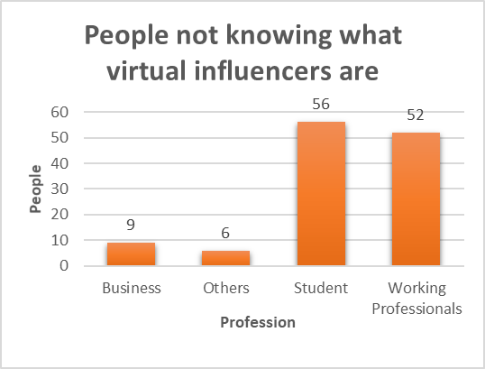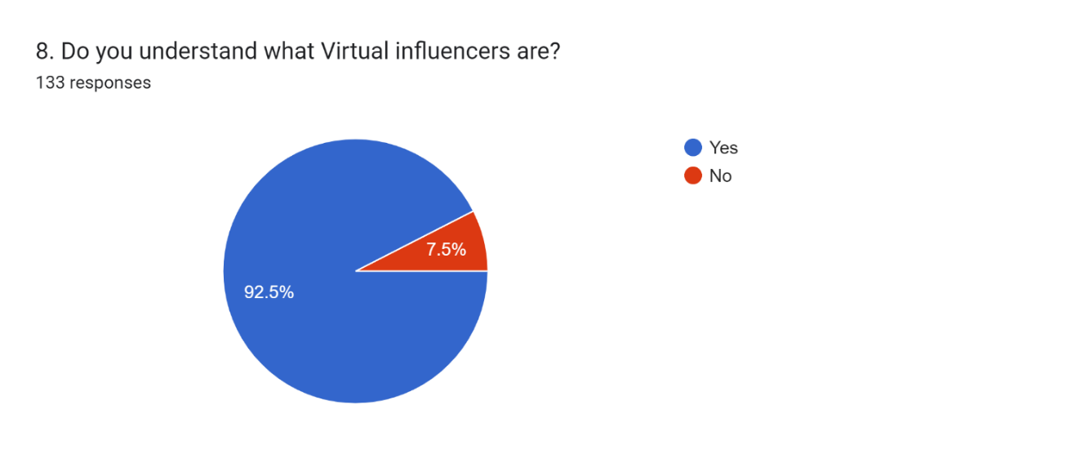

Out of 134 people, 10 i.e., 7.5% of people does not know who are virtual influencers and most of them are Working professionals, whereas 123 i.e., 92.5% of people knows about virtual influencers and most of them are students.

* + - 1. Top 3 Virtual Influencers according to the survey:

  

Kyra Lil Miquela Lu do Magalu

* + - 1. Reasons behind following Virtual influencers:



* + - 1. Trustworthiness:

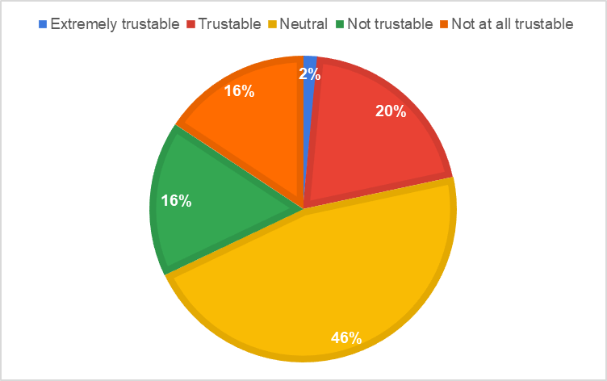

|  |  |
| --- | --- |
| **Trustworthiness** | **People** |
| Extremely trustable | 2 |
| Trustable | 27 |
| Neutral | 62 |
| Not trustable | 22 |
| Not at all trustable | 21 |

According to the survey, it has been found that only 2 people find the virtual influencers as “Extremely trustworthy” and 21 thinks that they are not at all trustworthy.

* + - 1. Online Advertisement VS Traditional Advertisement:

According to the survey, 88% of people find online advertisements more influential than traditional advertisements (T.V ads, banner, newspaper).

* + - 1. Shopping Mode

|  |  |
| --- | --- |
| **Which mode of shopping do you prefer?** | **No. of people** |
| Offline | 43 |
| Online | 91 |

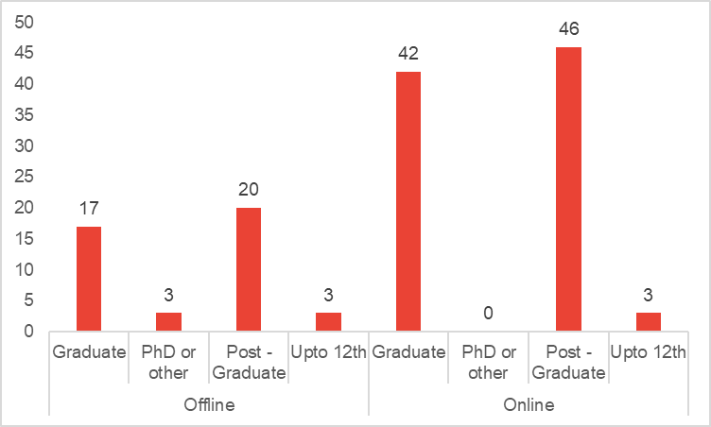

Online shopping mode is the most preferred mode of shopping according to the survey. Out of 134, 91 people prefer online mode of shopping, which is 67.9% of total sample size. Highest number of people choosing offline and online shopping are Post graduate and graduate.

* + - 1. **Influencing Factor for purchase**

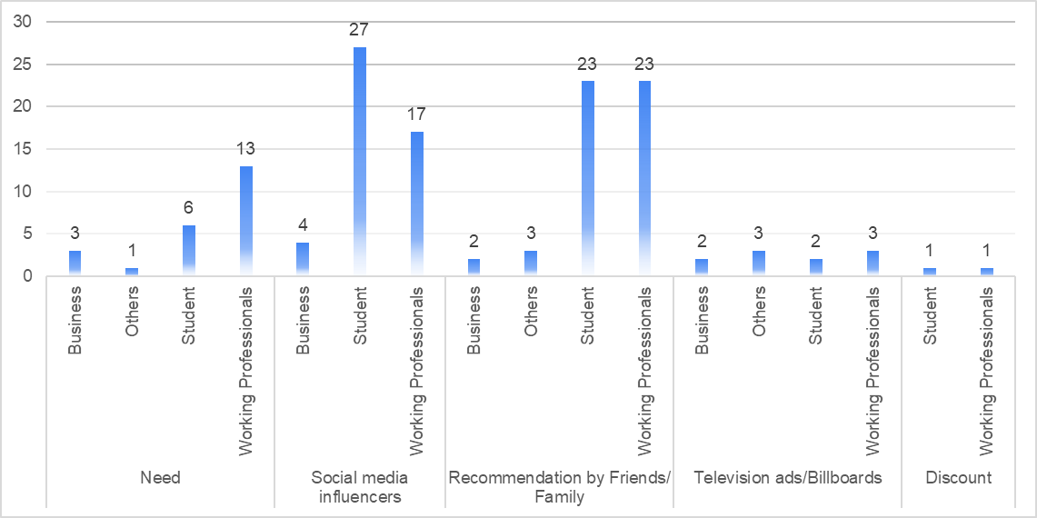

|  |  |
| --- | --- |
| **Influencing factors** | **Count of people** |
| Need | 23 |
| Social media influencers | 48 |
| Recommendation by Friends/ Family | 51 |
| Television ads/Billboards | 10 |
| Discount | 2 |

**W**e can see that the primary influencing factor for their latest purchase was through “Recommendation by friends/ family”. Secondly, “Social media influencer” do play an important role for customer’s purchase decision making process. It is found that “**Students”** are more likely to get influenced by **social media influencers** for buying any product. Whereas “**Working professional”** are more likely to buy a product when they feel the need.

**Discussion**

As per the survey and data analyzed, students are more likely to get influenced by social media influencer. Working Professional tends to relay on conventional buying only. Middle age group has major reliance on offline store and they get that assurance when they see or feel the product. Students has complete reliance on virtual influencer and they buy product once virtual influencer recommends it and they straight away order the product without any validation.

**Limitation**

As the current data collected, quite biasness was observed towards social influencer. Young group was totally biased as compared with working professional. So variance was observed. Sample Size was 134, with increase in sample size bigger variance will be observed.

As Survey was conducted to collect data, it’s generally data collection through survey is tedious and very time consuming process. And data will vary from region to region, as present data collected is limited to very specific region of India.

**Implication**

As per the surveys it was evident social media plays a vital role in influencing segment of graduate and post graduates. Maximum people choose online shopping mode and we can see shift in shopping mode from traditional towards online.

With availability of internet and smart phones at frugal price, majority of sample size was aware of virtual influencer and it does make an impact on decision while buying product.

**References**

* + - 1. **Joel MeroHeini, VanninenJoona Keranen Industrial Marketing Management journal homepage:** [**www.elsevier.com/locate/indmarmanhttps://doi.org/10.1016/j.indmarman.2022.10.017**](http://www.elsevier.com/locate/indmarmanhttps://doi.org/10.1016/j.indmarman.2022.10.017)

B2B influencer marketing: Conceptualization and four managerial strategies

* + - 1. **Noémie Gelati Jade Verplancke** The effect of influencer marketing on the buying behavior of young consumers A study of how the purchase intention of young consumer is affected by brands within the fashion and beauty industries
      2. **Sweta Leena Hota**, ANALYSIS OF INFLUENCER MARKETING IMPACT ON BUYING BEHAVIOUR AMONG TEENAGERS ISSN: 0974-5823, Vol. 7 No. 1 January, 2022.
      3. **Jan-Philipp Stein, Priska Linda Breves & Nora Anders**, Parasocial interactions

With real and virtual influencers: The role of perceived similarity and human-likeness

https://doi.org/10.1177/14614448221102900

* + - 1. **Zdenka KÁDEKOVÁ – Mária HOLIENČINOVÁ,** INFLUENCER MARKETING AS A MODERN PHENOMENON CREATING A NEW FRONTIE OF VIRTUAL OPPORTUNITIES

Communication Today, 2018, Vol. 9, No. 2.

* + - 1. **Influencer Marketing Platform Market Growth & Trends, Grandview research.**

[Influencer Marketing Platform Market Worth $143.10 Billion By 2030 (grandviewresearch.com)](https://www.grandviewresearch.com/press-release/global-influencer-marketing-platform-market#:~:text=The%20global%20influencer%20marketing%20platform%20market%20size%20is,a%20new%20report%20by%20Grand%20View%20Research%2C%20Inc.)