Review of Various Application of IOT Using Machine learning

Dr. Ajay Lala
Department of Computer Science & Engineering
Gyan Ganga College of Technology, Jabalpur
Jabalpur, India
ajaylala@ggits.org

Prof. Kamaljeet Singh Kalsi
Department of Computer Science & Engineering Gyan Ganga College of Technology, Jabalpur
Jabalpur, India
kamaljeetsingh@ggct.co.in

ABSTRACT
Now that the Internet of Things (IoT) is growing swiftly, a wide range of applications are being created by both academia and business. Machine learning allows millions of machines to collaborate in order to extract customer preferences from individual user-generated data. Machine learning is also essential in the IoT sector to manage the massive volume of data generated by those machines. Automated systems using actions deduced statistically can supplement or replace manual processes in critical activities. These applications of intelligent machine learning will be the main emphasis of this paper. Machine learning for IOT can be used to forecast trends of future, spot anomalies, and improve intelligence by ingesting picture, video, and voice data. By examining vast amounts of IoT data, machine learning can assist explain the underlying patterns in that data.
Keywords—Internet of Things; Machine Learning; Smart Devices (key words)

INTRODUCTION

For decades, there has been an increasing trend towards the expansion of the current Internet to include all linked devices (commonly referred to as "Things") and their digital representations. As a result, a large range of potentially unique goods, services, and applications will be developed in a number of industries, including smart housing, smart logistics, and smart environmental monitoring. Thanks to the cooperation of academics, industry, and standards bodies in various communities, including telecommunication, health insurance firms, semantic Web, and informatics, this field of study has recently gained a lot of interest as well as a lot of financing. As a result, many venture capitalists follow the crowd.
For a long time, common systems have lacked flexibility because they were only ever designed for particular purposes. This suggests that a system cannot be dynamically or flexibly altered while it is in use. Platforms for applications, products, and services that can gather, exchange, store, access, and share data from the real world are necessary for the IoT initiative currently under way—or, more generally, the future of the Internet—especially when it comes to cross-border communication. A wide range of businesses, including smart homes, green energy, smart retail, smart health, and customized end-user applications, will now have new opportunities as a result.
The Complicity low-code, self-service IoT platform from Software AG is important in terms of machine learning. The platform is equipped with everything you need to get started right away, including device connectivity and administration, application enablement and integration, streaming analytics, machine learning, and the deployment of machine learning models. The platform is accessible on-premises, in the cloud, and/or at the edge. Complicity IoT is the only platform that supports independent, edge-only applications. The standard data models used in conventional data analytics are frequently static and have a limited application to handling rapidly changing and unstructured data. Regarding the Internet of Things, it's usually crucial to detect connections between various sensor data sources and external components that are rapidly producing a large amount of data points. Unlike traditional data analytics, which would start with the result factors (such as sparing energy) and then inevitably look for indicator factors and their associations, machine learning starts with the result factors (such as sparing energy).
Machine learning is generally useful when you know what you need but are unsure of the crucial informational aspects that will influence your decision. You then specify the goal(s) for the machine learning algorithm, and it subsequently "learns" from the data which components are crucial for achieving that goal. Machine learning uses a variety of statistics to produce valuable insights that organizations can use to improve bureaucracy, lower costs, make services more sophisticated for customers, or establish new business models. The fact is that most institutions may obtain a significant portion of those advantages through conventional data analytics without the need for more sophisticated machine learning tools.

Clarifying facts is a strong suit of conventional information analytics. You could create analyses or simulations of contemporary events, bringing useful information to the organization. Records analytics may help to compare and fine-tune goals, enable wiser choice making, and then provide the method for monitoring achievement over time. By and large, machine learning is useful when you know what you need but are unsure of how to find the right information sources to provide that requirement. The machine learning method is therefore supplied by you, and it then "learns" from the data what components are essential for achieving that goal.

The ability to predict outcomes is quite helpful in a mechanical setting. Machine mastering calculations can "understand" what is typical for the machine and occasionally identify when something odd is about to emerge data for special sensors. Knowing when a system requires protection is unbelievably important, saving thousands of dollars in expenses. Businesses actually employ machine learning and anticipate above 90% accuracy even though machines will require renovation, which will result in significant cost savings. In reality, gadget learning programmes are a part of our daily lives for all of us. Machine learning is used by both Netflix and Amazon to understand our preferences and provide the customer with a better experience. This could include offering you the gadgets you want or making sensible suggestions for shows and flicks. As a result, machine learning in the IoT may also play a significant role in shaping our circumstances to fit our personalities. The Nest Thermostat is a fantastic example; it uses machine learning to understand how to take into account your preferences for heating and cooling, ensuring that the house is at the ideal temperature when you get home from work or when you get up in the morning. Figure 1 depicts many IOT applications using machine learning.

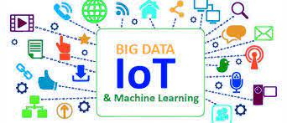

Figure 1- Application of IOT Using Machine Learning

RELATED WORK

Over the past ten years, based on applications such as smart phones, actuators and sensors have grown increasingly sophisticated, enabling connection of device and to complete difficult tasks. The number of network devices has surpassed the number of people on the planet [1] and has been growing exponentially ever since. With the presence of Internet of Things (IoT), virtually every device is connected to a local network, including smart phones, built-in systems, wireless sensors, and other gadgets. Numerous new applications have been developed for various mobile phones and distinct remote platforms as a result of the expansion of the Internet of Things (IoT), which involves smart phones [2], networks of sensors [3], sensors unique aerial vehicles (UAV) [4,5], other smart systems [6], and others. With an increase in the number of such devices, the volume of data obtained from them frequently rises. Agriculture Automation For the objective of increasing the effectiveness of the agriculture industry, IOT and machine learning are being used. In India, agriculture is essential to the growth of the food industry. The Internet of Things (IoT) represents a turning point in technological development. According to the modern interpretation of the industrial revolution, 4.0[7], we have a finite number of resources, and how they are used—whether it's the use of water or the use of minerals from ores—all have an indirect impact on our daily existence. Prices[8] have been growing as a result of the scarce supply of resources and rising consumption, thus their sustainable use is required. Similar to this, every loss at any level in farming—where we must feed a big number of consumers—proves to be a significant loss to the economy and to the consumer as well[9]. Additionally, there aren't enough research findings in this area. The primary goal is to introduce IoT and machine-assisted farming to India in order to expand farmers, researchers, and the government's use of AI and machine learning on a technical level[10].

CASE STUDY OF IOT APPLICATIONS USING MACHINE LEARNING

Healthcare is only one area where the Internet of Things (IoT) and machine learning (ML) have several uses. Due to the internet's rapid development and spread, traditional patient service methods were supplanted by electronic healthcare systems. Through the use of IoT technology, patients and medical professionals are given access to the most modern environment for medical equipment. From remote temperature monitoring to mechanical mechanization, machine learning and IoT devices are helpful in a wide range of categories.

An Overview of Machine Learning

Machine learning is another of our modern tools for change. The use of algorithms that can learn from data is known as machine learning. The advancement of machine learning is being pushed forward by the availability of cheap computer power and enormous amounts of data. Past machine observations serve as the basis for machine learning. A formula is developed. Machine learning is typically derived from data, to put it simply. Finding patterns in the data and using those patterns to complete practical tasks are the objectives of master learning. Machine learning is a wide, interdisciplinary approach that emphasizes statistics, algebra, data collecting, data processing, etc. Machine learning (ML), a fundamental method of artificial intelligence, gathers knowledge through data training. Since we're instructing robots to go there for this research and it's at the base of the tree.
Machine learning is classified into the following groups as seen in Figure 2
A. Supervised based Learning.
B. Unsupervised based Learning.
C. Reinforcement based Learning

Figure 2 Classification of Machine Learning

Internet of Things (IOT)
Physical devices that are embedded with other technologies, software as well as sensors to transfer data and communicate among the devices through the Internet are referred to as such. Examples include mobile phones, personal computers, home appliances, and many more electronic gadgets.
For Example: consider smart watches, mobile phones, air conditioners and sensors.

Industrial Internet of Things (IIOT)
The use of the internet of things in industrial applications and industries is how it is defined. The term "IIOT" refers to networked sensors, other devices, industrial computers, and gadgets used mostly in manufacturing.
For example: smart robotics, Amazon warehouse, Air bus etc.

Comparison o IOT and IIOT
IoT often emphasizes user convenience. In contrast, IIoT places a strong emphasis on return on investment (ROI) to ensure that organizations get the most out of deploying IIoT. The following observations may be made if IoT and IIoT are contrasted in terms of complexity, expense, and needs.

They are described below.
Cost
In essence, physical components like sensors, internet connections, and embedded systems are what IoT and IIoT rely on. However, IoT is less costly than IIoT since IoT devices require less accuracy than IIoT devices do.
Because IIoT works in crucial business sectors like manufacturing, machinery monitoring, it requires more advanced devices for greater precision.
Complexity
Applications for the IIoT are more sophisticated than those for the IoT. The complexity rises along with technological development.
Applications for the IIoT are therefore more complicated than those for the IoT.

Requirements
Consumer convenience is the IoT end need, while ROI, or return on investment, is the IIoT end demand.
IoT places a strong emphasis on controlling household appliances that improve user convenience while conserving resources like power.
The IIoT focuses on crucial systems including those in healthcare, aerospace, and factory automation, as well as on linking people and machines and using data analytics.
IIoT wants there to be less downtime and more uptime for business operations.

Differences
The major differences between IIoT and IoT are as follows −
IIOT | IOT
It is defined as the application of the internet of things in industrial smart applications and various distinct sectors. | It states as physical devices such as mobile phones, smart computers, home appliances, and many other electrical equipment that are embedded with other technologies, sensors and software that allow them to exchange data and communicate with one another over the Internet.
Examples include Amazon's warehouse, smart robotics, and Airbus. | Air conditioners, sensors, smart watches, mobile phones, and other devices are examples.
IIoT deals with large scale networks | IoT deals with small scale network
provides on-site remote programming | provides simple off-site scripting
provides simple off-site scripting | IoT demands privacy and identification
Long life cycle | Short product life cycle
High reliable | Less reliable

Machine Learning in IoT
IoT enables linked devices to connect, communicate, and gather enormous amounts of data every day. Depending on predetermined criteria or input from the Future Internet 2019, 11, 94 5 of 23 gathered data, IoT devices may also be created to carry out specific functions in a variety of applications. To assess the collected data, extract relevant data, and create intelligent applications, human participation is required. In addition to having the ability to gather data and connect with other devices, IoT devices also need to be autonomous. They must have the ability to decide based on context and infer meaning from the information they have acquired. The phrase "Cognitive IoT" (CIoT) was created in response to this demand. Furthermore, IoT devices that are intelligent are needed in order to create smart applications with autonomous resource management, communication, and network operation. By integrating ML algorithms in an IoT infrastructure, it is possible to drastically improve apps or the infrastructure itself. ML may be used for resource allocation optimisation, network optimization, congestion avoidance, and offline or online data analysis and decision-making. Additionally, the amount of data being collected increases along with the increase of devices. Dealing with "big data" is a common occurrence in IoT applications. Big data cannot be handled by conventional databases. A specific infrastructure and specialized procedures for analysis are needed due to the vast volume of structured and unstructured data. The next sections will describe several ML methods, such as "Ensemble" or Artificial Neural Networks (ANN), that can aid in effectively handling massive data.
Following are the various IOT applications in different streams using Machine Learning Concepts:-

Smart agriculture system
The development and application of Smart Agriculture technologies based on IoT and Machine Learning is altering the agricultural sector by not only enhancing crop output but also making it more cost effective as shown in figure 3. In recent years, the agriculture sector has seen a structural upheaval, as evidenced by price increases and influenced by population expansion and urbanization. There is no doubt that the government must invest in agriculture in order for it to thrive. The globe appears to be making technological advances, and it is vital to achieve reasonable advances in agriculture as well. According to the World Bank, if global population growth continues, food consumption would increase by 50% by 2050. Indeed, the effects of drastic changes in climatic conditions have reduced crop yield by more than a quarter. To achieve quality and volume crop production, there must be an emphasis on the adoption of smart technologies in agriculture. The integration of IoT along with Machine Learning can undoubtedly assist to reduce costs while also expanding production scale through the collecting of time series data from sensors. There are some aspects that are critical in crop productivity. The influence of these factors accounts for over 51% of crop production.
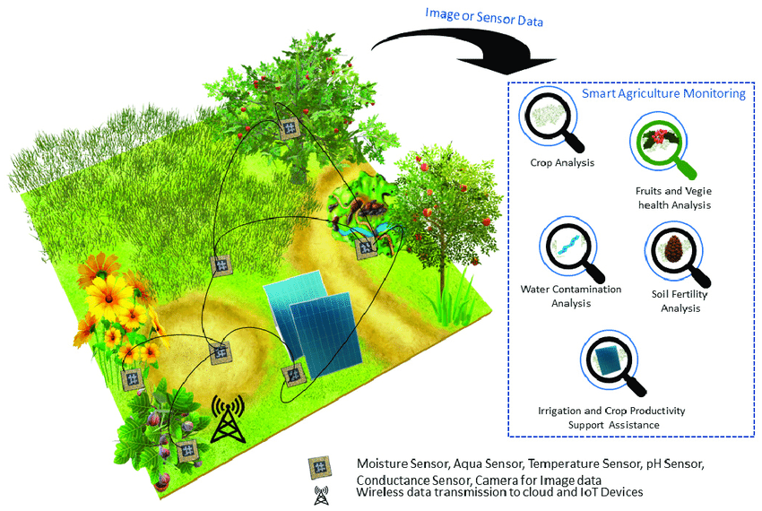
Figure-3 Smart Agriculture system Using IOT with Machine Learning

These factors include precipitation, temperature, humidity, and moisture and pH concentration.

- Precipitation is all of the water that falls from the atmosphere as rain, dew, or snow. Rain is one of the most essential factors influencing a location's vegetation. Rice, tea, and coffee are cultivated in areas with heavy and evenly distributed rainfall, whereas millet and sorghum are grown in areas with less rainfall.
- Temperature Temperatures between 15 and 40 degrees Celsius are excellent for most crops, resulting in maximum production. The temperature of an area is strongly reliant on its proximity to the equator. The temperature has a strong influence on crop growth and productivity.
3. Humidity is another significant factor influencing crop productivity. The water content present in the form of vapors is referred to as humidity. In fact, most crops prefer relative humidity levels of 45-60%, with only a few crops performing well at humidity levels of 75% or more. Pests and diseases are also more likely in humid environments.
4. Concentration of PH The pH concentration of the soil is critical to the good quality production of crops. Soils with pH levels ranging from 6.5-7 are ideal for agricultural growth. Low pH soils are hazardous to plants because of the high concentrations of iron and aluminum, and it also interferes with the plant's access to other nutrients.
Agriculture is the most important and vital occupation in India, as it balances required food requirements for humanity and produces essential raw materials for numerous businesses. Innovative farming practices are gradually increasing crop output, making it beneficial and reducing irrigation waste. The suggested model is a smart irrigation system that forecasts crop water needs using a machine learning algorithm. Temperature, moisture along with humidity is the three most important characteristics to consider when determining the amount of water needed in any agricultural area. This system, which consists of humidity, temperature and moisture sensors distributed in an agricultural field, delivers data via a microprocessor, resulting in the development of an IoT device with cloud connectivity. The decision tree approach, a powerful machine learning algorithm, is used to field data to effectively predict outcomes. Farmers are notified through email of the decision tree algorithm's findings, enabling them to make better choices about their water supply.

Agriculture is one of India's most important industries for economic development. Farmers in the traditional agricultural industry appear to be suffering from a variety of issues, including insufficient crop growth and insufficient weather conditions. The real-time data capture from sensors, combined with the usage of Machine Learning Algorithms, will not only assist farmers in making informed decisions about which crop to grow in a specific region, but will also recommend fertilisers based on various factors such as soil and climatic conditions, and so on. Furthermore, of the numerous machine-learning algorithms used, XGBoost appears to provide the best results, with 99.31% accuracy on recommendations. These IoT and ML-based advice will undoubtedly help farmers understand more about the many elements that will assist them in minimizing expenses and making strategic decisions. This results in a scalable and dependable solution that will affect millions of Indians.

Digital Supply chain
Supply chain and IoT are closely related nowadays, and one of the most popular IoT industries is logistics tracking. Supply chain management is challenging and risky; when anything goes wrong, it may sometimes have an industry-wide impact. IoT supply chain technology may help managers keep an eye on logistics and, in the long run, eliminate bottlenecks in crucial supply chain networks from production to delivery.
Well-managed supply chains are crucial investments in the direction of meeting quarterly sales targets and product delivery deadlines, which are goals shared by all businesses. Additionally, snags in crucial supply chains (such as those for drugs, necessary minerals, semiconductors, and large-capacity batteries) can harm regional, governmental, and international economies.

IoT in supply chain management enables logistics partners to gather and use data for better inventory management, transportation, and incident response. As shown in figure 4, these capabilities open the door for the application of machine learning models to create sophisticated, responsive supply management solutions that anticipate bottlenecks, conserve resources, and quicken incident response.

Figure 4- Digital Supply Chain

Many of the issues affecting today's supply chains, which are straining to keep up with increased demand, are brought on by "worker shortages and a lack of key components and raw materials." While there is little question that the COVID-19 outbreak has made these problems worse, it is more likely to have brought attention to existing problems than the actual cause.
When IoT devices are used across the supply chain, everything from production floor inventory systems to transportation and distribution centre fleet management systems can be seen and data collected. By connecting these gadgets to IoT device management solutions, real-time insights are delivered where they are most required while centralizing visibility. Businesses may also employ machine learning to develop intelligent Internet of Things (IoT) for supply chains that optimise supply chain efficiency.
For Example-
- Internet of Things, supply chain, and agriculture
The agricultural sector can help us comprehend the impact of the internet on supply chain strategies. Agriculture is one of the most difficult industries to support and manage in the global supply chain. Ranches, farms and commercial related fisheries provide relevant raw materials that must be packaged, processed and sent globally as soon as possible.
Every operations need to:
1) Watch over, look for, and fix specialized equipment.
2) Maintain track of changing market pricing and demand.
3) Order scheduling and fulfillment.
4) Analyse how external variables frequently affect agriculture production.
b. IoT helps prevent bottlenecks in the supply chains for agriculture
IoT devices do collection of relevant operational data, allowing agricultural warehouses to automate their management and issue alarms when supplies are running low. Vehicles that transport perishable food require particular temperature controls and must meet Food Safety Modernization Act (FSMA) criteria – IoT systems can transmit alarms when container conditions do not meet prescribed parameters.
When supplies are short or delivery is time-sensitive, preventing food loss can save money and prevent unnecessary spoilage. Remote monitoring of smart agricultural machines allows for equipment maintenance and repair that is more economical and effective.

- Using IoT in the Smart Supply Chain to Prevent Food Shortages
Food shortages can be prevented by using IoT to monitor agricultural inventory and eliminate waste in delivery. Researchers estimate that food loss damages 24% of agricultural goods at the supply chain's postharvest stage. Figure 5 illustrates how IoT and device management platforms now provide a potential alternative for addressing the world's food shortages and strengthening the agricultural supply chain.
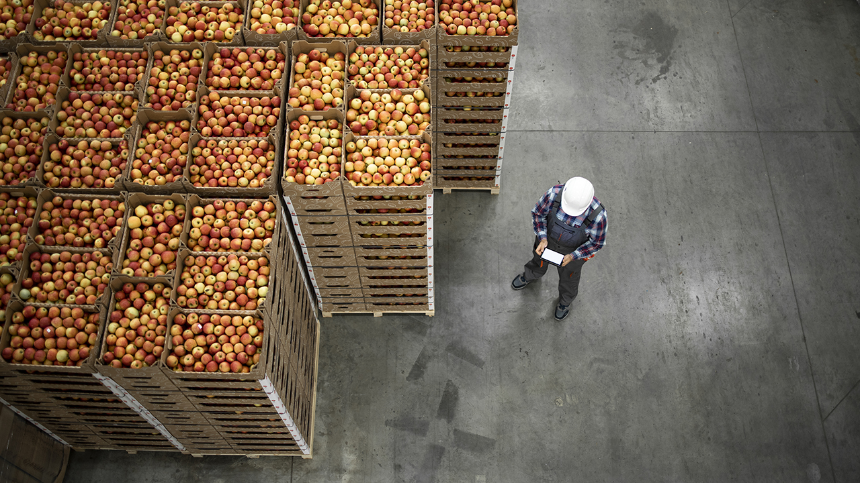

Figure 5- Food Shortages with Smart Supply Chain IoT

IoT in Inventory and Logistics Management
When employing IoT devices to optimise and operationalize the supply chain, inventory management is an essential tool. These systems make sure that deliveries from manufacturers to distributors, warehouses, end-users, and customers, as well as raw materials and completed products, are made.

It is impossible to exaggerate how important asset management is to supply chain management. Without reliable inventory data, distributors and transportation companies would not be able to ensure the smooth running of their intricate supply chain networks. However, today's networks find it difficult to react fast when demand exceeds supply.

IoT Supports Inventory Management using machine learning
  - Intelligent distribution facilities and warehouses help minimize inventory management mistakes and maintain precise counts of raw materials and finished goods.
  - Using IoT for warehouse management enables real-time inventory data updates, tracking availability, and restricting unfulfillable requests.
  - Businesses may use machine learning models to improve procedures and avert shortages by identifying repeating trends in IoT device data.
  - Christmas in 2022 and Retail Inventory: 55% of retail executives have made plans to switch to secondary suppliers because 82% of them are worried about shortages. It could be challenging to complete this procedure quickly enough to satisfy the increased demand of the season using traditional inventory management. When their inventory reached a certain level, retail outlets may use IoT technology to rapidly send orders to distribution centres.
Machine Learning along with IoT in the Supply Chain
  - As we've already mentioned, there is an exciting potential to use machine learning to create responsive supply chains as a result of the increasing popularity of IoT devices. IoT and machine learning use cases frequently overlap, and there are several connections between these two technologies.
  - Both offer value through the collection of real-time data, which is frequently used in the industrial, logistics, technology, and other industries.
  - IoT devices give organizations a mechanism to gather this data, and machine learning models analyze it to produce insights they can use.Having access to the high-bandwidth, low-latency connections that 5G networks offer might be crucial to the value that organizations derive from deploying IoT and machine learning technologies.
  - Machine learning models are frequently used to process data from IoT devices and platforms in order to produce relevant outcomes and insights.
Supply Chain Bottlenecks Can Be Reduced by Machine Learning

With the advancement and integration of IoT software and services throughout the global agriculture, manufacturing, logistics, and transportation sectors, machine learning may be able to use IoT data to forecast growing demand and supply shortages. Faster decision-making is made possible by these skills, whether they are used as part of an automated, integrated system or to provide alerts that call for human intervention.
1. Helps identify potential bottlenecks
Organizations may use machine learning to tackle their most pressing operational issues. Machine learning programmes can analyze enormous volumes of data, find patterns, and use those insights to predict what will happen next. When these technologies are used in supply chain management, they produce flexible supply chains that anticipate and prevent upcoming bottlenecks.
The benefits of machine learning-based responsive supply chains include:

- Lowering the costs of logistics and transportation by using shipping routes that offer the most flexibility in an emergency.
- Schedules for preventative maintenance and repairs of expensive equipment.
- Using data from several systems to make decisions in real time to avoid geographic supply shortages.
- IoT supply chain monitoring that aids in making sense of enormous volumes of data coming from thousands (or even millions) of connected devices.
2. Reduce Response and Costs Time
Effective machine learning algorithms may gather information that is exchanged throughout systems and create insights from data from many sources. Making data-driven decisions in supply chains based on retail or customer inventories, manufacturing plant production schedules, shipping tracking data, and more.
Machine learning may assist lower long-term costs for supply chain management and, if something goes wrong, reaction times by being integrated into IoT apps and platforms.
- Planning cost-effective shipping routes while achieving delivery goals using logistics data.
- Adapting orders and deliveries as soon as possible to new supply chain circumstances, such as blocked routes, supply shortages, or changing market pricing.
- Using predictive analytics to create adequate detours in the event of unforeseen but preventable obstacles (such as bad weather, backed-up ports, and crew shortages).
3. Asset Maintenance and Management
Organizations in the agricultural, industrial, distribution and logistics sectors may all gain from utilizing machine learning and IoT technologies to operate and maintain their equipment more effectively.
Since certain supply chain segments are almost constantly operational, equipment failures or unexpected downtime can be costly. With the use of machine learning and artificial intelligence (AI), organizations are able to recognize probable failure spots, automate service calls, and fix issues before they cause downtime.
Machine learning applications may be used by businesses throughout the supply chain to:
- To monitor and evaluate equipment performance, process hundreds of data points.
- By scheduling maintenance and repairs for when demand or traffic is expected to be lower, you may minimize equipment downtime.
- In order to avoid equipment failure or workplace injuries, it is important to monitor, adapt, or react to equipment or ambient conditions that are outside of acceptable operational parameters.
4. Transparent Monitoring
IoT devices may help businesses collect on-site data that they have never had access to before, but sometimes it is hard to utilize that data before it becomes outdated due to the amount, diversity, and speed at which it is created.
Real-time insight into an organization's systems, inventories, and distribution networks is made possible through machine learning.

Applications that use machine learning can assist in processing enormous volumes of data to identify what is crucial right now, what's likely to happen next, and what actions should be taken in light of that knowledge.
- Organizations are able to respond to changes rapidly and communicate real-time information with partners, customers, and supply chain providers because to this degree of insight.
- To more effectively respond to both direct and indirect effects on their production, several organizations can employ linked systems that rely on IoT apps that apply machine learning.
- Transparent monitoring enhances the effectiveness of supply chain management not just at the organizational level but also across the board for a whole sector as shown in figure 6.

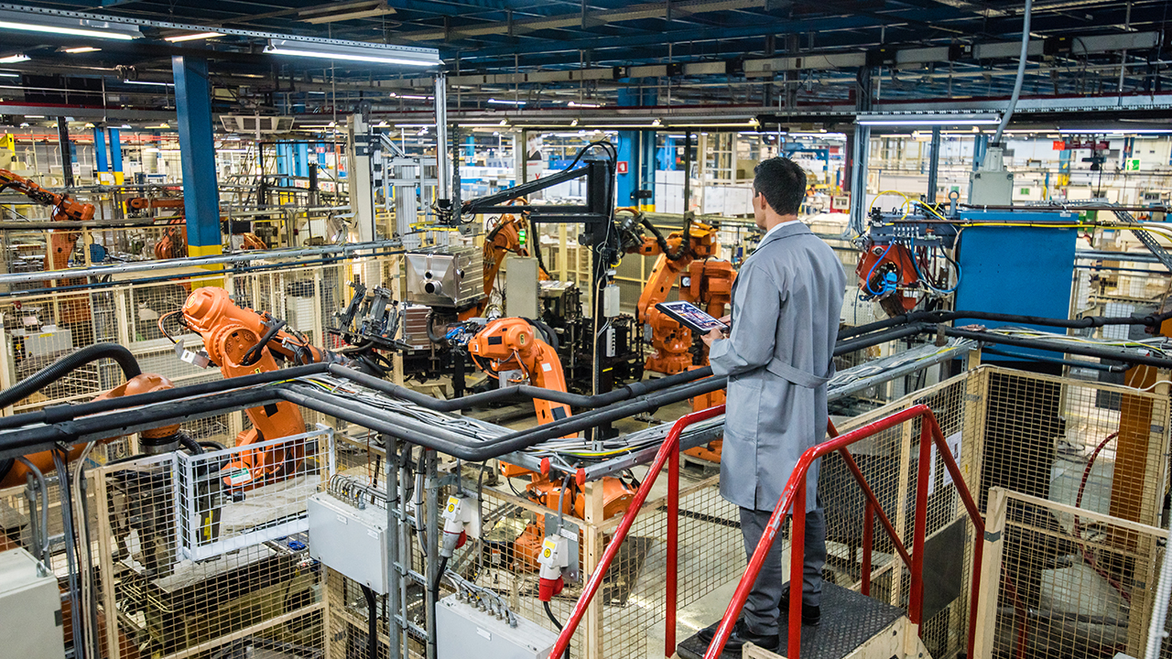
Figure 6- IOT along with Machine learning in Industries

Health-care assistance

Hospitals can quickly shift outpatients to less crowded treatment facilities with the use of health prediction tools. They expand the population of people who receive quality medical attention. Unexpected fluctuations in hospital patient flows are a problem that is frequently addressed by health prediction systems. Emergency situations, such as ambulance arrivals during natural disasters and traffic accidents, as well as ordinary outpatient demand, drive up the cost of healthcare for many institutions. While neighboring institutions might have fewer patients, hospitals without real-time data on patient flow typically struggle to keep up with demand. The Internet of Things (IoT) links physical things with digital computers to enable communication. It offers real-time data collection using cutting-edge microprocessor processors.

Environmental Conditions Monitoring

Environmental monitoring is a potential economic topic because it is a major contributor to the employment market and food production. Farmers are having difficulty lowering water usage and developing the optimal irrigation schedules due to the discontinuous monsoon and fluctuating weather conditions for improving crop production and soil fertility. In Agriculture, IoT-based decision making provides real-time insight into meteorological factors based on cost-effective sensor data collecting and cognitive processing, which eliminates human labour and saves time. Machine Learning and other ever-improving technologies have paved the road for discovering and adapting changes in crop design and irrigation patterns that take into consideration a multidimensional large variety of weather data to effectively predict climate conditions suited for crop irrigation.
By controlling the energy and other resources that are being polluted daily, IoT can be useful in monitoring the environment. If we follow the traditional procedures for monitoring the procedures, samples are taken and then analytically analyzed. These data may be gathered and tracked in two different ways. One involves a manual method that takes longer and has a higher likelihood of mistake. The second approach is instrumental, in which data is gathered, evaluated, and a conclusion is reached using tools and software. If we compare the two approaches, we can say that instrumental approaches are quicker and less error-prone.
One of the factors affecting soil production is pollution. Pesticide usage that is widespread has an effect on the environment. The chemicals and pesticides that are used in farming cause thousands of deaths each year. The application of AI and IoT for environmental sustainability includes techniques like crop, soil, and agricultural production monitoring with little environmental effect. With the use of these technologies, we can work towards developing productive and safe farming practices. To continually track a crop's progress, sophisticated monitoring devices and sensors can be added to it. These sensors allow us to determine the nutritional and hydration requirements of the plant, and based on those requirements, create better and safer environments.

Security and Surveillance Systems

In the modern world, video surveillance is quite important. It may be quite helpful in reducing crime and keeping track on facility conditions. The effectiveness of the video surveillance system is constrained by human factors including exhaustion, time efficiency, and human resources. The deployment of fully automated video surveillance technology would be advantageous for all parties. Numerous aspects of the automation of the video surveillance system, such as detector accuracy, bandwidth usage, storage utilization, and others, are still inadequate. This scientific research focuses on a video surveillance system that uses Convolutional Neural Networks (CNN), the Internet of Things (IoT), and the cloud. The system is made up of several nodes, each of which has a camera and a Raspberry Pi computer. Client-server architecture is the method used by the nodes to communicate with one another. A pretraining MobileNetv2-SSDLite model and the Common Objects in Context (COCO) dataset are used by the nodes to recognize humans, and the acquired video is sent to the main node (only one node will connect to the cloud). Additionally, when persons are found, the main node will send an SMS alert to the security team. IoT, cloud computing and Convolutional neural networks (CNN).The security and surveillance systems, including the concept of IOT using machine learning as shown in figure-7.

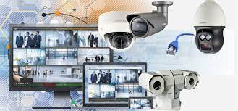

Figure 7 Security and surveillance systems using IOT with machine learning

REFERENCES

[1] Swan, M. Sensor mania! the internet of things, wearable computing, objective metrics, and the quantified self 2.0. J. Sens. Actuator Netw. 2012, 1, 217–253.
[2] Cai, C.; Hu, M.; Cao, D.; Ma, X.; Li, Q.; Liu, J. Self-deployable indoor localization with acoustic-enabled IoT devices exploiting participatory sensing. IEEE Internet Things J. 2019, 6, 5297–5311.
[3] Wang, C.; Lin, H.; Jiang, H. CANS: Towards congestion-adaptive and small stretch emergency navigation with wireless sensor networks. IEEE Trans. Mob. Comput. 2015, 15, 1077–1089.
[4] Hu, M.; Liu, W.; Peng, K.; Ma, X.; Cheng, W.; Liu, J.; Li, B. Joint routing and scheduling for vehicle-assisted multidrone surveillance. IEEE Internet Things J. 2018, 6, 1781–1790.
[5] Hu, M.; Liu,W.; Lu, J.; Fu, R.; Peng, K.; Ma, X.; Liu, J. On the joint design of routing and scheduling for vehicle-assisted multi-UAV inspection. Future Gener. Comput. Syst. 2019, 94, 214–223.
[6] Chen, M.; Herrera, F.; Hwang, K. Cognitive computing: Architecture, technologies and intelligent applications. IEEE Access 2018,6, 19774–19783.
[7] S.R. Juhi Reshma, Anitha S. Pillai from book Proceedings of the Eighth International Conference on Soft Computing and Pattern Recognition (pp.602-613)
[8] Abhishek L, Rishi Barath B International Journal of Innovative Technology and Exploring Engineering (IJITEE) ISSN: 2278-3075, Volume-8 Issue-8 June, 2019
[9] Prof. K. A. Patil, Prof. N. R. Kale “A Model for Smart Agriculture Using IoT” IEEE | December 2016.
[10] Agraj Aher, Janhavi Kasar, Palasha Ahuja, Varsha Jadhav International Research Journal of Engineering and Technology (IRJET) Volume: 05 Issue: 03 | Mar-2017

