Metamaterial Slot and S-Shaped Sot Loaded Band Notched Antenna for UWB Application

¹Kapil Jairath, ²Navdeep Singh, ³Anjali Kaushal, ⁴Vishal Kumar
¹Research Scholar, Department of Applied Sciences, I.K.G PTU, Kapurthala, Punjab, India.
jairathkapil@yahoo.com
²Associate Professor, Department of Applied Sciences, AGC, Amritsar, Punjab, India.
arora_navdeep@rediffmail.com
³ Research Scholar, Department of Applied Sciences, I.K.G PTU, Kapurthala, Punjab, India.
anjali13kaushal@gmail.com
⁴Assistant Professor, Department of Sciences, Trinity College Jalandhar, Punjab, India.
vishh07@gmail.com
ABSTRACT

The ultra wideband (UWB) antenna inspired by loaded metamaterials with band notches is elucidated in this manuscript. The prototyped antenna is 20×16×1.6 mm³ in dimension and accomplishes a large bandwidth between 3.4 GHz and 10.8 GHz. By inserting a single RSRR metamaterial notch on the radiating surface & a slot of shape S on the microstrip feed line, the notching of desired band’s frequencies have been achieved. WiMAX-band (3.51-3.7 GHz), C-band applications (3.7-4.2 GHz), WLAN band (5.15-5.62 GHz), X-band satellite communication system (7-8 GHz), and uplink X-band (8.89-10.38 GHz) frequency rejection have all been achieved. By altering the measurements of the S-shaped slot and metamaterial inspired slot, the frequency of the rejected band can be alternate. The proposed antenna has a high gain of 14.3 dB at 7.73 GHz frequency, and the radiation pattern of the simulated antenna is observed over operating bands.
Keywords
Patch antenna, UWB, Metamaterial, Gain, band-stop characteristics, SRR.

INTRODUCTION
Due to its high data rate transmission, large data density, and low power operation, UWB communication systems are quickly becoming very attractive to a wide range of researchers from academia and industry. With an effective radiated power spectral density of -41.3 dBm/MHz, the Federal Communication Commission (FCC) declared the ultra wideband frequency range from 3.1 GHz to 10.60 GHz as an unlicensed band for commercial use [1]. Planar antenna is an excellent choice for UWB communication applications. While designing a UWB system, there are a number of obstacles to overcome because competing technologies like the WiMAX band (3.3-3.6 GHz), the C-band downlink (3.8-4.2 GHz), the WLAN IEEE 802.11a band (5.15-5.825 GHz), the downlink of the X-band satellite communication system (7.25-7.75 GHz), and the ITU X-band satellite communication (8.025-8.4 GHz) can interfere with the UWB system. For this reason, it's crucial to develop antennas with band-notched characteristics in order to avoid the intervention being discussed.
Various methods have been used over the last few years to obtain mono band rejection in antenna [2-5]. Ultra wide band antennas featuring several frequency notches have recently been reported [6–13]. Various designs use slits/notches on the radiating patch and ground as well as three rectangular shaped cuts loaded with CPW-feed [6], EBG [8], embedded parasitic elements in an open rectangular [9], and a pair of inverted U- shaped ring strip in the radiating surface [10] to achieve dual notched bands. Along with creating triple notched bands [11], integrating band rejecting structures [12], and using asymmetrical slots [13], a quarter wavelength open ended slot and half wavelength slots on the radiating patch are also used. Split ring-resonators (SRR) can be used to create filters that have band notch at specific frequencies due to their extremely high quality factor. SRR may also be used as a slot-type structure to filter out unwanted frequencies [14–16].
In this report, authors elucidate a small novel low profile UWB antenna which is loaded with a metamaterial structure that has band notch properties. WiMAX band, C-band downlink, WLAN, X-band downlink satellite communication, and ITU band satellite communication interference is reduced by using an SRR structure inspired by metamaterial (MTM) and a slot of S-outline on the microstrip feed line. The frequencies of stop-bands can be modified by remoulding the size of both MTM and S-shaped slots. The presented antenna is made of an economical FR4 Epoxy substrate. In order to procure band-stop features, the simulated design also makes use of an S-shaped slot and a single rectangular split ring resonator (RSRR) structure.

Design of Antenna
The schematic of presented antenna having frequency rejection characteristics is illustrated in Figure 1.
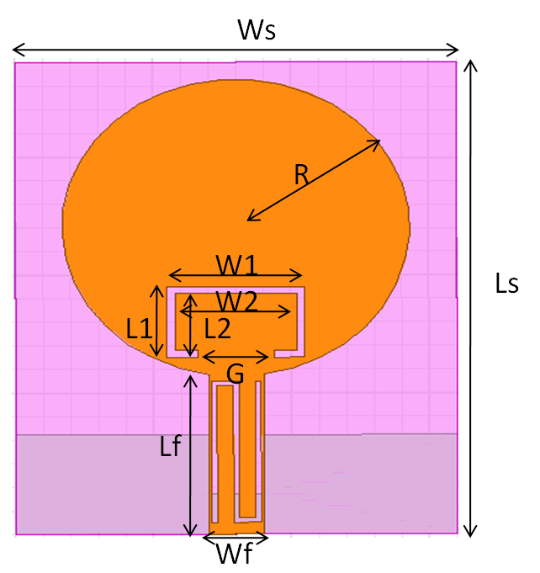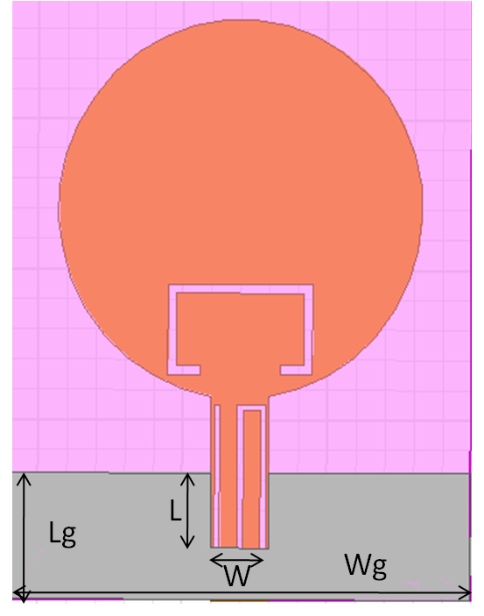
a) Front View b) Bottom View

c) S-shaped slot on microstrip feed line
Figure 1: Geometry of Presented antenna with band stop characteristics

Table 1: Measurement of UWB Antenna
Parameters | Ls | Ws | Lf
Unit | 20 mm | 16 mm | 7 mm
Parameters | Wf | R | L1
Unit | 2 mm | 6.3 mm | 3 mm
Parameters | W1 | L2 | W2
Unit | 5 mm | 2.4 mm | 4.4 mm
Parameters | L3 | L4 | L5
Unit | 6 mm | 6 mm | 6 mm
Parameters | W3 | W4 | G
Unit | 0.6 mm | 0.6 mm | 2.8 mm
Parameters | Lg | Wg | L
Unit | 0.6 mm | 0.6 mm | 4.2 mm
Parameters | W
Unit | 16 mm

Ansoft HFSS 15 is utilised to analyze the prototyped & the outcomes of analyzed antenna are obtained. The prototyped antenna is constructed on a layer of FR-4 epoxy substrate material with a dielectric constant of 4.4 and a loss tangent of 0.02 and having dimensions of 20×16 mm². To accomplish 50 ohm impedance matching, the width of feed-line is fixed at 2 mm and the antenna's height is 1.6 mm. Table1 provides specific information about the proposed antenna's dimensions.
Defining the location and dimensions of the metamaterial (MTM) inspired SRR element is one of the key elements of a band-notched antenna design [17]. The slot is typically designed to have a length of about one-half the guided wavelength at the band's notch frequency [17]. The variation in reflection coefficient between the primary antenna and the suggested antenna with the metamaterial structure is represented in Figure 2. Figure 3 displays the variation in VSWR between the primary antenna and the suggested antenna. The frequency rejection for WiMAX band, C-band, WLAN band, and X-band satellite communication has been successfully achieved by embedding a single SSR slot of rectangular shape on radiating patch and a microstrip feed line with an S-shaped slot, as shown in figure 3.
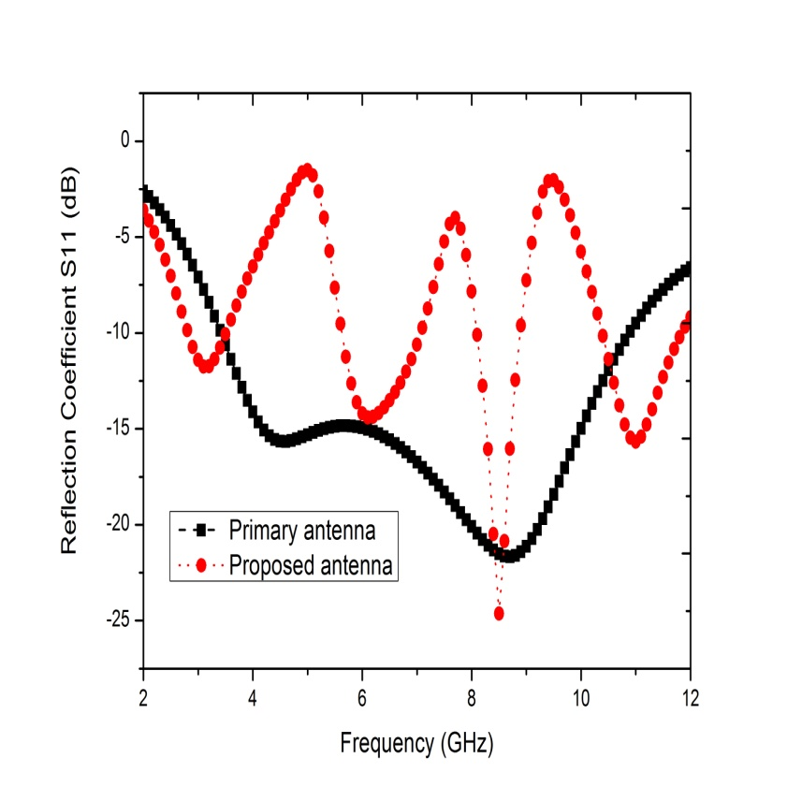
Figure 2: Reflection co-efficient curve for conventional and proposed antenna

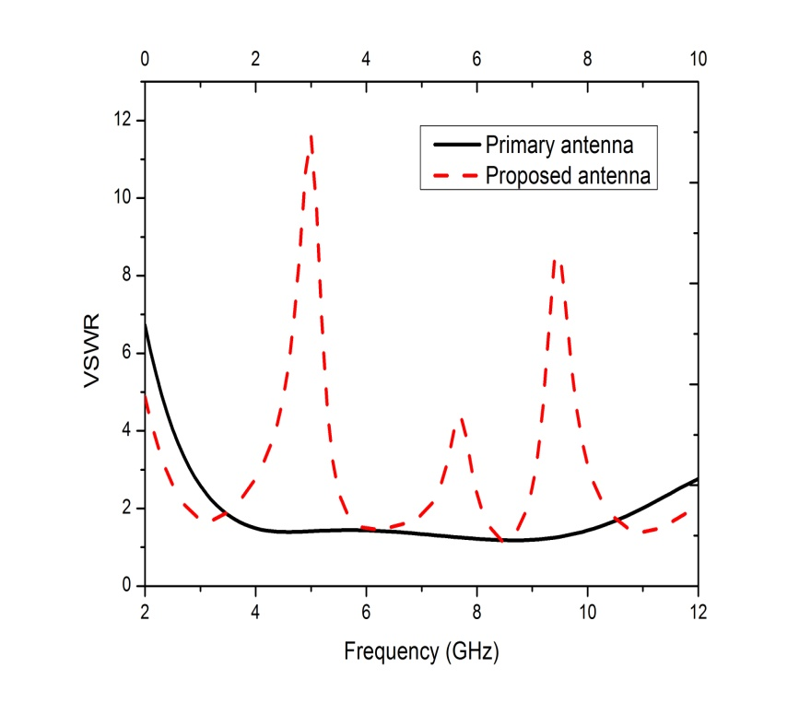
Figure 3: VSWR variation curve for primary and proposed antenna

Parametric Study of Proposed antenna
Using high frequency simulation software from Ansoft, the results of prototype antenna simulation are examined. The parametric investigation is being carried out to see how variations in the profile of the SRR metamaterial notch and the S-shaped slot affect results. Antenna optimization is performed using these parametric analyses. The length (L1) of the SRR metamaterial slot was optimised as shown in Figure 4.

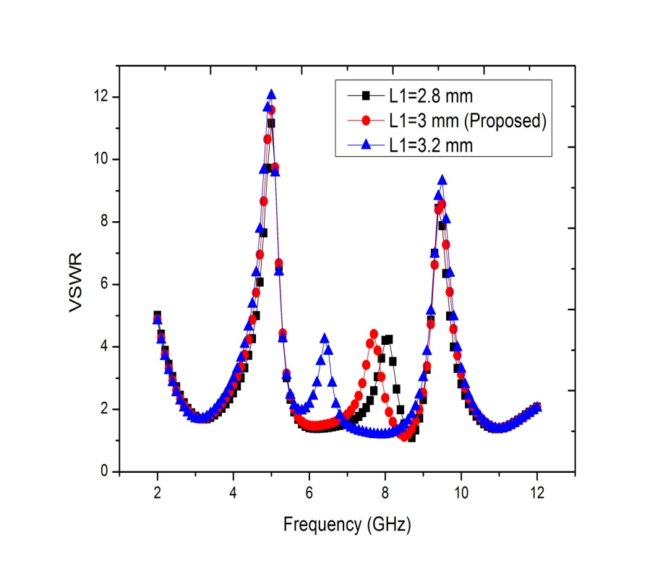

Figure 4: VSWR curve for different dimensions of L1 of antenna
Figure 4 shows that the frequency of the rejected band reallocated from 8.1 gigahertz to 6.4 gigahertz as the L1 value of the single rectangular split ring resonator (RSRR) metamaterial slot increased from 2.8 m to 3.2 mm.

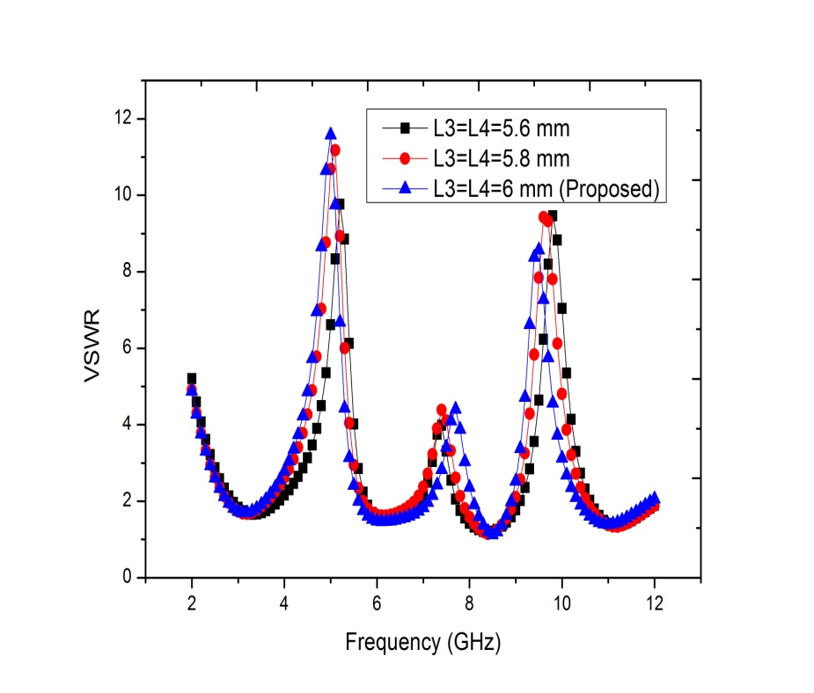

Figure 5: VSWR curve for different dimensions of S-shaped slot of antenna
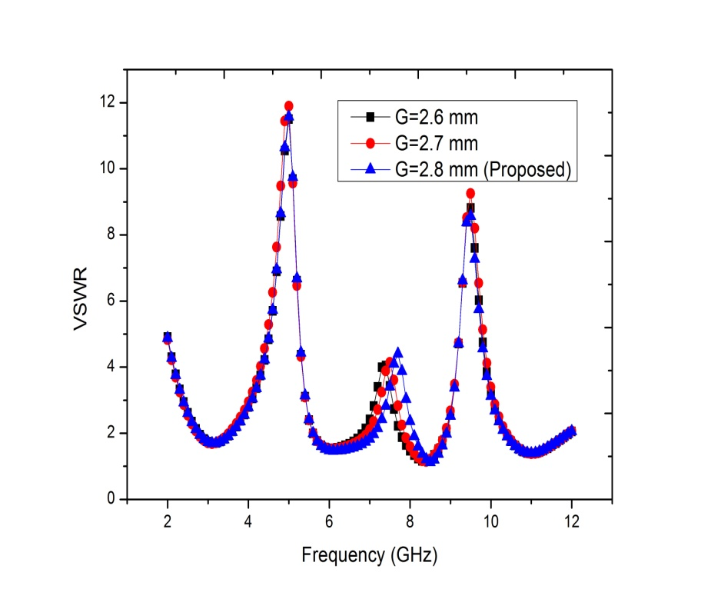

Figure 6: VSWR curve for different dimensions of G of antenna
Figure 5 elucidates the variation of VSWR curve with different dimension of lengths (L3 & L4) and optimization of slot length has been done. The rejected band’s frequency reduces as the value of (L3 & L4) of the DMS slot increases, as shown in Fig. 5. The effective inductance & capacitance of the feed-line (microstrip line) enhance as a result of the defective microstrip structure (DMS). A lower rejected band results from an increase in effective inductance, which is caused by an increase in slot length.
Fig.6 illustrates the variation in gap G VSWR consequences for a single rectangular SRR metamaterial slot on patch. Figure 6 shows that a single rectangular SRR is capable of producing notable band rejection characteristics. The effective inductance decreases along with the increase in gap size for the rectangular SRR inspired by metamaterials, leading to an upper resonance frequency.

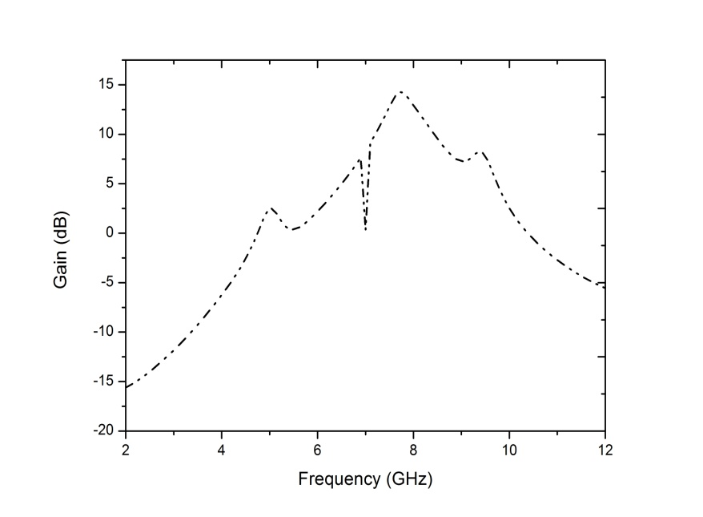

Figure 7: Gain of Simulated Antenna
Figure 7 elucidates the result of gain of simulated band rejected antenna over the UWB frequency range (3-12 GHz). The outcome reveals a high gain of 14.3 dB with a low value at the rejected bands.
Figure 8 describes radiation patterns of the suggested antenna by simulation in both the E-Plane (phi=0º) and the H-Plane (phi=90º). The proposed UWB antenna exhibits a bi-directional radiation pattern in the E-Plane and an omni-directional radiation pattern in the H-Plane, as shown in figure 8.
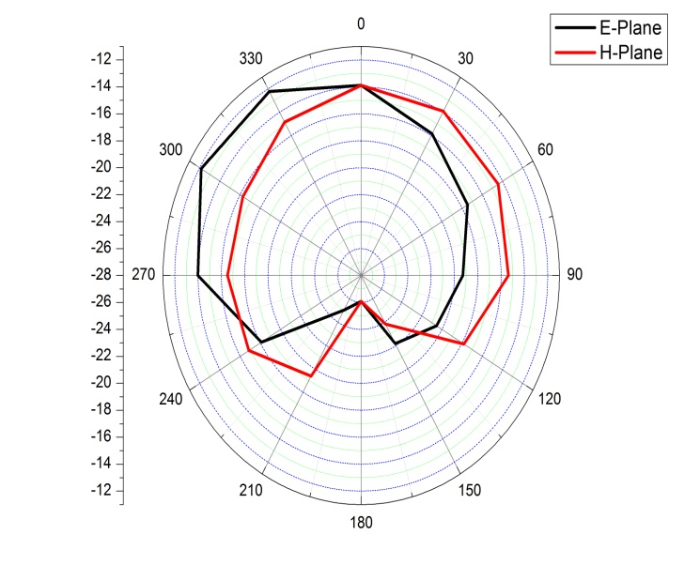
(a)
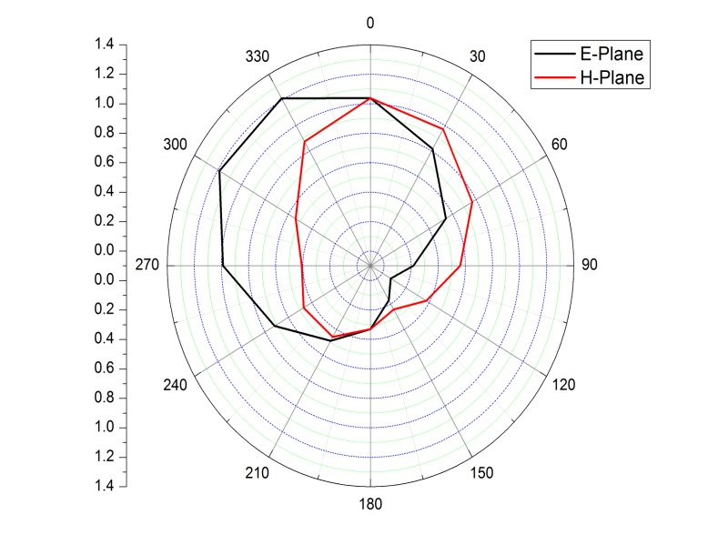
(b)

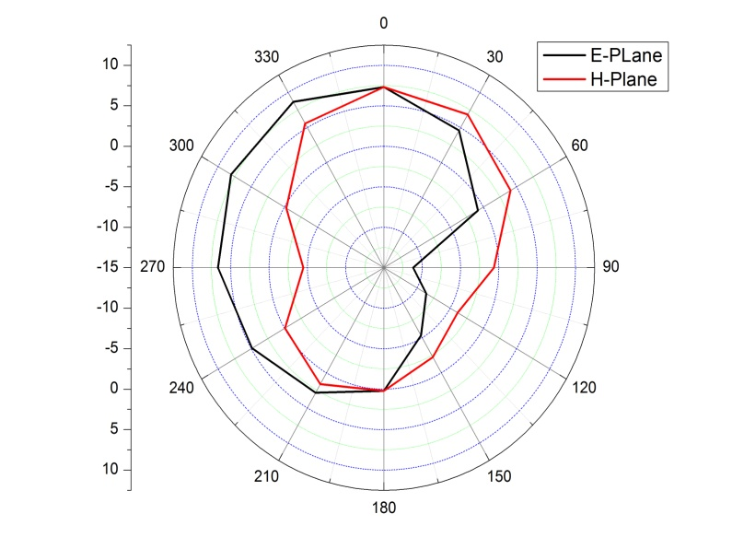
(c)
Figure 8: Radiation pattern at different frequencies (a) 3.10 GHz (b) 6.10 GHz & (c) 8.50 GHz
Figure 9 shows the simulated result of surface current distribution at various frequencies. Figure 9 shows that current is primarily distributed around the rectangular metamaterial slot for the split ring resonator (SRR) and slot of shape S for rejected bands.

(a) At 5 GHz (b) At 7.7 GHz

(c) 9.5 GHz
Fig 9: Surface Current distribution at various frequencies

CONCLUSION
This manuscript depicts a miniaturized UWB antenna with band stop properties based on a metamaterial inspired SRR slot and an S-shaped slot. Additional space is not required because they are introduced on the patch and the feedline of the primitive antenna. By altering the introduced slots' dimensions, the notch frequencies can be easily controlled. A wide bandwidth of 3.4 GHz to 10.8 GHz is achieved by the design, and a high gain of 14.3 dB at 7.73 GHz is achieved. In the E-plane and the H-plane, the proposed structure achieves omni-directional and bi-directional radiation patterns over UWB frequency.

REFERENCES
- First report and order, Revision of part 15 of the commission’s rule regarding ultra-wideband transmission system FCC 02-48, Federal Communications Commission, 2002.
- Kerkhoff A, Ling H (2003) Design of a planar monopole antenna for use with ultra-wideband (UWB) having a band notched characteristic. IEEE AP/S Int Symp Dig 1:830–833.
- Schantz HG, Wolenec G, Myszka E (2003) Frequency notched UWB antennas. In: Proceedings of IEEE conference on ultra wideband systems and technology, pp 214–218.
- Lin YC, Hung KJ (2006) Compact ultra-wideband rectangular aperture antenna and band-notched designs. IEEE Trans Antennas Propag 54(11):3075–3081.
- Huang CY, Hsia WC, Kuo JS (2005) Planar ultra-wideband antenna with a band-notched characteristic. Microw Opt Technol Lett 48(1):99–101.
- Shi R, Xu X, Dong J, Luo Q (2014) Design and analysis of a novel dual band-notched UWB antenna. Int J Antennas Propag 2014:1–10
- Yadav , A. and Sethi, D. and Khanna , R.K.: Slot Loaded UWB Antenna: Dual Band Notched Characteristics.Vol. 70(3), pp. 331-335. AEU-International Journal of Electronics and Communications (2016).
- Alshamaileh KA, Almalkawi MJ, Devabhaktuni VK (2015) Dual band-notched microstrip-fed Vivaldi antenna utilizing compact EBG structures. Int J Antennas Propag 2015:1–7
- Ryu KS, Kishk AA (2009) UWB antenna with single or dual band-notches for lower WLAN band and upper WLAN band. IEEE Trans Antennas Propag 57(12):3942–3950
- Ojaroudi M, Ojaroudi N, Ghadimi N (2013) Dual band-notched small monopole antenna with novel coupled inverted U-ring strip and novel fork-shaped slit for UWB applications. IEEE Antennas Wirel Propag Lett 12:182–184
- Nguyen TD, Lee DH, Park HC (2011) Design and analysis of compact printed triple band-notched UWB antenna. IEEE Antennas Wirel Propag Lett 10:403–406
- Zhu F, Gao S, Ho ATS, Abd-Alhameed RA, See CH, Brown TWC, Li J, Wei G, Xu J (2013) Multiple band-notched UWB antenna with band-rejected elements integrated in the feed line. IEEE Trans Antennas Propag 61(8):3952–3960
- Chen X, Xu F, Tan X (2017) Design of a compact UWB antenna with triple notched bands using nonuniform width slots. J Sens 2017:1–9
- Zhang, X., T.-L. Zhang, Y.-Y. Xia, Z.-H. Yan, and X.-M. Wang, “Planar monopole antenna with band-notched characterization for UWB applications,” Progress In Electromagnetics Research Letters, Vol. 6, 149–156, 2009.
- Kim, D.-O., N.-I. Jo, D.-M. Choi, and C.-Y. Kim, “Design of the ultrawide band antenna 5.2 GHz/5.8 GHz band rejection using rectangular split-ring resonators (SRRS) loading,” Journal of Electromagnetic Waves and Application, Vol. 23, 2503–2512, 2009.
- Thorat, S. and R. Kumar, “Design of rectangular-cut circular disc UWB antenna with band-notched characteristics,” International journal of Engineering Science and Technology (IJEST), Vol. 4, No. 04, April 2012.
- Gao, G. P. Mei, Z. L. and Li, B. N.:Novel Circular Slot UWB Antenna With Dual Band-Notched characteristic. Vol. 15, pp .49-63. Progress In Electromagnetics Research C. (2010).

