Quorum Sensing – The Way How Bacteria Communicate

Sujin Padmanabhan, Assistant Professor
Department of Microbiology
School of Allied Health Sciences, AVMC campus
Pondicherry, India
sujin3012@gmail.com

Valarmathi Balakrishnan, Assistant Professor
Department of Microbiology
School of Allied Health Sciences, AVMC campus
Pondicherry, India

Priya Ravi, Assistant Professor
Department of Microbiology
School of Allied Health Sciences, AVMC campus
Pondicherry, India

ABSTRACT
Quorum sensing, is an actual communication process that takes place between the bacterial cells. Autoinducers are the molecules which helps in the process of detecting and responding to the extracellular signals produced by the bacterial cell. The communication process between the bacterial components is important to control its virulence activities. The bacterial structures perform these activities synchronously to mutually benefit each other and to live tackling the opposite actions. The actions and functions of this quorum sensing systems varies between the Gram-Positive cell and Gram-Negative cell. The type of autoinducers produced varies between the two types of the cell depending on the cell structure and the functions. Inhibiting these quorum sensing systems of the bacteria using some substances helps in curbing the pathogenesis of the bacteria thereby curing the infection .

Keywords — Quorum Sensing System; Autoinducers; Extracellular signals; Bacterial Communication; Virulence

INTRODUCTION

Competitive nature prevails out everywhere including the microorganisms, therefore microbes must pertain surviving strategies to tackle for their survival. In order to sustain their lives bacteria accommodates various plans and actions for which a proper communication channel must be maintained between the bacterial cells for withstanding the physiological and pathological defects and restoring to their normal structure and function.[1] The bacteria communicate by creating signals which checks up on the cell density and number and helps in the gene expression regulation whenever there is an abrupt change in the bacterial cell mechanism. The genes control various factors of the bacterial cell such as biofilm formation, sporulation, antibiotic production, resistance mechanism activation and lot more functions needed for its survival in tough environments.[2]
This whole communication system that happens between the bacterial cells is known as Quorum sensing (QS). The signals produced due to any change in bacterial physiology are produced by extracellular signaling molecules called Autoinducers (AI). The type of QS systems and AI molecules differs between the Gram-Positive bacterial cell and Gram-Negative bacterial cell based on the function needed by the cell to resist and survive in the environment.[3]

QUORUM SENSING MECHANISM

Both the Gram-Positive and Gram-Negative cell produces different types of autoinducer molecules. Each bacterial cell individually produces autoinducers molecules which diffuse or transport through the bacterial cell wall and reaches the extracellular environment. As the bacteria replicates and its number increases, there is substantial rise in the autoinducers concentration as all the individual cell starts producing it. This results in the peak of the autoinducers extracellular concentration, thereby hitting the threshold of extracellular concentration and the AI molecules starts accumulating in the intracellular compartment. As the AI molecules increases in the intracellular environment it starts to bind to the receptors which in turn activates the signaling pathways which changes the transcription factor leading to expression of the gene. The expression of gene also downregulates the production of AI molecules as a negative feedback mechanism in most of the cases.[2][5]
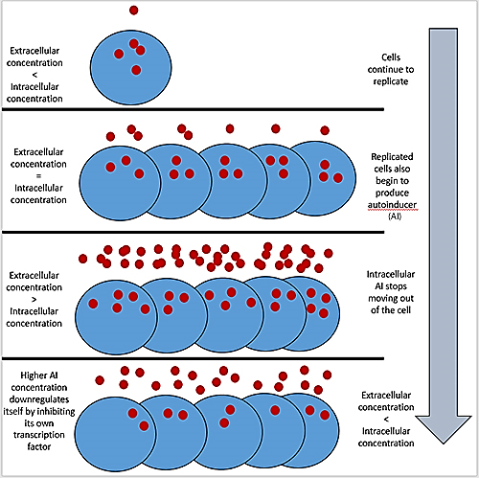
Figure 1: Diagrammatic representation of AI production mechanism

GRAM POSITIVE QS VS GRAM NEGATIVE QS
- Gram Positive Bacterial Cell QS system
Gram Positive bacterial cell mainly produces signaling molecules as peptide component called as the Autoinducing peptides (AIP). AIP are produced intracellularly and transported to the extracellular compartment by a transporter system as the peptidoglycan layer is thick in the Gram-Positive cell wall. The AIP binds with the ATP produced inside the cell and gets transported along with it to the extracellular part using the ATP binding cassette (ABC) transporter system. As the concentration of the AIP rises in the extracellular part, it begins to combine with histidine kinase receptor. The act of combination thereby activates kinase activity of the receptor molecule which results in the phosphorylation of cytoplasmic response regulator which in turn triggers the transcription of gene in the QS system.[3][6]
Figure 2: AI regulation in Gram Positive bacterial cell
- Gram Negative Bacterial Cell QS system
Gram Negative bacterial cell mainly produces signaling molecules called as the Acyl Homoserine Lactone (AHL). AHL diffuses through the membrane freely as the peptidoglycan layer is very thin in the Gram-Negative cell wall. When the extracellular AHL concentration rises it binds with the cytoplasmic receptors which thereby activates the transcription of gene in the QS system.[4]
Figure 3: AI regulation in Gram Negative bacterial cell

QUORUM QUENCHING: BOON IN MEDICINE
Antimicrobial resistance has become a major threat in today’s healthcare status. It is an emerging disaster due to the broad-spectrum usage of antibiotics, therefore a serious need has aroused to curb the bacterial infection and manage the bacterial resistance problem. Quorum quenching thus aims to reduce the virulence factors of the bacteria and to device naive therapeutic therapy which finally helps in stopping the spread of infection. A better understanding of the quorum sensing systems helps in blocking the communication pathway between the bacterial cell which results in failure of the gene expression (quorum quenching) and thus puts on an end to the bacteria from developing newer resistance mechanisms.[7][8]

REFERENCES
- Rutherford ST, Bassler BL. Bacterial quorum sensing: its role in virulence and possibilities for its control. Cold Spring Harb Perspect Med. 2012 Nov 1;2(11):a012427. doi: 10.1101/cshperspect.a012427. PMID: 23125205; PMCID: PMC3543102.
- Miller MB, Bassler BL. Quorum sensing in bacteria. Annu Rev Microbiol. 2001;55:165-99. doi: 10.1146/annurev.micro.55.1.165. PMID: 11544353.
- Pena RT, Blasco L, Ambroa A, González-Pedrajo B, Fernández-García L, López M, Bleriot I, Bou G, García-Contreras R, Wood TK, Tomás M. Relationship Between Quorum Sensing and Secretion Systems. Front Microbiol. 2019 Jun 7;10:1100. doi: 10.3389/fmicb.2019.01100. PMID: 31231316; PMCID: PMC6567927.
- Papenfort, K., Bassler, B. Quorum sensing signal–response systems in Gram-negative bacteria. Nat Rev Microbiol 14, 576–588 (2016). https://doi.org/10.1038/nrmicro.2016.89
- Mukherjee, S., Bassler, B.L. Bacterial quorum sensing in complex and dynamically changing environments. Nat Rev Microbiol 17, 371–382 (2019). https://doi.org/10.1038/s41579-019-0186-5
- Neil A. Whitehead and others, Quorum-sensing in Gram-negative bacteria, FEMS Microbiology Reviews, Volume 25, Issue 4, August 2001, Pages 365–404, https://doi.org/10.1111/j.1574-6976.2001.tb00583.x
- Li Y-H, Tian X. Quorum Sensing and Bacterial Social Interactions in Biofilms. Sensors. 2012; 12(3):2519-2538. https://doi.org/10.3390/s120302519
- ZHANG Jingjing, FENG Tao, WANG Jiayi, et al. The Mechanisms and Applications of Quorum Sensing (QS) and Quorum Quenching (QQ)[J]. Journal of Ocean University of China, 2019, 18(6): 1427-1442.

