CITRUS AND ITS BIOACTIVE COMPOUNDS: A POSSIBLE ALTERNATIVE SOURCE FOR ANTIMALARIAL DRUGS
Rony Bhowal¹, Puja Roy², Torali Baisya³, Rishi Raj Singh⁴
Rony Bhowal (M.Sc)
Department of Applied Biology, School of Biological Sciences, University of Science and Technology, Meghalaya, Baridua, Meghalaya, India, Pin -793101
E-mail: rohit.bhowal93@gmail.com
Ph.No: +91 7896136385
Puja Roy
Department of Botany, Gauhati University, Jalukbari, Guwahati, Assam, Pin- 781014
E-mail: pu.roy1999@gmail.com
Ph.No: +91 7635826803
Torali Baishya
Department of Botany, Gauhati University, Jalukbari, Guwahati, Assam, Pin- 781014
E-mail- toralibaishya99@gmail.com
Ph. No: +91 86387 92261
Rishi Raj Singh
Department of Biotechnology, SRM Institute of Science and Technology, Potheri, SRM Nagar, Kattankulathur, Tamil Nadu. Pin- 603203
E-mail- singh.rishirajofficial@gmail.com
Ph. No- +91 70024 14442
Corresponding Author: rohit.bhowal93@gmail.com
Abstract
Malaria is a parasite disease that can be fatal and is quite common in tropical and subtropical areas of the world. Five species of plasmodium, including Plasmodium falciparum and Plasmodium vivax, are primarily responsible for the incidence of sickness. Numerous artemisinin and chloroquine-resistant plasmodium strains have recently been identified as a result of widespread medication use. Plant bioactive chemicals target many plasmodium cellular and metabolic pathways. Citrus' importance in pharmacology and medicine has long been established. The method of treating malaria, however, has not yet been examined. Thus, the ability of citrus to prevent malaria is explained.

Keywords: Citrus, Bioactive compounds, malaria, plasmodium, metabolites, medicine

- Introduction
Plants and products derived from plants have long been utilised in medicine. With the quick development of technology, extracting complicated plant-based compounds has aided in the creation of new medications. Mankind has always had trouble using chemicals as medicines because of their possible adverse effects. Herbal treatments, however, are less expensive and safer in contrast. Plants have remarkable medicinal potential because of the variety of bioactive substances they contain, including terpenes, phenols, coumarins, flavonoids, and alkaloids. For instance, vinka alkaloid from Catharanthus roseus has been used in clinical settings to treat lymphatic and haematological neoplasms since it is a potent anti-cancer agent [3]. By preventing platelet aggregation and inflammation, many phenolic chemicals found in plants, such as caffeic acid, quercetin, and apigenin, can lower the risk of cardiovascular illnesses [59]. Strong anti-diabetic properties can be found in the curcumin, berberin, and capsaicin extracted from Curcuma longa, Berberis vulgaris, and capsicum, respectively. To combat diabetes, curcumin particularly inhibits the enzyme activity of α-amylase and β-glycosidase [60].
A larger emphasis has been placed on extracting plant-based compounds to treat various parasite disorders also, particularly malaria, because plants contain a huge diversity of therapeutic compounds. Malaria is a life-threatening parasitic disease spread by bites from infected female Anopheles mosquitoes. According to the latest WHO estimates, 241 million people contracted malaria, resulting in approximately 627 thousand deaths worldwide in 2020. Malaria is known to be caused by a unicellular protozoan parasite belonging to the genus Plasmodium. Although, more than 150 different species of plasmodium infect animals, five species, namely P. falciparum, P.malariae, P.vivax, P.ovale, and newly discovered P.knowlesi, cause severe Malaria in humans. P. falciparum and P. vivax are extremely common in Sub Saharan Africa, South East-Asia and the Western pacific regions of the world. In 2017, P. falciparum infection was responsible for about 99% of all the malaria cases in Africa [1]. Plasmodium knowlesi mediated malarial disease was first reported in Malaysia and then gradually observed in Thailand, Myanmar, Philippines, Vietnam, Brunei, and Cambodia [2].
The possibility of a new antimalarial drug is assessed according to a number of criteria, including novel modes of action without cross-resistance to the antimalarial drug now in use, single-dose treatments, and efficacy against both the asexual blood stages and the gametocytes that transmit the disease. Additionally, the new antimalarial drug should be effective at removing hypnozoites of P. vivax from the liver (anti-relapse agents) and preventing infection (chemoprotective agents). The traditional drugs follows plenty of approaches by optimising the current treatment regimens and formulations, the alteration of antimalarial medications, the screening of natural products, the isolation of molecules that reverse resistance, the use of combination chemotherapeutic strategies, and the exploitation of medications approved for other purposes are some of these methods. [63, 64].
Quinine, the first antimalarial medicine was discovered in Cinchona plants belonging to the family Rubiaceae (Fig.1.). During the twentieth century, Chloroquine, another excellent antimalarial medicine and a derivative of 4-aminoquinoline, was widely utilised (Fig.1.). However, the first chloroquine resistant parasites were identified in South-east Asia and South America. The resistance to chloroquine is due to a mutation in PfCRT gene, that code for Chloroquine resistant transporter protein, which facilitates chloroquine efflux from the parasite’s digestive vacuole [5]. Currently, the most preferred choice of drug against malaria is artemisinin. Artiseminin is a sesquiterpene lactone endoperoxide isolated from Chinese wormwood Artemesiaannua, is highly effective against Chloroquine and sulphadoxine-pyrimethamine resistant plasmodium [6]. Generally, Artemisinin is administered in conjugation with other medications, however recent data suggests that artemisinin-resistant Plasmodium species may be evolving [7]. Using CRISPR-Cas9 genome editing tools, transgenic mosquitoes with low blood-sucking propensity, egg hatchability, and reduced longevity have been engineered [4]. However, utilising genetically engineered mosquitoes raises various ethical concerns, thus widespread use is still restricted to field experiments in several countries. Due to these restrictions, we searched for other molecules that could function as powerful antimalarial agents. Many different bioactive chemicals found in plants can be used to create novel drugs. For instance, Quinine (Fig.1.) is an alkaloid collected from the chinchona plant, whereas artemisinin is a sesquiterpene isolated from Artemesiaannua.Naphthoisoquinolines a type of alkaloid isolated from various plants including Acistrocladaceae family have shown to exhibit anti-malarial activities against P. falciparum strains [8]. Plant based flavonoids, terpenes and phenolic compounds are also active in treating malaria. Limonoids, for example, isolated from Carpaguianensis show dose dependent suppression of Plasmodium bergehi NK65 strain [9].

Compared to other plants, citrus plants have a wide variety of the bioactive substances that were previously addressed. The fruits, which are consumed all over the world, contain a variety of secondary metabolites, including coumarins, terpenoids, limonoids, alkaloids, and flavonoids. These bioactive substances' existence has confirmed their function in the anticancer, anti-inflammatory, antifungal, and antibacterial characteristics. Ideally, citrus plants have previously shown the ability to efficiently heal parasite infections. Citrus sinesis essential oil was discovered to be the most efficacious in an in vitro setting against Leishmania amazonesis [61]. Sinesetin and Nobiletin extracted from different citrus cultivars possesses exceptional antitrypanosomal activity [62]. Therefore, it may be concluded that citrus plants will serve as a substitute antimalarial food and medicine source due to the bioactive chemicals they contain. In this review, we have examined the existing literature and provided support for the claims we have stated.
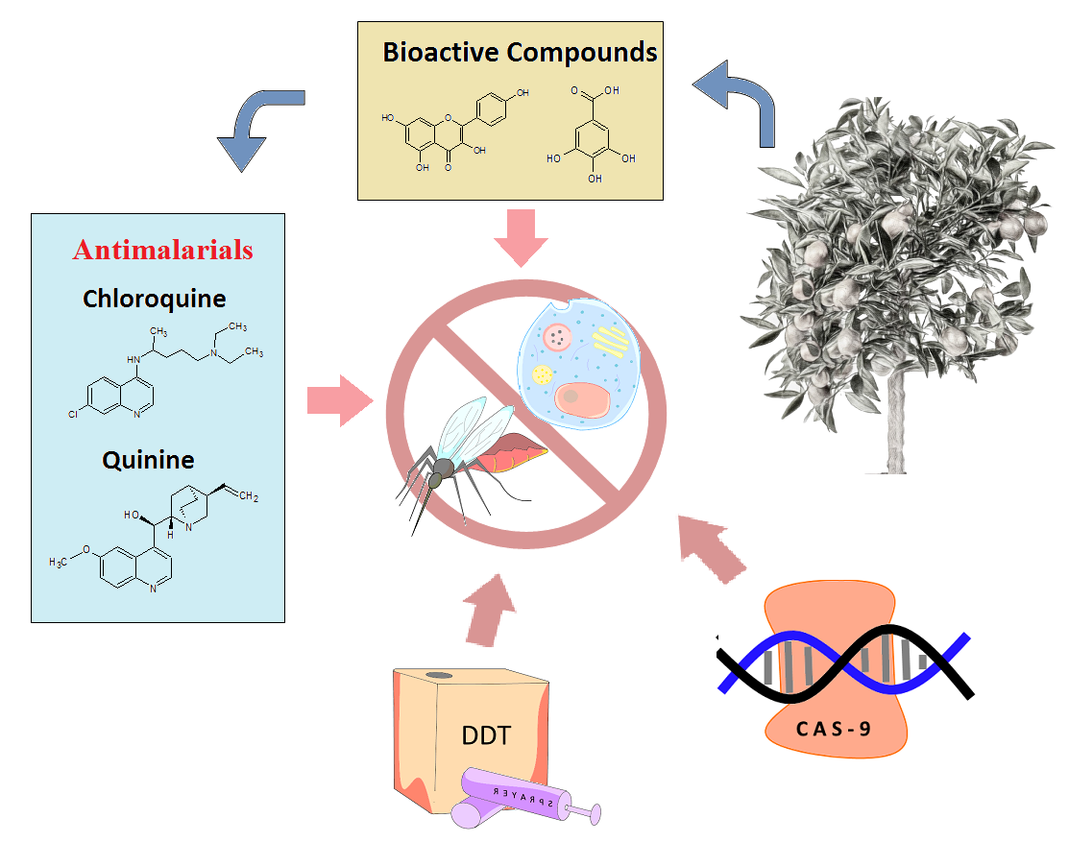
Fig.1. Diagram showing different methods used to control Malarial incidence

- Important Bioactive compounds in Citrus

Citrus plants are a rich source of bioactive substances, the majority of which are secondary metabolites such as Phenolics, Terpenoids, Flavonoids, Coumarins and Alkaloids. Citrus holds a significant position in the pharmaceutical and medical industries thanks to the existence of these bioactive compounds.

  - Flavonoids
Flavonoids are low molecular weight phenolic compounds that serve to draw pollinators and gives flowers and fruits their perfume and colour. Flavonoids are highly effective antioxidant and chelating agent because they contain numerous hydroxyl groups. Two phenyl (A and B) and a heterocyclic rings (C) make up the fundamental structure of a flavonoid (Fig.2.). Flavonoids are split into eight categories based on the attachment of these rings, including Flavones, falvonols, Flavanones, catechins, anthocyanins and chalcones [10]. Out of these subtypes most of the citrus fruits contains high number of flavones and flavanones. Neohesperinoids and rutinosides account for majority of the flavones in tropical citrus whereas apigenin (Fig.2.), phloretin (Fig.2.), hesperetin and naringenin are types of flavonoids that occur in moderate amount [11].
Citrus flavonoids can be extracted from a variety of fruit sections, although according to numerous studies, citrus fruit peel is considered to be the primary source of flavonoids [12]. For example, HPLC analysis of Citrus reticulata peel extracts led to the isolation of narningin, hesperitin, hesperidin, rutin and catechin in excessive amount [13]. The peel extract of Citrus aurantium also contains significant quantity of naringenin and apigenin [51]. Additionally, citrus fruit juice is well known for its flavonoid content. Apigenin and eriocitrin (5,7,3’,4’-tetrahydroxyflavone 7-β-rutinoside) is commonly found in lemon, orange, grapefruit and bergamot varieties of citrus. Whereas limocitrin glucoside and diosmetin flavonoids are only found in lemons [52]. It has already been established that flavonoids isolated from plants are beneficial in treating malaria. Nymphaeol and solophenol flavonoids isolated from Macaranga tanarium leaves have showed satisfactory antiplasmodial activity [14]. 1-(2,4-dihydroxy phenyl)-3-[8-hydroxy-2-methyl-2-(4-methyl-3pentenyl)-2H-1-benzopyran-5-yl]-1-propanone designated as Compound 1 by Hidayati[15] was isolated from Artocarpusaltilis leaves. The flavonoids IC50 value for Plasmodium falciparum growth inhibition during antiplasmodial screening was 1.05 μM.

  - Alkaloids
Alkaloids are natural chemical containing Nitrogen and are most frequently found in flowering plant species. Alkaloids (Fig.2.) may or may not have heterocyclic rings. True alkaloids and protoalkaloids are the two categories for alkaloids derived from amino acids. Pseudoalkaloids are instead derived from precursors of amino acid and are related to amino acid formation pathway [16]. Some typical examples of true alkaloids include quinine, morphine and, cocaine. Arcidone alkaloids are pretty prevalent in the Rutaceae family and have also been proven to have antimalarial effects. Normelicopidiene, a type of arcidone alkaloid isolated from Zanthoxylumsimullansm displayed effective antimalarial activity against chloroquine-sensitive (3D7) and (Dd2) strains of Plasmodium falciparum [17].Many different alkaloids have been extracted from citrus plants as well. DCM fractionation of C. aurantium showed the presence of six arcidone alkaloids i.e. citrusinine-I, 5-hydroxynoracronycine, glycofolinine, natsucitrin-I and citracridone-III [18]. Octopamine, Synephrine and Tyramine (Fig.2.) have also been isolated from wild citrus hybrid plants using the HPLC-UV detection method [19].
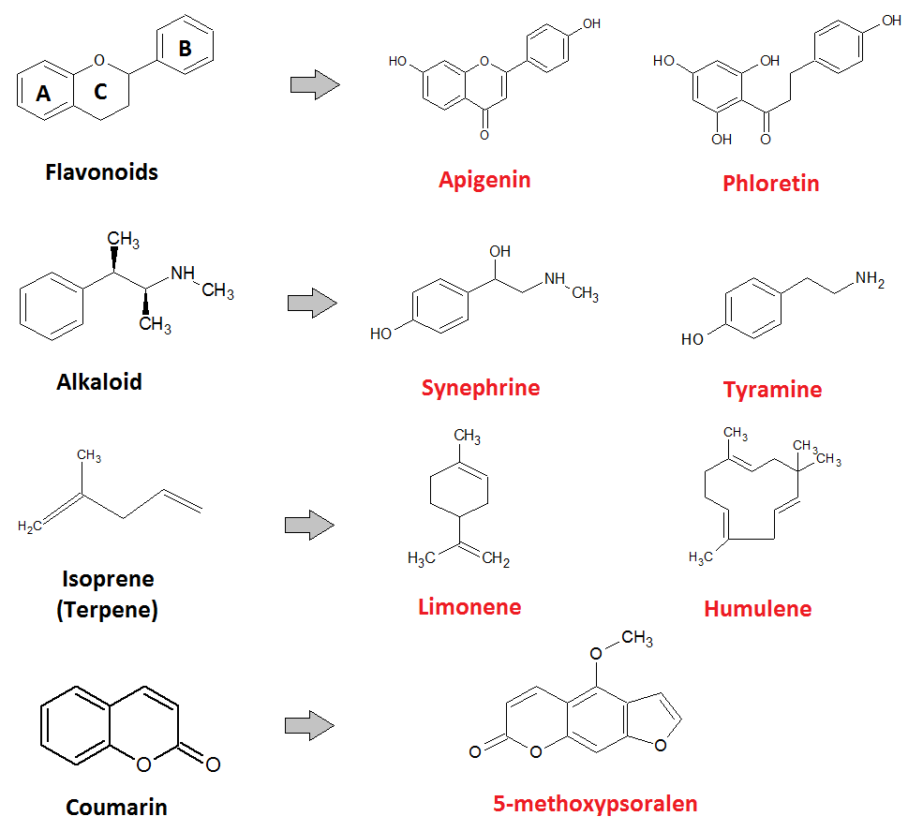
Fig.2. Diagram showing the structure of common metabolites found in citrus plants.

  - Terpenes
Terpenes are the major constituents of citrus essential oil. Terpenes are generally made up of either single or multiple Isoprene units with molecular formula C5H8 (Fig.2.). Based on the number of isoprene units, terpenes can be divided into mono (eg. Cineole, linalool, citronellol, cymene, carane, thujone), di (eg. terpineol, phytol, taxol, carnosic acid), tri (eg. Sitosterol, stigmasterol, amyrin) and sesquiterpenes (eg. humulene, cadinene, germacrene, curcumene) [20]. Terpene Hydrocarbons (Fig.2.) such as Limonene, humulene, ocimene, pinene, sabinine myrcene accounts for majority of the terpenes found in citrus essential oil followed by terpene alcohols and keto-terpenes [21].Numerous terpenes have been found to be present in Citrus aurantium peel essential oil (EO). Benayad [51] reported the presence of monoterpene hydrocarbons such as limonene, myrcene and linalool in excessive amount. However, Jha [54] discovered β-piene, D-limonene, eucalyptol and terpineol in Citrus aurantium flower EO. Different Citrus paradisi varieties are said to contain high amounts of Limonene in their peel and juice extract. Additionally, a moderate amount of Ocimene, carene and carveol can also be found in Citrus paradisi varieties [53]. Some studies have reported to found Citronellol (28.26%) an acyclic monoterpenoid to be present in highest amount followed by β-caryophyllene (16.89%) and spathulenol (9.32%) in some citrus varieties [22]. Limonene (Fig.2.) a cyclic monoterpene hydrocarbon may occur in concentration as high as 58% - 87.84% in essential oil of mousami, grapefruit, mandarin and malta [23]. The presence of high number of terpenes in citrus essential oil makes it an important contender for antimalarial activity. Nerolidol a sesquiterpene alcohol for example has the ability to inhibit Plasmodium berghei both in vitro and in vivo. Nerolidol at dose of 1000mg/kg decreased parasitemia in infected mice by >99% (oral administration) and >80% (inhalation) [24].

  - Coumarins
Coumarins (Fig.2.) are heterocyclic compound with chemical formula C₆H₆O₂ and is made up of a pyrone ring united to a benzene nucleus (1,2-benzopyrones). Based on the chemical structure, naturally occurring coumarins are divided into seven different types. These types include simple coumarins, pyranocoumarins, bicoumarins, phenylcoumarins, furanocoumarins and dihydrofuranocoumarins. Citrus plants contain abundant subtypes of coumarins which are usually associated with the defence mechanism of plants. Pumelos, citrons and papedas have been found to synthesize large amount of furanocoumarin and coumarins, but mandarins lack both in sufficient proportion [25]. 5-geranyloxy-7-methoxycoumarin, 5,7-dimethoxycoumarin, 5-8-dimethoxypsoralen, 5-methoxypsoralen and 5-geranoxypsoralen (Fig.2.) are key coumarins isolated from Citrus aurantifolia and Citrus latifolia[26].

- Mechanism of Action of Bioactive compounds against Plasmodium

It has already been established that terepenes have anti-plasmodial properties. Terpenes unquestionably targets different cellular elements of the plasmodium. Non-artemisinin based sesquiterpene lactones such as parthenin and parthenolide prevent parasites male gamete exflagellation and ookinete to oocyst transition. In plasmodium, male gamete exflagellation creates male gametes from single parental cell and necessitates rapid cell division and flagellar beating. The generation of male gametes is inhibited by parthenin and parthenolide, possibly by interfering with DNA replication or by producing reactive oxygen species [27]. Terpenes have also demonstrated hypolipidemic effect by lowering the level of triglycerids, LDL-cholesterol and phospholipids in Plasmodium berghei infected erythrocytes. This potentially regulates the growth of plasmodium in erythrocytes [28]. The apicoplast present in Plasmodium is a key site for the biosynthesis of Isoprenoids. These isoprenoids in P.falciparum are used for the synthesis of Vitamin E and dolichols. Linalool, Farnesol and nerolidol are potent inhibitor of dolichol biosynthesis in trophozoite and schizont stage of Plasmodium falciparum [29].
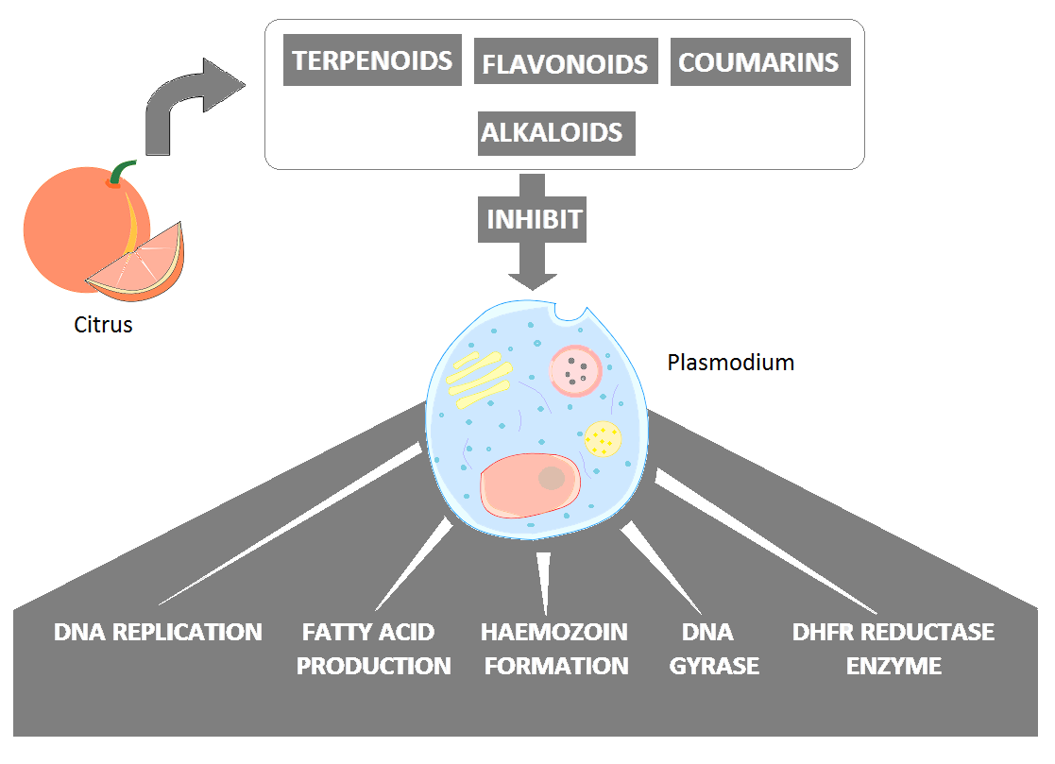
Fig.3. A simplified diagram showing the mode of action of citrus metabolites against plasmodium.

The involvement of flavonoids in targeting the plasmodium`s fatty acid production pathway has been supported by some earlier studies. Flavonoids target the Fab G, Fab Z and Fab I enzymes that are crucial for plasmodial fatty acid production. The inhibition depends on complexity of the flavonoids and the presence of hydroxyl group. Polyhydroxylated flavonoids were 10 times more effective in inhibiting FabG, FabZ and FabI [30]. Additionally, flavonoids such as myricetin and fistein targets key cystein protease enzymes Falcipain-2 and plasmepsin-II which are involved in breakdown of host haemoglobin [32]. A novel flavonoid glycoside, pinocembrin-7-O-β-D- glucopyranoside has been reported to inhibit Dihydrofolate-reductase thymidylate synthase (DHFR-TS) enzyme. This enzyme in Plasmodium falciparum is responsible for the production of thymidylate and folate, both of which are required for DNA synthesis [31].

Many antimalarial drugs, including chloroquine, work against plasmodium by obstructing with the process of haemozoin formation. Haemoglobin degradation by malaria parasite releases free heme, which is toxic to the parasite itself. For survival, the parasite transforms the heme into hemozoin, a biocrystal malarial pigment [33]. 4-nerolidylcatechol a sesquiterpene and its derivatives have been proven to prevent the formation of hemozoin at various concentrations (Silva et al. 2015). Flavonoids with increased methoxylation (Pentamethoxyquercetin) patterns are extremely effective in forming heme-flavonoid adducts and may be the cause behind its antiplasmodial efficacy [34]. Silymarin, another polyphenolic flavonoid forms heme-silymarin complex which destabilises the cell membrane of the parasite. Furthermore, the compound can inhibit polymerisation and degradation of heme [35]. According to molecular docking studies, chalcones is a key bioactive flavonoid that targets the Plasmodium falciparum DHFR-TS enzyme. A derivative of the chalcone designated 3b, used in the investigation show binding interaction with the 1J3I PfDHFR-TS proteins Ala16, Ile164, Phe58 and Tyr170 residues [36].

Recent research has revealed that DNA gyrase of plasmodium can be a novel target of several antiparasitic compounds. Coumarins which are abundant in rutaceae family exert antimalarial activity by hampering the function of DNA gyrase. This leads to the formation and accumulation of single stranded DNA breaks [37]. In addition to that, coumarins can regulate hemozoin formation and DNA interaction. The IC50 values have shown that coumarins are just as effective as chloroquine at preventing parasite from producing hemozoin [38].

- Citrus as a source to fight Malaria

Citrus is one of the many plants whose antimalarial qualities have been studied over time. Citrus is a significant choice to access its potential in anticancer, anti-inflammatory, antiparasitic, antibacterial and antioxidant roles due to the presence of a variety of secondary metabolites. Citrus is a relatively new antimalarial agent thus; more attention needs to be paid to it. Extracts of citrus plant parts as well as essential oil can be used as a malaria repellent or as a drug/food source directly to cure malaria. Below we have thoroughly discussed the potential of citrus plants as an antimalarial agent.

  - Anti-plasmodial activity of Citrus

Because they contain a wide range of important chemicals, citrus limon fruit and fruit parts are traditionally utilised as medicine in many parts of the world. Citrus limon leaf, fruit, and root extracts were found to be highly effective against plasmodium in numerous in vitro and in vivo experiments [39][40][41][42]. The effectiveness of acetone extract and Citrus limon leaf powder against Plasmodium bergheiAnka-infected mice was investigated by Bonkian and his colleagues [39]. At a dose of 250 mg/kg body weight, the acetone extract was shown to be efficient and reduced the parasitaemia by almost 75%. However, it was discovered that the leaf decoction proved useless at treating malaria.Citrus limonfruit aqueous decoction also showed low parasitic suppression of plasmodium compared to negative infected control groups. However, when taken with conventional antimalarial medications, lemon decoction had the strongest effect against Plasmodium berghei [40]. A viable option for usage as an antiplasmodial agent is to combine the therapies of Citrus limon and Carica papaya. The invitro testing of this combination on chloroquine sensitive D10 strain produced an outstanding IC50 value of 0.83 µg/ml. Citrus limon administration alone had a lower level of effectiveness. The best antiplasmodial activity was demonstrated by dichloromethane extract of Citrus limonwith IC50 value of 5µg/ml [41]. Additionally, it was shown that the dichloromethane extract of Citrus limon root was effective in reducing malaria brought on by both chloroquine-sensitive and multi-drug resistant strains of Plasmodium falciparum. [58].

Table 1: Antiplasmodial activity of different Citrus plant extracts.
Sl. No | Citrus plant | Plant part | Extract | Test | Plasmodial species | Reference
1. | Citrus limon | Leaf | Acetone | In vivo | Plasmodium berghei | Bonkian et al. 2019
2. | Citrus limon | Fruit | Aqueous Decoction | In vivo | Plasmodium berghei | Shija et al. 2020
3. | Citrus limon | Leaf | Dichloromethane | In vitro | Plasmodium falciparum | Melariri et al. 2012
4. | Citrus limon+ Citrus paradisi | Fruit | Fruit juice | In vivo | Plasmodium berghei^{Chl} | Elom et al. 2021
5. | Citrus limon | Root | Dichloromethane | In vitro | Plasmodium falciparum | Guya et al. 2022
6. | Citrus arantifolia | Fruit/ fruit | Aqueous-ethanolic | In vivo | Plasmodimberghei^{Chl} | Odediran et al. 2020
7. | Citrus aurantifolia | Leaf | Ethanolic | In vivo | Plasmodimberghei | Ettebong et al. 2019
8. | Citrus aurantifolia | Flower | Methanolic | In vitro | Plasmodium falciparum^{Chl} | Bapna et al. 2017
9. | Citrus maxima | Fruit peel | Methanolic | In vivo | Plasmodium berghei | Ihekwereme et al. 2017
10. | Citrus maxima | - | Hydro-alcoholic | In vitro | Plasmodium falciparum^{chl} | Gogoi et al. 2021
11. | Citrus sinensis | Peel | Ethanolic | In vivo | Plasmodium berghei | Kristhien et al. 2019
12. | Citrus paradisi | Leaves | Ethanolic | In vivo | Plasmodium berghei | Kristhien et al. 2019
13. | Citrus senensis | Stem | Ethanolic/aqueous | In vivo | Plasmodium berghei | Chinwuba et al. 2015
14. | Citrus aurantium | Flower | EO | In vitro | Plasmodium falciparum | Jha et al. 2022
15. | Citrus paradisi | Root | EO | In vitro | Plasmodium falciparum | Ogunjinmi et al. 2017

Combined therapy of Citrus limonand Citrus paradisifruit juice extract is also found to be effective in inhibiting the growth of chloroquine resistant Plasmodium berghei ANKA. When administered without combination, C. limon extracts were less powerful in treating disease compared to artemisinin combined therapy (ACT) whereas C. paradisi were least effective [42].
Extracts of different parts of Citrus aurantifolawere evaluated against Plasmodimberghei infected mice. The fruit extract of Citrus auratifola were found to be more active in chemosuppresive, prophylactic and curative model. The percentage reduction in parasitemia for chemosuppresive mode was found to be 92.9±1.2 [44]. Antiplasmodial activity of methanolic extract of Citrus aurantifolia leaf showed 77.66% chemosuppression in supressive test conducted in mice. However, in Repository and curative tests low doses of the extract demonstrated better activity then middle or high doses. The median lethal dose was calculated to be 3280 mg/kg ± 0.01 and is safe for oral use [45]. Chloroquine resistant Plasmodium falciparum 3D7 strain poses a considerable threat. According to some recent studies the 3D7 strain was effectively inhibited by methanolic extract of Citrus aurantifolia. The aqueous extract in comparison did not pose any considerable threat to the protozoan strain. [46].
Methanolic extract of Citrus maxima peel showed promising antimalarial properties against P. berghei. Mouse injected with malaria were administered with 125, 250 and 500 mg/kg/day for 7 consecutive days. At 125mg/kg/day 89% of the parasites were cleared by day 7 whereas for 500mg/kg, 95.87% of the parasites were effectively eliminated [47]. The hydro-alcoholic extract of Citrus maxima demonstrated its effectiveness in inhibiting the growth of chloroquine sensitive (3D7) and Chloroquine resistant (Rlk-9) strains of Plasmodium falciparum. The IC50 values of Citrus maxima against 3D7 stains (3.41±0.31 µg/ml) and RLK-9 strains (4.45±0.10 µg/ml) were found to be better than the IC50 values A.nilagirica alcoholic extracts against Plasmodium strains [48].

In a comparative analysis between Ethanolic extracts of Citrus sinensis, Citrus paradisi and Psidium guajava, highest anti-plasmodial activity was shown by Psidium guajava with 99.12% inhibition of parasitemia. Citrus paradisi was moderately active with 98.84% inhibition of parasitemia at 1000mg/kg concentration. Citrus sinensis was found to be least effective amongst the three [49]. Earlier research on Citrus sinensis effectiveness against Plasmodium berghei produced some intriguing findings. The effectiveness of stems aqueous extract was found to be lowest, while the ethanolic extract of the stem was found to be powerful enough to supress 30% to 50% of parasitaemia [56].

Essential oil from citrus can be extracted from various parts. However, the chemical makeup of the oil causes the effectiveness to vary. Root, fruit peel and stem essential oil of Citrus paradisi exhibit varying degree of effectiveness against malaria. The fruit peel oil with limonene and α-myrcene as major component showed no significant activity against Plasmodium falciparum strain. The root oil with IC50 value of 22.2µg/mL was somewhat effective against plasmodium parasites. Activity of stem essential oil was also not found to be satisfactory in arresting plasmodium growth [43]. EO extracted from Citrus aurantium flowers have shown antiplasmodial activity against drug sensitive and drug resistant varieties of Plasmodium falciparum. The IC50 values have shown that EO of flower provides similar usefulness against drug sensitive strains when compared to that of standard quinine drug. However, against drug resistant strains the effectiveness of EO was found to be 0.97 µg/ml [54].

  - Citrus as an antilarval/mosquito repellent
Although it wasn’t the main goal of this review, we did want to shed some light on the topic of citrus potential as a mosquito deterrent. Citrus is less toxic than chemical alternatives, making its use as a mosquito repellent a significant discovery. Citrus limon, Citrus sinensis, Citrus reticulata and Citrus aurantifoliaall have effective anti-larval property [55] [56]. Aqueous extract of Citrus limon has shown promising results in in-vitro tests against Anopheles gambiae larvae and can be used to control free floating larvae found in stagnant water [56]. In another study, aqueous extract of Citrus sinensispeel showed dose dependent inhibition with percentage mortality ranging from 65% to 100% when tested against mosquito larvae. This could be a reasonable and eco-friendly alternative to protect families from malarial attack [50].Anopheles stephensi and Cluexquinquefasciatusare two mosquito species that can be controlled using the essential oils of Citrus limetta, Citrus reticulata and Citrus limonleaves [57].

- Declaration

Conflict of interest: Authors have no competing or conflict of interests.
Funding: No funding received in making this manuscript

Authors contribution: Authors contributed equally in making the manuscript.

- Data availability: no data is available in this manuscript.

- References

- Goodarzi, E., Beiranvand, R., Darvishi, I., Naghibzadeh-Tahami, A., Bechashk, S.M., Naemi, H., Khazaei, Z., 2017. Geographical distribution of falciparum malaria in the world and its relationship with the human development index (HDI): countries based on the WHO report in 2017. J Public Health (Berl.): From Theory to Practice. https://doi.org/10.1007/s10389-020-01336-6.
- Preis, J., and Lutwick. L., 2014. Plasmodium knowlesi. Emerging Infectious Diseases. 337-345, DOI: http://dx.doi.org/10.1016/B978-0-12-416975-3.00025-X
- Martino, E., Casamassima, G., Castiglione, S., Cellupica, E., Pantalone, S., Papagni, F., Rui, M., Siciliano, A,M., Collina, S. 2018. Vinca alkaloids and analouges as anti-cancer agents: Looking back, peering ahead. Bioorganic & medicinal chemistry letters. 28(17): 2816-2826.
- Dong, Y., Simões, M.L., Marois, E., Dimopoulos , G., 2018. CRISPR/Cas9 -mediated gene knockout of Anopheles gambiae FREP1 suppresses malaria parasite infection. PLoS Pathogens 14(3): e1006898. https://doi.org/10.1371/ journal.ppat.1006898
- Bray, P.G., Martin, R.E., Tilley, L., Ward, S.A., Kirk , K., Fidoc, D.A., 2005. Deﬁning the role of PfCRT in Plasmodium falciparum chloroquine resistance. Molecular Microbiology (2005) 56 (2), 323–33. doi:10.1111/j.1365-2958.2005.04556.x
- Eastman, R.T., and Fidoc, D.A., 2009. Artemisinin-based combination therapies: a vital tool in efforts to eliminate malaria. 2009. Nat Rev Microbiol. 7(12): 864–874. doi:10.1038/nrmicro2239.
- Hott, A., Tucker, M.S., Casandra, D., Sparks, K., Kyle, D.E., 2015. Fitness of artemisinin-resistant Plasmodium falciparum in vitro. J Antimicrob Chemother; 2015. 70(10); 2787-2796. doi:10.1093/jac/dkv199.
- Bringmann, G., Teltschik, F, Michael M, Busemann S, Rückert M, Haller R, BärS,Robertson SA, Kaminsky R: Ancistrobertsonines B, C, and D as well as 1,2-didehydroancistrobertsonine D from Ancistrocladusrobertsoniorum.Phytochemistry 1999, 52:321–332.
- Pereira, T.B., Rocha e Silva, L.F., Amoin, R.CN, Melo, M., Zacardi de Souza, R., Eberlin, M.N., Lima, E.S., Vasconcellos, C.M., Pohlit, A.M., 2014. In vitro and in vivo anti-malarial activity of limonoids isolated from the residual seed biomass from Carapaguianesis (andiroba) oil production. Malaria journal 2014, 13:317
- Panche, A.N., Diwan, A.D., and Chandra, S.R., 2016. Flavonoids: an overview. Journal of Nutritional Science (2016), vol. 5, e47. doi:10.1017/jns.2016.41
- Roowi, S., and Crozie, A., 2011. Flavonoids in Tropical Citrus Species. J. Agric. Food Chem. 59, 12217–12225. dx.doi.org/10.1021/jf203022f
- Chen, Q., Dan Wang, Chun Tan, Yan Hu, Sundararajan, B., Zhou, Z., 2020. Proﬁling of Flavonoid and Antioxidant Activity of Fruit Tissues from 27 Chinese Local Citrus Cultivars. Plants 2020, 9, 196; doi:10.3390/plants9020196
- Raﬁq, S., Singh, B., Gat, Y., 2019. Effect of different drying techniques on chemical composition, color and antioxidant properties of kinnow (Citrus reticulata) peel. J Food Sci Technol 56(5):2458–2466. https://doi.org/10.1007/s13197-019-03722-9
- Marliana, E., Hairani, R., Tjahjandarie, T.S., Tanjung, M., 2018. Antiplasmodial activity of flavonoids from Macaranga tanarius leaves. IOP Conf. Series: Earth and Environmental Science 144 (2018) 012011. doi :10.1088/1755-1315/144/1/012011
- Hidayati, A.R., Widyawaruyanti, A., Ilmi, H., Tanjung, M., Widiandani, T., Siswandono, Syafruddin, D, Hafid, A.F., 2020. Antimalarial Activity of Flavonoid compound isolated from Leaves of Artocarpusaltilis. Pharmacognosy Journal, 2020, 12, 4, 835-842. Doi: 10.5530/pj.2020.12.120.
- Deya, P., Kundua, A., Kumarb, A., Meenakshi Guptac, Byung Mu Leea, TejendraBhaktad, SuvakantaDashd, Kima, H.S., 2020. Analysis of alkaloids (indole alkaloids, isoquinoline alkaloids, tropane alkaloids). Recent Advances in Natural Products Analysis. https://doi.org/10.1016/B978-0-12-816455-6.00015-9
- Wang, C., Wan, J., Mei, Z., Yang, X., 2014. Arcidone alkaloids with cytotoxic and antimalarial activities from ZanthoxylumsimullansHance. Pharmacogn Mag. 2014 Jan-Mar; 10(37); 73-76. Doi: 10.4103/0973-1296.126669.
- Segun, P, Ismail, FMD, Ogbole, OO, Nahar, L, Evans, AR, Ajaiyeoba, EO and Sarker, SD. 2018. Acridone alkaloids from the stem bark of Citrus aurantium display selective cytotoxicity against breast, liver, lung and prostate human carcinoma cells. Journal of Ethnopharmacology, 227. pp. 131-138. ISSN
- He, Shan, Y., Wu, Y., Liu, G., Chen, B., Yao, S., 2011. Simultaneous determination of flavanones, hydroxycinnamic acids and alkaloids in citrus fruits by HPLC-DAD-ESI/MS. Volume 127, Issue 2, 2011, 880-885.
- Bayala, B., Bassole, I.H.N., Riccardo Scifo4,5,6,7, Charlemagne Gnoula1,8, Laurent Morel4,5,6,7, Jean-Marc A Lobaccaro4,5,6,7, Jacques Simpore. 2014. Anticancer activity of essential oils and their chemical components - a review. Am J Cancer Res 2014;4(6):591-607
- Li, K., Xia, Y., Li, F., Fan,Y., Liu, T., 2020. Comparative analysis of volatile compounds in five citrus cultivars with hs-spme-gc-ms. Pak. J. Agri. Sci., Vol. 57(4), 1203-1209;2020
- Prasad, D.A., Prasad, B.R., Prasad, D.K., Shetty, P., Sunil Kumar, K.N., 2016. GC-MS Compositional Analysis of Essential Oil of Leaf and Fruit Rind of Citrus maxima (Burm.) Merr. from Coastal Karnataka, India. Journal of Applied Pharmaceutical Science Vol. 6 (05), pp. 068-072, May, 2016, ISSN 2231-3354 DOI: 10.7324/JAPS.2016.60511
- Javed, S., Javaid, A., Nawaz, S., Saeed, M.K., Mahmood, Z., Siddiqui, S.Z. Ahmed, R., 2014. Phytochemistry, GC-MS Analysis Antioxidant and Antimicrobial Potential of Essential oil from five Citrus species. Journal of Agricultural science; vol. 6, No.3;2014. Doi: 10.5533/jas.v6n3p201.
- Saito, A.Y., Rodriguez, A.A.M., Vega, D.S.M., Sussmann, R.A.C., Kimura, E.A., Katzin, A.M., 2016. Antimalarial activity of the terpene nerolidol. International Journal of Antimicrobial Agents. doi: 10.1016/ j.ijantimicag.2016.08.017
- Dugrand-Judek, A., Alexandre Olry1,2, AlainHehn1,2,GillesCostantino3, PatrickOllitrault4,5,YannFroelicher6*,FrédéricBourgaud. TheDistributionofCoumarinsandFuranocoumarinsinCitrusSpeciesCloselyMatchesCitrusPhylogenyandReflectstheOrganizationofBiosyntheticPathways. PLoSONE 10(11):e0142757. doi:10.1371/journal.pone.0142757
- Ramírez-Pelayo , C., Martínez-Qui~nones , J., Gil, J., Durango, D., 2019. Coumarins from the peel of citrus grown in Colombia: composition, elicitation and antifungal activity. Heliyon 5 (2019) e01937. https://doi.org/10.1016/j.heliyon.2019.e01937
- Balaich, J.N., Mathias, D.K., Baldwyn Torto,b Bryan T. Jackson,cDingyinTao,a Babak Ebrahimi,d Brian B. Tarimo,a,e,f Xavier Cheseto,b Woodbridge A. Foster,cDinglasan, R.R., 2016. The Nonartemisinin Sesquiterpene Lactones Parthenin and Parthenolide Block Plasmodium falciparum Sexual Stage Transmission. Antimicrob Agents Chemother 60:2108–2117. doi:10.1128/AAC.02002-15.
- Oluba, O.M., 2019. Ganoderma terpenoid extract exhibited anti-plasmodial activity by a mechanism involving reduction in erythrocyte and hepatic lipids in Plasmodium berghei infected mice. Oluba Lipids in Health and Disease (2019) 18:12 https://doi.org/10.1186/s12944-018-0951-x
- Goulart, H.R., Kimura, E.A., Peres, V.J., Couto, A.S., Duarte, F.A.A., Katzin, A.M., 2004. Terpenes Arrest Parasite Development and Inhibit Biosynthesis of Isoprenoids in Plasmodium falciparum. Antimicrobial Agents and chemotherapy. p. 2502–2509. DOI: 10.1128/AAC.48.7.2502–2509.2004
- Tasdemir, D., Lack, G., Brun, R., ¨edi, P., Scapozza, L., Perozzo, R., 2006. Inhibition of Plasmodium falciparum Fatty Acid Biosynthesis: Evaluation of FabG, FabZ, and FabI as Drug Targets for Flavonoids. 3345J. Med. Chem. 49, 3345-3353
- Zothantluanga, J.H., Aswin, S.K., Rudrapal, M., Cheita, D., 2021. Antimalarial Flavonoid-Glycoside from Acacia pennata with Inhibitory Potential Against PfDHFR-TS: An Insilico Study. Biointerface Research in Applied Chemistry. Volume 12, 4871 - 4887 https://doi.org/10.33263/BRIAC124.48714887
- Jin, H., Xu, Z., Cui, K., Zhang, T., Lu, W, Huang, J., 2014. Dietary flavonoids fisetin and myricetin: Dual inhibitors ofPlasmodium falciparum falcipain-2 and plasmepsin II. Fitoterapia 94 (2014) 55–61.
- Coronado, L.M., Nadovich, C.T., Spadafora, C., 2014.Malarial Hemozoin: From target to tool. BiochimBiophys Acta. 2014 June ; 1840(6): 2032–2041. doi:10.1016/j.bbagen.2014.02.009.
- Ortiza, S., Vásquez-Ocmínb, P.G., Cojeanb, S., Bouzidia, C., Michela, S., Bruno Figadèreb, Raphaël Grougneta, Sabrina Boutefnoucheta*, Alexandre Maciukb. 2020. Correlation study on methoxylation pattern of flavonoids and their heme-targeted antiplasmodial activity Bioorganic Chemistry, Vol. 104, 104243.
- Mina, P.R., Kumar, Y., Verma, A.K., Khan, F., Tandon, S., Pal, A., Darokar, M.P., 2019. Silymarin, a polyphenolic flavonoid impedePlasmodiumfalciparum growth through interaction with heme, Natural Product Research, DOI: 10.1080/14786419.2018.1548449
- Syahri, J., Yuanita, E., Nurohmah, B.A., Armunanto, R., Purwono. B., 2017. Chalcone analogue as potent anti-malarial compounds against Plasmodium falciparum: Synthesis, biological evaluation, and docking simulation study. Asian Pac J Trop Biomed. 7(8): 675–679
- Yadav, N., Agarwal, D., Kumar, S., Dixit, A.K., Gupta, R.D., Awasthi, S.K., 2018. In vitro antiplasmodial efficacy of synthetic coumarin-triazole analogs. European Journal of Medicinal Chemistry. doi: 10.1016/j.ejmech.2018.01.017.
- Mbaba, M., Dingle, L.M.K., Zulu, A.I., Laming, D., Tarryn Swart 2,4, Jo-Anne de la Mare 2,3,4, Heinrich C. Hoppe 2,4 , Adrienne L. Edkins 2,3,4 and Setshaba D. Khanye. 2021. Coumarin-Annulated Ferrocenyl 1,3-Oxazine Derivatives Possessing In Vitro Antimalarial and Antitrypanosomal Potency. Molecules 2021, 26, 1333. https://doi.org/10.3390/ molecules26051333
- Bonkian, L.N., Yerbanga, R.S, Sangare I, Koama B, Soma A, Cisse M, Bamba S, Valea I, Tinto H, Ouedraogo JB and Traore M. 2019. In vivo Antiplasmodial and Insecticidal Activities of Citrus Limon (L.) Osbeck (Rutaceae), Leaves Extracts. SAJ Pharma Pharmacol 6: 103
- Shija, K.M., Nondo, R.S.O., Mloka, D., Sangeda, R.Z., Bwire, G.M., 2020. Effects of lemon decoction on malaria parasite clearance and selected hematological parameters in Plasmodium berghei ANKA infected mice. BMC Complementary Medicine and Therapies 20:24. https://doi.org/10.1186/s12906-020-2820-1
- Melariri, P., Campbell, W., Etusim, P., Smith, P., 2012. In vitro antiplasmodial activities of extracts from five plants used singly and in combination against Plasmodium falciparum parasites. Journal of Medicinal Plants Research Vol. 6(47), pp. 5770-5779.
- Elom, M.O., Uche, A.G., Ukwah, B.N., Usanga, V.U., Okpara-Elom, A.I., Kalu, M.E., Ibe, O.E., 2021. Anti-plasmodial Effect of C. limon and C. paradisi extracts on Plasmodium berghei infected mice. World Journal of Biology Pharmacy and Health Sciences, 08(02), 026–033. DOI: https://doi.org/10.30574/wjbphs.2021.8.2.0118
- Ogunjinmi, O.E, Olawore N.O., Aliyu, A.A., 2017. Comparative studies of Chemical Constituents and Antimalarial Activity of Essential oils Extracted from the Stem, Root and Fruit peel of Citrus paradisi Grown in Nigeria. IOSR Journal of Applied Chemistry (IOSR-JAC). DOI: 10.9790/5736-1012010111
- Odediran, S.A., Awosode, K.E., Adegoke, T.A., Odebunmi, K.A., Oladunjoye, B.B., Obasanya, A.A., Omilani, I.M., Soyinka, K.T., Ugbo, J.U., Ogunleke, A.J., Adesida, S.A., Adebajo, A.C., 2020. Combinations of Chrysophyllumalbidum and Citrus aurantifolia as Antimalarial Agents and their Effects on Orthodox Antimalarial Drugs in Mice. Ann Complement Altern Med. 2(1): 1007
- Ettebong, E., Ubulom, P., Etuk, A., 2019. Antiplasmodial activity of methanol leaf extract of Citrus aurantifolia (Christm) Swingle. J HerbmedPharmacol. 2019;8(4):274-280. doi: 10.15171/jhp.2019.40.
- Bapna, S., Trupti Satvekar, Pradeep Jadhav and MrunalGhag Sawant (2017): Evaluation of in Vitro Antimalarial Activity of Calotropis gigantia and Citrus aurintofolia Flower extract against Plasmodium falciparum 3D7. World Journal of Pharmaceutical Research. Volume 6, Issue 16, 1619-1626
- Ihekwereme, C.P., Onyegbule, F.A., Okeke N.V., Obi, C.O., 2017. Preliminary studies on the antimalarial properties of the peels of Citrus maximalinn. The Bioscientist, Vol. 5(1): 57-65
- Gogoi, N., Gogoi, B., Chetia, D., 2021. In vitro antimalarial activity evaluation of two ethnomedicinal plants against chloroquine sensitive and resistant strains of Plasmodium falciparum. Clinical Phytoscience. 7:42. https://doi.org/10.1186/s40816-021-00269-1
- Kristhien, A., Blessing, A., Obiajunwa Kelechi O., Nwanjo U. H., Benson, N., 2019. Toxicological and Antiplasmodial Suppressive Activities of Ethanolic Extracts of Orange (Citrus sinensis) peels, Grape (Citrus paradisi) andGuava (Psidium guajava)Leaves in Albino Rats. International Journal of Engineering Science Invention. PP 37-44
- George, U.I., 2019. Environmental control of malaria: Can Citrus sinensis peel be a potent larvicide for household vector control. GSC Biological and Pharmaceutical Sciences, 09(03), 085–090. Article DOI: https://doi.org/10.30574/gscbps.2019.9.3.0236
- Benayad, O., Bouhrim, M.,Tiji, S., Kharchoufa, L., Addi, M., Drouet 4, Hano, S.C., Lorenzo, J,M.,Bendaha, H., Bnouham, M., Mimouni, M., 2021. Phytochemical Proﬁle, α-Glucosidase, and α-Amylase Inhibition Potential and Toxicity Evaluation of Extracts from Citrus aurantium (L) Peel, a Valuable By-Product from Northeastern Morocco. Biomolecules 11: 1555. https://doi.org/10.3390/biom11111555.
- Dugo, P., Presti, M,L., Ohman, M., Fazio, A., Dugo, G., Mondello, L., 2005. Determination of flavonoids in citrus juices by micro-HPLC-ESI/MS. J. Sep. Sci. 28: 1149-1156.
- Ahmed, S., Rattanpal, H.S., Gul, K., Dar, R.A., Sharma, A., 2019. Chemical composition, antioxidant activity and GC-MS analysis of juice and peel oil of grapefruit varieties cultivated in India. Journal of integrative Agriculture. 18(7): 1634-1642.
- Jha, V., Risbud, A.,Kasbe, S., Thube, S., Preman, G.,Maiti, S., Yadav, H Khan, F., Shaikh, F., Jain, T. 2022. GC–MS Analysis and Investigation of Bioactive Potential of Essential Oil from Citrus aurantium var. amara. 8(3): 24-34.
- Aïzoun, N., Koura, K.,Adjatin, A. 2021. Effect of aqueous extract of lemon (Citrus limon) on Anopheles gambiae sensulato (Diptera: Culicidae) larvae tolerance in malaria vector control in Dogbo district in south-western Republic of Benin, West Africa. 17(02): 001–007.
- Chinwuba, P., Akah, P.A., Ilodigwe, E.E. 2015. Invivo antiplasmodial activity of the ethanol stem extract and fractions of Citrus sinensis in mice. Merit Research Journal of Medicine and Medical Sciences. 3(4): 140-146.
- Sharma, S., Loach, N., Gupta, S., Mohan, L. 2022. Evaluation of Larval toxicity, mode of action and chemical composition of citrus essential oil against Anopheles stephensi and Cluexquinquefasciatus. Biocatalysis and Agricultural Biotechnology. 39: 102284.
- Guya, S.O., Njagi, E.N.M., Guantai, A.N.,Lang`at -Thoruwa, C.C., Yenesew, A., Mdachi, R., Auma, J.E., Peter, O., Chemulit, J.,Muleke, C.I., 2022. Journal of Scientific Research & Reports 28(5): 35-58.
- Lutz, M., Fuentes, E., Avila, F., Alrcon, M., Palomo, I. 2019. Roles of Phenolic Compounds in the Reduction of Risk factors of Cardiovascular Diseases. Molecules. 24: 366. Doi: 10.3390/molecules24020366
- Ezati, M., Ghavamipour, F., Khosravi, N., Sajedi, R,H., Chalabi, M., Farokhi, A., Adibi, H., Khodrahmi, R. 2023. Synthesis and Potential Antidiabetic Properties of Curcumin-Based Derivatives: An In vitro and In silico Study of α-Glucosidase and α-amylase inhibition. Medicinal Chemistry 19(1): 99-117.
- Garcia, A, R., Amaral, A, C, F., Azevedo, M, M, B., Corte-Real, S., Lopes, R, C, Celuta S. Alviano, Pinheiro, A, S., Vermelho, A, B., Rodrigues, I.A. 2017. Cytotoxicity and anti-Leishmania amazonensis activity of Citrus sinensis leaf extracts, Pharmaceutical Biology, 55:1, 1780-1786, DOI: 10.1080/13880209.2017.1325380
- Nakanishia, M., Mami Hinoa, MorioYoshimurab, Yoshiaki Amakurab, Hiroshi Nomotoa, 2019. Identiﬁcation of sinensetin and nobiletin as major antitrypanosomal factors in a citrus cultivar. Experimental Parasitology 200: 24–29.
- Diagana TT. Supporting malaria elimination with 21st century antimalarial agent drug discovery. Drug Discov Today. 2015;20(10):1265–1270. doi: 10.1016/j.drudis.2015.06.009.
- Rosenthal PJ. Antimalarial drug discovery: old and new approaches. J Exp Biol. 2003;206 (21):3735–3744. doi: 10.1242/jeb.00589.

