UNICYSTIC AMELOBLASTOMA
Authors: Dr. Prachi Patel, Dr. Bhupesh Patel, Dr. Himani Tiwari, Dr. Rina Mehta
ABSTRACT
Unicystic ameloblastoma (UA) is a monocystic lesion having odontogenic epithelium. UA arises from the epithelial remains of Malassez of Hertwig’s epithelial sheath. It usually affects men more than women and appears common in 20 to 30 years of age. Clinically, it is asymptomatic, although it can induce swelling and facial asymmetry by expanding the bony cortex and permitting soft tissue invasion. Chances of invasion and recurrence are more in this as compared to conventional ameloblatoma. UA has a well-defined, radiolucent, unilocular on radiographs, and histologically, it can be luminal, intraluminal, or mural, depending on the pathologic cavity characteristics. Most treatments depend on surgical excision of the lesion, which allows tumour removal with safe bone margins.
Keywords- Mural, Ameloblastoma, Mandible, Odontogenic tumours, Unicystic.

I. INTRODUCTION
Ameloblastomas defines as a real enamel organ type tissue neoplasm that does not differentiate to the stage of enamel development. Robinson stated the lesion as anatomically benign, unicentric, slow growing, non-invasive, and clinically persistent. The word 'ameloblastoma' was suggested by Churchill in 1934 to replace the term 'adamantinoma', coined by Malassez in 1885, because the latter term implies the production of hard tissue, which is not present in this lesion. The word Ameloblastoma is formed by the English term amel, which means enamel, and the Greek word blastoma, which means germ. It is the second most frequent odontogenic neoplasm, with only odontoma outnumbering it in terms of documented occurrence [1]. They are commonly characterised as solid/conventional, unicystic/ extraosseous/peripheral and metastasizing subtypes.
The UA is a rare variant of ameloblastoma that refers to cystic lesions that have clinical and radiographic characteristics of an odontogenic cyst but histologically show a typical ameloblastomatous epithelium lining, with or without mural and/or luminal tumour proliferation [2].

II. CLASSIFICATION
Modified classification of odontogenic tumour which was given by WHO in the year 2022 [3].
TABLE 1: CLASSIFICATION ODONTOGENIC TUMOURS GIVEN BY WHO:
1)Benign odontogenic tumours of epithelial origin | 2) Benign mixed epithelial & mesenchymal odontogenic | 3)Benign mesenchymal odontogenic | 4) Malignant odontogenic tumours
Ameloblastoma, unicystic | Ameloblastic fibroma | Cementoblastoma | Odontogenic sarcomas
Ameloblastoma, conventional | Odontoma | Cemento-ossifying fibroma | Odontogenic carcinosarcoma
Ameloblastoma, extraosseous/peripheral | Primordial odontogenic tumour | Odontogenic Myxoma | Ameloblastic carcinoma
Adenoid ameloblastoma | Dentinogenic ghost cell tumour | Odontogenic Fibroma | Sclerosing odontogenic carcinoma
Metastasizing ameloblastoma |  |  | Clear cell odontogenic carcinoma
Adenomatoid odontogenic tumour |  |  | Ghost cell odontogenic carcinoma
Squamous odontogenic tumour |  |  | Primary intraosseous carcinoma, NOS
Calcifying epithelial odontogenic tumour

TABLE: 2 AMELOBLASTOMA TYPES:
TYPES | FREQUENCY | HISTOLOGICAL VARIANTS ARE
Conventional | 91% | Follicular, Plexifom, Granular Cell, Acanthomatous, Basal Cell, Keratopapillary, Desmoplastic, Hemangiomatous.
Unicystic | 6% | Luminal, Intraluminal, Mural.
Peripheral OR Extraosseous | 2%
Metastasizing | 1%

III. PATHOGENESIS
Cause of ameloblastoma is unknown, although it may induce modifications or mutation in the genetic material of cells which are planned for dental embryological development, according to neoplasm principles. The mutant name BRAF 600 E is generated because of the substitution of valine by glutamic acid on codon 600, which was described by “BRAF” type activated mutant in axon of chromosome 15. 63% of this biomarker is present in UA’s; which can be used to diagnose this pathology using an immunohistochemistry approach [4,5].
However, three mechanisms for its pathogenesis have been proposed:
- Basal cell hamartias of the reduced enamel epithelium of a developing tooth, Malassezia remnants from the Hertwig’s sheet and heterotopic cells of epithelium in extraoral sites that undergo an ameloblastic transformation to give rise to a unicystic cavity.
- It develops as a result of epithelial changes in a Dentigerous Cyst (DC) or other odontogenic cyst, in which the neoplastic ameloblastic epithelial tissue is formed or preceded by non-neoplastic odontogenic stratified squamous epithelial lining.
- A conventional ameloblastoma with island deformation and followed by merging of its numerous cysts, forming a cystic cavity [4].
Most of the time it is associated with an unerupted tooth with the occurrence of 50 to 80% and commonly affected id the 3rd molar. The anterior and posterior regions of the jaw, parasymphysis, and the posterior part of the jaw include 90% of the lesions [4].

IV. CLINICAL FEATURES

Usually asymptomatic; may be discovered by chance during radiographic examination.
When symptoms do appear, they are typically restricted or nonspecific.
Age: Most often it occurs in younger patients, diagnosed during second decade of the life in 50% of cases. Most commonly
affected age group is between 20 to 30 years. [6].
Sex: There is no preference based on gender [6].
Location: The mandibular area accounts for more than 90% of instances. And frequently seen in the posterior region of mandible [6].
Pain: The affected jaw grows slowly and painlessly. Discharge and pain is seen mostly in secondarily infected lesions.
Expansion and Cortical Thinning: Neoplasm expands cortical plates and causes bone thinning (egg shell crackling), erodes them, and invades soft tissue. Ameloblastoma manifests clinically as a smooth-surfaced local enlargement of the jaw that causes facial asymmetry.
Other signs: Malocclusion and loosening of teeth may be seen. Usually associated with impacted mandibular 3rd molar [7].

V. RADIOGRAPHIC FEATURES
Radiographic examinations, such as panoramic radiography and computed tomography (CT) scans, are required for an initial diagnosis. UA has a well-defined radiolucent unilocular appearance on radiography [4].
Radiographically, UA may be seen multilocular or unilocular, with a honeycomb or soap bubble appearance; lingual and buccal cortical enlargement invariably occurs with ameloblastoma. Thinned and undamaged cortex exhibits an appearance of an egg shell [8]. Sometimes, a radiolucency which surrounds the crown of an unerupted mandibular third molar, mimics dentigerous cyst clinically [6].
Additionally, most UAs exhibit a homogenous interior density and signal intensity with clearly defined margins on computed tomography (CT) and magnetic resonance imaging (MRI). Imaging professionals may be misled by such features when seeking to distinguish this form of cystic lesion from others like dentigerous cyst (DC) and Orth keratinized odontogenic cyst (OKOC)/odontogenic kerato cyst (OKC). However, CT is efficient in quantitatively estimating the internal characteristics of lesions, making it useful for UA diagnosis. Due to its enhanced soft-tissue contrast and multiplanar capabilities, magnetic resonance imaging offers the ability to reveal much more about the internal structure of a unilocular ameloblastoma [9].

VI. HISTOPATHOLOGY
Finding a unicystic area covered in an odontogenic epithelium is one of the key indicators for diagnosing UA. In the year 1970, Vicker and Gorlin gave the criteria to identify odontogenic epithelium which are as follow: Tall columnar cell, Hyperchromatic nucleus, Palisaded nuclei, Reverse polarity of nuclei and subnuclear vacuole formation [10].
UA has three types of histopathological variants which was given by Ackermann: 1) Luminal 2) Intraluminal 3) Mural
LUMINAL UA: The tumour is restricted to the cyst's luminal surface. The lesion is formed up of a fibrous cyst wall containing a lining made up entirely or partially of ameloblastic epithelium. The basal layer is of cuboidal or columnar cells with reversal polarity and hyperchromatic nuclei, as well as basilar cytoplasmic vacuolization. Overlying epithelial cells resemble stellate reticulum and are only weakly cohesive. (Figure:1)
INTRALUMINAL UA: One or more ameloblastoma nodules protrude into the cyst lumen from the cystic lining. The cystic lumen may just contain a few of these nodules or it may be completely filled. In some cases, the tumor's nodules that protrude into the lumen exhibit an edematous, plexiform pattern which resembles the plexiform type of conventional ameloblastomas. So sometimes it is referred to as plexiform unicystic ameloblastoma.
MURAL UA: The epithelial invasion of connective tissue in follicular or plexiform form, the latter requiring considerably more rigorous treatment; it can be separated as islands [4,6].
SUBGROUPS HISTOLOGICALLY GIVEN BY PHILIPSEN AND REICHART [11]
- SUBGROUP 1- LUMINAL
- SUBGROUP 1.2- LUMINAL AND INTRALUMINAL
- SUBGROUP 1.2.3- LUMINAL, INTRALUMINAL AND INTRAMURAL
- SUBGROUP 1.3-LUMINAL AND INTRMURAL
Mural UA is the most aggressive component. In this variant, there is an increased expression of CD 34, MMP 2, and MMP 9. And now the research is going on to keep the mural type of UA into the conventional ameloblastoma. [12].

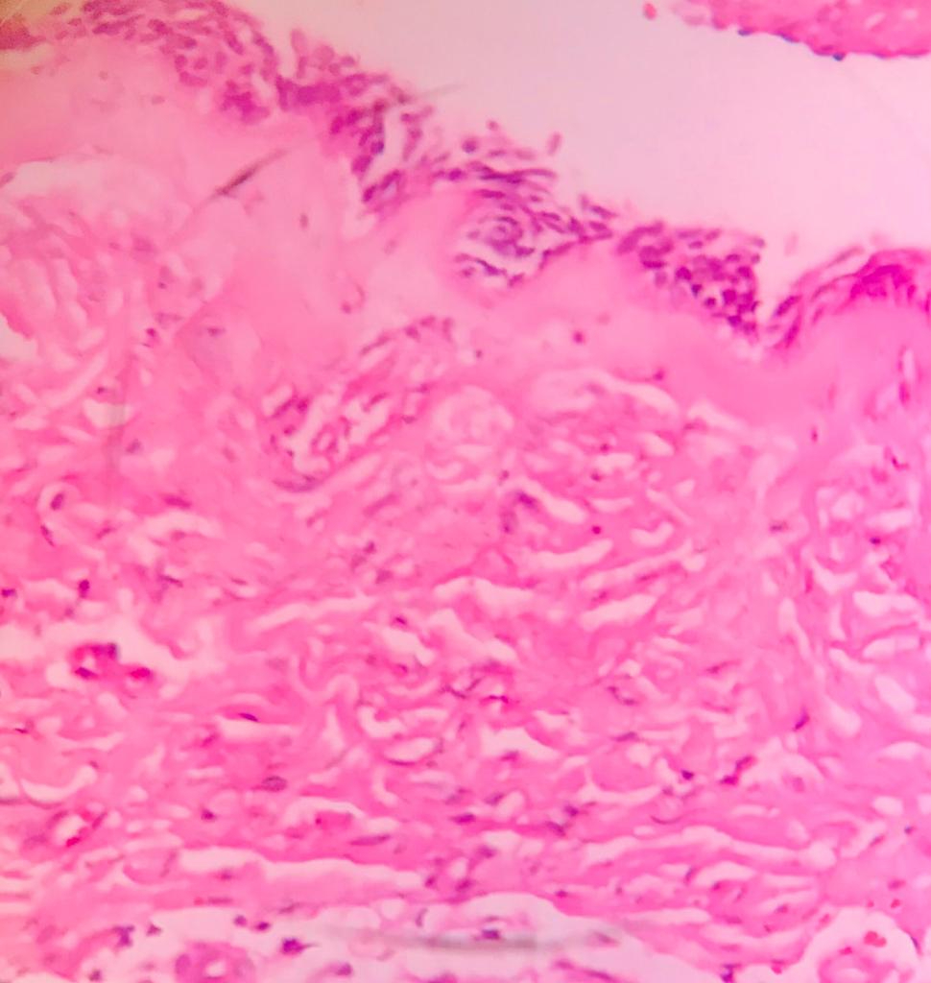
Figure1: Microphotograph (40x) of Luminal Unicystic Ameloblastoma

VII. IMMUNOHISTOCHEMISTRY
According to research, BRAFV600E is the most common mutation found in all three histologic variants (luminal, intraluminal and mural) of UA. Further it shows that rat sarcoma virus (RAS) and fibroblast growth factor receptor 2 (FGFR2) mutations are not present in UA but seen in ameloblastoma, so BRAF V600E is more common in UA (94%) than in ameloblastoma (74%). We can conclude that alteration of the Mitogen-activated protein kinase (MAPK) pathway is a substantial contribution to the pathogenesis of both UA and ameloblastoma. As a result, it is possible to conclude that UA and ameloblastoma are genetically and histomorphologically related odontogenic neoplasms. Analysis of BRAF V 600E might be taken into consideration for the standard ameloblastoma diagnostics in light of the prognostic and diagnostic implications of the mutant status [13].

VIII. DIFFERENTIAL DIAGNOSIS
Differential diagnosis can be given as: 1) Odontogenic Keratocyst 2) Dentigerous cyst 3) Calcifying odontogenic cyst.
The UA’s lining has been attempted to be distinguished from the lining of other cysts on numerous occasions in the past. Nevertheless, proliferating cells (PCNA and Ki-67) and lectins (Ulexeuropaeus agglutinin I and Bandeiraea simplicifolia agglutinin I) may help in their differential diagnosis. Due to the UA’s varied reactivity to tissue markers, Eversole et al. stated that the gold standard for diagnosis for UA is still unaided histologic evaluation. There is the minimal requirement for classifying a lesion as UA is the presence of a single cystic sac lined with odontogenic (ameloblastomatous) epithelium, which is frequently present only in isolated areas.[14].

IX. TREATMENT
The surgical path of resection, which involves the removal of the block tumour with a broad bone margin and the delayed or immediate bone restoration of the defect with grafts or prosthetic rehabilitation, is the current standard of care for ameloblastomas. A high patient morbidity rate is seen in the “radical treatment”. Treatment for ameloblastoma is determined by its location, size, extent, histological subtype, damaged bone type, and mandibular region. Either radical or conservative are accepted treatment options for UA. Marsupialization or enucleation are other options. As UA is less aggressive than the solid type of ameloblastoma and the rate of recurrence can be lowered by doing radical treatment. Recurrence of 3.6% is seen when resection is done and 30.5% recurrence seen while enucleating the cyst, so it can be concluded that cutting an appropriate bone margin can reduce recurrence; while selecting the type of treatment a proper discernment is recommended to achieve highest success. The radical surgery is often associated with masticatory dysfunctions, abnormal jaw movement, and tooth extraction; additionally, in young patients, changes in mandibular growth can result in severe deformities that affect the quality life of the patients. Some researches mentioned that it is critical to give the differential diagnosis between neoplasms and odontogenic cysts, and there is no option for conservative marsupialization of cysts in UA. The differential diagnosis between dentigerous cyst and UA is an exceptional case in which enucleation is done with the pre operative provisional diagnosis of dentigerous cyst, both have similar radiographic, clinical pathologies & there may not have definitive diagnosis with characteristic consistency in incisional biopsy. Enucleation with peripheral osteotomy along with the application of Carnoy solutionis the main stay of the treatment for the luminal and intraluminal subtypes, the treatment for "mural ameloblastoma" can be the marginal resection of 1 cm. The treatment options are simplified by using the UA subtypes as a guideline; subtypes I and II may be treated conservatively with enucleation. Subtypes III and IV patients require intrusive & vigorous therapies; however, a proper diagnosis is established post-surgical procedure and there following review.
X. RECURRENCE
According to the statistics, recurrence rates for resection are 3.6%, enucleation alone is 30.5%, the Carnoy solution is 16% after enucleation, and marsupialization is 18%. 80% of the cases shows highest recurrence in the jaw, mainly in the gonion and mandibular angle. According to racial groups recurrence has been recorded, where Asians show a lower predilection in compared to other racial groups, while it is highly seen in black people. Conservative therapy is suggested for children and adolescents because most lesions are unique at this age and recurrence in these situations is rare [4].

XI.PROGNOSIS
After doing a conservative surgical treatment UA has a fair prognosis because of its less aggressive biological behaviour. Some studies suggest that the prognostic-treatment association is more essential than the prognostic-histological type relationship, however other studies shows that there is an important relationship between the histological variants and the prognosis of UA. Although "UA" has a favourable prognosis, some research has mentioned that luminal UA has a better prognosis than other variants due to its less aggressive nature. Because of the absence of ameloblastomatous proliferation in the cyst wall it has been stated that intraluminal and luminal subtypes have the greatest prognosis [4].
XII. CONCLUSION
Second most common odontogenic tumour is UA having no gender preference and seen in age group of 20 to 30 years of life. No definitive cause has been identified till date, but most ideas are pointing to an epithelial mutation that results in a single cystic cavity. The prognosis and recurrence are tightly bound with its histological variants and therapy; the mode of diagnosis and the "gold standard" of treatment are ambiguous. There is a requirement of detailed research to establish a stable therapy guideline.

REFERENCES
- Gupta N, Saxena S, Rathod VC, Aggarwal P. Unicystic ameloblastoma of the mandible. Journal of oral and maxillofacial pathology: JOMFP. 2011 May;15(2):228.
- Sivapathasundharam B, Rajendran A. Shafer's textbook of oral pathology. Elsevier Health Sciences; 2020 June 23.
- Soluk-Tekkesin M, Wright JM. The World Health Organization Classification of Odontogenic Lesions: A Summary of the Changes of the 2022 (5th) Edition. Turk patoloji dergisi. 2022 Jan 1;38(2):168-84.
- Pinos LS, Ortiz JA, Calle MF, Mendoza FM. Unicystic ameloblastoma: Literature review. World Journal of Advanced Research and Reviews. 2021;10(3):095-103.
- Pereira NB, Pereira KM, Coura BP, Diniz MG, de Castro WH, Gomes CC, Gomez RS. BRAFV 600E mutation in the diagnosis of unicystic ameloblastoma. Journal of Oral Pathology & Medicine. 2016 Nov;45(10):780-5.
- Neville BW, Damm DD, Allen CM, Chi AC. Oral and maxillofacial pathology. Elsevier Health Sciences; 2015 May 13.
- Anne C. McLean-Holden, D.M.D., M.S., Kelly Magliocca, D.D.S., M.P.H. Mandible & maxilla Benign odontogenic tumors Ameloblastoma. Pathology outlines.com. 2021 May 17.
- Rayamajhi S, Shrestha S, Shakya S, Bhandari S, Twayana AR, Shahi K. Unicystic Ameloblastoma of Mandible: A Case Report. JNMA: Journal of the Nepal Medical Association. 2022 Jul;60(251):657.
- Wakoh M, Matsuzaka K, Imoto K, Goto T, Kamio T, Shibahara T. Luminal, Intramural Unicystic Ameloblastoma with Marked Fluid-Fluid Level: Validity of CT and MRI Findings. The Bulletin of Tokyo Dental College. 2020;61(1):61-9.
- Woolgar JA. Odontogenic tumors and allied lesions: Peter A. Reichart, Hans P. Philipsen, Quintessence Books, 388 pp., Price£ 106, 290 illustrations (146 colour), 9 sections, 42 chapters, ISBN 1-85097-059-9. British Journal of Oral and Maxillofacial Surgery. 2004 Oct 1;42(5):462-3.
- Ramesh RS, Manjunath S, Ustad TH, Pais S, Shivakumar K. Unicystic ameloblastoma of the mandible-an unusual case report and review of literature. Head & neck oncology. 2010 Dec;2:1-5.
- Panneerselvam K, Kavitha B, Panneerselvam E, Parameswaran A. Mural unicystic ameloblastoma mimicking odontogenic cyst. Journal of Family Medicine and Primary Care. 2020 May;9(5):2524.
- Heikinheimo K, Huhtala JM, Thiel A, Kurppa KJ, Heikinheimo H, Kovac M, Kragelund C, Warfvinge G, Dawson H, Elenius K, Ristimäki A. The mutational profile of unicystic ameloblastoma. Journal of dental research. 2019 Jan;98(1):54-60.
- Nagalaxmi V, Sangmesh M, Maloth KN, Kodangal S, Chappidi V, Goyal S. Unicystic mural ameloblastoma: an unusual case report. Case reports in dentistry. 2013 Apr 23;2013.
- Chaudhary Z, Sangwan V, Pal US, Sharma P. Unicystic ameloblastoma: a diagnostic dilemma. National journal of maxillofacial surgery. 2011 Jan;2(1):89.
- Kalmegh PP, Hande AH, Gawande MN, Patil SK, Sonone AM, Hande A, Gawande M. Unicystic Ameloblastoma (UA): A Case Series. Cureus. 2022 Nov 3;14(11).

AUTHOR’s NAME:
1) DR. PRACHI PATEL, (2nd YEAR P.G STUDENT) ORAL & MAXILLOFACIAL PATHOLOGY, FACULTY OF DENTAL SCIENCE, NADIAD.
2) DR. BHUPESH PATEL, (HOD & PROFESSOR) ORAL & MAXILLOFACIAL PATHOLOGY, FACULTY OF DENTAL SCIENCE, NADIAD.
3) DR. HIMANI TIWARI, (READER) ORAL & MAXILLOFACIAL PATHOLOGY, FACULTY OF DENTAL SCIENCE, NADIAD.

4)DR. RINA MEHTA, (READER) ORAL & MAXILLOFACIAL PATHOLOGY, FACULTY OF DENTAL SCIENCE, NADIAD.

