CORROSION INHIBITORS
Dr. Jyoti Ramojwar
Department of Life Sciences,
Kristu Jayanti College (Autonomous),
Bangalore, INDIA
Email ID: jyotimr@kristujayanti.com

Abstract: Corrosion is a natural process in which a pure metal or its alloy is converted into more chemically stable oxide or sulphide or other stable form. It is the gradual deterioration of materials (usually a metal) by chemical or electrochemical reaction with their environment. It causes huge loss to mankind hence research is done past few decades to find solution to this still existing phenomenon. Various techniques are used to prevent corrosion like electrodeposition, use of organic and inorganic corrosion inhibitors, green organic inhibitors, Ionic liquids etc. Most of corrosion inhibitors are effective but they are either expensive or toxic by nature. Some of them are non-biodegradable. But green organic corrosion inhibitors have been found to be better than others with this regard. The only problem with them is they are less efficient. Hence more advanced research is required in this field to increase its corrosion resistance ability.

Keywords: Corrosion Inhibitor, Corrosion, Ionic liquid, corrosion potential, current density

- Introduction:
Multiple metallic constructions are utilized for various purposes. We can travel and move around, thanks to ships. Our houses and businesses are fuelled by pipelines. We get clean water from treatment plants and countless other examples. However, corrosion the chameleon of chemical reactions, converts pure metals into their oxides or sulphides or hydroxides which are found to be comparatively more stable. This metamorphosis, while a natural course of events, exacts a toll of incalculable losses, particularly on an industrial scale where machinery, pipelines, and vital components are compromised. It is apparent that prevention is the most effective form of defence.
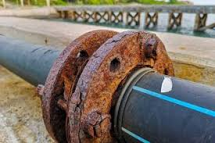
Figure 1: Corroding pipeline
Image Courtesy: https://www.unsw.edu.au/science/our-schools/materials/engage-with-us/high-school-students-and-teachers/online-tutorials/corrosion/dry-wet-corrosion

Figure 2: Corroded and non-corroded metal
Image Courtesy:
https://www.thoughtco.com/thmb/WXzS9m9mFcqv24i5wb9QuKL61Uk=/1500x0/filters:no_upscale():max_bytes(150000):strip_icc():format(webp)/GettyImages-548553969-56a134395f9b58b7d0bd00df.jpg

Corrosion inhibitor is one of the best known and most practical corrosion protection techniques in the industries, among other methods such as coating, alloying, galvanising etc. Due to its outstanding anti-corrosive properties and inexpensive costs, inhibitors have historically had wide industry adoption. In 1960’s inorganic compounds like nitrites and chromates were used to decrease corrosion rate. These substances adsorb on metal surfaces to create passivators, which are very effective passive layers. They were, however, replaced by less expensive substitutes including phosphonic acid, gluconates, and polyacrylates, which would precipitate at the metal-environment interface and are consequently known as precipitating inhibitors (precipitators) [1] [2]. The saga of corrosion inhibitors centres around their capacity to impede or modify the electrochemical reactions at metal surfaces, thus curtailing the progression of corrosion. However, the classical inhibitors often bear the weight of environmental concerns, arising from their potential to engender collateral ecological impacts. The quest for a sustainable balance between safeguarding our metallic foundations and preserving our delicate ecosystems has ignited a new chapter in the annals of corrosion protection. Organic corrosion inhibitors and ecologically benign alternatives are being used and researched on [2] [3].
This chapter gives a brief explanation of diverse types of corrosion inhibitors, their mechanism of action, their environmental impact, effectiveness, applications and a great deal of practical significance.

- CLASSIFICATION OF CORROSION INHIBITORS:
They can be classified as
- BASED ON CHEMICAL FUNCTIONALITY:

Based on their chemical functionality, or more specifically, the unique properties of the inhibitor molecules that allow them to interact with metal surfaces and prevent corrosion, corrosion inhibitors can be categorized. This categorization enables us to comprehend how various inhibitors function to keep metals from deteriorating. Inorganic inhibitors and organic inhibitors are the two main classifications based on chemical functionality.

- Inorganic compounds as Inhibitors:
These are the chemical substances that do not contain carbon and hydrogen atoms in their structures. These substances contain metal ions or anions from salts that interact with the metal surface to form protective layers. Some examples are:
- METAL BASED INHIBITOR – Zinc, Aluminium and Magnesium
- METAL OXIDE INHIBITOR – Anionic inhibition, cationic inhibition and mixed inhibition
- PHOSPHATE BASED INHIBITOR
- SILICATE BASED INHIBITOR
- PASSIVATORS
- OXYGEN SCAVENGERS [4] [5]

- Organic Inhibitors:
Organic inhibitors have more intricate chemical structures and incorporate carbon-hydrogen (C-H) bonds in their structure. Through ADSORPTION, they interact with metal surfaces and can create barriers or protective layers. They adsorb on metal surface and form a hydrophobic coating thereby inhibiting corrosion [2] [4] [5].

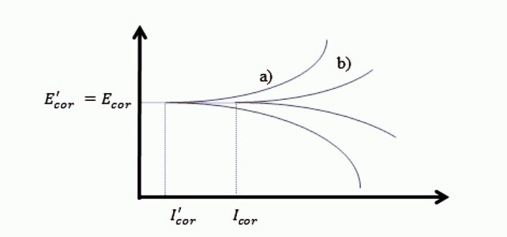

Figure 3: Potentiostatic polarization curve

Figure 1 depicts a Tafel curves, which highlights both cathodic and anodic response to the organic inhibitor solution. In presence of corrosion inhibitor, corrosion potential denoted by symbol Ecor does not change but the current density denoted by Icor decreases [2].

- Organic anionic Inhibitor: These inhibitors have negative charges on their molecules and are often used in water-based systems. Examples include compounds like mercaptobenzotriazole and various phosphonates. They form adsorbed layers on metal surfaces, protecting them from corrosion.
- Organic cationic Inhibitor: These inhibitors occur in solid or liquid form at room temperature. Examples are salts of sodium benzoate and sodium cinnamate. Their structure possesses large aliphatic or aromatic component with positively charged amine groups. They also form adsorbed layers on metal surfaces, protecting them from corrosion.

To summarise, Organic corrosion inhibitors shield metals from corrosion by forming protective layers, repelling ions, forming complexes, adjusting pH, reducing cathodic reaction rates, and scavenging oxygen. These mechanisms collectively contribute to their effectiveness in harsh environments. [6]
- Ionic Liquid’s as Inhibitor of Corrosion
Corrosion has become a worldwide problem due to industrialisation and dependence of mankind on various industries. Most of the industries use metals and their alloys like steel which have a major drawback of undergoing rust or corrosion. But this problem can be controlled to some extent by giving a coating to metals or their alloys with corrosion inhibitors. In past few decades a lot of research is done on ionic liquids and sevral scientists have interpreted that they can play an important role in industries as corrosion inhibitors. Ionic liquids such as imidazolium, phosphonium, pyridazinium, benzimidazole, pyridinium have been successfully used as corrosion inhibitors [21].
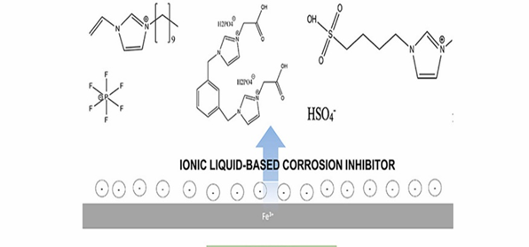
Figure 4: Ionic liquid-based corrosion Inhibitor and Inhibition
Image courtesy: https://ars.els-cdn.com/content/image/1-s2.0-S2590123022002328-ga1_lrg.jpg

- BASED ON THEIR EFFECT IN ELECTROCHEMICAL REACTIONS:
Inhibitors can be divided into three types on the basis of electrochemical reaction they undergo. They primarily function either by slowing down or stopping the electrochemical reaction.

- CATHODIC INHIBITORS:
These inhibitors bind with positive metal ions near the cathode, creating a shield that prevents the cathodic reaction from occurring. Corrosion is significantly slowed down by this favourable effect on the cathodic process.[2] [8]

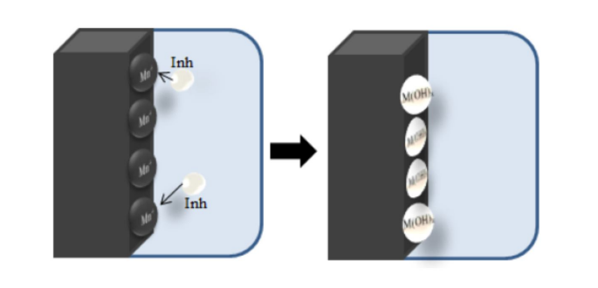
FIGURE 5- Mechanism of action of cathodic inhibitors (Dariva and Galio 2011)
Image Courtesy: https://www.researchgate.net/publication/341432727/figure/fig2/AS:891841180348416@1589642915089/The-mechanism-of-the-cathodic-inhibitors-Dariva-and-Galio-2011-7.jpg

- ANODIC INHIBITORS:
Similar to cathodic inhibitors, inorganic anodic inhibitors also enhance polarization. They induce negative ions to gather around the anode, promoting passivation and diminishing corrosion. This intervention in the anodic process significantly reduces the extent of corrosion.
[2] [8]
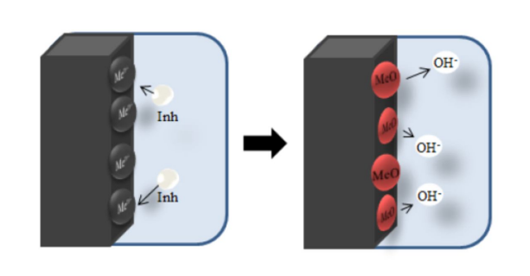FIGURE 6: Mechanism of action of Anodic Inhibitors (Dravia and Galio-2011)
Image Courtesy: https://www.researchgate.net/publication/341432727/figure/fig2/AS:891841180348416@1589642915089/The-mechanism-of-the-cathodic-inhibitors-Dariva-and-Galio-2011-7.jpg

- MIXED INHIBITORS:
Mixed inhibitors constitute a category of corrosion inhibitors that operate by intensifying polarization effects on both cathodic and anodic processes, resulting in a substantial reduction in the corrosion current [2][8].

- MECHANISM OF CORROSION INHIBITORS:
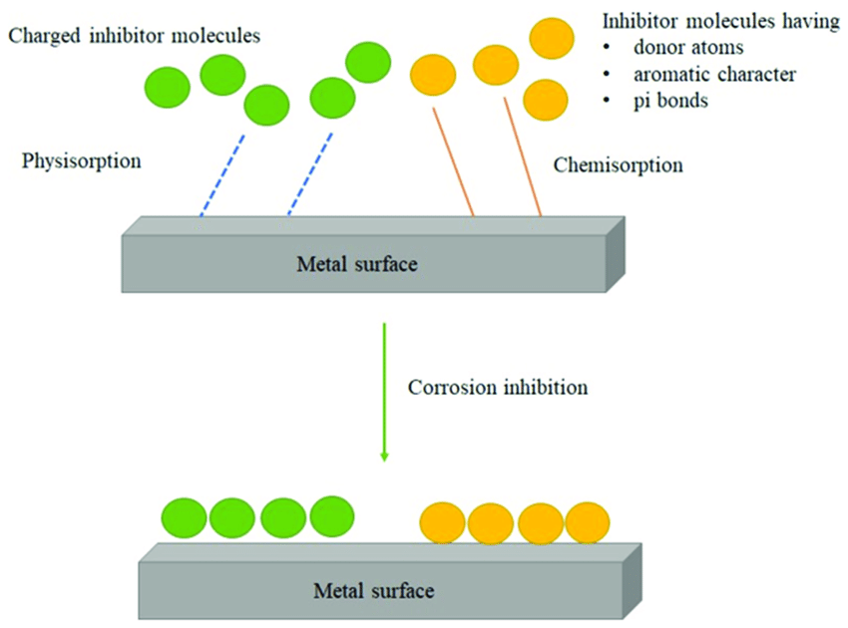
FIGURE 7: Mechanism for corrosion inhibition. Adapted from Eddy et al. (2022).
Image Courtesy: The-mechanism-for-corrosion-inhibition.png (850×630) (researchgate.net)
ADSORBTION:
It is now established that the role of inhibitors involves their adsorption in ionic or molecular form on the metallic surface. Alternatively, inhibitors can displace aggressive species that have previously been absorbed within this double layer. The success of these processes relies on factors such as the metal's zero charge potential and its corrosion potential.
- PASSIVATION:
Some corrosion inhibitors facilitate the formation of an inert metal oxide layer onto the surface of metal which forms an obstacle and prevents the further propagation of electrochemical reactions. This mechanism is particularly relevant for metals like aluminium and stainless steel.
- ION DISSOLUTION INHIBITION:
Metal ions are frequently dissolved during corrosion and released into the environment. By creating compounds with metal ions, decreasing their solubility, and restricting their capacity to move away from the metal surface, corrosion inhibitors can obstruct this process.
- pH EFFECTS AND NEUTRALIZATION:
Some inhibitors change the pH of the surrounding environment, making corrosion less likely to occur. Inhibitors lessen the possibility of violent electrochemical reactions by neutralizing acidic or alkaline environments.
- SYNERGISTIC EFFECTS:
Corrosion inhibitors can interact with other chemicals or each other in a way that is synergistic. Their combined corrosion inhibition abilities are improved by this interaction, creating a stronger overall impact.

- APPLICATIONS OF CORROSION INHIBITORS :
- ACID PICKLING
It is a process in which surface impurities and rust is removed from the surface of metals like iron or their alloys like steel. Concentrated mineral acids are frequently used for this purpose in industries. It is also called descaling process [1] [4].

- OIL AND GAS INDUSTRIES:
In these industries most of the apparatus is made of mild steel which easily undergoes corrosion (rust). Literature survey reveals that maximum number of times its organic acids that cause corrosion. Sometimes there is release of SO2 and CO2 which leads to pitting corrosion. One such example is Boilers. The pitting corrosion in boiler leads to boiler explosion causing destruction of life and property. Hence polymer-based coatings, zinc alloy-based coatings etc. are used to prevent corrosion [9] [10]. Even composite material-based coatings are encouraged which are efficient and economic.

- MARINE APPLICATIONS:
Inhibitors protect ships' hull, offshore platforms, and underwater equipment from the harsh marine environment, including the corrosive effects of seawater. In terms of weight-saving materials, beta titanium and its alloys are becoming more and more important from an economic and environmental standpoint. They like to have high toughness, high corrosion resistance, and high specific strength. The outstanding mechanical and electrochemical qualities of titanium have made beta titanium alloys widely employed in a number of industries, from the chemical sector to the maritime industry. The Beta C titanium alloy, one of several beta alloys, is renowned for its high ductility and resistance to corrosion. Ships, offshore vessels, and pipelines may all be constructed out of this alloy for use in maritime applications. To create the required faultless output for use in practical applications, every material must go through thermomechanical processing [16].

- CONSTRUCTION AND INFRASTRUCTURE:
Structures made of reinforced concrete are prone to corrosion because they are exposed to moisture and chloride ions. Inhibitors reduce this corrosion, increasing the life of infrastructure such as bridges and buildings. Hence several techniques have been discovered to protect reinforced steel in concrete, from corrosion [17] [6].

- AUTOMOTIVE INDUSTRY:
Corrosion inhibitors are used in automotive coatings to prevent rust formation on vehicle exteriors and undercarriages. Phosphates, molybdate are some examples of inorganic inhibitors used.

- AEROSPACE ENGINEERING:
Inhibitors safeguard aircraft components from corrosion caused by high humidity, temperature variations, and exposure to aviation fluids. Chromates are used to avoid aluminium alloy corrosion but they are highly toxic hence alternatives such as lanthanides and smart coating are being used [12].

- POWER GENERATION:
To prevent corrosion from high-temperature steam, acidic or alkaline solutions, and oxygen from damaging metal surfaces in boilers, condensers, and other equipment, the power generation sector uses inorganic corrosion inhibitors. Phosphates, silicates, and sulphites are the most often used inorganic inhibitors in this business and offer great defence against both general and pitting corrosion [4].

- CHALLENGES AND FUTURE DIRECTION:
IMPACT ON THE ENVIRONMENT
Corrosion can be controlled by means of corrosion inhibitors but the traditional inorganic and organic inhibitors are not eco-friendly due to their lethal nature.
The impact on the environment was studied by introducing corrosion inhibitors into soil samples, followed by analysing these samples over periods of 1 day and 2 weeks. The findings revealed that the corrosion inhibitors contained high levels of heavy metals that exceeded the limits set by FEPA (Federal Environmental Protection Agency). These heavy metals are harmful to human health, pose toxicity risks to plants and animals, and have detrimental effects on the ecosystem of the surrounding environment as well as the quality of surface and groundwater. They can also cause ecotoxicity of marine life [13].
To avoid their discharge into the environment, corrosion inhibitors must be carefully disposed of. Ineffective disposal techniques might contaminate soil and water supplies. Hence Greener and Safer alternatives are required for prevention of corrosion
Some alternatives that can be used includes Green corrosion inhibitors which is further classified as follows [14]:
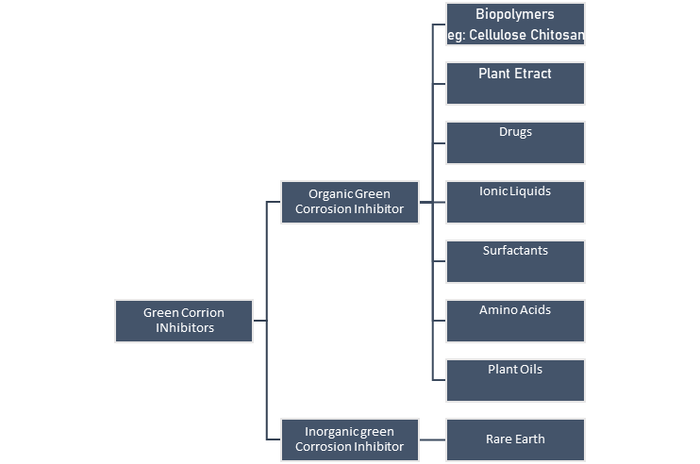

Figure 8: Classification of Green Corrosion Inhibitor

6. Biopolymers as an example of Organic green corrosion inhibitors (OGCIs)
They are normal polymers produced by nature. Just like other organic polymers, they are made of monomers, covalently bonded in chains to form larger polymeric molecule. They can be biodegraded and do not undergo bioaccumulation. Some examples of biopolymers include – polysaccharides, natural rubbers, lignin, polypeptides etc. Although all biopolymers can be used as corrosion inhibitors, Chitosan and Cellulose and their derivatives are comparatively more efficient [1]. A lot of research is going on composite and nanocomposites of biopolymers. Several biopolymers like chitosan, carboxyl methylcellulose, gum Arabic, and Xanthan gum etc. can be used for corrosion prevention. Available literature says that, use of composites and nanocomposites can be an effective method of improving the corrosion prevention capability of biopolymers [19].
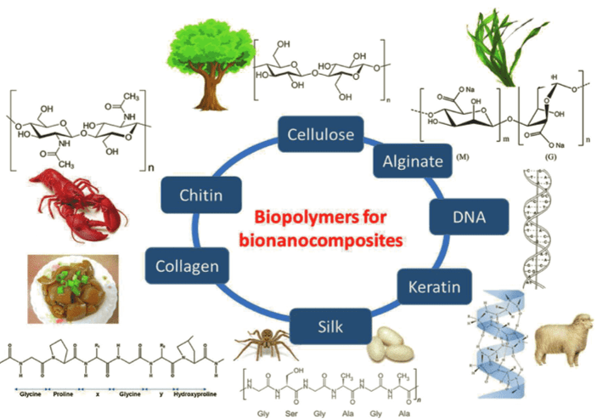
Figure 9: Sources of Biopolymers and their chemical structures
Image courtesy: https://ebrary.net/htm/img/39/1910/15.png
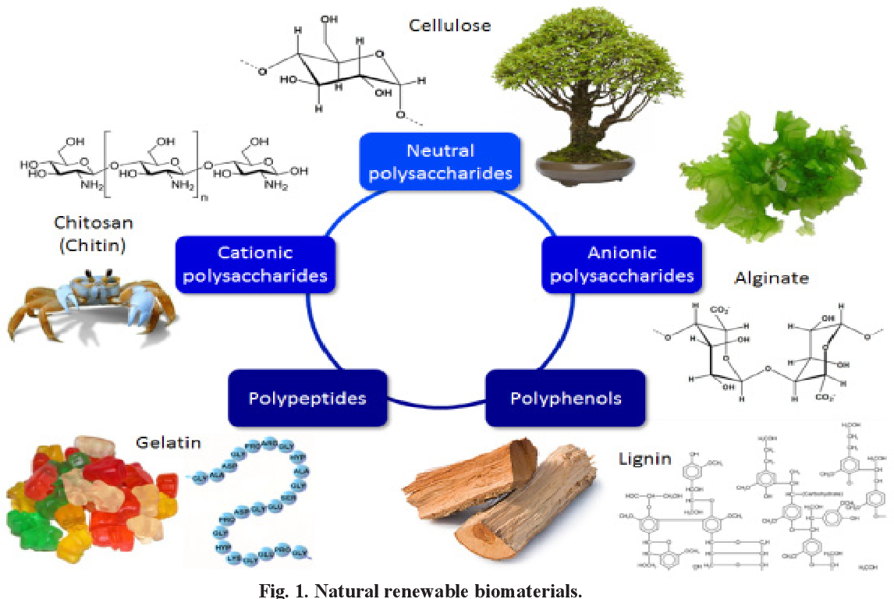
Figure 10: Natural Biopolymers
Image Courtesy: https://d3i71xaburhd42.cloudfront.net/5cb35b9ee7c69cf71c81215feddb813df87ad4e4/2-Figure1-1.png

Some organic green corrosion inhibitors are phytochemicals, extracted from plants and contain active functional groups which are responsible for corrosion inhibition. Examples of few such compounds are carbohydrates, flavonoids, benzoic acid, benzotriazole, thiourea, tannins, tryptamine etc. [20]. Some of such active functional groups are Hydroxy (-OH), Nitro (-NO₂), Amide (-CONH₂), Carboxyl (-COOH), Sulphide (-S-), Thio (-SH), Phosphonium (-P=O), Seleno (-Se-), Amino (-NH₂), Thiol (-SH), yne (-C≡C-), Sulphoxide (-S=O), Imino (-N=), Thiazole (-N=N-N-), Epoxy (-C-O-C-), Phospho (-PO4), Arsano (-As-) [20].

Table 1: Natural Source of Organic Green corrosion Inhibitor and their role in corrosion inhibition [20]

Natural Source of Organic Green corrosion Inhibitor | Organic compounds with Functional groups | Role in Corrosion inhibition
Leaf extract of G. biloba | The compounds present are Flavonoids and Terpenoids and functional group is phenol group and presence of aromatic rings which gives corrosion inhibition. | Terpenoids (quercetin) adsorb on steel surface and there is interaction between donor and acceptor Flavonoids: oxygen is adsorbed, corrosion is inhibited due to oxidation of flavonoids to benzoquinone.
Extract of Rothmannia longiflora | Organic compounds causing inhibition are Monomethyl fumarate, 4-oxonicotinamide-1-(1-β-D-ribofuranoside), and D-Mannitol
Phytochemical extract of Petersianthus macrocarpus | Organic compounds causing inhibition are Petersaponin, β-sitosterol and ellagic acid | These biologically active molecules adsorbed on the surface of mild steel due to hydroxyl group and aromatic ring protonation.  Constituent molecules have aromatic rings (π-electrons) and electron releasing groups. Hence there is an overall increase in the ability of π-electrons to bind vacant d-orbital of iron present in steel.
Phytochemical extract of Ficus asperifolia | Organic compounds causing inhibition are saponins, alkaloids, tannins, anthraquinones, flavonoids, reducing sugars, n-hexane, ethyl acetate, and butanol | The electron releasing property of this compounds is increased due to heteroatoms in their chemical structures. Thus, there is formation of complex compounds on the steel surface and corrosion inhibition is increased.
Plant extracts of D. kaki l. f husk | Organic compounds causing inhibition are vitamins, p-coumaric acid, gallic acid, catechin, flavonoids, carotenoids, and condensed tannin | Mechanism of corrosion inhibition is yet to be discovered.
Plant extract of Gum Arabic | Organic compounds causing inhibition are Arabinogalactan, oligosaccharides, polysaccharides, and glycoproteins | Mechanism of corrosion inhibition is yet to be discovered.
Extract of Tobacco plant | Polyphenols, terpenes, alkaloids, alcohols, carboxylic acids, and nitrogen-containing compounds | Corrosion inhibition on metals by electrochemical reaction (due to fused benzene ring system with charge dislocation property)
Extract of green wild jute tree (Grewa venusta) | Organic compounds causing inhibition are Polysaccharides, polyphenols (catechins and flavonoids) vitamins, tannins, minerals, volatile oils and alkaloids | These compounds show mixed corrosion inhibition
Extract of Anthocleista djalonesis | Organic compounds causing inhibition are Iridoid glucoside (DJN), dibenzo-α-pyrone (djalonensone), ursolic acid, and 3-oxo-∆-4,5-sitosterone | Mechanism of corrosion inhibition is yet to be discovered.
Extracts of Guar gum | Organic compounds causing inhibition are Polysaccharides, mainly sugars- Galactose and Mannose | Mannose forms complexes with the metal ions on the steel surface and thus inhibits corrosion
Plant leaf extract of Jatropha curcas | Organic compounds causing inhibition are Tannins, flavonoids, terpenes, anthraquinone, apigenin, cardiac glycoside, alkaloids, deoxy sugar, saponins, α-D-glucoside, sterols, stigmasterol, and vitexin | Corrosion inhibition occurs via the formation of complex metal ions on the metal surface. The presence of polar groups accelerate the process of corrosion inhibition.
Banana peel extract | Organic compounds causing inhibition are Bananadine (3Z,7Z,10Z)-1-oxa-6-azacyclododeca-3,7,10-triene | Mechanism of corrosion inhibition is yet to be discovered.
Plant extract of Aloe vera | Organic compounds causing inhibition are minerals, polysaccharides, vitamins, glycoproteins, and enzymes | Mechanism of corrosion inhibition is yet to be discovered.
Plant extract of Azadirachta indica | Organic compounds causing inhibition are Azadirachtin, salannin, meliantriol, and nimbin | In this case corrosion inhibition takes place due to geometry of molecules coupled with binding property
Plant extract of Locust bean gum | Organic compounds causing inhibition are Galactomannan-type polysaccharides | Mechanism of corrosion inhibition is yet to be discovered.
Plant extract of Oil palm frond | Organic compounds causing inhibition are Phenolic constituents like p-hydroxybenzoic acid, syringic acid, vanillic acid, vanillin, p hydroxybenzaldehyde, p-hydroxyacetophenone, and syringaldehyde. | The organic compound Lignin is brokendown to form aromatic carbonyl compounds i.e. syringaldehyde and vanillin by alkaline nitrobenzene oxidation. This reaction inhibits corrosion.
Plant extract of J. gendarussa | Organic compounds causing inhibition are Friedelin, β-sitosterol, o-substituted aromatic amines lupenol, phenolic dimmers and flavonoids | These compounds show mixed corrosion inhibition
Leaf and flower extracts of Heliconia rostrata | Organic compounds causing inhibition are Alkaloids, flavonoids, tannins, cellulose, and polycyclic compounds | Presence of heterocyclic aromatic compounds cause increase in layer formation on the metal surface, thereby enhancing corrosion inhibition process.
Seed extract of Celery (Apium graveolens) | Organic compounds causing inhibition are Flavonoids, linoleic acid, D-limonene, sesquiterpene alcohols, coumarins, selinene, sedanolide, and sedanonic anhydride | – Mechanism of corrosion inhibition is yet to be discovered.
Plant extract of Henna extract (Lawsonia inermis) | Organic compounds causing inhibition are Lawsone, α-D-glucose, gallic acid and tannic acid | These compounds show mixed corrosion inhibition

It is found from the literature that compounds like silicates possess ability to hinder the corrosion reactions by blocking corrosion active esites on the metal or its alloy structure. This automatically reduces rate of corrosion. Hence the present researchers should concentrate on producing composite organic green corrosion inhibitors from greener substances and silicates Ex. Rice husk waste. This effect is also called synergistic effect. There is huge gap between researchers and industries which needs to be bridged immediately to overcome the corrosion problem. Recent literature reveals that some people are still using toxic and non-biodegradable corrosion inhibitors which exist since long time and are also found to be costly and non-ecofriendly [20].
7. Comparison of OGCI’s with Synthetic Inhibitors
Though synthetic or manmade inhibitors are costly, toxic and their use is restricted, their inhibition ability is found to be high. Organic green corrosion inhibitors with biodegradable nature are nonhazardous but they have low corrosion inhibition ability. Hence an advanced research work is the need of the hour on the use of additives as green corrosion inhibitors. Literature also reveals that structure of organic compound of OGCIs play a vital role in successfully inhibiting the metallic corrosion. This means that if chemical structure of organic compounds is altered then it will enhance corrosion resistance to metallic objects like iron and its alloy like steel.
- Significance of OGCI’s
In present times, OGCIs are very significant due its comparatively cheap cost and desired corrosion resistant properties. But the major issue is its low inhibition effect in corrosive media. Ginkgo biloba leaf and Diospyros kaki L. f husk extract has active functional groups which are helpful in microbial-induced corrosion inhibition. They can be further explored to find if they are active against other types of corrosion [20].

- Microbiologically Influenced Corrosion Inhibitor (MICI):
MICI reduces corrosion either directly or indirectly by using microorganisms and their metabolic processes. When Iverson initially stated that bacteria may prevent copper from corroding in both freshwater and seawater, this phenomenon was first noted. The characteristics of the biofilm/metal interfaces can be altered by microbial activity to accelerate or decelerate the corrosion rate. Inhibition of corrosion caused directly or indirectly by microbial activity is known as microbiologically influenced corrosion inhibition, or MICI. [14] [15]. Bacillus subtilis was isolated from the South China Sea and it was found to form a protective layer on aluminium alloy. At pH 6.5, corrosion rate of the passive aluminium alloy was slightly reduced by the secretion of a peptide by an engineered Bacillus subtilis. On the other hand, the corrosion rate was reduced by 90% by a Bacillus licheniformis biofilm by secreting polyglutamate.
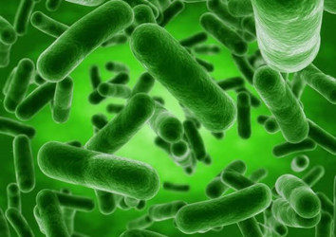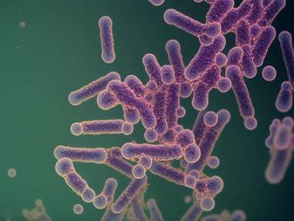
Figure 11 : Bacillus licheniformis Figure 12 : Bacillus subtilis- Bionity

Sulfate-reducing bacteria (SRB), a corrosive bacterium that can corrode iron in anaerobic conditions produces EPS (exopolysaccharides) changes its role under various corrosive media.
Conclusion:
Corrosion is an ecological worldwide danger with financial, preservation, and security influences in numerous engineering fields. Hence there is an urgent prerequisite to develop innovative procedures and approaches for handling this hazardous phenomenon. Ionic liquid corrosion inhibitors are still used to protect common metals and alloys like steel but are used very rare in the industries. The main reason behind this is – Some of the Ionic Liquids in pure form are very expensive. Also, they are toxic by nature and are non-biodegradable. Only few Ionic Liquids have been found to act as corrosion inhibitors. Hence advanced research is required in this field to explore the applications of ILs as corrosion Inhibitor. We also have some other ways by which corrosion can be controlled like use of metal or alloy coatings, giving Cathodic or anodic protection to metals and their alloys and giving coating of corrosion inhibitors which are efficient, biodegradable, cheap and eco- friendly. Literature reveals use of corrosion inhibitors is the simplest approach.
MICI is also a developing strategy for the eradication of the deadly disease, corrosion. It is less destructive to the environment than traditional techniques of corrosion protection. MICI still has difficulties in finding practical applications. This is because, firstly, there are numerous variety of microorganisms and second factor is that modification in environmental conditions alter their metabolic processes. Hence an advanced level and ceaseless efforts are required to overcome this worldwide problem of corrosion causing huge damage to life and property.

References:
[1] Chandrabhan,Verma, Eno E. Ebenso, M. A. Quraishi, and Chaudhery Mustansar Hussain. "Recent developments in sustainable corrosion inhibitors: design, performance and industrial scale applications." Royal Society of Chemistry, April 2021

[2] G., C., & F., A. (2014). Corrosion Inhibitors – “Principles, Mechanisms and Applications.” InTech. doi: 10.5772/57255 pp.365-375.

[3] Nayem Hossain, Mohammad Asaduzzaman Chowdhury & Mohamed Kchaou (2021) “An overview of green corrosion inhibitors for sustainable and environment friendly industrial development”, Journal of Adhesion Science and Technology, vol.35:7, 673-690, DOI: 10.1080/01694243.2020.1816793

[4] Al-Amiery, Ahmed & Yousif, Emad & Isahak, Wan & al-azzawi, Waleed. (2023). “A Review of Inorganic Corrosion Inhibitors: Types, Mechanisms, and Applications,” Tribology in Industry. 45. 313-339. 10.24874/ti.1456.03.23. 06.

[5] Al-Amiery, A. A., Isahak, W. N. R. W., & Al-Azzawi, W. K. (2023). “Corrosion Inhibitors: Natural and Synthetic Organic Inhibitors.” Lubricants, vol.11(4), pp.174. https://doi.org/10.3390/lubricants11040174.

[6] Abo El-Enin, Sanaa & Amin, Ashraf. (2020). “Review of Corrosion Inhibitors for Industrial Applications.” vol.3. pp.127-145.

[7] Tamalmani, K., & Husin, H. (2020). “Review on Corrosion Inhibitors for Oil and Gas Corrosion Issues. Applied Sciences,” vol.10(10), pp.3389. https://doi.org/10.3390/app10103389

[8] Askari, M., Aliofkhazraei, M., Jafari, R., Hamghalam, P., & Hajizadeh, A. (2021). Downhole corrosion inhibitors for oil and gas production – a review. Applied Surface Science Advances, vol.6, 100128. https://doi.org/10.1016/j.apsadv.2021.100128.

[9] Jenkins, A. (2010, March 14). The Application Of Corrosion Inhibitors To Prevent Localized Corrosion In A Sour Oilfield. Paper presented at CORROSION 2010, NACE-10330.

[10] Bethencourt, M., Botana, F.J., Calvino, J.J., Marcos, M., & Rodríguez-Chacón, M.A. (1998). “Lanthanide compounds as environmentally-friendly corrosion inhibitors of aluminium alloys: a review.” Corrosion Science, vol.40(11), pp.1803-1819. https://doi.org/10.1016/S0010-938X(98)00077-8

[11] Amadi, S.A. & Ukpaka, Chukwuemeka. (2007). “Impact of corrosion inhibitors on the environment,” vol.68. pp.18-35.

[12] Popoola, L. (2019). Organic green corrosion inhibitors (OGCIs): a critical review. Corrosion Reviews, vol.37(2), pp.71-102. https://doi.org/10.1515/corrrev-2018-0058

[13] Twite, R.L., & Bierwagen, G.P. (1998). “Review of alternatives to chromate for corrosion protection of aluminum aerospace alloys. Progress in Organic Coatings,” vol.33(2), pp.91-100. https://doi.org/10.1016/S0300-9440(98)00015-0

[14] Videla, H.A., & Herrera, L.K. (2009). “Understanding microbial inhibition of corrosion. A comprehensive overview. International Biodeterioration & Biodegradation,” vol.63(7), pp.896-900. https://doi.org/10.1016/j.ibiod.2009.02.002

[15] Lou, Y., Chang, W., Cui, T., Wang, J., Qian, H., Ma, L., Hao, X., & Zhang, D. (2021). « Microbiologically influenced corrosion inhibition mechanisms in corrosion protection: A review. Bioelectrochemistry,” vol.141, 107883. https://doi.org/10.1016/j.bioelechem.2021.107883

[16] Nichul, U., & Hiwarkar, V. (2023). “Carbon dot complimentary green corrosion inhibitor for crystallographically textured Beta C titanium alloy for marine application: A state of art,” Journal of Alloys and Compounds, vol.962, 171116. https://doi.org/10.1016/j.jallcom.2023.171116.

[17] Monticelli, C., Frignani, A., & Trabanelli, G. (2000)., A study on corrosion inhibitors for concrete application. Cement and Concrete Research,” vol.30(4), pp.635-642. https://doi.org/10.1016/S0008-8846(00)00221-0.

[18] Aliofkhazraei, M. (Ed.). (2018). Corrosion Inhibitors, Principles and Recent Applications. InTech., doi: 10.5772/intechopen.70101

[19] Biopolymer Composites and Nanocomposites for Corrosion Protection of Industrial Metal Substrates, Saviour A. Umoren and Moses M. Solomon, https://ebrary.net/184859/engineering/biopolymer_composites_nanocomposites_corrosion_protection_industrial_metal_substrates

[20] Popoola, L. (2019). Organic green corrosion inhibitors (OGCIs): a critical review. Corrosion Reviews, vol. 37(2), pp. 71-102. https://doi.org/10.1515/corrrev-2018-0058
[21] Megawati Zunita, Yosef Juliyus Kevin (2022), Ionic liquids as corrosion inhibitor: From research and development to commercialization, Results in Engineering, vol. 15, pp. 100562, https://doi.org/10.1016/j.rineng.2022.100562.

