From Water to Plate: Exploring the World of Fermented Fish Delicacies and Their Health Benefits
P Ramakrishna Reddy*¹, Neerudu Harika¹, B.B. Nayak¹, Subal Kumar Ghosh¹, Arya P¹.
*Corresponding author- parigeramakrishnareddy@gmail.com
¹ICAR-Central Institute of Fisheries Education, Versova, Mumbai, 400061
Abstract
Fermented fish products are revered for their rich nutritional content and unique flavors across diverse cultures. The need to preserve the perishable nature of fish has led to the exploration of various techniques. Fermentation is an age-old time-honored method of preservation. This chapter delves into the global practice of fermenting fish and its health implications. It highlights the significance of fermented fish products in various cuisines and explores their preparation methods. Probiotic-rich and nutrient-dense fermented fish offer benefits ranging from improved digestion to reduced allergenicity. The chapter underscores the role of fermentation in extending shelf life and enhancing flavors.
Introduction
Fish, inherently wholesome food, offers a plethora of health benefits due to its rich array of essential nutrients necessary for human growth and development. Despite its nutritional value, fish is highly perishable, leading to rapid deterioration. Effective preservation techniques are crucial to counteract this by preserving fish's vital nutrients (Reddy et al., 2020). Fermentation is a historically recognized method of preserving fish and other aquatic edibles without losing nutrients. This technique bestows many health advantages (Majumdhar et al., 2016).
Across the globe, an astonishing array of around 5,000 fermented foods are meticulously crafted and savored by diverse communities and ethnic groups. On a global scale, consumption estimates reveal that each consumes approximately 50 - 400 grams of fermented foods daily, constituting a notable 5 - 40% of their daily dietary intake (Tamang and Kailasapathy, 2010).
Fermented fish products are abundant sources of nutrients, boasting well-balanced amino acid and fatty acid compositions. The fermentation process elevates their nutritive value by augmenting their nutritional content and eliminating undesirable components. Additionally, this process imparts antioxidant properties and facilitates the creation of antimicrobial compounds. Furthermore, the fermentation process contributes to an enhancement in flavor for select products (Uchoi et al., 2018).
Fish fermentation
Fish fermentation is a preservation technique that involves the enzymatic and microbial transformation of fish and seafood through controlled fermentation. This process enhances the fish's flavors, textures, and nutritional properties, making it more palatable and extending its shelf life. During fish fermentation, microorganisms such as bacteria and yeast break down proteins, fats, and carbohydrates in the fish, forming new compounds that contribute to the distinctive taste and aroma associated with fermented fish products.
The fermentation process often requires the addition of salt, which helps control the growth of harmful bacteria while encouraging the development of beneficial microorganisms. Depending on the specific regional and cultural practices, other ingredients like herbs, spices, and plant materials might further enhance the final product's flavor profile (Thapa, 2016).
Fermented fish products vary widely across cultures and regions, resulting in various tastes and textures. These products are commonly used in multiple cuisines and can be consumed independently or incorporated into dishes for added flavor and nutritional benefits.
Fermented fish products across the world
Pla-ra-
Pla-ra is a traditional fermented fish from Thailand and other Southeast Asian countries. It is a type of fish sauce made by fermenting various types of fish, typically small freshwater fish like snakehead murrels, with salt and rice bran. The mixture is allowed to ferment in large containers for an extended period, usually three months to a year. This fermentation process gives pla-ra unique flavor, aroma, and characteristic qualities. Pla-ra is commonly used as a seasoning or condiment in Thai cuisine and other Southeast Asian dishes. It adds a distinctive umami flavor to dishes and is often used in soups, curries, and sauces. Despite its pungent smell and strong flavor, pla-ra is highly valued for the depth of flavor it brings to dishes (Rodpai et al.,2021)
Fish sauces
Fish sauce is a pungent, flavorful liquid condiment from fermented fish or seafood. It is a common ingredient in many Asian cuisines, particularly in Southeast Asian countries such as Thailand, Vietnam, Cambodia, and the Philippines. Fish sauce adds a rich umami flavor to dishes and is often used as a seasoning, dipping sauce, or marinade.
The production of fish sauce involves fermenting fish (Corica argentius, Stolephorus indicus, Clupeoides sp.) with salt for a longer duration, such as one year to three years, which breaks down the proteins and other components, resulting in a liquid that's full of complex flavors. The liquid is then extracted, filtered, and often aged to develop its distinct taste. The characteristics of fish sauce can vary depending on the type of fish or seafood used, the fermentation process, and the regional variations in production (Park et al., 2001).
Hongeo-hoe
The Korean dish prepared by fermenting skate (Hongeo koreana) is known for its distinct ammonia-like smell. After cleaning and gutting the fish, they are stored in compost (in colder areas) or straw piles (in warmer regions), where they undergo fermentation—typically served raw and unprocessed, sashimi-style alongside traditional Korean sides like kimchi and bossam (Rath, 2021).
Pekasam
Pekasam, also known as pakasam or bekasam, is a fermented fried coarse rice dish prepared by pickling various types of freshwater fish, such as Anabas testudineus, Tinfoil barb, Snakehead, Catfish, and Leptobarbus hoevenii.. The fish is cleaned, cut into pieces, and preserved with salt for several days. It's then mixed with half-fried rice bran, palm sugar, or brown sugar, serving as a starter for fermentation. Tamarind juice may also be added for extra sourness. The mixture ferments in a clay crock covered with cheesecloth for at least a week up to a year, resulting in a unique sweet, sour, and salty flavor (Suryani et al., 2023).
Prahok
Prahok, a key element in Cambodian cuisine, is a fermented fish paste, often made from mudfish. This unique condiment originated to preserve fish during seasons of scarcity. Its intense saltiness and rich flavor make it a popular addition to Cambodian dishes, including soups, enhancing their taste. Notably pungent, Prahok is playfully referred to as "Cambodian Cheese." In rural areas, it's commonly enjoyed with rice, forming a staple part of meals (Rodzi and Lee., 2021).
Rakfisk
Rakfish is a Norwegian dish made from trout; it is prepared by burning, salting, and fermentation for two to twelve months. The term "rakfisk" was first noted in 1348, but its roots likely extend further into the past. This dish is akin to Swedish surstromming, suggesting a potential shared origin. Conventionally enjoyed during Christmas, rakfisk carries cultural significance. It can be consumed without cooking, along with raw onion, mustard sauce, and sour cream (Bjerke et al., 2019).
Lakerda
Lakerda, a pickled bonito dish, is a mezze in the former Ottoman Empire's cuisine. Highly valued lakerda is prepared from one-year-old bonito on its Bosphorus migration. Traditionally, bonito steaks are brined, salted, and pressed for a week. They can be enjoyed immediately or preserved in olive oil. Sometimes, mackerel or small tuna stand in for bonito. In Greece, it's served with onion, while Turkey pairs it with red onion, olive oil, and black pepper, often accompanied by raki (Uchoi et al., 2018).
2.4. Fermented fish products in India
India has a rich culinary tradition that includes various fermented fish products, which are enjoyed
in different regions and communities. These fermented fish products are often used to enhance flavors in dishes and can have strong and unique tastes due to the fermentation process. Some of the common fermented fish products are mentioned below.
Shidal
Shidal, also known as sheedal or hidal is a traditional fermented fish product popular in the northeastern Indian states of Tripura, Assam, Mizoram, Arunachal Pradesh, and Nagaland. It is made from various types of small fish, typically of puntius sp. (Puntius sophore). It is commonly known as Punti shidal or similar species like Setipinna phasa and is called phasa shidal. Puntius fish, usually caught from local rivers and ponds, are sun-dried to remove moisture, and dried puntius are used for shidal preparation. The dried fish are placed in earthenware pots known as Matkas. These pots are made up of clay and oil processed to close the micropores and make a barrier for air and vapour. Once the pots are ready, they are filled with oil, preferably extracted from puntius, or mustard oil is also used. The dried puntius were soaked in water and dried again, making the texture soft and the surface dry. The pots were placed in earthen dugs, making pot belly fixed to the ground. Fish were spread in layers in matka till the neck tightly. The pots are sealed with the dust of dry fish. This helps initiate fermentation by acting as a good medium for microbes. Covered with leaves or newspapers and clay mud is added on the top and then left to ferment for 4- 6 months in microaerophilic condition. Fermentation breaks down the fish's proteins and fats, transforming its texture and flavor. Shidal is a staple in north east india and is valued for its unique flavor and role in traditional cuisine. Shidal can be used as a raw material for the preparation of ready-to-eat products like godak and shidal-chutney. Shidal is also believed to have the ability to cure malaria (Muzaddadi and Basu, 2012; Majumdar et al., 2016)
Ngari
Ngari is a traditional fermented fish product of Manipur. It is used to prepare dishes such as eromba, kangsoi, etc. Ngari is prepared from small sun dried fishes (Puntius sophore and Puntius ticto). These fish were sun dried and pressed hard with a stone roller to break down bones. On the other hand, the earthen pots' inner wall was applied with mustard oil, and the dried fish were filled and pressed tightly by a wooden stick. The pots were sealed airtight with clay and incubated at room temperature for 4-6 months. Ngari is eaten daily as a side dish with cooked rice. It is sold in local markets in earthen pots. Due to its unique flavour, it is used as a compulsory item in daily culinary preparation (Thapa et al., 2004; Majumdar et al., 2015).
Lona Ilish
Lona Ilish is a traditional Bengali dish that features salt fermented Indian shad (Tenualosa ilisha). Hilsa fish is a highly prized and flavorful fish commonly found in the waters of the Bay of Bengal and is a staple in Bengali cuisine. It has a high fat content ranging from 14-25%, making it a delicious fish. However, high-fat content results in fat oxidation, thus leading to difficulty in preservation by drying. To prepare lona ilish, fresh hilsa fish are washed descaled, and the tail and head removed, leaving the gut inside. The fish are cut diagonally in such a way that the steak/chunk has more flesh exposed than that of the skin. Fish steaks are salted (fish: salt- 4:1) and kept in a bamboo basket. Salt is sprinkled in between the layers of fish and on the top. The filled basket is covered with polythene for protection from light and stored in a dark place. The self-brine formed is drained, and dry salting is continued for 48 hours. Salted steaks were placed in the tin can in layers till the top, leaving 2-3 cm from the top. The saturated brine prepared earlier is filled until all the pieces are immersed in the brine. The containers (tin cans) were kept in a dark room for 4-6 months for fermentation. In the Northeastern states, lonailish is highly preferred by the Bengali community due to its typical flavor and aroma. Due to its high salt content (14%), no salt is added during its culinary preparation. The product is cooked before consumption and is mainly served as a side dish or accompaniment to steamed rice or rice-based dishes like rice and dal (Thapa et al., 2004; Majumdar et al., 2016).
Namsing
Namsing, a delicacy enjoyed by the Mising and Rajbonshi communities of Assam, is made from small to medium-sized freshwater fish (Puntius, Channa, Colisa, Danio. etc.). The process begins with gutting and thorough washing of the fresh fish. After dressing, the fish undergoes a few hours of smoking followed by sun-drying. The resulting dried fish is then crushed into a powder. Plant materials (Colocasia, Shizu, or Tage leaves) are similarly crushed and mixed in equal parts with the fish powder, forming a paste. This mixture is infused with condiments such as ginger, garlic, turmeric, and chili powder to achieve the desired flavor. The paste is shaped into small orbs and dried. These dried orbs are placed in long bamboo tubes, sealed airtight, and left over a fireplace for 30 days to ferment. Salt is not utilized in the preparation process (Uchoi et al., 2018).
Hentak
Hentak, a traditional fermented fish paste from Manipur, is crafted by blending sun-dried fish powder and aroid plant petioles. Esomus danricus fish are thoroughly washed, sun-dried, and crushed into powder. Simultaneously, Alocasia macrorhiza petioles are sliced, washed, and sun-exposed for a day. These plant pieces are combined with fish powder, creating a dense paste. This mixture is placed in a sealed earthen pot and fermented for 4-9 days. Hentak is a sought-after curry ingredient and condiment. It's even offered to pregnant women and patients with injuries and is believed to have several health benefits (Thapa, 2016).
Tungtap
Tungtap is traditionally prepared by the Khasi and Jaintia tribes of Meghalaya from Puntius spp or Danio spp. In its preparation, fish are meticulously cleaned and sun-dried for 3-4 days. These dried fish are salted (fish: salt- 1:10). The salted fish is then placed in earthen pots and sealed with a combination of fish scales, oil slurry, mud, or polythene cover to ensure airtightness. These pots are stored at room temperature for 3-6 months, allowing fermentation to occur. Once fermentation is complete, the product is made available for sale as a pickle and a flavor enhancer.

Health Benefits
While the flavors of fermented fish products are undeniably alluring, their health benefits make them even more appealing. Here are some of the notable advantages:
1. Probiotic Powerhouse: Fermented fish products are teeming with beneficial microorganisms like lactic acid bacteria. These probiotics promote a healthy gut microbiome, aiding digestion, boosting the immune system, and positively influencing mental health.
2. Rich in Nutrients: The fermentation process enhances the bioavailability of nutrients in fish, making them more accessible for the body to absorb. These products are a good source of protein, omega-3 fatty acids, vitamins, and minerals.
3. Reduced Allergenicity: Some studies suggest that the fermentation process can reduce the allergenic potential of fish proteins, making them more tolerable for individuals with fish allergies.
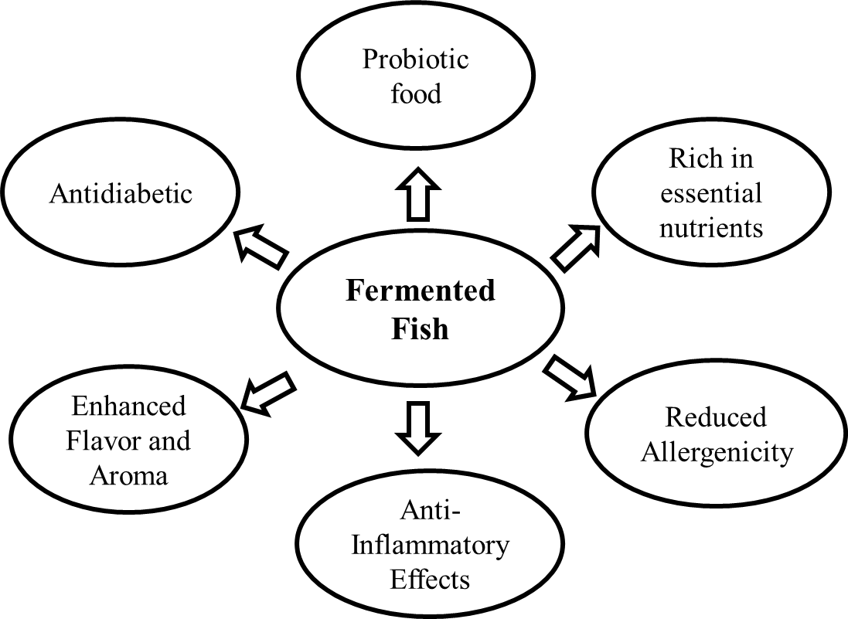
Fig. 1. Health benefits of fermented fishery products
4. Improved Shelf Life: Fermentation acts as a natural preservation method, extending the shelf life of fish products without artificial additives or preservatives.
5. Potential Anti-Inflammatory Effects: The bioactive compounds produced during fermentation may have anti-inflammatory properties, potentially aiding in the prevention of chronic inflammatory conditions.
6. Enhanced Flavor and Aroma: Fermented fish products develop complex flavors and aromas highly prized in Indian cuisine. These unique sensory experiences add to the pleasure of consuming these products.
7. Heart Health: Certain fermented fish, such as fermented cod liver oil, are rich in omega-3 fatty acids. Omega-3 supports heart health by reducing inflammation, improving cholesterol levels, and promoting healthy blood pressure (Kumar and Nayak et al., 2015).
Conclusion
In conclusion, the art of fermenting fish has transcended cultures and regions, contributing to a diverse range of flavorful and nutritious products. This age-old preservation technique not only extends the shelf life of fish but also enhances its nutritional value and flavor profile. With over 5,000 fermented foods enjoyed globally, fermented fish products are significant in daily dietary intake, offering a unique combination of taste and health benefits. The rich array of nutrients, including amino acids, fatty acids, and vitamins, coupled with probiotics, makes these products a powerhouse of advantages. The fermentation process not only aids in digestion but also showcases potential anti-inflammatory and allergenicity-reducing effects. As a sustainable and natural preservation method, fish fermentation continues to play a vital role in culinary traditions and dietary practices worldwide, fostering taste and health.
References

- Bjerke, G.A., Rudi, K., Avershina, E., Moen, B., Blom, H. and Axelsson, L., 2019. Exploring the brine microbiota of a traditional Norwegian fermented fish product (Rakfisk) from six different producers during two consecutive seasonal productions. Foods, 8(2), p.72.
- Kumar, S. and Nayak, B.B., 2015. Health benefits of fermented fish. Health benefits of fermented foods and beverages, pp.490-503.
- Majumdar, R.K., Bejjanki, S.K., Roy, D., Shitole, S., Saha, A. and Narayan, B., 2015. Biochemical and microbial characterization of Ngari and Hentaak-traditional fermented fish products of India. Journal of Food Science and Technology, 52, pp.8284-8291.
- Majumdar, R.K., Roy, D., Bejjanki, S. and Bhaskar, N., 2016. Chemical and microbial properties of shidal, a traditional fermented fish of Northeast India. Journal of Food science and Technology, 53, pp.401-410.
- Muzaddadi, A.U. and Basu, S., 2012. Shidal-a traditional fermented fishery product of North East India.
- Park, J.N., Fukumoto, Y., Fujita, E., Tanaka, T., Washio, T., Otsuka, S., Shimizu, T., Watanabe, K. and Abe, H., 2001. Chemical composition of fish sauces produced in Southeast and East Asian countries. Journal of food composition and analysis, 14(2), pp.113-125.
- Rath, E.C., 2021. Oishii: the history of sushi. Reaktion Books.
- Reddy, P.R., Kumar, S.H., Layana, P. and Nayak, B.B., 2020. Survival and histamine production by histamine-forming bacteria exposed to low doses of gamma irradiation. Journal of Food Protection, 83(7), pp.1163-1166.
- Rodpai, R., Sanpool, O., Thanchomnang, T., Wangwiwatsin, A., Sadaow, L., Phupiewkham, W., Boonroumkaew, P., Intapan, P.M. and Maleewong, W., 2021. Investigating the microbiota of fermented fish products (Pla-ra) from different communities of northeastern Thailand. Plos one, 16(1), p.e0245227.
- Rodzi, N.A.R.M. and Lee, L.K., 2021. Traditional fermented foods as vehicle of non-dairy probiotics: Perspectives in South East Asia countries. Food Research International, 150, p.110814.
- Suryani, I., Basir, N., Halim, M.Z.A., Ali, M.E.M., Rahim, N.A.A. and Mohamad, R.B.F., 2023, April. Research trends on Pekasam as heritage food in Malaysia. In AIP Conference Proceedings (Vol. 2544, No. 1). AIP Publishing.
- Tamang, J.P. and Kailasapathy, K. eds., 2010. Fermented foods and beverages of the world. CRC press.
- Thapa, N., 2016. Ethnic fermented and preserved fish products of India and Nepal. Journal of Ethnic Foods, 3(1), pp.69-77.
- Thapa, N., Pal, J. and Tamang, J.P., 2004. Microbial diversity in ngari, hentak and tungtap, fermented fish products of North-East India. World Journal of Microbiology and Biotechnology, 20, pp.599-607.
- Uchoi D, 2018. Proteolytic and biological amine Forming bacteria from fermented Fish products of north-east india. Ph.D. Thesis, ICAR- Central Institute of Fisheries Education (University Established Under Section 3 of UGC Act 1956) Panch Marg, Off Yari Road, Versova, Andheri (W), Mumbai – 400 061
- Uchoi, D. and Kishore, P., 2022. Quality and safety issues associated with fermented fishery products. Indian Technical and Economic Cooperation (ITEC) & ICAR-CIFT.

