HOME AUTOMATION USING SENSORS
Vishruth M V ¹, Huzzaif Hassan ², Yashaswini S ³, Vishwanth ⁴
¹ ² ³ ⁴ Student, Dept. of CSE
BNMIT, Banglore, Karnataka, India
¹ vishruth.mv10@gmail.com , ² hassanhuzaif147@gmail.com, ³ yashaswinisrinivas586@gmail.com

ABSTRACT
In recent years, the advancements in Information and Communication Technology (ICT) are mainly focused on the Internet of Things (IoT). In a real-world scenario, IoT-based services improve the domestic environment and are used in various applications.
Home automation-based IoT is a versatile and popular application. In-home automation, all home appliances are networked together and able to operate without human involvement. Home automation gives a significant change in human life which gives smart operation of home appliances. This motivated us to develop a model that uses the basic principles of home automation. With the use of various sensors like the Ultrasonic sensor, DHT11 sensor, and PIR Sensor, we have tried to achieve the most basic level of a home automated system.
The proposed model uses the sensor and detects the presence or absence of a human object in the housework accordingly. Also, it checks, if there is any gas leakage it reaches lesser than the threshold, it automatically informs the owner and creates a buzzing alarm. The proposed solution is deployed and tested for various conditions.
Finally, in this paper, the working model of our proposed solution is developed as a prototype and explained as a working model.

Acknowledgment

We would like to place on record our sincere thanks and gratitude to the concerned people, whose suggestions and words of encouragement has been valuable.

We express our heartfelt gratitude to BNM Institute of Technology, for giving us the opportunity to pursue Degree of Computer Science, and helping us to shape our career. We take this opportunity to thank Prof. T. J. Rama Murthy, Director, Dr. S.Y. Kulkarni, Additional Director, Prof. Eishwar N Maanay, Dean and Dr. Krishnamurthy G.N., Principal for their support and encouragement to pursue this project. We would like to thank Dr. R.V. Parimala, Professor and Head, Dept. of Electrical and Electronics Engineering, for her support and encouragement.

We would like to thank our Guide Ms. Kruthi Jayaram, Assistant Professor, Dept. of Electrical and Electronics Engineering, who has been the source of inspiration throughout our project work and has provided us with useful information at every stage of our project.

Finally, we are thankful to all the teaching and non-teaching staff of Department of Electrical and Electronics Engineering for their help in the successful completion of our project. Last but not the least we would like to extend our sincere gratitude to our parents and all our friends who were a constant source of inspiration.
VISHRUTH M V

VISHWANATH

WANI HUZZAIF HASSAN

YASHASWINI S

Table of Contents

Abstract
Acknowledgment
List of Figures
Introduction
Literature Survey
Methodology
Hardware and Software requirements
Results and Discussion
Conclusion and Future Scope

References

List of Figures
Figure No. | Description | Page No
1 | Circuit Connections of the Model | v
2 | Working Model and Circuit Connections | vii

- Introduction
The Internet of Things is the interconnection of the various computing devices embedded in daily appliances to the Internet, thus enabling them to communicate with each other. This enhances the end user’s quality of life and improves efficiency and sustainability in the da -day activities. Shortly, many the smart devices will be communicating over IoT.
The analyst firm Gartner predicts that by 2020 there will be more than 20 billion devices connected to the Internet of Things. As we will approach that value, it is predicted that around $6 billion will flow into the various domains of IoT like application development, device hardware, system integration, data storage, security, and connectivity. Nearly $6 Trillion will be spent on IoT solutions by 2025.
We are living in a world that is rapidly evolving regarding automation. Automation is the ability to schedule events for the devices connected to the local network or the internet through time-related or stimulus-triggered programs. From large industries to small offices, everywhere the concept of automation is being implemented to reduce human intervention and to improve energy efficiency and productivity. Home automation or domestics is the process of automating the various appliances inside a house thus converting it into a smart house.
It involves the automation of heating, lighting, ventilation, and climate control as well as various other embedded system devices that can be connected to the internet. Another major characteristic of the present generation of home automation is the remote monitoring and access of the automated appliances. With the evolution of smartphones and tablets and the development of various communication technologies like Wi-Fi, Bluetooth, and ZigBee we have gained the ability to connect to our home network while we are away indeed. One of the advantages is the immense potential for energy conservation and cost saving.
An efficient home automation system is proposed in this paper. The significant contributions of this paper are as follows:
- Initially, we automate the functioning of some essential home appliances like fans, lights, air-conditioners, and water heaters by the readings received by various sensors installed at different parts of the house.
- All These sensors will be connected to the Node MCU ESP8266 or the Arduino Uno which will process the readings received by the sensors and control the relays connected to the appliances.
- Literature Survey
Home automation is the use of technology to control various home appliances and systems. Home automation systems use sensors, controllers, and communication technologies to provide an automated home environment. Sensors play a critical role in home automation as they are responsible for monitoring different parameters and providing feedback to the controllers. In this literature survey, we will review some of the recent research work done in the area of home automation using sensors.
- "Smart home energy management using wireless sensors" by L. Han, J. Zhang, and L. Liu: The paper proposes a smart home energy management system that uses wireless sensors to monitor and control the energy consumption of home appliances. The system uses Zigbee wireless communication protocol for communication between sensors and controllers. The authors also present an energy consumption prediction model that uses machine learning algorithms to predict future energy consumption. The proposed system reduces energy consumption by up to 25%.
- "Smart home automation using IoT and cloud computing" by S. K. Patel and D. M. Patel: The paper proposes a smart home automation system that uses IoT and cloud computing. The system uses various sensors such as temperature sensors, motion sensors, and light sensors to monitor and control different parameters of the home environment. The authors also present a cloud-based architecture that provides remote access to the home automation system. The proposed system provides enhanced comfort, convenience, and security to the users.
- "A review of smart home sensing technologies" by C. M. Barnes and M. R. Hansen: The paper provides a comprehensive review of smart home sensing technologies. The authors discuss various types of sensors such as environmental sensors, occupancy sensors, and activity sensors. The paper also discusses different communication protocols used in smart home systems such as Zigbee, Z-Wave, and Wi-Fi. The authors conclude that smart home sensing technologies have significant potential to enhance the quality of life of people by providing a comfortable and secure living environment.
- "Smart home automation using machine learning algorithms" by S. K. Das and R. N. Mahapatra: The paper proposes a smart home automation system that uses machine learning algorithms to provide personalized services to the users. The system uses various sensors such as temperature sensors, humidity sensors, and light sensors to monitor the home environment. The authors also present a machine learning-based algorithm that provides personalized recommendations to the users based on their preferences. The proposed system provides enhanced comfort and convenience to the users.
Conclusion: The above literature survey provides a glimpse of recent research work done in the area of home automation using sensors. The papers reviewed in this survey demonstrate the potential of sensor-based home automation systems to provide enhanced comfort, convenience, and security to the users. The use of machine learning algorithms and cloud computing has further enhanced the capabilities of home automation systems. In the future, we can expect more sophisticated home automation systems that use advanced sensors and communication technologies.

- Methodology
Our proposed prototype mainly consists of three layers of implementation, namely:
- Sensor Node Layer
- Sensor Data and Database Interface Layer
- Notification Layer
Sensor Node Layer:
This layer consists of the sensors, namely, temperature sensor, humidity sensor and Ultrasonic sensor and PIR sensor are connected to the NodeMCU ESP8266. The sensors acquire the data of the variables of the home environment and send the data to the NodeMCU. The NodeMCU then triggers the relays connected to the lights, blinds, fan, air conditioner and the heater as and when the necessary conditions are met.
A microcontroller is a control device that comes embedded with peripherals, memory, and a processor. The remote controlling and automation of the appliances are made possible by the microcontroller which is programmed to process the response produced by the various sensors and to trigger the appliances according to the automation architecture. The microcontroller used in the project are:
Node MCU ESP8266: The low cost, compact size and the presence of an inbuilt Wi-Fi module were the reasons for selecting this microcontroller.
Sensor Dasta and Database Interface Layer:
In this we have configured Blynk IoT Platform, to read the sensed data of the sensor and transmit it to a pictorial form on the blynk iot platform, it also acts like an interface through which certain defined actions can be controlled from the platform onto the NODEMCU ESP8266.

Notification Layer:
This layer acts as an alarm system, which is accomplished by the usage of a buzzer. The buzzer buzzes as soon as a movement is detected which is brought about using the PIR sensor.
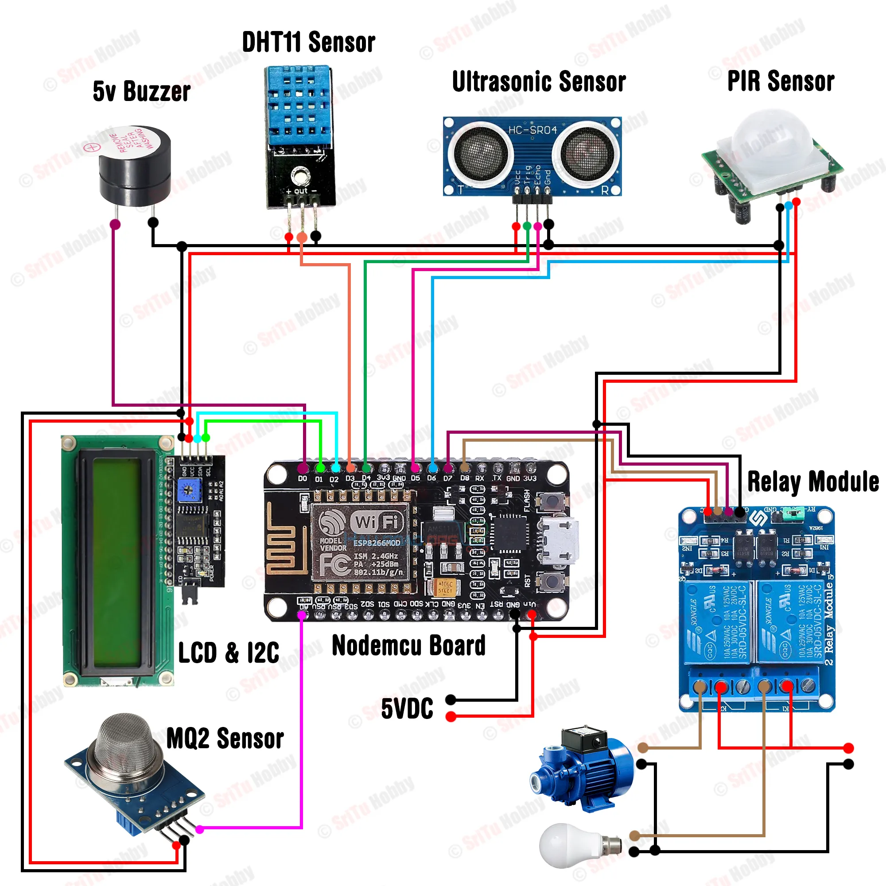
Figure 1: Circuit Diagram

- Hardware & Software Specifications

Hardware requirements
    - ESP8266 – A low power, energy efficient microcontroller with Wi-Fi enabled module where the program is loaded.
    - 5v Buzzer – used as an notification system that busses as per the defined conditions.
    - DHT11 Sensor – used to sense temperature and humidity in the environment.
    - Ultrasonic sensor – used to measure the water level in the water tank
    - PIR sensor – used to detect motion change in the environment and thus act like a security device.
    - Relay Module – used to isolate the voltages in the circuit connected to a different appliance
    - Breadboard – the base where all the foundations are laid
    - LCD and I2C – used to display the humidity and temperature readings

Software requirements
- Arduino IDE – open-source coding platform where the code is written and run for the prepared iot model.
- Blynk IoT Application App – open-source end-user interface that would aid us to display the desired output in the form of a gauge.

- Result and Discussion
In this paper, home automation is improved by considering a Wireless sensor node. A smart home integrates various electrical appliances in the home and automates them with no or minimum user intervention.
The smart home keeps track of different environment variables present and guides the appliances to work according to the needs of the user. By considering, the above features, we have developed the prototype and tested it.
We achieved the development of a Smart Home by using the Internet of Things technologies. From the experiment, it was found that we can manage to make low-cost, flexible and energy efficient smart home for the better and greener future.
Some potential benefits of home automation could include:
- Energy efficiency: Automated lighting, heating, and cooling systems can help reduce energy usage and save on utility bills.
- Convenience: With home automation, you can control various aspects of your home from a single app or device, making it easier and more convenient to manage your household.
- Security: Automated security systems can monitor your home for potential threats and alert you if something is amiss.
- Entertainment: Home automation can also include smart home entertainment systems that allow you to control your home theater, music, and other entertainment devices from a single app or device.
Some of the discussion potential points being –
- Cost: How much did the project cost, and was it worth the investment in terms of energy savings, convenience, and security?
- Usability: How easy is it to use the home automation system, and are there any issues with reliability or connectivity?
- Future potential: What other home automation technologies could be implemented in the future, and how might they further improve the efficiency and convenience of the home environment?

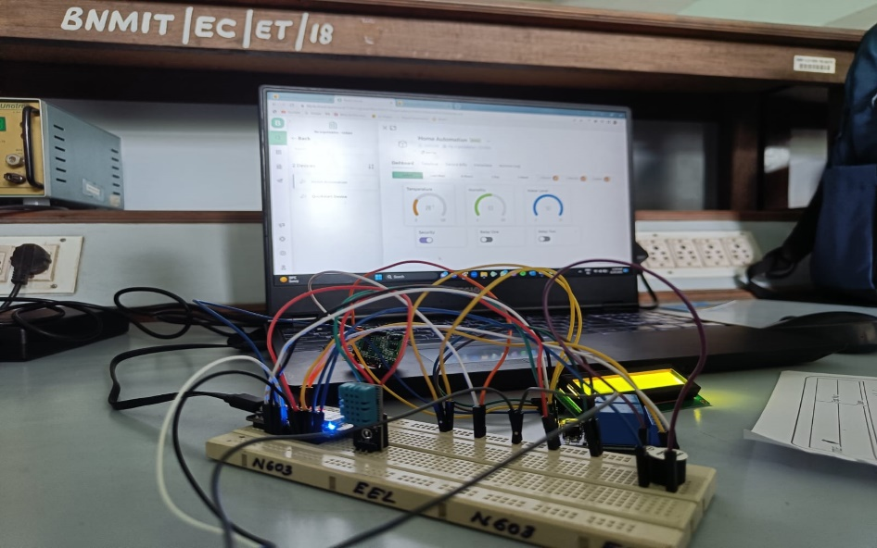
Figure 2: Working Model
- Conclusion and Future Scope
Conclusion:
In conclusion, a home automation project can bring many benefits to a household, including increased energy efficiency, convenience, security, and entertainment. By automating various systems and devices in the home, homeowners can save money on their utility bills, streamline their daily routines, and enhance their overall quality of life.
However, a successful home automation project requires careful planning and consideration of factors such as cost, usability, and impact on the home environment and its occupants. Homeowners should also be aware of potential privacy and security concerns associated with smart home technology and take steps to protect their data and personal information.
Overall, home automation technology is rapidly advancing and has the potential to transform the way we live and interact with our homes. As the technology continues to improve and become more accessible, we can expect to see even more innovative and exciting developments in the field of home automation in the years to come.
Future Scope:
The future scope of home automation is quite promising, as technology continues to advance and improve. Here are some potential areas where we can expect to see further development in home automation:

- Increased integration:
Home automation systems are likely to become even more integrated, allowing homeowners to control multiple devices and systems from a single platform. This could include everything from lighting and HVAC to security and entertainment systems.
- Improved energy efficiency:
Home automation systems can help homeowners save energy by optimizing heating and cooling, turning off lights when rooms are empty, and managing appliances more efficiently. As energy costs continue to rise, this will become an increasingly important feature.

- Enhanced security:
Home automation systems can provide enhanced security features, including remote monitoring, access control, and video surveillance. As concerns about home security continue to grow, this will become an increasingly important feature.

Overall, the future of home automation looks very promising, with a wide range of potential applications and benefits.

REFERENCE

- "Smart home automation using machine learning algorithms" by S. K. Das and R. N. Mahapatra.

- "A review of smart home sensing technologies" by C. M. Barnes and M. R. Hansen: The paper provides a comprehensive review of smart home sensing technologies.

- “IoT Based Smart Home Automation System” from the Journal of Emerging Technologies and Innovative Research by J. Vijaya Kumari, Pavithra Neelam.

The above literature survey provides a glimpse of recent research work done in the area of home automation using sensors. The papers reviewed in this survey demonstrate the potential of sensor-based home automation systems to provide enhanced comfort, convenience, and security to the users.

