Financial Inclusion at Indian Post Payment Bank-An Introductory Approach.

DR. SUTANSHU KHATUA,
Associate Professor, Department of Management, St. Xavier’s University, Kolkata.

DR. KUNAL SIL.
D.Litt. (Commerce & Management) Pursuing, Srinivas University, Mangalore.

Introduction- The 75th anniversary of Indian Independence & current Azadi ka Amrit Mahotasav earmarked the launch of “Finclusion”. INDIA POST PAYMENTS BANK(IPPB) is a 100% government owned entity, working under Department of Posts (DoP) announced the inauguration of Fincluvation– a joint inventiveness to team up with Fintech Startups to bring innovative solutions for financial inclusion.

Fincluvation will soon be an enduring platform of Indian Post Payment Banks to bring all-inclusive financial solutions with their participating start-ups. Indian Post Payment Banks and Department of Posts will jointly serve almost 430 million customers through nearby post offices to their doorsteps, with more than 400,000 trusted and proficient Post Office employees, along with Gramin Dak Sevaks. This would make postal services making as one of the largest and reliable postal networks in the country.

Key Words- Azadi ka Amrit Mahotasav, Fincluvation, IPPPB, Gramin Dak Sevaks.

Payment Banks- Nachiket Mor Committee made the recommendations of the Payments Bank. Accordingly, it was set up to function on a minor scale with very minimal credit risk.

The chief objective was to advance financial inclusion scheme by offering banking and financial services to the most unbanked and underbanked areas. It was also aimed at helping the migratory labour force, low- income families and small entrepreneurs etc.

Payment Banks are registered under the Companies Act 2013 but are ruled by a multitude of legislations such as Banking Regulation Act, 1949; RBI Act, 1934; Foreign Exchange Management Act, 1999, Payment and Settlement Systems Act, 2007 and the like.

India currently has 6 Payment Banks-

- Airtel Payment Bank.
- India Post Payment Bank.
- Fino.
- Paytm Payment Bank.
- NSDL Payment Bank, and
- Jio Payment Bank.

Indian Post Payment Bank (IPPB)- India Post Payments Bank (IPPB) has been set up under the Department of Posts, Ministry of Communication, with 100% equity owned by Government of India. IPPB was launched by our Prime Minister Shri Narendra Modi on September 1, 2018. The bank has been founded with the mission to build the most available, affordable and reliable bank for the common mass. The basic mandate of IPPB is to eliminate all the existing barriers for the most unbanked and under-banked people.
IPPB’s scope and its basic functioning model is primarily built on the key pillars of India- aiding Paperless, Cashless and Presence-less banking system in a simplistic and secured manner to the customers' convenience. It is implemented through a CBS-integrated smartphone and biometric device. IPPB delivers most simple and affordable banking services, by using in-built interfaces, which are currently available in almost 12 languages. Indian Post Payment Bank is devotedly working to provide a boost to a less cash economy and contribute most to the implementation of the vision of Digital India. India will definitely prosper, when every single citizen will have an equal opportunity to become economically secure and most importantly empowered.

Essential Features of IPPB-

Indian Post Payment Bank understand customer needs. They have tailored their product and services to be simple and easy to avail. Some prominent features of IPPB includes-

- Deposit.
- Money Transfer.
- Direct Benefit Transfers.
- Third Party Products.
- Billing & Utility Payments.
- Enterprise & Merchant payments.

Current Operational Strength-
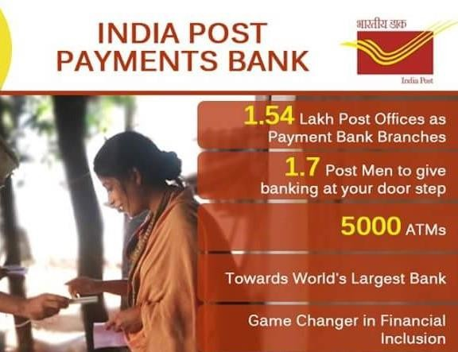

Indian Post Payment Bank Services

Account On Boarding

Merchant On Boarding

Third Party Services
Accounting Services

Other Account Related Services includes-
  - Updating PAN.
  - Beneficiary Management.
  - Account statement.
  - QR card.
  - Linking Adhaar Card.
  - Sharing complaints, etc.

Some Specific Attention to Rural Needs-

Indian Post Payment Bank has a specific orientation to rural sectors-
- Leveraging the trust which the India Post enjoys in the minds of the public.
- Minimizing and recovering NPAs.
- Helping to increase per capita income of rural people.
- Providing an effective financial service.
- Social Inclusion is another area, where IPPB is working rigorously.
- Rural MSME is getting leverage from Indian Post Payment Bank.
- IPPB has enabled Direct Benefit Transfer.

Low Digital Literacy RBI Mandates Service Charges

Some Operational Challenges

Stiff Competition Manpower Training

References-
1. Scher J Mark, 2001, "Postal Savings and the provision of Financial Services: Policy Issues and Asian Experiences in the use of the postal Infrastructure for Savings Mobilization", DESA Discussion Paper No 22, UN, 2001.
2. Rillo and Miyamoto, 2016, “Innovating Financial Inclusion: Postal Savings System Revisited”, ADBI Policy Brief No August 2016-3, ADBI, Japan.
3. Andorta and Manhas, (2017), "Emerging Role of Indian Post in Financial Inclusion and Socio-Economic Empowerment", Prestige International Journal of Management & ITSanchayan, Vol. 6(1), 2017, pp. 1-19
4. Das, S.K. (2011), “An Empirical Analysis on Preferred Investment Avenues among Rural and Semi-Urban Households”. Journal of Frontline Research in Arts and Science Vol. 01, pp. 26-36.
5. Chaubey, D.S. (2009), “Investment Pattern: A Psychographic Study of Investors of Garhwal Region of Uttarakhand”, RVIM Journal of Management Research, Rashtreeya Sikshana Samithi Trust, R.V. Institute of Management, Bangalore, Vol. 1, No. 1, Jan-June 2009, pp. 36.

