**Determination of Stable Zones of LFC for a Power System Considering Communication Delay**

**Dr.D.Venugopal1, Ch.Bhasker2, Dr.K.Madhulatha3**

**1Kamala Institute of Technology and Science, Singapur , Huzurabad. Karimnagar, Telangana State.**

**Email: venufacts20m@gmail.com**

**ABSTRACT:**

In this research, fractional based load frequency control (LFC) stable and unstable zones for a two area system have been estimated. In the current approach, the transmission latency caused by measurements and other factors is also taken into account. The location of the fractional controller settings has been determined using a graphical technique. By taking into account various controller parameter values from various locations, the system with a controller is studied in the MATLAB environment. The simulation findings demonstrate that a fractional controller has a wider range of stability zones than a standard PI controller.

Keywords: Power system, Delay, LFC, Stability regions

**1. Introduction**

Frequency, along with voltage control, is a crucial control parameter in an electrical power system network. This is due to the fact that numerous devices are using the same frequency spectrum. Therefore, it is necessary to maintain frequency fluctuation within a certain range. The relationship between frequency and active power is straightforward. As a result, adjusting the active power can be used to manage frequency fluctuations. [1-3]. Various power system linear models are taken into consideration for LFC problems in the literature [4-5]. But communication lag in the power system leads to a lot of issues. Delay in communication must therefore be considered while analyzing the LFC issue. One of two things could cause this delay. The first is the result of measuring frequency and active power. Between the generator units and the control center, there is a second delay [6–10]. This delay is defined by $e^{ST_{d}}$ (here *Td* is called approximated delay).

Different LFC techniques are described in the literature[11–12] for reducing frequency and tie line power variations. Due to its advantages, such as a broad range of stability and design flexibility, the fractional based LFC concept has been utilized in the current paper[13–15].When a system is capable of returning to its initial state following the removal of any undesirable disruption, it is considered to be stable. In order to protect the power system when it enters unstable zones, the controller parameters must be properly chosen.The unstable and stable power system zones are provided in this work for various values.

From Fig.1., $T_{d1}$ is defined asarea1 communication delay, $T_{d2}$ is defined as area2 delay, $T_{g1}, T_{t1}, M_{1}, D_{1}, β_{1}, R_{1, }T_{g2}, T_{t2}, M_{2}, D_{2}, β_{2}\&R_{2}$ are the governor time constant and turbine time constant, governor moment of inertia, governor damping factor, frequency bias factor, governor speed regulation of area1 and area2 respectively. From Fig. 1, $K_{ps1}$ and $T_{ps1}$ are the area1 power system gain and time constant respectively. ${ΔF}_{1}$ is the frequency deviation in area1, ${ΔF}_{2}$ is the frequency deviation in area2, ${ΔP}_{tie1}$ and ${ΔP}_{tie1}$ are the area1 and area2 tie-line power deviations respectively. ACE1 is the area1 control error and ACE2 is the area2 control error. The two area system parameters are considered from [8].



Fig.1: Two area LFC/AGC system.

**2. Stable and unstable areas of fractional LFC parameters**

Fig. 1 can be used to determine the features of LFC, such as ,&. The characteristic equation is developed while taking into account the following presumptions.

1. The deviation of the tie line power is taken to be zero.

2. There is the same communication latency in both areas.

3. The system settings are the same for both.

i.e., ,,,,&

From Fig. 1., characteristic equation of LFC system can be obtained as (1).

==0 (1)

After simplification of (1),

 (2)

Here,

,,  , 

Substitute=and =  (3)

Real part of =0 is

 (4)

Imaginary part of=0

 (5)

Simplifying equations (4)and (5), we get (6) & (7)

 (6)

 (7)

Where

=;=

  
;



**3. Results & discussion**

Various stable and unstable zones for a range of values are depicted in Figure 2. To examine the behaviour of the controller taking into account a point (,) in regions *R1, R2, R3*and *R4* for distinctvalues. AGC is absolutely stable in the zone for larger values, dynamic response analysis is used.



Fig.2: stable and unstable zones of fractional PI-controller for*Td*=2.28sec.

Table: 1 Parameters of fractional calculus based controller

|  |  |  |  |  |  |  |  |  |
| --- | --- | --- | --- | --- | --- | --- | --- | --- |
| $$α$$ | **Region *(R1)*** | | **Region *(R2)*** | | **Region *(R3)*** | | **Region *(R4)*** | |
| ***Kp*** | ***Ki*** | ***Kp*** | ***Ki*** | ***Kp*** | ***Ki*** | ***Kp*** | ***Ki*** |
| 1 | 0.4 | 0.2 | 0.6 | -0.5 | 1 | 1 | 1.5 | 3 |
| 1.1 | 0.2 | 0.5 | 0.4 | -1 | 1 | 2 | 1.5 | 3.5 |
| 1.2 | 0.8 | 0.2 | 0.7 | -0.2 | 1 | 3.55 | 1.1 | 3.85 |
| 1.3 | 1 | 0.5 | 0.5 | -0.5 | 1 | 4 | 1.5 | 4.5 |
| 1.4 | 1.1 | 0.65 | -0.5 | -2 | 1.5 | 2 | 2 | 6 |
| 1.5 | 1 | 0.5 | 0.5 | -5 | 1 | 5 | 1.5 | 7 |

***Case*1:When α = 1**

It can be noticed from Fig. 3(a), Fig. 4(a) and Fig. 5(a) that AGC is absolutely stable in R1. Also it is clear from Fig. 3(b), Fig. 4(b) and Fig. 5(b) that power system is unstable in R2

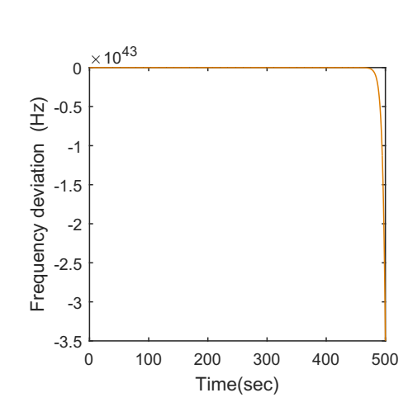

(a)&(Region R1) (b)&(Region R2)

Fig.3:Frequency deviations of area1(A1)

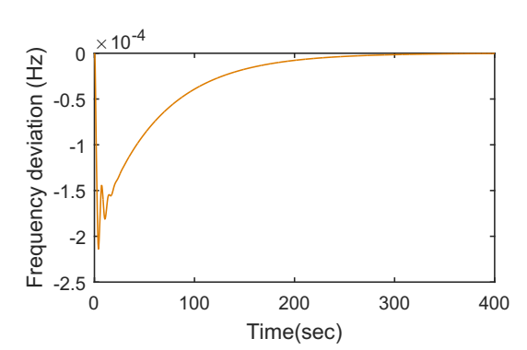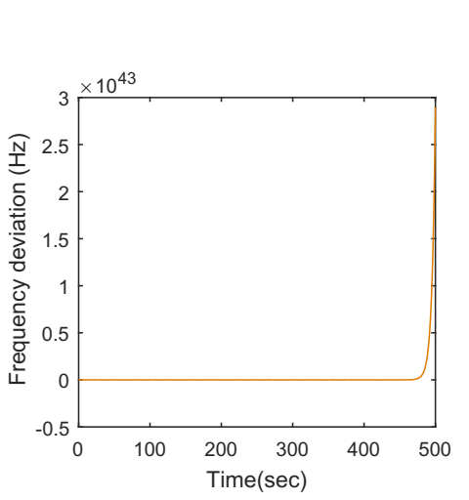

(a)&(Region R1) (b) &(Region R2)

Fig.4:Frequency deviations of area2(A2)

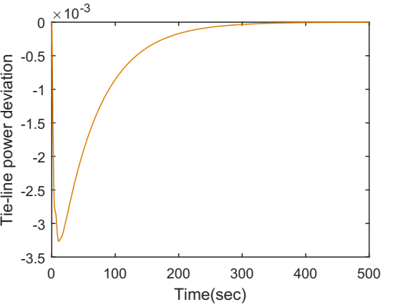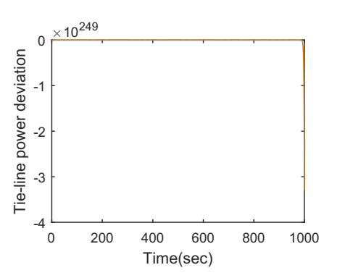

(a)&(Region R1) (b) &(Region R2)

Fig.5: Tie line power deviations

***Case2:* When α = 1.3**

It can be noticed from Fig. 6(a), Fig. 7(a) and Fig. 8(a) that AGC is stable in R1. Also it is clear from Fig. 6(b), Fig. 7(b) and Fig. 8(b) that power system is unstable in R2.

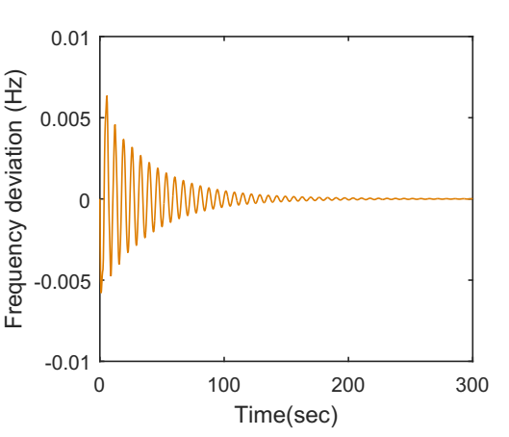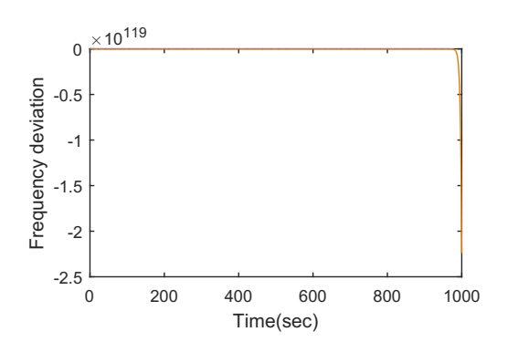

(a)&(Region R1) (b) &(Region R2)

Fig.6:Frequency deviations of area1(A1)

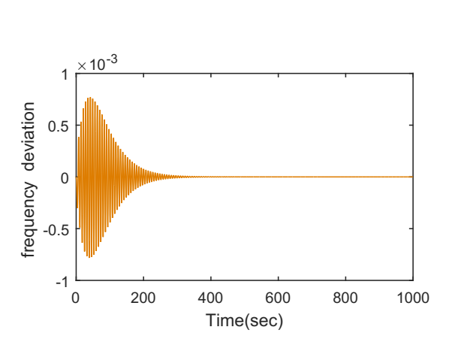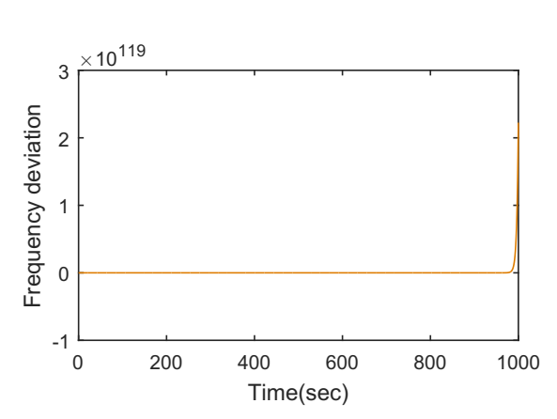

(a)&(Region R1) (b) &(Region R2)

Fig.7:Frequency deviations of area2(A2)

***Case 3:* When α = 1.5**

It can be noticed from Fig. 9(a), Fig. 10(a) and Fig. 11(a) that AGC is absolutely stable in R1. Also it is clear from Fig. 9(b), Fig. 10(b) and Fig. 11(b) that power system is unstable in R2.

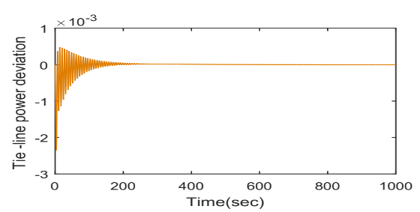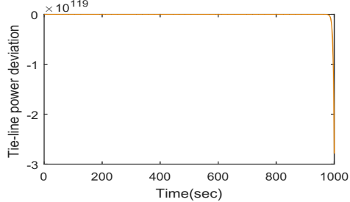

(a)&(Region R1) (b) &(Region R2)

Fig.8: Tie line power deviations

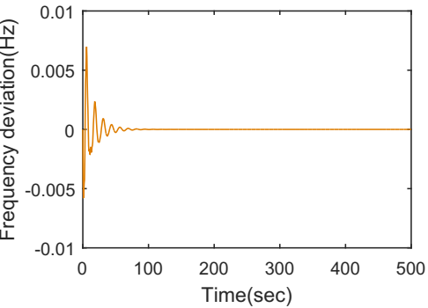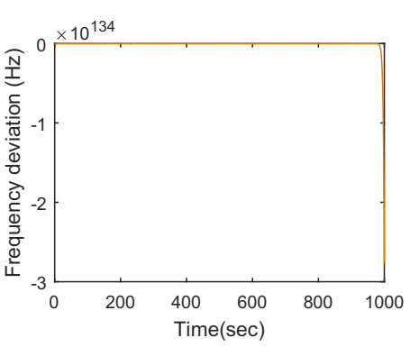

(a)&(Region R1) (b) &(Region R2)

Fig.9:Frequency deviations of area1(A1)

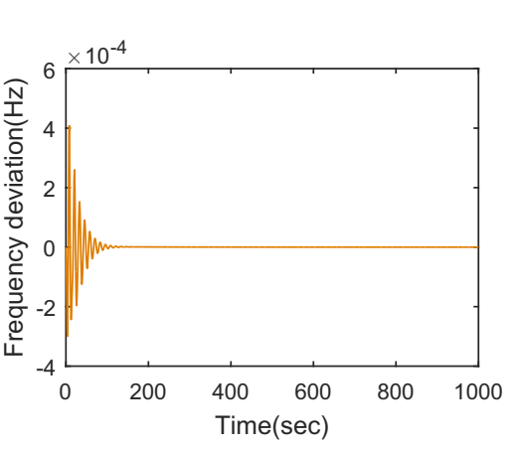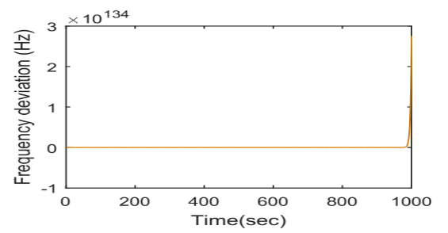

(a)&(Region R1) (b) &(Region R2)

Fig. 10:Frequency deviations of area2(A2)

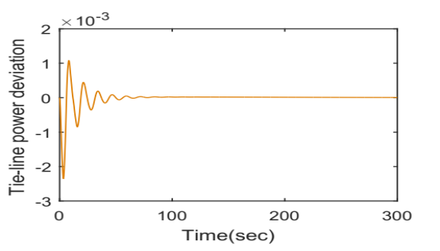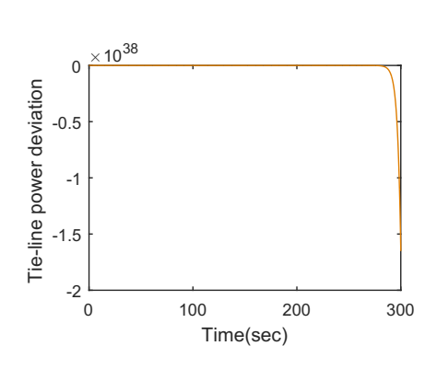

(a)&(Region R1) (b) &(Region R2)

Fig.11: Tie line power deviations

1. **Conclusion**

The stable and unstable regions of the controller parameters are identified in the current work by using a straightforward graphical method. MATLAB simulations show that the fractional controller has a wide range of stable zones. As a result, the fractional based controller can choose from a wider range of controller gains in order to keep the power system stable.

**References:**

[1] I.J. Nagrath, D.P. Kothari, power system engineering, 3rd ed., McGraw-Hill, Singapore, 2003.

[2]Olle I. Elgered, Electrical energy systems theory, Tata MCgraw -Hill ,1976.

[3] Prabha kundur, power system stability and control, Tata MCgraw –Hill, new York, 1994.

[4] Sahaj Saxena,Load frequency control strategy via fractional-order controller and reduced-order modeling,International Journal of Electrical Power & Energy Systems,Volume 104,2019,Pages 603-614,ISSN 0142-0615.

[5] I Kasireddy, A W Nasir and A K Singh, “Application of FOPID-FOF Controller Based on IMC Theory for Automatic Generation Control of Power System”, IETE Journal of research, Dec-2019.

[6]Hany M. Hasanien, Attia A. El-Fergany,Salp swarm algorithm-based optimal load frequency control of hybrid renewable power systems with communication delay and excitation cross-coupling effect,Electric Power Systems Research,Volume 176,2019.

[7]Gaber Magdy, G. Shabib, Adel A. Elbaset, Thongchart Kerdphol, Yaser Qudaih, Hassan Bevrani, Yasunori Mitani,Tustin's technique based digital decentralized load frequency control in a realistic multi power system considering wind farms and communications delays,Ain Shams Engineering Journal,Volume 10, Issue 2,2019.

[8]Sahin Sönmez, Saffet Ayasun, Stability region in the parameter space of PI controller for a single-area load frequency control system with time delay, IEEE Transactions on Power Systems, 31(1), 829-830, 2016.

[9] N. Tan, I. Kaya, C. Yeroglu, and D. P. Atherton, “Computation of stabilizing PI and PID controllers using the stability boundary locus,” Energy Convers. Manage., vol. 47, pp. 3045–3058, 2006.

[10]S. Sönmez, S. Ayasun, and U. Eminoglu, “Computation of time delay margins for stability of a single-area load frequency control system with communication delays,” WSEAS Trans. Power Syst., vol. 9, pp.67–76, 2014.

[11]Jianping Guo,Application of full order sliding mode control based on different areas power system with load frequency control,ISA Transactions,Volume 92,2019.

[12]Jitendra Sharma, Yogesh V. Hote, Rajendra Prasad,PID controller design for interval load frequency control system with communication time delay,Control Engineering Practice,Volume 89, 2019.

[13] Concepción A. Monje, Yang Quan Chen, BlasM. Vinagre, Dingyü Xue, Vicente Feliu, Fractional-order Systems and Control, Springer 2010.

[14]D Bensiker Raja Singh, R Suja Mani Malar,Implementation of Fractional Pi Controller for Optimal Speed Control of Induction Motor Fed with Quasi Z-Source Converter,Microprocessors and Microsystems,2020.

[15] C. Muresan, E. H. Dulf, and R. Both, “A novel tuning algorithm for fractional order IMC controllers for time delay processes,” Int. J. Mech. Eng. Robot. Res., Vol. 4, no. 3, pp. 218–221, 2015.