Title: Futuristic Trends in Radiology

Authors details:
Deb K Boruah¹, Pranjal Phukan², Kalyan Sarma³

¹Dr Deb K. Boruah, Associate Professor,
Dept. of Diagnostic & Interventional Radiology, AIIMS Guwahati
Email: debpal80@gmail.com
Mobile: 9435773549

²Dr Pranjal Phukan, Additional Professor
Dept. of Diagnostic & Interventional Radiology, AIIMS Guwahati
Email: pphukan10@gmail.com
Mobile: 7005115780

³Dr Kalyan Sarma, Assistant Professor,
Dept. of Diagnostic & Interventional Radiology, AIIMS Guwahati
Email: sarmakalyan@ymail.com
Mobile: 8257846764

Abstract:

Radiology is a field based on innovation with rapid changes and upgradation. In the past decades, radiology has continued to evolve as the imaging industry with the addition of MDCT and high field MRI and newer and advanced image guided interventional radiological procedures. As technology becomes more advanced, with the incorporation of artificial intelligence (AI) into healthcare, the Radiology subject or imaging standards are also going high. Various upcoming situations are impacting the healthcare system from the Radiology.
Keywords: artificial intelligence, radiology, magnetic resonance imaging

Introduction:
Various key incomings are there to impact radiology in future. These are big data analytics, artificial intelligence, cloud storage, robotics & smart machines,3D printing, augmented reality & virtual reality (ARVR), radiogenomics, brain computer interface etc. World Wide Web remote availability impact radiology services worldwide and permits a longitudinal and complete electronic record of the patient's data. [1]

1. Artificial intelligence (AI): AI can’t and won’t be able to replace radiology, but it will play a bigger role in healthcare as AI algorithms become more accurate and autonomous which impacts Radiologists. With the use of AI technology, it to help diagnose various diseases, conditions and identify the various hidden abnormalities. AI might be able to eliminate some radiologists’ tasks, but radiologists who would use AI will most likely replace those who don’t. However, healthcare professionals may use imaging AI independently, which could pose a threat to radiology if physicians begin to rely on AI to provide diagnostic readings and subsequent patient management. Formal guidelines and policies regarding imaging AI will have to be created, but at the moment, AI is still in the early stages of implementation.[2]
The rise in the usage of AI in radiology is a clear indicator of the rapid changes we can expect in the years to come. As per the Americal college of Radiology (ACR) the clinical adoption of AI has seen a rapid increase. The usage of AI has grown to 30% in 2020, compared with virtually non-existent use in 2015.
Though there are some obstacles to implementing Artificial Intelligence in radiology, we can expect doctors and scientists to find ways to overcome them in the future and find ways to leverage the power of AI in radiology.
The first step in the widespread adoption of AI in radiology is to ensure radiologists and other caregivers have the proper understanding and training for it. Then, they will be able to leverage AI in radiology to its fullest.
Today, AI technology is being used in a variety of ways throughout the healthcare industry.Artificial Intelligence can be found in many items, including the;
- Auto-segmentation of various human body parts in 3D post-processing.
- Using computers and multiple technologies for detecting cancer[3].
- NLP (Natural language processing) to simplify paramount reporting results.
Artificial intelligence will rapidly be deployed across medical imaging to help augment techs and radiologists so the existing staff can do more with less. AI will speed exam throughput, reduce retakes, improve image quality, help reduce dose, and help organize and pull data on the IT side to speed pulling priors, auto-complete of structured reports and automated measurements. AI will likely go a long way toward helping address physician burnout and help offset some issues with radiologist staff shortages.[4]
Pros and Cons of AI
AI technology has the potential to improve diagnosis and enhance access for those patients living in rural communities, on the otherhand, many think that AI will take over the work/ job of radiologist.
2. Increased precision and automation with advanced imaging:
Precision medicine has emerged as an approach to disease treatment and prevention. Due to this, radiomics has developed as a new field of radiology. With radiomics, radiologists and computers use deep learning to help AI find patterns of pixels. Precision medicine and radiomics will continue to grow, and with that comes the chance of some radiologists’ tasks being automated, leaving more time to do other work like Interventional Radiology.
3. Advanced imaging techniques
There are many new techniques developed in Radiology.[5] Radiomics is currently developing and becoming popular. Along with radiomics, photoacoustic imaging and terahertz imaging are also in the works and play an important role. These techniques will allow for images to be taken of the body in far greater detail and accuracy than is currently possible.
4. Molecular Imaging and Genomics in Radiology
These are now becoming an integral part of radiology. Physicians can study patients at the cellular and molecular levels inside the body using molecular imaging.
Genomics is also a new field similar to molecular imaging in radiology. It includes the study of the body’s genes and how their functions and characteristics influence the overall effects, movement, and growth of the human body.[6]
The primary function of genomics is to help /identify diseases at an early stage, enabling them to design a customized treatment for that particular disease.
How Does Molecular Imaging Help Physicians?
Molecular imaging is a critical tool for physicians, helping in numerous ways. For example:
- It helps to identify the scope or seriousness of any disease and its impact on the different parts of the body.
- It allows the option to choose the most effective therapy depending on the patients’ distinct biological characteristics and the molecular effect of a particular disease.
- Physicians can incorporate the new medication and treatment procedures due to the changing cellular activity
- It can identify any changes or recurrence of the illness to prevent it from spreading further.
- It can evaluate how the disease progresses to develop a treatment plan accordingly.
5. Interventional Radiology
There is a growing rise in the demand for various interventional radiological procedures. Interventional radiology entails using invasive medical treatments that doctors can do with the help of images, including X-rays, DSA and ultrasound.
Interventional radiology is seeing a rapid rise in its usage, and medical providers can often utilize it as a substitute for conventional surgeries. As a result, it can help the patients to get better treatments and reduce the time they have to stay in the hospital.
- Remove blood clots in a patient with stroke with aspiration/ retrieval of thrombus.
- Prevent extreme and life-threatening bleeding due to various conditions, such as complications infective, pancreatitis, or trauma injuries with embolization procedures.
- Opening of occluded vessels.
- Treated causes of subarachnoid hemorrhages with newer advanced in the techniques of management of aneurysm with the use of 3D coils [ Figure 1 & 2] , Flow diverter(FD) , Web device etc.
- Treating complex AVM and AVF with use of liquid embolic agents like Onyx, Squid etc.
- Doing various drainage procedures of abscess, collection etc.
- Various biopsy procedures of diagnosis, especially in oncology setting.
- Various ablative procedure like radiofrequency, laser ablation techniques in various oncologic as well as non-oncologic conditions.[7]
- Pre-surgical tumor embolization.[Figure 3]
6. Preventive Care aspects in Radiology:
As imaging evolves, radiology will play a bigger role in preventive care. Preventive imaging helps discover health issues before symptoms become more severe. Right now, there are preventive imaging techniques, such as getting a full-body MRI to detect any abnormalities, or getting regular mammograms to see if there are any changes in breast tissue.
Radiology is always striving to improve techniques and technology, so you can expect radiology to become more involved in preventive care. For instance, phase-contrast X-ray imaging, an imaging process used primarily in research labs, might be able to detect early-stage lung cancer.
6. Expect to see in Radiology in the next 20 Years?
The future of AI is driven by technological advancements, as it has in years passed. If we look at radiology 20 years ago, we see how practitioners and radiologists used films for diagnosis and treatment.With ever-changing technology, AI will be the driving force behind change in the medical landscape. It will open up numerous new avenues for not just radiologists but for many other professionals in healthcare. AI will enable breakthroughs in patient care and radiologists have the opportunity to develop a variety of new skills to take advantage of these breakthroughs. It will streamline the process for radiologists, enabling them to make better-informed decisions for their patients.
7. Future of Radiology helps in clearing the various quarries in the day to day medical practices, like
Helps in early-stage diagnosis of various chronic diseases: Worldwide early diagnosis is a key to successful treatment in most of the chronic disease states.
Major impacts during the COVID pandemic with chest imaging. AI-enabled radiographer reporting has a potential to improving quality of healthcare during Covid Pandemic situation.[8] Conventional, low dose and ultra-low-dose HRCT scans of the Chest played a pivotal role during COVID detection and follow-up, especially in the second wave in India.
Teleradiology : plays a big important role to improving radiology throughput, especially during the COVID pandemic, Teleradiolgy plays big role in solving the radiology reporting system.

8. Recent advances in Radiology:
As advancements in Radiology are occurring at a much faster rate than in the 20th century. Technological advancements are improving the way radiologists work, providing clearer images and interacting with machines that deliver results quickly and accurately.Radiology is now an integral part of the entire medical field and with the use of Artificial Intelligence on the rise in various industries, healthcare organizations are trying to make the most out of it in radiology. As the demand for better images and the ability to manage images and analytics across the enterprise, grows, physicians are looking for new innovative solutions to meet these needs.
Movement to web-based enterprise imaging systems
Web-based enterprise imaging systems are replacing traditional PACS, where clinicians can access images and reports from anywhere without the need for specific workstations. Access to AI and advanced imaging tools will be fully integrated into these systems and the data will interface mostly seamlessly with EMRs. This will enable greater access to images and reports across health systems and enable sharing with patients.
Movement to off-site cloud storage
Cloud-based archive storage by third-party server farm firms like Google Health, Amazon and others are quickly becoming the way of the future for storing images and patient data. Hospitals are realizing it is easier and possibly less expensive to outsource to companies with 24/7/365 monitoring by cyber security teams and the ability to upscale server storage without the need to install more hardware, cooling systems and utilizing physical space. This also allows hospitals the ability to scale storage to their needs quickly. Hospitals no longer want to house large IT storage areas, support infrastructure or devote staff to maintain these servers when it can be outsourced more economically.
Photon-counting CT detector technology:
Photon-counting CT will become the wave of the future for workhorse CT imaging systems. These systems promise to help cut dose, improve image quality and offer spectral imaging built into every exam. This enables views of datasets at any energy level, material decomposition imaging so things like calcium and iodine can be mapped and faded in or out of images to show perfusion defects and the ability to reduce or eliminate calcium blooming and see inside calcified arteries.
Advances in MRI: New MRI trends includes
- Helium-free systems
- Compressed sensing
- AI incorporation in MRI system
The new "helium free" Philips 5300 MRI system on display at RSNA 2022. It has a sealed cooling system so it only uses 7 liters of helium, as opposed to the usual 1,500 liters in conventional MRI systems. The sealed system prevent boil off and does not require a vent stack.
MRI is becoming easier to use and less expensive to maintain
MRI may see increased usage in the coming years due to several factors. These include AI to help setup protocols and simplify exams even with less experienced techs, speed exam times and increase the imaging protocols in a shorter exam time.
Cross-sectional picture of smaller inner organs and structures with use of various 3D sequences like inner ear structures[9] , understanding chemical metabolites in normal brain parenchyma, tumor or altered signal intensity with the incorporation of single or multi-voxel MR spectroscopy , use of 3D-ASL for knowing the status of blood flow velocity, 3D-CISS for observing smaller vessels, cranial nerves and inner ear structures in various neurological conditions.[Figure 4] Application of dynamic MRI images with kinetic curves in breast lumps with MR spectroscopy are routinely used.[Figure 5] Use of MR spectroscopy come to play an important role in pre-surgical evaluation of MSK tumor.
Advances in Mammography: 3D mammography will replace standard digital mammography. Mammography is rapidly moving to 3D tomosythesis systems. While tomosynthesis adds extra read time and produces datasets that take up a lot more archive storage space, the modality is seen as a big advantage to reduce false positives, unnecessary biopsies. [10] The New England Journal of Medicine, said digital mammograms are more productive than conventional ones, especially in menopausal age and under 50 years of age. [10] It also helps radiologists make better assessments because they can look through the slices of the breast tissue.
3D Printing: 3D printing can be used for specific patients for knowing the internal structures and complex anatomy. These models can help with diagnosis and guide surgeons through the most complex procedures.[11] 3D printing models were used to test-fit heart values before an operation. In this implementation, radiologists acted as consultants using their expertise to interpret the 3D printing models.
Cinematic Rendering
Cine provided realist images through merging 3D CT / 3D MRI with volumetric visualization. This innovation supports diagnosis helps direct surgeries and assists in planning treatments. Cinematic Rendering magnifies the texture of tumors and helps doctors determine whether tumors are cancerous.
Virtual and augmented reality (VR and AR) technology is being adopted in radiology. On the patient side, 3D medical imaging from the patient is being used for patient education about their disease or procedure.VR is being used to review complex anatomy in a virtual 3D/4D environment. This includes reviewing congenital heart disease 3D datasets and brain imaging prior to surgical interventions.
Point-of-care ultrasound (POCUS): Its an absolute explosion of use during the COVID-19 pandemic, further extending the number of clinicians using this imaging technology. Its utility was seen by many during the pandemic and clinicians are not willing to give up this tool that enables immediate "quick-look" triage imaging.This is partly due to the integration of artificial intelligence and the use of web-based computing power, so not all the functions need to reside on the mobile device being used to acquire the images.
9. Conclusion:
We can expect to see significant changes in the next 20 years in radiology. These advancements will come at a much faster pace than they did in the last 20 years due to the rapid evolution of technology, driven in large part by artificial intelligence, which has the potential to reshape the entire healthcare industry.
References:
- Hricak H. Oncologic imaging: a guiding hand of personalized cancer care. Radiology 2011;259:63340.
- S. Jha, E.J. Topol, Adapting to artificial intelligence, JAMA 2016; 316:2353
- Rinaldi P, Menchini L, Martinelli M, Pastore G, Marano P. Computer-aided diagnosis.Rays. 2003;28(1):103-8.
- Koteluk O, Wartecki A, Mazurek S, Kołodziejczak I, Mackiewicz A.How Do Machines Learn? Artificial Intelligence as a New Era in Medicine.J Pers Med. 2021;7;11(1):32.
- Boucher RC. Status of gene therapy for cystic fibrosis disease. J Clin Invest 1999;103:4415.
- C.F. Lundström, H.L. Gilmore, P.R. Ros, Integrated diagnostics the computational revolution catalyzing cross-disciplinary practices in radiology, pathology, and genomics, Radiology 2017; 285: 12–15.
- Hamburg MA, Collins FS. The path to personalized medicine. N Engl J Med 2010;363:3014.
- Wuni AR, Botwe BO, Akudjedu TN.Impact of artificial intelligence on clinical radiography practice: Futuristic prospects in a low resource setting.Radiography (Lond). 2021;27;1:S69-S73.
- B.M. Coursey, A reflection on the 150 anniversary of the birth of Marie Curie, Appl. Radiat. Isot.2017; 130 :280–284.
- A.S. Becker, M. Marcon, S. Ghafoor, M.C. Wurnig, T. Frauenfelder, A. Boss, Deep learning in mammography, Invest. Radiol. 2017; 52 :434–440.
- F.S. Collins, H. Varmus, A new initiative on precision medicine, N. Engl. J. Med. 2015; 372:793–795.

Figures:

Figure 1:
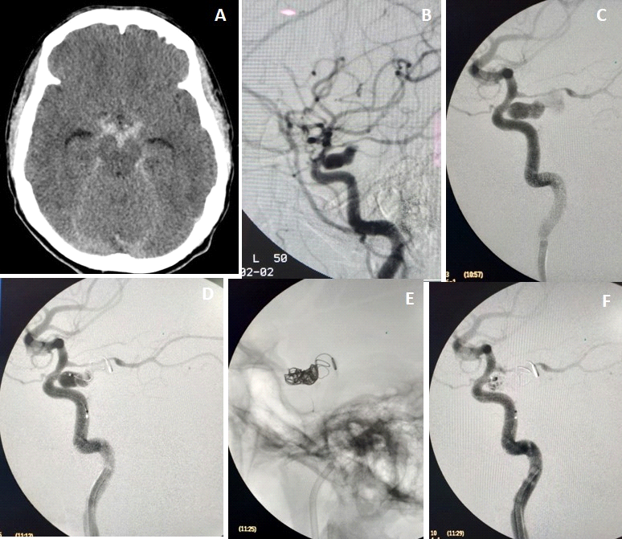

Figure 2:
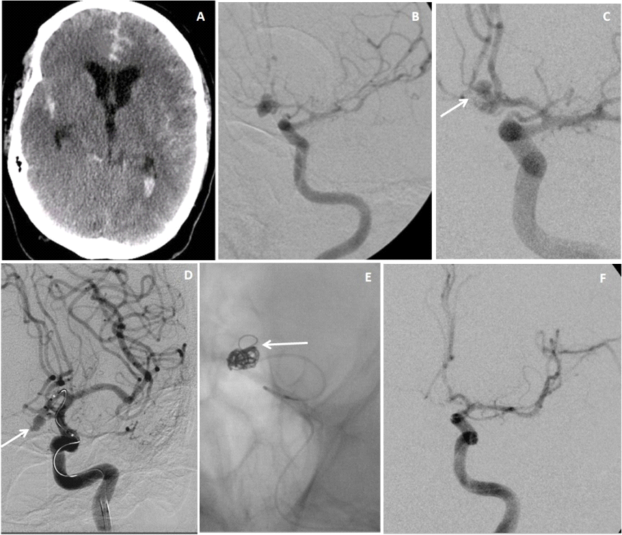

Figure 3:

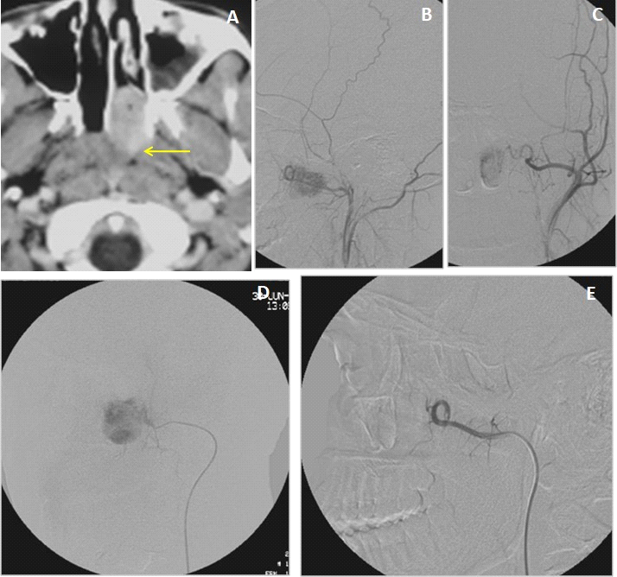

Figure 4:
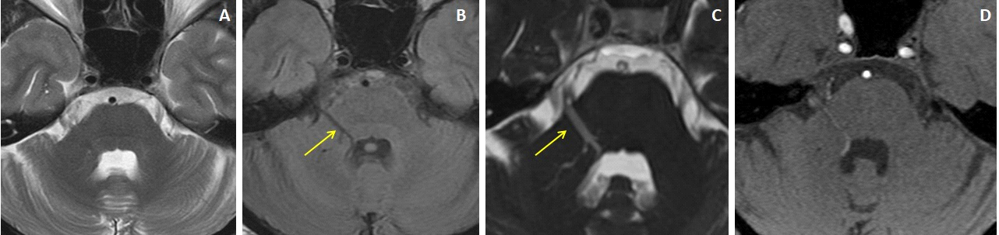

Figure 5:
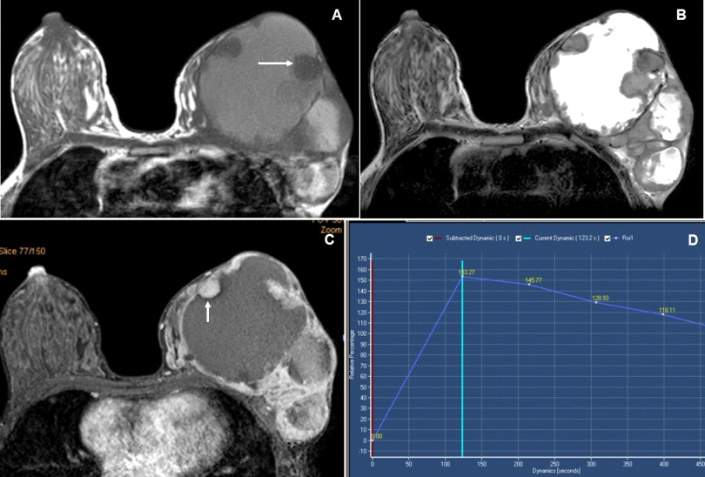

Legends:

Figure 1: 43 years female with grade-2 SAH. Axial plain CT scan of Brain (image A) shows plain CT hyperdense extra-axial bleed of SAH in the basal cisterns. Left ICA injection angiogram lateral views (images B and C) shows the lobulated ruptured aneurysm from the cavernous segment of left ICA. Microcatheter was negotiated to aneurysm sac and coil embolization was performed (image D &E).Post procedure angiography reveal (image F) near-total obliteration of the aneurysmal sac.
Figure 2: 47 years male with grade-4 SAH. Axial plain CT scan of Brain (image A) shows plain CT hyperdense extra-axial bleed of SAH in the cisternal spaces and lateral ventricles. Left ICA injection angiogram AP views ( images B and C) shows the lobulated ruptured aneurysm from the Acom. Microcatheter was negotiated to aneurysm sac and coil embolization was performed (image D &E).Post procedure angiography reveal (image F) near-total obliteration of the aneurismal sac.
Figure 3: CECT (image A) reveal a juvenal nasopharyngeal angiofibroma in left side of nasopharynx extends into the posterior nasal choana. Angiography of left external carotid artery ( B& C) reveals abnormal vascular blush from spheno-palatine branch of left IMA. Microcatheter was negotiated to feeding a artery and embolization was performed with PVA particles(image D).Post procedure angiography reveal (image E) complete obliteration of the vascular blush of the tumor.
Figure 4: Cranial MRI of 37 yr male patient of Trigeminal neuralgia presented with lancinating pain in the right side of the face since 22 years, precipitated during chewing, exposure to wind and during winter season. Axial T2W and FLAIR MRI images (A& B) showed an abnormal vascular channel running over the right middle cerebellar peduncle. 3D-CISS image and source image of 3D-TOF MRA (C &D) showed the abnormal venous angioma started from the ependymal lining of 4th ventricle and extends along the right trigeminal nerve with a positive NVB contact (arrows).
Figure 5: Breast MRI of 25 years female presented with a long-standing huge left breast lump. (A and B) Axial T1W and T2W images reveal a larger central T1 and T2 hyperintense dominant cystic lesion in the left breast with peripherally located T1 hypo and T2 isointense soft tissue nodules (arrow). (C and D) Axial dynamic post-contrast (DCE-MRI) image reveal thick irregular predominant peripheral enhancement of the cystic lesion with moderate heterogeneously enhancing peripheral soft tissue nodules (arrow) where the kinetic curve in the solid area shows rapid contrast uptake and rapid washout with Type-III curve. The MRI findings suggestive of BI-RADS 5 lesion, where histopathology showed mucinous carcinoma of the breast.

