Tribological study of in-situ Al–20Mg2Si composites at room and elevated temperature

Dayanand M.Goudar

*Tontadarya College of Engineering,Gadag-582101,India*

Rajashekar V. Kurahatti

*Basaveshwar Engineering College Bagalkot -562101, India*

**ABSTRACT**

The wear and friction properties of the aluminium metal matrix are of significant importance in the automotive and aerospace industries. The aim of the present study is to investigate the wear behavior of high content of Al-20Mg2Si of in-situ composite post processing by stir casting at elevated temperature and to compare it with the in situ cast composite. The microstructure of the in-situ cast and stir cast composites were have been studied by optical and scanning electron microscopy. The hardness was measured using a Vickers hardness tester. The wear test were carried out using a Pin on- Disc method at different applied loads and elevated temperatures (room temperature, 100 and 150°C) and a siding velocity of 1.0m/s. The in-situ stir-cast composite contains primary Mg2Si intermetallic particles uniformly distributed in a fine, spherical form. However, the cast in-situ composite displays coarse blocks of Mg2Si with sharp edges randomly distributed in the dendrite Al matrix. The hardness of in-situ stir cast composite shows 40% higher than cast composite. The result indicated that the stir cast composite showed a significant increase in wear resistance at test temperatures as compared to the in-situ conventional cast composite. The composite produced through in-situ stir casting exhibited low friction coefficients across various normal loads and elevated temperatures. The in-situ stir cast composite emerge to a better wear resistant material at elevated temperatures. The worn surfaces of alloys were examined with to understand the nature of the wear mechanism.

**1. INTRODUCTION**

**1.1 Overview of Aluminum alloys**: A typical composite material is a material system made up of two or more materials that have been macroscopically combined or bonded. Composite materials often include reinforcement like fibres, particles, flakes, and fillers that are incorporated into a matrix. Metals, ceramics, or polymers can make up the matrix. In the automotive and aerospace industries, metal matrix composites are crucial. Aluminum is commonly utilized in industry since it increases improved hardness and wear qualities and is lightweight and highly hard when reinforced with silicon carbide (SiC). Aluminum alloys differ from ductile iron or cast steel in that they have a relatively high tensile strength in relation to density. The castability, flowability, and melting points of aluminium casting alloys are comparable to those of other metals. The high specific tensile strength of aluminium alloys is significantly influenced by their multiphase microstructure [1]. Over 80% of all aluminium casting alloys contain silicon (Si), making it one of the most frequently alloyed elements with aluminium. Si increases the castability and hot cracking resistance of Al alloys [2]. The most typical uses for Al-Si alloys are in the marine, electrical, automotive, and aerospace industries. Excellent castability, high strength to-weight ratio, enhanced corrosion resistance, good weldability, and enhanced machinability are just a few of the benefits of hypoeutectic Al-Si alloys. Composites are created by combining two or more dissimilar materials from different phases to create a brand-new material with superior properties distinct from each of its distinct starting materials. This is done to meet the growing demands of the automotive, aerospace, and sporting goods industries[3]. The correct reinforcing metals are the foundation of Metal Matrix Composites (MMCs), an alternative material with improved qualities to satisfy certain applications. Comparatively to conventional materials, composites can be more easily customized to have particular properties like low weight, high specific strength and stiffness high wear resistance and a low coefficient of friction, high thermal conductivity, high energy absorption and cushioning capacity [4].

The attributes of the MMCs are influenced by their size, volume fraction, reinforcement morphology, processing technique, and matrix composition. Aluminum has been the most often used matrix for metal matrix composites since the 1920s, and there has been a lot of study done on it. In the 1980s, composite materials with an aluminum-reinforced matrix were developed for use in the transportation sector. Due to their low density, capacity to get stronger through precipitation, high thermal and electrical conductivity, and excellent damping capacity, aluminium and its alloys are highly sought-after materials. Because to its excellent fatigue and creep resistance, high specific modulus, and strength, aluminum-based metal matrix composites have caught the attention of structural materials in the aerospace, automotive, and transportation industries. [5]. In Fig. 1.1, a few application examples are displayed.

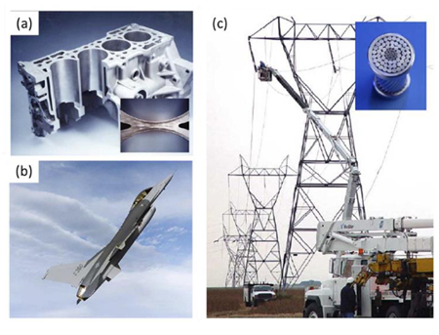

*Figure 1.1:* *Examples of applications of AMCs in industries.* ***(a)*** *Honda Prelude 2.01-cylinder  
block (Donaldson Steven L & Miracle Daniel B, 2001);* ***(b)*** *F-16 illustrating ventral fins on the bottom of the fuselage aft (rearward) of the wings (Donaldson Steven & Miracle Daniel, 2001);* ***(c)*** *Conductor cables of power transmission towers (Miracle, 2005)*

Alumina (Al2O3), zirconium diboride (ZrB2), titanium diboride (Mg2Si), magnesium silicide (Mg2Si), and aluminium nitride (AlN) are some of the different reinforcements that can be manufactured using in situ techniques.

These materials all have high melting points, high hardness, high elastic modulus, and high thermal conductivity [6]. Mg2Si is a popular choice at the interface between reinforcement and matrix because of its high melting point, high modulus, high hardness, good thermal conductivity, thermodynamic stability in liquid aluminium after formation, and most importantly the fact that it does not react with Al to form reaction product [7]. Table 1 lists the mechanical and physical characteristics of Mg2Si reinforcement.

Table 1: Physical and mechanical of properties of intermetallic compound Mg2Si

|  |  |
| --- | --- |
| **Material Properties (Units)** | **Values** |
| Melting point (0C) | 1085°C |
| Density (kg m−3) | 1.99×103 kg m−3 |
| Hardness (MN m−2) | 4500 MN m−2 |
| Coefficient of thermal expansion(K-1) | 7.5×10−6 |
| Elastic modulus (GPa) | 120 |

Due to its high melting point, high hardness, enhanced temperature resistance, and high modulus, the Mg2Si compound is a promising candidate for reinforcing particles in Al matrix composites [8]. Agglomeration, particle pushing by developing dendrites, weak particle-matrix interaction, and particle agglomeration at grain boundaries are just a few of the reasons that can cause unwanted non-uniform particle distributions in a metal matrix. To reap the rewards of particle reinforcement, the difficulties associated with composite synthesis and processing must be solved.

**1.2 Fabrication Techniques of AMCComposites**

Squeeze casting, compound casting, powder metallurgy, infiltration, spray deposition, stirred casting, and other manufacturing techniques have all been utilised to create aluminium matrix composites (AMCs), which can be used to create a metal matrix composite. The classification of the production of aluminium composite materials is shown in Fig. 1.2.

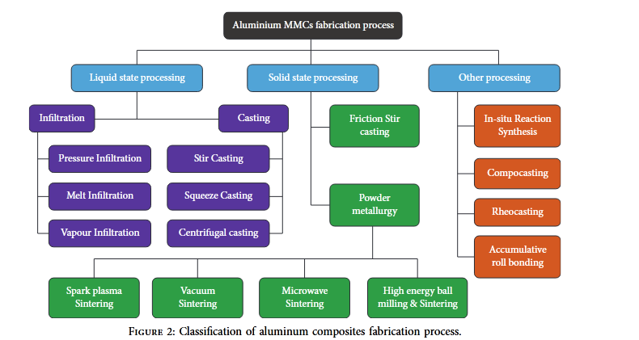

*Figure 1.2. Classification of aluminum composites fabrication process*

The classification of AMCs' production processes is shown in Fig. 3. A schematic diagram of the agitation casting, powder metallurgy, and hot extrusion processes is shown in Fig. 1.3 (a) (b) and(c). Due to mechanical incompatibility, mismatched thermal expansion coefficients between the matrix and the reinforcement particles, poor cohesion at the reinforcement-matrix interface brought on by improper wetting of the former by the latter, and undesirable interfacial reactions, these methods result in composites with poor properties [9]. The production of the reinforcing particles separately is traditionally the first step in the creation of AMCs. The integration of ceramic particles created either externally to or internally to the molten metal is a component of the liquid state processing method. Manufacturing. The first method is called ex situ stirred casting, while the second is called in situ direct smelting reaction or exothermic salt- Metal Reaction Engineering. A consistent distribution of filler particles in the matrix and strong interfacial adhesion between the matrix and the filler particle are just two of the unrivalled benefits of liquid state casting processes [10]. The most crucial factor to take into account when manufacturing AMCs is the processing procedure. Aluminum oxide (Al2O3) ceramic fillers were first introduced by S. Ray in 1968, and in this procedure, the filler is mechanically stirred into an alloy while it is still molten [11]. Fig.1.4 depicts the schematic diagram stir-casting method of producing composite materials.

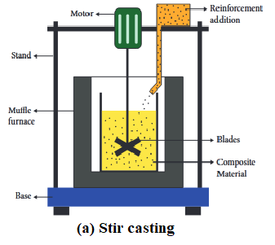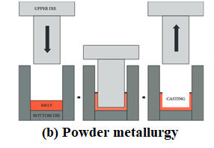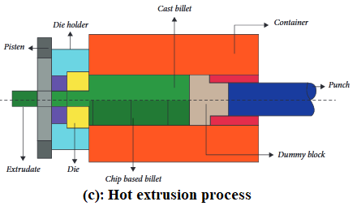

*Figure 1.3****:*** *Types of aluminum composites fabrication process; (a) Stir casting,*

*(b) Powder metallurgy (c) Hot extrusion process*

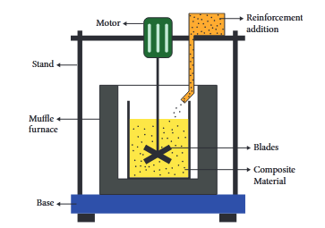

*Figure 1.4****:*** *Stir casting composite fabrication process*

Several researchers like the stir-casting method for processing discontinuously reinforced AMCs because melt-main stirring's advantages are that it is hassle-free, adaptable, non-problematic, reasonable, and appropriate for mass production [12].

**1.3. In Situ Casting**

The in situ method has been a desirable processing method for AMC production. Early in the 1990s, in situ synthesis was developed. The reinforcing particles are created in this technique through an in-situ interaction between the halide salts and the molten metal. The stirring casting method is less efficient than an exothermic process [13]. The in-situ reinforced structure exhibits a uniform distribution of fine-grain filler materials. Without using a wetting agent, it is simple to accomplish. AMCs, or aluminum matrix composites, have gained significant interest from the automotive and aerospace industries because of their impressive strength and stiffness, along with their enhanced hardness, wear resistance, and elevated temperature properties [1]. However, composites created by adding particles often encounter challenges, such as a weak matrix-reinforcement interface and uneven distribution of reinforcement particles. To address these issues, the in-situ processing of composites has been suggested as a potential solution.

The intermetallic compound Mg2Si exhibits a high melting temperature of 1085°C, low density of 1.99×103 kg m−3, high hardness of 4500 MN m−2, a low coefficient of thermal expansion (CTE) of 7.5×10−6 K−1 and a reasonably high elastic modulus of 120 GPa [14]. Due to its properties, Mg2Si can reinforce Mg- and Al-based MMCs to create ultra-light materials with improved specific properties. [15].Among in situ composites, Al-Mg2Si system has shown promising results, where the blocky-type primary Mg2Si reinforcements and flake-like eutectic or pseudo-eutectic Mg2Si inside the eutectic cell form during solidification of Al alloy containing Si and Mg [16]. Large reduction in density is thought to be a boon for automotive industries. Many investigations have been carried out in the past with incorporation of a high amount of Mg in Al-Si alloy [17]. First success is reported in a German patent specification [18] revealing an Al alloy containing up to 12% Mg and 5% Si (wt.% ) and the cast alloy contained 5 to 25% Mg2Si (wt.%) in aluminum. Furthermore, a German patent application deals also with an Al-Mg-Si based cast alloy which contains upto 11% Mg and 4.5% Si claiming it as a material for cylinder heads [19].

**1.4 Scope of the project**

The analysis of the microstructure, mechanical, and tribological characteristics of aluminium matrix composites reinforced with Mg2Si in situ particles is the main objective of this study. In situ composites are created by introducing varying concentrations of 20-Mg2Si composite by a in situ and stir casting. The in situ composites' microstructural, mechanical, and wear behaviour characteristics of Al-Mg2Si composites at room and elevated temperatures. The links between the microstructural features and hardness and wear properties of composite materials More research is done into how the matrix alloy and the quantity of Mg2Si reinforcing particles affect wear characteristics and wear mechanisms.

**1.5 Objectives**

The goals of this research are to investigate and assess the viability of producing composite made of aluminium utilising in-situ processing and to evaluate the microstructural, and tribological characteristics of the created composite s at room and elevated temperature .

The specific objectives of the present work are as follows:

1. To prepare of Al-20Mg2Si in-situ metal matrix composites
2. To study the microstructure characterization of the A1-20Mg2Si in-situ metal matrix by optical microscopy analysis.
3. To study the influence of normal pressure and sliding speed on the wear rate of the prepared A1-20Mg2Si in-situ metal matrix composite using a Pin-on-Disc wear testing machine both at room and elevated temperatures .

The Al-20Mg2Si in situ composite was produced by in situ stir casting. The new lightweight alloys have been studied with respect to microstructure, hardness, and wear behavior at room and elevated temperature.

**2. LITERATURE SURVEY**

Aluminum matrix composites containing numerous hard particles of Mg2Si are present in Hypereutectic Al-Si alloys that have a high Mg content. These Al-Mg2Si in-situ metal matrix composites have the potential to replace Al-Si alloys in automotive and aerospace applications because the intermetallic compound of Mg2Si has high melting temperature, low density, high hardness, low thermal expansion coefficient, and reasonably high elastic modulus [20].Al-Mg2Si composite is a new type of in situ AMCs that has recently been identified as a suitable material for various industries. This is primarily due to the presence of Mg2Si phases, which are believed to offer promising wear characteristics. However, there is currently limited research available on the wear behaviour of this material under different pre-wear history and wear conditions. A study has been conducted to investigate the effect of Yttrium addition and heat treatment on the room temperature tribological characteristics of Al-Mg2Si under applied loads of 10 N and 20 N. The study found that composites with Y-rich and heat-treated properties had better wear resistance than the as-cast ones. This was due to the hardness improvement resulting from Yttrium addition. Another study by Soltani et al. demonstrated that hot-extruded Al-Mg2Si composites had lower wear mass loss at room temperature, which was more pronounced with higher extrusion ratios. It was concluded that the dominant wear mechanism shifted from adhesion and delamination in as-cast specimens to abrasive wear in extruded composites.

In a study conducted by Saghafian et al. [24], the wear behavior of a thermoformed composite containing Al-25wt.%Mg2Si was analyzed. The study found that the dominant wear mechanism was delamination wear, caused by the formation of an MML containing pin and disc materials for all the applied loads. The study also reported that the transition from mild wear is designated as metallic wear, scuffing, seizure, and severe regimes [25]. In another study, the wear behavior of an in-situ Al-Mg2Si composite was investigated using a pin-on-disc configuration to analyze the effect of Mg2Si. The study found that the weight loss increased with an increase in reinforcing volume fraction, which could be due to the coarse morphology of primary Mg2Si particles. However, their main limitation is the presence of coarse and brittle primary and eutectic Mg2Si particles formed under conventional casting process conditions. These particles easily crack, causing the serious disseverance to the aluminum matrix and exposing the soft matrix to extreme wear, which results in poor mechanical properties and also makes wearing capacity unable to fully play. Therefore, it is essential for us to modify Mg2Si-reinforced aluminum matrix composites to change morphology and distribution of primary and eutectic Mg2Si phases with an aim of enhancing wear resistance of the composites.

# 3. EXPERIMENTAL PROCEDURES

## 3.1. Materials and casting procedure

The Al-20Mg2Si-2Cu cast hypereutectic ingots from Fenfee Metallurgical in Bangalore were melted again in an electric furnace, as depicted in figure 3.1a. The molten metal was super-heated and then poured into a preheated steel die to create cylindrical bars, as shown in figure 3.1b. Table 3.1 outlines the nominal compositions of the selected alloy. This study focuses on the results of hot extrusion and hot rolling, which aimed to refine the microstructure of the as-cast Al-Mg2Si composites. These findings will shed light on the future potential applications for these composites.

Table 3.1 Nominal compositions (wt.%) of h Al-Mg2Si-2Cu composites

|  |  |  |  |  |  |  |
| --- | --- | --- | --- | --- | --- | --- |
| Composites | Si | Fe | Mn | Mg | Ni | Al |
| Al-20Mg2Si | 7.39 | 0.7 | 0.04 | 11.8 | 0.24 | Bal |

To achieve a fine and uniform distribution of Mg2Si in the matrix, the alloy was melted and stirred intermittently for 60 minutes using a mechanical stirrer. The melt temperature was measured using a K-type thermocouple made of chrome-alumel. Afterward, the molten mixture was poured into a cylindrical graphite mold to create castings with a diameter of 50 mm and a length of 300 mm, as shown in figure 3.1b.

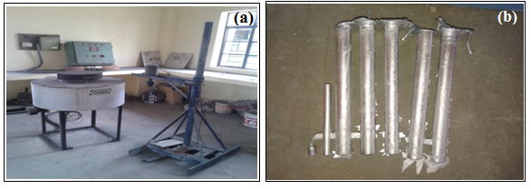

*Figure 3.1.(a) Electrical melting furnace with mechanical stirrer (b) cylindrical castings*

**3.2 Metallographic sample preparation**

To conduct microstructural analyses, we used standard metallographic techniques to prepare the samples. First, we sectioned them to a manageable size and then mounted them in a liquid mixture of resin and catalyst using the cold mounting method (as shown in Figure 4) to make handling, grinding, and polishing easier. We used Silicon Carbide water abrasive paper discs with varying grits (ranging from 120 to 2000) and a double-disc variable speed grinding/polishing machine (Metatech-DM-2T) to grind and micro polish the samples. For the final polishing, we used a Levi-gated polishing water suspended alumina on velvet cloth and a diamond paste of 0.5 to 2µm on a polishing Pressure Sensitive Adhesive (PSA) backed velvet cloth with aero spray. To prepare the samples from the composites, we machined them from the center portion of the cast. We then used standard metallographic techniques to grind them on emery paper with different specifications (1/0, 2/0, 3/0, and 4/0) and polished them on a wheel cloth using brasso and kerosene. Finally, we etched the polished samples with Keller's reagent (which consists of 1% vol. hydrofluoric acid, 1.5% vol. hydrochloric acid, 2.5% vol. nitric acid, and the rest water).

**3.2.2 Optical (OM) Microscopy**

To examine the microstructure of the base and composites, an optical microscope (Zynx) was used. The composites, which were cut from the billets, underwent preparation for optical microscopy to study their microstructures. To measure grain size, image analysis was conducted according to the protocol outlined in ASTM E-112-96 (ASTM, 2003).Microstructural observation of the worn specimens was studied by using a Optical microscope.

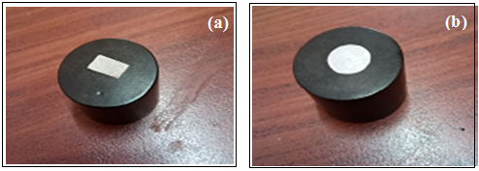

Figure 3.2. Mounted samples for microstructure and microhardness (a) insitu cast (b) sir cast composite

**3.3.1 Hardness test**

The composites underwent microhardness measurements using a Vickers hardness tester (Model: MVH, Meta-tech Industries, India). For each indentation, a load of 300 g was applied and allowed to dwell for 15 seconds. The micro-hardness values reported in this study are the average of five readings.

**3.4 Dry sliding wear characterization**

## 3.4.1. Wear testing procedure

The composites specimen were machined into cylindrical pins of 60 mm × Փ8 mm for conducting dry sliding wear tests (Figure 3.4) on a pin-on-disc testing machine (as shown in figure 3.5a) (DUCOM-Wear &Friction Monitor-TR-20LE) having a steel disk made of EN-32 material at a sliding velocity of 1.0 m/s (Disc speed- 160 rpm) and varying the normal loads of 10,20,30 and 40N.All the tests were carried out at room temperature and different elevated sliding temperatures (100, 200 and 300oC) with a wear track diameter of 120mm and sliding distance of 2000 m and repeated three times. The test pin was heated by inserting the shank portion of the pin into the hole surrounded by a heating element (Figure 3.5 b) and temperature was measured using a commercially available small chrome-alumel type thermocouple foil with a stainless steel sheath of 0.25 mm outer diameter placed inside the hole made at the pin centre. After completion of each wear test at different test conditions, wear samples were cleaned with acetone. Weight loss of pin (ΔW) was calculated by measuring the difference in weight of a pin before and after each test. The wear rate (*WR*) is calculated by using Equation 1.

|  |  |
| --- | --- |
| $$WR=\frac{(ΔW/density of alloy )}{SD }{mm}^{3}/m$$ | (1) |

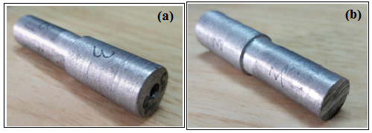

Figure 3.4. Wear test pins (a) top end (b) wear end

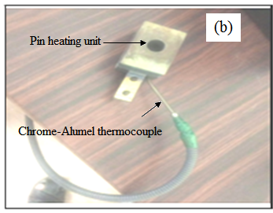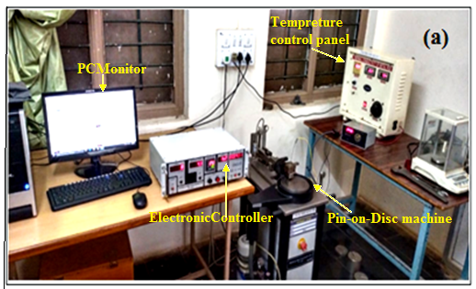

Figure 3.5. (a) Pin-on-Disc testing machine (b) specimen heating attachment.

### 4. RESULTS AND DISCUSSION

### 4.1 Microstructural study

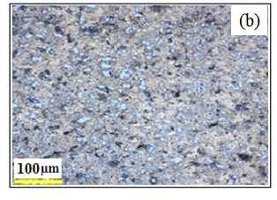Figure 4.1 (a) shows optical microscopic image of the as cast composite, which consists of coarse Mg2Si blocks with sharp-edged primary Mg2 Si particles non uniformly dispersed in the dendrite Al matrix. Figure 4.1b shows the optical micrograph as-cast Al-20Mg2Si composite . It consists of fine primary Mg2Si phase are distributed randomly in the Al- matrix of dendrite network structure.

**

*Figure 4.1 Optical microstructure of (a) In situ cast composite and (b) in situ stir cast composite*

**4.2. Hardness**

Table 4.31 shows the results of microhardness measurements. The composites hardness significantly increased as compared to the in situ as-cast composite. The increase in the hardness of the in situ stir is due to partial recrystallization, fragmentation, and redistribution of the primary Mg2Si phase. Uniformly dispersed hard β-particles with high volume fractions increase the flow stress and provide an appreciable impediment to plastic deformation. The flow stress value of the alloy with a higher level of Mg2Si increases due to the presence of a larger amount of fine Mg2Si particles. These phases obstruct the movement of dislocations more efficiently and make it more difficult for plastic deformation to proceed.

|  |  |  |
| --- | --- | --- |
| Alloy | Processing condition | Hardness (Hv) |
| Al-20Mg2Si-2Cu | in situ as-cast | 69 ±1.62 |
| Al-20Mg2Si-2Cu | stir cast | 110 ±1.74 |

**4.3. Wear test**

Figure 4.2 illustrates the wear rate variation of the in situ cast and stir cast composites at different sliding temperatures. It's clear that, as the applied load increases from 10 to 40 N, the wear rate for both types of composite materials increases linearly. This trend is observed across a range of sliding temperatures, from room temperature to 150oC. Interestingly, the in situ cast composites have higher wear rates than the stir cast composites at room temperature. Overall, there is a significant difference in wear rate between the two types of composites.



*Figure 4.2(a). Variation of wear rate with load at 1.0 m/s sliding velocity at room tempreture*



*Figure 4.2(b). Variation of wear rate with load at 1.0 m/s sliding velocity at 100oC tempreture*



*Figure 4.2(c). Variation of wear rate with load at 1.0 m/s sliding velocity at 150oC tempreture*

The increasing trend of the wear rate with increasing applied load causes an increase in the sliding contact area and excessive plastic deformation of the asperities, resulting in a greater degree of wear particle generation and a higher wear rate. The results show that the wear rate of the stir cast composites is approximately 57%, 52%, and 42% lower than that of the cast composite alloy at RT, 100, and 200°C sliding temperatures respectively, over the entire applied load range. The improved properties of the sir-cast composite can be attributed to the microstructural modifications. The Al matrix contains evenly distributed primary Mg2Si particles, which provide resistance and contribute to the composite's relatively high hardness. These fine particles are less likely to experience micro-cracks, and smaller particles are even less likely to rupture. As the service temperature increases within limits, the matrix can accommodate the Si and intermetallic particles better due to its improved ductility properties.

The high wear rate in the insitu conventional cast composite could be due to the presence of large irregular coarse Mg2Si particles, hard coarse intermetallic and needle-like eutectic Si with a high aspect ratio, resulting in high-stress concentrations at the particle/matrix interface, and an easy pathway for crack initiation and propagation [26]. The interaction of these cracks leads to the detachment of planar wear particles through the delamination wear process. In addition, Si particles with higher aspect ratios are more prone to fragmentation. Due to the deboning between particle and matrix, fragmented Si and intermetallic particles can no longer bear the load so; the disc surface and soft Al matrix come into direct contact. Large stresses are generated in the Al matrix around the contact surfaces, which promotes the development of subsurface cracks and delamination. However, the fragmented, hard Mg2Si intermetallic particles can act as the third body abrasives and increase the deterioration of the worn surface through an abrasive wear mechanism, resulting in a higher wear rate. Compared to the cast composite, spray-formed alloys show higher wear resistance both at RT and at elevated interface temperatures. The stir-cast composite exhibits high wear resistance over the full range of applied loads and sliding temperatures.

The stir cast composite has a higher level of hardness due to both precipitation and solid solution hardening, as well as a fine morphology of the Mg2Si intermetallic particles. This leads to a more mechanically stable matrix, which supports the formed tribolyer and increases the wear resistance of the in situ composites. The high content of Si and intermetallic compounds greatly improves wear resistance by providing high hardness that resists plastic deformation, delamination and oxidative wear, which can be further improved with the formation of an oxide film. It has been observed that when the temperature levels between RT and 150°C are increased, the rate of wear decreases. This is because the higher interface temperature leads to the oxidation of the alloys, resulting in a thicker glazed oxide layer which acts as a protective layer, ultimately reducing the wear rate. Additionally, the increase in temperature at the contacts of the interface asperities causes the rupture and fragmentation of the mechanically mixed tribo-layer due to temperature rise and their interactions.

When the amount of force applied increases, the combination of temperature, speed, and their interactions decrease in intensity. Friction, during sliding contact, causes the highest amount of stress to be transferred to the surface. At low loads, which fall between 10N-20N, the highest amount of shear stress is beneath the surface. The rate of wear is controlled by the fracture of the oxide layer and the removal of oxide debris particles, with no subsurface deformation. However, when the load increases to 20-30N, the stress created under the slider is lower than the strength of the Si particles. This leads to the unbroken Si and intermetallic particles acting as load-bearing elements and scratching the surface of the counterpart. This prevents the aluminum matrix from being directly involved in wear. However, some particles chipping from the Si and/or other intermetallic particles will wear away the soft aluminum matrix, resulting in a low wear rate. When the load is high, between 30N and 40N, Si and intermetallic particles cannot bear the load, causing the Al matrix to become directly involved in the wear process due to direct contact with the counter surface. As a result, a large amount of stress is generated, and microcracks form in the Al matrix adjacent to the contact area. Additionally, the Si and intermetallic particles break and become wear bodies of the third body, leading to the initiation of the groove profile on the worn surface. It is important to note that the stir cast insitu composite has significantly lower wear rates than the in-situ cast composite at both room temperature and increased temperature levels, regardless of the applied loads. There are several contributing factors to this low wear rate in the stir cast in situ composite.

Firstly, the high hardness of the stir cast insitu composite provides excellent resistance to abrasive wear. Secondly, the spherical morphology of Si and intermetallic particles reduces particle/matrix contact area, which ultimately decreases the potential for particle pullout. Additionally, the homogeneous distribution of the intermetallic Mg2Si particles enhances the stir cast insitu composite's resistance to adhesive wear. Lastly, the matrix surface is less exposed to the counter disk, thereby reducing its wear rate.

The fine and hard Mg2Si intermetallic particles in the stir cast insitu composite were more difficult to remove from the surface due to their superior mechanical properties. On the other hand, the abrasion of the rotating disk was caused by the rubbing action of hard Mg2Si intermetallic particles. As a result, iron oxide debris was generated and mixed with alloy debris. Fresh oxides developed on the wear marks, which were subsequently removed by the pin as it wore. As a result of the continued attrition of this debris, which sintered under the applied force, a tribolayer, or mechanically mixed layer, developed. According to reports, the presence of such a layer significantly reduces wear [27]. In addition, the thermal stability of the stir-cast composite was better than that of the cast composite due to the uniform distribution of the thermally stable Mg2Si particles. In Figure 4.3 a-d, changes in COF due to applied load and temperature are displayed. The data reveals that as load increases, the COF decreases for both cast and stir-cast composites. Interestingly, the COF for stir-cast composites is lower compared to conventional cast composites. The results indicate that in conventional cast in-situ composites, the surrounding matrix alloy of the coarse primary Mg2Si intermetallic phase gets eroded, leading to a loss of contact between intermetallic particles.





*Figure 4.3. The variation of friction coefficient with applied load at different sliding temperatures (a) RT, (b) 100oC and ,(c) 150oC*

In Figure 4.4, optical images of worn surfaces tested at 150°C are displayed. The worn surface of the cast in situ composite exhibits fine, smooth-edged grooves, with noticeable small indentations and patches of oxide layers. At 150°C, the worn surface appears relatively smooth with fine ridges and plowing marks. Only a few ridges are extending from end to end and a limited number of small pits. The presence of white spots indicates oxidation wear, and the formation of continuous wear grooves and some damaged areas and plowing marks suggest abrasive wear. In Figure 4.4b, it is evident that the worn surface appears smooth with shallow and narrow microgrooves. Some small dimples and a few scoring marks, which extend from one end to the other, are also visible on the surface. Furthermore, white patches and spots on the surface indicate the formation of oxide. These features are typical of abrasive wear where the harder surface's asperities dig into the softer material, resulting in material removal mainly through plowing, which creates grooves on the wear surface.

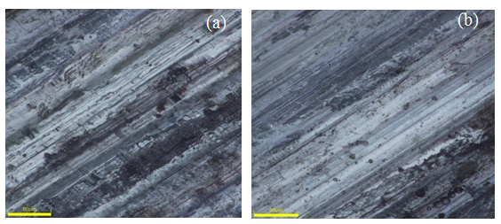

*Figure 4.4 .The worn surface of (a) in situ cast and (b)stir cast composite at applied load of 40Nand sliding velocity 1.0m/s*

**5 CONCLUSION**

This study explores the effectiveness of the in situ and stir cast method, which combines affordability with improved performance and characteristics. This method results in a microstructure that typically consists of fine, equiaxed, or nearly spherical grains, making it ideal for achieving microstructural homogeneity and low levels of microsegregation, while avoiding columnar or dendritic morphologies. Specifically, this study focuses on the tribological properties of in situ Al-20Mg2Si composite at high temperatures. The wear study was conducted at different loads and temperatures, with a constant sliding velocity of 1.m/s. Based on the findings, the following conclusions were drawn:

* The microstructure of the stir cast in situ composite consists of fine, spherical primary Mg2Si particles evenly distributed throughout the Al matrix.
* The in-situ conventional cast composite consists of primary coarse Mg2Si having sharp-edged primary Si particles non-uniformly dispersion in the dendrite Al matrix.
* The wear rate of both in-situ composites increases linearly with the increasing applied load throughout sliding temperature, which varies from room temperature to 150°C.
* The stir cast in situ composite shows a lower wear rate in the whole applied load range from 10 to 40N and a sliding temperature between RT and 150°C.
* Compared to the conventional in-situ cast composite, stir cast in situ composite shows higher wear resistance both at RT and at elevated interface temperatures.

**REFERENCES**

[1]. ASM International. All Rights Reserved. Aluminium-Silicon Casting Alloys: Atlas of Microfractographs(#06993G), https://www.asminternational.org/documents/10192/1849770/06993G_Chapter_1.pdf/68b fae89-f512-4bb4-8bb4-bd5d20111c612, 2004

[2]. Encyclopedia of Physical Science and Technology Reference Work Third Edition 2001 <https://www.sciencedirect.com/referencework/9780122274107/encyclopedia-of-physicalscience-and-technology>

[3]. S L, Pramod & Bakshi, Srinivasa & Murty, B. (2015). Aluminium-Based Cast In Situ Composites: A Review. Journal of Materials Engineering and Performance. 24. 10.1007/s11665-015-1424-2.

[4]. Encyclopedia of Physical Science and Technology (Third Edition) 2003, Pages 455-468 <https://www.sciencedirect.com/science/article/pii/B0122274105001289>

[5]. Advanced Mechanics of Composite Materials and Structural Elements Book, Third Edition 2013 <https://www.sciencedirect.com/book/9780080982311/advanced-mechanicsof-composite-materials-and-structural-elements>

[6]. MaryaRaji, Nadia Zari, RachidBouhfid, Abou el kacemQaiss, 5 - Durability of composite materials during hydrothermal and environmental aging, Composites Science and Engineering, Durability and Life Prediction in Biocomposites, Fibre-Reinforced Composites and Hybrid Composites, Woodhead, 2019, Pages 83-119, ISBN 9780081022900,https://doi.org/10.1016/B978-0-08-102290-0.00005-2.

[7]. Appendix IV - Sources of material property data, Editor(s): J.W. Martin, Materials for Engineering (Third Edition), Woodhead Publishing, 2006, Pages 237-239, ISBN 9781845691578, <https://doi.org/10.1016/B978-1-84569-157-8.50017-4>.

[8]. Composite Materials Volume I. Materials and Engineering Mechanics Part 1. Materials Carl Zweben First published: 20 February 2015 https://doi.org/10.1002/9781118985960.meh110 <https://onlinelibrary.wiley.com/doi/full/10.1002/9781118985960.meh110>

[9]. Rajak, D.K., Pagar. D.D., Kumar, R., &Pruncu, C.I. (2019). Recent progress of reinforcement materials: a comprehensive overview of composite materials. Journal of Materials Research and Technology.

[10]. Zeaid Hasan, Chapter 2 - Composite materials, Editor(s): ZeaidHasan, Tooling for Composite Aerospace Structures, Butterworth-Heinemann, 2020, Pages 21-48,ISBN 65 9780128199572, <https://doi.org/10.1016/B9780128199572.00002X>.

[11]. Polymer Science: A Comprehensive Reference Reference Work • 2012 <https://www.sciencedirect.com/referencework/9780080878621/polymer-science-acomprehensive-reference>

[12]. A. Treviso, B. Van Genechten, D. Mundo, M. Tournour, Damping in composite materials: Properties and models, Composites Part B: Engineering, Volume 78, 2015, Pages 144- 152, ISSN 1359-8368,

[13]. L. Lu, M.O. Lai, F.L. Chen, Al-4 wt% Cu Composite reinforced with in-situ TiB2 particles, Acta Materialia, Volume 45, Issue 10, 1997, Pages 4297-4309, ISSN 1359-6454

[14] Y. Sun, C. Li, Y. Liu, L. Yu and H. Li, Intermetallic phase evolution and strengthening effect in Al–Mg2Si alloys with

different Cu/Ni ratios, Mater. Lett., 2018, 215, 254–258.

[15] K. K. A. Kumar, U. T. S. Pillai, B. C. Pai and M. Chakraborty, Dry sliding wear behaviour of Mg–Si alloys, Wear, 2013, 303, 56–64.

[16] G. B. Hamu, D. Eliezer and K. S. Shin, The role of Mg2Si on the corrosion behavior of wrought Mg–Zn–Mn alloy, Intermetallics, 2008, 16, 860–867.

[17] .G.Shabestari and H.Moemeni, Effect of Cu and solidification conditions on microstructure and mechanical properties of Al-Si-Mg alloys. Journal of Mat Process Technol., Vol 153–154, 2004, pp 193-198.

[18] N.Ellendt, V.Uhlenwinkel, O.Stelling, A.Irretier and O. Kessler, Spray forming of Mg2Si- rich Aluminium alloys, Journal of Materials Science Forum Vol 534-536,2007, pp 437- 440.

[19] Olaf Stelling, Olaf KsBler, Hans- Werner Zpch, Nils Ellendt and V.Uhelenwinkel , New spray formed Aluminium-Silicon-copper alloys with high Mg2Si content, Proceedings of the Conference on Spray deposition and Melt Atomization (SDMA), 2006

[20] Q. C. Jiang, H. Y. Wang, Y. Wang, B. X. Ma and J. G. Wang,Modication of Mg2Si in Mg–Si alloys with yttrium, Mater. Sci. Eng., A, 2005, 392, 130–135.

[21] X. Wang, S. Esmaeili and D.J. Lloyd, The sequence of precipitation in the Al-Mg-Si-Cu alloy AA6111, Journal of Metall. Mater. Trans. A, Vol 37, 2006 ,pp 2691-2699.

[22] S.K. Chaudhury and D. Apelian, Fluidized Bed Heat Treatment of Cast Al-Si-Cu-Mg Alloys, Journal of Metallurgical and Materials Transactions A, Vol 37A, 2006,pp 2295-2311

[23] Y. Song and T. N. Baker, A calorimetric and metallographic study of precipitation process in AA6061 and its composites, Journal of Mater. Sci. Egg, A, Vol A 201, 1995, pp 251-260.

# [24] [Hassan Saghafian](https://www.researchgate.net/profile/Hassan-Saghafian), [S.G. Shabestari](https://www.researchgate.net/profile/Sg-Shabestari), [M.H. Ghoncheh](https://www.researchgate.net/scientific-contributions/MH-Ghoncheh-2191850829) , [Farzin Sahih](https://www.researchgate.net/profile/Farzin-Sahihi-2), [Farzin Sahih](https://www.researchgate.net/profile/Farzin-Sahihi-2). Wear Behavior of Thixoformed Al-25 wt% Mg 2 Si Composites Produced by Slope Casting Method,

[Tribology Transactions](https://www.researchgate.net/journal/Tribology-Transactions-1547-397X) 58(2):288-99’2015,DOI:[10.1080/10402004.2014.963770](http://dx.doi.org/10.1080/10402004.2014.963770)

## [25] Wear Behavior of Al‐Mg2SiAl‐Mg2Si Cast In‐situ Composite: Effect of Mg2SiMg2Si Different Volume Fractions AIP Conference Proceedings 1252, 1012 (2010); <https://doi.org/10.1063/1.3457493>

## [26 ] Soltani  H.R. Jafari Nodooshan , A. Bahrami , [M.I. PechCanul](https://www.sciencedirect.com/author/55993766200/martin-ignacio-pech-canul)[d](https://www.sciencedirect.com/author/55993766200/martin-ignacio-pech-canul), Wencai Liu b, Gouhua Wu b

## Effect of hot extrusion on wear properties of Al–15 wt.% Mg2Si in situ metal matrix composites

[27] [Dayanand M. Goudar](http://www.sciencedirect.com/science/article/pii/S0261306913003336), K.[Raju](http://www.sciencedirect.com/science/article/pii/S0261306913003336), V.C.[Srivastava](http://www.sciencedirect.com/science/article/pii/S0261306913003336), G.B. [Rudrakshi](http://www.sciencedirect.com/science/article/pii/S0261306913003336), Effect of secondaryprocessing on the microstructure and wear behavior of spray formed Al-30Mg2Si-2Cu alloy, Journal of Materials and Design, Vol 47, 2013, pp 489- 496.

[28]Y.J. Li, S. Brusethaug and A. Olsen, Influence of Cu on the mechanical properties and precipitation behavior of AlSi7Mg Alloy during aging treatment, Journal of Scripta Mater., Vol 54, 2006,pp 99-103