Overview of biofuel production by means of bio technology

Thapliyal shikha¹ , Rana Nisha^{1*}
*Corresponding author
¹ M.Sc Student, Department of zoology, Keral Verma Subharti college of science, Swami Vivekanand Subharti University, Meerut, 250005, Uttar Pradesh, India.
^{1*}Assistant professor, Central Research and Incubation Centre, Swami Vivekanand Subharti University, Meerut, 250005, Uttar Pradesh, India.

ABSTRACT
In the today’s era biotechnology plays a crucial role in various sectors including medicine, agriculture and environmental conservation. In order to create biofuels, biological organisms like microbes or algae are used to break down organic resources into useful fuels like ethanol or biodiesel. When compared to conventional fossil fuels, this strategy has the potential to minimise greenhouse gas emissions and be more sustainable. The production of biofuel can be scaled up and its efficiency is constantly being investigated by researchers employing biotechnological techniques. Biofuels, which emit fewer greenhouse gas emissions than fossil fuels do, contribute to reducing global warming while also supporting environmentally and socially responsible energy alternatives. This paper provides an overview of how biotechnology helped in the production of Biofuels in sustainable manner.
Keywords- Biotechnology, biofuels, Micro algae, E. coli.
- Introduction
“Biofuels” are substances containing additional energy that are made by biological processes or obtained from the biomass of living things like microalgae, plants, and bacteria.[1]. The demand for energy is rising daily as a result of the massive growth in the world’s population, and biofuels can serve as a source of energy to meet this demand. The most well-known source of biofuels for many years has been plant biomass.
Biofuels are seen as a way to reducing reliance on foreign oil, cutting emissions of greenhouse gases, primarily carbon dioxide (CO2) and methane (CH4), and reaching rural development goals by a growing number of developed and rapidly emerging nations [3].
The utilisation of photosynthetic organisms as a biofuel source is both inexpensive and viable, as atmospheric CO2 serves as a carbon supply and sunlight serves as an energy source [4].

- TYPES OF BIOFUELS
The primary biofuels include biodiesel, fatty acids, carbohydrates, ethanol, cellulose, or biological biomass, which can be produced by a variety of species of bacteria, yeast, or algae [5]. In general, primary and secondary biofuels are distinguished from one another. Secondary biofuels are made by processing biomass and are available from a variety of plant species, including jatropha, cassava, miscanthus, straw, grass, and wood, and can be used in vehicles and various industrial processes in contrast to primary biofuels, such as animal and forest plant firewood, which are used primarily for heating, cooking, or electricity production [2]. The secondary biofuels are further divided into first, second, and third generation biofuels.
First Generation include bioethanol or butanol and Biodiesel, bioethanol is produced by fermenting starches (from wheat, corn and potatoes) or sugars (from sugarcane, sugar beetroot, etc.), and Transesterification of oil crops (such as discarded cooking oil, animal fats, palm, coconut, and rapeseed) yields biodiesel.
Second generation includes bioethanol and biodiesel that are manufactured by traditional technologies from innovative starch, oil, and sugar crops like Jatropha, cassava, or Miscanthus, and Syndiesel, bioethanol, and biobutanol produced from lignocellulosic resources (such as straw, wood, and grass).

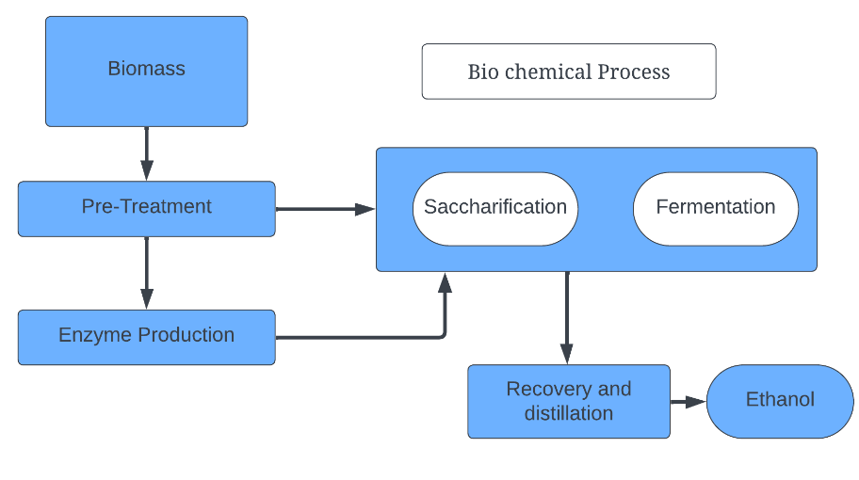
Figure 1.Production of second-generation Biofuels through biochemical process (14).

Third generation includes microalgae derived biodiesel, Hydrogen from green Microalgae and microbes and Seaweed and microalgae-based bioethanol [6].
Biotechnology methods such as fermentation, enzymatic digestion, or chemical conversion are used to manufacture biofuels. Ethanol, biodiesel, and biogas are examples of different biofuels. Biotechnology is essential in creating effective processes for producing biofuels, making them more environmentally friendly substitutes for fossil fuels. To increase the yields of biofuel production, it involves metabolic engineering, genetic engineering, and strain optimisation of microorganisms. As researchers look for ways to increase the effectiveness, scalability, and environmental impact of biofuel manufacturing processes, this sector continues to develop.
Developing effective enzymatic hydrolysis, investigating plant cell wall biosynthesis to understand the recalcitrant structure of ligno-cellulosic biomass, and exploring the different pretreatment processes used to deconstruct biomass are the main areas of interest in converting the polymeric carbohydrates present in plant biomass to fermentable sugars for affordable ethanol production [7]. The principal chemical building block for the synthesis of bioethanol and biomethanol is sugar [8].

The main biofuels are biodiesel, triglycerides, fatty acids, lipids, carbohydrates, ethanol, alcohols, cellulose, or the biomass of living organisms. Several species of algae, bacteria, or yeast can produce these fuels [9].
Although the production of biofuels has a tremendous deal of promise to be carbon-neutral, first-generation production techniques have significant economic and environmental drawbacks. The most frequent worry regarding the first generation biofuels currently in use is that as production capacity rise, so does competition for arable land utilised for food production between agriculture and biofuels. Additionally, intensive land use with heavy applications of fertiliser, pesticides, and water can result in serious environmental issues [10].
Through improved pre-treatments, enzymes, and fermentative organisms, methods for the biological conversion of cellulosic biomass have advanced particularly noticeably. The economics of biological conversion techniques have therefore improved. Second, the substantial recent increases in oil prices have made alternative fuels more competitive. Thirdly, governments have now adopted measures that support commercialization as a result of these high oil prices. Fourth, the choices for the large-scale, inexpensive synthesis of organic liquid fuels and chemicals to be utilised as biomass have become more limited due to growing worries about global climate change and the requirement for carbon-neutral fuels [11].
The output of biofuel is increased via biotechnology without significantly increasing the amount of energy required for manufacturing. With the aid of molecular biology, major advancements in microbial activity and enzymes have been produced during the past few decades [12]. In order to boost biofuel conversion, especially for lignocellulosic biomass, genetically modified organisms (GMOs) have been found to be the fastest and most effective way [13].
Researchers at TAMUK have improved the gas chromatography, mass spectrophotometry method, they have been successful in cloning the genes for cellulases and polygalacturonase enzymes to create a low-cost, effective biorefinery method to achieve maximal biomass conversion.[14].

- BIOFUELS FROM MICROALGAE
A thallophyte (a plant without roots, stems, or leaves) with chlorophyll an as its primary photosynthetic pigment and no sterile encasing of cells around the reproductive cells is known as a microalgae. one of the oldest known living creatures [15]. They produces a wide range of useful goods, including food, fuels (such as biodiesel, jet fuel, petrol, aviation gas and ethanol), dietary supplements, organic fertilisers, biodegradable polymers, pharmaceuticals and animal feed [16].
Microalgal cultivation is the first stage in the integrated production of biofuels from microalgae. Next, the cells are removed from the growth medium, and the lipids are extracted in order to produce biodiesel through transesterification [2].

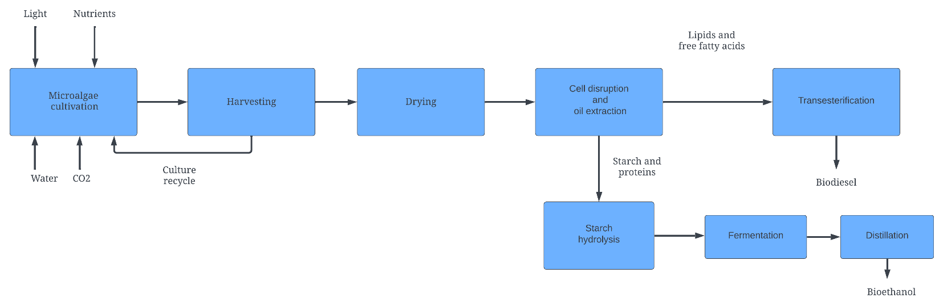

Figure 2.Production of microalgae-based biodiesel and bioethanol using an integrated process [2].

After oil extraction, amylolytic enzymes are used to promote starch hydrolysis and the creation of fermentable sugars. These sugars are fermented to produce bioethanol, which is then purified using conventional ethanol distillation methods [2].

- E. coli FOR BIOFUEL PRODUCTION

With the advancement of recombinant DNA technology, using a user-friendly bacteria like Escherichia coli for the production of biofuel could be an enticing alternative to the natural isolates [17]. Zymomonas mobilis ethanologenic pathway to E. Coli led to early studies on metabolic engineering for biofuels. Pyruvate is converted to ethanol in E. Coli by heterologous production of the enzyme’s pyruvate decarboxylase and alcohol dehydrogenase [18].

Compared to other industrial microorganisms, E. Coli offers several advantages for the production of biofuel, including the following: i) the capacity to grow both aerobically and anaerobically using various carbon sources in predetermined salt media; ii) the presence of high growth and metabolic rates; iii) a vast knowledgebase of genetic, metabolic, and physiological features; and iv) the availability of a variety of genetic tools for carrying out metabolic engineering.[19].

One of the most well-known and potential biofuel possibilities is 1-butanol, which is naturally produced from some Clostridium species (such as C. Acetobutylium) via the typical acetone butanol-ethanol (ABE) fermentation process. Starting from acetyl-CoAs, the fermentative butanol synthesis is catalysed by the enzymes thiolase, 3-hydroxylbutyryl-CoA dehydrogenase, crotonase, and butyryl-CoA dehydrogenase to produce butyryl-CoA, which is then transformed to 1-butanol by the enzyme aldehyde/alcohol dehydrogenase. Several research teams have rebuilt this route in E. Coli to produce butanol that is not native to the organism [19].

- CONCLUSION
The scope of biofuel biotechnology includes technological advancements, changes to degradation mechanisms, and feedstock chemistry. To promote scientific excellence and inform the global scientific and research community about the newest discoveries and developments in the area of biomass conversion to biofuels. [20]. It has been shown that using less pesticide and increasing agricultural yields are both benefits of biotechnology. A second generation of biofuels, which is already being created in lab settings, has the potential to use efficient, dedicated energy crops to produce more ethanol or better fuels with lower carbon emissions [21] Hence using biotechnology there is immense rise in the production of the biofuels without having adverse effect on environment.
Refrences
[1] Rodionova, Margarita & Poudyal, Roshan & Tiwari, Indira & Voloshin, Roman & Zharmukhamedov, Sergey & HG, Nam & Zayadan, Bolatkhan & Bruce, Barry & Hou, Harvey & Allakhverdiev, Suleyman. (2017). Biofuel production: Challenges and opportunities. International Journal of Hydrogen Energy,2017 42.
[2] G. Dragone, B. Fernande, A.A Vicente, J.A Teixeira, Third Generation biofuels from microalgae. In: Mendez-Vilas A, Editor. Current research, technology and education topics inApplied microbiology and microbial biotechnology. Formatex; 2010.
[3] L.P Koh and J. Ghazoul, Biofuels, biodiversity, and people: understanding the conflicts and finding opportunities. BiologicalConservation. 2008; 141, pp.2450-2460.
[4] R.A Voloshin, V.D Kreslavski , S.K Zharmukhamedov , V.S Bedbenov , S. Ramakrishna , S.I Allakhverdiev , Photoelectrochemical cells based on photosynthetic Systems: a review. Biofuel Res J 2015; 6:227.
[5] R.S Poudyal, I. Tiwari, M.M Najafpour, D.A Los, R. Carpentier, J.R Shen, S.I Allakjverdiev, Current insights to enhance hydrogen Production by photosynthetic organisms. In: Stolten D, Emonts B, editors. Hydrogen science and engineering; 2015, pp. 461-487.
[6] P.S Nigam, A. Singh, Production of liquid biofuels from renewable resources. Progress in Energy and Combustion Science. 2010, pp. 52-68.
[7] A. Mittal and S.R Decker. Special issue: Application of biotechnology for biofuels: transforming biomass to biofuels. 3 Biotech. 2013, 3(5) pp.341-343.
[8] M.O.S Dias, A.V Ensinas, S.A Nebra, R.M Filho, C.E.V. Rossell, M.R.W Maciel, Production of bioethanol and other bio-based Materials from sugarcane bagasse: integration to Conventional bioethanol production process. Chem Eng ResDes 2009, 87 pp.1206-1216.
[9] R.S Poudyal, I. Tiwari, M.M Najafpour, D.A Los, R. Carpentier, J.R Shen, S.I Allakjverdiev, Current insights to enhance hydrogen Production by photosynthetic organisms. In: Stolten D, Emonts B, editors. Hydrogen science and engineering; 2015, pp. 461-487.
[10] P. Schenk , S. Thomas-Hall, E. Stephens , U. Marx , J. Mussgnug , C. Posten , O. Kruse , B. Hankamer , Second generation biofuels: high efficiency microalgae for biodiesel production. BioEnergy Research. 2008; 1, pp. 20-43.
[11] B. Hahn-Hägerdal, M.E. Himmel, C. Somerville, C. Wyman, Welcome to Biotechnology for Biofuels. Biotechnol Biofuels 2008, 1, pp- 1-4.
[12] D. Lee, A. Chen, R. Nair, Genetically engineered crops for biofuel production: regulatory perspectives. Biotechnology and Genetic Engineering Reviews, 2008 25(1), pp.331-362.
[13] J.Gressel, Transgenics are imperative for biofuel crops. Plant Science, 2008 174(3), pp.246-263.
[14] T. Tseten and K. Murthy, Advances and Biotechnological Applications in Biofuel Production: A Review. Open Journal of Renewable and Sustainable Energy, 2014, pp. 29-34.
[15] L.Brennan ,and P. Owende Biofuels from microalgae—A review of technologies for production, processing, and extractions of Biofuels and co-products. Renewable and Sustainable Energy Reviews. 2010, 14, pp.557-577.
[16] O. Pulz, and W. Gross Valuable products from biotechnology of Microalgae. Appl Microbiol Biotechnol, 2004, 65, pp.635–648.
[17] H. Alper and G. Stephanopoulos, Engineering for biofuels: exploiting innate microbial 367 capacity or importing biosynthetic potential? Nat Rev Microbiol 2009, 7, pp.715-723.
[18] L.O. Ingram, T. Conway, F. Alterthum, Ethanol production by Escherichia coli strains co-expressing Zymomonas PDC and ADH genes. US Patent 1991.
[19] W. Chonglong, B.F Pfleger, S.W Kim, Reassessing Escherichia coli as a cell factory for biofuel production,Current Opinion in Biotechnology, 2017, 45, pp. 92-103.
[20] A. Mittal and S.R.Decker Special issue: Application of biotechnology for biofuels: transforming biomass to biofuels 3 Biotech (2013) 3 pp. 341–343.
[21] S. Sexton, D. Zilberman, D. Rajagopal, G. Hochman, The Role of Biotechnology in a Sustainable Biofuel Future. AgBioForum, 2009, 12(1) pp. 130-140.

