Digital Heritage of Asian Buddhist Caves Using Cultural Computing and AI: Special Reference to Ajanta Caves

Amrapali Prakash Tribhuvan
amrapaliprakash512@gmail.com

Dr. Binnaser Aziz Abdullah
azizbinnaser@gmail.com

ABSTRACT
UNESCO refers to 'digital heritage' as unique resources of human knowledge and expression "created digitally or converted into digital-form from existing analogue resources". Cultural Computing is emerging field for translation of culture. It uses scientific methods to represent essential aspects of culture. It includes computation of emotion, story, and culture. It is more than integrating cultural aspects into the interaction. Artificial Intelligence is another useful tool for preventing cultural heritage. Ajanta caves are universally regarded as masterpieces of Buddhist religious art. In this proposed research work author is trying to help to preserve, use and experience Ajanta Caves vast heritage in digital form. In this paper author presented the 3D reconstructed model of Cave 1 and restoration of damaged image of Bodhisattva Padmapani from cave 1 at Ajanta monastery.
Keywords— Ajanta Caves, Digital Heritage, Cultural Computing, Artificial Intelligence.

INTRODUCTION
The Ajanta Caves, a UNESCO World Heritage Site located in Maharashtra, India, are renowned for their exquisite ancient rock-cut Buddhist cave monuments. Dating back to the 2nd century BCE and spanning over a period of several centuries, these architectural marvels exhibit exceptional craftsmanship and artistic mastery. The caves consist of mesmerizing murals, sculptures, and architectural features that depict various scenes from the life of Buddha and other significant figures in Buddhism. These paintings portray an array of vibrant colors and delicate details that have withstood the test of time remarkably well. What makes Ajanta Caves truly remarkable is not only their aesthetic beauty but also the cultural significance they hold. They provide invaluable insights into Indian history, art, religion, and society during ancient times. It is fascinating to witness the intricate detailing in every corner of these caves and imagine how they were meticulously carved out by highly skilled artisans as places of worship and refuge for Buddhist monks. Visiting Ajanta Caves truly transports one to a different era, offering a unique glimpse into the rich heritage of India's past. It is need of time to digitize and preserve our Ajanta caves heritage for our future generations to know about our culture and understand it.
There are 30 rock-cut Buddhist cave monuments. The caves are numbered not chronologically but as a matter of convenience, starting with the one at the outmost extremity. Cave 1 is one of the finest monasteries at Ajanta, distinguished from other.
The main attraction within Cave No. 1 is the colossal sculpture of Lord Buddha seated in a preaching posture, known as dharma-chakra-mudra, surrounded by intricately carved Bodhisattvas and celestial beings. The sprawling hall with its impressive vaulted ceiling and ornate pillars reflects exquisite craftsmanship, providing valuable insights into ancient construction techniques. Amongst other notable elements are captivating murals depicting scenes from the Jataka tales and various aspects of Buddhist mythology. Ajanta Caves No. 1 serves as a testament to India's rich artistic and religious heritage and continues to draw scholars, historians, and tourists alike who marvel at its architectural grandeur and spiritual symbolism.
These caves serve as a masterpiece of ancient Indian art, showcasing intricate wall paintings that depict various aspects of Buddhist mythology and Jataka tales. The Ajanta Caves are renowned for their exquisite paintings, which are considered to be some of the finest examples of ancient Indian art. One painting technique used in these caves is tempera. Tempera is a method that involves mixing ground mineral pigments with a binder, often egg yolk, to create a rich and vibrant paint. The artists at Ajanta would first prepare the wall surface by layering it with clay and cow dung mixed with rice straw or grass. Thin layers of lime wash were then applied on top of this base to create a smooth canvas for the tempera paint. This meticulous process allowed for precise detailing and vivid colors in the artwork. The painters would work on dry plaster using fine brushes made from animal hair, carefully applying thin layers of tempera paint to achieve both delicate lines and bold shades. Ajanta Caves painting remains an enduring testament to the extraordinary talent of Indian artists and an iconic symbol of our rich artistic heritage.
In cave 1 Jataka Tales are painted on wall. Among its notable features is a series of Jataka tales – stories about the previous lives of Buddha before his enlightenment. The Jataka tale depicted in the Ajanta Caves showcases skillful storytelling and intricate rock-cut carvings dating back to the 2nd century BC. This particular tale is centered around moral virtues such as compassion, selflessness, and wisdom. Through beautifully executed murals and sculpted figures, the cave paintings bring to life scenes from various animalistic reincarnations of the Buddha-to-be. Set against vibrant backgrounds, these masterpieces not only reflect exceptional artistic expertise but also provide insight into Buddhism's teachings. As visitors explore the caverns adorned with these meticulously crafted artworks, they are transported back in time encountering narratives meant to inspire reflection on ethical living and spiritual growth. The Ajanta Caves' Jataka tales remain an enduring testament to human creativity and devotion towards religious expression while offering invaluable glimpses into ancient Indian culture and religious philosophy. Bodhisattva Padmapani and Bodhisattva Vajrapani painted on wall. So, Cave 1 is selected for study.
In this paper, 3D reconstructed model of Ajanta Cave1 and the restoration of world’s most famous 2200-year-old painting of Bodhisattva Padmapani from cave 1 at Ajanta monastery has demonstrated. Padmapani is extraordinary mural painting survives from early medieval India, preserved in the interior of the rock-cut Buddhist monastery of Ajanta.
The Charter on the Preservation of Digital Heritage is a significant initiative established by UNESCO to address the challenges associated with preserving and safeguarding digital content. In an era where technology rapidly evolves, it recognizes the importance of ensuring long-term access to valuable digital heritage. The Charter emphasizes the need for collaboration among various stakeholders, including governments, archives, libraries, museums, and private sector entities. It highlights crucial principles such as the development of appropriate policies, strategies, and technical standards to ensure effective preservation and dissemination of digital heritage. Moreover, it stresses the importance of capacity-building efforts to enhance knowledge and skills in managing digital content. By providing a comprehensive framework for addressing these pressing issues, the Charter aims to promote global cooperation in protecting humanity's cultural legacy present in diverse forms of digital media while fostering innovation and creativity in an increasingly digital world.
The purpose of digital heritage is to preserve, protect, and promote cultural artifacts and traditions in a digital format. Through digitization techniques such as scanning, imaging, and cataloging, important historical documents, artworks, archaeological findings, and other tangible objects can be documented and accessed remotely. By creating digital copies of these irreplaceable artifacts, the risk of damage or loss through environmental factors or human negligence is significantly reduced. Furthermore, digital heritage allows for wider accessibility and dissemination of these valuable resources to researchers, educators, students, and the general public. It enables individuals across geographical boundaries to engage with and learn from cultural heritage that they may not otherwise have access to. Additionally, digital preservation methods ensure the long-term survival of these artifacts for future generations. As technology continues to advance rapidly, it is crucial that we embrace digital heritage as a means of safeguarding our diverse cultural legacy while fostering broader understanding and appreciation for our shared human history.
Artificial Intelligence (AI) has emerged as a game-changing technology in the field of image restoration. Leveraging deep learning algorithms and neural networks, AI-driven image restoration can intelligently analyze images, identify various types of defects such as noise, blurriness, or deterioration due to compression, and automatically restore them with remarkable accuracy and efficiency. Advanced AI models have been trained on vast databases of high-quality images to learn from patterns and textures, enabling them to recognize even subtle details that might escape human perception. This enables AI-powered image restoration systems to bring seemingly irreparable images back to life, improving the overall visual quality while preserving the original content. The applications of AI-based image restoration are wide-ranging, including digital preservation of historic photographs, enhancement of low-resolution images or videos for investigative purposes, and improvement of satellite imagery for better environmental analysis. By harnessing the power of machine learning and AI technologies in this domain, professionals now have access to sophisticated tools that enable them to achieve unparalleled results in image restoration with utmost precision and authenticity. Image processing techniques helps digital restoration but it does not alter originality of the masterpieces.

DIGITAL HERITAGE ON AJNATA CAVES
Nashik-based artist-photographer Prasad Pawar, who has been documenting, photographing, and digitally restoring the Buddhist paintings and sculptures in Ajanta for 27 years, but without touching them. The artists could not have used mashaals because they would suck the oxygen out of the room, making it difficult to work, and leave carbon deposits on the artwork.
Today technological tools like AI and automation help make the restoration process easier and more efficient. The Tech4Heritage hackathon was conducted to digitally preserve and restore the murals recovered from these heritage sites. One team comprised Arjav Jain and Aryan Prasad (all second-year students of B.Tech. Mechanical Engineering at IIT Roorkee). They have started with damaged images from the Ajanta caves, which they downloaded from the Internet, to build a unique dataset of images. This served as a foundation upon which a generative model was trained to identify the damaged areas. These images were later restored, through AI models utilizing Generative Adversarial Networks (GANs).
After reviewing some of the work on digital heritage and cultural computing, it is observed that some work is done on Ajanta Caves using digital heritage but there is no work on Ajanta Caves using the concept of cultural computing.

PROPOSED SYSTEM
The proposed system is based on primary and secondary data. Primary data will be collected directly from Ajanta Cave Cultures and secondary data is collected from books, websites etc. Real contents and objects of Ajanta caves will be collected form primary and secondary data sources. After data collection, data processing, audio video visualization, digitization will be done. Once Digital collection is done digital artifacts will be created then final cultural heritage application will be created for digital experience of Ajanta Caves.
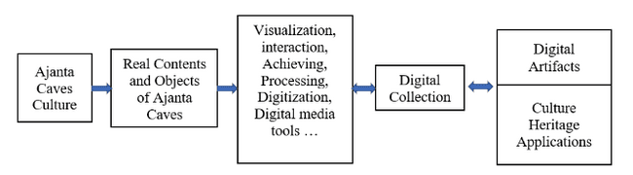
Figure 1: Proposed System Architecture

3D RECONSTRUCTION OF AJANTA CAVE 1
As one steps inside the dark chamber illuminated by natural light through intricately designed windows, they are instantly captivated by the serene aura that envelops the space. The central figure of Buddha, portrayed in an enlightened state or seated in meditation, exudes a sense of peacefulness and tranquility. Surrounding him are delicately adorned bodhisattvas and attendants, all depicted with meticulous attention to detail. The walls and ceilings are embellished with elaborate frescoes showcasing narratives from various Jataka tales as well as scenes from the life of Prince Gautama Buddha himself. The craftsmanship evident within this sacred space truly exemplifies the skill and devotion of ancient Indian artisans, enticing visitors on a spiritual journey back in time.
Visitor Struggle to view inside the caves due to darkness. there are reflectors are placed at entrance of the caves. This is reason to reconstructed cave 1 in 3D. Using 3D modelling software Blender 3D model of Ajanta Cave 1 is constructed.
A 3D model could provide an immersive digital experience for researchers, historians, and tourists alike, allowing them to explore and navigate these caves virtually with great precision and accuracy. This would be particularly valuable for those who are unable to physically visit this historical site due to geographical constraints or preservation concerns. Moreover, a 3D model would enhance our understanding of the architectural complexities, mural paintings, and sculptures found within the caves by providing detailed and interactive representations. With advancements in technology and photogrammetry techniques, creating such a model has become more feasible than ever before. Consequently, a 3D model of the Ajanta Caves promises to be an invaluable tool that enriches our knowledge and appreciation of this unique archaeological treasure.
Figure 2: Cave 1 Floorplan
Figure 3: Cave 1 3D Floorplan

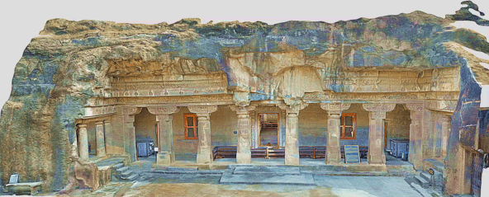
Figure 4: 3D Model of Ajanta Cave 1 – Exterior
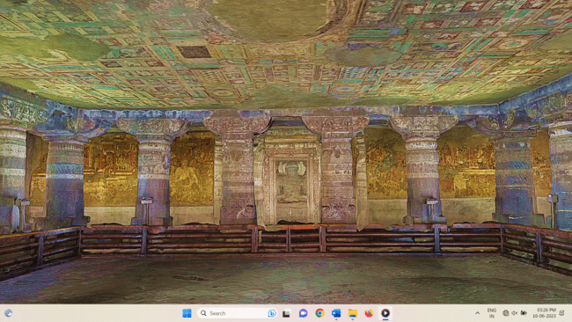
Figure 5: 3D Model of Ajanta Cave 1 – Interior

RESTORATION OF DAMAGED IMAGE OF BODHISATTVA PADMAPANI
This section describes image restoration process performed with AI programming with Python. The image restoration process AI programming with Python is an advanced method of applying artificial intelligence algorithms to repair and enhance digital images. With the aid of sophisticated machine learning techniques, this programming approach enables the identification and correction of various types of image defects such as noise, blur, and artifacts. Through the use of convolutional neural networks (CNNs), these algorithms analyze pixel data, learn from large datasets, and create models that can accurately restore damaged images. The Python programming language offers a powerful platform for implementing these AI-based image restoration processes due to its extensive libraries like TensorFlow and Keras. This allows developers to easily harness the capabilities of deep learning frameworks for training and deploying these models effectively. By using Python’s syntax simplicity and flexibility, professionals in this field can efficiently build applications that automate image restoration tasks with high accuracy and speed.
First step is Denoising damaged image. The concept of denoising a damaged image through the Fast Means Denoising method represents a cutting-edge approach in digital image processing. With an emphasis on speed and accuracy, this method utilizes advanced algorithms to remove unwanted noise from the image, resulting in a significant improvement in quality and clarity. By employing a combination of statistical techniques such as mean filtering and block similarity matching, this method effectively identifies and suppresses noise while preserving important image features. Through its efficient execution, the Fast Means Denoising method offers a solution for professionals who require timely restoration of their damaged images without compromising on quality. Its ability to process images quickly makes it particularly suitable for applications where time is of the essence, such as medical imaging or surveillance systems. This state-of-the-art denoising technique undoubtedly showcases advancements in the field of digital image processing and holds immense promise for various industries requiring precise and efficient image restoration capabilities.
In the next step, the creation of a greyscale masked image based on the areas requiring correction. This procedure involves identifying specific regions within a damaged image that necessitate repair and marking them accordingly. By creating this masked image, professionals obtain a detailed visual representation solely showcasing the problematic areas, which can be paramount for subsequent restoration processes. The greyscale format aids in isolating and emphasizing the damaged portions, facilitating targeted interventions to rectify issues such as scratches, blemishes, or other imperfections. This highly refined approach enables technicians to focus their expertise exclusively on these marked regions while avoiding any unnecessary alterations to intact parts of the image. As a result, greyscale masked images provide an invaluable tool for efficiently restoring damaged visuals with precision and accuracy.
In the next step , one commonly used technique is the thresholding and conversion of a greyscale masked image file into a binary image. This process involves assigning each pixel in the greyscale image to one of two classes - either black or white - based on its intensity value. By selecting an appropriate threshold value, pixels below it are classified as black, while those above it are classified as white. This operation effectively converts the original greyscale image into a binary representation, simplifying subsequent analysis and manipulation tasks. The choice of threshold greatly impacts the resulting binary image; selecting a higher value increases the number of pixels classified as black, thus reducing the amount of detail preserved in the final image. On the other hand, selecting a lower threshold result in a more detailed but potentially noisy binary representation. This technique finds applications in various domains including object recognition, segmentation, and feature extraction for further computational analysis.
Dilation is a vital step in image processing as it compensates for the loss of detail caused by thresholding, ultimately resulting in a more accurate and comprehensive representation. When thresholding an image, only pixels with intensities above or below a certain threshold value are selected, effectively converting the image into a binary form. While this technique proves effective in segmenting objects of interest from the background, it tends to decrease the thickness of the marked areas. Dilation comes into play by expanding and filling in these regions, thus reintroducing some of the lost information. By applying morphological operations such as dilation, we can restore the original size and shape of objects without introducing significant distortions. This process is particularly crucial when dealing with medical imaging or object recognition tasks where preserving accurate details is paramount for precise analysis and decision-making. Dilation works upon the Fast-Marching Method. The Fast-Marching Method (FMM) of image restoration is an advanced algorithm widely utilized in the field of computer vision and image processing. Developed by Greenberg and others, FMM allows for rapid and efficient reconstruction of damaged or degraded images. It is particularly effective in scenarios involving motion blur or noise corruption. The method operates by iteratively propagating information from the restored regions to the damaged ones, prioritizing pixels based on their local constraints such as image gradients and edge maps. This enables a controlled diffusion process that gradually restores missing details while preserving image coherence. Additionally, FMM incorporates adaptive stopping criteria to ensure convergence without introducing over-smoothing artifacts. Since its inception, the Fast-Marching Method has been continually refined and applied in various applications including medical imaging, surveillance, and entertainment industry where sharpness and clarity are crucial. Its ability to efficiently recover images with high fidelity makes it an indispensable tool within the realm of professional visual analysis and enhancement techniques.
Here we have used TELEA method. The TELEA method, with its seamless integration into images, has proven to be the superior choice for professionals in a variety of fields. This innovative technique utilizes advanced algorithms and machine learning capabilities, allowing for more accurate and efficient image processing. By seamlessly integrating into the image, the TELEA method is able to enhance its quality, clarity, and overall appearance without sacrificing any details or introducing artifacts. This level of precision is particularly crucial in industries where visual representation is paramount, such as graphic design, advertising, and medical imaging. Professionals who rely on high-quality visuals can confidently utilize the TELEA method to achieve exceptional results while saving time and effort. Additionally, the seamless integration provided by this method reinforces its reliability and effectiveness when compared to other image processing techniques. In conclusion, the TELEA method stands out as an indispensable tool for professionals seeking optimal image enhancement capabilities seamlessly integrated within their work process. As result the output image is ready, rendered as well as restored.
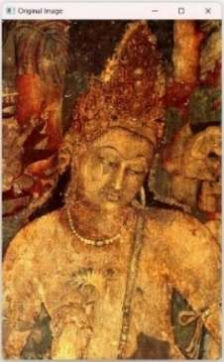
Figure 6 : Original Damaged Image of Bodhisattva Padmapani.

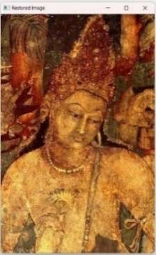
Figure 7: Restored Image of Bodhisattva Padmapani

Conclusion
In this paper architecture of proposed system is discussed. The methodology of restoration of damaged image of Bodhisattva Padmapani from cave 1 at Ajanta monastery is discussed. In this research work need of 3D reconstruction of caves is explained and presented 3D model of cave 1. In this proposed research work, author successful to digitally preserve and restore the cultural heritage site. In future work, restoration all painting of cave 1 and 3D model with restored paintings and mural will be constructed. Then Final cultural heritage application will be created for digital experience of Ajanta Caves.

References
- Ajanta Caves, India: Brief Description, UNESCO World Heritage Site. Retrieved 27 October 2006.
- Rauterberg, Matthias. "From personal to cultural computing: how to assess a cultural experience." Day IV (2006): 13-21.
- "Charter on the Preservation of Digital Heritage". UNESCO. October 15, 2003. Retrieved July 9, 2015.
- Smith, Laurajane. Uses of heritage. Routledge, 2006
- Grahman B 2002 Heritage As Knowledge : Capital Or Culture? Urban Studies , 39 , 1003 – 1017
- Rahaman, Hafizur. "A Framework for Digital Heritage Interpretation." (2012).
- Rauterberg, Matthias. Usability in the future–explicit and implicit effects in cultural computing. München: Oldenbourg Verlag, 2006.
- Digital Art: When Artistic and Cultural Muse Merges with Computer Technology" in IEEE Computer Graphics and Applications, vol.27, no. 05, pp. 98-103, 2007.
- Hao Jiang, Thomas Gonnot, Won-Jae Yi and Jafar Saniie, “Computer Vision and Text Recognition for Assisting Visually Impaired People using Android Smartphone “,2017 IEEE International Conference on Electro Information Technology (EIT).
- Kruti Goyal, Kartikey Agarwal, Rishi Kumar , “Face Detection and Tracking”, International Conference on Electronics, Communication and Aerospace Technology ICECA 2017
- Chaoxing Huang, Dan Chen ,Xusheng Tang, “Implementation of Workpiece Recognition and Location Based on Opencv”, 2015 8th International Symposium on Computational Intelligence and Design.
- Nidhi, “Image Processing and Object Detection”, International Journal of Applied Research 2015;1(9): 396-399
- Cristhian Rosales, Luis Jácome, Jorge Carrión, Carlos Jaramillo, Mario Palma, “Computer Vision for detection of body expressions of children with cerebral palsy”, 2017 IEEE Second Ecuador Technical Chapters Meeting (ETCM).
- G.D. Illeperuma, D.U.J. Sonnadara, “Computer Vision Based Object Tracking as a Teaching Aid for High School Physics Experiments”, Proc. EECSI 2017, Yogyakarta, Indonesia, 19-21 September 2017, 2017 4th International Conference on Electrical Engineering, Computer Science and Informatics (EECSI).
- Aniket V. Patil, Mrinai M. Dhanvijay, “Engraved Character Recognition Using Computer Vision To Recognize Engine And Chassis Numbers”, 2015 International Conference on Information Processing (ICIP).
- T. Arrighi, J. E. Rojas , J.C. Soto , C. A. Madrigal , J. A. Londoño, “Recognition and Classification of Numerical Labels Using Digital Image Processing Techniques “,2012 XVII Symposium of Image, Signal Processing, and Artificial Vision (STSIVA).
- Y ue Yaru, Zhu Jialin, “Algorithm of Fingerprint Extraction and Implementation Based on OpenCV”, 2017 2nd International Conference on Image, Vision and Computing,978-1-5090-6238-6/1 7©20 17 IEEE
- M. Ashok Kumar, R.R. Tewari, “Human gestures and recognizing faces in natural expressions by considering computer vision techniques on mobile devices”, Intelligent Computing and Control Systems (ICICCS), 2017 International Conference.

