Pest management with integrated intelligence: computer-based attack detection and prevention system
Monika Kalia¹ and Sonika Kalia^{2,3*}
¹College of Agriculture, CSKHPKV, Palampur, Himachal Pradesh, 176062
^{2*}Department of Agricultural Biotechnology, CSKHPKV, Palampur, Himachal Pradesh, 176062
^{3*}Department of Biotechnology, School of Applied and Life Sciences, Uttaranchal University, Dehradun, 248001
Abstract:
According to the Food and Agriculture Organization (FAO), agricultural pests reduce crop yield globally by between 20 and 40 percent each year. The main causes of crop loss are the pests and diseases that exist in the fields. In populous nations like India, it's important to get the most bang for your buck. If we can manage the insect attack in the fields, we can increase the efficiency of farming. In this digital age, many cutting-edge technologies are at our disposal to combat insect attacks. Therefore, the ideal way for farmers to use artificial intelligence methods combined with contemporary information and communication technology to get rid of these dangerous insect pests is through smart agriculture. As a result, their agricultural productivity can be raised. In order to assist experts and farmers, this article proposes a novel smartphone application that uses deep learning to automatically categorize pests. By using these technologies, we can anticipate a pest attack, identify the pest that has struck, and prepare the appropriate measures in advance to reduce the damage. These technologies include deep learning, computer vision, artificial intelligence, machine learning, and many others. In this article, we will examine several innovative strategies that scientists might use to fight off insect attacks.
Keywords: Pest Management, GIS, Remote sensing, models, IPM.
Content
- Introduction
- Pest forecasting
- Remote sensing
- Studies on incidence of insects through RS
- Geographic Information System (GIS) and its applications
- Pest Simulation models and decision support systems
- Integration of Pest and crop Simulation models
- Conclusion

Introduction:
Nearly 28% of the Gross Domestic Product (GDP) in India is attributed to agriculture, which is crucial to the country's economic development. The potential agricultural productivity is severely damaged by weeds (14% of losses), illnesses, and insect pests. To achieve sustainability in agriculture, technologies based on plant protection research for serious pests are crucial (Pratap et al., 2000). If the incidence or appearance of pest populations is recognized well in advance, it will be feasible to take corrective action in a timely manner, which will reduce production losses caused by pest populations to a greater extent. This gave rise to the idea of "forecasting," which is a prediction or estimate of a future trend that involves all the activities involved in determining and informing the community's growers that conditions are sufficiently favorable for specific insect pests, that applying control measures will result in economic gain, or, on the other hand, and just as importantly, that the amount expected is unlikely to be enough to justify the expenditure of time, energy, and money for control (Miller and O'Brien, 1952). An essential part of the IPM approach is the pest forecast. As a result, crop loss can be minimized, pest treatment can be optimized, and cultivation costs can be decreased. Early warnings and forecasts based on biophysical methodologies give time to handle incoming pest attacks. In order to plan spraying and farm operations to maximize crop yields and returns, current and expected weather information is helpful. Therefore, efficient plant protection measures can be put in place before the actual commencement of the harm. It provides advanced information on the outbreak of pests and diseases.
Thus, an insect forecasting service might be used to forecast the pest's level of impending infestation. To determine the crucial point at which the use of insecticides would provide the best level of protection. The prediction of pests informs farmers on the biology and timing of insect outbreaks, allowing them to avoid blanket pesticide applications, use less of them, and still get high-quality outcomes. The farmers can take prompt action by implementing various pest management strategies to reap the most rewards.

Pest forecasting
Pest forecasting is the perception of potential biotic agent activity that would have a negative impact on crop yield. In other words, the ability to estimate how seriously the insect population will affect the crop's ability to generate revenue is crucial. In order to predict the incidence of a pest, it may be useful to use long-term, consistently collected data on the pest's population or damage, as well as other variable elements that can affect the pest's growth.
Several inherent characteristics of the insects as well as the governing environmental and host conditions must be taken into account in pest forecasting. The phenology of the herbivore and its host is taken into account by most pest forecast models. A timely and spatially accurate early warning of impending pest buildup is made possible by the combination of near real-time pest incidence data with remote sensing and GIS tools. The governing environmental and host conditions must be considered. Additionally, collecting and examining weather data from pest-affected areas is a crucial component of model input.

The use of computers in agricultural research began with the transfer of statistical formulas or intricate models into digital form for quick, precise calculations that were comparatively laborious to perform manually. In recent years, remote sensing and geographic information systems have become increasingly important in agriculture research, particularly in the areas of yield prediction, soil suitability for various crops, and site-specific resource allocation of agricultural inputs, among other things.

The science of remote sensing involves analyzing data collected by a device that is not in direct contact with the thing or phenomenon being studied in order to learn more about it. Remote sensing is the process of looking at or acquiring data about a location from a distance. A ground-based device (such as a camera) may be used for such an evaluation, as well as sensors or cameras mounted on boats, planes, satellites, or other spacecraft (Prabhakar et al., 2012).

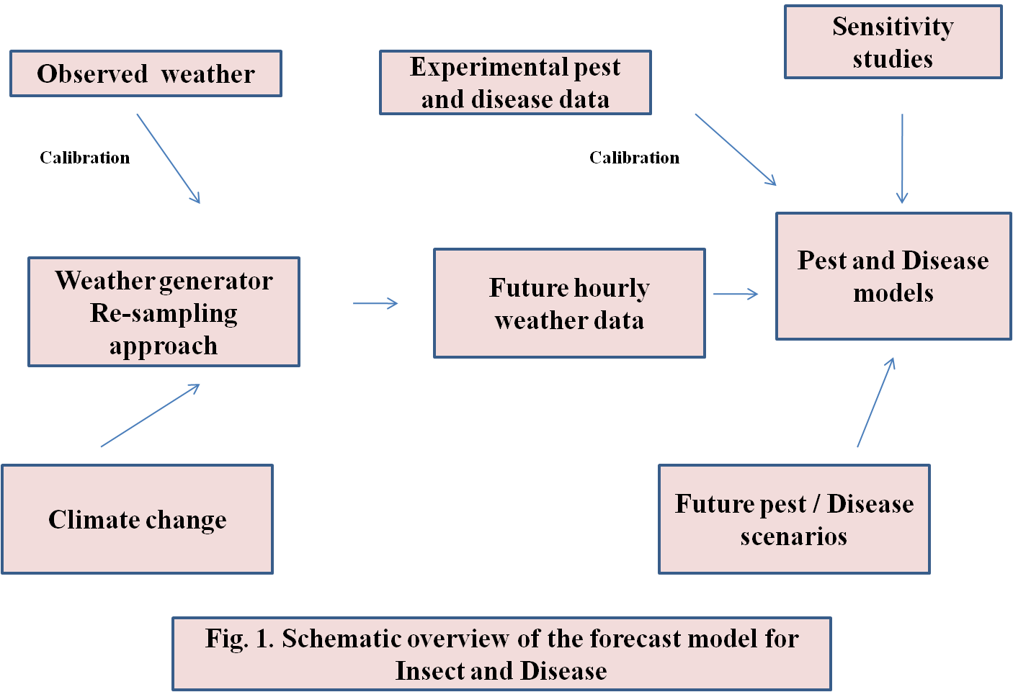

Remote sensing
Principles of remote sensing
Depending on its physical characteristics, every item reflects or scatters a portion of the electromagnetic radiation that strikes it. Objects also emit radiation based on their emissivity and temperature. Any object has a spectral signature, which is a pattern that appears in its reflectance or emission at various wavelengths and is unique to that thing.
Remote Sensing (RS) techniques in pest management
• The observation of insects themselves
• The detection of the effects that insects produce (Symptoms)
• The monitoring of environmental factors likely to influence insect occurrence or abundance and potential damage.

Pest damage can be predicted with
• Spectral indices based on leaf pigments
• Optical and video imaging in near-infrared and microwave regions
• Multi-spectral remote sensing (MRS)
• Area identification with help of portable GPS equipment

Studies on incidence of insects through RS
Due to reduced chlorophyll concentrations and wavelengths of 500–525 nm, 625–635 nm, and 685–695 nm, Russian Wheat aphids and green bugs have an adverse influence on leaf reflectance in wheat seedlings (Riedell and Blackmer, 1999).
• Remote sensing can be utilized to identify BPH-induced stress in rice. According to Zhou et al. (2010), the canopy measuring level of 1813–1836 nm may be the most susceptible to BPH infestation.
• Hemlock loopers and bark beetles are two important pests for which aerial color and color-infrared photography with conventional cameras have been successfully utilized to outline damage. By mapping the Mississippi River delta and using remote sensing to identify the most likely locations where insects may attack the wheat crop, the stress brought on by aphid species is discovered (Yang et al., 2016).

Studies on distribution of insects through RS
- In Hawaii, El Salvador, and Mexico, the distribution of host plants for tropical fruit flies was investigated using aerial photography (Hart et al., 1978). Milkweed (Asclepias spp.) is a prominent host plant for monarch butterflies (Danaus plexippus), which are depicted on the map (Malcom et al., 1993).
- High resolution data from SPOT and Landsat 5 has been used to pinpoint rice-growing regions in northern Luzon, the Philippines, that may serve as hosts for the brown planthopper, Nilaparvata lugens.

Geographic Information System (GIS)
A GIS is a tool for gathering, storing, manipulating, and displaying data that is pertinent to a specific geographic area. It consists of a database of attributes, some means of linking to both, and spatial information in the form of coordinates. GIS abstracts the world into layers of spatial and attribute data, with each layer representing a distinct characteristic or theme. Layers are then used to connect several themes.

Application of GIS in pest management
Characterization of habitat susceptibility to outbreaks and compilation of census data
In British Columbia between 1924 and 1986, defoliation caused by the Douglas-fir tussock moth was documented on historical maps by Shepherd et al. in 1988. The relationship between climate and outbreak frequency was then examined by superimposing maps of forest type and biogeoclimatic on top of the outbreak frequency map.
Insect census data and GIS
According to Liebhold (1996), a GIS is used in an IPM demonstration program to interpolate gipsy moth trap counts and egg mass densities, which helps with insect census. The data map compilations are helpful for organizing suppressive actions. Desert Locust Management Systems based on GIS
Locust monitoring at the FAO
In order to better understand the spatial and quantitative distribution of rainfall in the Desert Locust breeding sites, the Desert Locust Information Service (DLIS) employs rainfall estimates acquired from METEOSAT, primarily infrared and visible channels. In nations with a lupine problem, SPOT-VGT and MODIS imagery are made available every 10 and 16 days, respectively. Using these items, national survey teams can be directed to prospective patches of greenery where Desert Locust can be found.

Pest Simulation models and decision support systems

Simulation models that use mathematical descriptions of biological data that are affected by the environment can be used in a variety of settings and habitats with greater ease. In order to understand population dynamics and disseminate pest forecasts for timely pest control choices, computer programs or software to execute these models are helpful (Coulson and Saunders, 1987). The flexibility of simulation methodologies allows for the testing, improvement, sensitivity analysis, and field validation of produced models under a variety of environmental conditions and situations. To understand the interactions between pests, plants, and the environment, comprehensive descriptions of cropping systems that are managed or studied are required (Colbach, 2010). Systems models or other prediction methods can be used with the necessary biological, environmental, economic, or other inputs to analyze the most successful management actions based on acceptable control, sustainability, and assessment of economic or other risks (Strand, 2000).
In an effort to enhance Helicoverpa management in Australia, a detailed population dynamics model (HEAPS: Helicoverpa armigera and Punctigera Simulation) has been created (Fitt et al., 1995). This model specifically simulates adult mobility within a regional cropping system. It accounts for the habitat's spatial organization as well as the pest population. This model determines the population in each grid cell by incorporating modules for adult migration, oviposition, development, survival, and host phenology (Dillon and Fitt, 1990).
The SIRATAC decision support system, used by the Australian cotton industry from 1976 to 1993 to lower the risk associated with pest management using chemical pesticides, served as the foundation for the EntomoLOGIC decision tool. This was created by the University of Western Sydney and the Commonwealth Scientific and Industrial Research Organization (CSIRO) in Australia (Hearn and Bange, 2002).
Trnka et al. (2007) were able to account for 70% of the diversity in the timing of important developmental phases using a multi-generational phenology model, ECAMON. The European corn borer's presence or absence over a study zone in the Czech Republic between 1961 and 1990 was accurately predicted using ECAMON simulations.
The CIPRA (Computer Center for Agricultural Pest Forecasting) software was conceptualized, created, and put into use in the middle of the 1990s to retrieve weather data in real-time from a network of automated sensors. In addition to the phenology of the apple crop, the user is able to see forecasts for 13 insects, two illnesses, and two storage problems. These bioclimatic models, which have been created, used, and improved over the past 13 years, range from a straightforward degree-day method based on air temperature to more intricate epidemiological models based on air temperature, relative humidity, and the length of time that leaves are moist. Many field professionals are employing these model forecasts in conjunction with field pest scouting to offer useful extra information for decision-making in pest control and apple storage strategies (Bourgeois et al., 2008).
In Switzerland and southern Germany, SOPRA is used as a decision support system for eight significant insect pests of fruit orchards, and it has a wide variety of potential uses in the alpine valleys and north of the Alps. Phenology models were created using time-varying distributed delay techniques and were hourly driven by solar radiation, air temperature, and soil temperature. On the basis of local weather information, the age structure of pest populations is simulated, and the SOPRA system forecasts key moments for management activities. Phenology has a close connection to a thorough decision-support system, extensive information regarding pest insects, and registered plant protection products.

Integration of Pest and crop Simulation models
Crop system models can be employed to produce data on the crop's condition as influenced by the growing environment and pests, as well as different management strategies. There aren't many examples of these models in use that fully incorporate all the elements required for real-world decision-making. However, a more useful strategy has been the establishment of distinct crop and pest components that may be examined simultaneously to provide knowledge that will improve decisions.
Decision-making at the farm and policy levels has been facilitated by the development of decision support systems for agrotechnology transfer (DSSAT 4), which was funded by the United States Agency for International Development (USAID). Crop system models are increasingly being developed using a modular strategy (http://www.icasa.net). The creation of independent decision support systems for pest components may result in their practical application.

CONCLUSIONS
Pest monitoring provides the cornerstone for early warnings, the creation and validation of pest forecast models, and decision support systems, all of which are essential for the planning and execution of effective IPM programs. The available data and knowledge on the population dynamics of pests in agroecosystems and natural environments can be synthesized using models, which are potentially useful tools. The creation of long-term monitoring spatial data on crop-pest-weather connections will close the knowledge gaps necessary for accurate forecasts. Forecasting is now done more quickly and accurately while costing less thanks to computer-based technologies.
The widespread broadcast and use of pest forecasts is greatly facilitated by recent advancements in information and communication technologies. Greater crop diversity on tiny plots of land with constantly changing weather are characteristics of agroecosystems in the tropics. For improved accuracy, it is necessary to evaluate the existing generic simulation models with location-specific inputs. For specific crop sectors in poor nations, agro-meteorological networks must be established with the primary goal of pest forecasting using models and decision support systems.

REFERENCES
- Miller, P.R., and O'Brien, M.J. 1952. Plant disease forecasting. The Botanical Review, 18: 547- 601
- Prabhakar, M., Prasad, Y.G., and Rao, M.N. (2012). Remote sensing of biotic stress in crop plants and its application for pest management. In: Venkateswarlu, B. et al., (eds. ), Crop Stress and its Management. Springer Science, Dordrecht. pp. 517–545
- Riedell, W.E., and Blackmer, T.M. (1999). Leaf reflectance spectra of cereal aphid damaged wheat. Crop Science. 39:1835–1840
- Zhou, Z., Zang, Y., Zhao, Z., Luo, X, and Zhou, X. 2010. Canopy hyperspectral reflectance features of rice caused by rice brown planthopper (Nilaparvata lugens) infestation. American Society for Agriculture and Biological Engineering, Pittsburgh, Pennsylvania, June 20 - June 23, 2010
- Yang, Z., Rao, M.N., Elliott, N.C., Kindler, S.D., and Popham, T.W. 2009. Differentiating stress induced by green bugs and Russian wheat aphids in wheat using remote sensing. Computers and Electronics in Agriculture, 67: 64–70
- Hart, W.G., and Meyers, V.I. 1978. Infrared aerial color photography for detection of populations of brown soft scale in citrus groves. Journal of Economic Entomology, 61(3): 617–624
- Malcolm, S.B., Cockrell, B.J., and Brower, L.P. 1993. Spring recolonization of eastern North America by the monarch butterfly: successive brood or single sweep migration? In S.B. Malcolm and M.P. Zalucki, editors. Biology and Conservation of the Monarch Butterfly, 253-267. Natural History Museum of Los Angeles Country.
- Liebhold, A., Luzader, E., Reardon, R., Bullard, A., Roberts, A., Ravlin, F.W., DeLost, S., and Spears, B. 1996. Use of a geographic information system to evaluate regional treatment effects in a gypsy moth (Lepidoptera: Lymantriidae) management program. Journal of Economic Entomology, 89: 1192–1203
- Coulson, R.N., and Saunders, M.C. (1987). Computer-assisted decision making as applied to entomology. Annual Review of Entomology, 32, 415–437
- Colbach, N. (2010). Modeling cropping system effects on crop pest dynamics: how to compromise between process analysis and decision aid. Plant Science 179, 1–13
- Strand, J.F.(2000). Some agrometeorological aspects of pest and disease management for the 21st century. Agricultural and Forest Meteorology, 103: 73–82
- Dillon, M.L., and Fitt, G.P. (1990). HEAPS: a regional model of Heliothis population dynamics. In: Proceedings of the Fifth Australian Cotton Conference, 8–9 August, Broadbeach, Queensland, Australia. Australian Cotton Grower’s Research Association, Australia, pp. 337–344
- Hearn, A.B., and Bange, M.P. (2002). SIRATAC and CottonLOGIC: Persevering with DSSs in the Australian Cotton Industry. Agricultural Systems, 74:27–56
- Trnka, M., Muska, F., Semeradvoa, D., Dubrovsky, M., Kocmankova, E., and Zalud, Z. (2007). European corn borer life stage model: regional estimates of pest development and spatial distribution under present and future climates. Ecological Modelling, 207: 61–84
- Bourgeois, G., Plouffe, D., Chouinard, G., Beaudry, N., Choquette, D., Carisse, O., and DeEll, J. (2008). The apple CIPRA network in Canada: using real-time weather information to forecast apple phenology,insects, diseases, and physiological disorders. Acta Horticulturae, 803: 29–34

