FUTURISTIC TRENDS IN UNDERSTANDING SCAPULAR DYSKINESIS AND ITS RELATION TO SHOULDER PAIN
Anam Khan¹, Sahar Zaidi^{2*}, Huma Parveen¹, Adeeba Ali¹, Afsha Wali¹, Deepika Singla³

Authors’ Affiliation:
¹Student Researcher, Department of Physiotherapy, Jamia Hamdard, New Delhi, India 110062
^{2,CA}Assistant professor, Department of Physiotherapy, Jamia Hamdard, New Delhi, India 110062
ORCID ID: 0000-0002-1950-1150
E-Mail ID: sahar@jamiahamdard.ac.in
³Assistant professor, Department of Physiotherapy, Jamia Hamdard, New Delhi, India 110062

ABSTRACT-
Scapular dyskinesis is known as a change in the scapula's typical position or motion during paired scapulohumeral movements. It frequently results from injuries that inhibit or disorganize activation patterns in scapular stabilizing muscles. Additionally, it happens in a high percentage of shoulder joint injuries. Changing the normal scapular function during coupled scapulohumeral motions may exacerbate the functional deficiency related to shoulder injury. Since no particular pattern of dyskinesis is connected to a specific shoulder diagnosis, scapular dyskinesis is a general reaction to shoulder dysfunction. Patients with a shoulder injury should be suspected of having it, and a specialized physical examination can help identify and classify it. The goal of this review is to assess the relationship between scapular dyskinesis and shoulder pain. Treatment for scapular dyskinesis focuses on addressing the underlying problems and recovering function. We also go through its treatment , the effect scapular dyskinesia has on quality of life, and the disability it causes. A vital link in the kinetic chain that distributes power from the body's centre to the arm is the scapula. Even though SD may be initially asymptomatic, the likelihood of shoulder pain increases.

INTRODUCTION-
First, we have to see the normal scapular function to understand scapular dyskinesis. The scapula's principal function is as a key component of the glenohumeral articulation, which kinematically has a ball-and-socket configuration. Motion along the thoracic wall is the second function of the scapula. The scapula's last role in shoulder motion is as a junction between the proximal and distal sequences of forces, energy, and velocity.[1]

Changes in the scapula's resting position and dysfunctional movement are referred to as scapular dyskinesis. Since it can also be present in people who are asymptomatic, it is better regarded as an impairment of ideal shoulder function rather than pathology.[2]

During linked scapulohumeral movements, the scapula's typical position or motion is altered. It occurs in a variety of shoulder joint injuries and is frequently brought on by wounds that impede or disrupt the activation patterns of the scapular stabilising muscles.

The functional damage brought on by shoulder injury may intensify as a result of linked scapulohumeral motions altering the normal scapular function. No particular pattern of dyskinesis is connected to a particular shoulder diagnosis, suggesting that scapular dyskinesis is a general reaction to shoulder dysfunction. Scapular dyskinesis in injured patients is highly suspect, and they can be diagnosed and categorised by certain physical examinations.[1]

The cause of SD may be neurological, including spinal accessory nerve palsy, which affects the work of the trapezius muscle, long thoracic palsy, which can cause serratus anterior weakness. Acromioclavicular and glenohumeral joint instability, tight pectoralis minor and biceps short head, posterior shoulder stiffness, periscapular muscle lesions, altered muscular activation, and differences in strength are additional musculoskeletal causes. Additionally, posture issues such thoracic kyphosis may be connected to SD.

SD is a clinical diagnosis. To determine all potential causes of dyskinesis, a thorough physical exam must be conducted. However, there is no established technique for diagnosing SD at this time. The critical dynamic component of the clinical examination makes it a better option for diagnosing SD than static imaging methods. Computed tomography or magnetic resonance imaging scans can assist in making an aetiological diagnosis of SD when there are suggestive symptoms present. [2]

One of the major roles of the scapula is the glenohumeral articulation, which kinematically has a ball-and-socket shape. Allowing movement along the thoracic wall is the scapula's second purpose. As the last piece of the proximal-to-distal chain of velocity, energy, and forces, the scapula contributes to shoulder function. SD can occur in healthy people, although the prevalence rate is higher in overhead athletes (61%) compared to non-overhead athletes (33%). Elderly people have a higher prevalence of SD because they are more likely to sustain overuse injuries and develop shoulder degenerative disease.[2]
Studies on swimmers at different levels have shown that the frequency of dyskinesis is rising over the course of a single training session in young competitive swimmers, and more specifically, in individuals at the collegiate level who are pain-free competitive swimmers, though this may be the result of increasing fatigue.[3]
Types-
Based on the medial scapular boundary while the arm is relaxed or flexing forward, there are four types of SD:-
Type I = inferior angle prominence,
Type II = medial border prominence
Type III = excessive superior border elevation.
The normal, symmetric scapular motion was considered Type IV.[4]
Signs and symptoms-
Scapular dyskinesia can be symptomatic, but there is also the possibility that shoulder symptoms are absent.
There are the following common symptoms of scapular dyskinesia:
When the patient raises his arm and lifts weights, he feels pain and tenderness around the shoulder blade.
When the patient moves their shoulder, they feel a snap or pop.
Feeling the loss of strength in the affected arm and shoulder.
Some postural changes in the shoulder appear.
Some patients feel like their shoulder blade is out of place.
When present, SD causes the SICK syndrome, which is characterised by-
S-scapular malposition,
I-inferior medial border prominence,
C-coracoid pain and malposition, and
K-dyskinesis of scapular motion.[2]
When we try to see the cause of scapular dyskinesia along with this, so, we see that three categories can be used to classify the aetiology of scapular dyskinesia:
(a) Shoulder-related;
(b) Neck-related;
(c) Posture-related.
a) Shoulder-related causes of scapular dyskinesia:
Most problems are caused by shoulder diseases. A degree of dyskinesis is present with almost all shoulder disorders.
The disorders most frequently linked to various types of scapular dyskinesis are:
Acromioclavicular instability
Shoulder impingement
Rotator cuff injuries,
Glenoid labrum injuries,
Clavicle fracture and,
Nerve-related.
The disruption of the scapulohumeral rhythm is a shared feature of all these disorders.
Scapular protraction, posterior tilt, and internal rotation are all related to shoulder impingement in the resting positions, during abduction, and during plane elevation.
The scapula also exhibits less upward rotation when the scapular plane is higher. In shoulder instability, the scapula performs differently; it exhibits:
Rotation is lessened as the arm is raised,
Internal rotation becomes more intense when the scapular plane is raised.
The scapula externally rotates more quickly and to a larger extent in a frozen shoulder than it would normally. However, studies have been unable to demonstrate that the scapula's greater mobility constitutes a compensating mechanism.
An inappropriate pattern of muscle activation (too slow or too quick) or an inappropriate force of muscle contraction (too strong or too weak) can both disrupt the scapulohumeral rhythm, as was previously noted in the Biomechanics section. The scapula is influenced by numerous muscles that work in various directions, therefore it seems sense that the time and intensity of muscular activity govern its mobility.
A significant factor in determining how well muscles work is fatigue. The scapulohumeral rhythm is less effective as weariness increases, according to McQuade et al.
If the same experimental design were used to more difficult tasks involving more muscles, it might be fascinating. Researchers could then notice the following in this manner:
1) Muscle soreness after physical movements,
2) Which muscles were more prone to tiredness and
3) If once the synergists are worn out, muscles take control.
There have been reports of other muscle issues, like latissimus dorsi tightness, affecting scapula rotation and pushing the bone superiorly. Dyskinesis in the Shoulder impingement and instability have both been connected to the trapezius and serratus anterior muscles. The serratus anterior, upper and lower trapezius, and their activation patterns have all changed during impingement, with the trapezius displaying stronger activation than the serratus anterior. In comparison to symptomatic patients, rotator cuff arthropathy encourages enhanced motion from the rotator cuff muscles, supraspinatus and infraspinatus, and from the upper trapezius.[5]
b) Neck-related:
There are two neck diseases that might affect the shoulder:
1) "mechanical neck pain" syndromes and
2) cervical nerve root-related syndromes.
A group of disorders affecting the neck's muscles (such as weariness or imbalance) and joints (degenerative alterations) are referred to as "mechanical neck pain" syndromes. Although it is unclear how the symptoms are related to the shoulder, it is understandable given how close these structures are to the area.
It has been suggested that posture has an impact on muscle strength. Patients develop a "slouched" posture as a result of the Western way of life and widespread computer use. The higher thoracic and cervical spines lose their normal curvatures as a result.
On the other hand, a solid connection exists between neck-related nerve diseases (such as nerve root compression) and shoulder-related problems. All of the nerves that feed the shoulder's sensory and motor functions come from the brachial plexus, particularly from the C5 and C6 roots, and the accessory nerve, which crosses the sternocleidomastoid muscle from the higher areas of the spinal cord and the lower portions of the brain.
Pathologies develop when one or more of the nerves around the scapula are activated improperly, disrupting the rhythm of the scapular movements in relation to the upper limb or the main skeleton. As we will discuss later, the sequence of muscle activation is a crucial component of clinical assessment and therapy.[5]
c) Posture-related causes of scapular dyskinesis:
Significant cervical lordosis and thoracic kyphosis alter the scapula's position in rest. These alterations are more likely to affect athletes. According to their sport, people acquire core muscle imbalances that change the curvatures of their spines and the stress in their soft tissues.[5]
DIAGNOSIS-
Eighty-three percent of patients with shoulder pain seek medical attention from their doctor because they are unable to perform as they would want to in significant tasks; they see this as a malfunction that needs to be fixed.

Function could be modelled as anatomy being affected by physiology to provide mechanics that make it easier to complete a particular activity. This hypothesis claims that dysfunction results from various pathoanatomical, pathophysiological, and pathomechanics configurations, which lead to inadequate or ineffective decompensations or possible injuries manifested as symptoms. The clinical evaluation process may benefit from using this model as a framework.

Systematic reviews have conducted an effort to assemble and evaluate the worth of examination manoeuvres, and they have come to the conclusion that there needs to be more clinical utility, dramatic differences in study techniques, and subpar levels of critical appraisal outcomes.

It's interesting that the emphasis on clinical usefulness is at odds with scapular dyskinesis because clinical utility is the most reliable diagnostic standard to identify the condition. Because scapular dyskinesis is an impairment rather than a diagnosis, clinical utility cannot be achieved.

It is challenging to determine the diagnostic accuracy of an impairment since there is no universally accepted gold standard to which to compare it. Despite numerous attempts to employ biomechanical assessments (i.e., 3-dimensional analysis) as the gold standard, placing of anatomical landmarks in space relative to the equipment based on surface markers is, in short, a substitute for the genuine place.
The easiest way to describe bone pin investigations as a gold standard is to introduce sterile pins right into the bone. But they aren't used frequently in clinical settings due to their invasive nature and technical challenges.

Currently, Qualitative examinations of scapular position and motion are the most effective clinical instruments for detecting abnormalities, although there are inherent problems with the assessments' subjectivity.
The examination is conducted by:
First, the patient raises their arms in forward flexion to maximum elevation and after that lowers them, repeating it 3-5 times (figure 1). The test is repeated with 3-5 pound weights in both hands and by elevating the arm for up to 10 repetitions if the medical professional is unsure whether there is a change in motion.
Finding any altered motion may be aided by the heavier load and more repetitions. Scapular dyskinesis is easier to see during the arm's downward phase of motion, as was previously mentioned.
It is determined whether the outcome is "yes" (prominence detected) or "no" (prominence not detected) by observing the prominence of any part of the medial scapular border on the affected side.
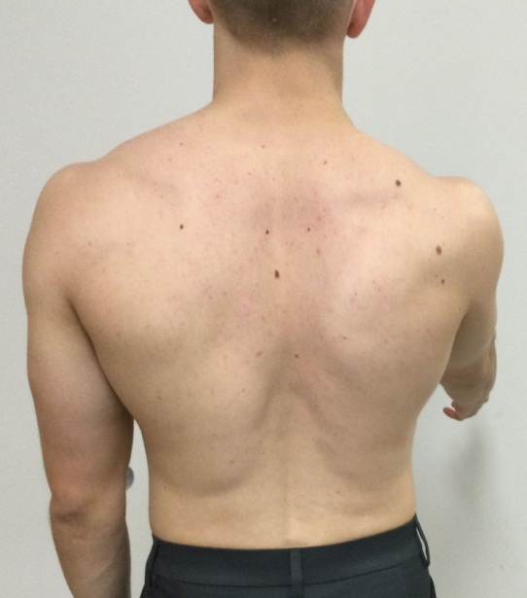

Figure 1: Scapular dyskinesis test. While being examined, the patient raises their arms above their heads three to five times.[6]
Three muscle tests:
(1) Serratus anterior is targeted by resistance that is manually applied to the arm at 130° of flexion.
(2) At 130–150 degrees of abduction, the arm is manually resisted (lower and middle trapezius are the muscles targeted) and,
(3) Exercises that target the rhomboids include side arm extensions..
By attempting to "break" the patient's arm position and checking to see if the scapula is visibly changing, the doctor differentiates this muscle test for the shoulder from others.
Result – Scapular muscular weakness is suggested by both a break in position and movement of the scapula. In order to "correct" the scapular mobility and placement, corrective manoeuvres should be carried out.
• The scapular assistance test - assesses scapular involvement in shoulder pain based on changes in motion,
• The scapular retraction test - determines how the scapula affects rotator cuff strength,
• Arm strength factors are assessed in the low row.
• The scapular assistance test -The patient raises their arms, and To aid in scapular upward rotation and posterior tilt, the examiner gives force to the medial aspect of the inferior angle of the scapula (figure 2). When the uncomfortable arc during arm motion is reduced and the arc of motion increases, a favourable outcome occurs.
• The scapular retraction test - It is carried out when the patient is in their natural posture and the examiner grades the patient's forward flexion strength used conventional manual muscle testing techniques (figure 3A). The examiner then retests the arm strength while manually stabilising the medial border of the scapula in a retracted position (figure 3B). When the shown strength increases while the physician is stabilising the scapula in the retracted position, the outcome is favourable.
• The low row test -The patient is directed to hold their arm in a mild forward flexion position with their humerus slightly extended (figure 4). The patient is then told to engage the gluteal muscles while the examiner (who is positioned posterior to the patient) exerts the same anterior force on the arm. If strength increases with gluteal contraction, it shows that hip and core strength sometimes aid the activation of the scapular and shoulder muscles. As a result, lower extremity/core training should be a part of the shoulder therapy plan. The clinician is informed by a successful corrective manoeuvre that the patient's rehabilitation should focus mostly on increasing their scapular mobility, scapular strength, or core strength rather than on activating or strengthening the rotator cuff.
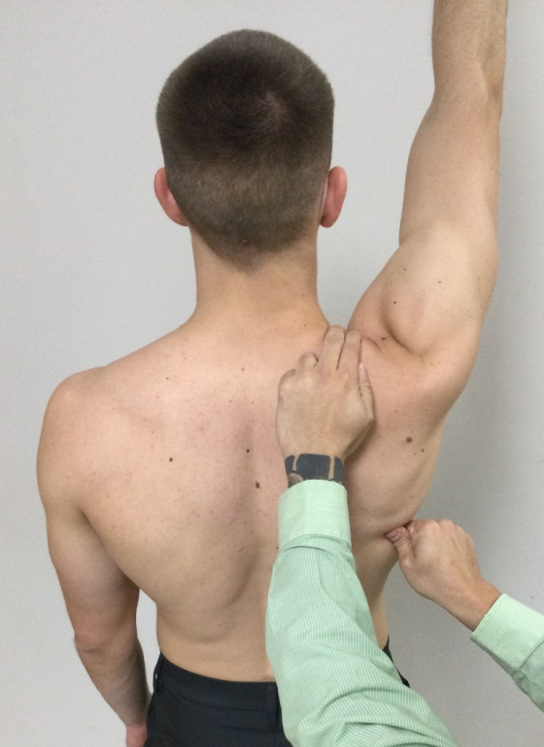
Figure 2: Scapular Assistance Test. One hand stabilises the scapula while the other helps it move through its proper motion plane.[6]
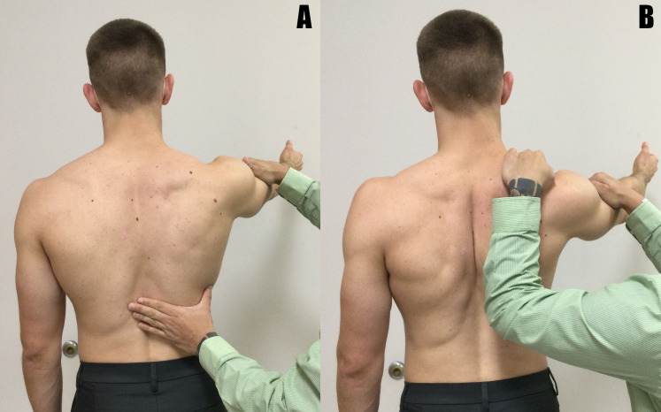
Figure 3: Scapular Retraction Test. The examination starts with the customary flexion manual strength test.(a). The test is repeated once the examiner stabilises the medial scapular boundary.(b).[6]

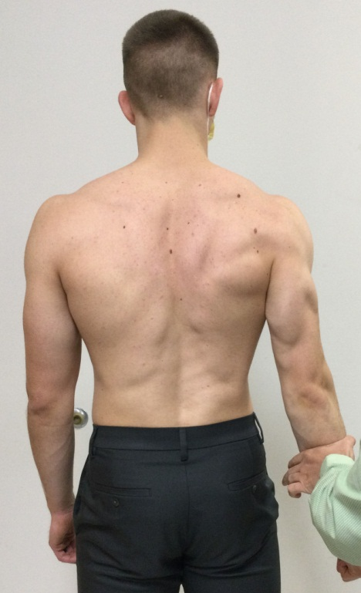
Figure 4: Low Row Test. The tester manually opposes arm extension without then activating the gluteal muscles.[6]
This qualitative method is based on recent ideas to use a classification system in the clinical context that is rely on mobility deficits rather than pathoanatomy.
Depending on the results of the assessment, the system can be subclassified. The system's main goal is to discover dysfunction's root causes so that it can be treated more effectively. For example, suppose. The scapular dyskinesis test detects abnormal scapular mobility. In that situation, the doctor should first pinpoint the precise visible elements (such as medial border prominence and scapular body location) and then determine the most probable reason for the alteration (such as a lack of mobility, strength, or motor control, or an obvious anatomical injury). Additional examination elements such as mobility, strength, and kinetic chain testing, as well as remedial manoeuvres, would aid the doctor in determining the underlying reason.
To establish the clinical diagnosis of dyskinesis and pinpoint the underlying anatomical (pathoanatomy) and physiological (pathophysiology) causes of the observed changes in position and motion as a foundation for creating treatment protocols, all of these efforts have been made.
Using the step-wise testing protocols, 462 consecutive patients with shoulder discomfort who met the algorithm stage 1 and stage 2 criteria were evaluated in an unpublished survey conducted at our institution.[6]
This survey revealed that –
Pathoanatomical causes of dyskinesis were present in 34.7% of the patients, including clavicle fractures, acromioclavicular joint problems, glenohumeral joint internal derangements, neurological damage, and periscapular muscle injuries. A pathophysiological basis, in contrast, was present in 65.3% of cases (muscle imbalance, inhibition, tightness/inflexibility, serratus anterior/lower trapezius insufficiency.
Additionally, a few of the pathoanatomically based disorders also include primary or secondary pathophysiology. The findings shows a two-step diagnostic process for people with clinically significant scapular dyskinesis.
Patients whose dyskinesis is brought on by known pathoanatomy were grouped in one section. Rehabilitation may be used as part of the treatment, although surgery is frequently needed to restore the anatomy. Patients who have secondary pathophysiologic dyskinesis will require treatment based on a thorough evaluation approach to comprehend the muscular changes.
About one-third of occurrences of scapular dyskinesis linked with clinical symptoms are caused by pathoanatomy. The evaluation procedure should be directed towards a thorough evaluation of the various potential modifications of physiology because the absence of demonstrable pathoanatomy is prevalent. [6]
MANAGEMENT OF SCAPULAR DYSKINESIS
Scapular dyskinesis has been described as a disability that is primarily brought on by soft-tissue deficits. As a result, the treatment's primary goals have been to increase mobility and strength. However, Several research have found that the majority of manual treatment and therapeutic exercise, which are used to address these inadequacies, have little effect on scapular motion.
There are several possible reasons for these findings:
First, the scapula and shoulder rarely experience acute movement changes. Although after a throwing incident or exposure, overhead athletes frequently have an initial decrease in glenohumeral rotation, without treatment, the reduction in motion normally resolves within 24 to 96 hours. Second, therapeutic activities aimed at particular muscles in the shoulder and scapula have been documented, however they were mostly located using electromyographic techniques.
Finally, if strength is not the main goal, then problems with motor control may be the more likely cause of scapular dysfunction. The kind and quantity of reviews a person gets while performing a task is one of the fundamental concepts of motor control. Visual feedback is used for joint alignment and mistake correction in the majority of upper extremity tasks. The scapula, however, cannot be seen because of its posterior placement on the thorax. Lack of visual feedback causes movement changes that show up as scapular dyskinesia.
Expert opinion/consensus publications have provided clinical advice in support of motor control/kinetic chain-based rehabilitation techniques. The clinical highlights of one such programme have been offered as an example:
Short lever progression
Standing and seated exercises are favoured to prone or supine ones.
Prioritise mobility, motor control, strength (if required), and endurance deficiencies in that order.
In the later stages of the rehabilitation programme, use lengthier lever manoeuvres.
Just before discharge, transition to plyometric exercises.[6]
To address the functional requirements of each patient as well as the concurrent deficits of nearby structures, such as the neck or shoulder, scapular rehabilitation should be a component of a larger shoulder physiotherapy programme.
Physiotherapy can be used to treat patients' symptoms either alone or as a supplement to surgery for structural injuries. Enhancing the kinematic chain at various stages, from the cervical and thoracic spine to the shoulder, is the major objective of therapy.
The clinical evaluation should determine if the lack of soft tissue mobility or muscular action is the cause of scapular dyskinesis. Different muscle groups and joint elements can be less flexible. Stretching the afflicted structure to lengthen its useful length is the major treatment.
The "unilateral corner stretch," which passively abducts the humerus at 90 degrees from the resting position, is the greatest method for stretching the pectoralis muscle. Techniques that increase joint mobility, such as "sleep stretch" and "cross-body stretch," have been shown to have the best effects on the posterior capsule of the glenohumeral joint.

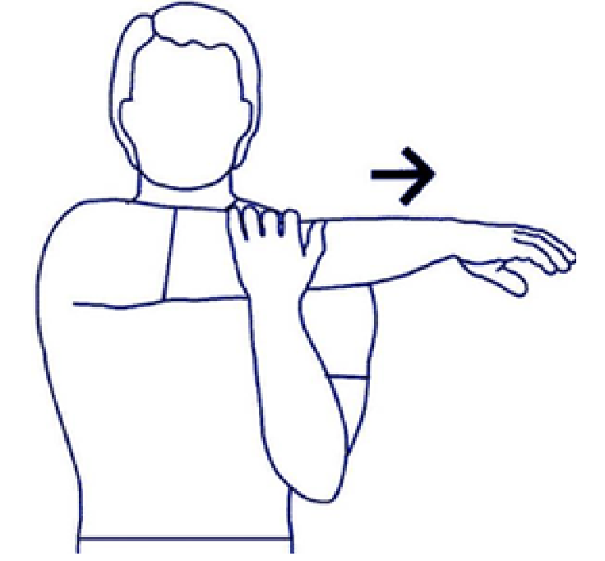
Figure 5: The "cross-body stretch," a useful method to ease the glenohumeral joint's posterior capsule. [5]
Rehabilitation of musculature
The rehabilitation of muscle activation process is divided into three stages:
(1) "active conscious control,"
(2) "strength and control for daily activities" and
(3) "control in athletic performance."
The serratus anterior and the superior, middle, and inferior trapezius are the muscles in question. Such programmes typically have a set duration of 12 weeks and deliver positive functional results. Individual populations with greater needs, such as volleyball players, should participate in a lenthier programme lasting about three months.
Active conscious control
For the scapular muscles to resume the proper activation pattern, they must be reoriented. A "scapular orientation exercise" that encourages targeted re-engagement of the muscle under tactile feedback from the other limb can be used to position the inferior section of the trapezius. The kinematic chain clearly benefits from conscious muscle training, but the effects can be reversed, according to research. The surrounding structures must be treated in addition to the muscles. The spine's resting position has to be taken care of in particular. The patient receives instructions on how to keep their spines in a neutral position in order to respect the various levels of the spine's curvatures. This retraining starts with the lumbar spine, moves on to the thoracic spine, and ends with the cervical spine. The result is that the paraspinal stabilising muscles are once again engaged to maintain a neutral spinal posture. It is suggested that the patients repeat this exercise several times each day.
Strength and control for daily activities
The simultaneous activation of muscles to carry out daily tasks is the main idea of this stage. Both "open-chain" and "closed-chain" activities should be included in the prescription. Repeating the workouts under various weight-bearing circumstances is advised. The "Open-Chain" workouts that reactivated the rhomboid muscle included the "low row," "inferior glide," "lawnmower," and "robbery" movements.
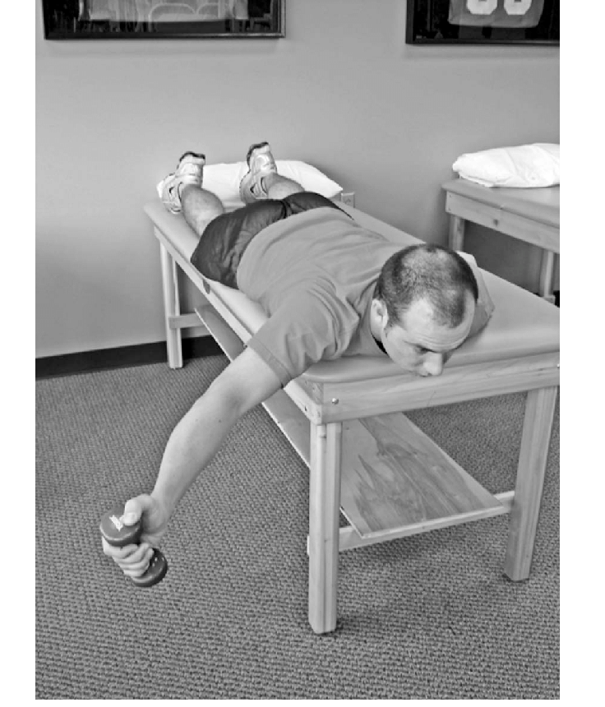
Figure 6: An illustration of an open chain exercise that encourages the activation of the supraspinatus and the rhomboid. [5]
The purpose of "Closed Chain" exercises is to improve the rotator cuff muscles' coordination and awareness of their position in space (proprioception). Furthermore, by isolating the weak muscles and reducing the action of the more powerful people, muscle strength can be attained.
Control in athletic performance
A thorough prescription of muscle-strengthening exercises should follow the principles of "scapular control" and "task-specific muscle strength," depending on the sport and the individual."[5]
Rehabilitation for scapular dyskinesis is based on a proximal-to-distal method. It concentrates on integrating appropriate and complete scapular mobility with complementary trunk and hip movements.
These movement patterns serve as the basis for scapular muscle strengthening exercises after scapular motion has been normalised. In this technique, a patient's progress is determined by function rather than by passage of time. To establish proper scapular motion in the early stages of therapy, hip and trunk motions are required. Exercises for the scapula may advance by putting less focus on proximal facilitation as scapular control improves.
This plan sometimes considered as a succession of exercises as the patient develops greater proximal control and gets closer to combining the scapular exercises with the shoulder and arm exercises. Although not yet reported, outcome studies using this rehabilitation regimen are being conducted. Our clinical experience has demonstrated that establishing scapular control, particularly early in rehabilitation, reduces rotator cuff discomfort and enhances rotator cuff function.[1]
Impact of Scapular Dyskinesis on quality of life -
The role of the upper limb and regular activities both heavily rely on the shoulder joint. [5].Normally shoulder joint perform: Average shoulder motions required to perform the 10 functional tasks were flexion, 121° ± 6.7°; extension, 46° ± 5.3°; abduction, 128° ± 7.9°; cross-body adduction, 116° ± 9.1°; external rotation with the arm 90° abducted, 59° ± 10°; and internal rotation with the arm at the side, 102° ± 7.7°.
All these movements help to perform the daily activities with comfort , but scapular dyskinesis affect these range of motion of shoulder joint and along with that the activities of daily living.[7]
Scapular dyskinesis is a frequent condition that causes shoulder joint discomfort and has a big influence on patients' daily lives. Women and overhead athletes are more likely to experience it. Patients frequently have persistent pain and restricted shoulder motion, which interferes with everyday activities and employment and places a financial burden on both individuals and societies. [8]
According to certain research, scapular dyskinesia has become more common in healthy people between the ages of 25 and 35 after the COVID pandemic lockdown as a result of improper postures and resulting muscular imbalance, which has a negative impact on people's daily lives.
Early detection is essential since it will serve as the starting point for future rehabilitation research. Studies show that scapular dyskinesia affects a population of healthy people with a variety of vocations, including desk employment, housework, and activities requiring prolonged sitting in posture, in addition to athletes.[9]
Abnormal scapular mobility, which is influenced by people's daily lives, can cause a variety of shoulder pathological disorders. Subacromial impingement syndrome is very frequent complication of scapular dyskinesia. Soft tissues, including the supraspinatus, long head of the biceps brachii tendon, subacromial bursa, and superior joint capsule, impinge in the subacromial area, resulting in this condition.
Shoulder impingement symptoms might, with time, progress to functional limitations. Additionally, neglected or subpar scapular dyskinesis rehabilitation might result in adhesive capsulitis and SLAP lesions.[10]
If we talk about the complications of scapular dyskinesis which has impacts on our life are:
- If not properly treated or given enough time to heal, increased healing time.
- Rotator cuff muscles may become chronically inflamed or impinged, resulting in ongoing pain with exercise that may eventually become continual pain (with or without activity).
- Limitation of mobility or stiffness in the shoulder.
- Rotator cuff tendon tear.
- Reappearing of symptoms after excessive use, when exercise is restarted too quickly, or when utilising inadequate technique.
Also, Increased neck disability, lower internal rotation range of motion and strength, and shorter pectoralis minor were all signs of scapular dyskinesis.[11]
In individuals with inferior angle and medial border prominence, respectively, upper and lower trapezius activity during arm elevation were linked to functional impairment. Scapular dyskinesis has been linked to changes in muscle coordination or activation as well as tightness in soft tissues.
First, to govern as force couples in specific to the task movements, the scapular muscles (the upper trapezius, UT; lower trapezius, LT; and serratus anterior, SA) coordinate the location and movement of the scapula(Magarey and Jones, 2003). Uncoordinated force coupling may lead to abnormal scapular kinematics. Patients with shoulder impingement have been found to have excessive UT muscle activity and decreased LT and SA muscle activity.
Second, altered scapular kinematics may result from tight muscles or ligaments. It is possible for severe scapular anterior tilt and downward rotation to be caused by the contracting of the pectoralis minor or the short head of the biceps.
Third, Excessive scapular internal rotation and anterior tilt might be caused by posterior shoulder muscles or capsules.[12]

CONCLUSION-
A crucial component in the chain of motion that distributes force from the body's centre to the arm is the scapula. Although SD may not initially cause symptoms, it raises the possibility of shoulder soreness. Because of the changed scapular mobility, there is a decreased subacromial space, which can result in RCT and other common shoulder illnesses. The anterior glenohumeral ligaments are also put under higher strain, and the RC is weakened. Studies have also demonstrated that restrictions in the range of motion (ROM) of the thoracic spine can result in a more pronounced compensatory response from the scapulothoracic and glenohumeral joints, increasing the risk of shoulder discomfort and injury. Early detection is essential since it will serve as a baseline for later research on rehabilitation. Studies show that scapular dyskinesia affects healthy people with a wide range of vocations, including desk employment, housework, and hobbies requiring prolonged sitting in posture and athletics.
References-
1) Kibler BW, McMullen J. Scapular dyskinesis and its relation to shoulder pain. JAAOS-Journal of the American Academy of Orthopaedic Surgeons. 2003 Mar 1;11(2):142-51.
2) Teixeira DC, Alves L, Gutierres M. The role of scapular dyskinesis on rotator cuff tears: a narrative review of the current knowledge. EFORT Open Reviews. 2021 Oct;6(10):932.
3) Welbeck AN, Amilo NR, Le DT, Killelea CM, Kirsch AN, Zarzour RH, Burgi CR, Sell TC, Faherty MS. Examining the link between thoracic rotation and scapular dyskinesis and shoulder pain amongst college swimmers. Physical Therapy in Sport. 2019 Nov 1;40:78-84.
4) McClure P, Tate AR, Kareha S, Irwin D, Zlupko E. A clinical method for identifying scapular dyskinesis, part 1: reliability. Journal of athletic training. 2009 Mar;44(2):160-4.
5) Panagiotopoulos AC, Crowther IM. Scapular Dyskinesia, the forgotten culprit of shoulder pain and how to rehabilitate. SICOT-J. 2019;5.
6) Sciascia A, Kibler WB. Current views of scapular dyskinesis and its possible clinical relevance. International Journal of Sports Physical Therapy. 2022;17(2):117.
7) Namdari S, Yagnik G, Ebaugh DD, Nagda S, Ramsey ML, Williams Jr GR, Mehta S. Defining functional shoulder range of motion for activities of daily living. Journal of shoulder and elbow surgery. 2012 Sep 1;21(9):1177-83.
8) Tang L, Chen K, Ma Y, Huang L, Liang J, Ma Y. Scapular stabilization exercise based on the type of scapular dyskinesis versus traditional rehabilitation training in the treatment of periarthritis of the shoulder: study protocol for a randomized controlled trial. Trials. 2021 Dec;22(1):1-1.
9) Dhami K, Sharma S. A Study to Assess Scapular Dyskinesia in Healthy Individuals Aged 25-35 Years.
10) Thiruvarangan S, Srigrishna P, Thileebphan B. A trial of conservative care for restoring scapular dyskinesis: A clinical series. Journal of Novel Physiotherapy and Rehabilitation. 2020 Jun 8;4(1):011-5.
11) Jung JW, Kim YK. Scapular Dyskinesis in Elite Boxers with Neck Disability and Shoulder Malfunction. Medicina. 2021 Dec 9;57(12):1347.
12) Huang TS, Huang CY, Ou HL, Lin JJ. Scapular dyskinesis: Patterns, functional disability and associated factors in people with shoulder disorders. Manual Therapy. 2016 Dec 1;26:165-71.

