“BASICS OF IC ENGINE FUEL SUPPLY SYSTEM DEFECT & FAILURE”
Dr. Harshit Bhavsar
Assistant Professor, Sal College of engineering, Department of Mechanical engineering

Introduction:
The general issue of internal combustion engines failure is very complex and comprehensive. In principle, an analysis of such failure must take into account the way the constructive/functional requirements are met by the engine’s mobile organs, the particularities of the operating regime of the equipment (specified by speed, load, the corresponding thermal regime and engine cooling conditions), lubrication regimes of the engine friction couples and the quality of the used lubricant.

It is also necessary to take into account the wear accumulated during the engine operating, as well as possible internal discrete defects of the engine’s parts. The systemic approach to this complex of conceptual, functional and intrinsic problems involves, on the one hand, the multidisciplinary engineering analysis and the polyvalent training of the operator team and, on the other hand, requires specific investigation equipment. This paper is in fact an application of analysis techniques in a particular case [1,2].

The subject of this case study is a 4-stroke compression ignition engine with 6-cylinder in-line, turbo-compressor medium-turbocharged and liquid-cooled. The engine is an older generation of the Case IH family and has equipped a grain-harvesting combine. Its cylinder capacity is 8.7 [liters] and runs at 230 [HP] at a nominal speed of 2300 [rpm]. The engine compression ratio is 18.

This engine failed during operation, the engine running in full load. At the time of the damage, the engine was about 1200 hours of operation since the last major repair and about 100 hours since the last oil change.

The fuel supply system and fuel pressure wave
Fully atomized diesel oil transported by the fuel supply system sprays into the cylinders at regular time, quantity and pressure, mixing and burning with air quickly and sufficiently. The fuel supply system is mainly composed of fuel tank, diesel filter, low-pressure oil pipe, fuel pump, injection pump, high-pressure oil pipe, injector and so on ^{[7]} (Figure. 1). The complex composition of the system leads to higher failure rate.
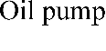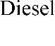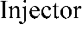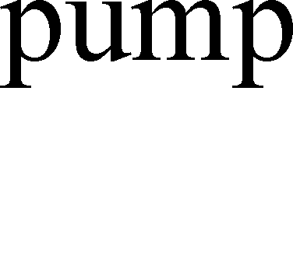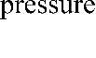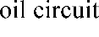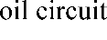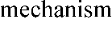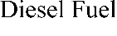

Figure 1. Composition of Diesel Fuel Supply System
The waveform characteristics of the high-pressure oil fuel pressure can get the fault cause analysis. The cause of failure can be obtained by analyzing the waveform characteristics of fuel pressure in high-pressure oil circuit. Figure 2 shows normal pressure waveforms and characteristic parameters.

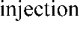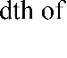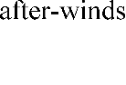
Figure 2. The normal pressure waveform

- Failure analysis: -

Once the engine starting failure, firstly, we should check the fuel quantity in fuel tank. And the fuel quantity according to the fuel index gauge is ensured. Then starting the engine could be permission. What’s more, the common reasons for the fault mainly contain ignition system fault, fuel feeding system fault and fuel injection nozzle fault. In ignition system, several faults would be making the starting failure such as the weaken spark, no high pressure spark and a rather large error between the ignition advance angle and the standard angle. And the low pressure in fuel system would cause injection mass shortage. Above of all, the causes of engine starting failure mainly have several reasons as follows: ignition system failure, fuel shortage in tank, fuel pump failure, injection system failure, low fuel system pressure, fuel filter chocking or pipeline chocking. It may also occur in crank case, connecting rod, bearings, cylinder head, timing gear, crank-shaft, valve, cam shaft, piston, cam-shaft.

Sings of failure:

1. The Engine is Sputtering
This often happens the faster you drive. You will hear and feel and engine as it sputters and struggles to produce power smoothly. This means there is not a constant stream of fuel being pumped into the engine.
2. Difficulty Starting the Car
This could be any number of mechanical problem such as a failing ignition system, alternator, dead battery or spark plug. It may also be a fuel system issue. If your car won’t start, it’s best to have a professional mechanic diagnose the cause.
3. Fuel Tank Whining Noise
Any unusual sound in your vehicle is cause for concern. A failing fuel pump is often heard with a loud whining sound that comes from the fuel tank. It usually means the vehicle is low on fuel, has contaminated fuel in the system or the fuel pump isn’t working correctly.
4. Lack of Power
A fuel system issue might also show itself when you are driving the car under stressful conditions (high temperatures, high altitude, steep uphill climbs, or carrying an uphill load). The engine may sputter or stall out completely. It may just lose a lot of power when you need it most, and that’s often an indicator of a fuel system problem.
5. Loss of Gas Mileage
If you keep diligent track of your gas mileage and notice you aren’t getting the MPG you are used to, a problem within the fuel system is one of several issues that could be causing a loss in fuel efficiency.

6. The Car is Surging
Sometimes, a fuel system problem will cause the car to surge while it is driving. It won’t maintain consistent speed and you’ll feel it struggling as you press the gas pedal.
7. Fuel is Leaking
A sure sign of a fuel system failure is if you notice that any gasoline or diesel fuel is leaking from under your vehicle. If you see a fuel leak don't drive the car and get it to an auto shop as soon as possible.

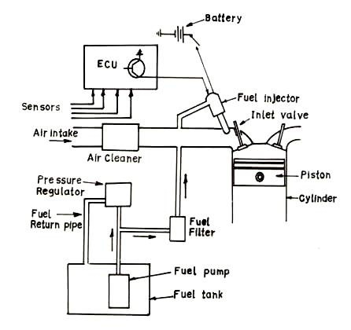
Figure 3. Fuel supply system

- Fuel supply system in Spark Ignition:

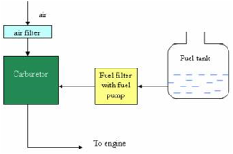

Figure 4. Fuel supply system in SI engine

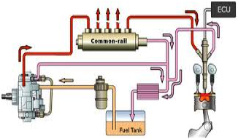

Figure 5. Fuel supply system in Fuel Injector

- Conclusion

The traditional BP neural network, using the steepest descent method for fault diagnosis, being easy to lead to reach local optimum rather than the global optimum. The training takes time, especially in the case of a great quantity of training data, network layer and the number of neurons. This paper adopts GA algorithm to optimize the initial weights and thresholds, then trains the network, and the diesel fuel supply system fault diagnosis is conducted at last. The results show that the training speed of the optimized BP neural network is improved, the training error is significantly reduced, and the diagnosis results are more real.

REFERENCES

- I. C. Engines by Heywood
- I. C. Engines by V.Ganeshan, Tata McGraw Hill
- https://www.researchgate.net/publication/348355485_Engine_Emissions_and_Their_Control_Review
- https://www.researchgate.net/publication/311470318_Emission_Control_in_IC_Engine_-Selective_Catalytic_Reduction_Method
- https://www.researchgate.net/publication/301515973_EXPERIMENTAL_INVESTIGATION_TO_REDUCE_ENVIRONMENTAL_POLLUTION_FROM_AN_AUTOMOBILE_USING_THERMAL_REACTOR
- https://dieselnet.com/

