THE STUDY OF ANTIOXIDANT, ANTIMICROBIAL AND ENZYMATIC PROPERTIES OF BIOENZYME Phyllanthus emblica
*Dr.R.Krishnaveni, Assistant Professor and Head, PG and Research Department of Microbiology. Idhaya College for Women, Kumbakonam.

K.THASLEEM BANU¹, J.THASLEEMA PARVEEN¹, M.SABANA¹.Research student, Department of Microbiology.IDHAYA COLLEGE FOR WOMEN.KUMBAKONAM
Corresponding Author-Dr.R.KRISHNAVENI,Mail.id ,krishnavenimicro@gmail.com

DR.R.KRISHNAVENI¹, K.THASLEEM BANU¹, J.THASLEEMA PARVEEN¹, M.SABANA¹.
INTRODUCTION:
Amla (Emblica officinalis) is rich in vitamin c.it manage the blood sugar level and good for skin and various anti-inflammatory and booster immune system.it is very useful in ayrveda medicines.it reduce obesity,and eliminate lipid from body.it belong to family Euphorbiaceae and is also known as Phyllanthus emblica or Indian gooseberry. Emblica officinalis also grows in tropical and subtropical China and Malaysia(Khan,H,2019It used conventional medicines. Medicinal plants are widely used for treat diseases (Sharma etal., 20120)The antioxidant activities followed in phyllanthus emblica bio-enzyme in Ascorbic method shows 59.50±1.15, 64.05±0.75, 73.15±1.35, 89.25±1.75 and 92.5±0.75 vice versa.
OBJECTIVES:
- The present work focused to prepare an hair serum to hair infections by using bioenzyme phyllanthus emblica
- The wound sample collected using sterile cotton swab
- From the wound sample the microbes were isolated
- Testing antimicrobial activities of wound with the bioenzyme phyllanthus emblica
- The medicinal plant phyllanthus emblica was collected
- The bioenzyme was prepared from the fresh, mature, healthy leaves of phyllanthus emblica
- The analysis of Antioxidant, enzymatic and Antimicrobial activities were studied
- The bioenzyme scalp serum was prepared.
Emblica officinalis has a natural balance of tastes (Bajracharya, 1979 The fruit is occasionally picked or preserved in sugar. When dry it is said to be gently laxative (Drury, 1970)
MATERIALS AND METHODS:
SITE OF THE COLLECTION:
Healthy, disease free mature phyllanthus emblica plant leaves was collected in green garden of Idhaya college for women, Kumbakonam. The herb was botanically identified and characterized. The leaves were separated and washed with sterile water.
PLANT PART USED:
Phyllanthus emblica leaves were used.
BIOENZYME PREPARATION:
The fresh leaves of Phyllanthus emblica were washed with sterile water and cut into small pieces and prPhyllanthusthe step of bio-enzyme preparation.
- The procedure for the preparation of bio-enzyme includes jaggery.Phyllanthus emblica leaves, water to be taken in the ratio of 1:3:10 added with little yeast and kept in the closed container. In this ratio the 10 parts of water, 3 parts of Phyllanthus emblica leaves, and 1 part of sugar.
- Jaggery or Black strap Masses – 200g

- Phyllanthus emblica leaves – 600g

- Water–2 litres

- Quarter (1/4) teaspoon dry yeast
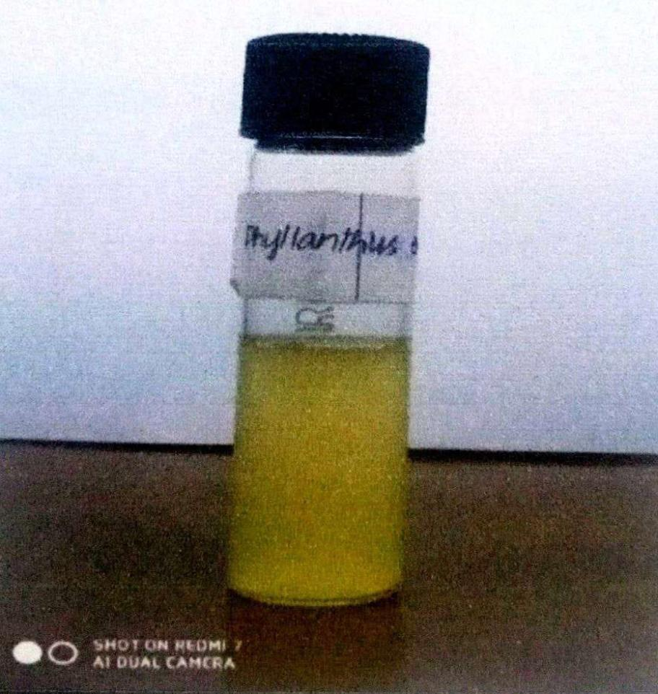
PHYTOCHEMICAL STUDY:
Phytochemical analysis in ethanolic extract was performed by standard procedure described by Surya Nath pandey (2020). Phytochemical analysis was done for phyllanthus emblica bio-enzyme, in which Tannin, saponin, alkaloids, terpenoids, flavonoid, glycoside and steroid assay, Tannin assay, Saponin assay, Flavonoid assay, Glycoside assay.

ANTIMICROBIAL ASSAY
The nutrient agar was prepared and sterilized. Then the Nutrient agar is poured into the plates (4mm depth) to grow the tested bacteria or organisms.
ANTIOXIDANT ACTIVITY:

The antioxidant potential of the aqueous fruit peels formulation extract was evaluated by DPPH free radical scavenging assay.
% DPPH scavenging = Control absorbance – Sample absorbance×100 / control adsorbent.

RESULT:
In this present study, Phyllanthus emblica bio-enzyme was used to check its antimicrobial activity against microorganisms isolated from wound sample. The bio-enzyme is prepared from phyllanthus emblica leaves which is then subjected to phytochemical, antioxidant and enzyme quantificatuon assay. Medicinal plants with different organic solvents were used to extract the active compound for various applications.

PHYTOCHEMICAL ASSAY:
The phytochemical analysis was done with the procedure of Sofowara (1990), Trease, Evans (1989) and Harbome (1973) and carried out many tests. Among which it was found that the presence of tannin indicates the colour change from light green to dark green. For saponin test, the change of clear solution to the foam formation, indicates the presence of saponin. White precipitate and it changes to milky white solution on addition of few drops of dilute Hcl indicates the presence of flavonoids. For the test of glycoside, presence of light yellow colour with orange ring indicates the presence of glycosides.

BACTERIAL SPECIES, IDENTIFICATION:

TABLE 1, represents the presence of phytochemical compounds in Bioenzyme of Phyllanthus emblica such as tannin, saponins, flavonoids and glycosides.

TABLE 2, represents Antioxidant activity at different concentrations like 20, 40, 60, 80, and 100µg/ml by Ascorbic acid and DPPH activity method (Fereidon Shahidi etal.,2015). The antioxidant activities followed in phyllanthus emblica bio-enzyme leaves in Ascorbic method shows 59.59±1.15, 64.05±0.75, 73.15±1.35, 89.25±1.75, and 92.5±0.75 vice versa. In DPPH method the antioxidant activities followed in phyllanthus emblica bioenzyme leaves shows 58.35035±0.95, 61.590150±1.15, 68.65165±1.05, 75.25025±0.95 and 81.35035±0.75 vice versa.
TABLE 3, represents the enzyme quantification at different concentration like 200, 400, 600, 800, and 1000µg/ml and the measurement of absorbance at 650nm in 1cm cuvettes were recorded and compared with the BSA standard reading (Lowry OH etal.,1951). The enzyme activity followed in phyllanthus emblica bioenzyme shows 0.17 nm, 0.26 nm, 0.48 nm, 0.59 nm, and 0.76nm vice versa.
TABLE 4, represents the isolated microorganisms such as Staphylococcus aureus, Pseudomonas aeruginosa from scalp.
TABLE 5-A represents, the isolated organism was subjected to various biochemical, and microscopic tests for identification. It showed the isolated organism was gram positive, non-motile and cocci shaped. On blood agar the colonies were golden yellow, round, smooth, opaque, raised and glistening colonies. It shows MRVP, citrate, TSI, catalase, coagulase, urease and lipid hydrolysis test positive result; while indole and starch hydrolysis test shows negative result. Hence, the isolated microorganisms was identified as Staphylococcus aureus.

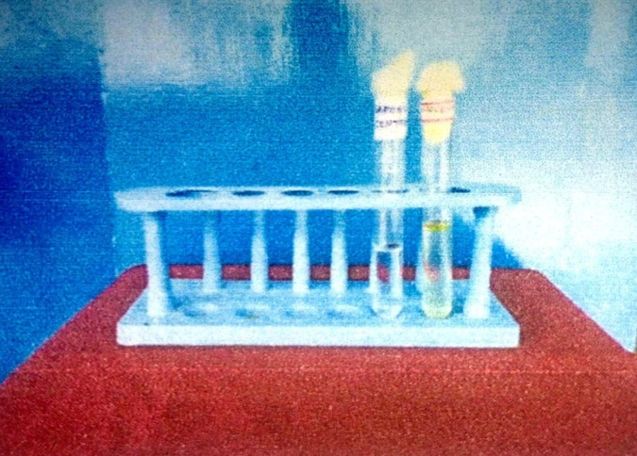
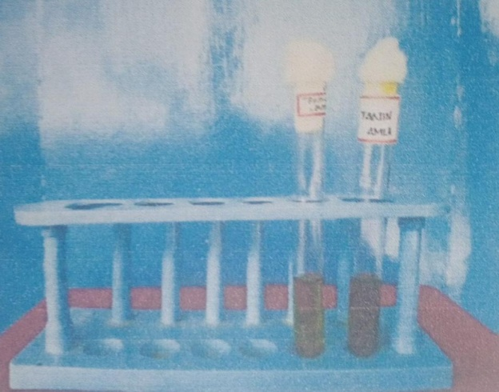
FIGURE 1: PHYTOCHEMICAL ANALYSIS OF phyllanthus emblica OF BIOENZYME: A. TANNINS POSITIVE B. SAPONINS TEST

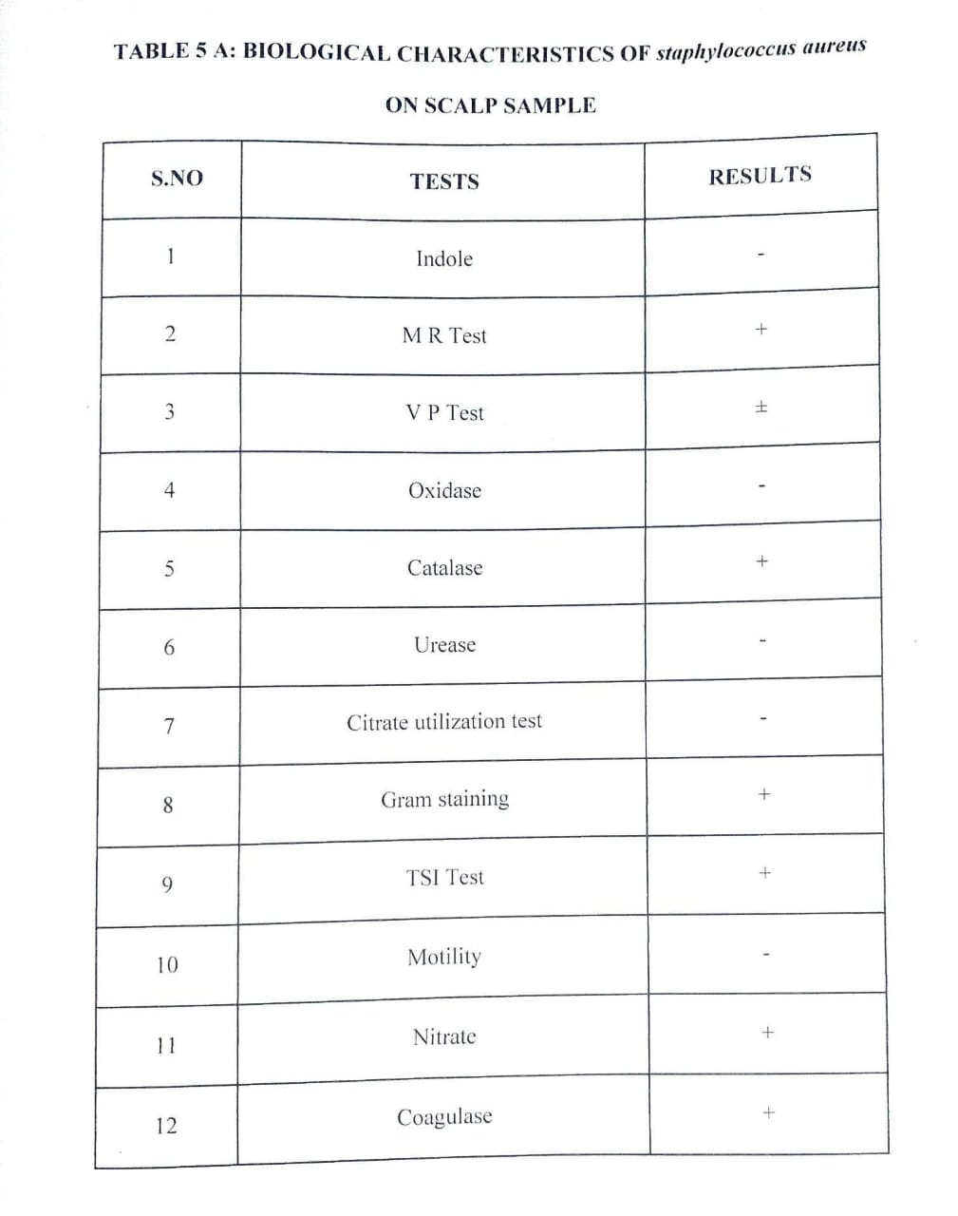
TABLE 1: BIOLOGICAL CHARACTERISTICS OF Staphylococcus aureus ON SCALP SAMPLE

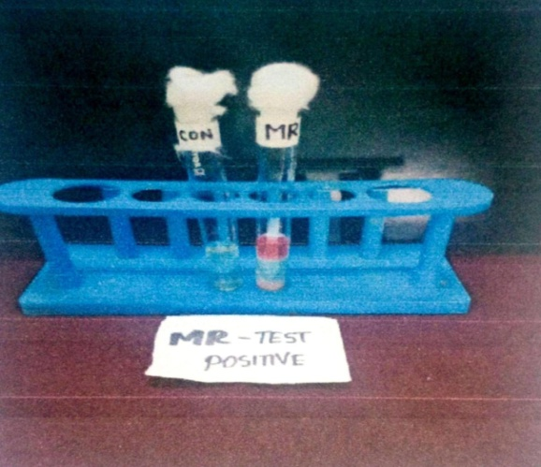
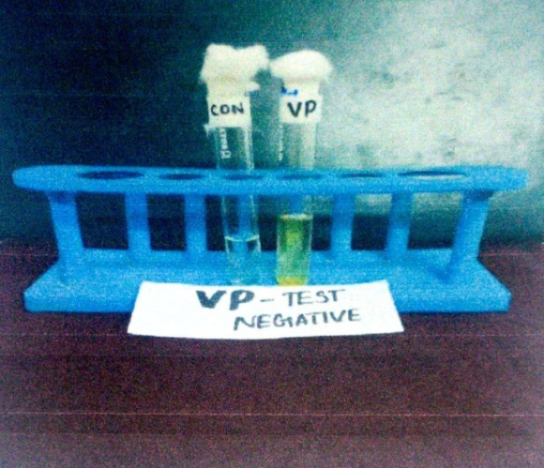
MR – TEST POSITIVE VP – TEST NEGATIVE

REFERENCES:
- Bajracharya, M.B. Ayurvedic medicinal plants, Kathmandu; Piyusavarsi Ausadhalaya, 1979.
- Dasaroju S, Gottumukkala KM.Current trends in the research of Emblica officinalis (Emblica officinalis) : A pharmacological perspective. Int J pharm sci Rev Res 2014; 24:150-9.
- Deep G, Dhiman M, Rao AR, Kale RK, Chemo preventive potential of Triphala (a composite indian drug) on Benzo(a)pyrene induced for stomach tumor genesis in Murine tumor model system, Journal of Experimental and Clinical Cancer Research, 2005; 24(4):555-63.
- Drury, Colonel Heber: The useful plants of India; with notices of their chief medicinal value in commerce, medicine and the arts. Higginbotham and co. Madras.1970.
- Khan, H. Role of Emblica officinalis in medicine, Bot Res. Int. 2009; 2(4):218-228.
- Krishnaveni M, Mirunalini S, Therapeutic potential of Phyllanthus emblica (Emblica officinalis) : the ayurvedic wonder, Journal of Basic and Clinical Physiology and Pharmacology, 21,2010, 93-105.
- Prakash D, Upadhyay G, Gupta C, Pushpangadan P, Singh KK, Antioxidant and free radical scavenging activities of some promising wild edible fruits, International Food Research Journal.2012; 19(3):1109-16.
- Santoshkumar J, Manjunath S, Pranavkumar MS, A study of perlipidemia, hypolipedimic and anti atherogenic activity of fruit of Emblica officinalis (Emblica officinalis) in high fat fed albino rats, International Journal of Medical Research and Health Sciences. 2013;2(1): 70-77.
- Sharma R, Thakur GS, Sanodiya BS, Savita A, Pandey M, Sharma A , et al. Therapeutic potential of Calotropis procera: A giant milkweed. ISOR J Pharm Biol Sci 2012;4:42-57.
- Varadacharyuli N, Damodara Reddy, Padmavathi P, Paramahamsa M, Modulatory role of Emblica officinalis against alcohol induced biochemical and biophysical changes in rat erythrocyte membrane, Food and chemical Toxicology.2009;47,1958-63.
- Vasudevan M, parole M, Memory enhancing activity of Anwalachurna (Emblica officinalis Gaertn) : An ayurvedic preparation, Physiology & Behaviour. 2007; 91(1): 46-54.

