BUSINESS TRANSFORMATION THROUGH DIGITAL MARKETING

Mr. AMIT GUNJAN
Assistant Professor,
Department of BBA,
Jamshedpur Women’s University

ABSTRACT:

COVID 19 has shifted the physical world to the digital world. In the world of the machine, they are not in a position to bifurcate between the various users. The bifurcation can be done only with the help of web analytics. With the help of cookies, server log, and page tag we can track the data in a proper way. There are various tools like Google Analytics and Adobe Analytics that can track online data in real-time. We can make our Website more efficient if we are able to analyze the data in the proper way and if we will give recommendation which is effective for the company.

KEYWORDS: Page Tag , Server log, Cookies

INTRODUCTION:
After COVID 19 pandemic the world is transformed from the physical medium to the digital medium. Now business is also transformed itself into a digital medium. To deal with the problem the business houses have to become proactive so that they can deal with the modern-day problem. The most important method that can help the business houses are web analysis. Web analysis is a process by which we can collect and then we can manipulate the data so that it can be used wisely. In the digital platform, there is termed coined as website traffic. Website traffic is the umbrella term and it refers to the traffic of people who are visiting our site. All the important information like time spent on the website, the key information they are looking for are part of the website traffic. All these data are used by the marketer to improve the customer experience and drive conversion. Now web analysis is changed to digital analysis, as web analysis deals with the website only whereas digital analysis deals with all the digital platforms. The digital analysis includes data from search, social platforms, email, websites, etc.
How we analyze the website: The user comes to your website in different ways and they are:
- Typing the URL of the website
- Clicking to a link that is available on another website. This link can be provided through
- Link via ad
- Link via a search engine.
- Link via Email
- Link via Social Media
Now Web Analytics solution collects the information about the user and all the activity of that user. To capture all the data of the user the Web Analytics solution uses Cookies. Cookies are small pieces of a file that web analytics solution drops on the user browser. The Cookie captures all the data that the marketer is looking for.
How data is collected:
- Through server log: When the user requests the information the server is the single point of contact from where he will get the data. During this exchange process server also writes a log file. Log file keeps the record of what was requested from the server and who initiated this request. The things that come under log file is:
- Date of login
- Time of login
- Reference etc
After this web analytics tools process the data of the log file to get meaningful information.
But due to some major problems in server logging like Browser caching and premature exit of the user new concept came into the market known as PAGE TAGS.

- Page Tags are the small JavaScript that is included in the page source. Tag is also called Pixel. As a user navigates the site and takes action, the JavaScript collects information and sends data to the Web Analytics Provider, and then the Web Analytics Provider process the data in real-time and generates the report. The benefits of page tagging are accurate page count, JavaScript is not cached by the browser.
- Most Web Analytics solution like Google Analytics solution or Adobe solution is tag-based solutions.

Member of Web and Digital Analytics: There are 4 members of Web and Digital analytics and they are:
1. Users or Visitors
2. Event or Page view
3. Time
4. Session or visit
All the actions revolve around these building blocks. The visit is also known as a session. 30
Minutes of Inactivity starts new visit.

Let’s take one example:

Comes at 11:00 am Leave at 11:10 am
Website
Website
USER

Comes at 11:20 am

Case 1
In this case the visit or session will be counted as 1 because inactivity is less than 30 minutes.

Website
Website
USER

Comes at 11:00 am Leave at 11:10 am

Comes at 11:59 am

Case 2
In this case the visit or session will be counted as 2 because inactivity is more than 30 minutes.

The visitors are counted through Cookies. Suppose a user visits the same site through two browsers i.e. one through a laptop and one through the website then the visit will be counted as 2 as Cookies are browser-specific. To overcome this problem many organizations use the 'login id' of the user. Let us take the example of Face book. When a user opens his account in Face book through multiple browsers at the same time the 'login id' of that user is dropped inside the cookie. In this case, the visit will be counted as 1.
Role of Web Analyst and Digital Marketer:
All the activities of the user are collected by the digital analytics tool and the digital analyst creates a report. The value of digital analysts comes through critical thinking. Critical thinking is the process by which the Digital Analyst finds the hidden facts which are beyond the report. Suppose your campaign manager has assigned your goal to send an email to the prospect and to generate the report. Then in that case you can create a report by using Digital Analytics tools like Google Analytics. But only creating the report is not enough you have to find out the hidden facts in that report.
Web Analytics
EMAIL
Search Data

EXHAUSTIVE INFORMATION

MEANINGFUL INFORMATION FOR THE STAKEHOLDERS

Fig: Role of Digital Analyst

Marketing Investigative Process: There are four steps in the web analytics process namely:
- Make the strategy: The various sub points that come under this process are:
- Business Objectives and Goals
- How we will measure the success
- Target Audience etc

- Data and Tools: The various sub points that come under this process are:
- Required data
- Tools
- Measurement Plan etc

- Insight: The various sub points that come under this process are:
- Reporting
- . Analysis
- Recommendation etc

- Optimization: The various sub points that come under optimization are:
- Act on the recommendation
- Make changes
- Conduct A/B Testing

ANALYSIS STRATEGY

- Define business objectives
- Goals for each objective
- Define KPI and matrix for each goal.
- The target for KPI's
In the first step, we ask a key question like 'Why do we have a website? The business objectives are made by the executives. Business objectives are the result of several discussions.
Business objectives example:
- To generate leads
- Drive sales
- Drive customer retention etc
- Create awareness of the brand
Once business objectives are defined then you have to assign 2-3 goals for each objective. Like objectives, goals are also driven by the executives. Goals are specific ways websites or marketing support objectives.

KPI(Key Performance Index) is a matrix to measure how you are doing against your goal. KPI's is generally expressed in percentage, ratio, or indexes.

DATA AND TOOLS
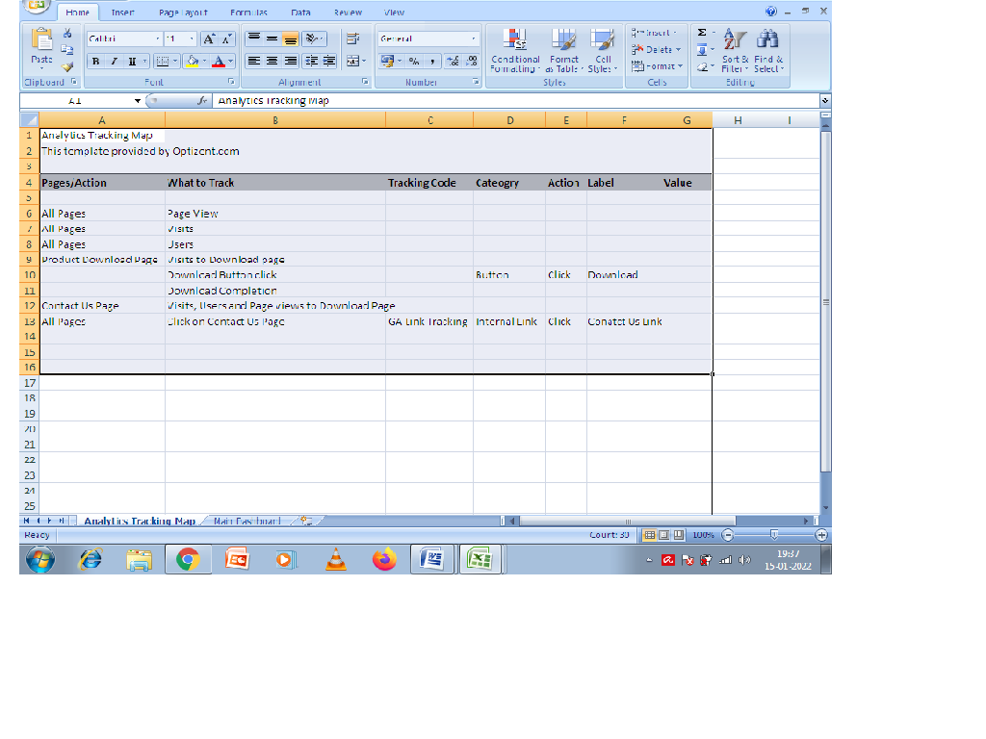
Here in the above example, we can see in the excel what actions are assigned to each entity. For 'all pages' we will track the 'page view', 'visits, and 'user'. Likewise, for every row, we will assign a pathway.
The third, fourth, fifth, and sixth column is very tool-specific and it is related to the tool. In the above example, the tool used is Google Analytics but in the case of Adobe, we can modify the tools.

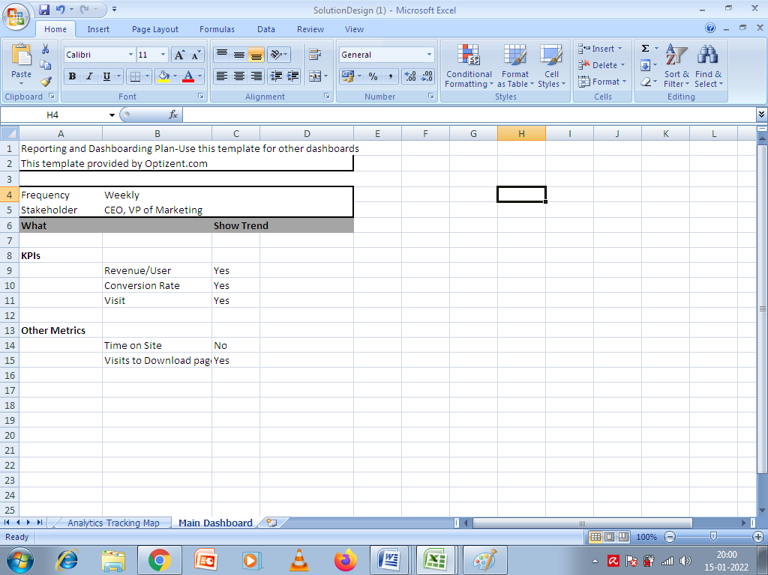

In the above example, there is a row called frequency where we will assign days. Then we will also give the stakeholder's name which is given in the excel sheet as VP of marketing or CEO. Now pathways for KPIs and other matrices are also given in the above excel sheet. Once everything is fixed then we will give our plan to the developer.
The recommendation is a very important step that should be included in the dashboard.

FINDING:
In the above article, we can see how we can implement Web analytics very easily. There is a difference between 'Risk' and 'Calculative Risk'. With the help of Web Analysis, we can implement our plan with minimum risk. Web analysis helps us to deliver our product to the right segment of people. As we know that if we will position our product to the right audience then there is a great chance of a conversion. For example, ladies' products should be placed in front of the ladies, not Gents. The machine cannot differentiate between Men and Women as they are not programmed to do so. But with the help of Web Analysis, we can bifurcate Ladies and Gents.

SUGGESTION:

- Before implementation of the plan in digital media we have to conduct a survey which can be door to door or virtually through digital media.

- The proper Q and A session will give us the ultimate output of the survey.

- All the essential elements should be included in the web analytics.

- To minimize the risk of failure we have to be specific in our approach.

CONCLUSION:
In today's cutthroat competition we have to make ourselves digitalized properly. The proper positioning of strategy is the key area where we have to work. Only segmentation will not work in the above example we have to target the product in the right way. The mood of the customer also plays a very vital role to track the needs. Through Web Analytics we can give a questionnaire we can also track the mood and then we can place our product.

References:

CIALDINI R(1984). The Psychology of Persuasion

HOPKINS C(1923). Scientific Advertisement

BRUNSON R(2017). Expert Secrets: The Underground Playbook for Creating a Mass Movement of People Who Will Pay for Your Advice

EYAL N(2013): Hooked: How To Build Habit- Forming Products

BATRA A(2020): Web analytics and Digital Marketing Analytics- Zero to Hero

VAYNERCHUK G(2013): Jab, Jab, Jab, Right Hook

Collis W & Collis David J.(2020): How to build a Digital Brand That Lasts (Harvard Business Review)

O’Reilly Lara(2018): The Future of Digital Marketing in Data- Privacy World( The Wall Street Journal)

engaiodigital.com

https://searchbusinessanalytics.techtarget.com

