Chapter:
Recent Advancement in Mammography: Enhancing Breast cancer detection and diagnosis.
Ms. Akanksha Singh¹, Mrs. Kajal Tyagi²
Abstract
Mammography plays a crucial role in the early detection and diagnosis of breast cancer, which is essential for improving patient outcomes. Over the years, significant advancements have been made in mammographic technology, leading to improved image quality, increased sensitivity and enhanced diagnostic accuracy. This chapter explores the latest development in mammography, including digital mammography, digital breast tomosynthesis, contrast-enhanced mammography, and artificial intelligence-based approaches. The ideas underlying these procedures are discussed, as well as their benefits and impact on breast cancer screening and detection. Furthermore, we highlight emerging trends and future directions in mammography research and technology.
Key words – Breast Cancer, Lesion, X-Rays, Mammography, Tumours, Self-examination, Diagnosis.

Introduction
Breast cancer is a major global health issue that affects millions of people globally. It is the most frequent cancer in women and accounts for a significant n umber of cancer-related fatalities. Breast cancer is responsible for around 2.3 million new cases and 685,000 deaths per year, according to the World Health Organization (WHO). In the United States, there are more than 3.1 million women having a history of breast cancer as of March 2017^{[1]}.
- Breast Cancer: A Global Health Challenge
Breast cancer has a substantial global health impact due to its prevalence and impact on mortality rates. It can afflict men as well as women, however at a far lower frequency. Age, genetic predisposition, hormonal factors, lifestyle choices, and environmental exposures are all risk factors for breast cancer. Early detection and treatments are crucial for increasing survival rates and lowering morbidity associated with breast cancer.
Figure 1: Breast Cancer: A Global Health Challenge
(https://ehealth.eletsonline.com/2021/02/covid-19-has-worsened-the-problem-of-delayed-breast-cancer-diagnosis/)
- Mammography for Breast cancer Detection
Mammography has developed as an important method for detecting and diagnosing breast cancer. It creates images of breast tissue using low-dose X-rays. Mammograms can detect anomalies such as tumors or calcifications that may signal breast cancer. Women over the age of 40, as well as those at higher risk due to family history or other circumstances, should have regular screening mammography. Mammography is one of the most extensively used modalities for breast cancer screening, and it has considerably contributed to the lowering of cancer mortality through early detection ^{[2]}.
Mammography provides various advantages in the identification of breast cancer. For starters, it enables the diagnosis of tiny cancers or lesions even before they are perceptible. Early discovery allows for timely treatment, which results in better outcomes and higher survival rates. Second, mammography can detect non-palpable breast abnormalities such as microcalcifications, which are early symptoms of breast cancer. Third, mammograms can detect benign illnesses that may be mistaken for breast cancer, avoiding unneeded procedures and anxiety. Still, because to the intricacy of mammography (MGs) and the high volume of tests per radiologist, incorrect judgements might do ^{[3]}.
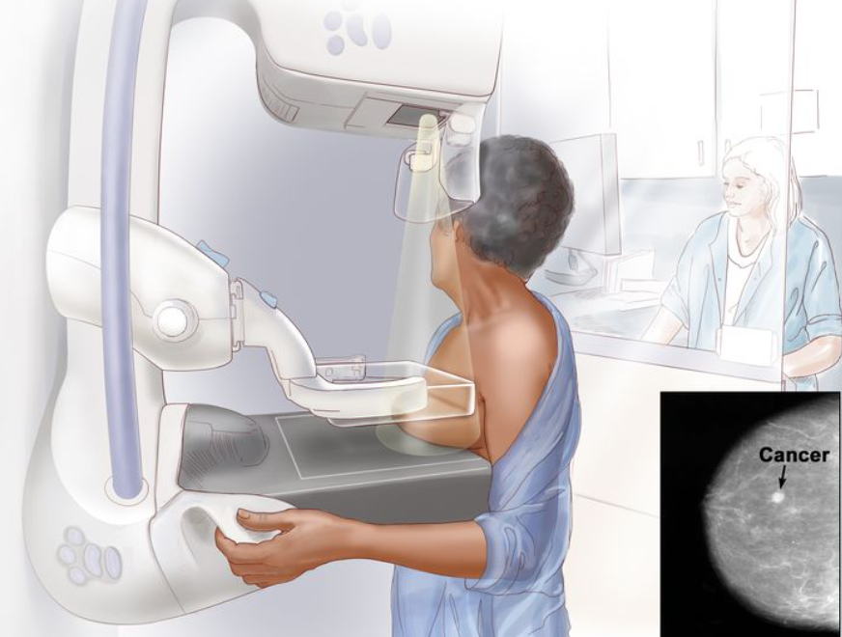
Figure 2: Mammography Machine
(https://www.cancer.gov/types/breast/patient/breast-screening-pdq)
- Advancement in Mammography
Mammography technology advancements have had a substantial impact on breast cancer detection and diagnosis. These advances have concentrated on enhancing image quality, increasing sensitivity, and decreasing false positives and false negatives. They also wanted to improve the entire patient experience and streamline healthcare providers' workflow.
In many healthcare settings, digital mammography has supplanted traditional film-screen mammography. Digital systems provide various advantages, including improved image quality, the capacity to modify images for enhanced visualization, and the possibility of computer-aided detection (CAD) systems assisting radiologists in spotting worrisome results.
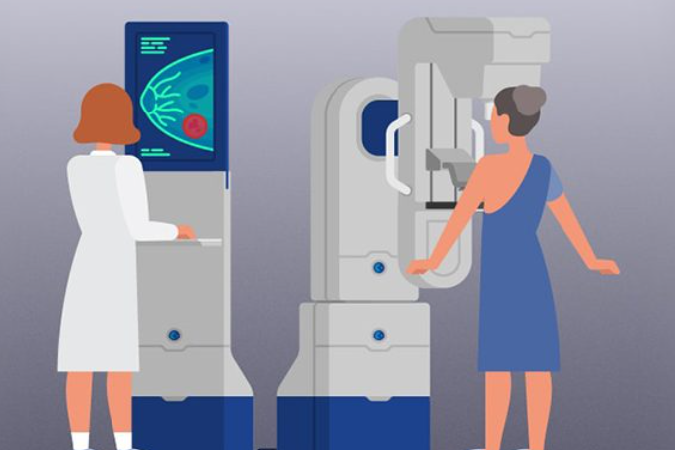
Figure 3: Advances in Mammography
(https://www.trivitron.com/blog/advances-in-mammography-paving-way-for-improved-detection-of-breast-malignancies/)
Another significant innovation in mammography is digital breast tomosynthesis (DBT). It generates three-dimensional pictures of the breast, improving lesion visibility and reducing overlapping tissue aberrations. DBT has showed encouraging outcomes in terms of lowering false positives and increasing cancer detection rates, especially in women with dense breast tissue.
Contrast-enhanced mammography (CEM) is a newer technique that uses intravenous contrast chemicals to improve imaging of cancers and aberrant blood vessels. CEM can help distinguish between benign and malignant tumors, especially when standard mammography or ultrasound results are ambiguous. In individualities with breast lesions, a mammography checkup may be useful as an fresh additional modality to ameliorate individual yield ^{[6]}.
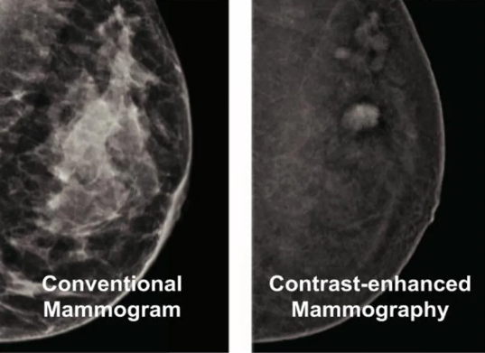
Figure 4: Contrast enhanced Mammography vs Normal Mammography
(https://www.breastimagingvictoria.com.au/contrast-enhanced-mammography)
Mammography has also benefited greatly from artificial intelligence (AI). AI algorithms can analyze mammogram pictures and help radiologists locate and characterize abnormal findings, resulting in more accurate and efficient diagnosis. Artificial intelligence-powered CAD systems have the potential to improve diagnostic accuracy and workflow efficiency in breast cancer screening programs.
The importance of mammography developments stems from their ability to improve early detection rates, reduce false positives and false negatives, improve patient comfort, and maximize healthcare resources. These improvements have the potential to save lives by diagnosing breast cancer earlier in its progression, when treatment is more successful. They also help to reduce unnecessary interventions, reduce patient anxiety, and improve the overall quality of breast cancer care.

Negative impacts of mammography
- False Positives: Mammography can occasionally provide false positive results, which means that an abnormality found on the mammography turns out to be non-cancerous upon additional examination. False positives can cause worry and necessitate unnecessary follow-up testing, such as biopsies, which are intrusive and risky. False positive cause patient concern, redundant radiation exposure, dispensable biopsies, high message rates, advanced health-care charges and fresh evaluation ^{[4].}
- False Negatives: Mammography, on the other hand, can produce false negatives, in which breast cancer is present but not identified by the mammogram. False negatives can create a false sense of security and delay breast cancer identification and treatment, potentially leading to poorer results.
- Radiation Exposure: Mammography employs low-dose X-rays that expose the breast tissue to ionizing radiation. Despite the modest dose, continued exposure over time can build to cumulative radiation exposure. While the benefits of mammography outweigh the risks for the majority of women, the long-term effects of radiation exposure are a worry, especially for women who have regular screenings.
- Discomfort and Pain: Because of the compression of the breast tissue required to generate quality images, some women may suffer discomfort or pain during mammography. This discomfort may discourage women from engaging in routine screening or cause anxiety and distress prior to and during the procedure.

Positive impacts of mammography
- Early Detection: Mammography is critical in the early detection of breast cancer because it allows abnormalities to be identified even before they are palpable. Early detection improves the odds of successful treatment and survival.
- Improved Survival Rates: Mammographic screening on a regular basis has been found to improve breast cancer mortality by finding malignancies at an earlier stage when therapy is more effective. Mammography has been shown in studies to assist identify tiny tumors and prevent breast cancer from progressing to advanced stages.
- Identification of High-Risk Individuals: Mammography can detect women who are more likely to develop breast cancer due to variables such as age, family history, or genetic susceptibility. This enables high-risk patients to be targeted for screening and surveillance, allowing for earlier discovery and individualized management.
- Guiding Treatment Decisions: Mammography is vital in the diagnosis and staging of breast cancer. It aids in the selection of appropriate treatment methods such as surgery, radiation therapy, or chemotherapy by providing information on the size, location, and features of the tumor.
Limitations
Despite being a frequently utilized screening method for breast cancer detection, mammography has some limitations that should be considered:
- Sensitivity in Dense Breast Tissue: Mammography's ability to identify breast cancer in women with dense breast tissue can be diminished. Dense breast tissue, like tumors, looks white on mammograms, making it difficult to discern between normal tissue and abnormalities. This can result in false-negative results, in which cancer exists but is not identified.
- False Positives: Mammography can provide false positive results, showing a non-cancerous abnormality. This can result in additional tests, such as biopsies, resulting in worry, unneeded procedures, and increased healthcare costs.
- Radiation Exposure: Although mammography's radiation dose is minimal, repeated exposure over time can contribute to cumulative radiation damage. This is a worry for women who have regular screening mammography, especially those who are younger or have high-risk characteristics.
- Limited performance in younger women: Mammography is often less successful in detecting breast cancer in younger women because their breast tissue is denser, making abnormalities more difficult to detect. As a result, for this population, different screening procedures such as ultrasonography or magnetic resonance imaging (MRI) may be indicated.
- Inability to Tell the Difference Between Benign and Malignant Lesions: Mammography can discover worrisome findings, but it cannot tell you whether the abnormalities are malignant or benign.
Measures to control breast cancer
Breast cancer management requires a comprehensive approach that focuses on prevention, early detection, and effective treatment. Here are some essential breast cancer prevention measures:
- Breast Cancer Education and Awareness: By raising public awareness about breast cancer risk factors, symptoms, and the need of early detection through educational programs, individuals can be empowered to take proactive steps for their breast health. Breast self-examination and regular clinical breast examinations can aid in the detection of any changes or abnormalities.
- Changes in Lifestyle: Promoting healthy lifestyle choices can help minimize the risk of breast cancer. This includes eating a well-balanced diet rich in fruits, vegetables, and whole grains, getting plenty of exercise, minimizing alcohol intake, quitting smoking, and keeping a healthy body weight.
- Breastfeeding: Breastfeeding has been related to a lower risk of breast cancer, especially when done over an extended period of time. Breastfeeding promotes both the mother's and the child's health.
- Regular Screening: Promoting and ensuring access to regular breast cancer screenings, such as mammography and clinical breast examinations, as well as, where appropriate, additional imaging modalities such as ultrasound or magnetic resonance imaging (MRI), can aid in the early diagnosis of breast cancer. Screening standards may differ depending on age, risk factors, and individual situations, thus it is critical to follow healthcare professionals' recommendations.
- Getting Counselling and Testing: Individuals with a strong family history of breast cancer or certain genetic variants linked to an elevated risk of breast cancer may benefit from genetic counselling and testing.
Figure 5: Ways to reduce breast cancer risk
(https://www.facebook.com/WHO/photos/a.167668209945237/2653218178056882/?type=3)

Breast cancer detection act
The Breast Cancer Detection Act aims to increase access to screening services and raise awareness about the importance of breast health. This act acknowledges the substantial impact of breast cancer on individuals, families, and communities, and it attempts to lessen the disease's burden through thorough screening techniques.
Section 1: Implementation and Access to the Screening Program
Creating a National Breast Cancer Screening Program: The act requires the creation and execution of a national breast cancer screening program to ensure that all eligible individuals have access to frequent screenings.
Promoting Access to Screening Services: Steps should be done to improve access to breast cancer screening services, especially for underserved populations, low-income people, and those living in distant places. Expanding screening facilities, mobile mammography machines, and outreach activities are all part of this.
Coverage and Insurance: The act pushes for complete insurance coverage of breast cancer screening, which includes mammography, clinical breast examinations, and other imaging modalities as determined by healthcare professionals.

Section 2: Public Awareness and Education
Breast Cancer Awareness programs: The act highlights the necessity of public awareness programs focusing on breast cancer risk factors, early detection procedures, and the importance of frequent screenings. These campaigns should target varied audiences and use a variety of communication methods.
Educational Programs in Schools and Communities: Implementing age-appropriate educational programs in schools and community settings to improve awareness of breast cancer, self-examination procedures, and the need of early detection. Collaboration with educational institutions, healthcare providers, and community organizations is critical in improving breast health education.
Summary of advancements in mammography
To summarize, advances in mammography have transformed breast cancer detection and diagnosis. Digital mammography has surpassed film-screen systems in image quality, dose optimization, and computer-aided detection. DBT (digital breast tomosynthesis) has enabled three-dimensional imaging, improving lesion visibility and lowering false positives. Contrast-enhanced mammography (CEM) has improved lesion distinction, particularly in difficult situations. AI has offered computer-aided diagnosis and the promise for increased accuracy and efficiency in screening programs.
Implications for Breast Cancer Detection and Diagnosis
Mammography improvements have had a substantial impact on breast cancer detection and diagnosis. Mammography has improved survival rates by finding breast cancer in its early stages, when treatment is most effective. The capacity to detect non-palpable lesions, microcalcifications, and suspicious findings has aided in breast cancer detection and management. DBT and CEM have improved diagnosis accuracy, reduced false positives, and given radiologists more tools to analyze breast abnormalities. AI-based techniques to assisting radiologists, boosting productivity, and contributing to more accurate diagnosis have showed promise.
Future Prospects and Consideration
Mammography's future possibilities are dependent on further developments and ongoing study. Ongoing attempts are being made to improve mammography's sensitivity and specificity, particularly in dense breast tissue and high-risk patients. The combination of AI algorithms and deep learning techniques has the potential to improve the diagnosis and characterisation of breast lesions even further. In fact, Deep learning isn’t a new conception, dating back to the 1940s for medical imaging ^{[5]}. To improve the effectiveness of mammography, personalized screening approaches including individual risk assessment and tailored imaging protocols are being investigated. Integration with other imaging modalities, such as ultrasound and MRI, could provide more information and improve diagnostic skills. In the developing landscape of mammography, ethical considerations, data protection, and standardization of methods and reporting will all be essential considerations.
In conclusion, advances in mammography have altered breast cancer detection and diagnosis, allowing for earlier detection, more accuracy, and improved patient care. These developments have had a substantial impact on breast cancer outcomes, highlighting the significance of regular screening and early intervention. Mammography's future holds enormous promise for additional advancements in breast cancer screening, customized care, and, ultimately, better patient outcomes with sustained research and innovation.
References
- Siegel RL, Miller KD, Jemal A. Cancer statistics, 2016. CA Cancer J Clin. 2016; 66(1):7–30.
- Li Y, Chen H, Cao L, Ma J. A survey of computer-aided detection of breast cancer with mammography. J Health Med Inf. 2016;4(7).
- Feig SA. Screening mammography benefit controversies: sorting the evidence. Radiol Clin N Am. 2014; 3(52):455–80.
- Welch HG, Passow HJ. Quantifying the benefits and harms of screening mammography. JAMA Intern Med. 2014; 3(174):448–54.
- LeCun Y, Bengio Y, Hinton G. Deep learning. Nature. 2015; 521(7553):436–44.
- Akanksha Singh, Surendra Singh, Shiv Kailash Yadav, Kajal Tyagi. Role of Mammography in Evaluation of Breast lesions. IJSR. 2022; 2277-8179.

