Futuristic Trends in Periodontology
Authors: Dr. Ruchir B. Patel, Dr. Bhupesh Patel, Dr. Ina Patel

- Abstract

The digitalization of dentistry and its specializations has brought about a revolution in today’s dental practice. The digital revolution has ushered in a transformative era in periodontology, which is driven by advancements in technology. Digital workflows, intraoral scanners, 3D printing, and computer-aided design/computer-aided manufacturing (CAD/CAM) systems have streamlined treatment planning and enabled the fabrication of customised materials and scaffolds which help in regeneration of tissues and bone with help of precision medicine and minimally invasive procedures . Furthermore, Teleperiodontology has improved patient access to care and integration of AI and Machine Learning in diagnosis and treatment decision-making shows promising outcomes.

Keywords: Periodontology, Digital Dentistry, Artificial Intelligence, Machine Learning, Technology.

- Introduction

Periodontology is a branch of dentistry that deals with the treatment of diseases related to supporting structures of the teeth. The supporting structures include gingiva, bone, cementum, periodontal ligament, and the alveolar bone. With the constant advent of technology along with research and development(R&D), the way dentistry is practiced nowadays is evolving on a regular basis. The future of periodontology is not only intriguing but also exciting and inspiring to get the latest technologies in day to day use. This chapter briefs about some of the latest innovations that are already in use in certain countries. Also, others which are under development or proposed and still need further Research & Development so that, there can be a widespread usage and hence have been briefly described in this chapter. The potential futuristic trends in periodontology are listed below.
- Newer Regenerative Therapies
- Precision Medicine
- Minimally Invasive Procedures
- Digital Dentistry
- Teleperiodontology
- Microbiome based therapies.
- Artificial Intelligence (AI) and Machine Learning (ML)
- Nanotechnology in Periodontology

- Newer Regenerative Therapies

Conventional clinical therapy for Periodontal Disease aims at eliminating infectious sources, and reducing inflammation to arrest disease progression, which cannot achieve the regeneration of lost periodontal tissues. Over the past two decades, various regenerative periodontal therapies, such as guided tissue regeneration (GTR), enamel matrix derivative, bone grafts, growth factor delivery, and the combination of cells and growth factors with matrix-based scaffolds have been developed to target the restoration of lost tooth-supporting tissues, including periodontal ligament, alveolar bone, and cementum.
Combination of natural and synthetic materials biomaterials have been developed recently with the focus on improvement of optimization of mechanical and degradation properties and incorporation of new functions of the biomaterials used for GTR. Materials like PCL+ β-TCP + CaP (Polycaprolactone,β- Tri Calcium Phosphate, Calcium Phosphate), Chitosan (Derived from chitin)+β-TCP, Collagen + HA(Hydroxy apatite), PCL + HA, drugs like atorvastatin and metformin and growth factors like Platelet derived Growth factor (PDGF), Fibroblast Growth Factor (FGF) and Bone morphogenetic proteins(BMP) etcetera have been used with varied success and more research is still undergoing.

IV) Precision Medicine

Precision medicine is grounded on a combination of clinical parameters and biological markers reflecting the underlying biological processes; this enables highly reliable prediction of periodontal disease susceptibility, early diagnosis, prognosis, and planning of the most effective and safe treatment strategy, meeting individual patient needs. Periodontal diagnostics is still founded on clinical and radiological parameters that provide limited therapeutic guidance due to the multifactorial complexity of periodontal pathology, which is why biomarkers have been introduced for the first time in the new classification of periodontal and peri-implant conditions as a first step towards precision periodontics.
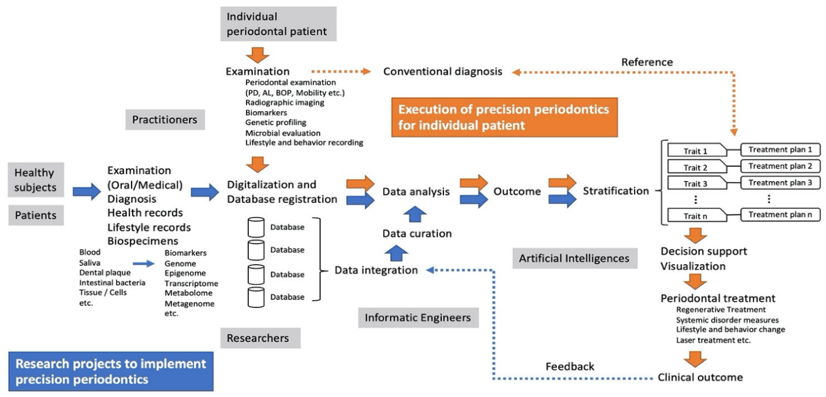
Hallmark of precision medicine is that such an approach actually represents a point where a plethora of various biomedical fields—such as genetics, microbiology, immunology, biochemistry, histology, and pathology—meet clinical practice, by compiling the knowledge into a highly performant management strategy. So, given the multifactorial nature of diseases targeted by precision medicine, such an approach implies a comprehensive assessment of a broad panel of anamnestic, clinical, and biological parameters that are implemented in a highly accurate diagnostic information pool via machine learning algorithms. Machine learning algorithms have the capacity to cross-analyse unlimited numbers of clinical and biological parameters while identifying a panel of critical determinants within highly specific patterns, which are further integrated into accurate and interpretable diagnostic information. ²
Figure 1: A flow diagram representing the steps to implement precision medicine, AI, ML .¹⁶

V) Minimally Invasive Procedures

Use of newer technologies in dentistry like the use of lasers, robotic surgeries, intra-oral scanning, Cone Beam CT can help in better and precise planning which helps in faster and better healing and improved patient outcomes.
Use of Soft tissue lasers for gingivectomy, gingivoplasty and hard tissue lasers, sulcular debridement including removal of granulation tissue from bony defects, low level laser therapy and hard tissue lasers for sulcular debridement, osseous crown lengthening, osteoplasty, ostectomy and osseous recontouring ³ can not only make the whole surgical procedure smoother, requires less time but also saves the hassles of conventional surgical technique and in most cases offers a blood less surgical field.
Use of intra-oral scanning and Cone Beam CT would help in accurate defect analysing and may be this technology can be used to 3d scan, design and print defect specific scaffolds which can make the bone grafting and regeneration procedure much easier and predictable.
Use of robots for implant placement has already started in many countries with outstanding precision. However, robotics in periodontology and other fields still needs more research before its widespread usage. Having said that, several research are ongoing at a good pace and in a few years, robotics might be common just like the intra oral scanners are routinely used nowadays.

VI) Digital Dentistry

Technology has become the backbone of modern dentistry with many procedures becoming easier and more comfortable. In periodontology newer generation digital probes which provide automated measurements, controlled force and digitised data are being used ⁴ .Digital method to check occlusal forces the ‘T-scan’ method (T-scan III version 7.0) analyses the order of occlusal contacts while at same time calculates changes in the percentage of force of the same contacts from the moment the teeth begin contact to the maximum intercuspation. This is helpful in trauma from occlusion cases ⁴.
3D imaging system like Cone beam CT has been used to correctly identify the type of defect and to plan its treatment with the help of 3D scanning and printing scaffolds for bone grafting as described in the minimally invasive procedures. Periodontal procedures require local anaesthesia and nowadays computerized local anaesthesia delivering systems are available which can help in giving the perfect amount and painless anaesthesia, improving patient comfort.

VII) Teleperiodontology

“Tele-periodontics” is a proposed branch of telehealth (telemedicine, tele dentistry) which focuses on the application of telecommunication and internet-based technologies, without demanding specialist presence in the delivery of oral health care related issues (diagnosis, consultation, treatment, public health, education, etc.) across geographic distances. ⁵
Periodontitis is a silent disease which leads to tooth loss and is one of the most common causes of tooth loss in adult populations. Teleperiodontology can offer quick detection and diagnosis in these cases by consultation with a periodontist. The most used methods of Teleperiodontology are store and forward method and video conferencing ⁵. The earlier method involves taking of all the necessary clinical pictures and parameters and then forwarding it to the periodontist. The other method involves real time video conferencing with either periodontist and general dental practitioner and the patient, this allows more in depth discussion and the general dental practitioner can get more clarity on the treatment while the patient can more understand about the disease. In addition to that considering the promising future of tele periodontology certain peripheral devices can be developed and attached to the video conferencing like tele probes, which can give real time parameters to the periodontist for better evaluation. Tele periodontology can be a boon for remote rural areas where easy access to quality healthcare is not possible, provided high speed internet and other required equipment are available.
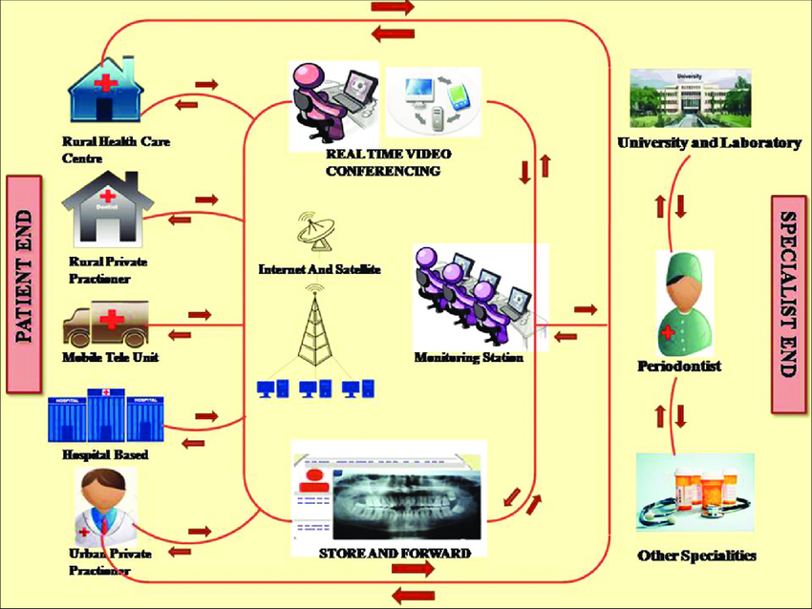

Figure 2: A conceptual model of Teleperiodontology as described above.⁵

VIII) Microbiome Based Therapies

Periodontal disease is a complex relationship between the host inflammation and polymicrobial dysbiosis of the oral-dental biofilm. This leads to chronic inflammation of the periodontal tissue, ultimately leading to bone destruction and tooth loss.
Conventional periodontal treatment includes mechanical and chemical removal of dental plaque and if required flap surgery. A recent newer approach microbiome targeted therapy has been introduced which includes the use of probiotics, prebiotics, and targeted antibiotic therapy. Probiotics are defined as live cultured microorganisms that provide health benefits in humans and animals when consumed, generally by improving or restoring the gut microbiota. Prebiotics are defined as compounds in food that induce the growth or activity of beneficial microorganisms such as bacteria and fungi by altering the composition of organisms in the gut microbiome. Antibiotics exert beneficial effects by non-specifically supressing the microbiome at the site used. ⁶
In a 2015 study, Pozhitkov et al put forward a concept of microbial transplant as a potential therapy for treatment of periodontitis which consisted of three steps : (i) harvesting sub- and supra-gingival microbiota from a healthy donor, e.g., spouse or a partner; (ii), performing deep cleaning, root planning and applying a broad-spectrum antimicrobial agent to the periodontitis patient; and (iii) neutralizing the antimicrobial agent immediately following by a rinsing with a microbial suspension harvested from the healthy donor in the periodontitis patient.⁷

IX) Artificial Intelligence (AI) and Machine Learning(ML)

As in other industries, AI in dentistry has started to bloom in recent years. From a dental perspective, applications of AI can be classified into diagnosis, decision-making, treatment planning, and prediction of treatment outcomes. Among all the AI applications in dentistry, the most popular one is diagnosis. ⁸ In periodontology, use of AI is still in infancy needs more research. Several studies are ongoing where they are using the existing and different types of data, various complex algorithms like Neural Networks(NN) - Artificial Neural Networks (ANN) and Convolutional Neural Network (CNN), Support Vector Machine (SVM), Random Forest(RF) and Regularized Logistic Regression (RLR) to identify the usability of these latest technologies in periodontics and dentistry (refer figure 1). CNN is specifically designed for handling image based data and its architecture has multiple layers where, early layers pick up gross content and later layers more specific.⁹ Hence, they more commonly used for periodontal applications like periodontal bone loss detection, detection of periodontally compromised tooth and other algorithms are mostly used to identify severity of chronic periodontitis prediction.⁸
Additionally, AI is also used in intra-oral scanner’s software to complete smaller parts of the scanned 3d image, not scanned properly due to less mouth opening, heavy undercut etc.
Like AI, Machine learning(ML) is also used in dental research and application. Machine learning is a subset of AI, and they work together to create an intelligent system that will be able to help in prediction and other use cases in dentistry. A ML data becomes more accurate when larger data sets are used. In the field of ML, mathematical algorithms listed above are employed to enable computers to learn inherent structures in data and to use the learned understanding for predicting on new, unseen data.¹⁰
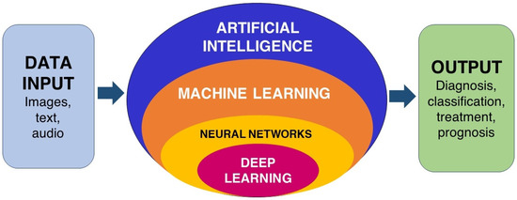

Figure 3: A simple understanding of how AI, ML works. ¹⁸

Example: A 2022 study by Tsoromokos et al uses Machine learning to estimate alveolar bone loss. In this study, Manual values are compared with the machine learning model developed by training a CNN algorithm to automatically assess Alveolar bone loss in periapical radiographs. There findings were very promising with a moderate to good reliability on ML to detect periodontal disease by estimating alveolar bone loss.¹¹

X) Nanotechnology in Periodontology

Nanotechnology is the science that deals with the manipulation of materials and technology at the atomic or molecular level, with at least one dimensions less than 100 nm.¹² Nanomaterials due to their small size have a much-increased surface area per unit mass compared to bigger particles. All properties, including electrical, optical, and magnetic ones, are altered.¹³
The fusion of nanotechnology in the treatment modalities for periodontal diseases can be considered as one of the major breakthroughs in the field of periodontics. The major challenge faced in treatment of periodontal diseases is access to area of inflammation. This problem can be solved by using nanomaterials and combining them with the existing modalities to make the treatment more predictable and site specific. Nanotechnology is present in almost all treatment modalities of periodontics from nonsurgical therapy to implants.
Widely used methods in periodontics include local drug delivery, where controlled drug release using nanomaterials has been tested using nanospheres, core-shell structures, nanotubes, and nanocomposites. Use of triclosan, tetracycline and doxycycline at localized inflamed sites have produced satisfactory results.
Tissue engineering using nanofibers have been experimented for regeneration of lost periodontal tissues due to periodontitis. Potential application of tissue engineering include use in dental implants by creating nanogrooves and nano pillars and chemical coatings with nano particles to reduce osseointegration time. Moreover, the nanoscale surface morphology augments the surface area and thus provides an increased implant surface area that can react to the biologic environment. ¹⁵
Nanocarriers and nanocomposites with calcium phosphate, interdigitates with bone supporting its growth. Nanoscale bone rafts have been successfully used in the treatment of intrabony defects, socket preservation, and sinus augmentation procedures.¹⁴
Nano titanium particles coated surface on laser irradiation have shown to increase collagen production. Based on this, gingival depigmentation and other periodontal procedures can be performed. Diode laser along with nanoparticles can be used to decontaminate the dentin surface. ¹⁴
Nanorobots (dentifrobots) left by mouthwash or toothpaste on the occlusal surfaces of teeth can clean organic residues by moving throughout the supragingival and subgingival surfaces, continuously preventing the accumulation of calculus. These nanorobots, which can move as fast as 1 to 10 micron/second, are safely deactivated when they are swallowed.¹⁵ This would be very helpful in periodontal maintenance phase post-surgery.
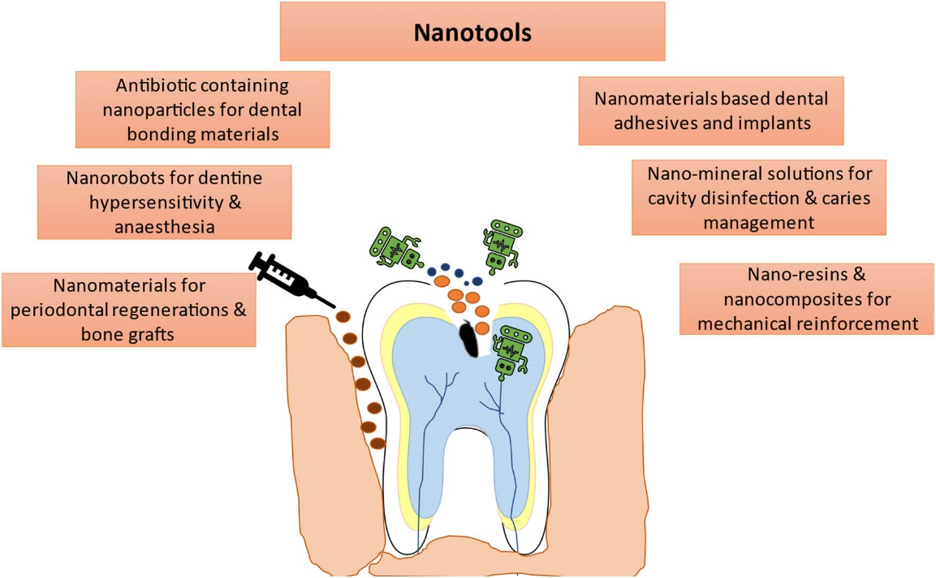

Figure 4: A sample diagram showing the applications of nanotechnology in periodontology. ¹⁷

XI) Conclusion

The future of periodontology with these trends hold tremendous promise driven by cutting-edge technologies and innovative approaches. Newer regenerative therapies, precision medicine and digital dentistry will likely reshape the landscape of periodontal care, providing more personalized and minimally invasive treatments. Furthermore, with the integration of AI, ML, nanotechnology and tele-periodontology, diagnostics and maintenance would be revolutionized, leading to enhanced and favourable outcome and overall improved patient experience. Embracing these futuristic trends can provide an exciting glimpse into the potential advancements and undoubtedly propel the field of periodontology into a new era of advanced and effective dental care. However, not all these trends are currently in practice, and a lot more research is to be done before these trends can become widespread or fully realized.

XII) References

1] Liang Y, Luan X, Liu X. Recent advances in periodontal regeneration: A biomaterial perspective. Bioact Mater. 2020 Feb 28;5(2):297-308.
2] Rakic M, Pejcic N, Perunovic N, Vojvodic D. A Roadmap towards Precision Periodontics. Medicina (Kaunas). 2021 Mar 3;57(3):233.
3] Krishna V, Rai NP, Sharma A, Kumar P. Advancements in lasers: a revolutionary tool in periodontics. JOCR. 2015;3(4):96-100
4] Dhanalakshmi NS, Rajula PB, Ravishankar PL, Rajarajeswari S. Digital revolution in periodontology. IOSR J Dent Med Sci. 2020;19(11 Ser.9):52-56.
5] Avula H. Tele-periodontics - Oral health care at a grass root level. J Indian Soc Periodontol. 2015;19(5):589-592.
6] Kuraji R, Shiba T, Dong TS, Numabe Y, Kapila YL. Periodontal treatment and microbiome-targeted therapy in management of periodontitis-related nonalcoholic fatty liver disease with oral and gut dysbiosis. World J Gastroenterol. 2023;29(6):967-996.
7] Pozhitkov AE, Leroux BG, Randolph TW, Beikler T, Flemmig TF, Noble PA. Towards microbiome transplant as a therapy for periodontitis: an exploratory study of periodontitis microbial signature contrasted by oral health, caries and edentulism. BMC Oral Health. 2015;15:125.
8] Ding H, Wu J, Zhao W, Matinlinna JP, Burrow MF and Tsoi JKH (2023) Artificial intelligence in dentistry—A review. Front. Dent. Med 4:1085251
9] Scott J, Biancardi AM, Jones O, Andrew D. Artificial Intelligence in Periodontology: A Scoping Review. Dent J (Basel). 2023;11(2):43.
10] Arsiwala-Scheppach LT, Chaurasia A, Müller A, Krois J, Schwendicke F. Machine Learning in Dentistry: A Scoping Review. Journal of Clinical Medicine. 2023; 12(3):937.
11] Tsoromokos N, Parinussa S, Claessen F, Moin DA, Loos BG. Estimation of Alveolar Bone Loss in Periodontitis Using Machine Learning. Int Dent J. 2022;72(5):621-627
12] Vora F, Nawagale V, Shetty A, Shetty D, Wadkar P Small is the new big; nanotechnology in periodontics: A review International Journal of Applied Dental Sciences 2021; 7(3): 246-248
13] Vaishali S, Nashra Kareem, Nanotechnology in Periodontics: A Review, J Res Med Dent Sci, 2021, 9 (1): 339-344.
14] Kennedy S, Srinivasan S, Jayavel K, Sundaram R. Nanotechnology in periodontal management. Int J Orofac Biol 2019;3:8-15
15] Ozak ST, Ozkan P. Nanotechnology and dentistry. Eur J Dent. 2013;7(1):145-151.
16] Kikuchi T, Hayashi J-i, Mitani A. Next-Generation Examination, Diagnosis, and Personalized Medicine in Periodontal Disease. Journal of Personalized Medicine. 2022; 12(10):1743
17] Jain P, Farooq U, Hassan N, Albratty M, Alam M, Makeen H, Mirza M, Iqbal Z. Nanotechnology interventions as a putative tool for the treatment of dental afflictions. Nanotechnology Reviews. 2022;11(1): 1935-1946
18] Patil S, Albogami S, Hosmani J, Mujoo S, Kamil MA, Mansour MA, Abdul HN, Bhandi S, Ahmed SSSJ. Artificial Intelligence in the Diagnosis of Oral Diseases: Applications and Pitfalls. Diagnostics. 2022; 12(5):1029.

Author Information
Dr. Ruchir B. Patel, B.D.S., M.D.S. [Periodontology],
Senior Lecturer, College of Dental Sciences and Research Centre, Bopal, Ahmedabad
Dr. Bhupesh Patel, B.D.S., M.D.S.[Oral Pathology],
HOD & Professor, Faculty of Dental Sciences, Nadiad
Dr. Ina Patel, B.D.S., M.D.S.[Prosthodontics and Crown & Bridge]
HOD & Professor, AMC Dental College & Hospital, Ahmedabad

