Phyto-phospholipid complexes and its application in cancer therapy
Juti Rani Devi*, Arijit Dutta, Trishna Sarma, Bhargab Jyoti Sahariah
NETES Institute of Pharmaceutical sciences, Shantipur, Mirza, Kamrup, Assam

Abstract:

Cancer is one of the leading causes of death worldwide. It has continued to provide a substantial challenge for treatments now being used and is still not completely resolved. The traditional cancer treatment options, such as surgery, chemotherapy, radiation therapy, etc., have serious side effects. The potential to improve the efficacy of conventional cancer therapy through the use of herbal active ingredients is enormous. It has been shown that natural plant active ingredients exhibit significant pharmacological activity in vitro but limited in vivo absorption. Phytosomes are one of the emerging nanotechnologies that can be used to improve the miscibility of bioactive phytoconstituents in lipid-rich barriers and overcome their poor bioavailability in order to increase their bioavailability and absorption and get around the drawbacks and adverse effects of conventional herbal extracts. For the targeted distribution of phytoconstituent at the site of action, a variety of cutting-edge drug delivery vehicles are used. The well-known biocompatible nanocarriers known as phyto-phospholipid complexes can be used to improve the solubility and permeability of phytopharmaceuticals in a variety of innovative drug delivery systems (NDDS). The primary focus of this review was on numerous traditional and cutting-edge techniques as well as diverse Nano carriers employed in cancer therapy. Including an overview of the most recent studies on the creation and application of phytosomes as a superior delivery system for herbal components in the treatment of cancer. Moreover, it contains details on the preparation, the method of characterisation, and the mechanism of drug release from the phytosome. Additionally, research is being done on some of the main phytosome-derived active components of herbs that have demonstrated anticancer action. Finally, difficulties and prospects for using phytosomes to treat cancer are also explored.

Keywords: Phytosomes, Cancer therapies, Targeted drug delivery, Herbal extract, Nanocarrier
I.Introduction:
As the frequency of additional cases of cancer or cancer-related fatalities continue to rise in the modern era, it is expected that the population size who have been with cancer diagnoses would double by twofold in the next decades. As a result, there has been an increased demand for the development of traditional sources' more potent anticancer medications in order to increase their medicinal value [1]. The development of novel anti-cancer drugs has advanced significantly the past few years, specially thanks to novel drug delivery systems that improve the pharmacodynamics and bioavailability of medicinal products and provide exact doses of drugs to cancerous cells via tiny toxicity to normal cells[2]. Traditional cancer treatment modalities include surgery, chemotherapy, radiation therapy, hormone therapy, vaccinations, specific therapy, or a combination of all of these are advanced significantly. improved the prognosis for cancer patients in recent years to some extent [3]. These techniques are harshly criticized since there is insufficient medication bioavailability at the desired side, which can have a number of negative effects, include dying The development of tailored or sitespecific pharmaceutical delivery strategies has been pursued by a number of scientists and scholars in order to address the aforementioned problems. The future of medical research and a unique and focused medication delivery mechanism to aid in the therapy of cancer is nanotechnology. For aid into the therapy of cancer, Nanotechnology including tiny particles, liposomes, dendrimers, and the micelles are currently employed controlled methods of administration. [4].
In order to generate potential nano-based treatments for illnesses like cancer; research has been focused on the potential uses and properties of tropical plant extracts [5].Because of their innate antibacterial properties, plants have been used in medicine. Extracts of natural materials are widely tested for expected bioactivities. The bioactive components are then isolated and identified by fractionation of extracts that demonstrate the requisite bioactivity. Particularly plants are a naturally occurring source whose anti-cancer benefits have been carefully investigated [6]. Strong in-vitro pharmacological effects have been elucidated for active components of plants, yet only mild in-vivo absorption. [7]. The problem of poor water solubility, or reduced in vivo absorption, calls for the development of a novel medication delivery technique. Medication administration techniques that employ nanoparticles are being created to address the bioavailability problem with low-solubility chemicals [8].
Phytophospholipid complexes, sometimes referred to as Phytosomes, have emerged as one of the most efficient ways to increase the bioavailability of the active components [7]. In certain publications, the term "herbosome," sometimes known as "phytosome," is made up of the terms "phyto" and "some," both of them relate to cells and plant-like structures. Liposomes and Phytosomes have many similarities. Phytosome is a cutting-edge vesicular medication transport technology, involve botanical extracts or hydrophilic phytochemicals into phospholipids to enhance their bioavailability and absorption while avoiding the disadvantages and adverse effects of conventional herbal extracts [9]. They are small particles created a result of phospholipid and water contact. Polyphenolic plant extracts are used to improve the connection. Through hydrogen bonding and polar contact, the polar functional groups of lipophilic substances bind to the cationic phosphate head of phospholipids to create micelles. These micelles hold the polyphenolic chemicals in place. In contrast to liposomes, phytosomes contain the bioactive substance either within their inner chamber or in spaces between the outer barrier layers. The bioactive substance is a crucial component of the small particles in phytosomes, in which particles are bonded chemically to the polar heads that form phospholipids. Only water-soluble substances are delivered by liposomes, whereas each water- and lipid-soluble substances can be delivered by phytosomes. Phytosomes are used to convey both water- and lipid-soluble chemicals, whereas liposomes are utilized to carry solely water-soluble compounds.
As a vesicular medication delivery mechanism for cancer, phytosomes are employed. Vesicular medication distribution methods, which evade immunity surveillance, passive select carriers of medication. Nevertheless, because of enhanced permeability and retention, phytosomes with molecular masses larger than 40 kDa and a nanometric scale of 100–1200 nm aggressively target cancer cells when used to treat tumors. While active targeting directly provides medications to the place of action, passive targeting enhances drug bioavailability. To transport bioactive chemicals, several techniques are integrated in phytosomes [10]. Over the past two decades, growing evidence of phytosome's potential for drug delivery has emerged. These applications include those for the treatment of cardiovascular disease, inflammation, hepatoprotection, and cancer [11]. Due to a strong chemical contact between the phytosome phospholipid and phytochemical, the production of phytosomes is simple, requires no necessitate complicated or costly devices, and does not interfere any way with botanical constituents that are encapsulated [12]. Thus, this study emphasizes the use of phytosomes in cancer diagnostics, as well as their composition, characterisation, method of action, difficulties, and potential for the years to come in cancer treatment.
II. Role of ethno medicine in cancer treatment:
The leading cause of death in the world today is cancer. It distinguishes itself through its extraordinarily rapid growth, resistance to growth stoppers, replicative immortality, and immune evasion. The majority of cancer suffers got surgery, radiation treatment, or conventional chemotherapy. Extreme tiredness, hair loss, bruising, bleeding, anemia, nausea, and vomiting are just a few of the serious side effects that patients who receive this systemic medication endure. As a result, complementary cancer medications and therapies must be created [13].
For many years, the backbone of health care in developing countries has been and still is herbal therapies. Plants have been employed in treatments because of their innate antibacterial properties.In order to create future medications based on nanomaterials, such as those for the treatment of cancer, research has proceeded to look at the potential usage of extracts from terrestrial plants. While many plants are consumed for their health benefits in modern nations, natural herbs have been used in traditional medicine for thousands of years by people in Asia and Africa. The World Health Organization (WHO) notes that certain nations continue to use a substantial number of herbal medications, and developing countries are taking advantage of the benefits of compounds originating from naturally occurring sources in terms of medicine. Based on the correlation between a number of clinical symptoms and tridoshas, the ayurvedic classification of neoplasms. Group I: Illnesses that canonically fall within the category of cancer. Group II illnesses include growths and ulcers with a propensity to become cancer.Group III comprises illnesses with an increased risk of turning cancerous, such as intractable leukorrhea, intractable sinusitis, and intractable jaundice [14]. Extracts rich in nutraceuticals and with medicinal value are used in ayurveda therapies since they provide many health benefits for people. The ayurvedatreatment can be applied topically, swallowed, chewed, consumed as milk, ghee, tea, or honey, among other ways. Indian traditional medicine has utilized There are currently over 25,000 herbal or plant-based treatments.More than 75 formulas for boosting human health and vigor are available on the Indian market. Triphala, a supplement with potent anticancer effects, is present in more than 219 formulations. It is well known that a number of plant extracts may enhance therapeutic results and act as adjuvants in cancer treatment protocols [15]. In cases where the biomedical treatment has failed or is unavailable, an Ayurvedic approach focusing on boosting tissue metabolism, tonifying digestion, eliminating toxins, and reducing tumor growth is thought to be useful [16].Due to factors such as limited water solubility, insufficient molecular size, and reduced systemic availability, phytomedicines have been found to have decreased in vivo activity. Various phytoconstituent extracts show biologically unstable structures, numerous biotransformations, enzymatic or gastric breakdown, early drug loss by fast clearance, and biological structural fragility [17]. Therefore, a cutting-edge strategy that encourages targeting cancer cells specifically withto counteract these harmful impacts, researchers are currently focusing on nanotechnology.[18].These biopharmaceutical issues may be resolved by nanotechnology, a young science that first aquired traction several years ago. To address unmet needs, nanotechnology has transformed the pharmaceutical and medical sectors. In order to achieve the necessary safety and efficacy, nano-based herbal production also offers the advantages of maintaining the release profile and boosting solubility, bioavailability, toxicity, pharmacological activity, stability, and physical and chemical stability[17].

III. Various approaches for cancer treatment:
Different forms of cancer therapy exist. The kind of therapy a patient undergoes is dependent on the kind of cancer, its stage, and characteristics specific to that patient.
Some people who are affected with cancer will have one treatment and some other will have combine treatment, such as surgery with chemotherapy or radiation therapy.
There are two types of approaches. They are discussed below:
AConventional approaches for cancer therapy
- Surgery
- Radiation treatment
- Chemotherapy
B. Novel approaches for cancer therapy
- Immunotherapy
- Gene therapy
- Precision medicine
- Nano particle drug delivery

A. Conventional approaches for cancer therapy:
- Surgery:
The most well-liked kind of cancer therapy for non-haematological tumors is surgery. The malignant tissues are surgically removed from the body by the surgeon. Surgery can either entirely or partially cure cancer. Different areas of the body have been affected by cancer, there is no surgical technique that can completely eliminate it. If the tumor is small and contained, surgery is an effective therapeutic option for cancer [19].

- Chemotherapy:
Chemotherapy primarily affects cancer cells by halting their increase and proliferation. Cancer cells frequently split and expand far more quickly than healthy cells do, and they physically experience very high amounts of endogenous stress. As a result, they are more quickly and efficiently attacked by the medications than other surrounding cells. The choice of whether to utilize chemo-preventive medications alone or in combo is greatly influenced by the kind and level of cancer. The main objectives of these medications are to fight cancerous cells and minimize the burden created by the growth of the tumor [20]. Cutting, abrading, suturing, treating severe diseases and wounds, or eliminating blockages from persistent and slowly progressing problems are all examples of surgery [21].

- Radiation treatment:
Cancer cells are destroyed physically by radiation. The radiation utilized is referred to as ionizing radiation due to its production of ions (electrically energized particles) and stores energy in the cells of the tissues it travels through. Cancer cells may either be destroyed or have their genetic composition altered by the accumulated energy [22]. Radiation has been shown to be beneficial by either directly destroying cancer cells or via causing DNA damage that culminates in tumor cell death[23].
B.Novel approaches for cancer treatment
1. Immunotherapy:
Immunotherapy boost the ability of immune system to fight cancer. This is sometimes known as biological treatment due to it mobilizes the body's built-in defenses in opposite disease to fight cancer. Utilizing monoclonal antibodies, which train the body's defense method to recognize and kill cancer cells, has been studied extensively. By adhering to cancer cells, these antibodies prevent a certain protein from performing its function. This is a safe method [19]
2. Gene therapy:
Ex vivo and in vivo cytokines transmission of genes, medication sensitiveness utilizing drug-resistant genes in the bone marrow are used as prodrug administration genes and as a defense against chemotherapy treatments with high doses, are all examples of gene-based cancer treatments now being tested in clinical trials. Gene replacement and oncogene as well as tumor inactivating suppressor genes are two strategies for combating the basic genetic defects in cancer cells[24].
3. Nano particle drug delivery:
Nanoparticles are organized and generally sizes between from 10 to 1000 nm, depending on their intended function. In the drug delivery region,[25] the medicine is solubilized, contained, bound, or attached to a small particle matrix. It has been found that NPS deep tissue penetration enhances the permeability and retention (EPR) impact. Moreover, by effectively crossing epithelial fenestration, surface characteristics influence the bioavailability and half-life. The frequency of medication or active substance excretion can be increased by modifying the particle polymer characteristics. Together, NPS's distinctive qualities regulate its therapeutic effect in the cancer screening and therapy [26].
IV. Phytosomes as a novel approach for cancer management:
With a structure similar to a liposome, phytosomes are a ground-breaking lipid-based delivery technology that may be utilized to entrap diverse phytoconstituents with polyphenolic bases to their absorption when supplied (Table 1). The initial phytosomes were created by the Italian business Indena in the late 1980s with the goal of enhancing the bioavailability of drugs via binding them with phospholipids [12]. Combining phytoconstituents with phospholipids like phosphatidylcholine (PC) to form lipid-compatible molecular complexes that can boost the absorption and bioavailability of the phytochemical is a patented technology. Phytosomes have been successfully employed in pharmacokinetic studies to enhance the formulation of several botanical extracts (including ginkgo, green tea, and milk thistle) and phytochemicals (such as silybin, curcumin, and ginkgolides) [27]. It is a nano-delivery system made up of conjugates of phospholipids and phytocompounds. The primary distinction between phytosomes and liposomes is that the main component in liposome is dispersed in the medium within the cavity or in the layers of the membrane, whereas in phytosome, the molecules are stabilized through hydrogen bonds to the polar head of the phospholipids, making them an integral part of the membrane (Fig. 1) [7]. In this, the phospholipids that make up the liposome interact on a molecular level with the trapped phytochemicals. According to one theory, a hydrogen bond forms between the trapped phytochemical and the polar head group of the phospholipid [28]. Phospholipids and plant chemicals, such as phosphatidylcholine(PC),phosphatidylethanolamine, phosphatidylserine, soy phospholipid, and egg lecithin, are combined to form phytosomes. PC is the most well-known phospholipid among them.

Table 1: Difference between Phytosome and liposome
Phytosome | Liposome
Chemical bond (Hydrogen bonding) is present | No chemical bonds are present
Drug molecular compound with a 1:1 or 2:1 phospholipid ratio | Around the drug, thousands of phospholipid molecules congregated
The bioactive compounds are adhered to the polar tip of the phospholipids via encapsulation H-bonds. | Encapsulation of Active components can be found in the lipid bilayer membrane or the aqueous inside of the vesicles.
Route of administration is oral and tropical | Route of administration is Tropical and parental
Bioavailability is High | Bioavailability is low
Stability is High | Stability is High

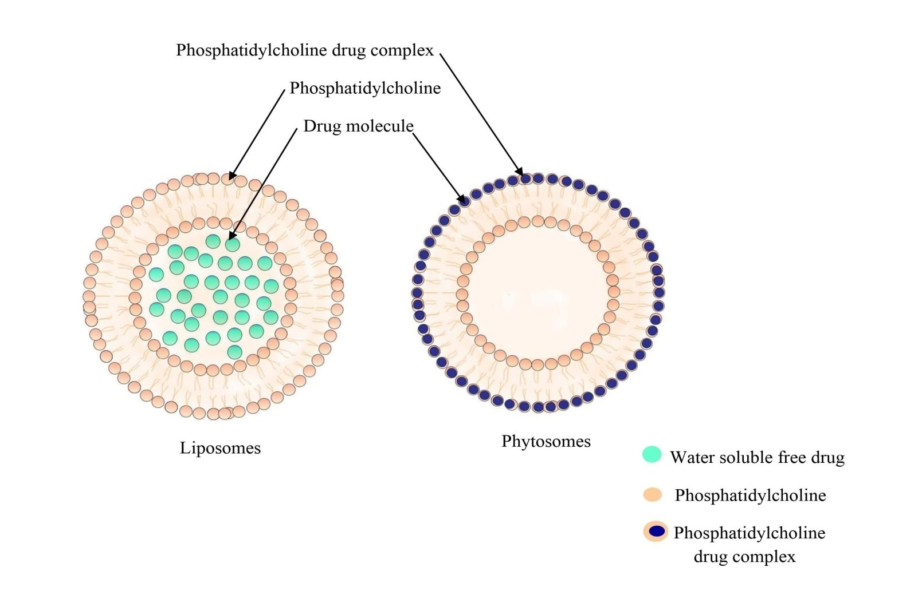

Fig 1: structural difference between liposome and phytosome
A. Method of preparation:
There are three basic methods for creating phyto-phospholipid complexes: solvent evaporation, freeze drying, and anti-solvent precipitation (Fig. 2). [7]. Standardized plant extracts need stoichiometric interactions with either natural or synthetic phospholipids to form phytosomes complexes. Molar ratios (phospholipid: phytoconstituents) range from 0.5 to 3. However, the normal recommendation for the molar ratio was 1:1 [2]. Five essential procedures are required to create a phytosome: combining biomaterials; dissolving the biomaterial in a clear solution applying phospholipids or an inorganic solvent; letting the solvent evaporate and generating a thin film; hydrating the mixture; and sonicating the combination.

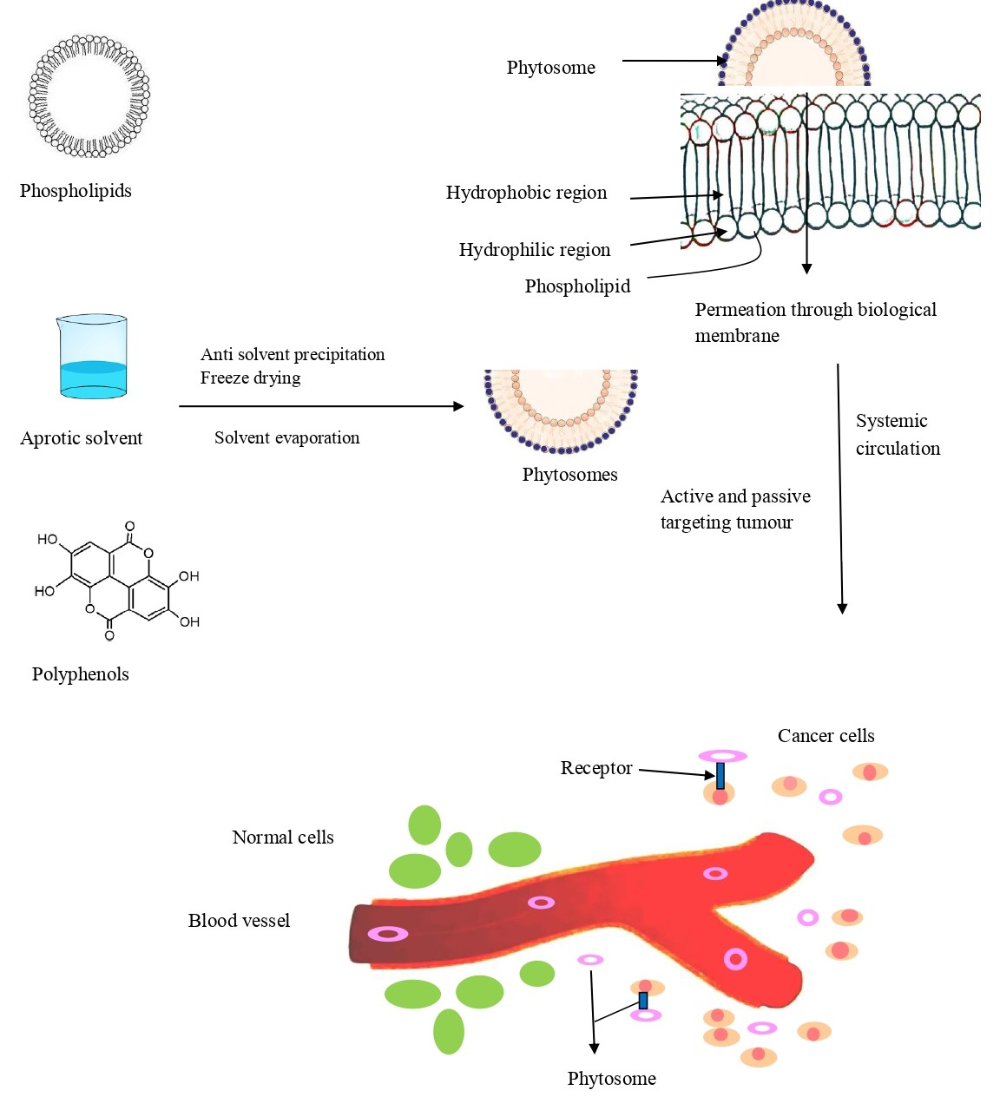

Fig Synthesis and mechanism of drug release from phytosomes.

The methods are discussed below:
1. Solvent evaporation/thin film hydration method : Solvent evaporation is a well-known and common method for creating phospholipid compounds. In the shared circular bottom, phosphatidylcholines and active substances were mixed. A good solvent was then added, and the mixture was heated at the perfect constant temperature for the specified period of time. By evaporating the solvent while maintaining vacuum, complexes that have already been formed can be obtained [7].By using the solvent evaporation approach, ZhenqingHou et al. created phytosomes that were filled with the mitomycin C (MMC) soybean phosphatidylcholine complex. To create the clear magenta mixture, they used 12.5 mL of tetrahydrofuran (THF), 10 mg of MMC powder, and 30 mg of soyabean phosphatidylcholine (SPC), which were all co-dissolved. The resulting solution was then transferred to a glass pressure vessel and vigorously stirred for 4 hours in a water bath at 40 °C. THF was then removed using a rotary evaporator and vacuum rotary evaporation [29].
2. Anti-solvent precipitation: It is the second most utilized technique for making phytosomes. Lawsone and soy lecithin were refluxed with dichloromethane during this process, keeping the temperature under 60 °C. The precipitate was then given N-hexane in so as to keep it overnight in vacuum desiccators [30]. By using anti-solvent precipitation in this refluxing process, Nabil A. Alhakamy et al. were able to construct ICA-phytosomes. The ICA (27 mg) and Phospholipon® 90H (32, 64, or 96 mg) were carefully weighed and dissolved in dichloromethane (20 mL) as per the experimental protocol. The solution was refluxed at the temperature and for the period prescribed by the experimental design, yielding a concentrate of roughly 5 mL. The concentrate was lyophilized for 72 hours in order to get the phytosomal complex. After drying, the complex was kept at 4 °C in an airtight amber-colored glass container until usage [31].
3. Freeze drying or lyophilization: In this, the phytosomes are made using a lyophilizer or freeze dryer. In this totally dissolved diosmin (DSN) in dimethylsulphoxide (DMSO), May S. Freag et al. manufactured diosmin (DSN) phytosome by freeze drying process. A t-butylalcohol-dissolved SPC solution was combined with the resultant DSN solution, and the mixture was then agitated for three hours on a magnetic stirrer until complex formation took place. To isolate the complex, lyophilization was employed. Prior to being put into a Cryodos-50 lyophilizer with a condenser temperature of 70 °C, the vials were frozen for 4 hours at 80 °C. Following a second day of secondary drying at 25 °C, lyophilization was performed for one day at a pressure of 40 mbar and a shelf temperature of 40 °C.The sample was then taken out of the freeze drier and stored in the desiccator. The phospholipid type, drug:lipid ratio, and co-solvent type all have an impact on these approaches [32].
B. Characterization of phytosomes:
1. Visualization: Using atomic force microscopy (AFM), scanning electron microscopy (SEM), and transmission electron microscopy (TEM), phytosome morphology may be studied. The surface structure of phytosomes may commonly be used to evaluate the trapping processes and possible pollutants on their surface [2]. Surface morphology is widely used to identify entrapment behavior, surface features, and the existence or lack of contaminants on the surface. The SEM gives photomicrographs of the phytosomes at the proper magnification after a very thin gold coating. Phytosome surfaces are generally free of crystalline particles and other surface contaminants. The majority of the time, the spherical bulging on the surface is produced, indicating the spherical form of the phytosomes. The TEM analysis may be utilized to clearly explore the interior structure.The interior milieu in which the medication is imprisoned and its distribution inside the phospholipid mesh may be clearly investigated using the TEM investigation [33].
2. Particle size and zeta potential: This is an important complex quality that is related to repeatability and stability. Phospholipid complexes typically had particles between 50 and 100 nm in size [7]. Dynamic light scattering (NANO ZS Malvern equipment) was used to measure the phytosomes' particle size, and their zeta potential was calculated using electrophoretic mobility in an electric field [34].
3. Entrapment efficiency: Utilizing ultracentrifugation, this is evaluated. The proportion of drugs entrapped is calculated using the formula below (%)[35].Drug entrapment efficiency can be calculated by using Equation :
Drug entrapment (%) = Actual amount determined / Theoretical amount present
4. Vesicle stability: DLS, SEM, and TEM are the fundamental techniques for assessing the stability of phytosome vesicles in relation to changes in size and shape during pertinent time intervals. The standard vesicular size may be determined using DLS and SEM. The evolution of phytosome structure and morphology was monitored using TEM and SEM [2].
5. Crystallinity: the hydrophilicity and hydrophobicity are balanced by crystallinity, which is lost when phytoactive compounds combine. DSC and X-ray diffraction (XRD) examinations are the two main techniques that are commonly utilized to assess the interaction of phospholipid with phytoconstituents as well as the crystallinity [2].
6. Drug release :Drug release behavior of vesicle carriers has recently been the subject of intense research since the release profile attained in vitro may function as an indicator of the carrier's effectiveness in vivo (Fig. 2). Continuous flow, sample and separate strategies, in situ procedures, and membrane diffusion strategies (dialysis, micro-dialysis, fractionalization, and reverse dialysis) are the most often used conventional techniques to measure the release rate of active compounds [24].
C. Advancement and application of phytosomes in cancer:
Due to its capacity to deliver pharmaceuticals to both passive and active targets, phytosomes technology is expanding in the pharmaceutical sector (Fig. 4). Phytosomes provide a number of advantages (Fig. 3). Compared to the majority of drug carrier preparations, phytosomes have a simpler and easier formulation process.This method is more inventive and useful because the components of plants used to create the phytosomes themselves act as active therapeutic compounds. The potential for developing phytosome technology is considerable [36].Chemical components of medicinal plants that have antioxidant properties include catechins, isocatechins, lignins, coumarins, anthocyanins, flavones, isoflavones, and flavonoids. These compounds are principally responsible for the plants' anticancer potential. The many side effects of the currently available, expensive conventional cancer treatments, such as radiotherapy and chemotherapy, may significantly reduce the quality of life. The ability of bipolar moiety plants to manufacture medicines that are high soluble, dispersible, and permeable makes them potent anti-cancer drugs [37].

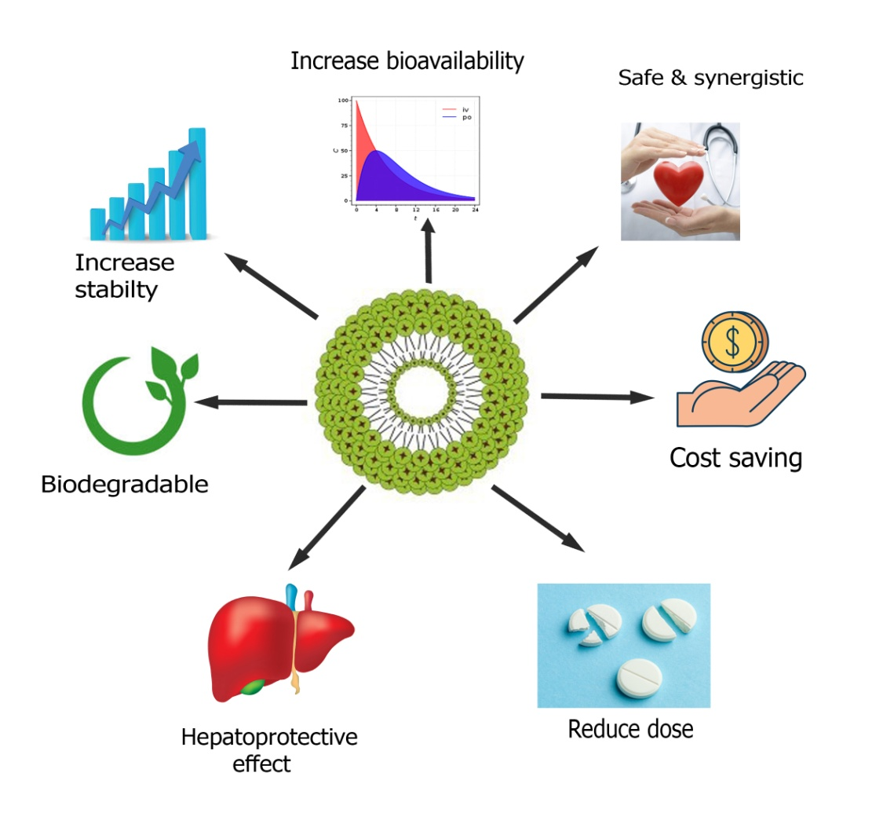
Fig3: Advantages of phytosomal drug delivery
Table 2 lists a variety of herbal active compounds have proven anticancer properties on different cancer cell lines. Nabil A developed quercetin phytosomes that function like scorpion venom. Alhakamy and colleagues for the treatment of breast cancer. He constructed optimized phytosomes and evaluated their efficacy against MCF-7 cells. According to his findings, the optimized phytosomes had vesicles that were 116.9 nm in size and had a 31.5 mV zeta potential.Cell cycle studies show that the therapy employing the enhanced QRT formula dramatically stopped the cell cycle at the S phase.The results of the study revealed that it would be advantageous to use a QRT phytosome formulation as a therapeutic approach for the treatment of breast cancer.The research's conclusions have a wide range of important practical implications [38]. Additionally, quercetin phytosomes improved the efficiency of doxorubicin in preventing the spread of MCF-7 human breast cancer cells [39]. YasmiwarSusilawati et al. reported in their article that the delivery of phytosomal drugs technology significantly improved quercetin performance. Redness, irritation, and inflammation were all diminished, and erythema was significantly (P 0.003) decreased. Also enhanced were the skin layers. In addition to increasing hydration levels, quercetin'sadditionally, solubility and absorption were elevated [40]. According to Dina A. Hafez et al., 160 patients got the lecithin curcumin phytosomal complex (Meriva®) in a different controlled study. Curcumin phytosomes are useful in the treatment of cancer because chemotherapy and radiotherapy have less harmful side effects when curcumin is lecithinized [41].ReyhanehMoradiMarjaneh et al. exposed CT26 cells to escalating dosages of curcumin (0-1000 M) and 5-FU (1-50 mg/ml) for 24, 48, and 72 h, both alone and together, in order to evaluate the anticancer potential of phytosomal curcumin. They demonstrated how the inhibition of cell proliferation was induced by 5-FU and phytosomal curcumin in a dose-dependent manner. Furthermore, co-treatment with 5-FU and phytosomal curcumin resulted in a reduced 5-FU IC50 value. They came to the conclusion that phytosomal curcumin improved the anti-antiproliferative effects of 5-FU in both in vitro and in vivo systems [42]. Ibrahim et al. investigated the efficacy of curcumin conjugated with phosphatidylcholine in the treatment of mammary gland tumors. Panahi et al. investigated the efficacy of utilizing phytosomal curcumin in addition to chemotherapy in patients with solid tumors [43]. Phytosomes containing soybean phosphatidylcholine complex and mitomycin (MMC) were created by ZhenqingHou et al. Phytosomes are made utilizing a solvent evaporation technique combined with a nanoprecipitation process to make an MMC drug delivery system. The anticancer activity of MMC-loaded phytosomes, according to the author, was astounding. Phytosomes containing MMC inhibited cancer growth more effectively and dose-dependently than free MMC, without causing weight loss. According to these results, phytosomes containing MMC may be a viable and successful formulation for drug delivery and cancer treatment. A new formulation of phytosome-containing MMC with improved formulation features, such as smaller size, reduced size dispersion, higher zeta potential, and good stability, was created using a straightforward but efficient technique.Comparing MMC to the phytosomescontaing MMC, it was shown that the latter had a significantly higher level of cytotoxicity and a larger inhibitory effect [44].In order to increase their cytotoxicity and ability to induce apoptosis in ovarian cancer cells (OVCAR), Nabil A. Alhakamy et al. created optimized icariin (ICA) phytosomesHe concluded that phytosome is an extremely reliable apoptosis indicator.The composition of ICA's phytosomes significantly increases the cytotoxic impact it has on OVCAR-3 cells [45]. Thymoquinone (TQ) loaded soy-phospholipid-phytosomes were created by Nabil A. Alhakamy and colleagues, and their anticancer effectiveness against cancer cells in human lungs was demonstrated.He comes to the conclusion that this phytosomal delivery would be a fortunate nanocarrier cargo to convey TQ [46]. According to Mehdi Sabzichi et al., doxorubicin sensitivity in MDA-MB 231 cells was increased when luteolin was used as an advanced nanoparticle carrier in phytosomes. In order to facilitate passive targeting in breast cancer cells and improve luteolin bioavailability,researchers produced luteolinnanophytosomes.The author came to the conclusion that phytosome increased the therapeutic efficacy of luteolin in addition to making it more water soluble.Phytosomes technology currently has stronger pharmacokinetic and pharmacological properties, making it a feasible choice for medical goals such cardiovascular, anti-inflammatory, immunomodulator, and anticancer medications [47].Manikkampatti et al. developed a new phytosome-contained gel that have aloe vera extract encapsulated with phospholipids.The molecular size of the phospholipid that is connected to aloe vera is larger, and the zeta potential values imply that the stable nature is still present. Aloe vera that has been loaded with phospholipids inhibits the MCF-7 cell line, and this inhibition is very concentration-dependent. Studies conducted in vitro have demonstrated the potent anticancer properties of phytosome gel.A lower IC-50 value is a sign of more anticancer activity [48]. Phytosomes produced from Terminalia arjuna bark were created by Sharma Shalini et al. and tested using the MTT method for their ability to inhibit the proliferation of the human MCF-7 cell line.The results show that pure methanolic plant extract and quercetin both have stronger antiproliferative effects on MCF-7 cells than do phytosomes of quercetin and phytosomes of Terminalia arjuna bark extract.According to the author's findings, pure extract demonstrated weaker antiproliferative effect than the phytosome formulation [49]. It was discovered that the sinigrin-phytosome combination was cytotoxic to A-375 melanoma cells in the earliest investigation of phytosomes on skin cancer.In comparison to free sinigrin, which lowered cell viability by more than 46%, the complex reduced it by more than 74% at 0.14 mg/mL. The second study looked into how silymarin affected in vitro nanostructured lipid carriers (NLC). Silymarin-NLC showed a higher decrease of cell viability than aa commercially available phytosome formulation (IC50: 21 g/mL vs. 26 g/mL) [50]. Additionally, it has been demonstrated that silybin has anticancer action and that its phospholipid complex, IdB1016, can enhance the effects of cisplatin. Tumor growth was significantly diminished in mice that received IdB1016 treatment on a regular basis along with human ovarian cancer xenografts. Turmeric has perhaps undergone the most investigation of any dietary supplement in terms of any potential benefits for the treatment of cancer.The bioavailability of pure curcumin and the active component of turmeric, MerivaTM (curcumin-PHYTOSOME®), was evaluated in rats.As compared to the parent molecule, MerivaTM has been demonstrated to be five times more bioavailable.MerivaTM seems to be the best substitute since it increases curcumin's bioavailability, which enhances its biological effect [51].

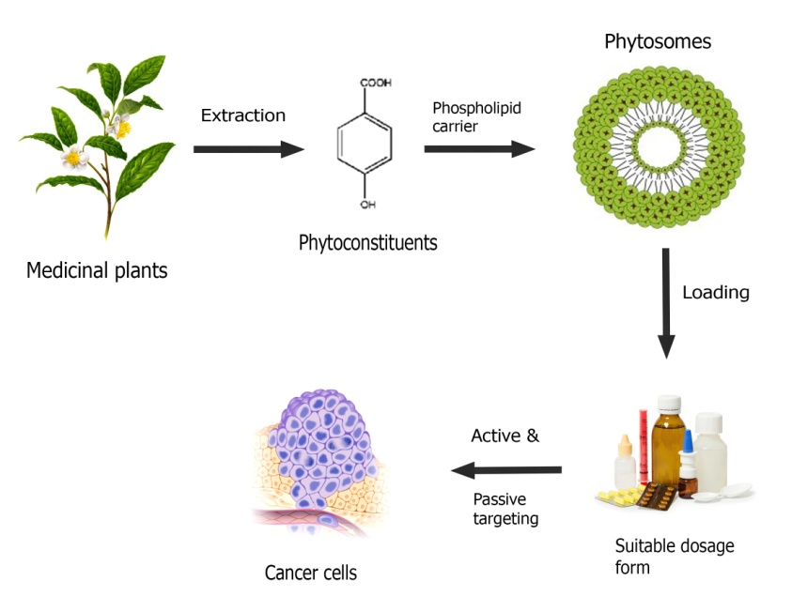

Fig.4. Advancement of phytosomal drug delivery system

Table 2: Phytosomes showing anticancer activity
Active Herbal constituent | Biological source | Preparation techniques | Types of cancer | Cell line study | Major findings
Curcumin | Curcuma Longa | Rotary evaporation technique | Pancreatic cancer | Myeloma cell line | The phytosomes with curcumin can effectively limit how quickly medications are released.
Icariin | Epimedium grandiflorum | Anti-solvent preparation | Ovarian cancer | OVCAR-3 cells | By boosting apoptosis, caspase 3, ROS generation, and MMP disruption, ICA-phytosomes can kill cells.
Quercetin | Terminalia Arjuna bark | Anti-solvent preparation | Breast cancer | MCF-7 cells | The improved QRT formulation may be used in the treatment of breast cancer.
Mitomycin | Streptomyces caespitosus | technique of solvent evaporation | Anticancer | Solid tumor-bearing mice using H22 cells | The accumulation in tumour tissue and oral bioavailability have both improved.
Luteolin | Vegetables and fruits | Method for hydrating thin layers | Breast cancer | MDA-MB231 cells | Increased luteolins water solubility and therapeutic effectiveness.
Aloe | Aloe vera extract | Thin film hydration | Anticancer | MCF 7 cells line | The biocompatible aloevera-loaded phytosomes had an impact on the proliferation of the MCF-7 cancer cell line.
Thymoquinone | Nigella sativa L | Anti-solvent preparation method | Cancer in lungs | Cell line (A549) for human lung cancer | The TQ-phytosomes' ability to induce apoptosis in lung cancer-causing A549 cells was tripled.
Genistein | Dyers Genistatinctoria L. | technique of solvent evaporation | Breast cancer | Ehrlich Ascites Carcinoma (EAC) | a particular breast cancer Strong chemotherapeutic effects of gen phytosomes are seen in breast cancer.
Emodin | Rhubarb | technique of solvent evaporation | Anticancer | - | Emodin's solubility and dissolution rate both increased.
Chrysophanol | Colubrine gregii | Anti-solvent preparation | Anticancer | - | better solubility, dissolving, and amorphous characteristics that are increased. Additionally enhances GI tract absorption and therapeutic usefulness.

V. Current phytosomal delivery against various cancers:
Lung cancer is the second most common malignancy and can be treated with effective phytosomal delivery. The majority of research focuses on the potential using phytochemicals paclitaxel, hydroxycamptothecin, docetaxel, elemense, dioscin, and vinorelbine in the treatment of lung cancer.Breast cancer is the most typical malignancy among women. Breast cancer may be treated using resveratrol, piperine, docetaxel, paclitaxel, and curcumin,among other phytochemicals.Colorectal cancer is the third most typical cancer worldwide. The phytochemicals galbanic acid, berberine, curcumin, and luteolin may be able to prevent colon cancer. The main phytochemicals that are used to treat leukemia are curcumin, phytol, quercetin, and vincristine. Cervical cancer is one of the main causes of death in women. As cervical cancer treatments, resveratrol, curcumin, and podophyllotoxin all showed promise. According to the WHO, liver cancer is the fourth most frequent cancer that results in mortality worldwide. Hepatocellular carcinoma can be successfully treated with 6-gingerol, betulinic acid, resveratrol, and triptolide among other phytochemicals. Pancreatic cancer is the growth of cancer in pancreatic tissue.There were three possible treatments for pancreatic cancer: paclitaxel, gemcitabine, and curcumin. Brain cancer may be treated with phytochemicals like vincristine and doxorubicin [52]. The current phytosomal approach to treating various malignancies is depicted in Fig. 5. Phytoconstituents can be given orally as phytosomes to treat cancer

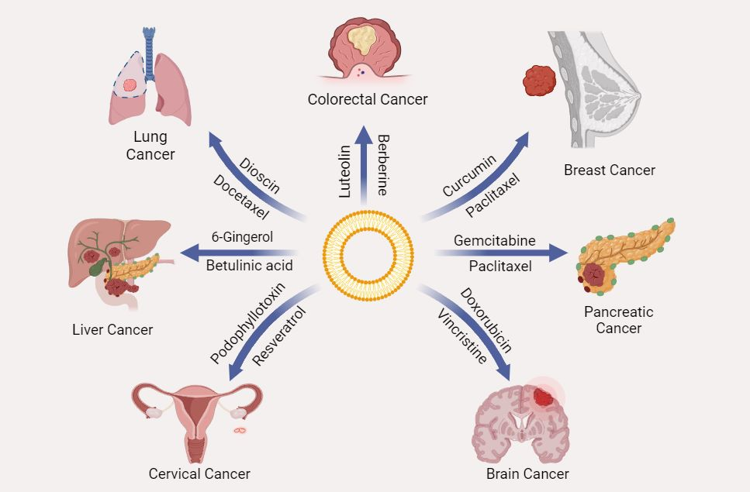
Fig. 5: Various phytosomal strategy against different tumours

VI. Challenges:
More attention should be paid to thorough optimization, quantitative and qualitative analysis, and exploration of the phytosomal drug delivery mechanism and its effects on various sickness scenarios [53]. Even though the topic has seen a lot of research, more needs to be done to concentrate on the challenges with formulation, stability, and the genuine therapeutic superiority of such drug delivery systemsThe formulation of phyto-phospholipid complexes has traditionally been done by the solvent evaporation method. The method of drying used—which hasn't been optimized in any research—often impacts the quality of the finished product in terms of particle size, appearance, and hygroscopicity. The process requires a lot of unit operations, which takes time.The supercritical fluid technique can be utilized to solve the drawbacks of current technologies since particle size and dispersion can be more accurately controlled at very low temperatures. There are no studies that link the pharmacological effectiveness of medicines in their phospholipid complex forms with better in vivo and in vitro pharmacokinetic characteristics.
Although clinical aspects of produced formulations have been disregarded, much attention has been paid to characterizing and evaluating the pharmacokinetic characteristics of phyto-phospholipid complexes. To close this gap and establish a connection between the rise in bioavailability and clinical efficacy, additional study is needed [54]. The mass synthesis of phytosomes presents the second difficulty. However, when it scales up, the product's qualities should be preserved. This is related to the use of laboratory methods in a business environment. Most phytosome types have a straightforward formulation procedure, however pH-sensitive phytosomes had low physicochemical stability, making commercial manufacture difficult. A lot of time passes between product creation and effective commercialization. Despite all the benefits, only a small number of phytosomal products have been released on the market. The verification of safety following the creation of a powerful formulation is a significant barrier to phytosome commercialisation. But before they are put on the market, certain factors includingIt is important to look into bioaccumulation, biocompatibility, metabolism, and excretion.To further prove a phyto-some's advantage over pure phyto-constituents, pharmacokinetic and pharmacodynamic properties in both animals and humans should be studied after development.Selecting the ideal dosage form is a subsequent step in the marketing process, which will boost the finished item's absorption and effectiveness [48].Despite the technology's obvious potential,phytosome has been used as a carrier in very few anti-cancer research for cancer treatment. Only a few as a result have been made available, such as Meriva® (curcumin phytosomes) and Siliphos® (silybinphytosomes). The production of nanophytosomes on a bigger scale is a significant component of this aspect. The ease of manufacture and simplicity of phytosomes made them more potent to be scaled up, although not being used on an industrial scale yet. The main reason for the non-industrial scale-up may be the pH sensitivity of phytosome structures. For the mass production of these kinds of nanocarriers, this is a key issue that impacts the physicochemical stability of phytosomes and needs to be addressed in the future. Despite recent advancements in vesicular system manufacture at the industrial level, such as extruding technologies, which raise hopeful aspirations for the commercial fabrication of these systems, the high cost of raw materials still remains a concern. One risk to this development is pegylated soy phosphatidylcholine [55].
VII. Future prospect:
Understanding how efficiently herbal extracts are taken systemically is becoming easier because to developments in phytophospholipid complex technology. The irrational fears regarding plant-based drugs have been successfully addressed by this way. These novel drugs make great candidates for dose-escalation treatment. Originally used in cosmetics, phytosomes are now often utilized in the treatment of heart disease, cancer, inflammation, tumors, and other liver-related illnesses. With the use of this newly developed formulation technology, Phytosomes is once more emphasising the value of herbals in current medication targeting strategies [56].By binding specific ligands and antigens to the cellular structures, phyto-phospholipid complexes can also be strong candidates for active targeting in addition to passive targeting. As a result, more illnesses, such as cancer, osteoarthritis, and rheumatism, can be treated using phyto-phospholipid complexes. The dimension of the result may be altered to a number of restricted ranges by utilizing more modern techniques, such as SCF system and optimizing the temperature, pressure, and various other aspects. Due to their increased penetrability and higher retention, such size-controlled products might be beneficial in more effectively targeting different microbiological locations including inflammation and tumours. Additional statistical tools, such as factorial design, spherical symmetric designing, and others, can be used to optimise the molar ratios of drug candidates with phospholipids, along with temperature and other variables with the goal of reaching the optimum drug release profile and the maximum level of entrapment efficiency. with the goal of reaching the optimum drug release profile and the maximum level of entrapment efficiency. [57]. By reducing barriers brought on by insufficient lipid solubility and improving the bioavailability of bioactive phytochemicals like silybin, ginkgo, and polyphenolic compounds found in olive oil, nanotechnology-based phytosomes may have an influence on drug delivery. As phytosomes, several phytochemicals have been effectively produced, and it is anticipated that further phytochemicals may benefit from similar formulations. Future studies may discover beneficial combined advantages when mixing phytosomes with different phytochemicals or when putting a medication and a phytochemical together in a nano-vesicle [12]. Phospholipids significantly boost bioavailability when contrasted with chemically equivalent non-complexed forms. With the assistance of doctors and other researchers, the potential of phyto-phospholipid complex has an appealing prospect for use in the pharmaceutical industry [7]. This might open up a big window of opportunity for the medicine to be used for further therapeutic applications.. Indeed, the utilisation of safe phytoconstituents such as curcumin in conjunction with novel drug delivery technologies may pave the way for the creation of safe, environmentally conscious remedies for the most prevalent human illnesses. Consumption of full curcumin Nanoparticles for targeted distribution to diverse tissues, including malignancies, is one critical topic that may be investigated [58]. In conclusion, Phytosomes is a boon for naturally occurring extracts with low bioavailability and well-proven analytical and processing techniques. It provides a variety of advantages over other traditional forms of medicine. On the market, there are a number of pharmaceutical products with registered patents. According to this study, Phytosomes have added a fresh perspective to pharmaceutical research and development that has a wealth of unrealized promise [59]. The popularity of the product is another factor in its successful marketing. People's interest for this form of treatment has grown recently due to factors such as biocompatibility, cost, and safety of natural ingredients. Furthermore, due to the simple manufacturing method and effortless support of the application of phytosomal technology on a commercial level, the commercial production of phytosomes is a quick process. Many pharmaceutical firms examined the advantages and biological effects of phytosome preparations, in addition the better bioavailability of polar plant constituents. The overall evidence for these formulations motivates the researchers to carry out more field study. The FDA has approved a few nano-particulate medication delivery devices for cancer treatment. Lipid-based nanoparticles, one of several new nanocarriers, offer various benefits over traditional drug carriers, namely biocompatibility and biodegradability, low cost, and ease of access to raw materials.Since combining both natural and synthetic anti-cancer medicines into nanophytosomes considerably increases oral bioavailability and inhibits tumor development, it is anticipated that nanophytosomal delivery methods for cancer therapy will progress and extend in the near future. The use of hydrophilic plant extracts in cancer treatment may be revolutionised by the use of phytosome nanotechnology in the nano-formulation of nutraceuticals [2]. Future research may find that using phytosomes along with other phytochemicals or putting a drug and a phytochemical together in a nano-vesicle has stimulatory effects [12].
VIII.Conclusion:
The solubility and permeability of phytopharmaceuticals among diverse NDDS can be increased by using phytosomes,which are well-known biocompatible nanocarriers. Phytosomes, a novel and emerging vesicular drug delivery method, include plant extracts or hydrophilic phytochemicals in phospholipids to enhance their bioavailability and absorption and avoid the disadvantages and adverse effects of conventional herbal extracts. Phytosome characterisation and formulation methods have been well-established. There are several advantages to phytosome technology, including improvedeffects on the liver, bioavailability, and stability, etc.However, there are certain downsides, including the fast loss of phytoconstituents from the phytosome and PH-sensitivity.The verification of safety following the creation of an effective formulation is a significant barrier to the commercialization of phytosomesIt is clear that combining nano-phytosomes with oral bioavailability of both natural and manufactured anti-cancer medications is markedly increased, and tumor growth is slowed.Currently, hydrophilic plant chemicals are used to treat cancer,however, employing phytosome technology in the nano-formulation of nutraceuticals could alter that.Future studies may reveal that the usage of phytosomes in combination with other phytochemicals or the combination of a drug and a phytochemical to produce a nano-vesicle may have stimulatory effects.
REFERENCES
[1]. Murugesan M.P., Ratnam M.V., Mengitsu Y., Kandasamy K. Evaluation of anti-cancer activity of phytosomes formulated from aloe vera extract. Mater. Today: Proc. 2020;42(2):631–636.
[2]. Baba Zadeh A., Zenial M., Hamishehkar H. Nano-phytosome: a developing platform for herbal anti-cancer agents in cancer therapy. Curr. Drug Targets. 2018;19(2):170–180
[3]. Tao F., Zhang Y., Zhang Z. The role of herbal bioactive components in mitochondria function and cancer therapy. Evid. Based Complementary Altern. Med. 2019;2019:1–12.
[4]. Mateti T., Aswath S., Vatti A.K., Kamath A., Laha A. A review on allopathic and herbal nanofibrous drug delivery vehicles for cancer treatments. Biotechnol. Rep. 2021;31:1–9
[5]. Palmier A. Cancer & ayurveda as a complementary treatment. J. Compl. Integr. Med. 2017;6

[6]. Yap K.M., Sekar M., Fuloria S., Wu Y.S., Gan S.H., Rani N.N.I.M., Subramaniyan V., Kokare C., Lump P.T., Begum, S M.Y., et al. Drug delivery of natural products through nanocarriers for effective breast cancer therapy: a comprehensive review of literature. Int. J. Nanomed. 2021;16:7891–7941.

[7]. Lu M., Qiu Q., Luo X., Liu X., Sun J., Wang C., Lin X., Deng Y., Song Y. Phyto-phospholipid complexes (phytosomes): a novel strategy to improve the bioavailability of active constituents. Asian J. Pharm. 2019;14(3):265–274.

[8]. Alhakamy N.A., Badr-Eldin S.M., Fahmy U.A., Alruwaili N.K., Awan Z.A., Caruso G., Alfaleh M.A., L Alaofi A., Arif F.O., Ahmed O.A.A., et al. Thymoquinone-loaded soy-phospholipid-based phytosomes exhibit anticancer potential against human lung cancer cells. Pharmaceutics. 2020;12(8):1–17.

[9]. Karpuz M., Gunay M.S., Ozer A.Y. Advances and Avenues in the Development of Novel Carriers for Bioactives and Biological Agents. 2020. Liposomes and phytosomes for phytoconstituents; pp. 525–553.
[10]. Azeez N.A., Deepa V.S., Sivapriya V. Phytosomes: emergent promising nano vesicular drug delivery system for targeted tumor therapy. Adv. Nat. Sci. Nanosci. Nanotechnol. 2018;9(3):1–6.
[11]. Semalty A., Semalty M., M Rawat M.S., Franceschi F. Supramolecular phospholipids-polyphenolics interactions: the PHYTOSOME strategy to improve the bioavailability of phytochemicals. Fitoterapia. 2010;81(5):306–314.
[12]. Alharbi W.S., Almughem F.A., Almehmady A.M., Jarallah S.J., Alsharif W.K., Alzahrani N.M., Alshehri A.A. Phytosomes as an emerging nanotechnology platform for the topical delivery of bioactive phytochemicals. Pharmaceutics. 2021;13(9):1–20.
[13]. Anwar D.M., El-Sayed M., Reda A., Fang J.Y., Khattab S.N., Elzoghby A.O. Recent advances in herbal combination nanomedicine for cancer: delivery technology and therapeutic outcomes. Expet Opin. Drug Deliv. 2021;18(11):1609–1625.
[14]. Aggarwal B.B., Ichikawa H., Garodia P., Weerasinghe P., Sethi G., D Bhatt I., Pandey M.K., Shishodia S., Nair M.G. From traditional Ayurvedic medicine to modern medicine: identification of therapeutic targets for suppression of inflammation and cancer. Expert Opin.Ther.Targets. 2006;10(1):87–118.
[15]. Koul B. 2020. Herbs for Cancer Treatment; pp. 1–1174.
[16]. Dhruva A., Hecht F.M., Miaskowski C., Kaptchuk T.J., Bodeker G., Abrams D., Lad V., Adler S.R. Correlating traditional ayurvedic and modern medical perspectives on cancer: results of a qualitative study. J. Alternative Compl. Med. 2014;20(5):364–370.
[17]. Handa M., Beg S., Shukla R., Barkat M.A., Choudhry H., Singh K.K. Recent advances in lipid-engineered multifunctional nanophytomedicines for cancer targeting. J. Contr. Release. 2021;340:48–59.
[18]. Chavda V.P., Vihol D., Mehta B., Shah D., Patel M., Vora L.K., Pereira-Silva M., Paiva-Santos A.C. Phytochemical-loaded liposomes for anticancer therapy: an updated review. Nanomedicine. 2022;17(8):547–568
[19]. Wang J.J., Lei K.F., Han F. Tumor microenvironment: recent advances in various cancer treatments. Eur. Rev. Med. Pharmacol. Sci. 2018;22(12):3855–3864.
[20]. Anand U., Dey A., Chandel A.K.S., Sanyal R., Mishra A., Pandey D.K., Falco V.D., Upadhyay A., Kandimalla R., Choudhary A., et al. Cancer chemotherapy and beyond: current status, drug candidates, associated risks and progress in targeted therapeutics. GENES DIS. 2022
[21]. Gautam L., Jain A., Shrivastava P., Vyas S., Vyas S.P. Nano Drug Delivery Strategies for the Treatment of Cancers. 2021. Emergence of novel targeting systems and conventional therapies for effective cancer treatment; pp. 1–35.
[22]. Baskar R., Lee K.A., Yeo R., Yeoh K.W. Cancer and radiation therapy: current advances and future directions. Int. J. Medical Sci. 2012;9(3):193–199.
[23]. Abshire D., Lang M.K. The evolution of radiation therapy in treating cancer. Semin. Oncol. Nurs. 2018;34(2):151–157.
[24]. Zaimy M.A., Saffarzadeh N., Mohammadi A., Pourghadamyari H., Izadi P., Sarli A., Moghaddam L.K., Paschepari S.R., Azizi H., Torkamandi S., et al. New methods in the diagnosis of cancer and gene therapy of cancer based on nanoparticles. Cancer Gene Ther. 2017;24(6):233–243.
[25], Ozturk-Atar K., Eroglu H., Calıs S. Novel advances in targeted drug delivery. J. Drug Target. 2018;26(8):633–642.
[26]. Gavas S., Quazi S., Karpiński T.M. Nanoparticles for cancer therapy: current progress and challenges. Nanoscale Res. Lett. 2021;16(1):1–21.
[27]. Mirzaei H., Shakeri A., Rashidi B., Jalili A., Banikazemi Z., Sahebkar A. Phytosomal curcumin: a review of pharmacokinetic, experimental and clinical studies. Biomed. Pharmacother. 2017;85:102–112.
[28]. Vu H.T.H., Hook S.M., Siqueira S.D., Müllertz A., Rades T., McDowell A. Are phytosomes a superior nanodelivery system for the antioxidant rutin. Int. J. Pharm. 2018;548(1):82–91.
[29]. Hou Z., Li Y., Huang Y., Zhou C., Lin J., Wang Y., Cui F., Zhou S., Jia M., Ye S., et al. Phytosomes loaded with mitomycin C-soybean phosphatidylcholine complex developed for drug delivery. Mol. Pharm. 2013;10(1):90–101.
[30]. Barani M., Sangiovanni E., Angarano M., Rajizadeh M.A., Mehrabani M., Piazza S., Gangadharappa H.V., Pardakhty A., Mehrbani M., Dell’Agli M., et al. Phytosomes as innovative delivery systems for phytochemicals: a comprehensive review of literature. Int. J. Nanomed. 2021;16:6983–7022.
[31]. Alhakamy N.A., Fahmy U.A., Badr Eldin S.M., Ahmed O.A.A., Aldawsari H.M., Okbazghi S.Z., Alfaleh M.A., Abdulaal W.H., Alamoudi A.J., Mady F.M. Scorpion venom-functionalized quercetin phytosomes for breast cancer management: in vitro response surface optimization and anticancer activity against MCF-7 cells. Polymer. 2022;14(1):1–21.
[32]. Freag M.S., Elnaggar Y.S.R., Abdallah O.Y. Lyophilized phytosomal nanocarriers as platforms for enhanced diosmin delivery: optimization and ex vivo permeation. Int. J. Nanomed. 2013;8:2385–2397.
[33]. Tripathy S., Patel D.K., Baro L., Nair S.K. A review on phytosomes, their characterization, advancement & potential for transdermal application. J. Drug Deliv. Therapeut. 2013;3(3):147–152.
[34]. Sharma S., Sahu A. Development, characterization, and evaluation of hepatoprotective effect of abutilon indicum and piper longum phytosomes. Pharmacogn. Res. 2016;8(1):29–36.
[35]. Gnananath K., Nataraj K.S., Rao B.G. Phospholipid complex technique for superior bioavailability of phytoconstituents. Adv. Pharmaceut. Bull. 2017;7(1):35–42.
[36]. Chavda V.P., Vihol D., Mehta B., Shah D., Patel M., Vora L.K., Pereira-Silva M., Paiva-Santos A.C. Phytochemical-loaded liposomes for anticancer therapy: an updated review. Nanomedicine. 2022;17(8):547–568
[37]. Azeez N.A., Deepa V.S., Sivapriya V. Phytosomes: emergent promising nano vesicular drug delivery system for targeted tumor therapy. Adv. Nat. Sci. Nanosci. Nanotechnol. 2018;9(3):1–6.
[38]. Chivte P.S., Pardhi V.S., Joshi V.A., Rani A.A review on therapeutic applications of phytosomes. J. Drug Deliv. Therapeut. 2017;7(5)
[39]. Alhakamy N.A., Fahmy U.A., BadrEldin S.M., Ahmed O.A.A., Aldawsari H.M., Okbazghi S.Z., Alfaleh M.A., Abdulaal W.H., Alamoudi A.J., Mady F.M. Scorpion venom-functionalized quercetin phytosomes for breast cancer management: in vitro response surface optimization and anticancer activity against MCF-7 cells. Polymer. 2022;14(1):1–21.
[40]. Gavas S., Quazi S., Karpiński T.M. Nanoparticles for cancer therapy: current progress and challenges. Nanoscale Res. Lett. 2021;16(1):1–21.
[41]. Susilawati Y., Chaerunisa A.Y., Purwaningsih H. Phytosome drug delivery system for natural cosmeceutical compounds: whitening agent and skin antioxidant agent. "J. Adv. Pharm. Technol. Research"" (JAPTR)". 2021;12(4):327–334.
[42]. Marjaneh R.M., Rahmani F., Hassanian S.M., Rezaei N., Hashemzehi M., Bahrami A., Ariakia F., Fiuji H., Sahebkar A., Avan A. Phytosomal curcumin inhibits tumor growth in colitis-associated colorectal cancer. J. Cell. Physiol. 2018;233(10):6785–6798.
[43]. Mirzaei H., Shakeri A., Rashidi B., Jalili A., Banikazemi Z., Sahebkar A. Phytosomal curcumin: a review of pharmacokinetic, experimental and clinical studies. Biomed.Pharmacother. 2017;85:102–112.
[44]. Hou Z., Li Y., Huang Y., Zhou C., Lin J., Wang Y., Cui F., Zhou S., Jia M., Ye S., et al. Phytosomes loaded with mitomycin C-soybean phosphatidylcholine complex developed for drug delivery. Mol. Pharm. 2013;10(1):90–101.
[45]. Alhakamy N.A., Fahmy U.A., Badr-Eldin S.M., Ahmed O.A.A., Asfour H.Z., Aldawsari H.M., Algandaby M.M., Eid B.G., Abdel-Naim A.B., Awan Z.A., et al. Optimized icariin phytosomes exhibit enhanced cytotoxicity and apoptosis-inducing activities in ovarian cancer cells. Pharmaceutics. 2020;13(1):346.
[46]. Alhakamy N.A., Badr-Eldin S.M., Fahmy U.A., Alruwaili N.K., Awan Z.A., Caruso G., Alfaleh M.A., L Alaofi A., Arif F.O., Ahmed O.A.A., et al. Thymoquinone-loaded soy-phospholipid-based phytosomes exhibit anticancer potential against human lung cancer cells. Pharmaceutics. 2020;12(8):1–17.
[47]. Sabzichi M., Hamishehkar H., Ramezani F., Sharifi S., Tabasinezhad M., Pirouzpanah M., Ghanbari P., Samadi N. Luteolin-loaded phytosomes sensitize human breast carcinoma MDA-MB 231 cells to doxorubicin by suppressing Nrf2 mediated signalling. Asian Pac. J. Cancer Prev. APJCP. 2014;15(13):5311–5316.
[48]. Murugesan M.P., Ratnam M.V., Mengitsu Y., Kandasamy K. Evaluation of anti-cancer activity of phytosomes formulated from aloe vera extract. Mater. Today: Proc. 2020;42(2):631–636.
[49]. Sharma S., Roy R., Shrivastava B. Antiproliferative effect of phytosome complex of methanolicextact of Terminalia arjuna bark on human breast cancer cell lines (MCF-7) Int. J. Drug Dev. Res. 2015;7(1):173–182.
[50]. Barani M., Sangiovanni E., Angarano M., Rajizadeh M.A., Mehrabani M., Piazza S., Gangadharappa H.V., Pardakhty A., Mehrbani M., Dell’Agli M., et al. Phytosomes as innovative delivery systems for phytochemicals: a comprehensive review of literature. Int. J. Nanomed. 2021;16:6983–7022.
[51]. Semalty A., Semalty M., M Rawat M.S., Franceschi F. Supramolecular phospholipids-polyphenolics interactions: the PHYTOSOME strategy to improve the bioavailability of phytochemicals. Fitoterapia. 2010;81(5):306–314.
[52]. Chavda V.P., Vihol D., Mehta B., Shah D., Patel M., Vora L.K., Pereira-Silva M., Paiva-Santos A.C. Phytochemical-loaded liposomes for anticancer therapy: an updated review. Nanomedicine. 2022;17(8):547–568.
[53]. Kumar S., Baldi A., Sharma D.K. Phytosomes: a modernistic approach for novel herbal drug delivery - enhancing bioavailability and revealing endless frontier of phytopharmaceuticals. J. Dev. Drugs. 2020;9(2):1–8. 10.3390/2Fpharmaceutics13091475.
[54]. Khan J., Alexander A., SarafAjazuddin S., Saraf S. Recent advances and future prospects of phyto-phospholipid complexation technique for improving pharmacokinetic profile of plant actives. J. Contr. Release. 2013;168(1):50–60.
[55]. Baba Zadeh A., Zenial M., Hamishehkar H. Nano-phytosome: a developing platform for herbal anti-cancer agents in cancer therapy. Curr.Drug Targets. 2018;19(2):170–180.
[56]. Kumar S., Baldi A., Sharma D.K. Phytosomes: a modernistic approach for novel herbal drug delivery - enhancing bioavailability and revealing endless frontier of phytopharmaceuticals. J. Dev. Drugs. 2020;9(2):1–8.
[57]. Khan J., Alexander A., Saraf Ajazuddin S., Saraf S. Recent advances and future prospects of phyto-phospholipid complexation technique for improving pharmacokinetic profile of plant actives. J. Contr. Release. 2013;168(1):50–60.
[58]. Ipar V.S., Dsouza A., Devarajan P.V. Enhancing curcumin oral bioavailability through nanoformulations. Eur. J. Drug Metab. Pharmacokinet. 2019;44(4):459–480.
[59]. Agarwal A., Chakraborty P., Chakraborty D.D., Saharan V.A. Phytosomes: complexation, utilisation and commerical status. J. Biol. Act. Prod. Nat. 2012;2(2):65–77

