SPECTRUM OF NODAL AND EXTRA NODAL LYMPHOMA IN A REGIONAL CANCER CENTRE, ODISHA, INDIA.
Ms D. Mohanty ^{α}, Dr. S. T. Pattnaik ^{α}, Dr K. C. Pani ^{β}& Dr P. C. Rout¥
^{α} Department of Zoology, College of Basic Sciences and Humanities, OUAT, Bhubaneswar-3
^{β} Assistant Professor of Pathology, Acharya Harihar Regional Cancer Centre, Cuttack-1
¥Assistant Professor of Zoology, Model Degree College, Deogarh- 758108, Odisha, India
Email id: pcr.bana@gmail.com

ABSTRACT
Lymphoma encompasses a large group of cancers, ranking 7th among the common malignancies. Commonly, lymphoma originates in the lymph nodes. Infiltration of malignant lymphomatous cells in organs other than the lymph node is termed as Extra Nodal Lymphoma. In this retrospective study of 253 cases of Lymphoma, the spectrum of histopathological features of Extra Nodal Lymphoma is illustrated to ascertain the histological and anatomical distribution of ENL & NL. ENL constituted about 16% of all lymphomas studied during this period. Gastro-intestinal tract is the most common anatomical site in ENL. The peak incidence is found among middle aged population. Cervical Lymph Node is the most prevalent node involved in case of Nodal Lymphoma. This study was carried out at the Acharya Harihar Regional Cancer Centre (AHRCC), Cuttack, Odisha, India.
This activity outlined the epidemiological and morphological evaluation of ENL & NL. future research will look to focus and highlight the survival analysis and genetic profile to understand the complex biology of primary Extranodal Lymphoma.
Key words: Lymphoma, Lymphomatous, Cervical Lymph Node, AHRCC.
INTRODUCTION
Lymphoma is an umbrella term that encompasses a large group of cancers, ranking 7th among the common malignancies in both the sexes together [1]. This neoplastic proliferation of lymphoid cells often affects the lymph nodes; with infiltration into the bone marrow, spleen and thymus. These are the organs constituting the primary lymphoid organs [2]. In nodes, uncontrollable proliferation and growth of cells due to lymphatic mutation results in tumorigenesis [3]. In extra nodal lymphoma, the sites involved include organs other than lymph nodes, spleen, thymus and pharyngeal lymphatic rings [4]. However, spleen being involved is considered as a nodal disease in Hodking’s disease, where as an extra nodal case in Non Hodking’s lymphoma [5]. The cause of lymphoma still remains unclear; however certain individuals show more susceptibility towards this disease. These individuals may include those who are infected with virus and bacteria like HIV, Helicobacter pylori, Epstein- Barr virus or Human T- Lymphotrophic virus [3]. Genetic link of an individual also increases his susceptibility [6]. In spite of complexity in classification of lymphoma, it can be broadly classified into Non- Hodking’s Lymphoma and Hodking’s Lymphoma, with their sub classes ranging to 30 in number [7-10]. This neoplastic disease is highly treatable and often curable when caught early. However extra nodal lymphomas pose a challenge during their diagnosis due to varied clinical presentations, morphological mimicry and molecular alterations [11,12].Although the incidence of ENL has seen a hike in the last 20 years, the literature on ENL is limited. Hence the study was undertaken to ascertain the incidence, anatomical distribution and other factors.
AIMS AND OBJECTIVES
To ascertain the incidence, distribution and histological subtypes of nodal and extra nodal lymphoma in a Regional Cancer Centre, Odisha.
MATERIALS AND METHOD
This hospital based retrospective study was conducted on patients who came to the department of Acharya Harihar Regional Research Centre (AHRCC) , 0disha and diagnosed to have lymphoma. The study was carried out over a period from January, 2018 - January, 2019 and included prospective data collected during the period from February, 2019 – April,2019. During this period, 350 patients are diagnosed with lymphoma. Among which 253 cases were included for the study who were confirmed of lymphoma based on histopathological test and the rest 93 cases were excluded due to incomplete evaluation and lack of data in the records. The tissues from the patients who underwent biopsy of the lesion was processed and stained with haematoxylin and eosin. The patients with nodal lymphoma underwent excisional biopsy and the patients with extranodal lymphoma were diagnosed based on operated histopathological specimen. IHC studies were performed using a panel of antibodies depending on morphology of tissue section of the cases resected during biopsy. The protocol followed for H&E stain & IHC test have been mention below. HISTOPATHOLOGICAL TECHNIQUES Tissue collection: Tissue resected from biopsy was fixed in normal buffer formalin (NBF) 10% formalin immediately [100ml formalin (37.4% stock solution) + 900 ml of distiiled water + 9mg NaCl + 12gm Na2HPO4] for 6-72 hours.
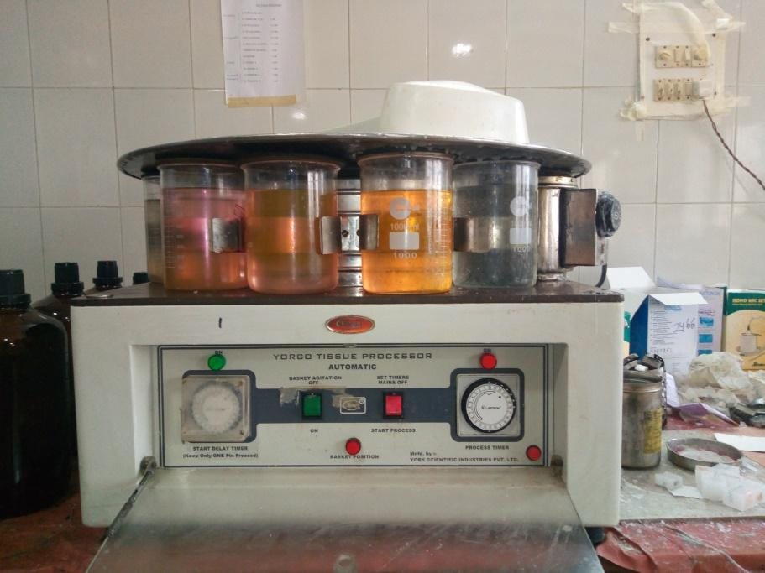

Figure1: Automatic tissue processor
Grossing and processing : The tissue was grossed and the sections were processed in automatic tissue processor (histokinetics) . The processing of tissue included dehydration in increasing gradients of alcohols followed by clearing in xylene & then embedding in paraffin wax .
Section–cutting : After impregnation with paraffin , thin sections of 5 micrometer thickness were cut using microtomy and then stained with H&E staining
H&E staining : The tissue section of slide first undergoes deparafinization by xylene 1 & 2 for 10-20 mins each. Then follows hydration with decreased concentration of alcohol (100% , 85% , 70% , 50%) . Then it is counter stained with haematoxylene for 5-10 minutes and washes and then stained with eosin. This is followed by dehydration with increasing concentration of alcohol (50- 100%). It was then cleaned with acetone and xylene and observed with DPX mount.
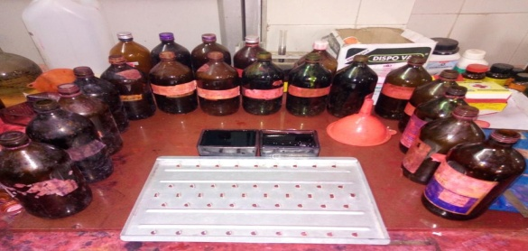

Figure 2 : Experimental set up for H & E Staining

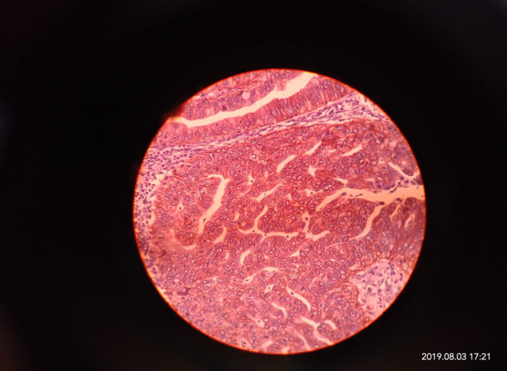
The data pertaining to patients, demography, clinical signs and symptoms, routine CBC, imagery finding , IHC reports were received from the medical records .

Figure3: Stained cancer cells under microscope
Patients diagnosed with lymphoma in organs other than lymph nodes and primary lymphoid organs were considered for extra nodal cases. Nodal lymphoma involvement of primary lymphoid organ or otherwise not specified were considered nodal by default. Classification of lymphoma classes were considered according to the WHO classification.

World Health Organization (WHO) classification of lymphoid neoplasms as under:
Non-Hodgkin lymphoma |  |  |  | Hodgkin lymphoma
B cell neoplasms |  | T cell Neoplasms |  | Classical | Lymphocyte-predominant  Hodgkin disease
Precursor B cell neoplasms | Mature B cell neoplasms | Precursor T cell neoplasms | Mature T cell and NK-cell  neoplasms
Precursor B-lymphoblastic lymphoma | Small lymphocytic lymphoma | Precursor T-lymphoblastic lymphoma | T cell large granular lymphocytic leukemia | Nodular sclerosis Hodgkin lymphoma | Nodular lymphocyte-predominant Hodgkin lymphoma
 | B cell prolymphocytic lymphoma |  | Adult T cell lymphoma | Mixed cellularity Hodgkin lymphoma
 | Splenic marginal zone lymphoma |  | Extranodal T cell lymphoma | Lymphocyte-rich Hodgkin lymphoma
 | Extranodal marginal zone B cell lymphoma |  | Enteropathy T cell lymphoma | Lymphocyte-depleted Hodgkin lymphoma
 | Lymphoplasmacytic lymphoma |  | Mycosis fungoides
 | Follicular lymphoma |  | Primary cutaneous T cell lymphoma
 | Mantle cell lymphoma |  | Systemic anaplastic large cell lymphoma
 | Diffuse large B cell lymphoma |  | Peripheral T cell lymphoma
 | Large B cell lymphoma |  | Hepatosplenic gamma/delta T cell lymphoma
 | Burkitt lymphoma |  | Aggressive NK-cell leukemia
 | Lymphomatoid granulomatosis |  | Blastic NK-cell lymphoma

STATISTICAL ANALYSIS:
Measurement data were expressed as mean +/- SD. Count Data were expressed as percentage. The age group distribution, organ involvement were compared for nodal and extra nodal cases separately using histograms and pie-charts.
RESULTS
Extranodal lymphoma constituted 16.06% (35/218) of all lymphoma studied during this period . The mean age at presentation for ENL and nodal lymphoma was 52 years and 48 years respectively (range 4-95 years) . There were 20 male and 15 female in ENL group compared to 154 male and 64 female in nodal lymphoma group [Table 1] . The peak incidence was in 5th decade in both ENL and NL.
Table 1: Age and sex distribution of nodal and extra nodal lymphoma.
Age & Sex | NODAL L | ENL | TOTAL
MEAN AGE | 48.15+-18.56 | 52.29+-18.72 | 48.54+-18.56
MEDIAN | 50 | 55 | 50
MALE:FEMALE | 77:32 | 4:3 | 174:79
RANGE | 4-85 | 12-95 | 4-95
PEAK INCIDENCE(IN DECADES) | 5TH | 5TH

Among ENL cases , the gastro-intenstine was the most common site (17/35 , 48.57% ) [somach 14 and colon 3] followed by oronasal (6/35 , 17.14%) , testis (5/35 ,14.29%) , retroperitoneal (2/35 , 5.71%) and bones (2/35 , 5.71%) . Breast , CSF , Thigh were other rare anatomical sites of ENL of 1 patient each .
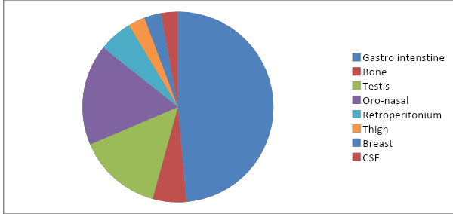

Fig4 : Site wise distribution in ENL
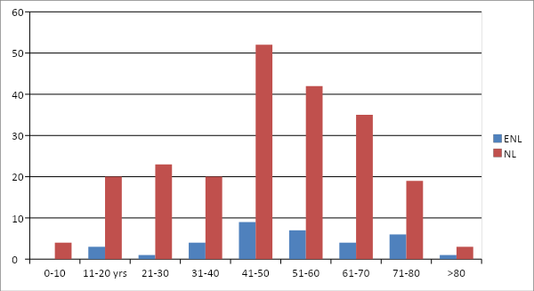
Fig5: Age group distribution.
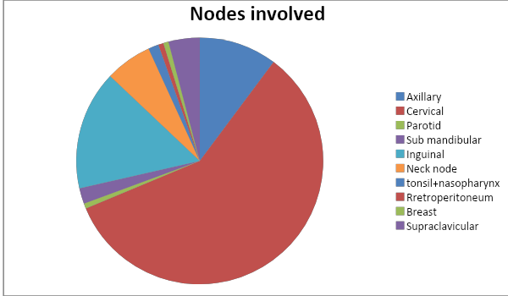
Fig 6: Site wise distribution in Nodal Lymphoma

Cervical lymph node was the most prevalent node involved in case of nodal lymphoma (86/ 218 , 39.45%) followed by inguinal node (23/218 , 10.55%) and axillary node (15/218 , 6.88%) . Neck nodes , node of supraclavicular , sub mandibular , parotid , nasopharyngeal and breast were other rare cases noted in nodal lymphoma
Table 2 : Histology of the Lymphomas
N  H  L | TYPES | ENL | NL
 | DLBCL | 1 | 11
 | NHL-Unclassified | 16 | -
 | T-Cell | 1 | 12
 | Follicular | - | 3
 | SCL | - | 2
 | Mantle Cell Lymphoma | - | 1
 | MALT lymphoma | 6 | 1
 | ALCL | - | 5
 | Diffused | - | 23
 | Large cell type | - | 6
 | Lymphoblastic | - | 2
 | Lymphoplasmacytic | - | 1
H  L | Mixed cell type | - | 13
 | Nodular type | - | 2
 | Nodular sclerosis type | - | 4
ENL-Extra Nodal Lymphoma; NL-Nodal Lymphoma; DLBCL-Diffused Large Cell Lymphoma; SCL-Small Cell Lymphoma; ALCL-Anaplastic Large Cell Lymphoma
Diffused type , DLBCL and otherwise unclassified were 3 most common histological type in NHL ; mixed type and nodular sclerosis type were common in HL . Small lymhocytic lymphoma , follicular lymphoma , anaplastic large cell lymphoma and HL and its sub classes that were noted in nodal lymphoma were not seen in extra nodal cases .
CD20 AND CD45 were the markers that were predominantly positive in IHC report obtained from the patients.
Table 3 : Sex-Age group distribution
Age Groups | NODAL L |  |  | ENL |  |  | TOTAL
 | M | F | T | M | F | T | M | F | T
0-10 | 4 | 0 | 4 | 0 | 0 | 0 | 4 | 0 | 4
11-20 | 12 | 8 | 20 | 3 | 0 | 3 | 15 | 8 | 23
21-30 | 19 | 4 | 23 | 1 | 0 | 1 | 20 | 4 | 24
31-40 | 11 | 9 | 20 | 2 | 2 | 4 | 13 | 11 | 24
41-50 | 41 | 11 | 52 | 4 | 5 | 9 | 45 | 16 | 61
51-60 | 33 | 9 | 42 | 3 | 4 | 7 | 36 | 13 | 49
61-70 | 18 | 17 | 35 | 3 | 1 | 4 | 21 | 18 | 39
71-80 | 15 | 4 | 19 | 3 | 3 | 6 | 18 | 7 | 25
>80 | 1 | 2 | 3 | 1 | 0 | 1 | 2 | 2 | 4
TOTAL | 154 | 64 | 218 | 20 | 15 | 35 | 164 | 79 | 253
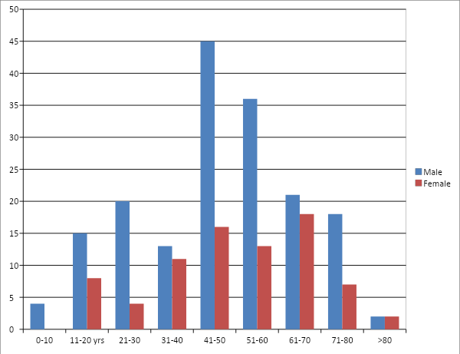
Fig 7 : Gender distribution among different age groups
DISCUSSION
Extra nodal lymphoma is a heterogeneous disease with respect to the geographical distribution, ethnic variation, anatomical localisation, etiological and morphological diversities . The frequency of extra nodal lymphoma incidence is high. A study by Singh et al from north India reported an incidence of 44% with DLBCL being the commonest histological type and head and neck and GIT being the common anatomical site[15].. Another study from south India by Padhi et al have reported an incidence of 22% with brain and GIT being common anatomical sites, whereas the study by Pai et al [noted an incidence of 35.96% with DLBCL and B-cell NHL being the common histological type[16-17].. Studies from Pakistan , Korea and China have also reported incidence ranging from 45% to 62%.

TABLE 4: Various studies of clinicopathological comparisions
Author & year | Total no of lymphoma | period | No of ENL (%) | Common anatomical site | Histopathology |  | Remarks
 |  |  |  |  | Nodal | Extranodal
Singh et al.,2003, India | 241 | 3 | 106 (44) | Head & neck, GIT | DLBCL | DLBCL | Poor oro-dental hygiene
Yoon et al.,2010, Korea | 48 | 11 | 48 (100) | Oesophagus, pancrease prostrate, adrenal, |  | DLBCL, | Bad prognosis
Nagi et al.,2010,Pakistan |  | 5 | 147 | GIT, NNPS | DLBCL, FL | DLBCL, ALCL, BL | M:F= 1:1
Yang et al., 2011, China | 5549 | 9 | 2968 (53.5) | Waldeyer’s Ring, NNPS, GIT | DLBCL,FL,SLL | DLBCL, ENKTCL, MALT | High frequency of ENKTCL,EBV positive
Padhi et al.,2012,India | 308 | 5 | 68 (22) | Brain, GIT | DLBCL,FL, ALCL | DLBCL, MALT | Early stage, immunocompetent
Pai et al.,2015,south India | 114 | 4 | 41 (35.9) | GIT,NNPS, testis | DLBCL,NHL(U) | DLBCL, B-cell | Early stage, immunocompetent, M:F= 1:1.05
Present study, 2019,Odisha | 253 | 1 | 35 (13.83) | GIT, testis, head & neck | DLBCL, mixed type HL | NHL (U), MALT | M:F= 2.2:1

This present study showed the incidence to be 16.06% which is lower than the studies followed in and around India. In this study, in comparison to the patients with extra nodal lymphoma, patients diagnosed to have NL were younger [mean 52.29 years vs 48.15 years] which differed from the study done by Pai et al in South India that stated the ENL where younger than the nodal. Follicular lymphocytic, small cell lymphoma and mantle cell lymphoma seen in nodal lymphoma, were not seen at extra nodal sites and thin may be possibly due to the geographic variations in molecular expression profiling of the lymphoma as reported by Biagi and Seymour et al . A similar result was obtained from this study of mine. The incidence of GIT lymphomas has been increasing throughout the world has been reported to be the most common site and involvement among extra nodal cases [18].. After GIT, the most common involved extra nodal site in head and neck DLBCL being the commonest histological type . The ENL have been known to have complex biological behaviour as shown in various studies. In spite of significant diagnostic and treatment development, the therapeutic outcome has been worse for patients with ENL involving rare sites as shown by Yun et al . Studies have also shown that the age, stage of lymphoma, performance status and serum LDH level have 71 been independent prognostic variables, where as the site involvement did not bear any prognostic significance as shown by Lal et al In this present study at initial presentation, patients with NL were younger than extra nodal lymphoma.
CONCLUSION

This study showed that the overall incidence of ENL in our centre is less common in comparison to the data from other parts of India and Asia. The GIT was the most common site of involvement among the ENL as seen in other studies. Compared to previously published studies of extra-nodal lymphoma series, no major specific differences were noted with respect to the gender preponderance and the histopathology. Majority of the patients presented at younger age, with early stage of lymphoma and were immune-competent. This study being mostly an epidemiological and morphological study, failed to address the outcomes as the long-term follow-up data pertaining to the survival analysis are lacking. However, we do believe at this point of time that more studies of similar kind with focus on outcomes and also highlighting the genetic profile, must be carried out to understand the complex biology of the primary extra-nodal lymphomas.
.
REFERENCES
1.Altekruse SF, Kosary CL, Krapcho M, et al. SEER Cancer statistics review, 1975-2007. NationalCancerInstitute,Bethesda,D. http:// seer.cancer.gov/ csr/1975_2007/, based on November 2009 SEER data submission, posted to the SEER web site, 2010.
2.Kuppers R. The biology of Hodgkin’s lymphoma. Nat Rev Cancer. 2009;9(1):15–27.
3. Engels EA. Infectious agents as causes of non-Hodgkin lymphoma. Cancer Epidemiol Biomarkers Prev.2007;16(3):401–404.
4. Freeman C, Berg JW, Cutler SJ. Occurrence and prognosis of extranodal lymphomas. Cancer. 1972;29:252–60.
5. Guermazi A, Brice P, de Kerviler EE, Fermé C, Hennequin C, Meignin V. Extranodal Hodgkin disease: spectrum of disease. Radiographics. 2001;21:161–176
6. Cerhan JR, Slager SL. Familial predisposition and genetic risk factors for lymphoma. Blood.2015;126(20):2265–2273.
7. Campo E, Swerdlow SH, Harris NL, Pileri S, Stein H, Jaffe ES. The 2008 WHO classification of lymphoid neoplasms and beyond: evolving concepts and practical applications. Blood. 2011;117(19):5019–5032.
8. Swerdlow SH, Campo E, Pileri SA, et al. The 2016 revision of the World Health Organization classification of lymphoid neoplasms. Blood. 2016;127(20):2375–2390.

9. Swerdlow SH. Lymphoma classification and the tools of our trade: an introduction to the 2012 USCAP Long Course. Mod Pathol. 2013;26(Suppl 1):S1–S14.
10. Turner JJ, Hughes AM, Kricker A, et al. WHO non-Hodgkin’s lymphoma classification by criterion-based report review followed by targeted pathology review: an effective strategy for epidemiology studies. Cancer Epidemiol Biomarkers Prev. 2005;14(9):2213–2219.
11. Zucca E, Roggero E, Bertoni F, Conconi A, Cavalli F. Primary extranodal non-Hodking’s lymphomas. Part 1: Gastrointenstinal, cutaneous genitourinary lymphomas. Ann Oncol 1997;8:727-37.
12. Zucca E, Roggero E, Bertoni F, Conconi A, Cavalli F. Primary extranodal non-Hodking’s lymphomas. Part 2: Head and neck, central nervous system other less common sites. Ann Onocol 1999;10: 1023-33.
13. Muto R, Miyoshi H, Sato K, Furuta T, Muta H, Kawamoto K, Yanagida E, Yamada K, Ohshima K. Epidemiology and secular trends of malignant lymphfoma in Japan: Analysis of 9426 cases according to the World Health Organization classification. Cancer Med. 7(11):5843-5858. doi: 10.1002/cam4.1805. Epub 2018 Oct 11.
14. Ferlay J, et al. Estimates of worldwide burden of cancer in 2008: GLOBOCAN 2008. Int. J. Cancer.2010;127:2893–2917. doi: 10.1002/ijc.25516.
15. Mortimer PS, Rockson SG. New developments in clinical aspects of lymphatic disease. J. Clin. Investig.2014;124:915–921.
16. Hos D, Schlereth SL, Bock F, Heindl LM, Cursiefen C. Antilymphangiogenic therapy to promote transplant survival and to reduce cancer metastasis: What can we learn from the eye? Semin. Cell Dev. Biol. 2015;38:117–130.
17. Goel S, Gupta N, Walcott BP, Snuderl M, Kesler CT, et al. Effects of vascular-endothelial protein tyrosine phosphatase inhibition on breast cancer vasculature and metastatic progression. J. Natl. Cancer Inst.2013;105:1188–1201.
18. Arora N, Manipadam MT, Nair S. Frequency and distribution of lymphoma types in a tertiary care hospital in South India: Analysis of 5115 cases using the World Health Organization 2008 classification and comparison with world literature. Leuk Lymphoma. 2013;54:1004–11.82
19. Naresh KN, Srinivas V, Soman CS. Distribution of various subtypes of nonHodgkin's lymphoma in India: A study of 2773 lymphomas using R.E.A.L. and WHO classifications. Ann Oncol. 2000;11(Suppl 1):63–7.

