An overview of carbon dots synthesis, properties, and applications towards energy and environmental remediation

Vinoth Selvaraj^{a,}
ª Department of Chemistry,
Ben-Gurion University of the Negev,
P.O. Box 653, Beer-Sheva 84105, Israel.

Abstract
This book chapter captured the importance of existing and emerging carbon dots (CDs) based materials that are inexpensive and vigorously used towards environmental remediation-based applications. This chapter can summarize the photocatalytic degradation of organophosphates by CDs-based composites and hybrid materials synthesis, characterization, and applications towards photocatalytic degradation of organophosphates. Indeed, this chapter would bounce the future insights for the researchers working on the photocatalytic degradation of organophosphates. This survey could scrutinize the fascinating photocatalytic features of CDs that can aid in investigating their interaction with other environmental pollutants. This chapter has benefited materials scientists, chemists, biologists, and clinicians.

Keywords:
Carbon dots; synthesis and properties; photocatalytic degradation; atmospheric pollutants; environmental remediation.

1. Introduction
Environmental protection is anticipated to benefit considerably from nanotechnology [1]. Numerous nanomaterials have been thoroughly studied over the last two decades for their potential to offer fresh solutions or improve on already effective ones to many urgent environmental concerns, such as water and air pollution [2]. Nanomaterials with diverse uses in pollutant monitoring, environmental decontamination, and energy production include transition metal dichalcogenides, carbon-based nanomaterials, metallic nanoparticles, and metal-organic frameworks [3-6]. Researchers and scientists are fascinated by carbon nanostructures [8-9]. Carbon-based nanomaterials, such as fullerene, pristine graphene, graphene oxide (GO), carbon nanotubes (CNT), and reduced graphene oxide (RGO) exhibit exceptional water stability, high specific surface areas, and substantial pore volumes. As a result, they are frequently employed in various environmental applications, including sensing, adsorptive contamination removal, membrane-based separation, catalytic degradation, energy conversion, and storage [10-13]. The carbon nanostructures come in a variety of shapes, from zero-dimensional "Carbon Dots" (CDs), 1D CNT and nanowires, 2D graphene, and other materials [14]. In a study published in 2004, two significant impurities like, "short tubular carbon fragments" and "fluorescent carbon," were identified and examined while single-walled carbon nanotubes (SWCNTs) were being purified. This study is where the first reports of CDs appeared [15]. Further work in 2006 discovered that the surface functionalization of the fluorescent carbon impurities further improved their intriguing size-dependent emissive capabilities [16]. The CDs are spherical-shaped nanoparticles with diameters under 10 nm that frequently have surface-functionalized carbon cores with sp² and sp³ hybridized carbon entities [17]. An example of a low-dimensional system like this would exhibit quantum confinement and unique qualities like a more significant band gap, photostability, improved water solubility, biocompatibility, and non-toxicity [18]. This book chapter explains the potential utilization of CDs in environmental pollution control and remediation technologies (Figure 1).

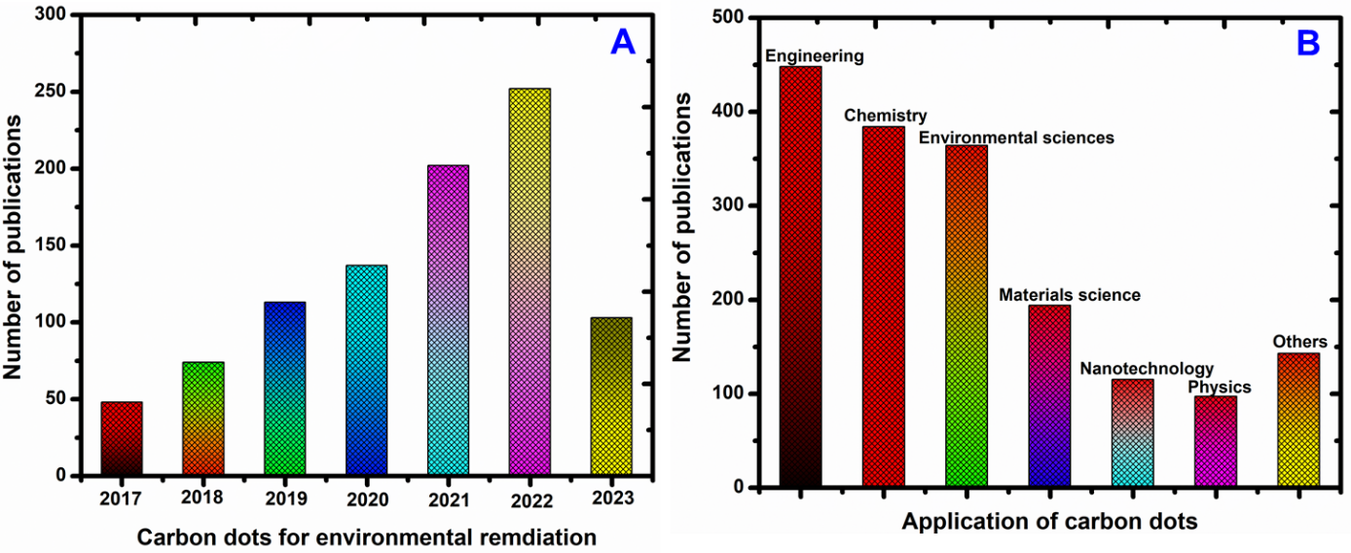
Figure 1. (A) Number of papers published on “Carbon Dots for Environmental Remediation” from 2017 to 2023, (B) Number of papers published under different fields for “Carbon Dots for Environmental Remediation” according to a Web of Science database search up to August-2023.

2. Carbon dots synthesis
Since Xu, et al, discovered CDs in 2004 [19], several techniques have been created to produce CDs. Top-down and bottom-up methods have both been used to manufacture carbon dots. CDs are formed when larger precursor molecules are broken down top-down. This strategy uses arc discharge, electrochemical processes, and laser ablation as techniques [20]. Contrarily, bottom-up strategies use simpler molecular precursors that are polymerized into CDs [21].
Some examples of bottom-up techniques are microwave and solvothermal synthesis, high thermal breakdown, and hydrothermal carbonization. Continuous and microfluidics-based techniques, such as low-temperature co-fired ceramic microreactors and continuous hydrothermal flow synthesis, have gained popularity recently because of improved heat transfer and homogenous distribution of the reaction mixture, which significantly cuts down on the amount of time needed, boosts yield, and makes them more suitable for industrial use [22-25].

2.1. Top-down synthesis
With the top-down approach, bigger carbon structure fragments like graphite, graphene, carbon nanotubes, and activated carbon are broken down using arc discharge, electrochemical oxidation, and laser ablation processes. Due to the simplicity of morphological control during this process, arc discharge has been widely employed for CD preparation.
Another popular method for producing CDs is electrochemical oxidation, which has the benefits of being inexpensive, high-purity, high-yield, simple to adjust size, and repeatable [26]. The first report on an electrochemical method for CD production was made in 2007 by Zhou's group [27].
Ming and colleagues recently developed a one-step electrochemical process that produced high-quality and pure CDs using only water as the electrolyte [28]. The CD synthesis process is cost-effective and ecologically benign thanks to this technique's excellent manufacturing efficiency. Chen et al. synthesized CDs using easily accessible and inexpensive sucrose as a carbon source, which allowed them to considerably lower the costs of the initial materials and increase the scale of CD production [29].
Additionally, Sun et al. invented the process of creating CDs by laser ablation of graphite powder while employing argon as a carrier gas and water vapor as a shield [30]. These synthesis techniques have significantly aided in the production of CDs.

2.2. Bottom-up approach
As an alternative to the above procedure, CDs can be produced by carbonizing small-molecule precursors using hydrothermal techniques, microwave-assisted synthesis, pyrolysis, or carbonization [31]. Hydrothermal carbonization is a widely used technique because of the readily available and inexpensive precursors, straightforward synthesis, ecologically friendly procedure, independence from large instruments, and nontoxic route. The carbon sources can come from discarded peels, organic acids, sugars, or juice.
Natural carbon sources are utilized in creating CDs more frequently than conventional sources due to their affordability, environmental friendliness, and recent growth in availability [32–34]. Most hydrothermal techniques for CDs often call for a hydrothermal reactor to seal and react with the organic precursor under high pressures, for extended times, and at high temperatures.
Electromagnetic waves with frequencies between 300 MHz and 300 GHz are known as microwaves, and they have the power to disrupt the chemical bonds in raw materials sufficiently. The microwave approach can deliver uniform heating and efficiently shorten reaction times, resulting in uniform CD particle size distribution [35-36]. Recent research has shown that short external heat pulses can help to chemically oxidize and carbonize organic materials, converting them into CDs [37].
Because they utilize readily available, low-cost precursors, simplicity of operation, quick reaction times, and solvent-free processes, the hydrothermal and microwave synthesis methods are most frequently utilized in CD environmental applications. Generally, the synthesis can be categorized into “top-down” and “bottom-up” methods (Figure 2).

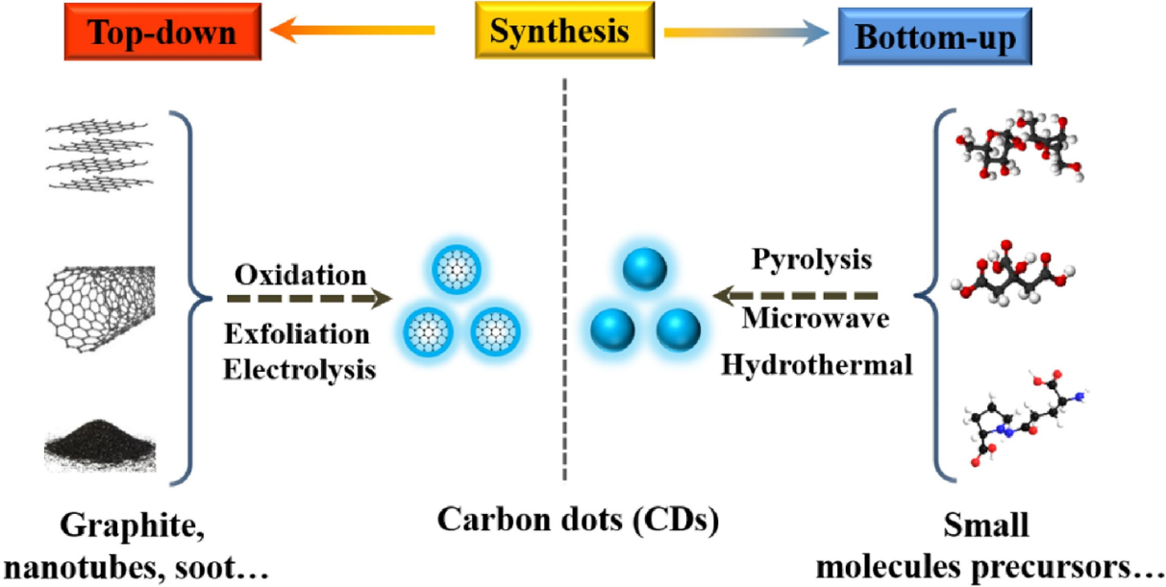

Figure 2. Different synthesis methods of CDs (adapted from Ref. 7)

3. Carbon dot properties
CDs have a wide range of physical and chemical properties due to the diversity of raw materials and synthetic approaches. Similar characteristics shared by several CDs include their solubility in water, environmental friendliness, lack of toxicity, tunable fluorescence, and excellent stability [38-39]. This section discusses CDs' physical, chemical, and optical properties in greater detail.

3.1. Physicochemical properties
An intriguing class of carbon nanoparticles with an average size of 10 nm is known as CDs [38,40]. CDs demonstrate the quantum confinement effect due to the oxygenated functional groups on their surfaces changing their surface structures and particle sizes [41-42].
Additionally, CDs are better at moving charges (excellent at trapping and moving electrons), which can effectively prevent the recombination of charges created by light [43-44]. The increased charge transport is partly due to the size-dependent optical properties of CDs, where the distance between charge carriers is small and typically less than the carrier diffusion length [45].
Since photocatalysis occurs at edges more frequently than at basal planes, CDs' edge-rich properties are highly beneficial for this reaction. Therefore, destroying organic contaminants using photocatalysis is a fantastic alternative for CDs. Additionally, CDs' particular chemical inertness and exceptional water stability make them suitable for application in nanotechnology and sensor production.

3.2. Optical properties
In general, CDs show strong optical absorption in the ultraviolet region, with a tail that reaches into the visible range and absorption peaks that concentrate between 260 and 320 nm [46]. The chemical groups found on CDs may influence the UV-visible regions' absorption. The observed variations in the absorption spectra data imply that diverse hybrid derivatives have different compositions or structures, at least in part.
Excitation-dependent fluorescence emission properties are present in the bulk of previously characterized CDs, and CDs get redder as the excitation wavelength increases [47]. On the other hand, some research has covered the emission spectrum of excitation-independent CDs. As an illustration, Liu et al. reported creating fresh CDs using potassium persulfate and acrylamide as a precursor.
Intriguingly, the independence of CDs from excitation was demonstrated by the fact that the fluorescence emission peak at 434 nm barely changed when the excitation wavelength was changed within the 280-390 nm range. CDs' quantum size impact was thought to be related to this phenomenon [48].
Understanding the mechanics underlying the fluorescence of CDs is essential for controlling their fluorescence and other physicochemical properties and expanding their range of applications. The fluorescence mechanism has thus been the focus of in-depth study.

3.3. Upconversion Photoluminescence
CDs' characteristic upconversion photoluminescence (UCPL) has been widely applied in photocatalysis and bioimaging. The UCPL process, which concurrently absorbs multiple photons and generates fluorescence with a shorter wavelength than the excitation source, produces an anti-stokes emission [49-50].
Cao et al. first saw significant two-photon fluorescence brought on by near-infrared stimulation by laser ablation [51]. It recommended NIR photoluminescent built of dopamine and o-phenylenediamine that displayed two-photon emission utilizing an 800 nm femtosecond pulse laser [52].
Since they can be combined with wide-band semiconductors to increase the absorption range, CDs with well-behaved UCPL have great potential to be used as spectral converters in photocatalysis.

3.4. Photoinduced Charge Migration
The distribution of graphitized-conjugated areas in CDs guarantees good electrical conductivity. Therefore, CDs have emerged as a rising star with an emphasis on charge transfer capability, such as in photocatalysis or optoelectronics [53-54].
Steady-state and time-resolved spectroscopy showed that this fluorescence quenching was caused by charge migration in the excited state. Guldi et al. used CDs as adaptable building blocks for supramolecular frameworks with customized electronic properties to further investigate charge migration behavior as electron-acceptor/donor in detail [55-56].
The charge separation, migration, and recombination process during the excited-state deactivation of the CDs-tetraarylporphyrin conjugate were confirmed by the ultrafast transient absorption spectrum of the excited conjugate, which reflected a similar outline to the integration of one-electron reduced CDs and the one-electron oxidized porphyrin.
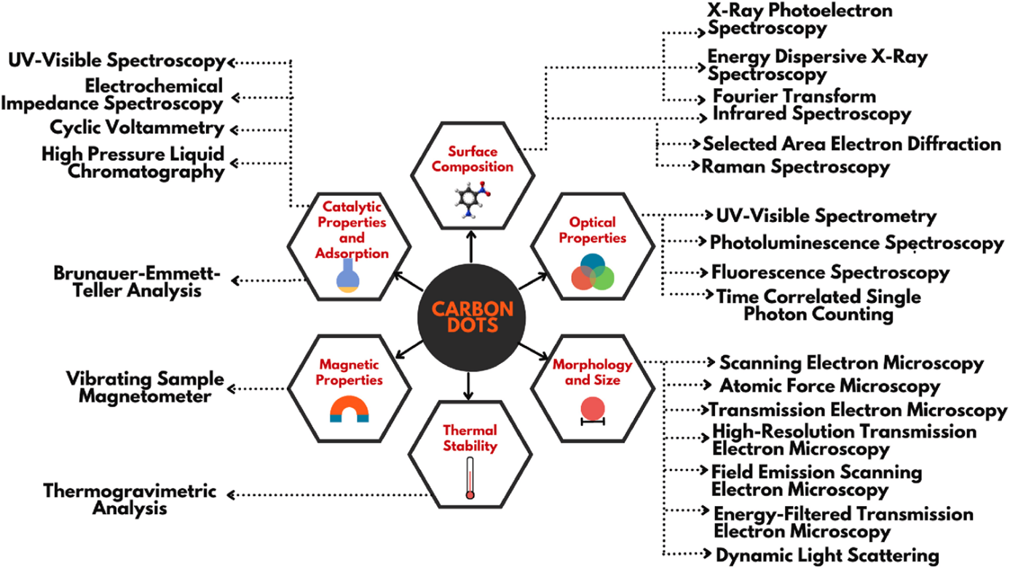

Figure 3. Characterization of carbon dots based on various properties (adapted from Ref. 8)

4. Carbon dots for environmental remediation
Although membrane separation and adsorption can remove organic or inorganic pollutants from water, they cannot entirely decompose the pollutants; this would necessitate additional disposal. Environmental contaminants may completely degrade or become mineralized with photocatalytic treatment.
Photocatalytic degradation has emerged as an appealing method for treating wastewater compared to adsorption and membrane separation in water treatment [57-58]. Due to the following characteristics, CDs have a great deal of potential for use in the photocatalytic destruction of environmental pollutants:
(i) CDs outperform conventional photocatalytic materials (such as ZnO, TiO₂, and CdS) in terms of water solubility, chemical stability, affordability, and environmental friendliness;
(ii) CDs have outstanding and adjustable optoelectronic and photoluminescent capabilities. In particular, wide bandgap semiconductors' sunlight absorption into the visible and near-infrared regions can be significantly increased by CDs' up-conversion photoluminescence;
(iii) CDs are excellent electron acceptors and donors that can effectively separate electrons from holes. As a result, CDs can be utilized in the design of photocatalysts as an electron mediator, spectrum converter, solitary photocatalyst, photosensitizer, photocenter, and catalytic center [31, 38].
Table 1 provides an overview of current developments in pure CDs and CDs-based hybrid photocatalysts for the degradation of environmental pollutants.

Table 1. Summary of CDs and CDs-based composites for photocatalysis.
Photocatalysts | Synthetic methods | Degraded pollutants | Influence of CDs | Ref.
CDs | Reflux | Methylene blue | The CDs facilitate the separation of electron-hole pairs and carrier migration. | [59]
N-CDs | Hydrothermal | 2, 4-dichlorophenol | N-CDs as nano-sensitizers can maximize solar light harvesting. | [60]
N-CDs | Ultrasonic | Rhodamine B | The intramolecular solid hydrogen bonds formed among the oxygen‐containing groups. | [61]
Au/CDs | Electrochemical | Cyclohexane | Promote broader spectrum absorption and separation of electrons and holes and stabilize photolysis semiconductors. | [62]
Cu–N-CDs | Pyrolysis | 1, 4-dihydro-2, 6-dimethylpyridine-3, 5-dicarboxylate | The electron-accepting and donating abilities are enhanced, and the electric conductivity is also increased. | [63]
TiO₂/CDs | Hydrothermal-calcination | Ciprofloxacin | The enhancement mechanism is triggered by the photoexcited electron accumulated on CDs and transferred by ozone, resulting in the continuous generation of H⁺, O³, and O² | [64]
TiO₂/CDs | Hydrothermal | Paraoxon pesticide | CDs show exciting wavelength-dependent down and up-conversion fluorescence properties. | [65]
ZnO/CDs | Electrochemical Hydrothermal | Gas-phase benzene | CDs’ crucial role is enhancing the photocatalytic activity of the ZnO/CDs. | [66]
Fe₂O₃/CDs | Electrochemical and Hydrothermal | Benzene and methanol | CDs play crucial roles in enhancing the photocatalytic activity of the Fe₂O₃/CDs. | [67]
g-C₃N₄/S, N: CDs | Hydrothermal | Rhodamine B | The enhancement of photodegradation activity is attributed to the efficient separation of photo-generated electrons and holes. | [68]

4.1. Photodegradation of dyes
Large-scale dye discharges into the aquatic environment, ubiquitous components in industrial effluent, may increase oxygen consumption during natural degradation and result in widespread anoxic demise of organisms.
There has been much research done so far on the photocatalytic degradation of common organic dyes like Rhodamine B (RhB), Methylene Blue (MB), and Methyl Orange (MO) using various CDs-based photocatalysts. Additionally, CDs can serve as an electron transfer conduit in a photocatalytic system between two photosensitive parts, allowing for a better separation of photoinduced electrons and holes.
Chen et al. added CPDs to a ternary plasmonic photocatalyst composed of CPDs/Ag/Ag₂O to improve photostability and the separation of electron-hole pairs [69]. This ternary photocatalyst displays exceptional degrading efficiency across the spectrum, following the higher electron transfer capacity and upconversion characteristic of CPDs (Figure 4A).
For the photodegradation of RhB, MB, and phenol, Feng et al. synthesized a CdS/CPDs/g-C₃N₄ composite (CSCCN) photocatalyst with a Z-scheme energy-level arrangement and vis-NIR light response (Figure 4B) [70].
Using the PL spectra, electron chemical impedance spectroscopy (EIS) Nyquist plots, and the transient photocurrent responses characterization, the authors compared this ternary catalyst to dualistic CdS/g-C₃N₄ and CPDs/g-C₃N₄. More vigorous photocurrent intensity was visible in CSCCN's transient photocurrent responses, indicating that carriers had longer lifetimes.
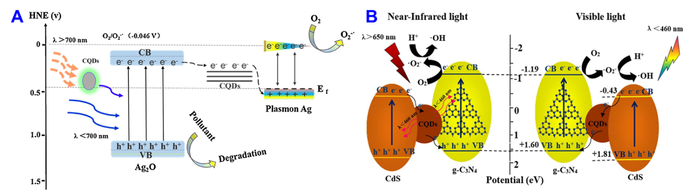
Figure 4. (A) A proposed reaction mechanism for total spectrum degradation organic pollution on CQDs/Ag/Ag₂O nanocomposites and (B) Energy band diagram of the Z-scheme electron transfer (CdS/CQDs/g-C₃N₄) mechanism (Adapted from Ref. 69 and 70)

4.2. Photodegradation of plastics
Along with pollutants in the water, a significant issue in the realm of eco-sustainability is the degradation or conversion of solid plastic trash. The annual production of plastic worldwide has remained constant in recent years at hundreds of millions of tons [71].
Most plastics, however, cannot break down naturally, and their combustion or disposal in landfills may release large amounts of flue gas or plastic particles into the environment, harming nearby wildlife [72]. Han et al. created a metal-free CPDs-based photocatalyst recently, realizing photocatalytic recycling of polyethylene terephthalate (PET) and polylactic acid (PLA) along with simultaneous H₂ generation [73].
Preparing graphitic carbon nitride (GCN) powders are added to CPD solutions before hydrothermally processing to create this composite catalyst. During the aforementioned process, photogenerated holes were continually consumed, and the residual electrons powered the conversion of H₂O to H₂.
It has been demonstrated that adding CPDs to GCN can significantly increase the carrier lifetime and assist carrier separation by reducing fluorescence lifetime and PL intensity. A correct CPD doping ratio in GCN enables a decreased resistance and more extraordinary charge transfer ability, as shown by EIS and photocurrent-time plots.
This research offers a revolutionary method for recycling plastic and photo-catalytically converting optical energy into H₂ fuels.

4.3. Photocatalytic CO₂ reduction
The world's population growth and rapid industrial development have led to an enormous rise in energy demand. As the primary direct energy source at this time, fossil fuels have caused a significant increase in the atmospheric concentration of greenhouse gases, of which CO₂ is the most well-known.
The global ecological system is under serious threat due to the greenhouse effect, global warming, and rising sea levels rise by the rapidly rising atmospheric CO₂ level [74]. To achieve CO₂ capture, it is required to investigate practical, effective, and environmentally beneficial solutions. An appealing and likely possibility is the photocatalytic conversion of CO₂ into CO or other valuable low-carbon fuels [75].
Theoretically, compared to the water reduction reaction, the multielectron and multi-proton reduction of CO₂ is often more advantageous because of its comparatively low thermodynamic barriers [76]. The crucial problem today is to obtain highly selective target products due to the identical thermodynamic potentials of the reduction products CO₂ and H₂O [77].
Currently, CO₂ has been reported to be converted by CDs-based photocatalysts into CO, methanol, methane, and carboxylic acids. The first publication on photocatalytic CO₂ conversion using CDs-based catalysts mainly concentrated on processes that produced carboxylic acid. For photocatalytic CO₂ conversion, Sun and colleagues first presented PEG functionalized CQDs with metal coating on the surface in 2011 [78].
K. Wang and workers reported the high-achievement CO₂ methanation by H₂O over carbon dots (CDs) drafted Cu/TiO₂ (Cu/TiO2-C), a photo-thermal linked device is created [79]. Under UV irradiation at higher temperatures (>150 °C), CH₄ synthesis shows dramatic promotion but mediocre photo-promotion at ambient temperatures.
On the Cu/TiO2 sample lacking CDs, the synergy effect of UV light and temperature does not exist. Here, Cu (II) is primarily reduced to Cu (0) by H₂ pretreatment, but a weak Cu(I)/Cu(II) cycle was visible after UV exposure. This study demonstrates that adding UV light makes it possible to construct this non-spontaneous reaction as two separate, ongoing, spontaneous processes (Figure 5).

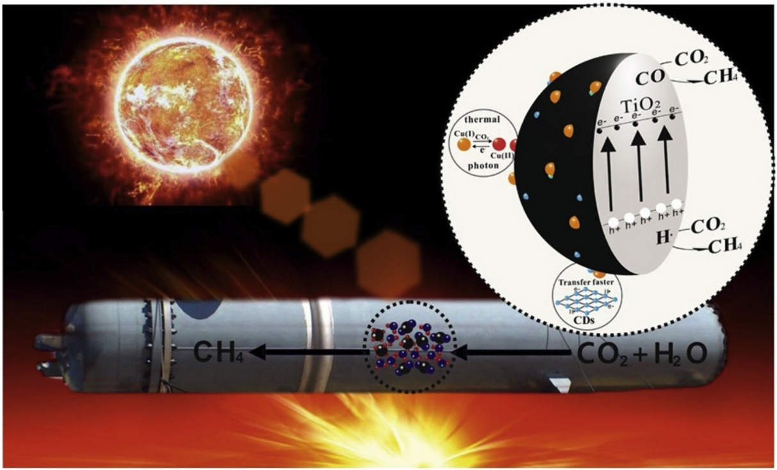
Figure 5. The non-spontaneous thermodynamic reaction of CO₂ methanation by H₂O could efficiently occur over a carbon dots (CDs) drafted Cu/TiO₂ catalyst in a designed photo-thermal coupling system, herein, the cycle of Cu(I)/Cu(II) induced by both UV light and CDs would contribute to the reaction. (Adapted from ref. 79)

4.4. Photocatalytic N₂ fixation
Despite making up to 78% of the atmosphere, nitrogen has a very high N-N bond energy, making it difficult to convert and utilize properly [80]. By reacting ambient nitrogen with hydrogen in the presence of iron at high pressure and temperature, Haber developed a way to make ammonia, and the Haber-Bosch process (20-40 MPa, 673-873 K) is still employed in the industrial nitrogen fixation process today [81].
Regrettably, the extreme situation will utilize many fossil fuels and produce a million tons of greenhouse emissions annually. Moderate artificial nitrogen fixation techniques, including photocatalysis, are desperately needed for the environment’s sake and long-term energy sustainability. Metallic semiconductors dominate the list of catalysts used in photocatalytic nitrogen fixation.

The antibonding -orbitals of nitrogen atoms and metal cation sites are likely to interact due to nitrogen atoms' positive electron affinities, activating N-N bonds and speeding up nitrogen fixation [82]. When combined with the appropriate semiconductors, CDs, a superior electron mediator, and a light harvester enable the promotion of charge separation and extend the range of light absorption during the photocatalytic process.
Through a microwave-assisted technique, Khalilabad et al. added CPDs to g-C₃N₄ nanosheets (CN-NS) that were embellished with CdS NPs [83]. CPDs' upconversion photoluminescence assisted in converting long-wavelength light into short-wavelength light that CN-NS could directly absorb.

5. Summary
The top-down, bottom-up, and continuous synthesis procedures and the characterization methods utilized to ascertain the physical, chemical, and optical properties of CDs were all thoroughly described in this book chapter.
CDs have outstanding optical and photoelectric capabilities because of their distinct nanoscale structure and internal integration of graphitized sp² domains. Diverse fabrication techniques also provided several tools for CD preparation or subsequent modification.
The characteristics of UCPL and the capacity for photoinduced charge movement make CDs an effective wide-response photocatalyst. Additionally, photoinduced processes such as pollutant degradation, CO₂ conversion, N₂ fixation on individual CDs, and CDs-based composite were thoroughly examined by focusing on performance and mechanism.
The structure of CDs and the corresponding structure-activity relationship in photocatalytic systems as different roles, such as photosensitizer, photocatalyst, or combining with other semiconductors as cocatalyst, must be thoroughly discussed in light of the future designs of CDs-based photocatalysts.
For instance, structural natures can be changed to increase the stability of CDs, such as by raising the degree of graphitization of carbon cores. A high molecular state concentration in CDs makes it susceptible to photobleaching under photoexcitation, deactivating the CDs-based catalyst.
Additionally, greater graphitization gives better charge movement capabilities for CDs. On the other hand, many functional groups on the surface of CDs can interact with specific substrates, lowering the energy barrier and making it easier for CDs to operate as a photocatalyst in catalytic reactions.
Notably, these functional groups are advantageous for CDs when combined with other semiconductors as cocatalysts. In Even if the development path is fraught with obstacles, it is hoped that CDs will open up more intriguing possibilities for environmental applications. As it develops and is integrated with other nanotechnology, future environmental science and engineering will be increasingly impacted by nanotechnology.

6. References
[1] Q. Zhang, E. Uchaker, S.L. Candelaria, G. Cao, “Nanomaterials for energy conversion and storage”, Chem. Soc. Rev. 2013, 42, 3127–3171.
[2] W. Yang, K.R. Ratinac, S.P. Ringer, P. Thordarson, J.J. Gooding, F. Braet, “Carbon nanomaterials in biosensors: should you use nanotubes or graphene?” Angew. Chem. Int. Ed. 2010, 49, 2114–2138.
[3] F. Perreault, A.F. De Faria, M. Elimelech, “Environmental applications of graphene-based nanomaterials”, Chem. Soc. Rev. 2015, 44, 5861–5896.
[4] Y. Fu, G. Zeng, C. Lai, D. Huang, L. Qin, H. Yi, L. Li, “Hybrid architectures based on noble metals and carbon-based dots nanomaterials: a review of recent progress in synthesis and applications”, Chem. Eng. J. 2020, 399, 125743.
[5] B.E. Meteku, J. Huang, J. Zeng, F. Subhan, F. Feng, Y. Zhang, Z. Yan, “Magnetic metal–organic framework composites for environmental monitoring and remediation”, Coordin. Chem. Rev. 2020, 413, 213261.
[6] T. Wu, M. Jing, Y. Tian, L. Yang, J. Hu, X. Cao, X. Ji, “Surface-driven energy storage behavior of dual-heteroatoms functionalized carbon material”, Adv. Funct. Mater. 2019, 29, 1900941.
[7] Caicheng Long, Zixin Jiang, Jingfang Shangguan, Taiping Qing, Peng Zhang, Bo Feng, “Applications of carbon dots in environmental pollution control: A review” Chem. Eng. J. 2021, 406, 126848.
[8] Akshatha Hebbar, Raja Selvaraj, Ramesh Vinayagam, Thivaharan Varadavenkatesan, Ponnusamy Senthil Kumar, Pham Anh Duc, Gayathri Rangasamy, Chemosphere 2023, 313, 137308.
[9] F. Li, X. Jiang, J. Zhao, S. Zhang, “Graphene oxide: a promising nanomaterial for energy and environmental applications”, Nano energy 2015, 16, 488–515.
[10] B. Song, P. Xu, G. Zeng, J. Gong, P. Zhang, H. Feng, X. Ren, “Carbon nanotube-based environmental technologies: the adopted properties, primary mechanisms, and challenges”, Rev. Environ. Sci. Bio. 17 (2018) 571–590.
[11] H.K.H. Lee, A.M. Telford, J.A. Röhr, M.F. Wyatt, B. Rice, J. Wu, J.R. Searle, “The role of fullerenes in the environmental stability of polymer: fullerene solar cells”, Energy Environ. Sci. 2018, 11, 417–428.
[12] W. Hong, Y. Zhang, L. Yang, Y. Tian, P. Ge, J. Hu, X. Ji, “Carbon quantum dot micelles tailored hollow carbon anode for fast potassium and sodium storage”, Nano Energy 2019, 65, 104038.
[13] Y. Zhu, J. Li, X. Yun, G. Zhao, P. Ge, G. Zou, X. Ji, “Graphitic carbon quantum dots modified nickel cobalt sulfide as cathode materials for alkaline aqueous batteries”, Nano-Micro Lett. 2020, 12, 1–18.
[14] Yue Yu, Qingsen Zeng, Songyuan Tao, Chunlei Xia, Chongming Liu, Pengyuan Liu, and Bai Yang, “Carbon Dots Based Photoinduced Reactions: Advances and Perspective” Adv. Sci. 2023, 2207621.
[15] Xiaoyou Xu, Robert Ray, Yunlong Gu, Harry J. Ploehn, Latha Gearheart, Kyle Raker, and Walter A. Scrivens, “Electrophoretic analysis and purification of fluorescent single-walled carbon nanotube fragments”, J. Am. Chem. Soc. 2004, 126 (40), 12736–12737.
[16] Ya-Ping Sun, Bing Zhou, Yi Lin, Wei Wang, K. A. Shiral Fernando, Pankaj Pathak, Mohammed Jaouad Meziani, Barbara A. Harruff, Xin Wang, Haifang Wang, Pengju G. Luo, Hua Yang, Muhammet Erkan Kose, Bailin Chen, L. Monica Veca, and Su-Yuan Xie, “Quantum-sized carbon dots for bright and colorful photoluminescence”. J. Am. Chem. Soc. 2006, 128 (24), 7756–7757.
[17] Jagpreet Singh, Sukhmeen Kaur, Jechan Lee, Akansha Mehta, Sanjeev Kumar, Ki-Hyun Kim, Soumen Basu, Mohit Rawat, “Highly fluorescent carbon dots derived from Mangifera indica leaves for selective detection of metal ions”, Sci. Total Environ. 2020, 720, 137604.
[18] Giacomo Filippini, Francesco Amato, Cristian Rosso, Giulio Ragazzon, Alberto Vega-Pen aloza, Xavier Companyo, Luca Dell’Amico, Marcella Bonchio, and Maurizio Prato, “Mapping the surface groups of amine-rich carbon dots enables covalent catalysis in aqueous media”, Chem 2020, 6 (11), 3022–3037.
[19] X. Xu, R. Ray, Y. Gu, H.J. Ploehn, L. Gearheart, K. Raker, W.A. Scrivens, “Electrophoretic analysis and purification of fluorescent single-walled carbon nanotube fragments”, J. Am. Chem. Soc. 2004, 126, 12736–12737.
[20] N. Dhenadhayalan, K.C. Lin, T.A. Saleh, Recent advances in functionalized carbon dots toward the design of efficient materials for sensing and catalysis applications, Small, 2020, 16, 1905767.
[21] F. Arcudi, L. Dordevic, M, Prato, Design, Synthesis, and Functionalization Strategies of Tailored Carbon Nanodots, Acc. Chem. Res. 2019, 52, 8, 2070–2079
[22] S. Kellici, J. Acord, K. E. Moore, N. P. Power, V. Middelkoop, D. J. Morgan, T. Heil, P. Coppo, I. A. Baragau, C. L. Raston, “Continuous hydrothermal flow synthesis of graphene quantum dots” React Chem Eng, 2018, 3, 949-958.
[23] I. A. Baragau, Z. Lu, N. P. Power, D. J. Morgan, J. Bowen, P. Diaz, S. Kellici, “Continuous hydrothermal flow synthesis of S-functionalized carbon quantum dots for enhanced oil recovery,” Chem. Eng. J. 405, 126631.
[24] M. B. Alonso, I. O. Gomez, B. Fernández, P. Couceiro, J. A. Chamarro, L. F. C. Vallvey, A. S. Castillo, M. Puyol, “An LTCC monolithic microreactor for the synthesis of carbon dots with photoluminescence imaging of the reaction progress”, Sensor. Actuator. B Chem. 296, 2019, 126613.
[25] S. B. Peh, D. Zhao, “Synthesis and development of metal–organic frameworks in Nanoporous Materials for Molecule Separation and Conversion” Micro and Nano Technologies 2020, 3-43.
[26] G.A. Hutton, B.C. Martindale, E. Reisner, “Carbon dots as photosensitizers for solar-driven catalysis”, Chem. Soc. Rev. 2017, 46, 6111–6123.
[27] J. Zhou, C. Booker, R. Li, X. Zhou, T.K. Sham, X. Sun, Z. Ding, “An electrochemical avenue to blue luminescent nanocrystals from multiwalled carbon nanotubes,” J. Am. Chem. Soc. 129 (2007) 744–745.
[28] H. Ming, Z. Ma, Y. Liu, K. Pan, H. Yu, F. Wang, Z. Kang, “Large-scale electrochemical synthesis of high-quality carbon nanodots and their photocatalytic property,” Dalton Trans. 2012, 41, 9526–9531.
[29] B. Chen, F. Li, S. Li, W. Weng, H. Guo, T. Guo, S. You, “Large scale synthesis of photoluminescent carbon nanodots and their application for bioimaging,” Nanoscale, 2013, 5, 1967–1971.
[30] Y.P. Sun, B. Zhou, Y. Lin, W. Wang, K.S. Fernando, P. Pathak, P.G. Luo, Quantum-sized carbon dots for bright and colorful photoluminescence, J. Am. Chem. Soc. 2006, 128, 7756–7757.
[31] R. Wang, K.Q. Lu, Z.R. Tang, Y.J. Xu, “Recent progress in carbon quantum dots: synthesis, properties, and applications in photocatalysis,” J. Mater. Chem. A 2017, 5, 3717–3734.
[32] J. Yue, L. Li, L. Cao, M. Zan, D. Yang, Z. Wang, W.F. Dong, “Two-step hydrothermal preparation of carbon dots for calcium ion detection”, ACS Appl. Mater. Inter. 2019, 11, 44566–44572.
[33] B.C. Martindale, G.A. Hutton, C.A. Caputo, E. Reisner, “Solar hydrogen production using carbon quantum dots and a molecular nickel catalyst”, J. Am. Chem. Soc. 2015, 137, 6018–6025.
[34] J. Zhou, Z. Sheng, H. Han, M. Zou, C. Li, Facile synthesis of fluorescent carbon dots using watermelon peel as a carbon source, Mater. Lett. 2012, 66, 222–224.
[35] X. Zhai, P. Zhang, C. Liu, T. Bai, W. Li, L. Dai, W. Liu, “Highly luminescent carbon nanodots by microwave-assisted pyrolysis,” Chem. Commun. 2012, 48, 7955–7957.
[36] Y. Liu, N. Xiao, N. Gong, H. Wang, X. Shi, W. Gu, L. Ye, “One-step microwave-assisted polyol synthesis of green luminescent carbon dots as optical nanoprobes,” Carbon 2014, 68, 258–264.
[37] C. Long, T. Qing, Q. Fu, Z. Jiang, J. Xu, P. Zhang, B. Feng, “Low-temperature rapid synthesis of high-stable carbon dots and its application in biochemical sensing”, Dyes and Pigments, 2020, 175, 108184.
[38] Y. Wang, A. Hu, “Carbon quantum dots: synthesis, properties and applications,” J. Mater. Chem. C 2014, 2, 6921–6939.
[39] M. Han, S. Zhu, S. Lu, Y. Song, T. Feng, S. Tao, B. Yang, “Recent progress on the photocatalysis of carbon dots: classification, mechanism and applications”, Nano Today, 2018, 19, 201–218.
[40] M.J. Molaei, “Principles, mechanisms, and application of carbon quantum dots in sensors: a review,” Anal. Methods, 2020, 12, 1266–1287.
[41] L. Xiao, H. Sun, “Novel properties and applications of carbon nanodots,” Nanoscale Horiz. 2018, 3, 565–597.
[42] X. Shi, H. Meng, Y. Sun, L. Qu, Y. Lin, Z. Li, D. Du, Far-red to near-infrared carbon dots: preparation and applications in biotechnology, Small, 2019, 5, 1901507.
[43] L. Xu, X. Bai, L. Guo, S. Yang, P. Jin, L. Yang, “Facial fabrication of carbon quantum dots (CDs)-modified N-TiO_{2-x} nanocomposite for the efficient photoreduction of Cr (VI) under visible light,” Chem. Eng. J. 2019, 357, 473–486.
[44] Y. Zhang, M. Xu, H. Li, H. Ge, Z. Bian, “The enhanced photoreduction of Cr (VI) to Cr (III) using carbon dots coupled TiO₂ mesocrystals,” Appl. Catal. B-Environ. 2018, 226, 213–219.
[45] Y. Guo, P. Yao, D. Zhu, C. Gu, A novel method for the development of a carbon quantum dot/carbon nitride hybrid photocatalyst that responds to infrared light irradiation, J. Mater. Chem. A 2015, 3, 13189–13192.
[46] S. Zhu, Y. Song, X. Zhao, J. Shao, J. Zhang, B. Yang, “The photoluminescence mechanism in carbon dots (graphene quantum dots, carbon nanodots, and polymer dots): current state and future perspective,” Nano Res. 2015, 8, 355–381.
[47] L. Pan, S. Sun, A. Zhang, K. Jiang, L. Zhang, C. Dong, H. Lin, “Truly fluorescent excitation-dependent carbon dots and their applications in multicolor cellular imaging and multidimensional sensing,” Adv. Mater. 2015, 27, 7782–7787.
[48] Y. Liu, Q. Zhou, Y. Yuan, Y. Wu, “Hydrothermal synthesis of fluorescent carbon dots from sodium citrate and polyacrylamide and their highly selective detection of lead and pyrophosphate,” Carbon, 2017, 115, 550–560.
[49] B. Wang, S. Lu, “The light of carbon dots: From mechanism to applications,” Matter 2022, 5, 110-149.
[50] S. Li, L. Li, H. Tu, H. Zhang, D. S. Silvester, C. E. Banks, G. Zou, H. Hou, X. Ji, “The development of carbon dots: From the perspective of materials chemistry” Mater. Today 2021, 51, 188.
[51] L. Cao, X. Wang, M. J. Meziani, F. Lu, H. Wang, P. G. Luo, Y. Lin, B. A. Harruff, L. M. Veca, D. Murray, S.-Y. Xie, Y.-P. Sun, “Carbon Dots for Multiphoton Bioimaging” J. Am. Chem. Soc. 2007, 129, 11318.
[52] S. Lu, L. Sui, J. Liu, S. Zhu, A. Chen, M. Jin, B. Yang, “Near‐infrared photoluminescent polymer–carbon nanodots with two‐photon fluorescence” Adv. Mater. 2017, 29, 1603443.
[53] T. Feng, S. Tao, D. Yue, Q. Zeng, W. Chen, B. Yang, “Recent advances in energy conversion applications of carbon dots: from optoelectronic devices to electrocatalysis” Small 2020, 16, 2001295.
[54] C. Hu, M. Li, J. Qiu, Y. P. Sun, “Design and fabrication of carbon dots for energy conversion and storage” Chem. Soc. Rev. 2019, 48, 2315.
[55] F. Arcudi, V. Strauss, L. Dordevic, A. Cadranel, D. M. Guldi, M. Prato, “Porphyrin antennas on carbon nanodots: excited state energy and electron transduction” Angew. Chem., Int. Ed. 2017, 56, 12097.
[56] A. Cadranel, J. T. Margraf, V. Strauss, T. Clark, D. M. Guldi, “Carbon nanodots for charge-transfer processes” Acc. Chem. Res. 2019, 52, 955.
[57] M.N. Chong, B. Jin, C.W. Chow, C. Saint, Recent developments in photocatalytic water treatment technology: a review, Water Res. 2010, 44, 2997–3027.
[58] H. Yu, R. Shi, Y. Zhao, G.I. Waterhouse, L.Z. Wu, C.H. Tung, T. Zhang, Smart utilization of carbon dots in semiconductor photocatalysis, Adv. Mater. 2016, 28, 9454–9477.
[59] S. Hu, R. Tian, Y. Dong, J. Yang, J. Liu, Q. Chang, Modulation and effects of surface groups on photoluminescence and photocatalytic activity of carbon dots, Nanoscale 2013, 5, 11665–11671.
[60] M.C. Ortega-Liébana, J.L. Hueso, S. Ferdousi, K.L. Yeung, J. Santamaria, Nitrogen-doped luminescent carbon nanodots for optimal photo-generation of hydroxyl radicals and visible-light expanded photo-catalysis, Diam. Relat. Mater. 2016, 65, 176–182.
[61] P. Yang, J. Zhao, L. Zhang, L. Li, Z. Zhu, Intramolecular hydrogen bonds quench photoluminescence and enhance photocatalytic activity of carbon nanodots, Chem. A Eur. J. 2015, 21, 8561–8568.
[62] R. Liu, H. Huang, H. Li, Y. Liu, J. Zhong, Y. Li, Z. Kang, Metal nanoparticle/carbon quantum dot composite as a photocatalyst for high-efficiency cyclohexane oxidation, ACS Catal. 2014, 4, 328-336.
[63] W. Wu, L. Zhan, W. Fan, J. Song, X. Li, Z. Li, H. Zeng, Cu–N dopants boost electron transfer and photooxidation reactions of carbon dots, Angew. Chem. Int. Ed. 2015, 54, 6540–6544.
[64] Y. Zeng, D. Chen, T. Chen, M. Cai, Q. Zhang, Z. Xie, W. Lv, Study on heterogeneous photocatalytic ozonation degradation of ciprofloxacin by TiO₂/carbon dots: kinetic, mechanism and pathway investigation, Chemosphere 2019, 227, 198–206.
[65] D. Hazarika, N. Karak, Photocatalytic degradation of organic contaminants under solar light using carbon dot/titanium dioxide nanohybrid, obtained through a facile approach, Appl. Surf. Sci. 2016, 376, 276–285.
[66] H. Yu, H. Zhang, H. Huang, Y. Liu, H. Li, H. Ming, Z. Kang, ZnO/carbon quantum dots nanocomposites: one-step fabrication and superior photocatalytic ability for toxic gas degradation under visible light at room temperature, New J. Chem. 2012, 36, 1031–1035.
[67] H. Zhang, H. Ming, S. Lian, H. Huang, H. Li, L. Zhang, S.T. Lee, Fe₂O₃/carbon quantum dots complex photocatalysts and their enhanced photocatalytic activity under visible light, Dalton Trans. 2011, 40, 10822–10825.
[68] A. Cai, Q. Wang, Y. Chang, X. Wang, Graphitic carbon nitride decorated with S, N co-doped graphene quantum dots for enhanced visible-light-driven photocatalysis, J. Alloy. Compd. 2017, 692, 183–189.
[69] J. Chen, H. Che, K. Huang, C. Liu, W. Shi, “Fabrication of a ternary plasmonic photocatalyst CQDs/Ag/Ag₂O to harness charge flow for photocatalytic elimination of pollutants” Appl. Catal., B 2016, 192, 134.
[70] S. Feng, T. Chen, Z. Liu, J. Shi, X. Yue, Y. Li, “Z-scheme CdS/CQDs/g-C₃N₄ composites with visible-near-infrared light response for efficient photocatalytic organic pollutant degradation” Sci. Total Environ. 2020,704, 135404.
[71] C. M. Rochman, T. Hoellein, “The global odyssey of plastic pollution” Science 2020, 368, 1184.
[72] C. M. Rochman, “Microplastics research—from sink to source” Science 2018, 360, 28.
[73] M. Han, S. Zhu, C. Xia, B. Yang, “Photocatalytic upcycling of poly(ethylene terephthalate) plastic to high-value chemicals” Appl. Catal., B 2022, 316, 121662.
[74] J. P. Smol, ”Climate Change: A planet in flux” Nature 2012, 483, S12-S15.
[75] G. A. Olah, G. K. S. Prakash, A. Goeppert, “Anthropogenic Chemical Carbon Cycle for a Sustainable Future” J. Am. Chem. Soc. 2011, 133, 12881-12898.
[76] X. Li, J. Yu, M. Jaroniec, X. “Cocatalysts for Selective Photoreduction of CO₂ into Solar Fuels” Chen, Chem. Rev. 2019, 119, 3962.
[77] S. Navarro-Jaén, M. Virginie, J. Bonin, M. Robert, R. Wojcieszak, A. Y. Khodakov, “Highlights and challenges in the selective reduction of carbon dioxide to methanol” Nat. Rev. Chem. 2021, 5, 564.
[78] L. Cao, S. Sahu, P. Anilkumar, C. E. Bunker, J. Xu, K. A. Fernando, P. Wang, E. A. Guliants, K. N. Tackett 2nd, Y. P. Sun, “Carbon Nanoparticles as Visible-Light Photocatalysts for Efficient CO₂ Conversion and Beyond” J. Am. Chem. Soc. 2011, 133, 4754.
[79] Ke Wang, Ruimin Jiang, Ting Peng, Xu Chen, Wenxin Dai, Xianzhi Fu, “Modeling the effect of Cu-doped TiO₂ with carbon dots on CO₂ methanation by H₂O in a photo-thermal system” Appl. Catal., B 2019, 256, 117780.
[80] M. Kitano, S. Kanbara, Y. Inoue, N. Kuganathan, P. V. Sushko, T. Yokoyama, M. Hara, H. Hosono, “Electride support boosts nitrogen dissociation over ruthenium catalyst and shifts the bottleneck in ammonia synthesis” Nat. Commun. 2015, 6, 6731.
[81] J. W. Erisman, M. A. Sutton, J. Galloway, Z. Klimont, W. Winiwarter, “How a century of ammonia synthesis changed the world” Nat. Geosci. 2008, 1, 636.
[82] G. Liao, C. Li, S. Y. Liu, B. Fang, H. Yang, “Emerging frontiers of Z-scheme photocatalytic systems” Trends Chem. 2022, 4, 111.
[83] H. Khalilabad, A. Yangjeh, D. Seifzadeh, S. Khaneghah, E. Kermani, “g-C₃N₄ nanosheets decorated with carbon dots and CdS nanoparticles: Novel nanocomposites with excellent nitrogen photofixation ability under simulated solar irradiation” Ceram. Int. 2019, 45, 2542.

