ORIGINAL ARTICLE
EFFECT OF INTERFERENTIAL THERAPY ON PAIN LEVEL IN PEOPLE WITH TRAPEZIUS MYALGIA FOLLOWING A SINGLE TREATMENT SESSION
Pinky Dutta – Associate Professor, Garden City University, Bangalore
Corresponding author – dutta.pimky@gmail.com
ABSTRACT
BACKGROUND:
Trapezius myalgia is a leading disability. The microcirculation is disrupted by the mitochondrial disruption, which also results in discomfort and stiffness. By activating large-diameter nerve fibres, IFT(interferential therapy) causes analgesia. IFT is typically offered in a single session per day. IFT is known to alleviate pain; however, it is unknown if the hypoalgesic effect lasts up to 24 hours before the delivery of the following session. Therefore, it becomes necessary to assess IFT's impact on trapezius myalgia sufferers 24 hours after the session.
OBJECTIVES:
To evaluate and compare the degrees of pain in trapezitis prior to the treatment, just after, and 24 hours after providing an IFT session
METHODOLOGY:
Subjects were divided into experimental and control groups. IFT using suction electrode was administered to the research group, and a placebo therapy was given to the control group. Visual Analogue scale(VAS) and Pain pressure threshold( PPT) was measured before the treatment, immediately after, and 24 hours. Also, a patient report card was given.
RESULTS:
The experimental group showed a significant decrease in pain level and an increase in pressure threshold after the therapy.
DISCUSSION:
IFT and sham therapy both reduced pain right away and for up to 24 hours within and between the groups. But when compared to sham therapy, the pain was significantly reduced by IFT after 24 hours rather than right away. This study suggests that although the immediate effect of IFT on pain levels is not obvious, it has definitely been demonstrated to generate a substantial effect 24 hours after the treatment session, therefore demonstrating that the hypoalgesic effect of IFT lasts for 24 hours after a single treatment session.
CONCLUSION:
IFT has a hypoalgesic effect on persons with trapezius myalgia's pain level that lasts for 24 hours after a single session.
KEY WORDS:
Interferential therapy (IFT), pain pressure threshold (PPT), trapezius myalgia, visual analogue scale (VAS), hypoalgesic, pressure algometer
INTRODUCTION:
“Myalgia” refers to pain in the muscle. ¹. “Myalgia” is composed of “my(o)” from the greek ‘myos’ meaning muscle and “algia” from the Greek ‘algos’ meaning pain ² . The neck and shoulder muscles help in arm movements, the upper fibres of trapezius, levator scapulae and the deep intrinsic muscles of neck plays an important role ³. Neck and shoulder muscles are one of the common muscles which frequently suffer from myalgia. The upper fibres of trapezius has increase firing, as a result of which myalgia of upper trapezius is frequently experienced by people^{4,5}. Trapezius myalgia causes pain, stiffness and fatigue in neck and shoulder. ^{6,7,1}. Trapezius myalgia can be treated by both invasive and non invasive therapy⁸. Invasive therapy includes the use of pharmacological drugs. Non invasive therapy methods include exercise and electro therapy techniques. Some of the commonly used electrotherapy techniques are Transcutaneous electrical nerve stimulation (TENS), Ultrasound, Interferential therapy(IFT) Laser etc^{8,9,10.} In TENS only the superficial tissues are stimulated whereas in interferential therapy (IFT) deep tissues are stimulated ^{9,11,12} .The basic principle of IFT is that when two medium frequency currents are applied to the skin a low frequency current will be induced that is equivalent to the difference in frequency between the two medium frequency currents⁹,¹³. There is direct stimulation of muscle fibres which causes vasodilatation and enhances blood flow to the muscle, thus increasing microcirculation¹⁴ . In IFT skin electrodes are used and it modulates the amplitude of electric current to minimize the discomfort of stimulating deeper tissues ^{14.} IFT relieves muscle pain, spasm, swelling, promotes healing, ^{15,16,17,18.} TENS also decreases fatigue ¹⁹.The conventional practice of delivering IFT for the relief of muscular pain is one session a day but it is not known whether single session a day is sufficient enough to cause hypoalgesia lasting upto 24 hours. There is a very limited literature which gives a clear idea to the therapist that delivering one single session of IFT a day is beneficial to the patient or not. Hence here a strong need arises to measure the effect of IFT on pressure pain threshold in people with trapezius myalgia following 24 hours after the session.
AIMS AND OBJECTIVES:
- To assess the level of pain in the study and control group participants with trapezius myalgia before, immediately after and 24 hours after providing an IFT session.
- To assess the degree of pain in study participants with trapezius myalgia and the control group before, immediately after, and 24 hours after receiving a single IFT session.
METHODOLOGY:
An ethical clearance was obtained from institutional ethical committee. Fifty subjects with trapezius myalgia within 20-35 years were included. The subjects should not have any allergy, fracture in and around the shoulder and neck region or any metal implants. Also the pain in the trapezius should be mechanical in origin. A digital IFT stimulator, Pressure algometer, patient reported card were used in the study.
Procedure of data collection:
An informed consent of all the subjects were taken. Subjects who satisfied the inclusion criteria were included in the study. Randomly subjects were divided in two groups- a experimental and control group. The therapist was blinded to the pain scores and pressure threshold readings to avoid bias and the readings were taken by a qualified physiotherapist and the subjects were blinded to which therapy they were receiving. A subjective measurement of pain was taken by using VAS and the PPT was measured by using pressure algometer. The subjects were instructed to press a button when the sensation of pressure becomes a painful stimuli and the resultant PPT reading was recorded.
A single session of IFT via suction electrode was delivered to the study group and sham treatment was given to the control group. In the study group the intensity was according to patient’s tolerance and duration for both the group was for 20 mins.
Parameters used in IFT: Conventional IFT, Carrier wave frequency: 4.0 KHz, Pulse time: 1.25μs, Amplitude modulated Frequency: 100Hz, Duration: 20minutes.
Immediately after the therapy the PPT and VAS was recorded in both the groups. Also a patient reported card was given to the patients where they had to mark as to how long the hypoalgesic effect lasted within 24 hours and if they had taken pain killer then after how long post therapy they had taken and they will also note the VAS score.On the next day, PPT and VAS was measured and the patient reported card was also collected from the patients. The PPT, VAS scores taken at three different instants and the patient reported card for both the groups were taken for analysis.
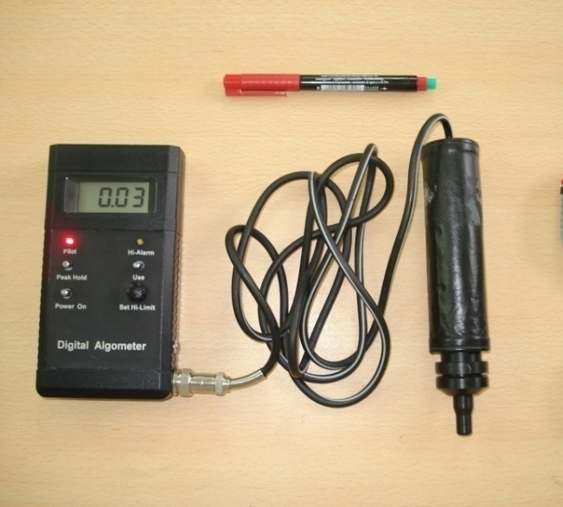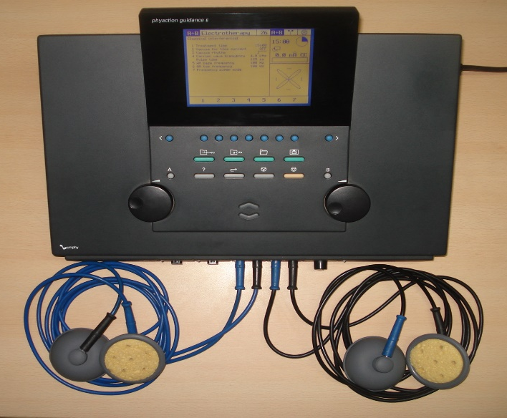
Picture 1: Pressure Algometer Picture 2: IFT with suction electrode
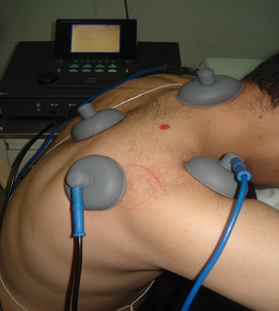
Picture 3: Measuring PPT Picture 4: IFT with suction electrodes
DATA ANALYSIS AND RESULTS:
The Statistical software namely SPSS 15.0, Stata 8.0, MedCalc 9.0.1 and Systat 11.0 were used for the analysis of the data and Microsoft word and Excel have been used to generate graphs, tables etc.

Table 1: Comparison of mean VAS within control and study groups
VAS | Control group  mean±SEM | Study group  mean±SEM
PRE | 4.68 ± 0.30  (2-7) | 5.00 ± 0.30  (3-8)
IMMEDIATE POST | 4.00 ± 0.33  (1-8) | 4.60 ± 0.33  (2-8)
24hours POST | 3.48 ±0.35  (1-8) | 3.32 ± 0.40  (0-8)
SIGNIFICANCE | F=170.71;p<0.001*** | F=175.761;p<0.001**
Bonferroni’s correction as post hoc test:
PRE TO IMMEDIATE POST | F=37.29;p<0.001*** | F=4.800;p<0.013**
IMMEDIATE TO 24 hours POST | F=13.255;p<0.001*** | F=26.540 ;p<0.001***
PRE TO 24 HOURS POST | F=39.273;p<0.001*** | F=45.231;p<0.001***
Percentage of change in VAS score
PRE TO IMMEDIATE POST | 14.53% | 8%
IMMEDIATE TO 24 HOURS POST | 13% | 27.83%
PRE TO 24 HOURS POST | 25.64% | 33.6%

The table 1 shows that there is a statistically significant difference between the VAS scores reported prior to and immediately after the treatment session (p<0.001***). Additionally, the VAS scores taken 24hrs after the treatment are shown to be significantly different from those recorded before and also immediately after the interferential therapy session.

VAS | Control(Mean ±SEM) | Study (Mean ±SEM) | Effect size | 95% CI |  | significance
 |  |  |  | low | high
Pre to immediate post | 1.84 ± 0.111 | 2.52± 0.182 | 0.55(M) | -0.77 | -0.59 | p=0.013**
Immediate post to 24 hours post | 0.78± 0.142 | 0.06 ± 0.248 | 0.62(M) | 0.61 | 0.83 | p =0.037
Table 2: Comparison of mean difference of VAS between control and study groups.

The table 2 shows that the mean difference in VAS from before to immediately after the therapy is of significant difference (p=0.013**) and from immediately after to 24 hours after the therapy the mean difference in the VAS score was p=0.037.

PPT | Control group  mean±SEM | Study group  mean±SEM
PRE | 3.65±0.56  (0.08-9.02) | 2.29±0.32  (0.15-4.94)
IMMEDIATE POST | 3.80±0.54  (0.05-9.05) | 2.45±0.31  (0.19-5.67)
24hours POST | 3.84±0.57  (0.06-10.01) | 3.91±0.46  (0.60-8.74)
SIGNIFICANCE | F=45.187;p<0.001*** | F=67.233;p<0.001***
Bonferroni’s correction as post hoc test:
PRE TO IMMEDIATE POST | F=5.828;p=0.008** | F=4.846; p=0.013**
IMMEDIATE TO 24 hours POST | F=0.470;p=0.170 | F=31.074;p<0.001***
PRE TO 24 HOURS POST | F=8.738;p=0.002*** | F=35.343;p<0.001***
Percentage change in PPT
PRE TO IMMEDIATE POST | 4.11% | 6.99%
IMMEDIATE TO 24 HOURS POST | 0.79% | 59.59%
PRE TO 24 HOURS POST | 4.93% | 70.74%
Table 3: Comparison of mean PPT within control and study groups

The table 3 shows that there is a significant increase in PPT within the control and the study group with a significance of p<0.001*** respectively. The control group shows a strong significance of p=0.008** from before to immediately after but from immediate after to 24 hours after the difference was not significant. The study group showed a significance of p=0.013 from prior to immediately after the intervention and from immediately after to 24 hours after there was a significance of p<0.001***. The overall change in PPT from pre to 24 hours post in the control group has a significance of 0.002** and in the study group there is a significance of p<0.001**

Table 4: Comparison of mean difference of PPT between control and study groups
PPT | Control  Mean ±SEM | Study  Mean ±SEM | Effect  size | 95% CI |  | significance
 |  |  |  | low | high
Pre to immediate post | 0.15±0.063 | 0.16 ±0.075 | 0.02(S) | -0.05 | 0.03 | t =0.146  p=0.885
Immediate post to 24 hours post | 0.04 ±0.056 | 1.40±0.261 | 1.44(VL) | -1.47 | -1.25 | t =5.307  p<0.001***

The table 4 shows that the mean difference from before to immediately after the therapy is not significantly different but between immediately after to 24 hours after the mean difference is statistically significant with p<0.001***.
Recurrence | control | study
Nil | 12(48%) | 18(72%)
Yes | 13(52%) | 7(28%)
Total | 25(100%) | 25(100%)
Inference | Recurrences are 0.35 times less likely in study group with p=0.083+
Table 5: Recurrence of increased pain in Patient Log

Time of recurrence | Control group  (N=25) | Study group  (N=25)
Up to 10 hrs | 11(44.0%) | 0
11-15 hrs | 2(8.0%) | 2 (8%)
16-20 hrs | 0 | 1 (4%)
>20 hrs | 0 | 4 (16%)
Table 6: Time taken for the recurrence of increased pain in Patient Log

The table 6 shows that maximum number of subjects in the control group had recurrence of pain within 10 hours and in the study group after 20 hours.

DISCUSSION

This study evaluated the Effect of IFT on pain level in people with trapezius myalgia before, immediately after and 24 hours after following a single treatment session.
Analysis of VAS and PPT within the study group showed a strong significant reduction in pain level immediately after intervention and persisted up to 24 hours after intervention
This could be because of the hypoalgesic effect of IFT mediated through pain gate mechanism by stimulation of Aß nerve fibres and the vasodilatation that occurs within the muscle which increases the micro circulation in the trapezius muscle (Dr Gareth Noble,2006; John H Brown,2005)
Analysis of VAS and PPT within control group showed a significant reduction in VAS and increase in PPT immediately after intervention which persisted upto 24 hours.
Suction electrodes were used to deliver IFT in both groups.These electrodes creates a negative suction pressure causing a mild massaging effect on the skin. It stimulates the cutaneous sensory nerves and causes vasodilatation, which in turn increases the microcirculation in the localized muscle. (Low J et al; Kitchen S electrotherapy, 2002)
Another reason could be the placebo component (Low J et al; Kitchen S electrotherapy,2002)
So the reduction of VAS and increase in PPT, could be because of the use of suction electrode and placebo component.
The hypoalgesic effect produced between the study and the control group found no significant difference in VAS immediate post and 24hour after intervention.
The difference in these could be because VAS is a subjective measurement.
By analysis of covariance, the immediate post is not statistically significant keeping baseline pressure threshold as covariate with F=0.215; P=0.645 & 24 hours post the pressure threshold in the study group is significantly higher when compared to the control group with F=25.766; P<0.001**.
This shows that immediately after the intervention both the groups had similar effects and 24 hours following intervention the study group had significantly increase in pressure threshold and relief of pain as compared to the control group.
The Immediate effect in the control group could be because of the suction provided by the suction electrodes and the study group it could be because of the suction or the effect of IFT or can be both.

After 24 hours in the study group the pressure threshold has increased when compared to control group(F=25.766; P<0.001**)
This could be that the suction pressure which had caused the vasodilatation effect had faded off and so the control group had decrease in threshold but in the study group the threshold has significantly increased which could be because of the effect of IFT that had persisted following 24 hours post intervention.
Analysis of the patient reported outcome proved that recurrence is 0.35 times less likely in the study group
The higher recurrence level in the control group could be because the physiological effect in the localized muscle caused by the suction pressure is not sufficient enough to cause vasodilatation to increase the microcirculation and stimulate the cutaneous nerves such that the hypoalgesic effect can remain up to 24 hours post intervention
It also revealed that 72% of the subjects in the study group and 45% in the control group had no recurrence of pain within 24 hours.
16% of the subjects in the study group had recurrence of pain after 20 hours, 4% within 16 -20 hours and 8% within 11-15 hours post intervention
44% of the subjects had recurrence of pain within 10 hours, 11% within 11-15 hours post intervention.

LIMITATION: The sample size was limited and subjects were not categorized based on severity of involvement of trapezius myalgia

FUTURE STUDIES: Studies can be conducted by comparing the long term effects of IFT with other electrotherapy modalities

CONCLUSION: It is thus concluded from present study that the effect of IFT on the pain level in people with trapezius myalgia lasts for more than 24 hours following a single session which supports my alternate hypothesis.

ABBREVIATIONS:
IFT – Interferential Therapy, PPT – Pain Pressure Threshold, VAS – Visual Analogue Scale, TENS- Transcutaneous electrical nerve stimulation, NSAID – Non Steroidal Anti Inflammatory Drugs

REFERENCES:
- Last editorial review: 9/05/2005, MedicineNet.co
- Bengtsson Rheumatology Unit,University Hospital,581 85 Linkoping Sweden Editorial The muscle in fibromyalgia,Rheumatology 2002;41:721-24
- Anderson HI, Eilertsson G, Leden I, Rosenberg C. Chronic pain in a Geographical defined general population:studies of differences in age, gender, social class and pain localization. Clin J Pain 1993;9:174-82.
- Larson, Britt. Morphological and electromyographical studies of trapezius Myalgia in cleaners. Faculty of medicine: department of laboratory medicine,Lund: occupational and environmental medicine, 2001.
- Leesa K Huguenin. Myofascial trigger points:the current evidence. Physical Therapy in sport,5, 2004; 2-12
- Kitchen S electrotherapy evidence based practice, 11th edition, London: Churchill livingstone; 2002.
- Low J, Reed A. Electrical stimulation of nerve and muscle. In: Low J, Reed A, Eds. Electrotherapy Explained: Principles and Practise 2nd ed. Oxford, United Kingdom; Butterworth-Heinemann Ltd 1994:39-116
- Noble JG et al, The effect of interferential therapy upon cutaneous blood flow in humans. Clinical Physiology 2000;20:2-7.
- John H Brown. Stimulation-produced analgesia: acupuncture, TENS and Alternative techniques. Anaesthesia and intensive care medicine 6:2. PAIN 2005 The Medicine Publishing company Ltd.
- Mantle J et al Physiotherapy for stress urinary incontinence: a national survey. BMJ.1991;302:753-755.
- Johnson MI et al. A questionnaire survey on the clinical use of interferential Currents(IFC) by physiotherapists. The Pain Society of Great Britain Annual Conference, abstracts, Leicester, United Kingdom; Pain society of Great Britain;1998.
- Chen S-H et al. Current management of myofascial pain syndrome. Clinical Journal of Pain 1996; 6:27-46
- Moore SR, Shurman J: Combined neuromuscular electrical stimulation and Transcutaneous electrical nerve stimulation for treatment of chronic back pain: a double-blind, repeated measures comparision. Archives of Physical Medicine and Rehabilitation 1997; 78:55-60
- Mark I Johnson et al. An investigation into the analgesic effect of interferential Currents and transcutaneous electrical nerve stimulation on experimentally Induced ischemic pain in otherwise pain free volunteers, Physical Therapy; 83:2003:208-223.
- S 11279 Stockholm, Kerstin Fredriksson, National Institute for Working Life & authors 2000. National institute for Working life. Sweden.Nr 2000:14 On causes of neck and shoulder pain in the general population. Epidemiological studies on associations between workload and leisure Time activities, and disorders in the neck/shoulder region
- Backman C, Boquist L, Friden J, Lorentzon R & Toolanen G. Chronic Achilles paratendonitis with tendinosis: an experimental model in the rabbit. Journal of Orthopedics Research, 1998; 8, 541-754.
- Melin B & Lundberg U.A biopsychosocial appraoch to work-stress and musculoskeletal disorders. Journal of Psychophysiology,1997 11, 238-247.
- Hägg G.Muscle fibre abnormalities in the upper trapezius muscle related to occupational static load- A review. In: Christensen H & Sjögaard G Eds. Muscular disorders in computer users: Mechanisms and models.2000; 138-139, Copenhagen.
- Ethne L Nussbaum et al. Reliability of clinical pressure pain algometric Measurement obtained on consecutive days. Physical Therapy, volume 78. February 1998.

