PHARMACEUTICAL PREPARATION AND DRUG DELIVERY

¹Abirami M, ²Rajesh Kumar N.

¹Assistant Professor, Department of Pharmaceutics, Tagore College of Pharmacy, Rathinamangalam, Chennai, Tamilnadu-600127, India.

²Associate Professor, Department of Pharmaceutics, Senghundhar College of Pharmacy, Tiruchengode, Namakkal, Tamilnadu-637205, India.

Correspondence:

Mrs. ABIRAMI M

Assistant Professor, Department of Pharmaceutics, Tagore College of Pharmacy,
Rathinamangalam, Chennai, Tamilnadu-600127, India. Contact number: +919715525408
E-mail: m.k.abirami21@gmail.com

PHARMACEUTICAL DOSAGE FORMS AND ITS DELIVERY INTRODUCTION
An agent that is used to diagnose, mitigate, treat, cure, or prevent disease in humans or other animals is known as a drug. Medicinal products intended for human or veterinary use, in their finished dosage form. Formulations designed for topical or local administration or for direct administration to the specific region to increase bioavailability and improve patient
compliance.
The formulations comprise microparticles or nanoparticles of drug molecules that may be formed from the drug alone or in combination with an excipient or polymeric carrier. The excipient or polymer may be used to affect the release rate and increase adhesion to the affected region. The particular formulation may be applied as a dried powder, liquid suspension or dispersion, topical ointment, cream, lotion, foam or suppository.

Principles for designing dosage form

Drugs are rarely administered as pure chemical substances, but almost always in the form of preparations or medicines. These can vary from relatively simple solutions to complex drug delivery systems through the use of appropriate additives or excipients in the formulations. The excipients perform diverse and specific pharmaceutical functions such as solubilizing, suspending, thickening, preserving, emulsifying, modifying dissolution, and improving compatibility and flavor to the dosage form. To maximize the therapeutic effect, dosage forms may be designed for administration through various routes.
The primary objective for designing various dosage forms is to achieve a predictable therapeutic response to a drug product contained in a formulation that can be manufactured on a large scale with reproducible product quality.

The following features are required to ensure the quality of the product:

- Physical and Chemical stability
- Uniformity of dose
- Suitable preservation against microbial contamination
- Accelerated stability studies
- Suitable packaging and labelling
- Acceptability to patients

In addition, dosage forms should be unaffected by variations between patients. However, it is still challenging to implement that feature in real life. Recent developments are beginning to take notice of this requirement, nevertheless. Among them are medication delivery methods that depend on the specific metabolic patterns of particular patients and implants that, for instance, trigger a drug delivery mechanism when subjected to sound or magnetic fields applied from the outside.

Since it is now known that formulation parameters can affect the therapeutic effectiveness of pharmaceutical products having an equivalent dose of a pharmacological substance, more focus has been placed in recent years on removing variance in bioavailability features.

Types of dosage forms

In general, medicines often come in various dosage forms:

Liquid

To facilitate administration or improve absorption, the liquid component of the medication is mixed with the active ingredient. A mixture, solution, or syrup are additional terms for liquids. Today, many common liquid dosage forms can be found without any coloring or sugar.

Tablet
All of the excipients are mixed with the active ingredient before being compacted into
a solid round or oval shape. Tablet dosage forms come in various types. In that, it is acceptable to dissolve dispersible tablets in water.

Capsules
Inside a gelatin shell that breaks down gradually in the GIT exists the medication's ingredient that works. Gelatin may be of hard gelatin or soft gelatin. Capsules need to be swallowed whole so that the drug in the capsule is not absorbed until gastric acid breaks down the gelatin shell.

Types of other dosage forms:

Topical dosage forms
The topical medicines are gel, lotion, creams and ointments, which are applied directly on the skin surface. They may be available in tubes or bottles depending on the type of dosage forms.

Suppositories
All additional ingredients are mixed with the drug's active component before being formed into a bullet shape, in order to fit into the bottom ie., through the rectal or vagina. Suppositories shouldn't be swallowed.

Drops

These can be used during situations where the treatment needs to contact the affected area directly in order to be effective. They tend to treat the nose, ears, or eyes.

Inhalers
The active ingredient of the medication is forced directly into the lungs. To take the medication properly in young children, a spacer device could be required because it might be challenging to use.

Injections
With respect to where and how they are injected, there are different kinds of injection. Subcutaneous injections are administered just below the skin's surface. the drugs that are Injected into a muscle are intramuscular injections. Injections are administered intrathecally into the spinal fluid. Injections into a vein are administered intravenously.

Patches or implants
The drugs, such as nicotine patches help people to quit smoking and are absorbed via the skin. Contraceptive implants are also available.

Buccal or sublingual tablets
These tablets resemble regular tablets. However, they are not swallowed. Buccal medications are retained in the cheek to allow the active ingredients to be absorbed by the mouth lining. Sublingual tablets function similarly to oral pills but are stored beneath the tongue. Buccal and sublingual pills are meant to be used in very specific conditions.
Drug delivery refers to the approaches, formulations, production techniques, storage systems, and technologies used to transfer a pharmaceutical molecule to its targeted therapeutic site.

The following are some drug administration systems:
- Parenteral drug administration
- Pulmonary drug administration
- Nasal drug administration
- Topical and transdermal drug administration
- Ocular drug administration
- Rectal and vaginal drug administration
- Modified release oral drug administration
- Novel drug administration
- Systems with magnetic modulation.

PARENTERAL DRUG DELIVERY
According to the USP Parenteral drug delivery systems are defined as "formulations intended for parenteral administration via a primary layer of the body, such as primary protective skin or additional external boundary tissue, other than the gastrointestinal tract (GIT)."

MICROBUBBLES AS TARGETED DRUG DELIVERY
The most recent revolutionary methods for non-invasive therapeutic agent delivery are effective for molecular biology and gene therapy. In addition to their well-known usage in ultrasound diagnostic contrast agents, microbubbles have been found to be a successful method for the targeted delivery of medications and genes. Microbubbles have a diameter that is greater than a micrometer but less than one-tenth of a millimeter, which is the size of a red blood cell. It can fit via the body's capillaries and micro-vessels because of its tiny size. The microbubbles are unstable and exhibit a surface tension effect in an aqueous environment. Lipids, proteins, and polymers help to stabilize the gas core of microbubbles.
Microbubbles are made up of a total particle volume that functions as a single chamber. By using different shell materials, such as lipid with a thickness of less than 3 nm, protein with a thickness of 15-20 nm, and polymer with a thickness of 100-200 nm, the shell of the microbubbles is able to separate the encapsulated gas from the surrounding aqueous medium. Lipid molecules are bound together by hydrophobic and Vander Waals interactions and protein molecules are cross-linked by covalent disulfide bonding to produce bulk-like material. Microbubbles are tiny gas bubbles in water that have a diameter of less than 50µ. It floats in the water for a considerable amount of time and is largely made of oxygen or air. Microbubbles lose their bubbles when the gas inside them dissolves in the water.
The drug is incorporated into a microbubble by
- binding the drug to the microbubble shell and
- attaching the drug to the specific spot of the ligand.
High-intensity ultrasound can rupture capillary blood vessels, resulting in the deposit of protein and genetic material into the tissue, and ultrasonic rupture of microvessels with a diameter of 7µm in ultrasound-mediated microbubbles. Ultrasound creates pores in the shell's membrane. A temporary break in the cell membrane caused by an ultrasound microbubble results in the fast translocation of plasmid DNA from the outside to the cytoplasm. The use of a low-intensity ultrasonic microbubble (0.6 W/cm²) resulted in improved medication delivery.
Microbubbles are often given intravenously, which is a safer technique than using typical techniques such as magnetic resonance imaging and radiography. Microbubbles are employed in the medical field as diagnostic aids to scan the various organs of the body and they are currently being proposed to be utilized as a gene carrier, as well as for cancer treatments.

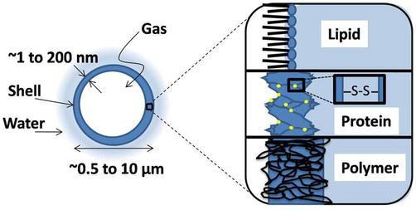

Fig 1. Various shell compositions of microbubbles
A diameter of 0.5-10µm is used in biomedical applications so that it can pass through the capillary of the lung.

Microbubble's Composition and Physicochemical Properties

Protein acts as a stabilizer in the development of microbubbles
Microbubbles are coated with albumin and other proteins. Amphipathic proteins are very surface-active in nature. The disulfide bridge between two thiol groups is present in the majority of proteins.

Surfactant acts as a stabilizer in the development of microbubbles
In the preparation of microbubbles, SPAN-40 and TWEEN-40 have been used as stabilizing agents. The SPAN/TWEEN solution was sonicated in the presence of air to produce stable microbubbles.

Lipid acts as a stabilizer in the development of microbubbles
During ultrasound and sonication procedures, lipid molecules bound together by weak physical forces form a microbubble shell with expansion and compression properties but no chain entanglement. As a result, lipid-coated microbubbles reduce the effect of resonance and reseal around the gas core during the fragmentation process.

Polymer as a stabilizing factor in microbubble production
The term "polymer microbubble" usually refers to a type of microbubble that is stabilized by a thick shell made up of cross-linked or entangled polymeric species. Polymer shells are hardly susceptible to expansion and compression. Polymer microbubbles released a gas core during insonification, which was unstable and quickly disintegrated.

Types of Microbubbles
- Perfluorocarbon-filled microbubble: This is stable and may be utilized as a carrier in the vascular system as a blood pool.

- Ultrasound microbubble: When applied to the skin, it ruptures for delivering the medication. It also has a higher therapeutic index. It is advantageous for medications with dangerous and harmful side effects.
- Albumin-encapsulated microbubble: This type of microbubble adheres to vessel walls.
- Phospholipid-coated microbubble: This type of microbubble has a strong affinity for chemotherapy drugs.
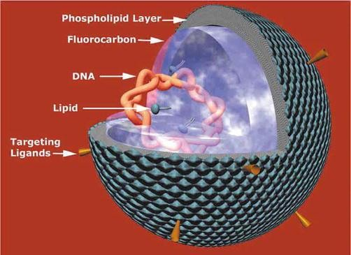

Fig. 2. Perfluorocarbon filled microbubbles
Amphipathic lipids stabilize the outer surface. Targeting ligands have been integrated into the lipid head groups. The cationic lipid stabilizes the genetic material. According to electron microscopy investigations, the DNA is condensed into electron-dense granules within the nanoparticle's center. These particles have a diameter of 100-200 nm. Lipid shells have various advantages. When the air space is minimized, the hydrophobic acyl chain of the phospholipids encounters the phospholipids gas, while the hydrophilic head groups face the water. As a result, the monolayer will form around a freshly trained gas bubble. Below the phase transition temperature, saturated diacyl phospholipids exhibit relatively low surface tension. This is significant because surface tension at the curved interface causes place overpressure, forcing the gas core to dissolve. The lipid monolayer allows the microbubbles to stabilize at low tension. Because of the attractive hydrophobic interaction between the tightly packed acyl chains and Vander Waals, lipid monolayers are very cohesive and have a solid- like quality. These effects may be effective because, unlike proteins, the stability of microbubbles during sonication is not dependent on the production of superoxide to permit disulfide bridging. As a result, as recent advances have demonstrated, lipids are suited for a number of production processes other than sonication.
In the absence of ultrasound, plasmid transgene expression could be directed to the heart with greater precision than viral vectors, and this expression could be modulated through repeated treatments if the adenovirus was supplied with microbubbles using the same model. Even in the absence of ultrasound, albumin-coated microbubbles greatly increased transgene expression in mice skeletal muscle.

TRANSDERMAL DRUG DELIVERY SYSTEM
Transdermal drug delivery systems (TDDS) allow therapeutic amounts of pharmacological substances to pass through the skin and into the general circulation for systemic effects. Measurable blood levels of the drug, identifiable excretion of the drug, its metabolites in the urine, and clinical response of the patients to the therapy can all be used to demonstrate percutaneous drug absorption. The blood concentration needed to determine therapeutic efficacy with transdermal drug delivery can be assessed by comparing the patient's response to medication blood levels. It is suitable for transdermal drug delivery for the drug to move through the skin to the underlying blood supply without building up in the dermal layers.

Structure of skin
Anatomically, human skin comprises of three layers:
  - The epidermis
  - The dermis
  - The subcutaneous fat layer.
Human skin has numerous hair follicles, sweat glands, and sebaceous glands.
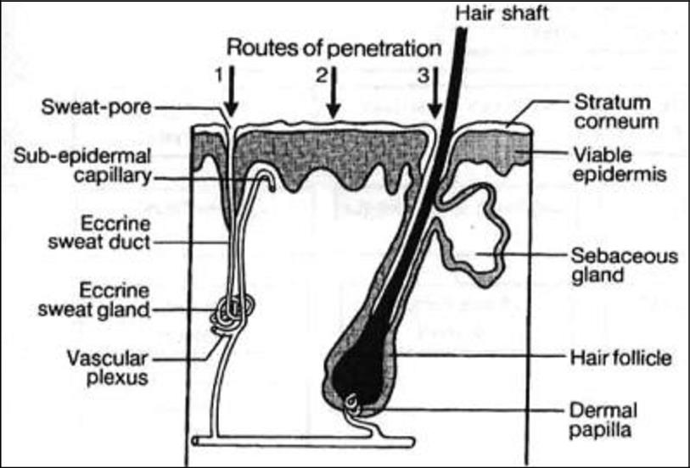

Fig. 3. Structure of skin
The epidermis, the skin's outermost layer, is made up of stratified squamous epithelial cells. Keratinized, flattened remnants of these constantly dividing epidermal cells aggregate at the skin surface as a stratum corneum or horny layer (approximately 10-20µm thick). The horny layer is lamellar in structure, with keratinized cells overlaying one another, joined by intercellular bridges, and compacted into around 15 layers. The stratum corneum lipid-rich intercellular space is made up of lamellar matrices with alternating hydrophilic layers and lipophilic bilayers generated during the keratinization process. The stratum corneum is a robust but flexible cohesive membrane that is significantly more hygroscopic than other keratinous

materials such as hair or nails. The stratum corneum is a physical and chemical barrier that is very slightly permeable to water. It slows water loss from underlying tissues and reduces UV radiation penetration.
The dermis is a gel like structure composed of a fibrous protein matrix immersed in an amorphous, colloidal ground substance. The dermis contains blood arteries, lymphatics, and nerves. The dermis provides support to and interacts with the epidermis, allowing it to conform to underlying muscles and bones.
The dermis and epidermis are supported by the subcutaneous fat layer. Collagenous fibers from the dermis thread between fat cell accumulations, connecting the superficial skin layers to the subcutaneous layer.

Drugs released from the dosage form to the targeted site

Release of drug molecule
Drugs are administered to the skin in liquid and semisolid forms to treat local diseases. The polarity of these products varies, and they include ointments, liquid and semisolid emulsions (creams), gels, and pastes. Except for paste, all other dosage forms contain a dissolved medicine that diffuses into the top layer of the skin from the dosage form. Pastes contain significant amounts of undissolved active substance, which is designed to protect the skin's surface and is thus not released from the dose form.

Absorption
Most of the absorption of drugs takes place through the stratum corneum 0.1µm broad intercellular (paracellular) areas. While the stratum corneum cells have a larger surface area than the intercellular space, they are too densely packed with protein to provide a good medium for drug transport. By expanding the keratinocytes of the membrane and loosening the lipid lamellae between the cells, hydration of the stratum corneum considerably enhances medication absorption. Hair follicles, sebaceous glands, and eccrine glands stretch from the skin's surface to the subcutaneous tissue as skin appendages. The skin appendages comprise approximately 1% of the total skin surface, and their significance in drug transport is undetermined, but it appears likely that these structures contribute despite their tiny surface area due to their thinner stratum corneum layer. Their function may be limited to transporting ions, high molecular weight drugs, and hydrophilic drugs. It is expected that most drugs administered topically absorb between 0% and 15% systemically.

Distribution
Drugs with viable epidermis or dermis targets diffuse through the stratum corneum and partition into the viable epidermis. Drugs generally travel through the viable epidermis via passive diffusion. Organic transporting polypeptide carriers and p-glycoprotein have been discovered in normal human keratinocytes. None of the transporters have been thoroughly described. Evidence suggests that p-glycoprotein possesses influx transporter activity in the skin, which is surprising considering the skin's barrier role. The dermis is made up of structural proteins like collagen and elastin that are floating in a watery gel of complex polysaccharides.

There are also scattered cells inside the dermal layer, such as fibroblasts, which make collagen and elastin, macrophages, and mast cells, which cause allergic and inflammatory reactions in sensory neurons.

The Layer of the skin and drugs
  - Stratum corneum - protectants, emollients, keratolytics, sunscreens
  - Viable epidermis - Antibiotics, antifungals, antivirals, keratoplasty, depigmenting and pigmenting agents, retinoids, immunosuppressants
  - Dermis - Corticosteroids, antihistamines, local anesthetics, Immunosuppressants, drugs applied for systemic action
  - Skin appendages - Antibiotics, antifungals, anti-proliferative agents, antiperspirants

SELECTION OF DRUG MOLECULE
The following stages must occur for a medicine administered to the skin to produce a response at a target in the dermis. The drug must be dissolved in the vehicle and then diffused through the skin, partitioning into the stratum corneum, diffusing through the stratum corneum, partitioning into the viable epidermis, diffusing through the viable epidermis, partitioning into the dermis, diffusing through the dermis.

TECHNIQUES INVOLVED IN TDDS
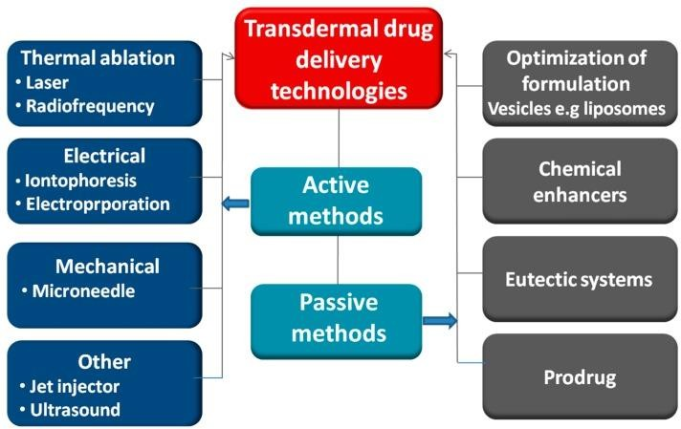

NASAL DRUG DELIVERY
The nasal route is non-invasive, frequently utilized for local treatment, and can also be used for systemic therapy because the drug enters the systemic circulation directly. When compared to large molecules, the nasal route provides good absorption of tiny compounds, which can be enhanced with absorption promoters. Nasal administration of drugs has been employed as an alternate route for the systemic availability of pharmaceuticals that are normally administered intravenously. This is owing to the vast surface area, permeable endothelium membrane, high total blood flow, lack of first-pass metabolism, and ease of access. The nasal route is an alternative to parenteral therapy and can potentially be used for long-term treatment.
Proteins and peptides are excellent choices for intranasal administration of drugs since they are active at low dosages and have no minimal oral bioavailability. Nasal medication delivery techniques include nasal spray, nasal pumps, gels, microemulsions, suspensions, powders, and thermos-reversible mucoadhesive gels.
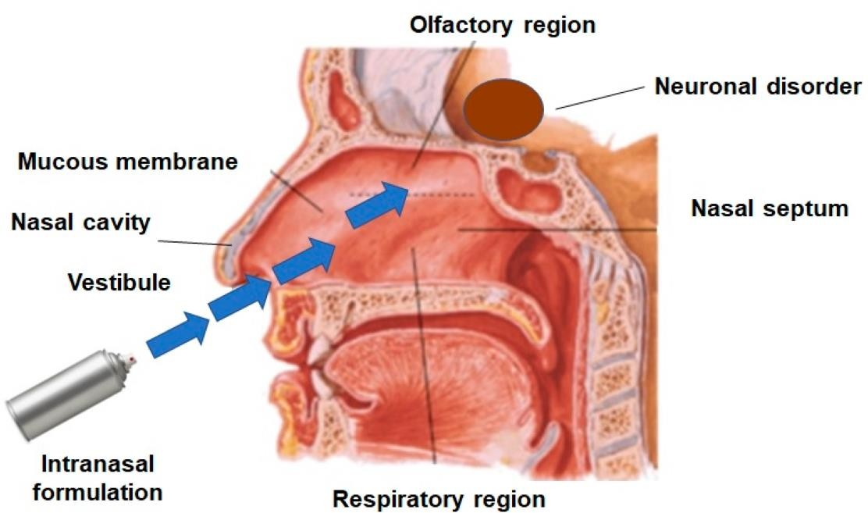

Fig.4. Structure of nose Influencing Factors in Nasal Drug Absorption
Several factors influence the systemic bioavailability of medicines delivered via the nasal route. The parameters can have an impact on the physiochemical properties of the medications, the anatomical and physiological qualities of the nasal cavity, as well as the nature and characteristics of the selected nasal drug delivery system. The following are the factors that influence nasal medication absorption.

Physiochemical properties of the drug
Molecular size
Lipophilic-hydrophilic balance Enzymatic degradation in the nasal cavity

- Nasal Effect Membrane permeability Environmental pH Mucociliary clearance Cold, rhinitis

Delivery Effect
Formulation (Concentration, pH, osmolarity) Delivery effects
Drug distribution and deposition Viscosity²⁹

The mechanism involved in Nasal Absorption
The first step in absorption involves drugs absorbed from the nasal cavity to pass through the mucus layer. Mucin is the main protein in mucus; it has a tendency to attach to solutes, preventing diffusion. Furthermore, environmental changes (such as pH and temperature) can cause structural changes in the mucus layer. Many absorption methods have been identified previously, but only two have been widely used, such as:
- The first mechanism involves an aqueous transport route, also known as the paracellular route, but it is slow and inactive. Intranasal absorption and the molecular weight of water-soluble substances have an inverse log-log connection. Drugs with molecular weights larger than 1000 Daltons have low bioavailability.
- The second method, commonly known as the transcellular process, involves transport through a lipoidal channel. It is in charge of transporting lipophilic drugs that have a high dependency rate due to their lipophilicity. Drugs can also cross cell membranes by active transport via carrier-mediated processes or via tight junction opening.
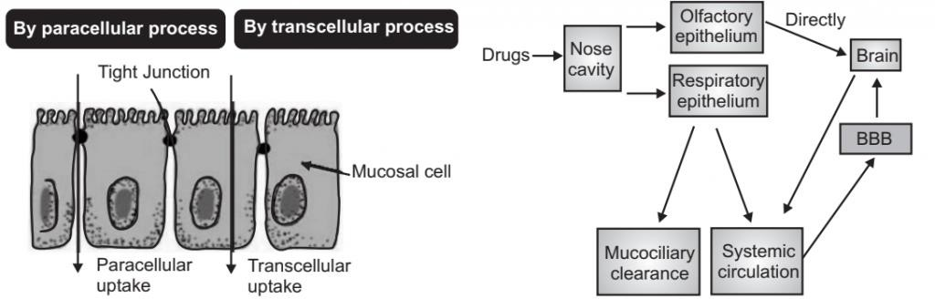

Fig.5. Mechanism of nasal absorption Formulation (Concentration, pH, Osmolarity)
The pH of the formulation and the nasal surface can both influence medication penetration. Because lysozyme can be found in nasal secretions and is responsible for eliminating some bacteria at acidic pH, the pH of the nasal formulation should be adjusted to 4.5-6.5 to avoid nose irritation. Lysozyme is inactivated in alkaline conditions, making the tissue susceptible to

microbial infection. In addition to minimizing difficulty, it results in efficient drug permeability and the prevention of bacterial growth.
Because of nasal mucosal damage, the concentration gradient plays an important part in drug absorption/permeation via the nasal membrane. In nasal perfusion examinations, nasal absorption of L-Tyrosine was demonstrated to increase with drug concentration. Another finding is that salicylic acid absorption decreases with concentration. This reduction is most likely related to persistent nasal mucosa damage.
The osmolarity of the dosage form influences nasal absorption; this was examined in rats using a model drug. The formulation's sodium chloride content influences nasal absorption. The highest absorption was attained with a concentration of 0.462 M sodium chloride; greater concentrations not only increase bioavailability but also cause damage to the nasal epithelium.

Methods for Improving Nasal Absorption
Various options for improving medication bioavailability in the nasal mucosa include:
  - Improving nasal residence duration
  - Increasing nasal absorption
  - Modifying drug structure to change physicochemical qualities.

Inhibitors of nasal enzymes
Drug metabolism in the nose can be avoided by employing enzyme inhibitors. Enzyme inhibitors such as peptidases and proteases are commonly used in the creation of proteins and peptide molecules.³² Absorption enhancers such as salts and fusidic acid derivatives also block enzymes, increasing the absorption of drugs and bioavailability.

Permeation enhancers
Permeation enhancers are primarily used to improve the absorption of active drugs. In general, absorption enhancers work by one of the following mechanisms:
  - Reduce mucus viscosity or elasticity;
  - Inhibit enzyme activity;
  - Reduce mucociliary clearance;
  - Release tight joints;
  - Solubilize or stabilize the medication.

Nasal Drug Delivery System Dosage Forms
- Liquid Nasal Formulations
  - Instillation and shingle catheter
  - Compressed air nebulizers
  - Squeezed bottle
  - Metered-dose pump spray

Powder Dosage Forms
  - Insufflators

  - Dry powder inhaler:
  - Pressurized metered dose inhalers
  - Nasal Gels

OCULAR DRUG DELIVERY SYSTEM
It is the administration of medications to the eyes. Ophthalmic preparations are those that are used to treat illnesses of the eyes. Ophthalmic preparations, such as solutions, suspensions, and ointments, can be administered topically to the cornea or infused in the area between the eyeball and lower eyelid (the cul-de-sac or lower lid conjunctival sac).
When drops of an aqueous solution are applied to the cornea, through which the drug must pass to reach the interior of the eye, the solution is immediately diluted with tears and washes away quickly through the lachrymal apparatus.
As a result, eye drops do not stay in touch with the eye for long and must be supplied at regular intervals. Suspensions have the advantage of prolonged contact time in the eye, but they also have the disadvantage of irritability due to the particle size of the suspended medicine.

ANATOMY OF EYE
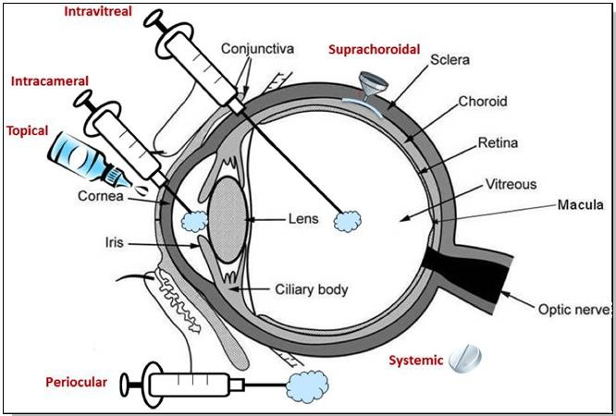
Fig.6. Anatomy of eye and drug administration
Ocular medications can be administered through a variety of administration locations within the eyes. The anterior part of the eye can be delivered via topical and subconjunctival methods, or it can be injected intracamerally. Posterior segment delivery can be accomplished topically, systemically, and periocularly (i.e., through the subtenon), as well as intraocularly (i.e., intravitreal). The success of therapeutic drug distribution is determined by the delivery site, the tissue barrier, and the type of pharmacological agent used.

OCULAR DOSAGE FORMS:
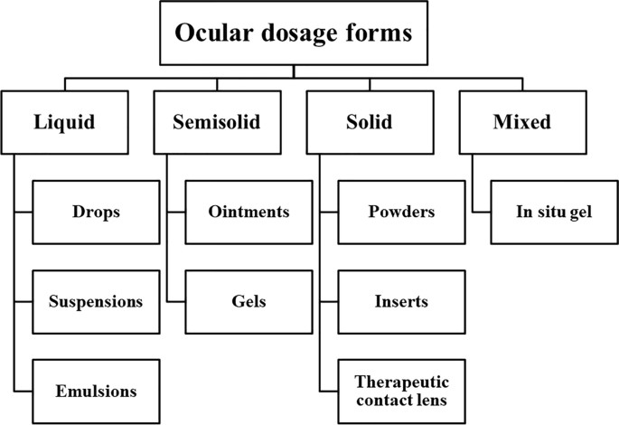
Nano micelles, microneedles, nanosuspensions, liposomes, microcatheters, intravitreal implants, solid corticosteroid implants, and encapsulated hydrogel delivery systems are some more novel ocular drug delivery methods.

Physiological ocular barriers
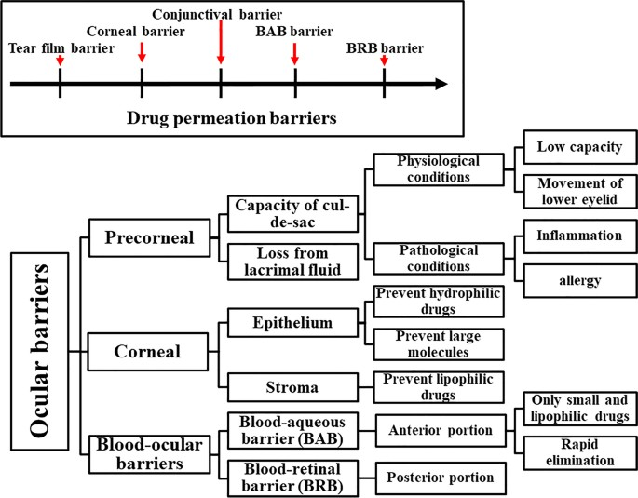
Routes for ocular drug delivery:
Topical administration is the most frequent method for ocular medication delivery, which comprises more than 95% of marketed ocular drugs. It is the non-invasive route, however, due to limited corneal penetration and a short residence duration, it has a low

bioavailability (<5%). Furthermore, tear drainage, blinking, and entering the systemic circulation via the nasolacrimal pathway limit bioavailability.

Intracameral Injections
Antibiotics are administered directly into the anterior region of the eyeball or the vitreous cavity during intracameral injections. The use of intracameral injection for the treatment of glaucoma with hydrogel functionalized with vinyl sulfone and thiol groups was recently published.

Intravitreal injections/Implants
Intravitreal injection is a method of delivering medicine into the vitreous, which is located near the retina at the back of the eye. A new technique for the treatment of glaucoma includes a single intravitreal injection of vitamin E/poly-lactic-co-glycolic acid microspheres containing glial cell line-derived neurotrophic factor, which has a 6-month release. After intravitreal injection of polymer-free dexamethasone dimer implants, similar effects were found. Intravitreal injection of a bio-degradable Rho kinase and protein kinase inhibitor for diabetic macular edema and neovascular age-related macular degeneration resulted in a 6- month release.

Juxtascleral injections
Juxtascleral injections are used to treat some posterior-part symptoms that cannot be treated with topical medications. It is used to treat cystoid macula edema, trauma, and diabetes complications. Juxtascleral injections of anecortave cortisone exhibited extended release in the choroid and retina for 6 months in a new approach to AMD treatment. Adeno-associated virus- carrying trans-scleral microneedles for retinal gene therapy have been developed.

Retrobulbar Injection
A needle is inserted through the eyelid and orbital fascia to deliver medication behind the globe into the retrobulbar space through the retrobulbar route. Amphotericin B retrobulbar injection outperformed intravenous injection in terms of antifungal effectiveness. A retrobulbar injection of chlorpromazine is used to treat uncomfortable blind eyes. To treat macular edema caused by retinal vein occlusion, a retrobulbar injection of triamcinolone is used.

Sub-conjunctival injection
In cases of very low drug penetration into the anterior region of the eye after topical delivery, sub-conjunctival infection is routinely employed. Sub-conjunctival infection of human mesenchymal stromal cells in mice with graft versus host disease resulted in a significant reduction in corneal inflammation and squamous metaplasia.

Irrigating solution
They are aseptically prepared solutions that do not contain preservatives. Surgeons use them as balanced salt to eliminate blood and cellular waste while maintaining the proper hydration volume of the eyes. For example, using ketorolac (0.3%w/v) and phenylephrine (1%w/v) in irrigation solutions can reduce cataract surgery duration and reduce pupil meiosis.

Iontophoresis
Iontophoresis is a method of delivering drugs into the posterior portion of the eye. The technique makes use of a voltage gradient. The incorporation of micro-needle-based devices in novel systems increased the amount of formula delivered to the back of the eye when compared to suprachoroidal injection. The combination of iontophoretic administration and contact lens results in a duration that is 550-1300 times shorter than drug uptake into choroidal capillaries. Acyclovir prodrug permeability and bioavailability were increased by short-duration iontophoresis. Dexamethasone phosphate ocular iontophoresis was found to be more effective in treating non-infectious anterior uveitis.

Characterization of Nanocarriers
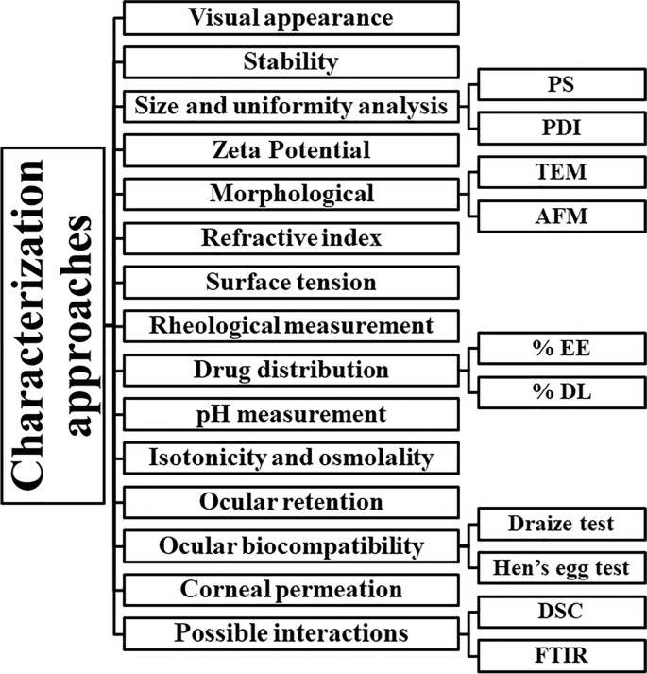

VAGINAL ADMINISTRATION, INTRAUTERINE AND RECTAL METHODS OF DRUG DELIVERY SYSTEMS
Many therapies depend on the rectal route to achieve either local or systemic effects.

Local action:
For the relief of localized discomfort and itching. Mostly because of the presence of hemorrhoids. Astringents, antiseptics, local anesthetics, vasoconstrictors, anti-inflammatory compounds, soothing and protecting agents, and some laxatives are all examples of locally active medications.

Systemic action
Despite the limits noted above, all medications that are orally administered can be supplied through the route, and many are. Rectal administration is used for antiasthmatic, anti- inflammatory, and analgesic drugs. Rectal preparations can also be used to make diagnostics.
Passive diffusion is the primary mode of absorption of drugs from the rectum. Because of inter-individual differences and rectum venous drainage. The bioavailability of medicines after rectal delivery is highly variable. Because of the tiny surface area of oral absorption, the rate and extent of drug absorption are often decreased.

Advantages and limitations of rectal administration Advantages
  - Safe and painless means of administration and removal of the dosage form are usually possible
  - Drugs liable to degradation in the gastrointestinal tract can be administered
  - Hepatic first-pass elimination of high-clearance drug is partially avoided
  - Small and large doses can be administered
  - The duration of drug action can be controlled by using a suitable formulation
  - Drugs can be administered rectally in long-term care of elderly and terminally ill patients
  - It is a useful way to administer medication to children unwilling or unable to tolerate the drug orally.
  - Administration of rectal suppositories, tablets, or capsules is a simple procedure that can be undertaken by the patient and/or unskilled health care personnel.
  - It is useful for patients who are nauseous or vomiting

Limitations
  - The patient's acceptability and compliance is poor. Especially for long–term therapy
  - Upward movement of the dosage form from the local site can increase first-pass metabolism
  - Suppositories can leak
  - Insertion of suppositories may be problematic

  - Generally, drug absorption from suppositories is slow compared to oral or intravenous administration

Vaginal delivery system
It is used for estrogen replacement therapy, which carries the risk of endometrial cancer when used alone. This danger is traditionally mitigated by progesterone medication for 14 to 30 days, although it is associated with low oral bioavailability, lack of effectiveness, and high levels of metabolites. As a result, progesterone tablets, suppositories, and gel for vaginal administration have been developed. Vaginal delivery results in higher and sustained plasma levels, as well as a lower number of metabolites. Various vaginal estrogen and progesterone formulations are now available for use as contraception, hormone replacement therapy, and the in-vivo fertilization process.
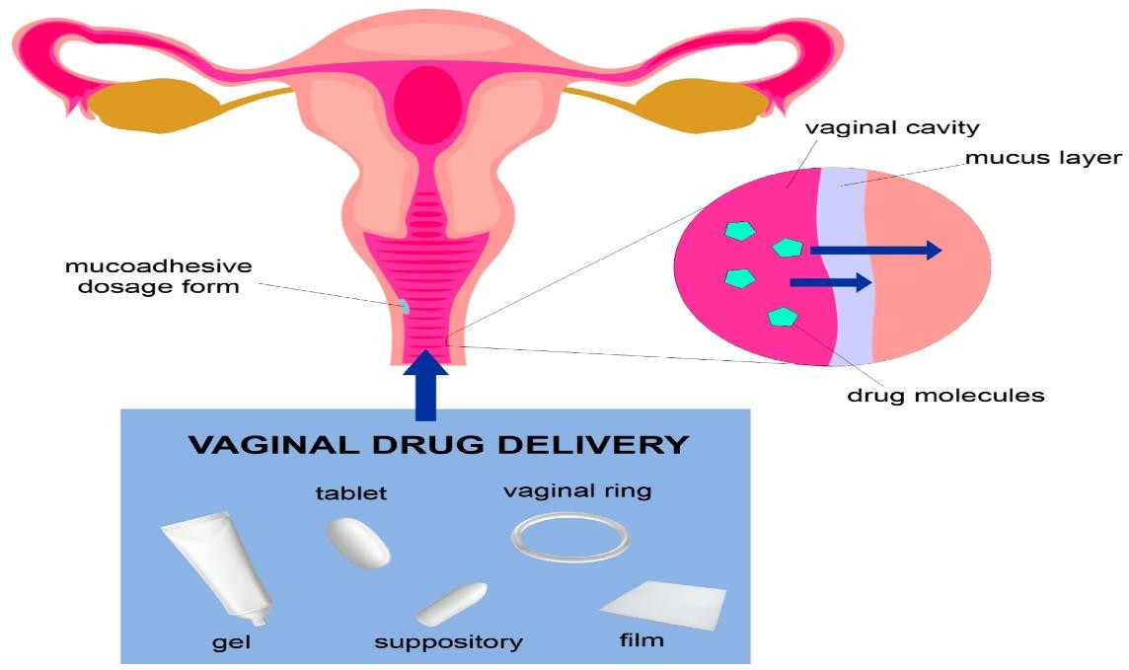

Fig.7. Drug delivery through vaginal cavity Physiological factors affecting absorption from the rectum
  - Quantity of fluid available
  - Properties of rectal mucus
  - Contents of the rectum
  - Motility of the rectal wall Rectal and vaginal preparations Rectal capsules
Rectal capsules (shell suppositories) are solid, single-dose preparations that resemble capsules in many ways. They feature an oval elongated shape with a smooth exterior that can be lubricated. Systemic capsules are often filled with a solution or suspension of the drugs in vegetable oil or liquid paraffin. There is minimal experience with this dose form, however there seems to be no significant variations in bioavailability between rectal capsules and fatty suppositories.

Rectal tablets
Due to the limited amount of water in the rectum, tablets are not excellent dosage forms since they cannot dissolve quickly. Rectal pills that release CO2 after insertion can be used to induce defecation.

Suppositories
As previously stated, suppositories are solid dosage forms that are designed to be inserted into bodily orifices where they melt, soften, or dissolve in order to deliver localized or systemic drug administration.

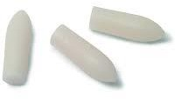

Fig.8. Suppositories
The suppository base melts, softens, or dissolves after being placed, delivering the drugs within it to the tissues of the region. Suppositories are ideal because of their safety, adaptability for long-term systemic and local medication delivery, and ease of administration. Progesterone and estrogen vaginal suppositories are commercially available.

Vaginal rings
As steroidal contraceptives, vaginal rings containing different progesterone and estrogens are available. A drug reservoir is enclosed by a polymeric membrane in these rings. These are adaptable drug delivery devices that can be put into the vagina where the medicine is gently released and absorbed into the bloodstream. The most frequent is a silastic toroidal- shaped ring about 21/4'' in diameter and the size of a diaphragm, designed for insertion into the vagina and placement around the cervix for around 21 days.

Fig.9. Vaginal ring
The device releases levonorgestrel (progesterone alone) at a concentration of 20µg/day in an almost zero-order release. These rings are simple to use and have the benefits of reversibility, self-insertion and removal, continuous drug administration at an effective dose

level, and improved patient compliance. This device, however, was linked to irregular bleeding. Another vaginal silastic silicone ring (Estring) was introduced in the United States in 1997 to treat postmenopausal women with urogenital aging symptoms. The ring produces a consistent release of estradiol (6.5-9.5 g/day) over a 3-month period and outperforms estradiol-containing pessaries and lotions.

Vaginal inserts
Prostaglandins are delivered by means of vaginal implants. Prostaglandin E2 (PGE2) is a hormone that is used to prepare the cervix for induction of labor and second-trimester abortion. Prostaglandins have advantages such as a faster commencement of labor, a lower demand for oxytocin, and a shorter time for vaginal and cesarean delivery. These implants are made of polymeric hydrogel material, which absorbs fluid and swells without losing its physical form. Incorporated medicine is released in a regulated manner as it grows. A Dacron polyester net with a long ribbon end surrounds the insert as part of the retrieval mechanism. Another example is the Hycore-V, a hydrogel pessary designed to administer medication locally through the vagina, and the Hycore-R, a device used to administer medication continuously through the rectal cavity. When compared to oral administration, misoprostol (a prostaglandin E1 analog used to end second-trimester pregnancies) had three times better bioavailability when administered vaginally at a dose of 100 to 200 g every 12 hours.

INTRAUTERINE DEVICE
A standard intrauterine device (IUD) is designed like a T and carries a drug, typically progesterone, in its vertical arm. It is a small plastic device that is inserted into the uterine cavity for prolonged intrauterine drug delivery and is typically used for contraception. Sperm cannot penetrate the thickened cervical mucus as a result of the progesterone release. Additionally, the uterine lining is altered, making it impossible for a fertilized egg to implant. The cervix is used to insert the IUD, which is then placed within the uterus. The IUD is frequently checked using a thin string that hangs down into the top section of the vagina. An embedded IUD may be indicated by a string that is shorter than usual.
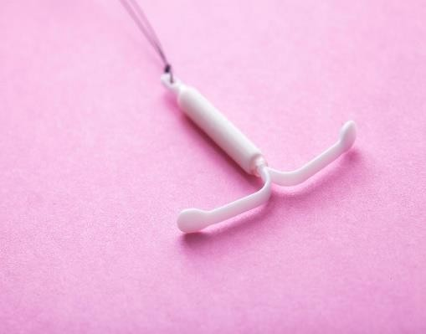

Fig.10. Intrauterine device

Quality control of vaginal and rectal dosage forms
A variety of in-vitro and in-vivo tests are used to evaluate the quality, safety, and effectiveness of rectal and vaginal dosage forms. Organoleptic evaluation (color, odor, shape, and surface), release properties, melting and solubility, stability, pH, viscosity, spreading, bio- adhesion, and mechanical strength are a few of these. Some of these are carried out during the development stage, while others are pharmacopoeial requirements.

The following properties should be controlled
  - Appearance
  - Weight
  - Disintegration
  - Melting (dissolution) behaviour
  - Mechanical strength
  - Content of active ingredient
  - Drug release

REFERENCE

- Ansel Pharmaceutical dosage forms & drug delivery systems 10th edition. Page no.2.
- Aulton’s pharmaceutics - The design and manufacture of medicines. Page no.7.
- Compiled by: the pharmacy department in collaboration with the child and Family information group last review date: April 2019 Ref: 2019F0731.
- Drug Delivery Systems. www.reference.md. Retrieved 2021-04-20.
- Rayaprolu, Bindhu Madhavi; Strawser, Jonathan J.; Anyarambhatla, Gopal (2018-10- 03). "Excipients in parenteral formulations: selection considerations and effective utilization with small molecules and biologics". Drug Development and Industrial Pharmacy. 44 (10):1565-1571. ISSN 03639045. PMID 29863908. S2CID 46934375.
- Vasant V Rannade & Mannfred.A Hollinger - drug delivery systems 2nd edition.
- Using Microbubbles as Targeted Drug Delivery to Improve AIDS by Harsha Virsingh Sonaye, Rafik Yakub Shaikh and Chandrashekhar A. Doifode Submitted: October 7th, 2018 Published: June 25th, 2019 DOI: 10.5772/intechopen.87157
- Lindner JR, Song J, Jayaweera AR, Sklenar J, Kaul S. Microvascular rheology of Definity microbubbles after intra-arterial and intravenous administration. Journal of the American Society of Echocardiography. 2002;15:396-403 [PubMed: 12019422]
- Epstein PS, Plesset MS. On the Stability of Gas Bubbles in Liquid-Gas Solutions. The Journal of Chemical Physics. 1950;18:1505-1509
- Chomas JE, Dayton P, May D, Ferrara K. Threshold of fragmentation for ultrasonic contrast agents. Journal of Biomedical Optics. 2001;6:141-150 [PubMed: 11375723]
- Singhal S, Moser CC, Wheatley MA. Surfactant-stabilized microbubbles as ultrasound contrast agents: Stability study of Span 60 and Tween 80 mixtures using a Langmuir trough. Langmuir. 1993;9(9):2426-2429
- Wang WH, Moser CC, Wheatley MA. Synthesis, Characterization and Application of Microbubbles: A Review. Journal of Physical Chemistry. 1996;100:13815-13821
- Dayton PA, Morgan KE, Klibanov AL, Brandenburger GH, Ferrara KW. Optical and acoustical observations of the effects of ultrasound on contrast agents. IEEE Transactions On Ultrasonics, Ferroelectrics, and Frequency Control. 1999;46(1):220- 232. [PubMed: 18238417]
- Bloch SH, Wan M, Dayton PA, Ferrara KW. Optical observation of lipid- and polymer- shelled ultrasound microbubble contrast agents. Applied Physics Letters. 2004;84:631- 633 [Scopus144]

- Miller MW. Gene transfection and drug delivery. Ultrasound in Medicine & Biology. 2000;26(Suppl 1):S59-S62
- Duncan PB, Needham D. Test of the Epstein-Plesset model for gas microparticle dissolution in aqueous media: Effect of surface tension and gas undersaturation in solution. Langmuir. 2004;20:2567-2578 [PubMed: 15835125]
- Kim DH, Costello MJ, Duncan PB, Needham D. Mechanical Properties and Microstructure of Polycrystalline Phospholipid Monolayer Shells: Novel Solid Microparticles. Langmuir. 2003;19:8455-8466
- Stride E, Edirisinghe M. Novel Microbubble preparation technologies. Soft Matter. 2008;4:2350-2359
- Bekeredjian R, Chen S, Frenkel PA, Grayburn PA, Shohet RV. Ultrasound-targeted microbubble destruction can repeatedly direct highly specific plasmid expression to the heart. Circulation. 2003;108:1022-1026
- Lu QL, Liang HD, Partridge T, Blomley MJ. Microbubble ultrasound improves the efficiency of gene transduction in skeletal muscle in vivo with reduced tissue damage LU2003. Gene Therapy. 2003;10:396-405
- Pharmaceutics 2015 Dec; 7(4): 438–470. Published online 2015 Oct doi: 10.3390/pharmaceutics 7040438 PMCID: PMC4695828 PMID:26506371 Transdermal Drug Delivery: Innovative Pharmaceutical Developments Based on Disruption of the Barrier Properties of the stratum corneum Ahlam Zaid Alkilani,^{1,2} Maeliosa T.C McCrudden,¹ and Ryan F Donnelly¹ Diganta
B. Das, Academic Editor.
- Remington – Essential of pharmaceutics Page no.565.
- Remington education (Shelley Chambers Fox) – pharmaceutics Page no.409.
- Remington education (Shelley Chambers Fox) – pharmaceutics Page no.404- 406.
- The Pharma Innovation Journal 2019; 8(3): 169-177 Nasal drug delivery system: A innovative approach Syed Moinuddin, SM Hasan Razvi, M Shanawaz Uddin, Mohd Fazil, SM Shahidulla and M Mustaneer Akmal.
- Kisan R Jadhav, Manoj N Gambhire, Ishaque M Shaikh, Vilarsrao J Kadam, Sambjahi S Pisal. Nasal Drug Delivery System-Factors Affecting and Applications, Current Drug Therapy, 2007; 2:27-38. 4.
- Duquesnoy C, Mamet JP, Sumner D, Fuseau E. Comparative clinical pharmacokinetics of single doses of sumatriptan following subcutaneous, oral, rectal and intranasal administration. Eur J Pharm Sci. 1998; 6:99- 104.
- Corbo DC, Liu JC, Chien YW. Characterization of the barrier properties of mucosal membranes. J Pharm Sci. 1990; 79:202-206. 22. Bawarshi RN, Hussain A, Crooks PA.
- Illum L. In: Mathiowitz E, Chickering DE, Lehr CM Ed, Bioadhesive formulations for nasal peptide delivery: Fundamentals, Novel Approaches and Development. Marcel Dekker. New York. 1999; 507-539. 20.

- Aurora J. Development of Nasal Delivery Systems: A Review. Drug Deliv Technol 2002; 2(7):1-8. 21. Corbo DC, Liu JC, Chien YW. Characterization
- Arora P, Sharma, Gary S. Permeability issues in nasal drug delivery. Drug Discov Today. 2002; 7(18):967-975. 15. Merkus FW, Verhoef JC, Schipper NG, Martin E.
- Satish BB, Adhikrao VY, Amelia MA, Rajkumar M. Bioavailability of intranasal drug delivery system. Asian J of Pharmaceutics. 2008; 201-15
- Ohwaki K, Ando H, Watanabe S, Miyake Y. Effects of dose, pH, and osmolarity on nasal absorption of secretin in rats. J Pharm Sci. 1985; 74:550-2
- Donnelly A, Kellaway IW, Taylor G, Gibson M. Absorption enhancers as tools to determine the route of nasal absorption of peptides. J Drug Target. 1998; 5:121- 7. 34. Ramesh RP, Mahesh C, Patil O. Obire.
- Vasant V Rannade & Mannfred.A Hollinger - drug delivery systems 2nd edition.
- Kang-Mieler JJ, Osswald CR, Mieler WF. Advances in ocular drug delivery: emphasis on the posterior segment. Expert Opin Drug Deliv. 2014;11:1647–60.
- Kang-Mieler JJ, Kiernan DF, Mieler WF. Duane’s ophthalmology: drug delivery to the posterior segment. Philadelphia: Lippincott Williams & Wilkins; 2011
- Published: 18 February 2020. Advances in ocular drug delivery systems Jennifer J. Kang-Mieler, Kayla M Rudeen, Wenqiang Liu & William F. Mieler Eye volume 34, pages 1371–1379 (2020)
- Ocular Drug Delivery: a comprehensive review published:14 February 2023 volume 24, Article number: 66(2023)plug Delivery: a Comprehensive Review
- Elsayed I, Sayed S. Tailored nanostructured platforms for boosting trans corneal permeation: Box-Behnken statistical optimization, comprehensive in vitro, ex vivo and in vivo characterization. Int J Nanomed. 2017;12:7947– 62. https://doi.org/10.2147/IJN.S150366.
- Chan KC, Yu Y, Ng SH, Mak HK, Yip YWY, van der Merwe Y, et al. Intracameral injection of a chemically cross-linked hydrogel to study chronic neurodegeneration in glaucoma. Acta Biomater. 2019;94:219– 31. https://doi.org/10.1016/j.actbio.2019.06.005
- Battiston K, Parrag I, Statham M, Louka D, Fischer H, Mackey G, et al. Polymer-free corticosteroid dimer implants for controlled and sustained drug delivery. Nat Commun. 2021;12(1):2875. https://doi.org/10.1038/s41467-021-23232-7.
- Glendenning A, Crews K, Sturdivant J, Kopczynski C, Lin C-W, de Long M. Sustained release, biodegradable PEA implants for intravitreal delivery of ROCK/PKC inhibitor AR-13503. 2018.
- Agban Y, Thakur SS, Mugisho OO, Rupenthal ID. Depot formulations to sustain periocular drug delivery to the posterior eye segment. Drug Discov Today. 2019;24(8):1458–69. https://doi.org/10.1016/j.drudis.2019.03.023.
- Yiu G, Chung SH, Mollhoff IN, Nguyen UT, Thomas SM, Yoo J, et al. Suprachoroidal and subretinal injections of AAV using transscleral microneedles for retinal gene delivery in nonhuman primates. Mol Ther Methods Clin Dev. 2020;16:17991. https://doi.org/10.1016/j.omtm.2020.01.002.

- Safi M, Ang MJ, Patel P, Silkiss RZ. Rhino-orbital-cerebral mucormycosis (ROCM) and associated cerebritis treated with adjuvant retrobulbar amphotericin B. Am J Ophthalmol Case Rep. 2020;19:100771. https://doi.org/10.1016/j.ajoc.2020.100771.
- Cosgrove R, Rossow T, Cosgrove M, Siegel M. Suspected systemic uptake of chlorpromazine after retrobulbar injection. Am J Ophthalmol Case Rep. 2020;19:100801. https://doi.org/10.1016/j.ajoc.2020.100801.
- Hayashi K, Hayashi H. Intravitreal versus retrobulbar injections of triamcinolone for macular edema associated with branch retinal vein occlusion. AmJOphthalmol.2005;139(6):97282. https://doi.org/10.1016/j.ajo.2004.12.087.
- Martinez-Carrasco R, Sanchez-Abarca LI, Nieto-Gomez C, Martin Garcia E, Sanchez- Guijo F, Argueso P, et al. Subconjunctival injection of mesenchymal stromal cells protects the cornea in an experimental model of GVHD.Ocul Surf. 2019;17(2):28594. https://doi.org/10.1016/j.jtos.2019.01.001.
- Sobaci G, Tuncer K, Tas A, Ozyurt M, Bayer A, Kutlu U. The effect of intraoperative antibiotics in irrigating solutions on aqueous humor contamination and endophthalmitis after phacoemulsification surgery. Eur J Ophthalmol. 2003;13(9–10):773– 8. https://doi.org/10.1177/1120672103013009-1007.
- Walter K, Delwadia N, Coben J. Continuous intracameral phenylephrine-ketorolac irrigation for miosis prevention in femtosecond laser-assisted cataract surgery: reduction in surgical time and iris manipulation. J Cataract Refract Surg. 2019;45(4):465–9. https://doi.org/10.1016/j.jcrs.2018.11.004.
- Jung JH, Chiang B, Grossniklaus HE, Prausnitz MR. Ocular drug delivery targeted by iontophoresis in the suprachoroidal space using a microneedle. J Control Release. 2018;277:14–22. https://doi.org/10.1016/j.jconrel.2018.03.001.
- Christopher K, Chauhan A. Contact lens-based drug delivery to the posterior segment via iontophoresis in cadaver rabbit eyes. Pharm Res. 2019;36(6):87. https://doi.org/10.1007/s11095-019-2625-4.
- Chen Y, Kalia YN. Short-duration ocular iontophoresis of ionizable aciclovir prodrugs: a new approach to treat herpes simplex infections in the anterior and posterior segments of the eye. Int J Pharm. 2018;536(1):292– 300. https://doi.org/10.1016/j.ijpharm.2017.11.069.
- Cohen AE, Assang C, Patane MA, From S, Kornfeld M, Avion Study I. Evaluation of dexamethasone phosphate delivered by ocular iontophoresis for treating noninfectious anterior uveitis. Ophthalmology. 2012;119(1):66 73. https://doi.org/10.1016/j.ophtha.2011.07.006.
- Aulton pharmaceutics – The design and manufacturer of medicines. Page no:733-740.
Martin physical pharmacy and pharmaceutical sciences. Page no:1144.

