Optimizin*g* EDM Process Parameters Using RSM Method Linked with Grey Relational Analysis and Artificial Neural Networks

***\*R. Rajesh1 M. Dev Anand2 and K.S.Jai Aultrin3***

*1Associate Professor and Head, 2Professor and Dean,*

*Department of Mechanical Engineering,*

*3Associate Professor, Department of Marine Engineering,*

*Noorul Islam Centre for Higher Education,*

*Kumaracoil – 629 180,Kanyakumari District, Tamilnadu, India*

***\****Email: rajesh2009@niuniv.com

**ABSTRACT**

Electro discharge machining is recently recognized as one of the versatile manufacturing technologies to guarantee less surface roughness and high rate of material removal throughout machining of aluminium composite materials. This work depicts a trial analysis of a full factorial design carried out on aluminium composite material with EDM process by differentiating the machining parameters such as Peak current, Pulse On Time , Pulse Off Time, Discharge Voltage, Gap Width and Oil Pressure. To evaluate the optimum cutting conditions the machined slot quantity parameters examined comprise Surface Roughness (SR) and Material Removal Rate (MRR). Methodology used is the multi objective optimization using Modeling and suitable simulation method to evaluate the optimum cutting conditions for producing defect free machining. Aluminium composite material machinability parameters were optimized; using ANN techniques experimental data is collected and tested. Implementing Black Propagation Algorithm using input and tool type, the Multi Layer Perceptron model has been created. Surface Roughness and Material Removal Rate are output parameters of the machined components on completion of the experimental test and ANN are involved in validating the results evolved and also to determine the performance of the system under various conditions within the operating range.

**Keywords:** Electro Discharge Machine, Response Surface Methodology, Gray Relational Analysis, Artificial Neural Network

1. **INTRODUCTION**

Electro Discharge Machining (EDM) is a notorious electrical type eccentric machining process mainly used in specific machining process for intricate shaped work pieces. It is a thermal erosion process where an electrically produced spark vaporizes electrically conductive material. The electrode (tool) and work piece should be electrically conductive. The spark arises in a gap filled with dielectric solution between the tool and work piece. The metal removal process via electrical and thermal energy has no mechanical contact with the work piece. It’s an exceptional feature of using thermal energy to electrically machine the conductive parts despite of their hardness; its unique advantage is in the manufacture of above said modern industry. EDM does not make direct contact between the electrode and the work piece, eliminating mechanical stresses, chatter and vibration problems during machining. Today, an electrode as small as 0.1mm can be involved in making hole into curved surfaces as steep angles without drill. The spark is generated by the gap between the work piece and a tool. Better Surface Roughness (SR) can be obtained using smaller gaps. Composites are materials comprising of at least or more than two constituents bonded together along the interface in the composite, where each instigate from a separate ingredient material which pre-exists the composite. Metal Matrix Composites (MMCs) are materials in which one component is a metal or alloy forming at least one penetrating network. Typical MMCs combine a tough metallic matrix that is adjacent with a hard ceramic reinforcement. Most common matrix materials are aluminium, magnesium and titanium while the most popular reinforcements are Silicon Carbide (SiC), Titanium Carbide (TiC), Titanium Boride (TiB2), Boron Carbide (BiC) and Alumina (Al2O3). The density of a good number of the MMC’s is approximately one third of steel, ensuing in high specific strength and stiffness. In machining of such materials conventional manufacturing processes are being replaced by more advanced techniques that use different fashion of energy to eliminate the material because these advance materials are complicated to machine by conventional machining process and it is hard to accomplish good surface finish and close tolerance. With the progression of automation technology, manufacturers are more fascinated in processing and miniaturization of components made by these costly and hard materials.

Possibility of evaluating a global optimum solution and its accuracy depends on the type of optimization modeling techniques used in expressing the objective functions and limitation in terms of the decision variables. Accurate and reliable models of the process can compensate for incapability to absolutely understand and satisfactorily describe the process mechanism. Hence the formulation of optimization model is the most important task in optimization. It involves conveying optimization problem as a mathematical model in a standard format which could be directly solved by RSM. Optimization of EDM, type of objective function and constraints, number of objectives and extend of the importance or priority to be provided to objective relies on the output parameter SR and input parameters such as Peak Current (Ip), Pulse On Time (Ton), Pulse Off Time (Toff), Discharge Voltage, Gap Width and Oil Pressure, machining of Al/10% SiCp was performed and prominent performances are weighed against.

1. **LITERATURE SURVEY**

Different researchers have performed process parameter optimization of different types of EDM from time to time using different optimization models and solution techniques. The reviews of such past studies have prominent decision variables, objective functions, constraints, variable bounds, remarks and their limitation. The results were recapitulated as follows: (Kuldeep Ojha et al., 2010) informs research on EDM relating to improvement in MRR along with some insight into mechanism of material removal. (Later Sen and Shan, 2007, Gao et al, 2008 and Rao et al., 2009) followed the similar methodology for the modeling and optimization of EDM process for different work-tool material pairs. The (Tolga Bozdana et al., 2010) reports that experimental investigation of EDM drilling of Ø2mm holes on Inconel718 using brass electrode. The effect of process parameters on process outputs was reported based on minimum number of experiments. The mathematical modeling of process has been performed using Response Surface Methodology (RSM). The results show that the developed model can attain reliable prediction of experimental results within acceptable accuracy. (Musraat Ali et al., 2009). Differential Evolution (DE) is an influential yet simple Evolutionary Algorithm (EA) for optimization of real valued, multimodal functions. (B.H. Yan, et al., 1999) reviews the characteristics of micro hole and minimal tool electrode wear rate to obtain a high precision micro-hole in the carbide, the effects of changing the polarity, the tool electrode shape and the rotational speed of the tool electrode are premeditated. (S. S. Mahapatra, et al., 2006) proposed to study factors like discharge current, pulse duration, pulse frequency, wire speed, wire tension and dielectric flow rate and few preferred interactions both for for maximizations of MRR and minimization of SR in WEDM process using Taguchi method. (Qing GAO et al., 2008) depicts Artificial Neural Network (ANN) and Genetic Algorithm (GA) are exclusively used to create the parameter optimization model. An ANN model which adapts L-M algorithm has been set up to depict the relationship between MRR and input parameters, and GA is used to optimize parameters, so that optimization results are attained. The model is exhibited to be efficient, and MRR is progressed using optimized machining parameters. (M. R. Shabgard, et al., 2009), endeavor has been made to develop mathematical models for relating the MRR, TWR (Tool Wear Rate) and SR to machining parameters. Furthermore, a study was performed to analyze the effects of machining parameters in respect of listed technological characteristics. (Sushant Dhar a, et al., 2007) describes aluminium matrix composites are hard to machine due to the presence of hard and brittle ceramic reinforcements. EDM is a significant process for machining such materials. The work estimates the effect of current (c), pulse-on time (p) and air gap voltage (v) on MRR, TWR, and Radial over Cut (ROC) on EDM of Al–4Cu–6Si alloy–10%weight SiCp composites. The optimum conditions for maximum MRR with reduced TWR and ROC can also be achieved through linear programming. The MRR, TWR and ROC increase considerably in a nonlinear fashion with enhanced current. (I. Puertas. et al., 2003), this work is concentrated on features related to surface quality and dimensional precision, which are one of the most predominant parameters form the point of view of selecting not only the optimum conditions of processes but also the economical aspects. (A. Thillaivanan, et al., 2010) suggested practical method of optimizing cutting parameters for EDM under the minimum total machining time supported by Taguchi Method and ANN is presented. This methodology is not only economical and time saving but also efficient and accurate in examining the machining parameters. It is found that current has a noteworthy control on the total machining time. As a result, the performance attributes like total machining time can be improved through this approach. (Sameh S. H, 2009), shows the improvement of a wide-ranging mathematical model for correlating the interactive and higher order manipulation of various EDM parameters through RSM, utilizing relevant experimental data as acquired through conducting tests. The mathematical models have been developed on the basis of RSM, employing the data from practical observable conditions of the EDM of work pieces. Exploration was performed for analysis of the control conditions required for the control of the MRR, electrode Wear Ratio (EWR), gap size and SR. (Seung-Han Yanga et al., 2009), recommends an optimization methodology for the selection of best process parameters EDM. Regular cutting experiments are performed on die-sinking machine under different conditions of process parameters. This system model is utilized to simultaneously maximize the MRR as well as minimize the SR using SA scheme. (Ramezan Ali Mahdavi Nejad, 2011), proposed the work which aims the optimization of SR and MRR of EDM of SiC parameters simultaneously. As the output parameters are contradictory in nature, so there exists no single combination of machining parameters, making available with the best machining performance. ANN with back propagation algorithm is used to reproduce the process. A multi-objective optimization method, non dominating sorting genetic algorithm-II is used to optimize the process. Effects of three important input parameters of process viz., discharge current, pulse on time (Ton), pulse off time (Toff) on EDM of SiC are believed. Experiments have been performed over a collection of considered input parameters for training and verification of the model. (G. Krishna Mohana Rao et al., 2010), work is intended at optimizing the hardness of surface formed in die dipping EDM by considering the simultaneous effect of various input parameters. The experiments are performed on Ti6Al4V, HE15, 15CDV6 and M-250 by varying the peak current and voltage and the corresponding values of hardness were measured. (Majumder, et al., 2012) propose investigation of the process parameters of EDM has optimized for minimum EWR. The machining parameters used in this study are spark-current, pulse-on duration and pulse-off duration.The relation between electrode wear rate and machining parameters has been developed by using RSM. The main reason of this work is to demonstrate the input process distinctiveness of EDM and has influenced by the process parameters. These works demonstrate a study of the intervening variable in EDM of material (Al alloy with HE9 and LM25 Al/15%SIC). The MRR and SR were studied. Six parameters were modified during the experiments. The result illustrate that current was the main parameter affecting the MRR. Different investigators were presents the classification of the various research areas in EDM and possible future research directions as shown in Figure 1.The retro analysis of literature exposed and brought out into view that no works were performed in EDM of Al/10% SiCp and with more than three parameters.(Wang et al 2016) implemented a pulse counting method to analyze the alternating current run during discharge to see the effect of reverse current. The reverse current flow helps to polish the edges and to form the crater. Bypassing the reverse current by connecting the diode between the spark tracks of the discharging circuit enhances the tool wear with respect to the work piece removal.



**Figure 1: Classification of Major EDM Research Areas**

1. **EXPERIMENTAL DETAILS**

Innumerous experiments were accomplished in order to examine the performance and study the effects of various machining parameters of EDM process on MMC in the structure of rectangular block of test pieces. These studies have been assumed to investigate the effects of Peak Current (Ip), Discharge Voltage (V), Spark Gap, Pulse on Time (Ton), Pulse Off Time (Toff) and Oil Pressure (Poil) on SR and these parameters are considered as design variable in this optimization process. The formulation of an optimization problem starts with categorizing the underlying design variables, which are principally assorted during the optimization process. The constraints symbolize some purposeful relationship among the design variables and other design filling certain physical phenomenon and certain resource are greater than or equal to, a resource value. In this work, oversize and the EDM hole are measured as constraints.

* 1. **Work Material**

The work material Al-10% SiCp (MMC) was manufactured using stir casting method, appropriately estimated and preferred for rectangular piece (120mm x 120mm x 8mm) dimensions. The material is chosen with its vast emerging range of applications in the area of manufacturing tools in mould industries and also used effectively in aeronautical and automobile industries because of their high strength to weight ratio, mechanical and physical properties judged against with monolithic material. Table-1 shows the physical and mechanical properties of Al-10% SiCp MMC material. Table–2 shows the chemical composition of Al-10% SiCp MMC material.

**Table 1: Physical and mechanical properties of Al-10% SiCp MMC**

|  |  |  |  |  |  |
| --- | --- | --- | --- | --- | --- |
| Material | Density  (gms/cm3) | Tensile Strength  (N/mm2) | Hardness  (BHN) | Modulus of Elasticity  (x103N/mm2) | % Elongation |
| Al-SiC10p | 2.68 | 275 | 110 | 90 | 1.2 – 1.8 |

**Table 2:** **Chemical composition of Al-10% SiCp MMC**

|  |  |
| --- | --- |
| **Work Material** | **LM 25 Al-SiC10p** |
| Mg (%) | 0.45 |
| Si(%) | 7.5 |
| Cu(%) | 0.2 |
| Mn (%) | 0.1 |
| Fe (%) | 0.2 |
| Zn (%) | 0.1 |
| Ti (%) | 0.2 |
| SiC (%) | 10 |
| Reinforcement | 10% SiCp Particles (by Volume) |
| Particle Size (µm) | 20 |

* 1. **Tool Material**

A cylindrical pure copper with a diameter of 10mm was utilized as a tool electrode and it is used to pierce the work piece to 1mm depth as per ISO specification cutting and tool holder M16 type were used for the manufacturing trials under different setting condition.

1. **FABRICATION OF COMPOSITE**

The casting process with its initial stage is to put 90% aluminium LM25 metal into the vertical muffle furnace and set a temperature of 900ºC from initial stage. After reaching the 900ºC temperature the solid metal was melted and then 10% of powdered SiCp is supplemented to it for removing slag formed in furnace. Then the molten metal is poured into the die. The die used for casting is rectangular die. Then the die is divided and finished Aluminium LM25 10% SiC composite material is taken. The desired end product composition is Mg .45%, Si 7.5%, Cu -.2, Mn.1, Fe .2, Zn .1, Ti .2,SiC 10%.

* 1. **Sintering**

Figure 2 shows the stir casting furnace and die their specifications are given below. Figure 3 shows the fabricated aluminum composite material.

|  |  |
| --- | --- |
| Furnace Type | : Stir Casting Furnace |
| Load Voltage | : 100 Volt |
| Load Current | : 7 to 8 Amps |
| Melting Temp:  Lm25 Al-alloy | : 900˚C |
| SiC | : 1400 ˚C |
| Degassing Tablet | : To remove moisture and gases |
| Soaking Time | : 3 Hours |
| Stir Rate | : 300 rpm |

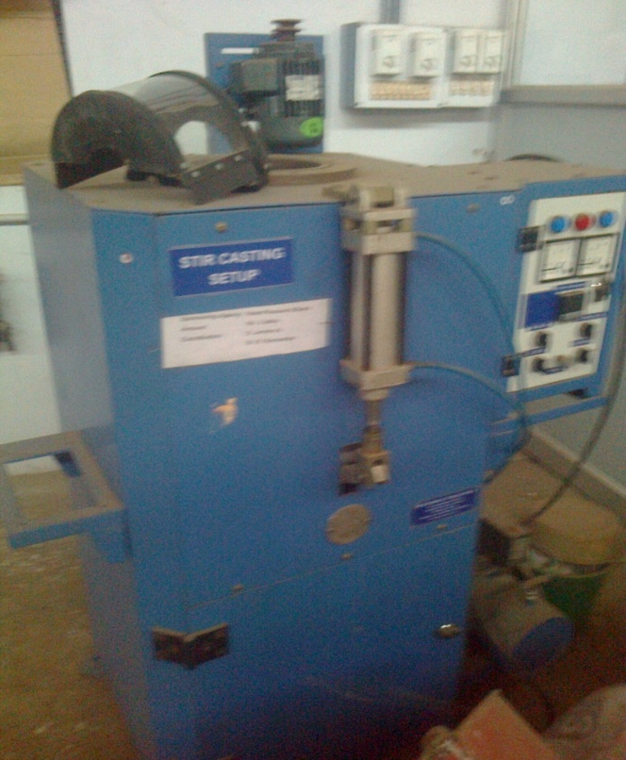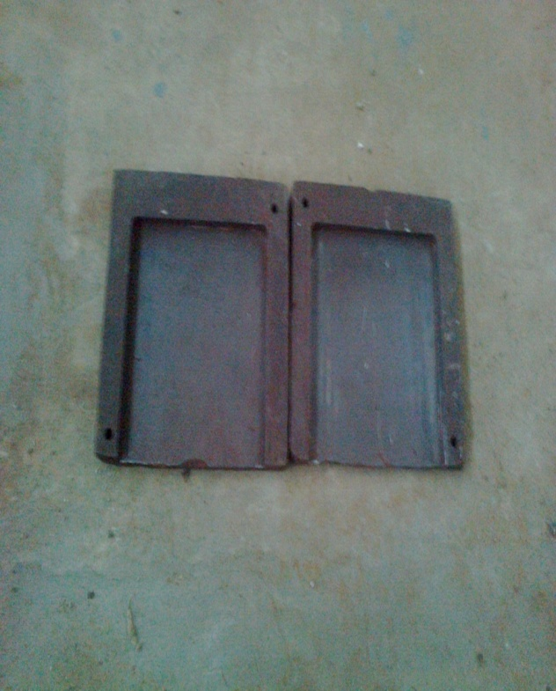  
**Figure: 2: Stir Casting Furnace and Die**

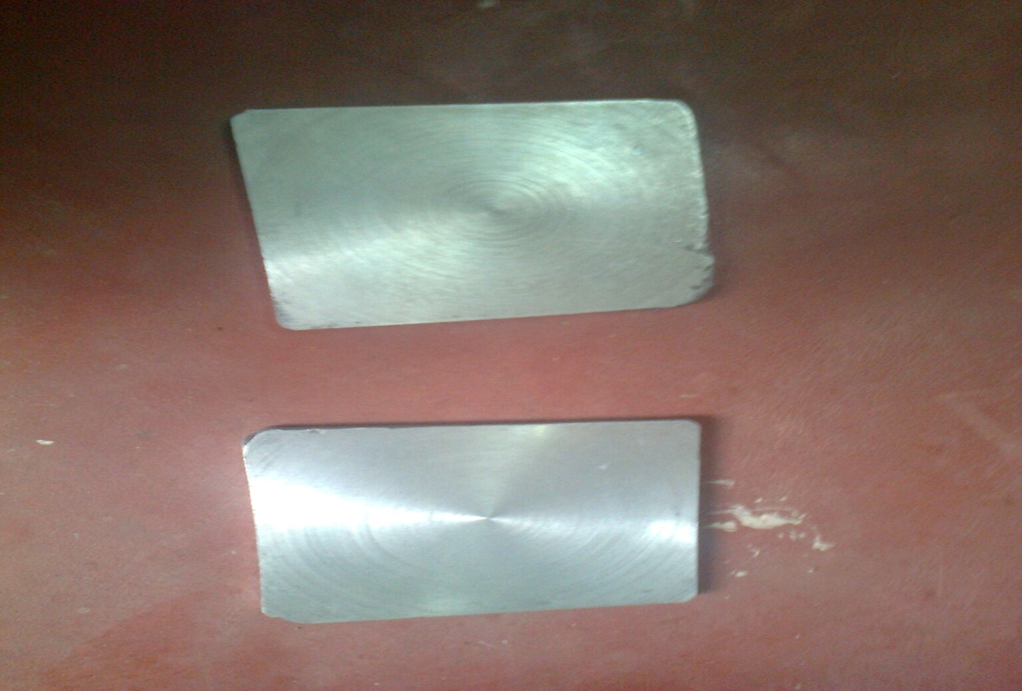

**Figure 3: Al-10%SiCp Composite Material**

* 1. **EDM MACHINE**

With Electronica 5030 Die Sinking EDM machine experiments were conducted as shown in Figure 4. The dielectric fluid and electrode flushing method was utilized. The design of experimental conditions for EDM is depicted in Table 3.

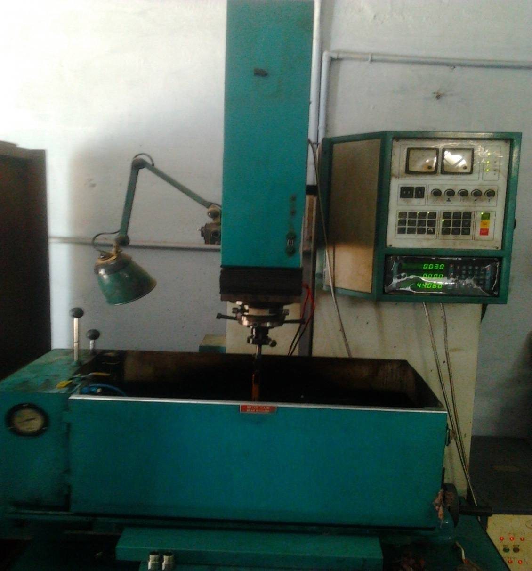

**Figure 4: Electronica 5030 Die Sinking EDM Machine**

**Table 3:** **EDM Machining Conditions**

|  |  |
| --- | --- |
| **Conditions** | **Descriptions** |
| Machine | Electronica 5030 die sinking EDM machine |
| Test Specimen | Composite Material (Mg .45%, Si 7.5%, Cu -.2, Mn.1, Fe .2, Zn .1, Ti .2, SiC 10%) |
| Tool | Copper Electrode of Diameter 10mm |
| Tool Polarity | Positive |
| Dielectric Fluid | EDM Oil (DEF-92) |
| Flushing Type | External |
| Depth of Cut (mm) | 1 |
| Electrode Polarity | Positive |
| Dielectric Flushing | Injection Flushing |
| Weight Measuring Instrument | Digital Balance (FX-3000) |
| SR Measuring Instrument | Portable SR Tester SJ201 |
| **Technical Data** | **Co-Ordinate Table** |
| Supply Voltage : 415V, 3Ph.,50Hz | Mounting Surface (l*b) : 500*300mm |
| Taps : 380V, 415V, 440V | Maximum Workpiece Height : 175mm |
| Power Factor : 0.8 Approx | Maximum Workpiece Weight : 175kg |
| Height : 2075mm | Longitudinal Travel (X-axis) : 280mm |
| Width : 1230mm  Depth : 1035mm | Transverse Travel (Y-axis) : 200mm |
| Net Weight : 800Kg (Approx.) | L.C of Hand Wheel Graduations with Vernier Scale : 0.005mm |
| Width of Work Tank – Internal : 725mm |
| Depth of Work Tank – Internal : 415mm |
| Height of Work Tank : 315mm |
| **Working Parameters** | |
| Machining Current Max.: 35 Amps | Pulse Current : 2Amps |
| Open Gap O/V : 140 ± 5% | Current Range Selection : 10 Selection |
|  | 1 = 1Amp  2 = 2Amps   * 1. = 4Amps |
| Pulse Current : 2 Selection | Pulse On Duration : 2 to 1000μs |
| 1 = 1Amp  1 = 1 Amp |  |
| Weight : 250 Kg. (Approx.) |  |

1. **EXPERIMENTAL PROCEDURE**

The machining process is performed in ELECTRONICA EMS5030 as exhibited in Figure 5; the work piece is mounted on the V-block which is located on the machine with magnetic table. The tool holder holds the tool and dial gauge has been used to test its alignment. 54 runs were decided involving various parameter combinations based on Analysis of Variance.

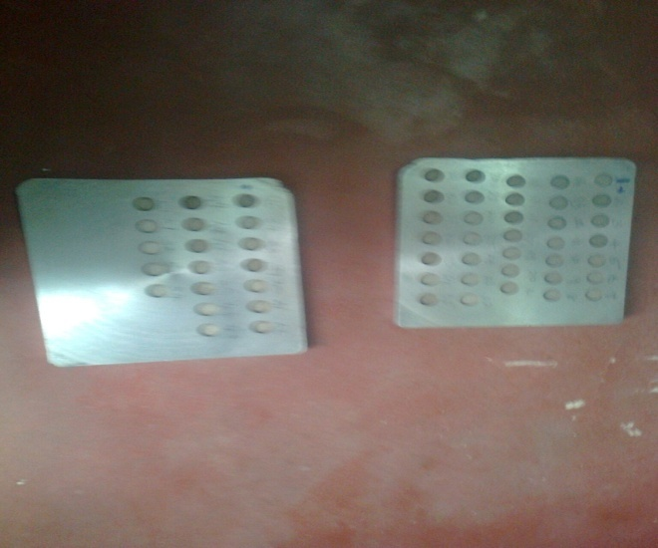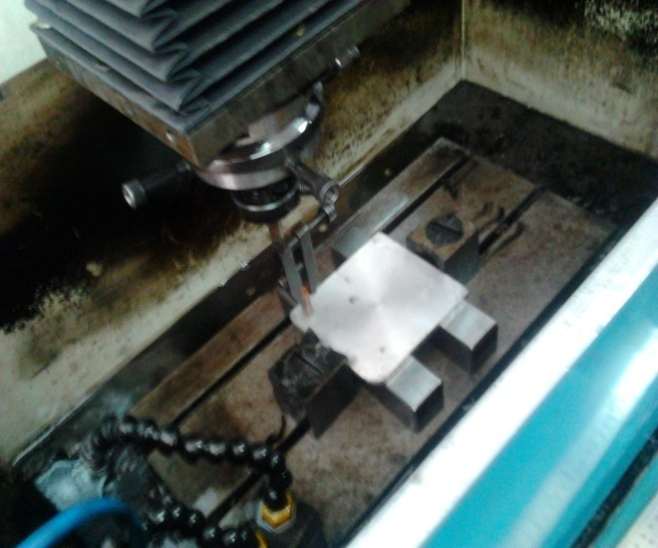

**Figure 5: Electronica 5030 Die Sinking EDM Machining Process Underway**

1. **MEASUREMENT PROCEDURE**

Portable Roughness Tester SJ201 has been utilized to measure roughness which is shown in Figure 6. It is a portable, self contained instrument for the measurement of surface texture. The parameters are performed on basis of microprocessor. LCD screen displays the measurement and carry away the output via an optical printer or another computer for auxiliary examination. Non-rechargeable alkaline battery supplies power. It is also furnished with a Diamond stylus having a tip radius 5μm. From extreme external position the measuring stroke starts always. During the last of the measurement the pickup returns to the position prepared for the next measurement. The collection of cut-off length determines the traverse length. Habitually by default, the traverse length is five times the cut-off length though the magnification factor can be altered. The profile meter is placed to a cut-off length of 0.8mm, filter 2CR and traverse speed 1mm/sec and 4mm traverse length. Roughness measurements, in the traverse direction, on the work pieces have been recurring four times and average of four measurements of SR parameter values bas been recorded.

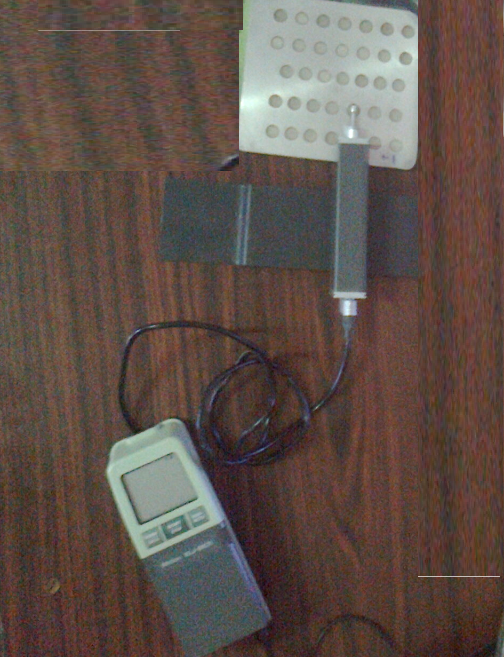

**Figure 6: Experimental Setup for Measuring Roughness**

1. **EXPERIMENTAL SET-UP**

Under various machining conditions the tests were conducted using Electronica 5030 Die Sinking EDM machine, which is 3HP/2.2KW power. By setting the machine and shape of the surface of work piece the input parameter was obtained. With normal above described procedure the tests were performed. On specifying levels for each process parameter as given in the Table 4, the parameter levels were preferred within the intervals proposed by machining tool manufacturer and investigation of the present study. From the54 tests two three levels with six process parameters involved in machining operation.SR tester SJ201 is utilized subsequent to each test, to measure the work piece to determine the SR. The observations are depicted in the Table v for auxiliary analysis and studies. Based on the conditions of design matrix, the machining operations were performed at random to make error free measurement.

**Table 4: Different Variables Used in the Experiment and Their Levels**

|  |  |  |  |  |
| --- | --- | --- | --- | --- |
| **Variable** | **Coding** | **Level** | | |
| **1** | **2** | **3** |
| Discharge Voltage (V) in V | A | 60 | 65 | 70 |
| Discharge Current in A | B | 5 | 10 | 15 |
| Pulse on time (Ton)in s | C | 15 | 30 | 45 |
| Pulse off Time (Toff) in s | D | 5 | 7 | 9 |
| Spark gap (G) in mm | E | 0.1 | 0.2 | 0.3 |
| Oil Pressure in kg/cm2 | F | 1 | 1.5 | 3 |

In the next step, the planning to accomplish the experiments by means of RSM using a Box Behnken approach with six variables. Total numbers of experiments conducted with the combination of machining parameter and the corresponding recorderd SR are presented in Table 5.

**Table 5: Planning Matrix of the Experiments with the Optimal Model Data**

|  |  |  |  |  |  |  |
| --- | --- | --- | --- | --- | --- | --- |
| **Sl. No.** | **A**  **Voltage**  **(V)** | **B**  **Current**  **(A)** | **C**  **Pulse on Time**  **(sec)** | **D**  **Pulse off Time**  **(sec)** | **E**  **Gap Width (mm)** | **F**  **Oil Pressure**  **(Kg/cm²)** |
| **1.** | 65 | 5 | 15 | 7 | 0.3 | 1.5 |
| **2.** | 75 | 10 | 45 | 7 | 0.2 | 2.0 |
| **3.** | 75 | 10 | 30 | 9 | 0.1 | 1.5 |
| **4.** | 65 | 15 | 45 | 7 | 0.3 | 1.5 |
| **5.** | 75 | 15 | 30 | 5 | 0.2 | 1.5 |
| **6.** | 75 | 5 | 30 | 5 | 0.2 | 1.5 |
| **7.** | 65 | 10 | 15 | 9 | 0.2 | 1.0 |
| **8.** | 75 | 15 | 30 | 9 | 0.2 | 1.5 |
| **9.** | 75 | 10 | 45 | 7 | 0.2 | 1.0 |
| **10.** | 65 | 5 | 45 | 7 | 0.3 | 1.5 |
| **11.** | 60 | 10 | 30 | 9 | 0.1 | 1.5 |
| **12.** | 60 | 5 | 30 | 5 | 0.2 | 1.5 |
| **13.** | 60 | 10 | 30 | 5 | 0.3 | 1.5 |
| **14.** | 60 | 10 | 30 | 9 | 0.3 | 1.5 |
| **15.** | 65 | 5 | 30 | 7 | 0.1 | 1.0 |
| **16.** | 65 | 10 | 30 | 7 | 0.2 | 1.5 |
| **17.** | 60 | 10 | 45 | 7 | 0.2 | 2.0 |
| **18.** | 65 | 5 | 30 | 7 | 0.3 | 2.0 |
| **19.** | 65 | 10 | 15 | 5 | 0.2 | 2.0 |
| **20.** | 60 | 5 | 30 | 9 | 0.2 | 1.5 |
| **21.** | 75 | 10 | 30 | 5 | 0.1 | 1.5 |
| **22.** | 65 | 15 | 15 | 7 | 0.1 | 1.5 |
| **23.** | 75 | 5 | 30 | 9 | 0.2 | 1.5 |
| **24.** | 75 | 10 | 30 | 5 | 0.3 | 1.5 |
| **25.** | 75 | 10 | 15 | 7 | 0.2 | 2.0 |
| **26.** | 65 | 10 | 15 | 9 | 0.2 | 2.0 |
| **27.** | 65 | 5 | 30 | 7 | 0.1 | 2.0 |
| **28.** | 65 | 10 | 45 | 5 | 0.2 | 2.0 |
| **29.** | 65 | 5 | 30 | 7 | 0.3 | 1.0 |
| **30.** | 65 | 15 | 30 | 7 | 0.1 | 1.0 |
| **31.** | 65 | 15 | 30 | 7 | 0.3 | 2.0 |
| **32.** | 65 | 10 | 30 | 7 | 0.2 | 1.5 |
| **33.** | 65 | 10 | 45 | 9 | 0.2 | 1.0 |
| **34.** | 60 | 10 | 15 | 7 | 0.2 | 1.0 |
| **35.** | 65 | 10 | 45 | 9 | 0.2 | 2.0 |
| **36.** | 65 | 10 | 45 | 5 | 0.2 | 1.0 |
| **37.** | 65 | 5 | 15 | 7 | 0.1 | 1.5 |
| **38.** | 75 | 10 | 15 | 7 | 0.2 | 1.0 |
| **39.** | 65 | 15 | 30 | 7 | 0.1 | 2.0 |
| **40.** | 65 | 15 | 15 | 7 | 0.3 | 1.5 |
| **41.** | 65 | 10 | 30 | 7 | 0.2 | 1.5 |
| **42.** | 75 | 10 | 30 | 9 | 0.3 | 1.5 |
| **43.** | 65 | 10 | 30 | 7 | 0.2 | 1.5 |
| **44.** | 65 | 10 | 30 | 7 | 0.2 | 1.5 |
| **45.** | 65 | 15 | 45 | 7 | 0.1 | 1.5 |
| **46.** | 60 | 15 | 30 | 5 | 0.2 | 1.5 |
| **47.** | 60 | 10 | 45 | 7 | 0.2 | 1.0 |
| **48.** | 65 | 15 | 30 | 7 | 0.3 | 1.0 |
| **49.** | 60 | 15 | 30 | 9 | 0.2 | 1.5 |
| **50.** | 65 | 10 | 30 | 7 | 0.2 | 1.5 |
| **51.** | 65 | 10 | 15 | 5 | 0.2 | 1.0 |
| **52.** | 60 | 10 | 15 | 7 | 0.2 | 2.0 |
| **53.** | 65 | 5 | 45 | 7 | 0.1 | 1.5 |
| **54.** | 60 | 10 | 30 | 5 | 0.1 | 1.5 |

**Table 6: Process Variables and Their Corresponding Responses**

|  |  |  |  |  |  |  |  |  |
| --- | --- | --- | --- | --- | --- | --- | --- | --- |
| **Sl. No.** | **A**  **Voltage (V)** | **B**  **Current (A)** | **C**  **Pulse ON (sec)** | **D**  **Pulse OFF**  **(sec)** | **E**  **Gap**  **(mm)** | **F**  **Oil Pressure (Kg/cm²)** | **G**  **MRR (Mg/sec)** | **H**  **SR (µm)** |
| **1.** | 65 | 5 | 15 | 7 | 0.3 | 1.5 | 1.435 | 3.01 |
| **2.** | 75 | 10 | 45 | 7 | 0.2 | 2.0 | 5.800 | 6.09 |
| **3.** | 75 | 10 | 30 | 9 | 0.1 | 1.5 | 4.952 | 5.82 |
| **4.** | 65 | 15 | 45 | 7 | 0.3 | 1.5 | 8.823 | 6.86 |
| **5.** | 75 | 15 | 30 | 5 | 0.2 | 1.5 | 7.880 | 5.88 |
| **6.** | 75 | 5 | 30 | 5 | 0.2 | 1.5 | 2.083 | 4.43 |
| **7.** | 65 | 10 | 15 | 9 | 0.2 | 1.0 | 3.355 | 4.32 |
| **8.** | 75 | 15 | 30 | 9 | 0.2 | 1.5 | 7.960 | 5.22 |
| **9.** | 75 | 10 | 45 | 7 | 0.2 | 1.0 | 6.444 | 6.27 |
| **10.** | 65 | 5 | 45 | 7 | 0.3 | 1.5 | 2.653 | 6.16 |
| **11.** | 60 | 10 | 30 | 9 | 0.1 | 1.5 | 5.205 | 6.20 |
| **12.** | 60 | 5 | 30 | 5 | 0.2 | 1.5 | 1.990 | 4.41 |
| **13.** | 60 | 10 | 30 | 5 | 0.3 | 1.5 | 4.613 | 5.77 |
| **14.** | 60 | 10 | 30 | 9 | 0.3 | 1.5 | 4.511 | 6.41 |
| **15.** | 65 | 5 | 30 | 7 | 0.1 | 1.0 | 2.182 | 5.69 |
| **16.** | 65 | 10 | 30 | 7 | 0.2 | 1.5 | 4.951 | 5.39 |
| **17.** | 60 | 10 | 45 | 7 | 0.2 | 2.0 | 6.059 | 6.36 |
| **18.** | 65 | 5 | 30 | 7 | 0.3 | 2.0 | 2.136 | 4.35 |
| **19.** | 65 | 10 | 15 | 5 | 0.2 | 2.0 | 3.383 | 4.86 |
| **20.** | 60 | 5 | 30 | 9 | 0.2 | 1.5 | 2.206 | 4.91 |
| **21.** | 75 | 10 | 30 | 5 | 0.1 | 1.5 | 5.272 | 5.79 |
| **22.** | 65 | 15 | 15 | 7 | 0.1 | 1.5 | 5.342 | 3.12 |
| **23.** | 75 | 5 | 30 | 9 | 0.2 | 1.5 | 2.280 | 4.87 |
| **24.** | 75 | 10 | 30 | 5 | 0.3 | 1.5 | 4.951 | 6.17 |
| **25.** | 75 | 10 | 15 | 7 | 0.2 | 2.0 | 3.500 | 5.18 |
| **26.** | 65 | 10 | 15 | 9 | 0.2 | 2.0 | 3.248 | 5.14 |
| **27.** | 65 | 5 | 30 | 7 | 0.1 | 2.0 | 1.411 | 5.09 |
| **28.** | 65 | 10 | 45 | 5 | 0.2 | 2.0 | 5.544 | 7.44 |
| **29.** | 65 | 5 | 30 | 7 | 0.3 | 1.0 | 1.906 | 4.30 |
| **30.** | 65 | 15 | 30 | 7 | 0.1 | 1.0 | 7.381 | 6.39 |
| **31.** | 65 | 15 | 30 | 7 | 0.3 | 2.0 | 7.518 | 6.33 |
| **32.** | 65 | 10 | 30 | 7 | 0.2 | 1.5 | 5.272 | 5.10 |
| **33.** | 65 | 10 | 45 | 9 | 0.2 | 1.0 | 6.643 | 5.60 |
| **34.** | 60 | 10 | 15 | 7 | 0.2 | 1.0 | 3.383 | 3.74 |
| **35.** | 65 | 10 | 45 | 9 | 0.2 | 2.0 | 6.343 | 5.60 |
| **36.** | 65 | 10 | 45 | 5 | 0.2 | 1.0 | 6.766 | 8.19 |
| **37.** | 65 | 5 | 15 | 7 | 0.1 | 1.5 | 1.684 | 4.20 |
| **38.** | 75 | 10 | 15 | 7 | 0.2 | 1.0 | 2.859 | 5.31 |
| **39.** | 65 | 15 | 30 | 7 | 0.1 | 2.0 | 6.655 | 8.12 |
| **40.** | 65 | 15 | 15 | 7 | 0.3 | 1.5 | 3.866 | 4.01 |
| **41.** | 65 | 10 | 30 | 7 | 0.2 | 1.5 | 4.613 | 6.82 |
| **42.** | 75 | 10 | 30 | 9 | 0.3 | 1.5 | 4.142 | 7.08 |
| **43.** | 65 | 10 | 30 | 7 | 0.2 | 1.5 | 4.511 | 6.49 |
| **44.** | 65 | 10 | 30 | 7 | 0.2 | 1.5 | 4.720 | 6.51 |
| **45.** | 65 | 15 | 45 | 7 | 0.1 | 1.5 | 9.441 | 7.77 |
| **46.** | 60 | 15 | 30 | 5 | 0.2 | 1.5 | 6.766 | 7.70 |
| **47.** | 60 | 10 | 45 | 7 | 0.2 | 1.0 | 5.486 | 7.98 |
| **48.** | 65 | 15 | 30 | 7 | 0.3 | 1.0 | 5.205 | 8.02 |
| **49.** | 60 | 15 | 30 | 9 | 0.2 | 1.5 | 6.444 | 7.31 |
| **50.** | 65 | 10 | 30 | 7 | 0.2 | 1.5 | 3.941 | 5.01 |
| **51.** | 65 | 10 | 15 | 5 | 0.2 | 1.0 | 2.743 | 4.91 |
| **52.** | 60 | 10 | 15 | 7 | 0.2 | 2.0 | 2.985 | 4.97 |
| **53.** | 65 | 5 | 45 | 7 | 0.1 | 1.5 | 2.040 | 5.28 |
| **54.** | 60 | 10 | 30 | 5 | 0.1 | 1.5 | 4.776 | 6.54 |

* 1. **Equation for MRR**

MRR = 1.6059+0.0852A-0.2872B-0.0740C-0.1632D-4.1745E-0.9694F - 0.0008A2-0.0071B2-0.00C2+0.05D2-7.6986E2-0.4526F2+0.0084AB+0.0006AC-0.0056AD -0.0663AE-0.0045AF+0.0125BC-0.0082BD-0.5275BE+0.1064BF +0.0008CD +0.1433CE -0.0197CF -0.6375DE + 0.0219DF+10.1EF

* 1. **Equation for SR**

SR = 4.4805-0.1893A+1.2479B+0.6101C-0.4769D-41.5598E-3.2685F + 0.0021A2-0.0163B2-0.0023C2+0.0165D2+22.4167E2 + 1.3300F2 - 0.0116AB - 0.0043AC +0.0060AD+0.4410AE-0.0007AF+0.0038BC-0.0249BD + 0.1575BE+0.0295BF-0.0172CD+0.1058CE-0.0368CF+1.1625DE + 0.2025DF-6.9250EF

A - Working Voltage

B - Working Current

C - Pulse ON Time

D - Pulse OFF Time

E - Spark Gap

F - Oil Pressure

These relations are obtained by using Minitab software. All the experimental values and the predicted input values are taken for the analysis for finding optimized inputs. The above said equation are used to analyzed all the input data’s in MINITAB software and the optimized values for surface roughness and material removal rates are in the table.

**Table 7: Result Obtained in Response Surface Methodology**

|  |  |  |  |  |  |  |
| --- | --- | --- | --- | --- | --- | --- |
| **Sl. No.** | **MRR (Mg/sec)** | **SR (µm)** | **Predicted MRR (Mg/sec)** | **Error MRR (Mg/sec)** | **Predicted SR (µm)** | **Error SR (µm)** |
| **1.** | 1.435 | 3.01 | 1.344776 | -0.09022 | 3.087113 | 0.077113 |
| **2.** | 5.8 | 6.09 | 6.061756 | 0.261756 | 5.813608 | -0.27639 |
| **3.** | 4.952 | 5.82 | 5.251514 | 0.299514 | 5.541237 | -0.27876 |
| **4.** | 8.823 | 6.86 | 8.973476 | 0.150476 | 7.680313 | 0.820313 |
| **5.** | 7.88 | 5.88 | 7.859906 | -0.02009 | 6.124508 | 0.244508 |
| **6.** | 2.083 | 4.43 | 1.970906 | -0.11209 | 4.953008 | 0.523008 |
| **7.** | 3.355 | 4.32 | 3.160856 | -0.19414 | 4.599508 | 0.279508 |
| **8.** | 7.96 | 5.22 | 7.552506 | -0.40749 | 5.527908 | 0.307908 |
| **9.** | 6.444 | 6.27 | 6.375656 | -0.06834 | 6.473108 | 0.203108 |
| **10.** | 2.653 | 6.16 | 2.740976 | 0.087976 | 5.119313 | -1.04069 |
| **11.** | 5.205 | 6.2 | 5.020214 | -0.18479 | 6.347487 | 0.147487 |
| **12.** | 1.99 | 4.41 | 2.133056 | 0.143056 | 4.587758 | 0.177758 |
| **13.** | 4.613 | 5.77 | 4.523526 | -0.08947 | 6.079263 | 0.309263 |
| **14.** | 4.511 | 6.41 | 4.461126 | -0.04987 | 6.085663 | -0.32434 |
| **15.** | 2.182 | 5.69 | 2.530314 | 0.348314 | 5.174287 | -0.51571 |
| **16.** | 4.951 | 5.39 | 4.661306 | -0.28969 | 5.942458 | 0.552458 |
| **17.** | 6.059 | 6.36 | 5.660656 | -0.39834 | 7.111108 | 0.751108 |
| **18.** | 2.136 | 4.35 | 2.182026 | 0.046026 | 4.482963 | 0.132963 |
| **19.** | 3.383 | 4.86 | 3.450356 | 0.067356 | 4.357608 | -0.50239 |
| **20.** | 2.206 | 4.91 | 2.489656 | 0.283656 | 4.627158 | -0.28284 |
| **21.** | 5.272 | 5.79 | 5.139914 | -0.13209 | 6.104837 | 0.314837 |
| **22.** | 5.342 | 4.12 | 5.155064 | -0.18694 | 4.953837 | 0.833837 |
| **23.** | 2.28 | 4.87 | 1.991506 | -0.28849 | 5.352408 | 0.482408 |
| **24.** | 4.951 | 6.17 | 4.891926 | -0.05907 | 6.236013 | 0.066013 |
| **25.** | 3.5 | 5.18 | 3.335956 | -0.16404 | 5.370808 | 0.190808 |
| **26.** | 3.248 | 5.14 | 3.526756 | 0.278756 | 5.456008 | 0.316008 |
| **27.** | 1.411 | 5.09 | 1.014914 | -0.39609 | 5.618787 | 0.528787 |
| **28.** | 5.544 | 7.44 | 5.948156 | 0.404156 | 7.122408 | -0.31759 |
| **29.** | 1.906 | 4.3 | 1.677426 | -0.22857 | 5.423463 | 1.123463 |
| **30.** | 7.381 | 6.39 | 7.410814 | 0.029814 | 6.702787 | 0.312787 |
| **31.** | 7.518 | 6.33 | 7.071526 | -0.44647 | 6.621463 | 0.291463 |
| **32.** | 5.272 | 5.1 | 4.661306 | -0.61069 | 5.942458 | 0.842458 |
| **33.** | 6.643 | 5.6 | 6.345656 | -0.29734 | 6.404308 | 0.804308 |
| **34.** | 3.383 | 3.74 | 2.860256 | -0.52274 | 4.278308 | 0.538308 |
| **35.** | 6.343 | 5.6 | 6.120556 | -0.22244 | 6.156808 | 0.556808 |
| **36.** | 6.766 | 8.19 | 6.260856 | -0.50514 | 8.179908 | -0.01009 |
| **37.** | 1.684 | 4.2 | 1.617564 | -0.06644 | 3.847837 | -0.35216 |
| **38.** | 2.859 | 5.31 | 3.058856 | 0.199856 | 4.926308 | -0.38369 |
| **39.** | 6.655 | 8.12 | 6.959414 | 0.304414 | 7.442287 | -0.67771 |
| **40.** | 3.866 | 4.01 | 3.827276 | -0.03872 | 4.508113 | 0.498113 |
| **41.** | 4.613 | 6.82 | 4.661306 | 0.048306 | 5.942458 | -0.87754 |
| **42.** | 4.142 | 7.08 | 4.493526 | 0.351526 | 6.602413 | -0.47759 |
| **43.** | 4.511 | 6.49 | 4.661306 | 0.150306 | 5.942458 | -0.54754 |
| **44.** | 4.72 | 6.51 | 4.661306 | -0.05869 | 5.942458 | -0.56754 |
| **45.** | 9.441 | 7.77 | 9.441464 | 0.000464 | 7.491237 | -0.27876 |
| **46.** | 6.766 | 7.7 | 6.762056 | -0.00394 | 7.499258 | -0.20074 |
| **47.** | 5.486 | 7.98 | 5.907056 | 0.421056 | 7.760108 | -0.21989 |
| **48.** | 5.205 | 8.02 | 5.502926 | 0.297926 | 7.266963 | -0.75304 |
| **49.** | 6.444 | 7.31 | 6.790656 | 0.346656 | 6.542658 | -0.76734 |
| **50.** | 3.941 | 5.01 | 4.661306 | 0.720306 | 5.942458 | 0.932458 |
| **51.** | 2.743 | 4.91 | 3.172056 | 0.429056 | 4.311108 | -0.59889 |
| **52.** | 2.985 | 4.97 | 3.204856 | 0.219856 | 4.733308 | -0.23669 |
| **53.** | 2.04 | 5.28 | 2.153964 | 0.113964 | 5.245237 | -0.03476 |
| **54.** | 4.776 | 6.54 | 4.572614 | -0.20339 | 7.271087 | 0.731087 |

1. **GREY RELATIONAL ANALYSIS**
   1. **INTRODUCTION TO GRA**

To examine the suitable selection of machining parameters for Electrical Discharge Machining (EDM) process, Grey Relational Analysis (GRA) are applied. Solution of a system provided by Grey theory is that the model is uncertain or the information is unfinished. Besides, it exhibits an efficient solution to the uncertainty, multi-input and discrete data problem. According to the Taguchi quality design concept, a L32 mixed-orthogonal-array table was preferred for the experiments. With both GRA and statistical method, it is observed that the table-feed rate has a prominent impact on the machining speed, whilst the gap width and pulse-on time influences the SR. Moreover, by setting the maximum machining speed and minimum SR, optimal machining parameters (or a desired SR) can be acquired.

In the previous section the relationship between different factors mentioned is unclear. Those are called “grey”, implying poor, incomplete and uncertain information. Without large data sets their analysis by standard statistical procedure may not be acceptable or reliable. In this work, to renovate the multi-response optimization model into a single response grey relational grade, GRA has been utilized. Grades are used to study about multi-response characteristics, as an alternative of using experimental values directly in multiple regression model and GA.

* 1. **STEPS IN GRA**

The below mentioned steps to be followed while applying grey relational analysis to find the Grey relational coefficients and the grey relational grade:

1. Normalizing the experimental results of MRR and surface roughness to avoid the effect of adopting different units to reduce the variability.

Zij= $\frac{yij-min⁡(yij, i=1,2,……..n)}{ \max\left(yij, i=1,2…….n\right)-min⁡(yij, i=1,2…….n)}$**(1)**

Zij= $\frac{\max\left(yij, i=1,2……n\right)-yij}{\max\left(yij, i=1,2…….n\right)-min⁡(yij, i=1,2…….n)}$**(2)**

1. Performing the grey relational generating and calculating the grey coefficient for the normalized values yield.

γ(y0(k),yi(k))= $\frac{∆min+ξ∆max}{∆oj\left(k\right)+ξ∆max}$**(3)**

Where,

* j=1, 2...n; k=1, 2...m, n is the number of experimental data items and m is the number of responses.
* y0(k) is the reference sequence (yo(k)=1, k=1, 2...m); yj(k) is the specific comparison sequence.
* Δoj=║yo(k)-yj(k)║= The absolute value of the difference between y0(k) and yj(k).
* Δmin=minmin║yo(k)-yj(k)║ is the smallest value of yj(k).
* Δmax=maxmax║yo(k)-yj(k)║is the largest value of yj(k).
* ζ is the distinguishing coefficient which is defined in the range 0 ≤ ζ≤ 1 (the value may adjusted based on the practical needs of the system).

1. Calculating the grey relational grade by averaging thegrey relational coefficient yields:

γj= $\frac{1}{k}$ ∑ γij **(4)**

Where γj is the grey relational grade for the jth experiment and k is the number of Performance characteristics. To normalize the experimental value, Equation (1) is used, when the target of the original value is with the characteristic of ‘higher the better’. Here MRR is standardized using the above equation. When the ‘lower the better’ is a characteristic of the original sequence, then the original sequence is normalized using Eqn. (2), i.e., surface roughness is normalized using this equation. Using Eqn. (3), we calculate the grey relational coefficient for MRR and SR as Shown in Table 2. Also the grey relational grade is computed as per Eqn. (4)

**Table 8:** **Grey Relational Grade**

|  |  |  |  |  |  |
| --- | --- | --- | --- | --- | --- |
| **Sl. No.** | **Normalized**  **Values for**  **MRR** | **Normalized**  **Values for**  **SR** | **GRC Values for**  **MRR** | **GRC**  **Values for SR** | **Grade** |
| **1.** | 0 | 1 | 0.333 | 0.4169 | 0.6665 |
| **2.** | 0.5452 | 0.405 | 0.523 | 0.4393 | 0.4699 |
| **3.** | 0.4394 | 0.457 | 0.4714 | 0.3641 | 0.4553 |
| **4.** | 0.923 | 0.257 | 0.8665 | 0.4344 | 0.6153 |
| **5.** | 0.805 | 0.446 | 0.7194 | 0.6100 | 0.5769 |
| **6.** | 0.08 | 0.728 | 0.3521 | 0.6234 | 0.4810 |
| **7.** | 0.239 | 0.747 | 0.3965 | 0.4991 | 0.5099 |
| **8.** | 0.815 | 0.573 | 0.7299 | 0.4035 | 0.6145 |
| **9.** | 0.625 | 0.371 | 0.5714 | 0.4117 | 0.4874 |
| **10.** | 0.152 | 0.392 | 0.3709 | 0.4085 | 0.3973 |
| **11.** | 0.470 | 0.384 | 0.4854 | 0.6109 | 0.4469 |
| **12.** | 0.069 | 0.729 | 0.3494 | 0.4439 | 0.4801 |
| **13.** | 0.396 | 0.461 | 0.4528 | 0.3891 | 0.4483 |
| **14.** | 0.384 | 0.332 | 0.4480 | 0.4514 | 0.4185 |
| **15.** | 0.093 | 0.483 | 0.3553 | 0.4805 | 0.4033 |
| **16.** | 0.439 | 0.540 | 0.4712 | 0.4838 | 0.4758 |
| **17.** | 0.652 | 0.546 | 0.5896 | 0.6216 | 0.4367 |
| **18.** | 0.087 | 0.741 | 0.3538 | 0.5438 | 0.4477 |
| **19.** | 0.243 | 0.643 | 0.3977 | 0.4939 | 0.4707 |
| **20.** | 0.096 | 0.564 | 0.3561 | 0.4221 | 0.4250 |
| **21.** | 0.479 | 0.463 | 0.4897 | 0.6654 | 0.4659 |
| **22.** | 0.488 | 0.786 | 0.4940 | 0.5424 | 0.5797 |
| **23.** | 0.105 | 0.641 | 0.3584 | 0.4105 | 0.5404 |
| **24.** | 0.439 | 0.389 | 0.4712 | 0.5038 | 0.4408 |
| **25.** | 0.257 | 0.581 | 0.4022 | 0.5087 | 0.4530 |
| **26.** | 0.226 | 0.589 | 0.3924 | 0.5142 | 0.4505 |
| **27.** | 0.089 | 0.598 | 0.3543 | 0.3323 | 0.4343 |
| **28.** | 0.4173 | 0.145 | 0.4618 | 0.6308 | 0.3970 |
| **29.** | 0.058 | 0.751 | 0.3467 | 0.3945 | 0.4887 |
| **30.** | 0.7426 | 0.347 | 0.6601 | 0.3989 | 0.5273 |
| **31.** | 0.759 | 0.359 | 0.6747 | 0.5129 | 0.5365 |
| **32.** | 0.479 | 0.596 | 0.4897 | 0.4597 | 0.5013 |
| **33.** | 0.65 | 0.5 | 0.5882 | 0.7511 | 0.5239 |
| **34.** | 0.243 | 0.859 | 0.3977 | 0.5497 | 0.5744 |
| **35.** | 0.613 | 0.5 | 0.5636 | 0.2985 | 0.5116 |
| **36.** | 0.665 | 0 | 0.5988 | 0.6491 | 0.4486 |
| **37.** | 0.311 | 0.77 | 0.3403 | 0.4894 | 0.4947 |
| **38.** | 0.177 | 0.556 | 0.3779 | 0.3012 | 0.4346 |
| **39.** | 0.652 | 0.013 | 0.5896 | 0.6879 | 0.4454 |
| **40.** | 0.303 | 0.807 | 0.4177 | 0.3663 | 0.5528 |
| **41.** | 0.396 | 0.264 | 0.4528 | 0.3512 | 0.4095 |
| **42.** | 0.3381 | 0.214 | 0.4303 | 0.6332 | 0.3857 |
| **43.** | 0.3842 | 0.328 | 0.4481 | 0.3863 | 0.5406 |
| **44.** | 0.4103 | 0.324 | 0.4588 | 0.3165 | 0.4225 |
| **45.** | 1 | 0.081 | 1 | 0.3196 | 0.6582 |
| **46.** | 0.665 | 0.094 | 0.5988 | 0.3071 | 0.4592 |
| **47.** | 0.505 | 0.040 | 0.5025 | 0.3056 | 0.4048 |
| **48.** | 0.470 | 0.033 | 0.4854 | 0.3338 | 0.3955 |
| **49.** | 0.625 | 0.151 | 0.5714 | 0.5243 | 0.4526 |
| **50.** | 0.313 | 0.614 | 0.4212 | 0.5369 | 0.4727 |
| **51.** | 0.163 | 0.633 | 0.3739 | 0.5245 | 0.4554 |
| **52.** | 0.193 | 0.622 | 0.3825 | 0.4928 | 0.4560 |
| **53.** | 0.075 | 0.562 | 0.3508 | 0.3842 | 0.4212 |
| **54.** | 0.4173 | 0.318 | 0.4618 | 0.3841 | 0.4230 |

1. **ARTIFICIAL NEURAL NETWORKS ARCHITECTURE**

Generally ANN consists of a number of layers: the layer where the input patterns are applied is called the input layer, the layer where the output is obtained is the output layer, and the layers between the input and output layers are the hidden layers are shown in Figure 7. One or more hidden layers are present, which are so named because their outputs are not directly observable. When the size of the input layer is large, the addition of hidden layers makes possible the network to extract higher-order statistics which are predominantly valuable. Fully or partially interconnected Neurons layers are proceeding and subsequent layer of neurons with each interconnection having an associated connection strength (or weight). In a forward direction, the input signal propagates through the network, on a layer-by-layer basis which are commonly referred to as Multilayer Perceptrons (MLP). Many publications discuss the development and theory of ANN.

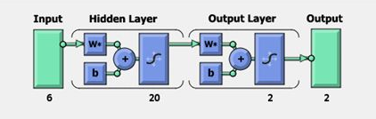

**Figure 7: General configuration of Artificial Neural Network**

To iteratively minimize the following cost function, the back-propagation training algorithm is commonly used, with respect to the interconnection weights and neurons thresholds:

$$E=\frac{1}{2}\sum_{1}^{P}{\sum_{i=0}^{N}{\left(d_{i}-o_{i}\right){}^{2}}} (5)$$

Where P is the number of training input/output patterns and N is the number of output nodes. di and Oi are the target and actual responses for output node i respectively. Iteratively, the interconnection weights between the jth node and the ith node are updated as:

$$W_{ij}\left(t+1\right)= {αw}_{ji}\left(t\right)+x_{i}f^{'}\left({net}_{j}^{k}\right)\sum_{i=1}^{N}{(d_{i}}-O_{i})f^{'}({net}_{i}^{0})w_{ij} (6)$$

where a is a momentum constant, g the learning rate, xi the input pattern at the iterative sample t, net0N the input to node N at the output layer and netkj is the input to a node j in the kth layer. The learning rate establishes error sensitivity to weight change, which will be used for the weight correction. The convergence speed and the stability of weights during learning get affected. Depending on the characteristics of the error surface, the ‘‘best’’ value of the learning rate exists. A smaller rate is desirable for rapidly changing surfaces, while, a larger value of the learning rate will speed up convergence for smooth surfaces. The invariable momentum (usually between 0.1 and 1) smoothes weight updating and avoids oscillations in the system and makes the system escape local minima in the training process by supporting the system less sensitive to local changes. Similar to the learning rate, the momentum constant ‘‘best’’ value is also weird to specific error surface contours.

The training process is concluded either when the Mean-Square-Error (MSE), Root-Mean-Square-Error (RMSE), or Normalized-Mean-Square-Error (NMSE), between the experiential data and the ANN outcomes for all elements in the training set has reached a pre-specified threshold or after the pre-specified number of learning epochs completion.

Input requirements and modeling and generalization abilities are different even though all neural network models share common operational features. Consequently, every paradigm possesses pros and cons based on the particular application and in selecting the apt network class with suitable parameters is imperative to make certain a successful application.

* 1. **Back-Propagation Network Algorithm**

The algorithm for the back-propagation network program is depicted below with the support of flow diagram as shown in Figure 8.



**Figure 8: Back-Propagation Network Program**

**Step 1:** Confirm the number of hidden layers.

**Step 2:** Confirm the neurons number for the input layer and the output layer. For the input layer, the neurons number equalizes the number of input variables and for the output layer it equalizes the number of outputs required. Set few neurons number for the hidden layer.

**Step 3:** Get the training input pattern.

**Step 4:** Assign small weight values for the neurons interconnected between the input, hidden and output layers.

**Step 5:** Calculate the output values for all the neurons in hidden and output layers using the following formula.

${out}_{i}=f(\sum_{wij}{{Out}_{j}}+ θ_{1}$**(7)**

Where outputi is the output of the ith neuron in the layer under consideration; outputj is the output of the jth neuron in the preceding layer. f is the sigmoid function can be expressed as:

Where q is termed as temperature.

**Step 6:** Determine the output at the output layer and compare it with the desired output values.

$f\left({net}_{1}\right)= \frac{1}{1+e^{-net i/q}}$**(8)**

Determine the error of the output neurons,

Error = desired output - actual output **(9)**

Similarly, determine the root mean square error value of the output neurons.

**Step 7:** Determine the error existing at the neurons of the hidden layer and back-propagate those errors to the weight values connected in between the neurons of the hidden layer and input layer. Similarly, back propagate the errors available at the output neurons to the weight values connected in between the neurons of the hidden layer and output layer using the following formula.

$$E_{p}= \frac{1}{2}\sum{{(t_{pj}- O_{pj})}^{2}} (10)$$

Where Ep is the error for the pth presentation vector, tpj is the desired value for the jth output neuron and Opj is the desired output of the jth output neuron.

$$\left(11\right)$$

for output neurons,

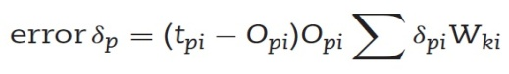 **(12)**

for hidden neurons Weight adjustment is made as follows:

Eqn 8.jpg **(13)**

Where η is the learning rate parameter and α is momentum factor.

**Step 8:** Go to **Step 3** and do the calculations up to **Step 7** at the end of cycle determine the root-mean-square error value, mean percentage of error and worst percentage of error over the complete patterns. To reach to **Step 9** check for reasonable error, if so, go to Step 9 otherwise go to **Step 3** and repeat the same from **Step 3** to **Step 7**.

**Step 9:** Stop the iteration and note the final weight values of the hidden layer neurons and also to the output layer neurons.

**Step 10:** Testing neural network model with the trained weight values, determine the output for the testing pattern and check whether the deviation from desired value is reasonably less or not. If not, try the back propagation with revised network by modifying the number of neurons, varying learning rate parameters, momentum value and temperature values as well. Table 9 shows the typical observation of network performance while testing the pattern.

**Table 9:** **Results Obtained in Artificial Neural Network**

|  |  |  |  |  |
| --- | --- | --- | --- | --- |
| **Sl. No.** | **MRR**  **(Mg/sec)** | **SR**  **(µm)** | **Predicted MRR**  **(Mg/sec)** | **Predicted SR**  **(µm)** |
| **1.** | 1.435 | 3.01 | 1.435 | 3.01 |
| **2.** | 5.8 | 6.09 | 5.8 | 6.09 |
| **3.** | 4.952 | 5.82 | 4.957 | 5.82 |
| **4.** | 8.823 | 6.86 | 8.823 | 6.85 |
| **5.** | 7.88 | 5.88 | 7.88 | 5.88 |
| **6.** | 2.083 | 4.43 | 2.085 | 4.43 |
| **7.** | 3.355 | 4.32 | 3.355 | 4.32 |
| **8.** | 7.96 | 5.22 | 7.96 | 5.22 |
| **9.** | 6.444 | 6.27 | 6.444 | 6.25 |
| **10.** | 2.653 | 6.16 | 2.653 | 6.16 |
| **11.** | 5.205 | 6.2 | 5.205 | 6.2 |
| **12.** | 1.99 | 4.41 | 1.99 | 4.41 |
| **13.** | 4.613 | 5.77 | 4.613 | 5.77 |
| **14.** | 4.511 | 6.41 | 4.511 | 6.41 |
| **15.** | 2.182 | 5.69 | 2.182 | 5.68 |
| **16.** | 4.951 | 5.39 | 4.954 | 5.39 |
| **17.** | 6.059 | 6.36 | 6.059 | 6.34 |
| **18.** | 2.136 | 4.35 | 2.136 | 4.35 |
| **19.** | 3.383 | 4.86 | 3.383 | 4.86 |
| **20.** | 2.206 | 4.91 | 2.205 | 4.93 |
| **21.** | 5.272 | 5.79 | 5.272 | 5.79 |
| **22.** | 5.342 | 4.12 | 5.342 | 4.12 |
| **23.** | 2.28 | 4.87 | 2.28 | 4.86 |
| **24.** | 4.951 | 6.17 | 4.951 | 6.17 |
| **25.** | 3.5 | 5.18 | 3.5 | 5.18 |
| **26.** | 3.248 | 5.14 | 3.245 | 5.15 |
| **27.** | 1.411 | 5.09 | 1.411 | 5.09 |
| **28.** | 5.544 | 7.44 | 5.545 | 7.45 |
| **29.** | 1.906 | 4.3 | 1.908 | 4.3 |
| **30.** | 7.381 | 6.39 | 7.384 | 6.36 |
| **31.** | 7.518 | 6.33 | 7.518 | 6.33 |
| **32.** | 5.272 | 5.1 | 5.272 | 5.1 |
| **33.** | 6.643 | 5.6 | 6.643 | 5.6 |
| **34.** | 3.383 | 3.74 | 3.383 | 3.75 |
| **35.** | 6.343 | 5.6 | 6.343 | 5.6 |
| **36.** | 6.766 | 8.19 | 6.766 | 8.19 |
| **37.** | 1.684 | 4.2 | 1.687 | 4.2 |
| **38.** | 2.859 | 5.31 | 2.859 | 5.31 |
| **39.** | 6.655 | 8.12 | 6.655 | 8.12 |
| **40.** | 3.866 | 4.01 | 3.866 | 4.01 |
| **41.** | 4.613 | 6.82 | 4.613 | 6.82 |
| **42.** | 4.142 | 7.08 | 4.144 | 7.07 |
| **43.** | 4.511 | 6.49 | 4.511 | 6.49 |
| **44.** | 4.72 | 6.51 | 4.72 | 6.51 |
| **45.** | 9.441 | 7.77 | 9.441 | 7.77 |
| **46.** | 6.766 | 7.7 | 6.766 | 7.7 |
| **47.** | 5.486 | 7.98 | 5.488 | 7.99 |
| **48.** | 5.205 | 8.02 | 5.205 | 8.02 |
| **49.** | 6.444 | 7.31 | 6.444 | 7.31 |
| **50.** | 3.941 | 5.01 | 3.941 | 5.01 |
| **51.** | 2.743 | 4.91 | 2.743 | 4.91 |
| **52.** | 2.985 | 4.97 | 2.985 | 4.97 |
| **53.** | 2.04 | 5.28 | 2.04 | 5.28 |
| **54.** | 4.776 | 6.54 | 4.776 | 6.54 |

1. **RESULT AND DISCUSSION FOR MRR AND SR**

The orthogonal array was planned by using Central Composite Design of 54 runs. The Central Composite Design, Response Surface Methodology, Contour plots and Optimization plots are formed by using MINITAB Software. Figure 9 represents MRR as a function of pulse off time and pulse on time, whereas the Voltage, current, gap width and Poil remains constant in its higher level. It is observed as the highest MRR values occurred at the higher pulse on time and lower pulse off time. Figure 10 shows MRR as a function of pulse on time and voltage, whereas the current, gap width, Poil and pulse off time remain constant in its higher level. It shows that the highest MRR values occurred at the higher pulse on time and lower voltage. Figure 11 represents SR as a function of current and gap width, whereas the voltage, pulse on time, pulse off time and oil pressureremains constant in its higher level. It exhibits that the highest SR values occurred at the maximum current and lower gap width.

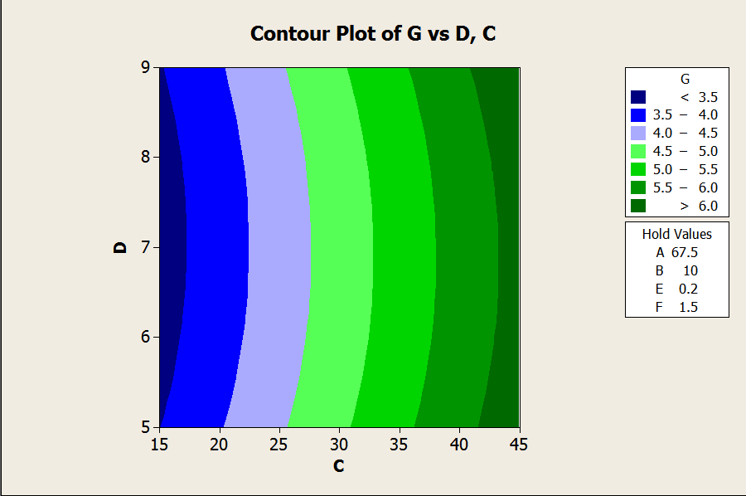

**Figure 9: MRR as a Function of Pulse OFF Time and Pulse ON Time**

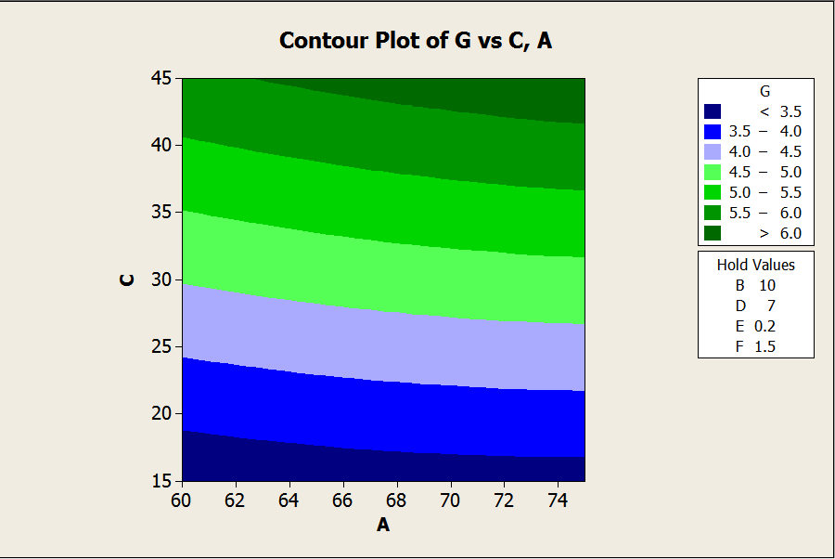

**Figure 10: MRR as a Function of Pulse OFF Time and Voltage**



**Figure 11: SR as a Function of Current and Gap Width**

Figure 12 represents SR as a function of voltage and pulse off time, whereas the current, pulse off, voltage, gap width and Poil remains constant in its higher level. It is observed that the highest SR values occurred at the minimum voltage and minimum gap width value. Figure 13 represents SR as a function of pulse on time and pulse off time, whereas the voltage, gap width, current and Poil remains constant in its higher level. It’s observed that the highest SR values occurred at the higher pulse off time and lower pulse on time.



**Figure 12: SR as a Function of Voltage and Pulse OFF Time**



**Figure: 13 SR as a Function of Pulse ON Time and Pulse OFF Time**

The bar chart for MRR and SR are shown in Figure 14 and 15 along with the various parameters using RSM and ANN. The ANN is trained with various numbers of nodes in the hidden layer. 10 hidden layers are obtained from the exact nodes. The motive for using two hidden layer and 10 nodes in this configuration is due to reduced error. The Average error for the performance of ANN during testing of all the training and testing pattern is 1.47%. ANN is an appropriate tool, used in calculating the material removal rate and surface roughness in machining process. ANN model has been tested using the training data and bar charts were plotted using determined and tested values. The results illustrate that ANN model has been successfully applied to the machining parameters of LM25 Aluminum composites. It is observed from Figure 14 (Validation of ANN and RSM model for SR) Figure 15 (Validation of ANN and RSM model for MRR) that predicted based on ANN model is very close to the experimental observation. The validation for the MRR SR values using ANN has been listed in Table 4. The percentage of error between the experimental and predicted values is found that minimum of 0.30 and maximum of 3.22. This error is a logical one and shows that the ANN model predicted satisfactory for MRR and SR.

**Figure 14: Variation of MRR and MRR Output of Training Data Set w.r.t RSM**

**Figure 15:** **Variation of SR and SR Output of Training Data Set w.r.t RSM**

1. **CONCLUSION**

In this work, the input parameters are Discharge Current, Discharge Voltage, Pulse ON time, Pulse OFF Time, gap width, Oil Pressure and Metal Removal Rate, Surface Roughness are the output machining parameters. Various levels of input conditions are consequential of Surface Design of Experiments. The experiments are performed on Electrical Discharge Machining machine. Using the experimental results, two models viz., the Response Surface Methodology and Artificial Neural Networks are created and calculated. The final conclusions based on these two prediction models, the ANN back propagation method with a kind of empirical model gives good result when compared with RSM model and the optimized parameter for this composition are given in table 10.

|  |  |  |  |  |  |  |  |
| --- | --- | --- | --- | --- | --- | --- | --- |
| **A**  **Voltage (V)** | **B**  **Current (A)** | **C**  **Pulse ON (sec)** | **D**  **Pulse OFF**  **(sec)** | **E**  **Gap**  **(mm)** | **F**  **Oil Pressure (Kg/cm²)** | **G**  **MRR (Mg/sec)** | **H**  **SR (µm)** |
| 65 | 15 | 15 | 7 | 0.1 | 1.5 | 5.342 | 3.12 |

**REFERENCES**

Kuldeep Ojha, R. K. Garg, Singh.K. K. (2010). MRR Improvement in Sinking Electrical Discharge Machining, *A Review Journal of Minerals and Materials Characterization and Engineering,* 9, (8), 709-739.

Sen. M, Shan. H. S. (2007).Electro Jet Drilling Using Hybrid NNGA Approach, *International Journal Robot and Computer Integrated Manufacturing,* 23, 17–24.

Gao. Q, Zhang. Q. H, Su. S. P, Zhang. J. H. (2008). Parameter Optimization Model In Electrical Discharge Machining Process, *Journal of Zhejiang University Science,* A9, (1), 104–108.

Rao. G. K. M, Janardhana. G. R, Rao. D. H, Rao. M. S. (2009). Development of Hybrid Model and Optimization of Surface Roughness in Electric Discharge Machining Using Artificial Neural Networks and Genetic Algorithm, *Journal of Material Processing Technology,*.209, 1512–1520.

Tolga Bozdana. A, Oguzhan Yilmaz, Ali Okka. M, Huseyin Filiz. I.(2010). Mathematical Modelling of EDM Hole Drilling Using Response Surface Methodology, *Department of Mechanical Engineering, The University of Gaziantep,* 27310, Gaziantep, Turkey 90 – 94.

Musrrat Ali, Millie Pant, and Singh. V. P. (2009). An Improved Differential Evolution Algorithm for Real Parameter Optimization Problems, *International Journal of Recent Trends in Engineering,* 1, (5).

Yan. B. H, Huang. F. Y, Chow. H. M, Tsai. J. Y. (1999). Micro-Hole Machining of Carbide by Electric Discharge Machining, *Journal Materials Processing Technology,* 87, 139–145.

Mahapatra.S and Amar Patnaik. (2006). Parametric Optimization of Wire Electrical Discharge Machining Process using Taguchi Method, [*Journal of the Brazilian Society of Mechanical Sciences and Engineering*](http://www.scielo.br/scielo.php?script=sci_serial&pid=1678-5878&lng=en&nrm=iso)*,* 28(4) 422-429.

Qing Gao, Qin-He Zhang, Shu-peng SU, Jian-hua Zhang.(2008). Parameter Optimization Model in Electrical Discharge Machining Process, *Journal of Zhejiang University Science* A, 9(1), 104-108*.*

Shabgard M. R, Shotorbani. R. M, (2009).Mathematical Modeling of Machining Parameters in Electrical Discharge Machining of FW4 Welded Steel, *World Academy of Science, Engineering and Technology,* 52.

Sushant Dhar, Rajesh Purohit, Nishant Saini, Akhil Sharma, Hemath Kumarb. G*.* (2007).Mathematical Modeling of Electric Discharge Machining of Cast Al–4Cu–6Si alloy–10 wt.% SiCp Composites, *Journal of Materials Processing Technology,* 194, 24–29.

Puertas. I, LuisA. C. J. (2003).Study on the Machining Parameters Optimization of EDM, *Journal of Materials Processing Technology,* 143–144, 521–526.

Thillaivanan. A, Asokan. P, Srinivasan. K. N and Saravanan. R. (2010). Optimization of Operating Parameters for EDM Process Based on the Taguchi Method and Artificial Neural Network, *International Journal of Engineering Science and Technology,* 2, (12), 6880-6888.

Sameh S. Habib. (2009). Study of the Parameters in EDM Through Response Surface Methodology Approach, Applied Mathematical Modeling, 33, 4397–4407.

Seung-Han Yanga, Srinivas .J, Sekar Mohana, Dong-Mok Leea, Sree Balaji B. (2009). Optimization of Electric Discharge Machining Using Simulated Annealing, *Journal of Materials Processing Technology,* 209, 4471–4475.

Ramezan Ali MahdaviNejad. (2011). Modeling and Optimization of EDM of SiC Parameters, Using Neural Network and Non-dominating Sorting Genetic Algorithm (NSGA II), *Materials Sciences and Applications,* 2, 669-675.

Krishna Mohana Rao. Gand Hanumantha Rao. D. (2010).Hybrid Modeling and Optimization of Hardness of Surface Produced by Electric Discharge Machining Using Artificial Neural Networks and Genetic Algorithm, *Journal Engineering and Applied Sciences,* 5, (5), 1819-6608.

[Majumder, Arindam.](mailto:arindam2012@gmail.com) (2012). Parametric Optimization of Electric Discharge Machining by GA-Based Response Surface Methodology, *Journal for Manufacturing Science and Production,* 12, (12), 25–30.

Jun Wang, Fei Yang, Jun Qian, Dominiek Reynaerts. (2016). Study of alternating current flow in micro-EDM through real time pulse counting, Journal of Materials Processing Technology (231) 179–188.