Analysis of Rain Gauge Charts for Different Intensity
Komal Gangaram Rokade^{1,} Prajakta Babasaheb Labade² and B. K. Gavit³
¹Ph.D Student, Soil and Water Conservation Engineering Department, Dr. ASCAET, Mahatma Phule Krishi Vidyapeeth, Rahuri- 413722, Maharashtra, India.
²Ph.D Student, Soil and Water Conservation Engineering Department, Dr. BSCAET, Dr. Balasaheb Sawant Kokan Krishi Vidyapeeth, Dapoli- 415712, Maharashtra, India.
³Associate Professor of Soil and Water Conservation Engineering Department and Deputy Director of Research, Mahatma Phule Krishi Vidyapeeth, Rahuri- 413722, Maharashtra, India.
Corresponding email: komalrokade112@gmail.com

Analysis of Rain Gauge Charts for Different Intensity
Abstract
The distribution and variation of rainfall over time in a specific area are referred to as rainfall patterns. These patterns are impacted by a number of variables, including topography, geography, climate, and atmospheric conditions, and they can differ significantly from one location to another. The tool used to measure rainfall is called a rain gauge. The measured precipitation is known as the point precipitation. The mean aerial rainfall is calculated from the point rainfall using a variety of computation techniques. By multiplying the mean depth of rainfall, watershed area, and region, the mean aerial rainfall may be used to calculate the amount of rainwater received over the watershed's surface. A Rainy day is considered to be rainfall of 2.5 mm rainfall or more than 2.5mm. By using the analysis of rain gauge charts the 30-minute rainfall intensity can be calculated.
Keywords: Point precipitation, Point rainfall, Rainfall, Rainfall intensity.
1. Introduction
1.1 Rainfall
Just one type of precipitation is rain. Other terms for precipitation include snow, sleet, and hail, but when people use the term "rainfall," they typically mean water droplets that are falling from the sky. Rainfall is a prime input for various engineering designs such as hydraulic structures, bridges and culverts, canals, stormwater sewers, and road drainage systems (Arvind et al., 2017). The rate at which rainwater falls on a particular region during a predetermined amount of time is referred to as rainfall intensity. It is commonly expressed as the number of millimeters (or inches) of water per minute or hour. Rainfall acts as a natural irrigation system for crops, providing water without the use of artificial irrigation techniques. As a result, less money and energy are needed for irrigation. Rainfall provides the required moisture for seed germination, assisting the process. Without enough rain, seeds might not sprout, which would result in poor crop establishment. For crops to grow and develop, there must be sufficient rainfall during the growing season. In order to enable photosynthesis, nutrient uptake, and general plant growth, it makes sure that plants have a steady flow of water. Crop yields can be greatly increased by timely and adequate rainfall. It encourages strong plant development, resulting in larger and better-quality harvests. Rainfall restores soil moisture levels, which is essential for plant roots to have access to water. By doing this, water is always available to crops when they require it. Farmers can use less expensive irrigation systems when rainfall is plentiful and evenly distributed, which results in water and energy cost reductions. By encouraging the breakdown of organic matter and the creation of aggregates, rain can assist in improving soil structure. This improves the soil's fertility and moisture-holding capacity. Crop rotation, in which several crops are planted in succession, is made possible by sufficient rainfall. By doing so, insect and disease growth as well as soil depletion are prevented. Insects and pathogens that could harm crops can be washed away by rain, which helps to control pests and diseases. Additionally, it promotes the development of advantageous microbes that can control pests. Extreme rainfall also causes soil loss. Soil loss refers to the amount of sediment that reaches the end of a specified area on a 90 hillslope that is experiencing a net loss of soil by water erosion (Nearing et.al., 2017). Utilizing rainfall from the sky instead of excessive groundwater pumping or surface water extraction for irrigation has less of an impact on the environment. Natural rainfall-based sustainable agricultural methods are more environmentally beneficial. The financial risks connected with irrigation expenditures and water shortages are frequently reduced for farmers in areas with consistent rainfall patterns, making agriculture a more reliable source of revenue.

1.2 Rainfall Intensity
Rainfall intensity is a crucial variable in meteorology, hydrology, and civil engineering since it can have a big impact on a lot of different systems and processes, such as urban planning, drainage design, and flood control. Based on variables including geographic location, weather patterns, topography, and the type of precipitation event (for example, gentle drizzle, severe downpour), the intensity of rainfall can vary significantly. The influence on rainfall characteristics on erosion is erosivity and it is generally related to rainfall amount and intensity. (Nandgude et al., 2013). The classification of intensity into levels, such as light, moderate, heavy, and very heavy, each of which corresponds to a certain range of millimeters per hour, is common. The possibility of floods or soil erosion, for example, are some potential effects of the rains that these categories can assist express using specialized rain gauges, which are devices created to record and quantify the amount of rainfall during a certain time period, it is normal practice to assess rainfall intensity. The rainfall intensity is determined on the basis of rainfall depth and duration (Nandgude et al., 2013).
1.3 Rain gauge Chart
A rain gauge chart, sometimes referred to as a rainfall chart or a water column chart or a hyetograph is a data visualization tool that mimics the appearance of a rain gauge. It is generally used to present and contrast data values within or between groups. The rain gauge chart also refers to as a hyetograph. Each hyetograph is divided into different segments based on the change in the slope of the line (Nagargoje et al., 2022). To illustrate and compare precipitation data for various times, places, or events, rain gauge charts are frequently employed. When analyzing rainfall patterns, this can be helpful to meteorologists, hydrologists, and climatologists. The 30-minute rainfall intensity can be determined by analyzing rain gauge charts (Weishmeir et al., 1958).
1.4 Rainfall Measurement
A region's rainfall distribution and variation over time are referred to as rainfall patterns. These patterns can differ significantly from location to location and are impacted by a number of variables including geography, climate, topography, and atmospheric conditions. Instruments used to measure rainfall most frequently include rain gauges. Although they exist in a variety of styles, the fundamental idea is to gather and measure the amount of precipitation that falls into a container. The rain gauge is a simple mechanical device that is deployed on the surface to directly measure rainwater entering the gauge in discrete quantities (Wang et al., 2000).
The rain gauge is the instrument used for rainfall measurement. Broadly it is classified as a non-recording type; and a recording-type rain gauge.
Non-recording type rain gauge: The Simon kind of rain gauge is the most used type of rain gauge. The start and finish of a rainfall event are recorded by a rain gauge of the recording type. This data can be used to calculate the area under measurement's rainfall intensity and depth. The most popular kind of rain gauge is a cylindrical vessel with a 127 mm diameter and a 210 mm base width for stability. A funnel with a brass rim that is precisely 127mm in diameter is given at the top to suit the vessel properly. The receiving bottle located below receives this funnel shank. Receiving bottles range in height from 75 to 100mm. Rainfall falls on the bottle. The receiving bottle has a 100mm capacity to measure the depth of the rainfall. The amount of rainfall during periods of severe rain is likely to be greater than the bottle's capacity. It is advised to take the observations regularly in this circumstance, typically 3–4 times each day. A graduated measuring cylinder is used to determine how much water has been collected in the receiving bottle. The graduated cylinder has a 0. 1mm measurement accuracy. Every day at 8:30 AM IST, the measurement of rainfall is conducted consistently. In order to ensure accurate measurement, the rain gauge should be properly cared for, maintained, and inspected during dry weather.
The following rain gauges are commonly used recording-type rain gauges,
- Float-type rain gauge: The natural siphon-type rain gauge is another name for it. This rain gauge is used as the industry standard for recording rain in India. This rain gauge functions similarly to weighing-type rain gauges. The rainwater is gathered in this and funneled into a container with a float at the bottom. Depending on how much rainwater enters the container, the float's location rises as the water level does. A pen positioned on a clockwise revolving drum and driven by the movement of the float draws a curve on the rain chart. When the float reaches the top of the container, the siphon activates and drains all of the water inside. The pen is now drawing a straight line. If the rain keeps flowing down and more water is entering the container, the float will continue to rise and the pen will draw the curve. This procedure is carried on. The pen draws a horizontal line on the graph when rain is stopped. The mass curve is the one that was obtained.
- Weight type rain gauge: The most popular type of self-recording rain gauge consists of a receiver (bucket) that is supported by a spring/lever balance or other weighing device. The movement of the bucket is conveyed to a pen, which draws a curve on the rain chart that is wrapped around the clock, due to the weight of the bucket increasing as more rainfall accumulates. The plot of cumulative rainfall vs. elapsed time, or mass curve, represents the obtained rainfall data in terms of a curve.
- Tipping bucket type rain gauge: The Tipping Bucket Type Rain Gauge is a recording-style rain gauge with a 30 cm diameter. This rain gauge is used by the US Weather Bureau to measure rainfall. A sharp-edged receiver with a 30 cm diameter is part of its structure. A funnel is provided at its end so that rainwater can be directed into the receiver. When one of a pair of buckets receives 0.25mm of rainwater, it tips and dumps its contents into a container, and the second bucket immediately descends below the funnel. The buckets are pivoting on a fulcrum below the funnel. The number of tips made for a given amount of rainfall is used to measure rainfall. event, which is indicated on a dial actuated by an electrical circuit.
2. Materials and Methodology
2.1 Materials
2.1.1 Sample Rain gauge
The sample Rain gauge charts Fig. 1 and Fig. 2 of recording rain gauge collected from float type recording rain gauge from Dept. Soil and Water Conservation Engineering, Mahatma Phule Krishi Vidyapeeth Rahuri.
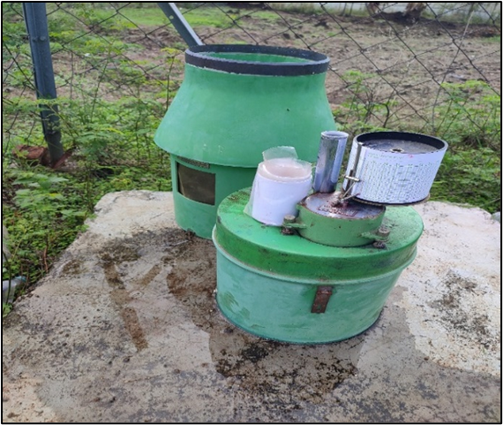
Plate 2.1 Float type self-recording rain gauge
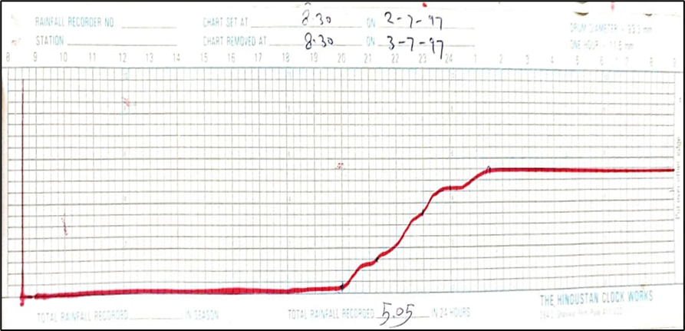
Fig 1. Sample Rain gauge Chart
Here is some information about the chart given, The Horizontal Scale ranges from 0 – 1 mm of rainfall. One division is equal to 0.5 mm of rainfall and the lowest count is 0.5 mm. Vertical Scale ranges from 8.00 AM morning today to 9 AM morning tomorrow. The total time for reading is 25 hours maximum. Here, 1 h = 11.5 mm in linear scale.
The rain gauge chart is also referred to as a hyetograph. Each hyetograph is divided into different segments based on the change in the slope of the line (Nagargoje et al., 2022). This method totally depends on the accuracy of the measurement of the fragmented slope. This leads to the accuracy of the measurement of rainfall intensity.
2.2 Methodology

2.2.1 Rainfall Intensity

Storms are isolated using Rainfall Intensity (I) to determine their intensity. The rain gauge charts are used to determine the depth and duration of each storm.

Intensity = $\frac{Rainfall Depth}{Duration of Rainfall}$

Where Rainfall is in millimeters or centimeters and duration is in hours. Rainfall that is less than 2.5 mm cannot be effectively analyzed. These records will be disregarded because they barely affect erosivity estimation.
2.2.2 30-min Maximum Rainfall Intensity
It is computed from rain gauge charts by locating the greatest amount of rain, received in any 30 minutes duration and then multiplying it by two to get the same dimensions as intensity. It is expressed in mm/h or cm/h. I₃₀ indicates maximum amount of rainfall in 30 min for 24-hour duration. This is usually calculated by visual analysis of charts. This 30 min intensity will be then converted into I₃₀ (mm/h) or (cm/h).
- Results and Discussions
A rain gauge chart is a data visualization tool that mimics the appearance of a rain gauge. The rain gauge chart also refers to as a hyetograph. The rain gauge chart provides the following information.
- Depth of rainfall
- Intensity of rainfall at any time during rainfall
- Start of rainfall
- Cessation time of rainfall.
3.1 Rainfall Intensity
From Fig 2 it is depicted that the rain gauge chart is continuous type of rain gauge. It also showing mass curve with time in hours on x-axis and rainfall depth on y- axis in mm. The total rainfall recorded on rainguage chart is 94.05 mm.
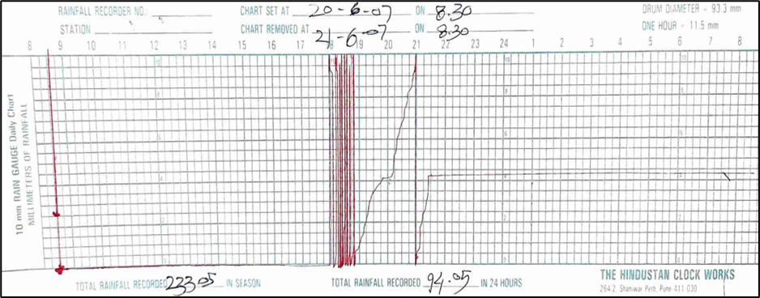
Fig 2. Analysis of continous type raingauge chart
Table 1 shows that the time interval is obtained by subtracting shift time and start time. It is usually taken zero value at starting of rainfall. The rainfall starts at 18.00 PM and stops at 21.30 PM. The rainfall depth is obtained by subtracting column 5 from column 4. The depth of rainfall divided by the time interval is rainfall intensity of that particular storm event.
Table 1. Analysis of Rainfall Intensity
Sr.  No. | Start  Time  (h) | Shift  Time  (h) | Time  Interval  (min) | Read at  Start  (mm) | Read at  Shift  (mm) | Rainfall  (mm)  (col.5-4) |  | Rainfall  Intensity(I)  (mm/h)
Col. | (1) | (2) | (3) | (4) | (5) | (6) | (7)
1 | 18.00 | 19.15 | 75 | 0.00 | 82 | 82 | 65.6
2 | 19.15 | 19.45 | 30 | 82 | 84 | 2 | 4
3 | 19.45 | 20.15 | 30 | 84 | 84.5 | 0.5 | 1
4 | 20.15 | 21.15 | 60 | 84.5 | 92 | 7.5 | 7.5
5 | 21.15 | 21.30 | 15 | 92 | 94.5 | 2.5 | 10
  - The 30-minute maximum rainfall intensity
The maximum rainfall occur in 30 minute is found 40 mm. The 30-minute maximum rainfall intensity is obtained 80 mm by multiplying the maximum rainfall occur at 30- minute with two.
- Conclusion
The selected rain gauge is a continuous type of rain gauge that has about 80 mm of continuous rainfall. The maximum rainfall that occurs in 30 minutes is found 40 mm. The 30-minute maximum rainfall intensity is obtained by 80 mm by multiplying the maximum rainfall occur at 30- minutes by two. From the observations given in Table 2, it can be concluded that rainfall intensity is directly proportional to the rainfall depth and inversely to the duration of the rainfall storm. The accuracy of the rainfall storm events observation is totally depending on the skilled observer, it may slightly vary with the observation of another observer.
- Limitations
The rain gauge chart analysis required skilled and experienced observers to find the rainfall events. Also, while putting a chart on the drum of the recording type of rain gauge the setting of the rain gauge should be correct, otherwise it will fail to interpret the recordings of rainfall events through the pen.
- Future Scope
The analysis of the rain gauge chart is useful to find out different rainfall intensities. The intensity can be used to predict the probability chances of rainfall in that particular area or it is helpful to find out the pattern of rainfall. Rainfall intensities can be used to find out the erosivity of the area and conservative measures can be applied.

- References
Arvind, G., A.P. Kumar., S. Girishkarthi, S., and C.R. Suribabu (2017). Statistical Analysis of 30 Years Rainfall Data: A Case Study. Institute of physics conference series: Earth and Environmental Science, 01-09.
Nagargoje, A. L., Upadhye, S. K., Nandgude, S. B., Barai, V. N., and Atre, A. A. (2022). Synthesis of rainfall characteristics for study of the erosivity pattern of Solapur district, Maharashtra.
Nandgude, S. B., V. Shinde, D. Mahale and M. Singh (2013). Synthesis of Rainfall Characteristics for Predicting the Erosivity Pattern of Wakavali Region in Maharashtra, India. Journal of Hydrualic Engineering 18(1): 92-98.
Nearing, M. A., Yin, S. Q., Borrelli, P., and Polyakov, V. O. (2017). Rainfall erosivity: An historical review. Catena, 157, 357-362.
Wang, J., & Wolff, D. B. (2010). Evaluation of TRMM ground-validation radar-rain errors using rain gauge measurements. Journal of Applied Meteorology and Climatology, 49(2), 310-324.
Wischmeier, W.H, Smith, D.D (1958). Rainfall energy and its relation to soil loss. Trans American Graduate University; 39:285-29

