"The Genetic Underpinnings: Deciphering the Inheritance Pattern of Thalassemia"

Abstract
Thalassemia, a congenital blood illness caused by faulty haemoglobin production, causes anemia and other health issues. Understanding its genetics is crucial for understanding its inheritance pattern and implications for affected individuals and their families. Chapter explores thalassemia's genetic basis, inheritance pattern, and haemoglobin structure and function in RBC, highlighting the illness's impact on RBC , Pathophysiology of thalassemia, Clinical Presentation and Diagnosis, Treatment of thalassemia and Future Prospects of Thalassemia Advancements and Promising Directions. We also provide historical context for the identification and discovery of thalassemia, including inputs from eminent experts in the area.

Key words : inheritance pattern , thalassemia ,health issue, blood.

Introduction
An autosomal recessive genetic condition called thalassemia exists. Anaemia and a number of other possible health issues can result from a category of genetic blood diseases known as thalassemia, which are characterised by faulty haemoglobin synthesis. Red blood cells ,which are essential for delivering oxygen throughout the body. Thalassemia comes in two varieties: beta and alpha. These illnesses are mostly caused by gene mutations that result in insufficient or malfunctioning globin proteins, respectively. Sometimes one of these proteins might not even exist. The globin chains create a fold or concise that is utilised by heme (Fe++) part to carry oxygen. The genes for the alpha and beta globin proteins are located on chromosomes 16 and 11, respectively[1].thalassemia is a kind of haemolytic anaemia’s and Anemia resulting due to increase in the rate of red cell destruction haemolytic anomia classification is given bellow.
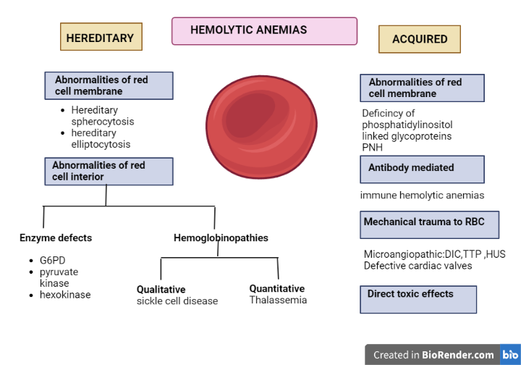
Fig1: classification of Haemolytic anemias

Background knowledge and research: Thomas Cooley, an American doctor, first identified a group of patients with severe anaemia and large spleens in 1925. Previously known as "Cooley's anaemia," this condition is now referred to as thalassemia major.
A doctor by the name of George Whipple documented cases of newborns in Sicily, Italy, in 1927 who had a severe form of anaemia that he named "Mediterranean anaemia." Later, the terms beta thalassemia and this expression became synonymous
- Types of thalassemia
- Alpha thalassemia:
- One gene mutation: no symptoms or indications, but a silent carrier who may convey the disease to their offspring.
- two gene abnormalities: Mild signs and symptoms, also known as alpha-thalassemia minor or alpha-thalassemia trait.
- Three gene mutations :often known as haemoglobin H illness or intermediate alpha-thalassemia, cause symptoms that range from mild to severe.
- four gene abnormalities :Alpha-thalassemia major or hydrops fetalis, caused by is frequently deadly before or soon after childbirth.
- Beta thalassemia:
- Mild indications or symptoms, also known as beta-thalassemia minor or alpha-thalassemia trait, are caused by a single gene mutation.
- Moderate to severe symptoms of beta-thalassemia major, often known as Cooley's anaemia, are caused by two gene abnormalities.[7,8]

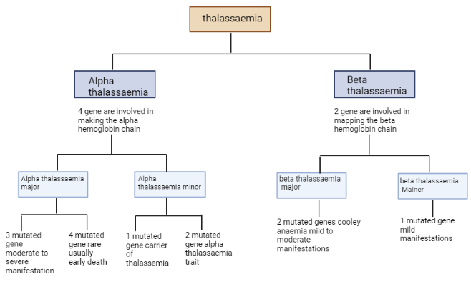

Fig6: Diagnostic flow chart for determining thalassemia

- Etiology and Genetics:

Changes in the beta-globin gene reduce the quantity of beta-globin generated, resulting in the common genetic disorder known as beta-thalassemia. More than 200 unique mutations have been found to cause -thalassemia and modify the expression of the -globin gene to varying degrees. Nucleotide replacements and frameshift insertion-/deletion-type mutations that disrupt molecular processes like the transcription of the -globin gene, splicing process, and translation of the -globin gene prevent or limit the formation of -globin chains. Patients with thalassemia must all go through molecular testing.
2-alpha-globin and 2-beta-globin chains in haemoglobin interact with heme to produce a tetramer that carries oxygen in the blood. The red bone marrow of growing erythrocytes produces this iron-containing protein. Because globin polypeptides bind heme molecules, Erythrocytes may be capable to carry oxygen from the lungs to various parts of the body by reversibly binding to it. [2].
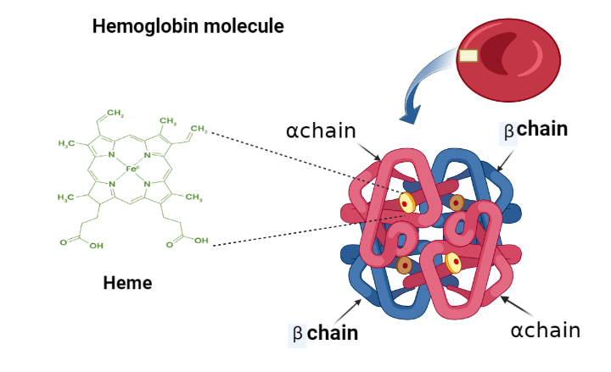

Fig3: Structure of haemoglobin.

The main hemoglobin type is HbA in usual adult establish about 98% and comprises two alpha and two beta globin chains (α2β2). The minor type HbA2 constitute less than 3% of the adult haemoglobin contains of two alpha chains and two delta chains (α2δ2). HbF is predominant hemoglobin sub-type, found only during fetal life and consist of two alpha and two gamma (γ) subunits (α2γ2) [3].

Genetic basis of hemoglobin

Human Hb consists of proteins with symmetric combining of α-like and β-like globin dimers, which form a tetrameric structure, as well as serviceable units. cluster contains cis-acting regulatory components that play a role in the regulation of globin gene expression. Within 30–70 kb upstream of the α-globin gene cluster, multispecies conserved sequence (MCS) regions (MCS-R1, 2, 3, and 4) were found. MCR-R2, also known as HS-40, is a single DNase hypersensitive site that is crucial for α-globin gene expression [5]. β-globin gene expression is regulated by the locus control region (LCR), which consists of five DNase I hypersensitive sites (HS-1, 2, 3, 4, and 5). β-globin LCR (β-LCR) spans 34 kb upstream of the ε-globin gene.
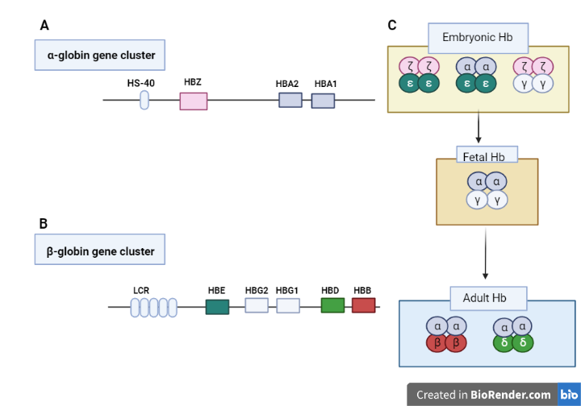
Fig4:The human alpha and beta -globin gene clusters are located on chromosomes 16 and 11, respectively. The α-globin gene cluster encloses three functional globin genes, the embryonic ζ gene (HBZ) and two fetal/adult α, α1 and α2, genes (HBA1 and HBA2) (A). The β-globin gene cluster contains five functional genes, the embryonic ε gene (HBE), two fetal Gγ and Aγ genes (HBG2 and HBG1), and adult δ and β- (HBD and HBB) genes(B). HS-40 and the locus control region (LCR) regulate α- and β -globin gene expression, respectively. Hemoglobin differentially expressed at embryonic, fetal, and adult stages are represented (C) [4].

- Pathophysiology of thalassemia
Before being able to appreciate Understanding the typical pathophysiology of globin gene synthesis and the generation of haemoglobin is necessary to comprehend the pathophysiology of thalassemia. Understanding the typical physiology of globin gene synthesis and the production of haemoglobin is necessary before one can comprehend the pathophysiology of thalassemia. [6]. Aberrant globin chain synthesis has a role in the pathophysiology of alpha- and beta-thalassemia. Both alpha- and beta-thalassemias are monogenic illnesses, which means a genetic anomaly is the sickness' underlying cause. Numerous mutational incidents, such as deletions, insertions, and point mutations (substitutions), can cause the clinical manifestations of thalassemias. A nonfunctional or defective gene product (protein) is created as a result of the altered genetic sequence, which inhibits the new globin chain from correctly delivering oxygen to peripheral tissues.
Haemoglobin is made up of four globin chains—2- alpha chains and 2- beta (or gamma) chains—plus an iron heme ring. The kind of thalassemia is determined by the number of gene mutations and whether the damaged area is in the alpha or beta splice of the haemoglobin molecule.
insufficient alpha-hemoglobin chain synthesis and an excess of beta chain synthesis result in alpha-thalassemia. The alpha region of haemoglobin is made up of four genes, two of which are inherited from each parent and are located on chromosome 16. The severity of the ailment and the number of gene mutations are correlated as written above.
Insufficient synthesis of beta-hemoglobin chains and an excess of alpha chains result in beta-thalassemia. The beta section of the haemoglobin chain is made up of two genes on chromosome 11, each of which is inherited from a single parent. The severity of the disorder is inversely correlated with the number of gene mutations, as written above.
The degree of severity of the sickness is based on the amount of alleles lost on each globin-cluster. The thalassemias are inherited in a Mendelian autosomal recessive manner, regardless of the kind of mutation.. One pair of chromosomes that determine sex and 22 pairs of numbered chromosomes (autosomes). Also a female possesses two X chromosomes, whereas a male carries both an X and a Y chromosome. The sex of the child is chosen at random by the father, who has the option of passing down either an X or a Y chromosome.

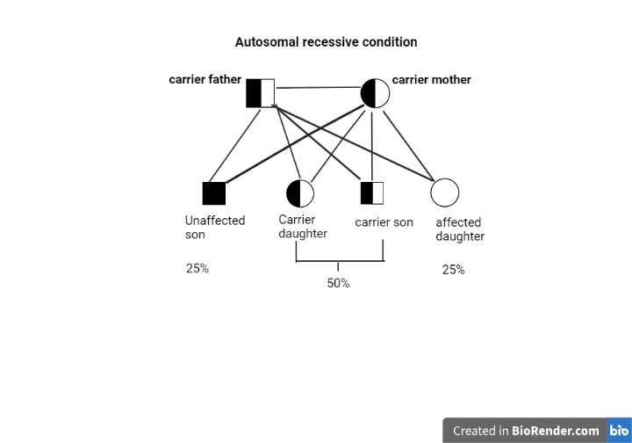

Fig5: if mother and father both are carrier then probability of progeny is 25% unaffected ,50% carrier and 25% affected progeny.
DNA mutations linked to thalassemia are handed down from parents who have the condition in an autosomal recessive fashion. Each child who inherits one gene mutation inherited from both parents has a 25% chance of developing it, regardless of whether the parents exhibit symptoms. Multiple gene mutations in one or both parents enhance the risk of gene inheritance and the likelihood that the offspring may experience symptoms.
People with a family history of thalassemia are more likely to be impacted since the disorder is hereditary. Additionally, those of Italian, Greek, Middle Eastern, Asian, and African descent are more likely to have the illness than those of other particular ethnicities.[7]
- Clinical Presentation and Diagnosis:

Thalassemia comes in several forms. Your condition's kind and severity will determine the indications and symptoms your experience. Signs and symptoms of thalassemia include:
- Fatigue
- Weakness
- Pale or yellowish skin
- Facial bone deformities
- Slow growth
- Abdominal swelling
- Dark urine
Since symptoms commonly develop inside the first two years of your child's existence, serious and sensible cases of thalassemia are typically identified in children.
To identify thalassemia, your doctor may do a number of blood tests, including those listed below.
- a complete blood count (CBC) that counts red blood cell amount (and size) as well as haemoglobin. Thalassemia patients have fewer normal RBCs and less haemoglobin than average. They can also have red blood cells that are smaller than usual.
- The bone marrow in your body may not be creating enough RBCs, according to reticulocyte count, a marker of immature red blood cells.
- Studies on iron will reveal if thalassemia or an iron deficit is to blame for your anaemia.
- The diagnosis of beta thalassemia is made via haemoglobin electrophoresis.
- Using genetic testing, alpha thalassemia is identified.
Haematological testing makes it possible to identify carriers, which is essential for this genetic condition. A differential diagnosis is required to rule out iron-deficient anaemia when microcytic hypochromic parameters are present in beta- and alpha-thalassemia carriers (heterozygotes) with or without anaemia. ferritin or zinc a substance called pro analysis[9] When addressing the laboratory diagnosis of thalassemias, information about family history and ethnicity may be helpful. The basis for identifying a thalassemia carrier is the haematological characteristics, such as red cell indices and morphology, followed by the separation and analysis of Hb fractions. Figure reports a flowchart for identifying thalassemia carriers.

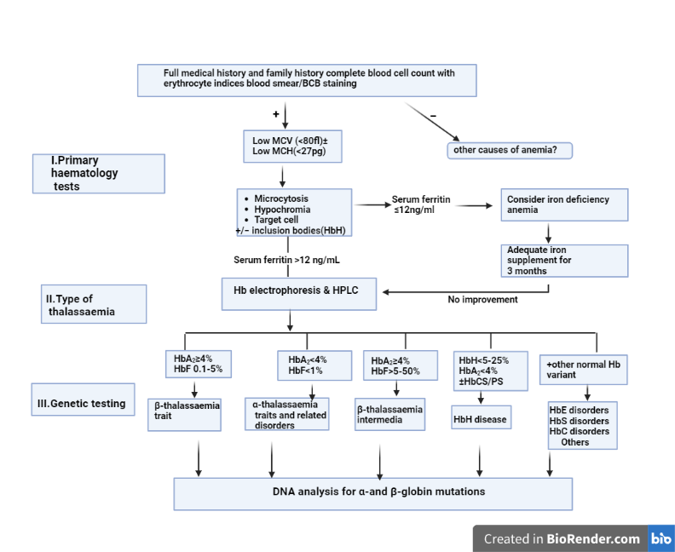

Fig6: Diagnostic flow chart for determining thalassemia

It is also advised against screening infants for thalassemia because it is too late for prophylaxis, thus alternative age groups may be the focus of the screening. There are several carrier screening protocols run globally at the premarital or early prenatal stage. These courses can be categorised as required or discretionary. All couples must now undergo hemoglobinopathy testing before gaining the all-clear to be married in a number of Islamic high-risk countries, including Iran, Saudi Arabia, and the Palestinian Territories[10]
- Treatment of thalassemia:
Iron chelation and blood transfusions are common thalassemia major therapies.
- Blood transfusions
During a blood transfusion, red blood cells are injected into a vein to restore the body's regular supply of healthyRBC and haemoglobin. For moderate or severe thalassemia, transfusions are given every four months, and for beta thalassemia major, they are given every two to four weeks. Sometimes transfusions are needed for beta thalassemia intermedia or haemoglobin H disease (for instance, when an infection is present).
Occasional blood transfusions:
may be recommended for those who have beta thalassemia intermedia or haemoglobin H illness. Specifically, when the human body is under stress—for example, after an illness, pregnancy, or surgery—a transfusion may be necessary.
regular transfusions of blood:
For those who have beta thalassemia major, (every 3–4 weeks) can be required. These blood transfusions support normal levels of haemoglobin and red blood cells.

- folic acid supplements
Supplementing with folic acid may help your body produce healthy blood cells.

- Iron chelation therapy
The removal of excess iron from your body is a step in the iron chelation process. Blood transfusions have a risk of iron excess. Too much iron might injure your organs. If you receive transfusions regularly, you'll need iron chelation therapy (which you can take as a pill).
- Deferasirox is used once day as a pill. Possible adverse effects include skin rash, nausea, and diarrhoea.
- Deferiprone is a drug that you might use if other treatments don't work. Your susceptibility to infections might increase if it lowers your white blood cell count.
- Deferoxamine is a liquid medication that is slowly administered under the skin, typically overnight using a tiny portable pump. This therapy requires time and might be slightly uncomfortable. Symptoms may include hearing loss and visual issues

- Bone marrow and blood transplantation
Only a bone marrow and stem cell donation from a compatible related donor may cure thalassemia.The compatibility of a donor and receiver of a contribution is determined by human leukocyte antigens (HLA), which are proteins located on the cell surfaces. During the process, your medical professional will infuse donor bone marrow stem cells into your circulation. After a month, the transplanted cells will begin producing fresh, normal blood cells.

- Other treatment
- A healthcare professional might recommend hydroxyurea with the drug luspatercept (Reblozyl) to treat thalassemia. People with moderate to severe anaemia due to thalassemia may require fewer blood transfusions as a result of luspatercept. Hydroxyurea can help reduce the risk of thalassemia-related health issues and is typically used for treating sickle cell disease.
- Surgery to remove the spleen is known as a plenectomy. If you're diagnosed with mild to severe thalassemia, your doctor might recommend you to get a splenectomy to reduce your symptoms. However, the body's capacity to fight infections is diminished when the spleen is removed.
- You'll get a medication called lupatercept every three weeks, which may help your body make more red blood cells. In the US, it is approved for the treatment of transfusion-dependent beta thalassemia.[11,12]
- Future Prospects of Thalassemia: Advancements and Promising Directions
advancements in thalassemia science and medicine provide those who have this inherited blood illness hope for better treatment and eventual treatments. Here are some hopeful future scenarios and directions for thalassemia:

Gene Therapy and Gene Editing: Scientists are exploring gene therapy for thalassemia treatment using viral vectors to transport functional copies of the damaged HBB gene into bone marrow stem cells, aiming to rectify genetic mutations and restore regular haemoglobin synthesis.
CRISPR-Cas9 gene editing technology enables precise and permanent thalassemia mutation editing, providing a targeted solution.

Fetal Hemoglobin Induction: Researchers are exploring pharmacological agents and gene regulation approaches to increase fetal hemoglobin production in thalassemia patients, as it has a higher oxygen-carrying capacity than adult hemoglobin.

Ex Vivo Stem Cell Therapies:Ex vivo stem cell treatments can be therapeutic by removing bone marrow or hematopoietic stem cells from thalassemia patients, genetically altering them to create healthy haemoglobin, and reinfusing them back into the patient.

Non-Transfusion-Dependent Thalassemia (NTDT) Treatments: NTDT refers to milder thalassemia without routine blood transfusions. Researchers are exploring novel medications to control symptoms, reduce iron overload, and improve overall quality of life.

Improved Iron Chelation Therapies: Thalassemia patients require iron chelation treatment for blood transfusions. Researchers are developing efficient, practical, and fewer adverse effects iron chelators to improve patient adherence and results.

Personalized Medicine and Precision Therapies: Personalised treatments based on genetic alterations and the severity of the disease are now possible because to breakthroughs in genomic medicine.

Conclusion: The diagnosis, administration, and prospective treatment of this complicated blood illness depend critically on our ability to comprehend the genetic foundation and inheritance pattern of thalassemia. With this information, researchers, medical professionals, and families are better able to handle the difficulties associated with thalassemia and strive towards better treatment and preventative methods. We expect more developments that will improve our capacity to tackle thalassemia as genetics and molecular medicine continue to evolve. Gene therapy and gene editing are two cutting-edge treatment modalities that have the potential to change the lives of people with thalassemia and give them hope for a future without the burden of their illness.

References:
- Shafique F, Ali S, Almansouri T, Van Eeden F, Shafi N, Khalid M, Khawaja S, Andleeb S, Hassan MU. Thalassemia, a human blood disorder. Braz J Biol. 2021 Sep 3;83:e246062. doi: 10.1590/1519-6984.246062. PMID: 34495151.
- Poonam Tripathi Genetics of Thalassemia June 17th, 2022 Reviewed: July 26th, 2022 Published: October 18th, 2022 DOI: 10.5772/intechopen.106748.
- Stamatoyannopoulos G. Control of globin gene expression during development and erythroid differentiation. Experimental Hematology. 2005;33(3):259-271. DOI: 10.1016/j.exphem.2004.11.007.

- Lee JS, Cho SI, Park SS, Seong MW. Molecular basis and diagnosis of thalassemia. Blood Res. 2021 Apr 30;56(S1):S39-S43. doi: 10.5045/br.2021.2020332. PMID: 33935034; PMCID: PMC8093999.

- Thein SL, Rees D. Haemoglobin and the inherited disorders of globin synthesis. In: Hoffbrand AV, Higgs DR, Keeling DM, Mehta AB, eds. Postgraduate haematology. 7th ed. Hoboken, NJ:Wiley-Blackwell, 2015:72-97.

- C. Michael Gibson, Shyam patel, Neel Patel thalassemia pathophysiology.

- Thalassemia - Symptoms and causes (2021). Available at: https://www.mayoclinic.org/diseases- conditions/thalassemia/symptoms-causes/syc-20354995 (Accessed: 8 September 2021).

- https://www.news-medical.net/health/Thalassemia-Pathophysiology.aspx.

- https://www.mayoclinic.org/diseases-conditions/thalassemia/symptoms-causes/syc-20354995.

- Hashemieh M, Timori Naghadeh H, Tabrizi Namini M, Neamatzadeh H, Hadipour Dehshal M. The Iran Thalassemia prevention program: success or failure? Iran J Ped Hematol Oncol 2015; 5: 161– 6

- https://my.clevelandclinic.org/health/diseases/14508-thalassemias#:~:text=Management%20and%20Treatment&text=Standard%20treatments%20for%20thalassemia%20major,red%20blood%20cells%20and%20hemoglobin.

- https://www.nhlbi.nih.gov/health/thalassemia/treatment#:~:text=Blood%20transfusions%20are%20the%20main,healthy%20blood%20through%20this%20line.

