Research Article

**Analytical QbD approach to HPLC method development and validation for Pregabalin**

**Shah Chandra K, *Dedania Zarna R, Dedania Ronak R, Jain Vineet C**

Department of Quality Assurance, Bhagwan Mahavir College of Pharmacy, Bhagwan Mahavir University, Vesu, Surat-395017, Gujarat, India.

*Corresponding Author:

Department of Quality Assurance,

Bhagwan Mahavir College of Pharmacy,

Bhagwan Mahavir University,

Nr. VIP Road, Vesu, Surat-395017.

**Email address:** [**zaroo229@gmial.com**](mailto:zaroo229@gmial.com)

**Mob No:** 9427239022

**ABSTRACT**

Analytical QbD helps in provides end to end solution for complete analytical life cycle management by systemic method development and maintenance. An efficient CCD - central composite design was developed with two factors mobile phase composition and pH at three different levels law, medium and high for RP-HPLC method. The response to be evaluated being retention time, peak asymmetry and theoretical plates. The chromatographic conditions were optimized with the Design Expert Software version10.0.1.0, i.e. Inertsil ODS column C18 (250mm × 4.6mm, 5.0µm), mobile phase phosphate buffer: methanol: acetonitrile 92:5:3 (v/v/v) adjusted to pH 5, at 1.2 ml/min flow rate at 210 nm detection wavelength with PDA detector. The retention time of Pregabalin was found to be 6.083 min. The developed RP-HPLC method was found to be linear from 200-1000 µg/ml with r2 = 0.9992. The system suitability parameters were; 0.916 as value of tailing factor and 4238 as value of theoretical plates. The % RSD for inter day and intraday precision was found to be 0.0112-0.0225 and 0.0058- 0.0182 respectively. The precision and robustness values were observed less than 2% indicate the preciseness of developed method. The results of assay was found to be 100.01 ± 0.72 %. The chromatographic peak purity indicate only pregabalin peak at observed retention time and any other peaks were absent. The results of all the validation parameters were as per ICH guidelines within the acceptance criteria. This experiment provides a better knowledge of the parameters that improve chromatographic separation with more dependence on the capabilities of the created HPLC technique to meet their intended demand. It gives practical information understanding that aids in the construction of chromatographic optimization for future application. The QbD technique of method development has aided in the understanding of method variables, lowering the probability of failure during method validation and transfer.

**KEY WORDS:** Quality by design, HPLC, Pregabalin, Design approach, CCD

**INTRODUCTION:**

Pregabalin is an antiepileptic agent which has structural similarity to gabapentin, it produces it action by binding with alpha2-delta subunit of voltage gated calcium channels [1]. Pregabalin was found to be stable at room temperature for about 26hrs. According to literature survey, few reports on determining pregabalin in pharmaceutical dosage form like spectrophotometric method [2], HPLC, Stability indicating HPLC method [3-6] and UPLC [7]. No method has been reported on QbD approach for RP-HPLC method. This proposed experiment is to develop an optimize HPLC method for pregabalin by QbD approach in pharmaceutical dosage form.

The quality by design method suggests investigating the analytical process's quality throughout the development stage. It states that rather than assessing the end outputs of the analytical process, quality should be embedded into the process design. A QbD is defined as "A systemic approach to method development that begins with predefined objectives and emphasizes product and process understanding and process control, all while relying on sound science and quality risk management." The QbD technique was founded on an awareness of and adherence to the ICH Q8 (Pharmaceutical Development), ICH Q9 (Quality Risk Management), and ICH Q10 (Pharmaceutical Quality System) principles. Many times, the difficulties in reaching the needed "six-sigma" performance are attributable to inadequate analytical technique robustness and dependability rather than manufacturing constraints. One of the methods is analytical testing. [8-10]

The aim of analytical QbD is to achieve quality in measurement. It entails different steps in method development by QbD approach and implementation of QbD in analytical validation.

The most widely used analytical technique in the pharmaceutical sector is high performance liquid chromatography, particularly reversed phase chromatography (RP-HPLC). In a QbD setting, the quality of RP-HPLC procedures has become more crucial. The analytical chemist's main task is to build a strong and durable analytical technique with optimal separation and lower run time. The conventional way for developing analytical methods is based on 'trial and error.' In this strategy, the analytical chemist optimizes one factor at a time utilizing past information. This strategy may produce in stable method circumstances, although they may not be optimum. Methods built using a conventional methodology may have robustness concerns. [11-15]. By statistical design of experiments, DoE develop multidimensional region of experimental space in which the effect of key factors are understand and documented. There is a high degree of confidence that the approach will work reliably, and this region can be characterized as the operating region. By doing earlier testing of robustness and ruggedness at the HPLC method's development stage using the QbD approach, the efficiency of the method is improved throughout the product's life cycle. If a non-rugged or non-robust system is adapted, it decreases the amount of time and effort needed to redesign and revalidate analytical procedures [16-18].

Regulatory bodies do not specify any specific procedure of analytical QbD; nevertheless, a parallel strategy based on product QbD can be strained. Analytical QbD (AQbD) produces results that are well understood and suitable for purpose throughout the life cycle, like process QbD. The Analytical Target Profile (ATP) such as system suitability test parameters like retention time, theoretical plates, peak asymmetry, and resolution. The Critical Method Attributes (CMAs) such as mobile phase composition, pH of mobile phase, detection wavelength, temperature. With given set of ATP and CMA, the method operable design region (MODR) was developed for Analytical QbD method. [19,20]

Required steps in developing analytical method with QbD approach are as follows: a) Selection of API and formulation b) Literature review and initial risk assessment c) Identification of ATP, CMAs, risk assessment d) HPLC Method optimization and development with Design of Experiment e) MODR, Control strategy and risk assessment f) AQbD method validation g) Continuous method monitoring.

With all of these processes, the goal of the study was to go through the essential procedures, such as developing an HPLC technique for the quantitative detection of pregabalin and optimizing it according to the QbD principle. The technique was then validated in accordance with ICH Q2(R1) [21] requirements, and the improved and validated HPLC method was used to quantify Pregabalin in pharmaceutical dose form.

**MATERIALS AND METHODS:**

**Instrument and reference standards**

The Agilent HPLC 1260 infinity (binary pump) with Detector–PDA absorbance detector, Inertsil ODS C18 (250 mm×4.6 mm, 5.0 µm) was used at room temperature.

**Materials**

Pregabalin Active Pharmaceutical Ingredient (API) was obtained as gift sample from Intas Pharmaceutical Pvt. Ltd., Ahmedabad, Gujarat. All reagent and chemical used were of analytical grade, and HPLC grade solvents were used. The marketed formulation 75 mg Neurica by micro labs was used for assay.

**Preparation of reference standard solution**

A 1000 µg/ml Pregabalin solution was prepared by dissolving 10 mg of Pregabalin API to 10 ml volumetric flask with methanol as solvent. The resulting solution was further diluted to 100 µg/ml with methanol as solvent as sub-stock solution.

**Selection of detection wavelength**

10g/ml of pregabalin was scanned in the 200-400nm range, and the maximum wavelength of 210 nm was chosen as the detection wavelength.

**HPLC method development and optimization by QbD approach**

**Selection of Analytical target profile**

The ATP is crucial in determining the elements that influence the ATP parameters. For the suggested HPLC technique, the retention duration, theoretical plates, and peak asymmetry were recognized as ATP.

**Determine critical material attributes**

CMAs have a direct effect on the ATP parameters. The mobile phase composition and buffer pH were two CMAs essential factors that needed to be regulated in order to maintain an appropriate ATP response range.

**Preparation of standard solution**

The working standard solution of 10 µg/ml was prepared by diluting 1 ml form sub-stock solution of 100µg/ml and dilute upto 10 ml with methanol.

**Optimization of chromatographic condition**

The Inertsil ODS C18 column (250mm × 4.6mm, 5 µm) as stationary phase equilibrated with a mobile phase phosphate buffer: methanol: acetonitrile (with pH 5) to (92:5:3 v/v/v) at 1.2 ml/min flow rate. The experiment was carried out at room temperature. The PDA (photo diode array) detector was used and 210nm was selected as detection wavelength. With these optimized chromatographic parameters, the drug acquired a decent separation and peak asymmetry. Using a central composite design, the HPLC technique for pregabalin was adjusted for several parameters, including mobile phase and pH as two variables at three distinct levels i.e. law, medium and high.

**Factorial design**

In AQbD analytical quality by design, after defining the ATP and CMAs the central composite experimental design (CCD, Design Expert version 10.0.1.0) was used for optimization and selection of two key components: mobile phase and pH of HPLC method. For three levels, BBD (Box behnken design) and CCD (central composite experimental design) are best designs. We choose CCD (central composite experimental design) in which star points are at the center of each face of the factorial space [22-29] so; resolution is more with CCD matrix. This variety requires three levels (-1, 0, +1) of each factor.

The mobile phase composition and buffer solution pH were chosen as independent variables (factors based on preliminary investigation). For a total of 11 experimental runs with triplicate testing for the central point (0, 0), a design matrix with the selected components at low (-1), medium (0), and high (+1) values was used.

Design Expert* (Version 10.0.1, State-Ease Inc.), the best suited response for second order polynomial exploring response surface, was used to create the central composite statistical screening design at three different levels to study the various interaction effects and quadratic effects of the mobile phase composition and pH of buffer solution on the retention time, theoretical plates, and peak asymmetry. [30].

Y=ß0 + ß1X1 + ß2X2 + ß12X1X2+ ß11X12 + ß22 X22 (1)

ß0 is an intercept, ß1, ß2, ß12, ß11, ß22, are regression coefficients and X1 and X2 are independent variables coded for levels.

Independent variables are mobile phase composition and pH and dependent variables or responses were retention time, theoretical plates and peak asymmetry were selected for proposed method. Interaction and quadratic terms respectively is represented by X1X2, X12, and X22.

We may use ANOVA to decide whether to include or omit the coefficients of linear terms (such as X1, X2), interaction terms (such as X1X2), and quadratic terms (such as X12, and X22). The p-values for each coefficient regression term are used to make this conclusion. When the p-value of a coefficient regression term is less than 0.05, it should usually be included in the regression model. In other words, when the regression coefficient term (p-value > 0.05) shows that modifying the input factor levels has no effect on the output response. As a result, this coefficient regression term may be removed from the regression model.

Variable and process parameter multivariable interactions have been investigated. These procedure conditions were being selected by evaluating experimental results utilizing the CCD methodology. The retention time, theoretical plates, and peak asymmetry were all investigated first. The chromatographic condition for pregabalin was distinct. The demonstrated acceptable ranges are derived from resilient zones where purposeful modification in procedure parameters has no effect on quality. This guarantees that the method will not fail during validation testing. If the modeling trials do not produce the intended results, the variables must be tuned at various levels until the results are within the acceptable range. Table 1 shows the most appropriate chromatographic condition, which will be tuned using Design Expert Tools.

**Table 1 Coded values for independent variables**

|  |  |  |  |  |
| --- | --- | --- | --- | --- |
| **Analytical Factors** | **Coded value** | **Different Levels** | | |
|  |  | -1 | 0 | 1 |
| Phosphate buffer: methanol: acetonitrile | A | 87:8:5 | 92:5:3 | 97:2:1 |
| pH of buffer | B | 4 | 5 | 6 |

**Risk Assessment and Control Strategy**

A risk-based methodology based on the QbD concept outlined in the ICH Q8 and ICH Q9 recommendations was used to evaluate the robustness and ruggedness of the procedure. According to the ICH Q8 guideline, process robustness is defined as "the ability of a process to tolerate material variability and changes in the process and equipment without negatively impacting quality."

The Ishikawa diagram is one way for determining risk through cause and effect analysis. The final optimized technique is chosen based on the method's qualities; the produced method is efficient and will remain operational throughout the product's lifespan. A design of experiment (DoE) is required to determine the robustness of a procedure. The characteristics and performance of the technique were assessed in many purposefully obtained situations (different reagents, analysts, and days) for the robustness and ruggedness studies. The technique's robustness was tested by making slight adjustments to the CMPs (Critical method parameters) such as methanol supply, mobile phase flow, and buffer solution pH, and ruggedness was determined by changing the analyst and the days when analyses were done. The acceptability limit for retention duration, peak area, and symmetry factor must be less than 2% relative standard deviation (RSD).

Correlations between technique and analyte features for the capacity to achieve analytical target profile (ATP) requirements may be derived using this statistical experimental data. The discrepancy of method parameters will be resolved by the control strategy. It consists of a designed set of controls generated from an awareness of many characteristics, such as analytical technique, risk management, and fitness for purpose. All of these criteria guarantee that the method's performance and product quality outputs are within the analytical target profile.

Continuous improvement for controlling the analytical life cycle. CMM (continual method monitoring) is the final phase in the AQbD life cycle; it is a continual process of sharing information gathered during the creation and execution of design space. Management of the analytical life cycle will result in continuous improvement by monitoring the quality consistency and periodic maintenance of HPLC instruments, computers, and upgrading software and other relevant apparatus and instruments within the laboratory. [28].

**Analytical method validation**

The Analytical method validation is recorded proof that provides a high degree of assurance for the specific technique employed to certify the analytical process is adequate for its intended usage. The developed HPLC technique for estimating pregabalin was validated in accordance with ICH Q2 (R1) requirements.

**System suitability studies**

The system suitability was determined by analyzing six replicates of pregabalin. The retention time, peak asymmetry and theoretical plates were calculated for standard solution.

**Linearity**

Pregabalin's linearity was assessed by examining 5 different level conc. ranges of 200-1000 µg/ml. Concentration versus peak area was shown as the calibration curve. The values of the regression line equation and correlation coefficient were calculated.

**Precision**

The repeatability was determined by measuring six samples of 1000 µg/ml pregabalin. The intraday and interday precision were assessed by evaluating three distinct concentrations of pregabalin 400, 600, and 800 g/ml three times, twice on the same day at a 2hr interval, and three times on different days. The % RSD acceptability limit was less than 2.

**Accuracy**

The method's accuracy was determined by spiking or standard addition of API method at 80%, 100%, and 120% level to pharmaceutical formulation. The acceptability limit for % recovery was 98-102%.

**LOD and LOQ**

The lowest drug concentration that can be properly detected from the background is referred to as a detection limit LOD, while the lowest concentration that can be measured is referred to as a quantification limit LOQ.

**Robustness and ruggedness**

Robustness is measured by subjecting the technique to slight changes in its condition, such as pump flow rate and mobile phase pH. Changing the analyst as an extrinsic influencing element determines the toughness. The computed% RSD of peak area acceptability limit was less than 2.

**Assay**

Twenty tablets were pulverized and weighed. Transfer the powder equivalent to 75 mg of pregabalin tablet powder was transferred to 100 ml volumetric flask and weigh it properly. Add 25 ml of methanol and sonicate for 15 minutes, or until the powder dissolves, before making up the volume with the mobile phase. Using 0.42 Whatman filter paper, filter the solution. Dilute 6 ml of the filtrate upto 10 ml with mobile phase to get a concentration of 450µg/ml. Calculation was based on the mean of three separate experiments.

**RESULTS AND DISCUSSION:**

The mobile phase consisting phosphate buffer: methanol: acetonitrile 92:5:3 (v/v/v) adjusted to pH 5. The optimized chromatographic peak showed the results as per acceptance criteria of system suitability test parameters. So, this mobile phase composition and pH is chosen as further introduced to Design Expert Software. QbD approach using CCD by studying the interrelationships of two factors mobile phase composition and pH at three different levels were shown in Table 2. The 3D response surface plot for (a) retention time (b) peak asymmetry (c) theoretical plates, showing effect of mobile phase ratio and pH were shown in Figure 1.

**Table 2 Optimization of parameters for analysis of pregabalin using CCD**

|  |  |  |  |  |  |
| --- | --- | --- | --- | --- | --- |
| **Experiment No** | **Factor 1**  **Phosphate buffer: methanol: acetonitrile** | **Factor- 2**  **pH** | **Response 1**  **Retention time** | **Response 2**  **Theoretical plate** | **Response 3**  **Peak asymmetry** |
| 1 | 92:5:3 | 5 | 4.310 | 1440 | 0.916 |
| 2 | 92:5:3 | 6 | 9.973 | 4073 | 0.793 |
| 3 | 97:2:1 | 4 | 13.127 | 3230 | 1.917 |
| 4 | 97:2:1 | 6 | 18.037 | 3952 | 0.844 |
| 5 | 87:8:5 | 5 | 7.607 | 1469 | 0.810 |
| 6 | 87:8:5 | 4 | 7.937 | 3502 | 1.555 |
| 7 | 97:2:1 | 5 | 15.467 | 2846 | 0.704 |
| 8 | 92:5:3 | 5 | 4.310 | 1440 | 0.916 |
| 9 | 92:5:3 | 4 | 12.217 | 3816 | 2.062 |
| 10 | 87:8:5 | 6 | 6.083 | 4238 | 0.885 |
| 11 | 92:5:3 | 5 | 4.310 | 1440 | 0.916 |

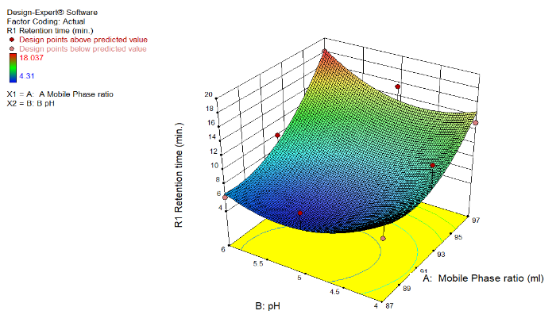 (a)

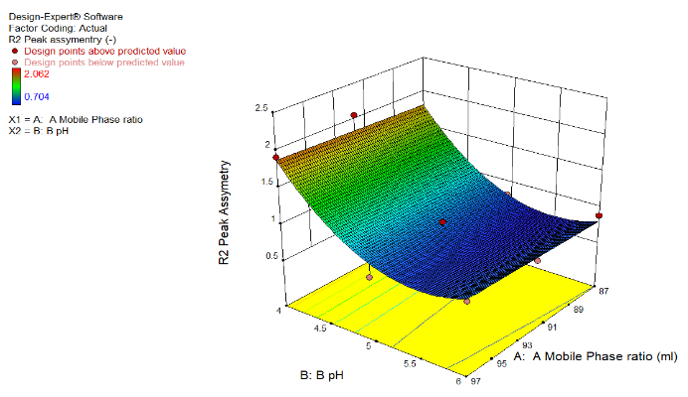 (b)

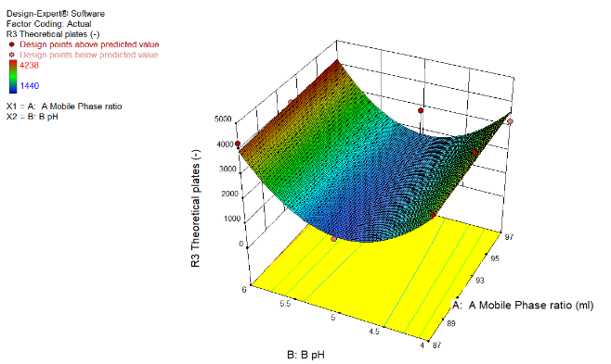

(c)

**Figure 1: 3D response surface plot for (a) Retention Time (b) Peak Asymmetry (c) Theoretical Plates, showing effect of mobile phase ratio and pH at three different levels**

From Fig 1(a) and equation Retention Time (for actual values) = 1355.99 -26.83*A -61.85*B +0.3382*AB + 0.1411*A2 +3.087B2, it was concluded that as A negative coefficient (-26.83) suggest that the amount of phosphate buffer in mobile phase (A) decreases and B also negative coefficient (-61.85), It resulted that, amount and pH of the buffer decreases the value of retention time increased.

From Fig 1(b) and equation peak assymetry (for actual values) = 3473.55-1641.66*A.-19792.13*B- 0.700*AB + 9.089 *A2 + 2014.23*B2, it was concluded that as A negative coefficient (-1641.66) suggest that the amount of phosphate buffer in mobile phase (A) decreases and B also negative coefficient (-19792.13) so, the amount and pH of the buffer decreases the value of theoretical plates increased.

From Fig 1(c) and equation theoretical plates (for actual values) =44.26 + 1.155*A – 3.93*B - 0.02*AB- 5.611E-003*A 2+ 0.52*B2, it was concluded that as A positive coefficient (1.155) suggest that the amount of phosphate buffer in mobile phase (A) increases and B also negative coefficient (-3.93) so, amount and pH of the buffer decreases the value of peak asymmetry increased.

The optimized solution showed the mobile phase composition phosphate buffer: methanol: acetonitrile in a ratio of 87:8:5 (v/v/v) and buffer pH were 6 for which the observed desirability was 0.906 which is very close to 1 as shown in Table 3 and Figure 2.

**Table 3 Obtained solution for optimized chromatographic conditions**

|  |  |  |  |  |  |
| --- | --- | --- | --- | --- | --- |
| **Phosphate buffer: methanol: Acetonitrile** | **pH** | **Retention time** | **Peak asymmetry** | **Theoretical Plates** | **Desirability** |
| 87:8:5 | 6 | 6.682 | 0.805 | 4030 | 0.906 |

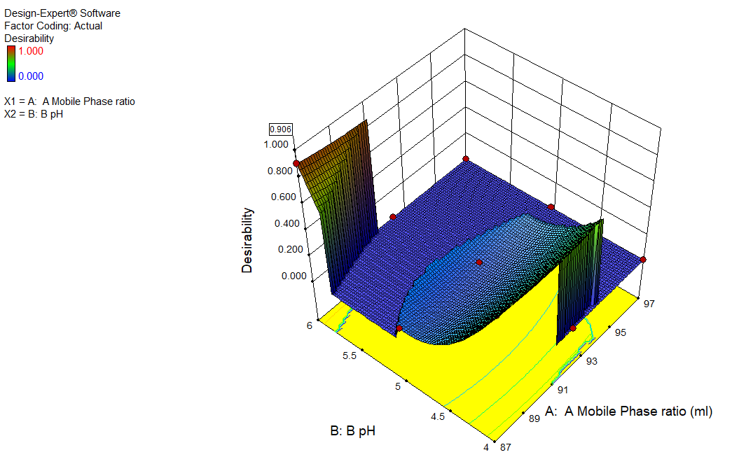

**Figure 2: 3D surface plot of desirability for obtaining optimized formulation**

**HPLC method development by QbD approach**

**Analytical target product profile (ATP)**

The ATPs used for optimization of HPLC chromatographic conditions were retention time, peak asymmetry, and theoretical plates.

**Critical Material Attributes (CMAs)**

The mobile phase was identified as phosphate buffer: methanol: acetonitrile 92:5:3 (v/v/v), pH adjusted to 5.

**Factorial design**

For the suggested HPLC technique development, the CCD central composite design was chosen. Table 2 depicts the optimization of several parameters.

**Design space**

With 11 runs, the response surface research type, central composite design, and quadratic model were applied. The proposed CCD experimental design was used, and five center points were chosen to evaluate the mobile phase composition and pH of the buffer against three responses, retention time, peak asymmetry, and theoretical plates.

It was achieved by analyzing all answers in various experimental conditions with the Design expert software10.0.1 and optimized HPLC conditions, and anticipated responses were determined. Figure 3 depicts the design space plot for the Retention time, Peak asymmetry, and Theoretical plates.



**Figure 3** Design space plot for pregabalin.

The observed value for response was derived by conducting the HPLC chromatogram with a specific combination of mobile phase and buffer pH and comparing it to the anticipated values to get the percentage predicted error.

**Method validation**

**System suitability**

The system suitability test was done to a typical chromatogram to examine several characteristics such as retention time, which was determined to be 6.236min and theoretical plates were 4038, peak asymmetry, which was 0.914, and the percentage RSD of six duplicate injections, which was 0.0045.

**Linearity**

The calibration curve for pregabalin was plotted across the concentration range 200-1000µg/ml. When a graph was constructed with peak area versus concentration, the regression equation for the calibration curve was determined to be y = 780.3x - 58085 with a 0.9992 correlation coefficient, as shown in Table 3.

**Table 3** Linearity of Pregabalin

|  |  |  |
| --- | --- | --- |
| **Sr. no.** | **Concentration (µg/ml)** | **Peak area (mean ± SD) (n=5)** |
| 1 | 200 | 91274 ± 19.40 |
| 2 | 400 | 255735 ± 23.57 |
| 3 | 600 | 419160 ± 22.94 |
| 4 | 800 | 569721 ± 11.69 |
| 5 | 1000 | 714579 ± 12.72 |

**Precision**

Based on six measurements of the same concentration (1000g/ml), the % RSD for repeatability for pregabalin was determined to be 0.0045, which is less than 2. Table 5 displays intraday and interday precision. The % RSD result of less than 2 demonstrated that the devised approach is accurate.

**Table 5 Intraday and Interday Precision Study for pregabalin**

|  |  |  |  |
| --- | --- | --- | --- |
| **Precision** | **Concentration (µg/ml)** | **(Mean ± SD) (n= 3)** | **%RSD** |
| Intraday precision | 400 | 255641 ± 20.01 | 0.0078 |
|  | 600 | 419067 ± 76.64 | 0.0182 |
|  | 800 | 568854 ± 33.02 | 0.0058 |
| Interday precision | 400 | 255651 ± 57.56 | 0.0225 |
|  | 600 | 419018 ± 87.09 | 0.0208 |
|  | 800 | 569306 ± 68.13 | 0.0112 |

**Accuracy**

The accuracy was determined using a recovery study, and sample solutions were created by spiking at three levels: 80%, 100%, and 120%. The results in Table 6 demonstrate that the percentage recovery ranges between 98 and 102%. As a result, is justifying that the established approach was accurate in accordance with ICH Q2 (R1) requirements.

**Table 6 Recovery of Pregabalin**

|  |  |  |  |  |  |
| --- | --- | --- | --- | --- | --- |
| **Assay level** | **Amount equivalent to tablet powder (mg)** | **Spiked Amount (mg)** | **Total amount (mg)** | **Recovered amount (mg ± SD) (n=3)** | **% Recovered spiked amount ± SD (n=3)** |
| Blank | 450 | 00 | 450 | 450.59 ± 0.88 | 101.19 ± 1.42 |
| 80% | 450 | 360 | 810 | 803.23 ± 8.08 | 99.18 ± 1.08 |
| 100% | 450 | 450 | 900 | 899.34 ± 8.73 | 99.93 ± 1.78 |
| 120% | 450 | 540 | 990 | 991.24 ± 7.67 | 100.13 ± 1.76 |

**Robustness and ruggedness studies**

Pregabalin 1000µg/ml solution was utilized for robustness and roughness studies. The resilience was investigated by making little but purposeful changes to intrinsic technique parameters such as ump flow rate and buffer pH. The roughness was investigated as an external influencing element by a change in analyst. By changing the pH of the mobile phase, the flow rate, and the analyst, the % RSD for the peak was determined to be less than 2.

**LOD and LOQ**

The LOD and LOQ for pregabalin based on standard deviation of slope and intercept were found to be 36.30µg/ml and 110.02µg/ml respectively.

**Assay**

When the analysis was done from tablets, the optimized chromatogram for pregabalin indicated a resolved peak at retention time 6.083. The % evaluation of drug content for pregabalin found it to be for the label claim. The results of the experiment demonstrated the method's capacity to measure properly and precisely in the presence of excipients in tablet powder.

**CONCLUSION:**

A quality by design approach to HPLC method development has been described for pregabalin. Analysis of the target product profile reveals the method's precise objectives. The experimental design CCD explains the function of HPLC technique elements, such as mobile phase composition and buffer solution pH. The analytical Qbd strategy simplifies the development of the Pregabalin HPLC procedure, identifies the higher performing system, and selects the final design space. Using a central composite design, a multivariate investigation of numerous process parameters such as mobile phase composition and buffer solution pH was undertaken at three distinct levels. Chromatographic optimization gives the idea about the factors influencing chromatographic separation in the ability to meet their intended purpose. Then method validation is done. Method validation gives the idea about all the parameters were in acceptable range. The method found to be accurate, precise, linear, specific, robust and rugged for determination of pregabalin.

Less method failure during method validation and transfer, thanks to the QbD approach to method development's improved understanding of method variables. In comparison to manual Qbd, the Design Expert Software 10.0.1 automates the process, which takes less time and uses less solvent. The relationship between independent factors or variables and dependent factors or responses is shown through statistical analysis of the data. It conveys the sense of robust, accurate selection, and reproducibility. Future analyses of quality control in the pharmaceutical business will follow this methodology.

**CONFLICT OF INTEREST:**

The authors have no conflicts of interest regarding this investigation**.**

**REFERENCES**

1. Blommel ML, Blommel AL. Pregabalin an antiepileptic agent useful for neuropathic pain. Am J Health Syst Pharm. 2007 Jul 15; 64(14):1475-82. https://doi.org/10.2146/ajhp060371.
2. Santosh S. Chhajed a, Sandeep S. Sonawane, Akshada P. Pingle, Neelam Dashputre, Sakshi, Sanjay J. Kshirsagara. Development and Validation of UV Spectrophotometric Method for Estimation of Pregabalin. Asian J. Pharm. Ana. 2019; 9(1):15-18.
3. Janmajoy Banerjee, H. Padmalatha, Rahul, Ranabir Chanda. Method Development and Validation for the Simultaneous Estimation of Eplarestat and Pragabalin in Bulk and Pharmaceutical Formulation by using RP-HPLC. Asian J. Pharm. Ana. 2018; 8(3): 174-180.
4. Prashant Pingale, Tanmay Singasane. Development and validation of HPLC method for the determination of pregabalin in bulk and in pharmaceutical formulations. Research J. Pharm. and Tech. 5(6): June 2012; Page 829-833.
5. S. Ashutosh Kumar, Manidipa Debnath, J.V.L.N. Seshagiri Rao, D. Gowri Sankar. Stability Indicating Analytical Method Development and Validation for Simultaneous Estimation of Pregabalin, Mecobalamin and Alpha Lipoic Acid in Bulk as well as in Pharmaceutical Dosage Form by using RP-HPLC. Research J. Pharm. and Tech. 7(9): Sept. 2014 Page 1004-1013.
6. Sreekanth.D, P. Ramya, Vishwanadham.Y, Vanitha. R. Development and Method Validation of RP-HPLC For Simultaneous Determination of Pregabalin and Methylcobalamin in Pure and Pharmaceutical Dosage Form. Asian J. Research Chem. 2017; 10(4):557-565.
7. Parthasarathi Thoddi, Girendra Kumar Gautam CH, Narasimha Raju BH. A Stability-Indicating UPLC Method for Simultaneous Quantification of Epalrestat and Pregabalin in Bulk and Marketed Formulations. Research Journal of Pharmacy and Technology. 2022; 15(1):206-2.
8. The international Conference on Harmonisation ICH Technical Requirements for Registration of Pharmaceuticals for Human Use on Pharmaceutical Development Q8 (R2). 2009; https://database.ich.org/sites/default/files/ Q8_R2_Guideline.pdf
9. The international Conference on Harmonisation ICH Technical Requirements for Registration of Pharmaceuticals for Human Use on Quality Risk Management Q9. 2005; https://database.ich.org/sites/default/files/ Q9_Guideline.pdf
10. The international Conference on Harmonisation ICH Technical Requirements for Registration of Pharmaceuticals for Human Use on Pharmaceutical Quality System Q10. 2008; https://database.ich.org/sites/default/files/Q10_Presentation.pdf
11. Dhand V, Dedania Z, Dedania R, Nakrani K. QbD approach to HPLC method development and validation of orciprenaline sulphate. J Global Trends Pharm Sci. 2020; 11: 8634-8640.
12. Rajkotwala A, Shaikh S, Dedania Z, Dedania R, Vijyendraswamy S (2016) QbD Approach To Analytical Method Development and Validation of Piracetam By HPLC. World J Pharmacy Pharmaceutical Sci 5:1771-1784.
13. Singh P, Maurya J, Dedania Z, Dedania R (2017) QbD Approach for Stability Indicating HPLC Method For Determination of Artemether And Lumefantrine In Combined Dosage Form. Int J Drug Reg Affairs 5:44-59.
14. Prajapati R, Dedania Z, Jain V, Sutariya V, Dedania R, Chisti Z (2019) QbD Approach to HPLC Method Development and Validation for Estimation of Fluoxetine Hydrochloride and Olanzapine In Pharmaceutical Dosage Form. J Emerging Tech Innovative Res 6:179-195.
15. Babar S, Sudhakar L, Padwal. QbD approach to HPLC method development and validation for estimation of lenvatinib in bulk and pharmaceutical formulation. Int J App Pharm. 2021;13(5): 183-188.
16. Bhutani H, Kurmi M, Singh S, Beg S, Singh B. Quality by Design (QbD) in analytical science: an overview. Pharma Times. 2014; 46(8): 71-75.
17. Noel Baker, Walkiria S, Mark G. Quality Risk Management https://onlinelibrary.wiley.com/doi/10.1002/9781118895238.ch2
18. Patel, K.Y., Dedania, Z.R., Dedania, R.R. et al. QbD approach to HPLC method development and validation of ceftriaxone sodium. Futur J Pharm Sci 7, 141 (2021). <https://doi.org/10.1186/s43094-021-00286-4>
19. Desai Devanshi, Dedania Zarna, Jain Vineet. Analytical Qbd Approach to HPLC Method Development and Validation for Tolfenamic Acid. International Journal of Research and Analytical Reviews. 2022;9(3):498-507
20. Kalleshvar P. Jatte, R. D. Chakole, M. S. Charde. Degradation Profiling of Lisinopril and Hydrochlorothiazide by RP- HPLC method with QbD Approach. Asian Journal of Pharmaceutical Analysis. 2021; 11(4):270-4.
21. The international Conference on Harmonisation ICH Technical Requirements for Registration of Pharmaceuticals for Human Use on Validation of Analytical Procedure Text and Methodology Q2(R1). 2005; https://database.ich.org/sites/default/files/Q2%28R1%29%20Guideline.pdf
22. D. D. Masne, R. D. Chakole, M. S. Charde. QbD Approached in Method Development, Validation and Degradation Profiling of Aripiprazole a Antidepressent Agent. Asian Journal of Pharmaceutical Analysis. 2022; 12(1):29-4.
23. Patil Karishma Ashok, Firke Sandip Dinkar. Determination and Development of UV-Spectrophotometric method for the Amodiquine Hydrochloride by using quality by design (QBD) approach. Asian J. Pharm. Ana. 2019; 9(3):113-117.
24. G. K. Dyade, Bhushankumar Arve, Chaitanya Nimbalkar. Implementation of QBD Approach in Analytical Method Development of Fluvastatin by UV-VIS Spectrophotometry. Asian Journal of Pharmaceutical Analysis. 2022; 12(2):87-3.
25. Kumar N, Sangeetha D, Analytical method development by using QbD An emerging approach for robust analytical method development. J. Pharm. Sci. Res. 2020; 12, 1298–1305.
26. Fukiuda IM, Pinto CF, Moreira CS, Saviano Am, Lourenco FR. Design of experiment applied to pharmaceutical and analytical QbD. Braz. J. Pharma. Sci.2018; 54: https://doi.org/10.1590/s2175-97902018000001006
27. Ramalingam P, Kalva B, Reddy Y. Analytical quality by design; a tool for regulatory flexibility and robust analytics, Int J ana Chem. 2015; https://doi.org/10.1155/2015/888727
28. Bhattacharya S. Central Composite Design for Response Surface Methodology and Its Application in Pharmacy. In Response Surface Methodology in Engineering Science; Kayaroganam P. Ed.; Intech Open: London, UK, 2021; p. 270.
29. Jaybhave AR, Shindhe M, Mogal R, Narkhede S, Jadhav A. QbD Approach to Analytical RP-HPLC Method Development and Validation of Tenofovir Disoproxil Fumarate in Dosage Form. J of Pharm Sci. and Research. 2021; 13(7), 381-386.
30. Sandhu, PS, Beg S, Katare OP, Singh B, QbD-Driven Development and Validation of a HPLC Method for Estimation of Tamoxifen Citrate with Improved Performance. J. Chromatogr. Sci. 2016; 54: 1373–1384. Petitti DB, Crooks VC, Buckwalter JG, Chiu V. Blood pressure levels before dementia. Arch Neurol. 2005 Jan;62(1):112-6.