Greening Construction: Harnessing Waste Starch Water as an Eco-friendly Admixture for Sustainable Concrete Structures
T.Praveen Kumar¹, G.Naresh²*, M.Aswathy^{3#}, Aaryan Anil^{4#}
^{1, 2} Department of Automobile Engineering, SRM Institute of Science & Technology, Kattankulathur Campus, Chengalpattu – 603 203, tamilnadu, India.
^{3, 4} Department of Mechanical Engineering, SRM Institute of Science & Technology, Kattankulathur Campus, Chengalpattu – 603 203, tamilnadu, India.
*Corresponding author:- E-mail: nareshg@srmist.edu.in || Tel: +91 99401 77837
Abstract
This research investigates the novel utilization of waste starch water as an admixture in concrete, targeting enhanced workability and mechanical attributes. The study explores compositions with 10%, 15%, and 20% starch water by weight, relative to conventional potable water, to fabricate concrete specimens. Noteworthy outcomes include a 100% increase in initial setting time with 20% starch water and a remarkable improvement in workability, as evidenced by a 50% decrease with 10% starch water and a 70% reduction with 20% starch water. Compressive strength analysis reveals an optimal composition with 15% starch water, showcasing a notable 3.5% increase (44.44 N/mm²) compared to conventional concrete. Microstructural examinations highlight starch-water induced alterations. These findings underscore the feasibility of sustainable concrete production, offering an innovative avenue for eco-friendly construction practices and improved material utilization.

Keywords: Admixture, Waste starch water, Concrete admixture, Sustainable construction, Potable water replacement.
1. Introduction
Concrete, a cornerstone of modern infrastructure, stands as a testament to the synergy between structural engineering, strength of materials, and solid mechanics [1]. Mechanical engineers, deeply vested in optimizing mechanical properties like compressive strength, durability, and fracture resistance, underpin the very essence of this symbiotic relationship [2]. However, as the global construction industry burgeons, so does the strain on limited freshwater resources, particularly acute in regions grappling with water scarcity. This pressing challenge has spurred a quest for innovative solutions that not only bolster concrete's mechanical prowess but also align with the ethos of eco-conscious construction practices [3]. While sustainable strategies have flourished within civil engineering, the intersection with mechanical engineering's purview remains a fertile ground for exploration [4]. In the intricate tapestry of construction, where structural integrity meets material resilience, this study navigates the convergence of mechanical engineering principles and sustainable construction practices. Focused on the infusion of waste starch water—an oft-neglected byproduct of rice boiling—into the matrix of concrete, this research uncovers an uncharted terrain where mechanical ingenuity merges with environmental stewardship. Mechanical engineers, well-versed in analyzing material behavior under the duress of loads and strains, occupy a pivotal role in advancing material science, and their partnership with eco-friendly materials, such as waste starch water, beckons an era of transformative concrete technology.
Waste starch water, typically consigned to environmental neglect, emerges as a latent gem, embodying biogenic potential with the capacity to sculpt concrete's mechanical attributes [5]. This study is meticulously designed to gauge the impact of waste starch water on the mechanical characteristics of concrete. By casting the spotlight on the crossroads of eco-friendly construction and mechanical resilience, this research embodies a holistic perspective, embracing the enduring goal of engineering structures that harmonize seamlessly with nature. In the orbit of these ambitions, our research objectives stand resolute to comprehensively elucidate waste starch water's multifaceted influence on concrete. Rooted in this purpose, our research questions bear witness on how does the infusion of waste starch water modulate the initial setting time and Workability of concrete? What is the dynamic interplay between waste starch water and concrete's compressive strength, spanning diverse curing periods? How does the integration of waste starch water augment the split tension resistance of concrete structures? By responding to these queries, we delve into the mechanical integrity of waste starch water and concrete, painting a panorama where mechanical integrity fuses harmoniously with sustainable construction paradigms.
Moving beyond the realms of conventional concrete mixing, this study manifests its mechanical perspective by delving into the nuances of material behavior at the microscale. Within this exploration, the mechanical engineer's lens seeks to unravel the intricate interaction between waste starch water and the cementitious matrix. The initial setting time, a critical mechanical parameter, is meticulously probed, revealing how the introduction of waste starch water retards the cement hydration process. As the narrative of mechanical engineering entwines further, the study's focus extends to Workability—a term resonating deeply with mechanical engineers as it encapsulates a material's behavior under external forces. The unique lubricating properties of waste starch water are unveiled, meticulously explored through Workability tests. These findings escorts in a novel chapter in the mechanical engineer's playbook, offering insights into improved pouring, compaction, and finishing, ultimately amplifying the efficiency and quality of construction. Compressive strength, the bedrock of structural integrity, casts its formidable shadow on this investigation. In this symbiotic dance of mechanical and environmental synergy, the research investigates how waste starch water influences compressive strength over varied curing periods. While an initial reduction in early-age compressive strength is observed due to the retarding effect of starch, the long-term trajectory sees these mechanical parameters converging, unveiling the latent promise of waste starch water's harmonious integration into the concrete matrix.
SEM and EDX analyses unravel the microstructural nuances of waste starch water-infused concrete, offering visual narratives of how the mechanical engineer's decisions ripple across the material's fabric at a microscopic level. Within this multifaceted realm of mechanical-engineering-integrated sustainable construction, this research bridges an essential gap between civil and mechanical engineering. The aim, beyond constructing ecologically friendly structures, is to empower mechanical engineers to wield their expertise in creating sustainable solutions that boast formidable mechanical integrity. In conclusion, as waste starch water breathes new life into concrete, it also rekindles the synergy between mechanical and environmental consciousness, positioning mechanical engineers as torchbearers of sustainable construction's mechanical fabric.
2. Materials and Methods
2.1. Materials used
For this experimental study, cement of grade-OPC 53 (IS 12269-1987) was procured from Ultratech Ltd, India. The consistency of cement was determined to be 30% as per IS 4031 PART 4 1988 [6], with an initial setting time of 30 minutes as per IS 4031 PART 5 1988 [7]. The specific gravity of cement was measured to be 3.15 as per IS 4031 PART 11 [8], and its fineness was found to be 2% as per IS 4031 PART 1. Fine aggregate with a specific gravity of 2.67 (as per IS 2386 PART 3-1963 [9]) and a fineness modulus of 3.76 (confirmed from zone 1 as per IS 383-1970 [10]) was used. Coarse aggregate had a specific gravity of 2.8 (as per IS 2386 PART 3-1963), and its fineness modulus was 3.08 with the arrangement of sieve sizes being 80 mm, 40 mm, 20 mm, 16 mm, 12.5 mm, and 4.75 mm. The specific gravity of rice porridge water was measured to be 1.08.
2.2. Particle size distribution for aggregates
The particle size distribution of aggregates is a crucial parameter that directly affects concrete's mechanical characteristics, durability, and performance. Accounting it, this study conducted a detailed analysis of the particle size distribution for both fine and coarse aggregates. Figure 1 presents the particle size distribution of fine and coarse aggregates used in the experimental investigation.
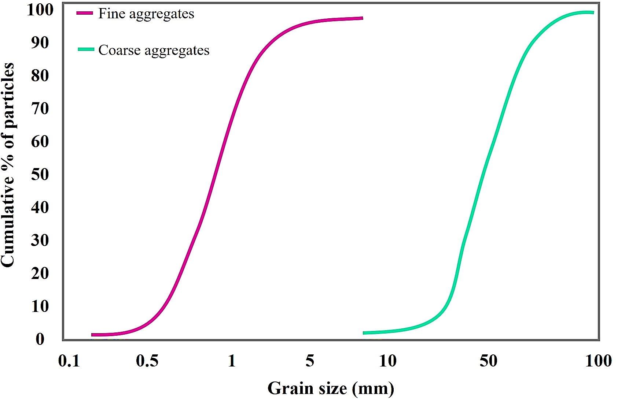
Figure 1. Particle size distribution
The results indicate that the majority of the fine aggregate particles are smaller than or equal to 0.8 mm in size. Specifically, 35% of the fine aggregate passes through the 0.8 mm sieve size. As the sieve size increases, the percentage of fine aggregate passing through the sieves gradually increases. The significance of the fine aggregate consisting of a wide range of particle sizes, with a significant portion falling within the 0.1 mm to 1 mm range, lies in its ability to enhance the packing density and workability of concrete mixes [11]. The presence of various particle sizes allows for better particle interlocking, filling voids, and optimizing the distribution of cementitious materials within the concrete matrix [12]. Fine aggregates with a diverse range of sizes also improve the overall strength and durability of the concrete, as the smaller particles contribute to the densification of the mixture, while the larger particles provide stability and reduce shrinkage [13]. Similarly, for coarse aggregates, considerable portion falling within the 8 mm to 100 mm range, lies in its ability to contribute to the mechanical properties and overall performance of concrete mixes. The presence of varying particle sizes in the coarse aggregate helps in achieving better packing density, resulting in a more stable and robust concrete matrix [14]. Larger coarse particles provide improved load-bearing capacity, enhancing the compressive strength and resistance to stress and deformation in the concrete. On the other hand, the smaller particles assist in filling the voids between the larger particles, leading to increased durability and reduced permeability [15]. This diverse particle size distribution in the coarse aggregate facilitates a well-graded mix that optimizes the use of cementitious materials and results in cost-effective and high-performance concrete suitable for various construction applications, including structural elements and pavement construction [16].
2.3. Composition of optimized composites
In line with the IS 10262-2009 standard [17], four composite mixes were fabricated, and are labelled as A, B, C, and D. These compositions involved a gradual decrease in potable water content and a corresponding increase in waste starch water content. The water-to-cement ratio was adjusted accordingly. Table 1 provides the composition details for the various mixes.
Table 1. Composition for various mixes
Label | Cement (kg/m³) | Fine (kg/m³) | Coarse (kg/m³) | Water (kg/m³) | Starch water (kg/m³) | water-to-cement ratio
A | 410 | 710 | 1115 | 205 | - | 0.5
B | 410 | 710 | 1115 | 185 | 21 | 0.45
C | 410 | 710 | 1115 | 175 | 31 | 0.42
D | 410 | 710 | 1115 | 165 | 41 | 0.4
2.4. SEM & EDX analysis for concrete
The microstructural analysis of the proposed concrete compositions was conducted using a scanning electron microscope (SEM). In this study, electron dispersive x-ray (EDX) analysis was performed for the optimized concrete composition, label C. Figure 2 illustrates the SEM images of the Label C composition, revealing the presence of starch adsorbed on the concrete surface.
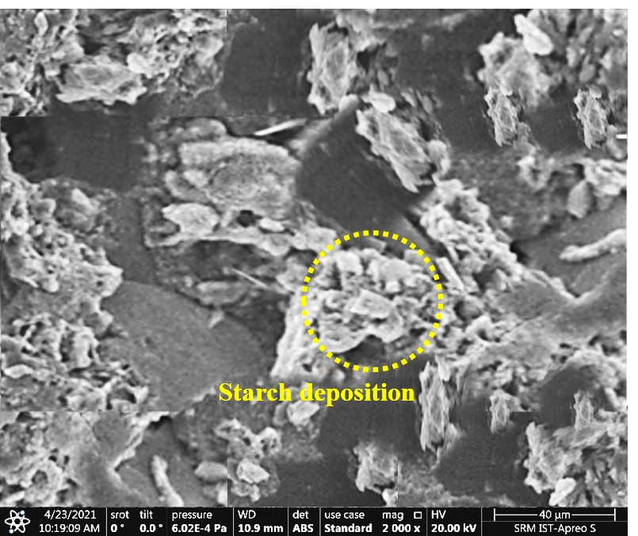
Figure 2. SEM image for Optimal Composite at various Magnification
Figure 3 reveals the EDX analysis of composition C, which is very much about the presence of various minerals in the starch water, such as Calcium, Silica, Cobalt and Zinc.
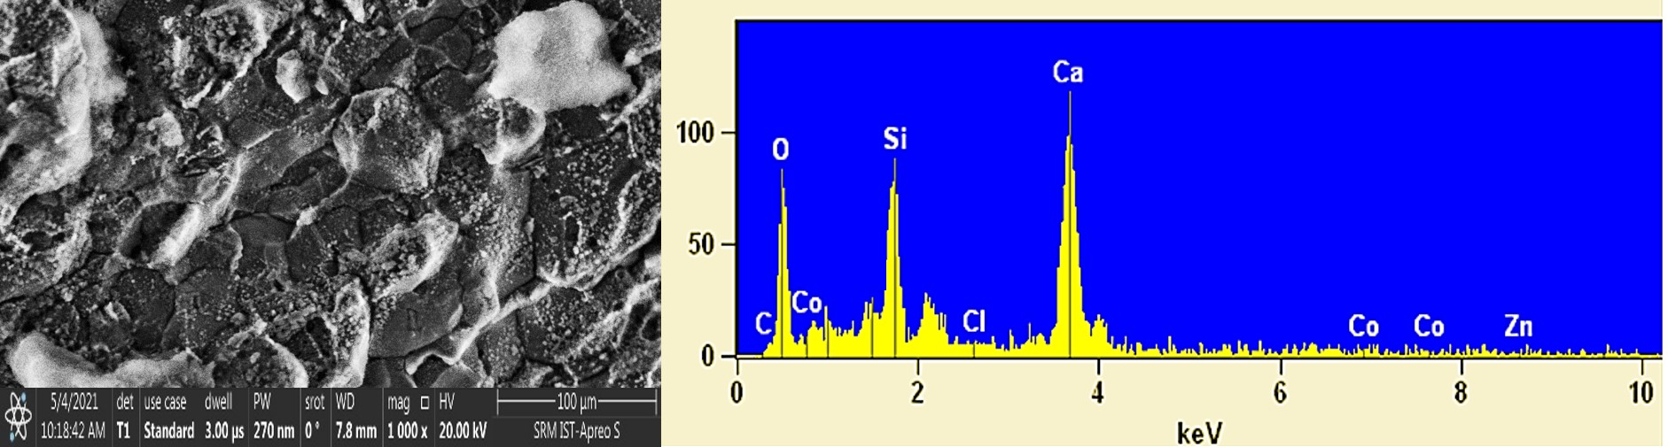
Figure 3. SEM with EDX analysis for the selected SEM surface of Label C
These elements holds profound significance in understanding the potential interactions and contributions to the concrete matrix. Ca and Si are key components in cement, suggesting possible chemical reactions in binding properties and contribute to the overall strength of the concrete mixture [18]. Si also has potential pozzolanic reactions, leading to increased densification over time [19]. Co and Zn are enablers of complex mineralogical reactions. Additionally, Co and Zn might act as nucleation sites for hydration, influencing microstructural development [20].
3. Results and Discussion
3.1 Initial Setting Time and Workability
The initial setting time of cement is a critical parameter that influences the handling and placement of concrete during construction. In this study, we investigated the effect of incorporating waste starch water at various weight percentages (10%, 15%, and 20%) on the initial setting time of concrete. The observed increase in the initial setting time with higher percentages of waste starch water can be attributed to the retarding effect of starch on cement hydration kinetics [21]. Starch molecules in the waste starch water adsorb onto the cement particles, forming a surface barrier that hinders the dissolution of cement compounds. This retarding action delays the formation of the cement gel, resulting in a prolonged initial setting time [22].
Workability is a crucial property that directly impacts the concrete's durability, quality, appearance, and labor efficiency during construction. Workability was tested for various concrete compositions containing 10%, 15%, and 20% waste starch water. The results demonstrated that as the percentage of waste starch water increased, the Workability of the concrete improved significantly. This enhancement in Workability can be attributed to the lubricating effect of starch particles within the concrete mix [23]. Starch molecules are dispersants, reducing the frictional forces between cement and aggregate particles. As a result, the concrete becomes more fluid and cohesive, facilitating better flow and ease of handling during construction operations [24]. The initial setting time and Workability are measured and given in Table 2.
Table 2. Initial setting time and Workability for various compositions
Waste starch water (%) | Initial setting time (minutes) | Workability (mm)
10% of starch water | 25 | 150
15% of starch water | 50 | 75
20% of starch water | 50 | 30
100% of potable water | 30 | 100

3.2 Compressive Strength
The compressive strength of concrete is a critical mechanical property that determines its structural performance [25]. In this study, we investigated the compressive strength of concrete with different percentages of waste starch water at curing durations of 7, 14, and 28 days. At early curing durations (7 and 14 days), the compressive strength of concrete with waste starch water was slightly lower than conventional concrete. This decrease in early-age compressive strength can be attributed to the retarding effect of starch on the cement hydration process during the initial curing stages. The presence of starch molecules on cement particles hinders the early development of the cement gel, leading to reduced early-age strength [26]. However, at 28 days of curing, the compressive strength of concrete with waste starch water reached levels comparable to that of conventional concrete. This phenomenon suggests that the retarding effect of starch diminishes over time, and the concrete with waste starch water eventually achieves similar long-term compressive strength. The gradual dissolution of starch particles during curing allows for continued cement hydration, leading to the development of a well-formed and interconnected cementitious gel network. Consequently, the concrete with waste starch water demonstrates resilience and compatibility, ensuring its long-term structural integrity [27]. Figure 4 provides the resultant compressive strength values.

Figure 4. Compressive Strength of Various Compositions
3.3 Split Tension
The split-tension test was conducted to evaluate the concrete's tensile properties and resistance to cracking. The results showed that the optimized composition (Label C) containing waste starch water exhibited superior split tension performance compared to conventional concrete. The improvement in split tension performance can be attributed to the unique interaction between starch particles and the concrete matrix. Starch particles act as micro-fillers, enhancing the interlocking and bonding of cementitious materials. This reinforcement results in improved tensile strength and crack resistance, as the presence of starch particles impedes crack propagation and fracture development [28]. The uniform dispersion of starch particles also ensures more effective load transfer across the concrete microstructure, contributing to the observed enhancement in tensile properties [29]. Figure 5 represents the split tension for various compositions, and it is observed that the proposed composition (Label C) exhibits a better performance than the conventional concrete.

Figure 5. Split tension for various compositions
3.4 Comparison of Density and Compressive Strength
The comparison of density and compressive strength across various concrete compositions highlights the influence of waste starch water on these properties. Table 3. Compares the density and strength of various components of concrete. The composite C (Label C) has reasonable density and strength among the four configurations.
Table 3. Comparison of density and compressive strength
Composition | Density (kg m⁻³) | Strength (N mm⁻²)
A | 2525.42 | 42.92
B | 2466.37 | 40.96
C | 2488.49 | 44.44
D | 2551.81 | 43.26
It's noteworthy that composition B exhibited the lowest density at 2466.37 kg m⁻³, suggesting a higher porosity or interconnected voids. This porosity might be attributed to the specific arrangement of particles and the influence of starch water content on the curing process. Notably, composition C (2488.49 kg m⁻³) displayed the highest density among the investigated compositions. This finding can be attributed to the balanced incorporation of waste starch water, which likely contributed to better particle packing and reduced porosity. The corresponding increase in density is of paramount importance as it signifies a denser microstructure, which can lead to enhanced mechanical properties, improved load-bearing capacity, and resistance to external factors such as freeze-thaw cycles. The significance of composition C's superior density extends to its influence on compressive strength. As observed in Table 3, composition C also exhibited the highest compressive strength at 44.44 N mm⁻². This correlation between density and strength further reinforces the critical relationship between microstructure and mechanical performance. The densely packed structure of composition C is indicative of minimized voids, thereby facilitating more effective load transfer between particles and contributing to its higher compressive strength.
- Limitations of the Study
While the results of this study are promising, certain limitations should be acknowledged to provide a comprehensive perspective.
- The rice variety used in this study was boiled rice, a hybrid of Pusa-677 (IET-12617) and Triguna (IET-12875) family. It is essential to acknowledge that different rice varieties may possess varying properties, potentially affecting the characteristics of starch water [30]. Further investigations with various rice varieties would be valuable to explore any variability. This could translate into varied outcomes in terms of workability, strength, and durability, influencing the generalizability of the findings.
- The SEM and EDX analyses were primarily focused on the optimized composition (Label C). To gain a more comprehensive understanding of waste starch water's interaction with other concrete compositions, further, SEM and EDX characterizations are warranted. The microstructural variances in other compositions could yield different interactions between the starch water and cement matrix, leading to distinct mechanical properties [30], that haven't been fully explored.
- Notably, the study observed that a higher percentage of starch water (20%) led to poor workability. This outcome underscores the need to strike a balance between incorporating admixtures and maintaining optimal workability. While excessive starch water might reduce the ease of concrete placement, the degree of reduction and its practical implications could vary depending on specific construction requirements [31]. This limitation points to the challenge of predicting the exact threshold beyond which workability significantly deteriorates, thus prompting the need for more precise guidelines in mix design.
- The strength decreased with increased density for compositions above 20% starch content. A denser structure might not always lead to proportionate strength gains, necessitating a deeper exploration of the intricate interactions between these factors. Further studies are needed to understand the balance between strength and density at higher starch contents.
- It was noted that the composition (Label B) with 10% of starch water exhibited increased Workability with a marginal reduction in strength compared to conventional concrete. This is limited due to the oversight of tailoring the concrete mixes to align well with if any specific requirements demanded. This limitation highlights the ongoing need to strike an equilibrium between these opposing factors, considering the practical implications for construction processes and long-term structural performance.
5. Conclusion
In summary, this study has successfully investigated the incorporation of waste starch water as an innovative admixture in concrete, aiming to enhance both workability and mechanical performance. Among the investigated compositions, MIX C (with 15% starch water) emerged as the optimal blend, exhibiting a commendable compressive strength of 44.44 N/mm² and a density of 2488.49 kg/m³. The study revealed trade-offs between workability and strength, underscoring the intricate balance required for achieving both desirable attributes. This emphasizes the challenge of formulating concrete mixes that cater to multiple performance criteria. The main contributions of this study align seamlessly with the broader goals of eco-friendly construction practices. By utilizing waste starch water, a byproduct that would otherwise be discarded, this research establishes a sustainable approach to reducing waste and minimizing environmental impact. Moreover, the identification of an optimized composition that simultaneously enhances workability and strength speaks to the potential of waste starch water as a viable alternative to traditional concrete mixing practices. This not only addresses the challenge of water scarcity in construction but also aligns with the ethos of sustainable construction methodologies.
References
[1] A. Sandak, Engineered living materials for sustainable and resilient architecture, Nat Rev Mater. 8 (2023) 357–359. https://doi.org/10.1038/s41578-023-00554-0.
[2] L.S. Silva, M. Amario, C.M. Stolz, K.V. Figueiredo, A.N. Haddad, A Comprehensive Review of Stone Dust in Concrete: Mechanical Behavior, Durability, and Environmental Performance, Buildings. 13 (2023) 1856. https://doi.org/10.3390/buildings13071856.
[3] H. Brown, B. Stigge, Infrastructural Ecologies: Alternative Development Models for Emerging Economies, MIT Press, 2017.
[4] S.B. Sarte, Sustainable Infrastructure: The Guide to Green Engineering and Design, John Wiley & Sons, 2010.
[5] H. Zhang, Y.X. Li, P.L. Wang, Y. Zhang, B.W. Cheng, Q.M. Sun, F. Li, Synthesis of β-Cyclodextrin Immobilized Starch and Its Application for the Removal of Dyestuff from Waste-Water, J Polym Environ. 27 (2019) 929–941. https://doi.org/10.1007/s10924-019-01365-7.
[6] Bureau of Indian Standards, IS 4031-4: Methods of physical tests for hydraulic cement, Part 4: Determination of consistency of standard cement paste, 1988. http://archive.org/details/gov.in.is.4031.4.1988 (accessed July 31, 2023).
[7] Bureau of Indian Standards, IS 4031-5: Methods of physical tests for hydraulic cement, Part 5: Determination of initial and final setting times, 1988. http://archive.org/details/gov.in.is.4031.5.1988 (accessed July 31, 2023).
[8] Bureau of Indian Standards, IS 4031-1: Methods of physical tests for hydraulic cement, Part 1: Determination of fineness by dry sieving, 1996. http://archive.org/details/gov.in.is.4031.1.1996 (accessed July 31, 2023).
[9] Bureau of Indian Standards, IS 2386-3: Methods of test for aggregates for concrete, Part 3: Specific gravity, density, voids, absorption and bulking, 1963. http://archive.org/details/gov.in.is.2386.3.1963 (accessed July 31, 2023).
[10] Bureau of Indian Standards, IS 383: Specification for Coarse and Fine Aggregates From Natural Sources For Concrete, 1970. http://archive.org/details/gov.in.is.383.1970 (accessed July 31, 2023).
[11] B. Li, S. Hou, Z. Duan, L. Li, W. Guo, Rheological behavior and compressive strength of concrete made with recycled fine aggregate of different size range, Construction and Building Materials. 268 (2021) 121172. https://doi.org/10.1016/j.conbuildmat.2020.121172.
[12] G. Bai, L. Wang, G. Ma, J. Sanjayan, M. Bai, 3D printing eco-friendly concrete containing under-utilised and waste solids as aggregates, Cement and Concrete Composites. 120 (2021) 104037. https://doi.org/10.1016/j.cemconcomp.2021.104037.
[13] J. Du, W. Meng, K.H. Khayat, Y. Bao, P. Guo, Z. Lyu, A. Abu-obeidah, H. Nassif, H. Wang, New development of ultra-high-performance concrete (UHPC), Composites Part B: Engineering. 224 (2021) 109220. https://doi.org/10.1016/j.compositesb.2021.109220.
[14] K. Wille, A.E. Naaman, S. El-Tawil, G.J. Parra-Montesinos, Ultra-high performance concrete and fiber reinforced concrete: achieving strength and ductility without heat curing, Mater Struct. 45 (2012) 309–324. https://doi.org/10.1617/s11527-011-9767-0.
[15] M.M.U. Islam, J. Li, Y.-F. Wu, R. Roychand, M. Saberian, Design and strength optimization method for the production of structural lightweight concrete: An experimental investigation for the complete replacement of conventional coarse aggregates by waste rubber particles, Resources, Conservation and Recycling. 184 (2022) 106390. https://doi.org/10.1016/j.resconrec.2022.106390.
[16] Z. Yu, L. Wu, C. Zhang, T. Bangi, RETRACTED: Influence of eco-friendly fine aggregate on macroscopic properties, microstructure and durability of ultra-high performance concrete: A review, Journal of Building Engineering. 65 (2023) 105783. https://doi.org/10.1016/j.jobe.2022.105783.
[17] Bureau of Indian Standards, IS 10262: Guidelines for concrete mix design proportioning, 2009. http://archive.org/details/gov.in.is.10262.2009 (accessed July 31, 2023).
[18] O. Heinz, H. Heinz, Cement Interfaces: Current Understanding, Challenges, and Opportunities, Langmuir. 37 (2021) 6347–6356. https://doi.org/10.1021/acs.langmuir.1c00617.
[19] R. Snellings, G. Mertens, J. Elsen, Supplementary Cementitious Materials, Reviews in Mineralogy and Geochemistry. 74 (2012) 211–278. https://doi.org/10.2138/rmg.2012.74.6.
[20] M. Boni, N. Mondillo, The “Calamines” and the “Others”: The great family of supergene nonsulfide zinc ores, Ore Geology Reviews. 67 (2015) 208–233. https://doi.org/10.1016/j.oregeorev.2014.10.025.
[21] S. Liu, Y. Kong, L. Wang, Hydration mechanism of low quality fly ash in cement-based materials, J. Cent. South Univ. 21 (2014) 4360–4367. https://doi.org/10.1007/s11771-014-2436-z.
[22] L. Crépy, J.-Y. Petit, E. Wirquin, P. Martin, N. Joly, Synthesis and evaluation of starch-based polymers as potential dispersants in cement pastes and self leveling compounds, Cement and Concrete Composites. 45 (2014) 29–38. https://doi.org/10.1016/j.cemconcomp.2013.09.004.
[23] H. Uguru, O. Eboibi, O. Akpokodje, Evaluation of organic enhancer on the mechanical properties of periwinkle shells concrete, Journal of Engineering Innovations and Applications. 1 (2022) 13–22. https://doi.org/10.31248/JEIA2022.020.
[24] A. Tutal, S. Partschefeld, J. Schneider, A. Osburg, EFFECTS OF BIO-BASED PLASTICIZERS, MADE FROM STARCH, ON THE PROPERTIES OF FRESH AND HARDENED METAKAOLIN-GEOPOLYMER MORTAR: BASIC INVESTIGATIONS, Clays Clay Miner. 68 (2020) 413–427. https://doi.org/10.1007/s42860-020-00084-8.
[25] R. Ganesamoorthy, K. Vimalanathan, R. Aruna, G. Suresh, C.M. Meenakshi, D.K. Madheswaran, M. Puviyarasan, Analyzing the mechanical behavior of nano particle incorporated glass fiber reinforced composite pipes, AIP Conference Proceedings. 2747 (2023) 020008. https://doi.org/10.1063/5.0132678.
[26] J. Liu, C. Yu, X. Shu, Q. Ran, Y. Yang, Recent advance of chemical admixtures in concrete, Cement and Concrete Research. 124 (2019) 105834. https://doi.org/10.1016/j.cemconres.2019.105834.
[27] C. Magniont, G. Escadeillas, Chemical Composition of Bio-aggregates and Their Interactions with Mineral Binders, in: S. Amziane, F. Collet (Eds.), Bio-Aggregates Based Building Materials : State-of-the-Art Report of the RILEM Technical Committee 236-BBM, Springer Netherlands, Dordrecht, 2017: pp. 1–37. https://doi.org/10.1007/978-94-024-1031-0_1.
[28] A.Y. Al-Maharma, P. Sendur, Review of the main factors controlling the fracture toughness and impact strength properties of natural composites, Mater. Res. Express. 6 (2018) 022001. https://doi.org/10.1088/2053-1591/aaec28.
[29] H. Kargarzadeh, N. Johar, I. Ahmad, Starch biocomposite film reinforced by multiscale rice husk fiber, Composites Science and Technology. 151 (2017) 147–155. https://doi.org/10.1016/j.compscitech.2017.08.018.
[30] A.A. Wani, P. Singh, M.A. Shah, U. Schweiggert-Weisz, K. Gul, I.A. Wani, Rice Starch Diversity: Effects on Structural, Morphological, Thermal, and Physicochemical Properties—A Review, Comprehensive Reviews in Food Science and Food Safety. 11 (2012) 417–436. https://doi.org/10.1111/j.1541-4337.2012.00193.x.
[31] B. Han, L. Zhang, J. Ou, Smart and Multifunctional Concrete Toward Sustainable Infrastructures, Springer, Singapore, 2017. https://doi.org/10.1007/978-981-10-4349-9.

