Title: A STRATERGIC APPROACH TO ENDODONTIC DIAGNOSIS WITH BASIC AND ADVANCED TRENDS
Authors: Dr. ANSHU GUPTA¹, Dr. NAVNEET KUKREJA², Dr. ANAMIKA THAKUR³
¹Consultant Conservative Dentist and Endodontist at Gupta Dental Professionals, Jammu.
²Professor and Head of department of Conservative Dentistry and Endodontics at MMCDSR, Mullana, Ambala.
³Reader, Department of Conservative Dentistry and Endodontics at MMCDSR, Mullana, Ambala.

ABSTRACT
A cautious evaluation of patient’s clinical symptoms as well as dental pathosis is a key to manifest a sound endodontic diagnosis. The intention of diagnosis is to consider the problem the patient is having and the reason of that problem. The diagnostic tests in endodontics are used to govern the pulp condition in teeth affected by caries, trauma or other kind of insult. In this chapter a systematic diagnostic process involving history taking, clinical and radiographic examination, recent methods forestablishing pulp status, including electric/ thermal pulp testing, or methods for measuring pulpal blood circulation are discussed with basic and advanced approaches. Unquestionably, accurate treatment begins with accurate diagnosis.

key words: diagnosis, endodontics, dental pulp tests, caries, sensitivity, sensibility.

Introduction
Diagnosis can be described as the art of recognizing a disorder from its signs and symptoms.¹ Diagnosis is basically a procedure of accepting a patient, recognizing his/her problem, establishing the cause of problem and then evolving a treatment plan that will solve the problem.² Diagnosis can also be defined as correct determination, discriminative estimation & reasoning appraisal of conditions found in the course of examination as documented by peculiar signs, marks & symptoms.³ The essential steps to be followed to arrive at correct diagnosis are summarized in fig 1.
Chief Complaint: It is a symptom or symptoms described by the patient in his own words relating to the presence of an abnormal condition.⁴
Medical history: To recognize any chance of risks that the patient may be sensitive to at the time of dental treatment, to aware the dentist about the cautions that need to be taken and about allergies to dental products or drugs.
Dental history: The chronological episodes suggestive of chief complaint is documented as dental history. It includes all the past/present symptoms together with any procedures or trauma that might have elicit the chief complaint.¹
History of present dental illness: include mode of onset (sudden/gradual), cause of onset, duration (time span of complaint) and progress (increase or decrease in severity).
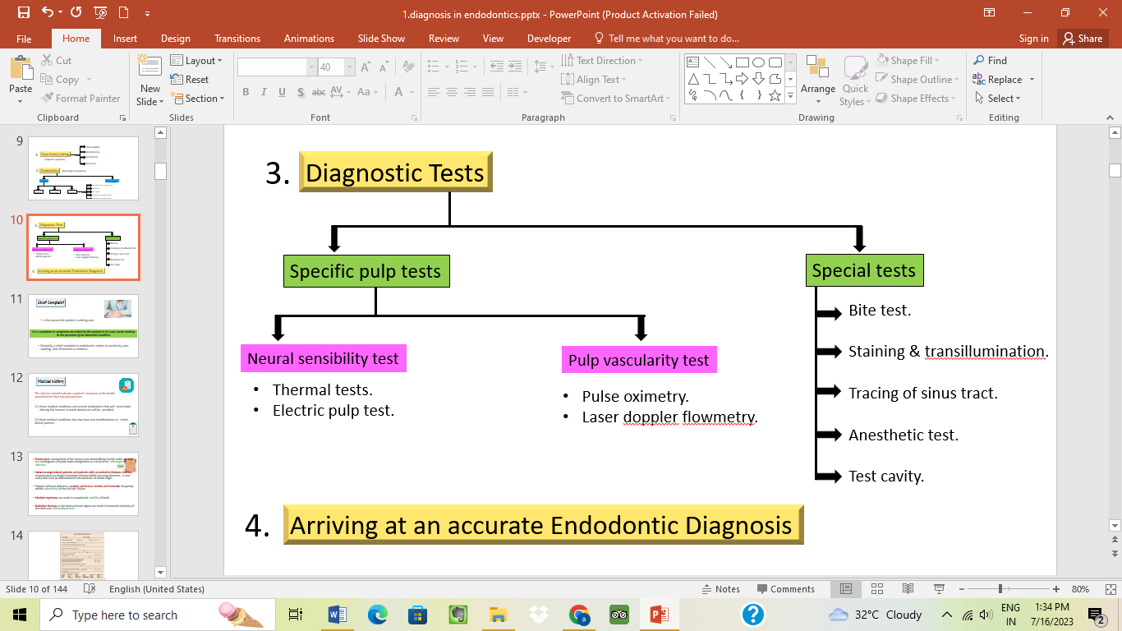
PAIN: certainly, the most common chief complaint that lead to dental procedures is pain. The history of pain should include the criteria in fig 2.⁵

fig1: Steps to be followed to arrive at correct diagnosis

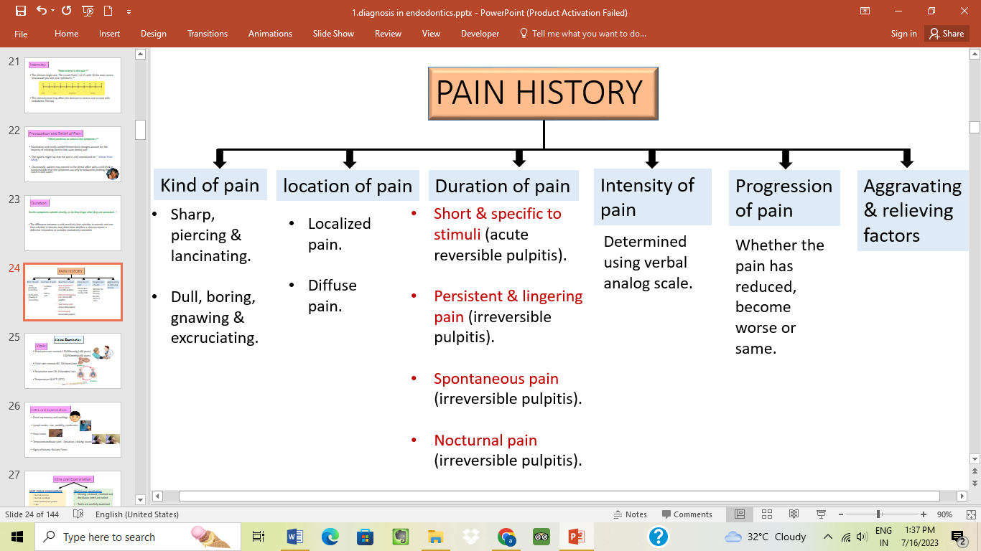

fig 2: Pain Diagnosis

CLINICAL EXAMINATION & INVESTIGATIONS IN ENDODONTICS

- Visual and tactile inspection:
Soft tissue
- Color: Normally, gingiva is coral pink, change in gingival color can easily be envisioned in inflammatory conditions.
- Contour: changes in normal scalloped contoured gingiva characterize swelling of tissue.
- Consistency: normally gingival tissue is healthy, stiff and resilient at the same time a soft, fluctuant or porous tissue is suggestive of a pathology.
Hard tissue
- Color: Tooth with normal pulp show life-like translucency and sparkle. Discolored teeth with opaque and less life-like appearance are indicative of inflamed, degenerated or necrotic pulp.
- Contour: teeth with fracture, wear facets, poorly contoured restorations or crown margins should be examined.
- Consistency: Caries, resorption.²
- PERCUSSION: involved tooth is struck by a rapid, moderate blow initially by the finger (low intensity), then with greater intensity using the handle of an instrument. Positive response to percussion occurs in case of:
- Rapid orthodontic movement.
- Restorations with high points.
- Occlusal trauma.
- Lateral periodontal abscess.
- Apical periodontitis.
- Periapical abscess.^{1,2}

- PALPATION: using fingertip with light pressure to investigate tissue consistency as well as pain response.

- MOBILITY AND DEPRESSIBILITY TEST:
- Mobility is checked with handles of two instruments or by using fingers by moving the tooth in its socket.
- Test for depressibility is checked by applying apical pressure on the tooth and observing vertical movement if present.
Grades of mobility
- +1 mobility: The first distinguishable sign of movement more than normal.
- +2 mobility: Horizontal tooth movement not more than 1 mm.
- +3 mobility: Horizontal tooth movement >1 mm, with /without rotation or vertical depressability.¹
- PERIODONTAL PROBING TEST
A periodontal probe is stepped around the long axis of a tooth, proceeding in 1mm increments. Periodontal probing evaluates
- Health of periodontium.
- Furcation involvement.
- Pathological grooves.
- Differentiate disease of periodontal origin from pulpal origin.⁶

- BITE TEST/ OCCLUSAL PRESSURE TEST used for identification of a cracked tooth or fractured cusp. Devices used include tooth sloth, frac finder, orangewood stick, burlew rubber disk, wet cotton roll, cotton applicator.^{7,8}
- Pain on biting indicates apical periodontitis.
- Pain on release of biting force is indicative of cracked tooth.³

DIAGNOSTIC TESTS
Pulp testing attempts to make a determination of the responsiveness of the pulpal sensory neurons in teeth. Various pulp tests used are summarized in fig 3.

fig 3: Pulp tests

- THERMAL TESTING:
Thermal tests simply identify the presence of pulp tissue which can respond to changes in temperature. Basically, these tests trigger the hydrodynamic fluid movement within dentinal tubules, which ultimately excites A-delta ﬁbres .⁹
- COLD TEST: Cold test is the primary pulp testing procedure for most clinicians now. Various agents used are
- ICE STICK: (0˚C):
- Made by filling discarded anesthetic carpules or anesthetic needle cover with water & then freezing in a refrigerator in an upstanding position.¹⁰
DISADVANTAGES:
- Ice is not too cold compared to another available material.
- Melted ice water can also spread to soft tissue or another tooth & create a false +ve effect.
ADVANTAGES:
- Easy availablility
- Inexpensive

- ENDO ICE: Tetrafluoroethane (-50˚F) is sprayed onto a cotton pellet and applied to the middle third of the facial/labial aspect of tooth crown for 5 sec or as late as the patient begins to feel pain.³
- CO₂ SNOW: Dry ice (-78˚C)
‘Pencil’ or ‘stick’ of dry ice is applied to the middle third of the labial/ facial aspect of tooth crown for 2–5 s or as late as the patient feels pain.¹¹
ADVANTAGES:
- Accurate, reliable, consistent & fast.
- Complete dentition can be examined within 1–2 min without tooth isolation.
- Effective method for teeth having full coverage crowns.
DISADVANTAGES:
- Not to be used in calciﬁed pulps and in elderly patients with significant secondary dentine present.
- Expensive apparatus compared to ethyl chloride or ice sticks.
- Occupies large clinical space.
- May cause infarction lines in tooth because of very low temp.
- Burns of soft tissue can occur.^{1,3,12}
- ETHYL CHLORIDE/ SKIN REFRIGERANT (58.8˚F)
Tooth isolated with rubber dam & is sprayed with ethyl chloride or is applied with a cotton pellet saturated with ethyl chloride.
- COLD WATER/ DRINK: (69.2˚F)
Involved tooth is isolated with rubber dam and iced water is syringed onto the tooth.^{1,3}

- HEAT TEST

- Hot ball burnisher: was a traditional method used to apply heat, not used anymore due to uncontrolled temperature.
- Rubber wheal mounted on a mandrel: a dry rubber-polishing wheel at a high speed is made to run against the dry surface of involved tooth.
- Hot gutta percha stick: Gp stick is placed over the flame till it starts to sag but doesn’t produce any smoke and applied to Vaseline coated tooth.
- Hot water: Isolate the tooth with rubber dam, filling a syringe with hot water & apply the water to the tooth.
- Heating device (system B): System B permits to set specific temperatures for thermal testing.
- After lubricate the tooth, a hot test tip attached to the handle of system B with the set temperature at 150°F is placed on the tooth surface and the patient’s response is assessed.^{3,10}
- ELECTRIC PULP TESTING (EPT):
EPT is delineated to trigger a response of sensory fibers (A delta) in the pulp with electrical stimulation.

ADVANTAGES OF EPT
- The digital display provides instant, easy and reliable information.
- Produce a quantitative reading and can also be compared with the normal control tooth.

DISADVANTAGES OF EPT
- Recently traumatized teeth cannot be tested.
- Does not give any indication regarding the vascular supply.
- False readings from partially vital pulps (posterior teeth) (fig 4).^{10,13,14}
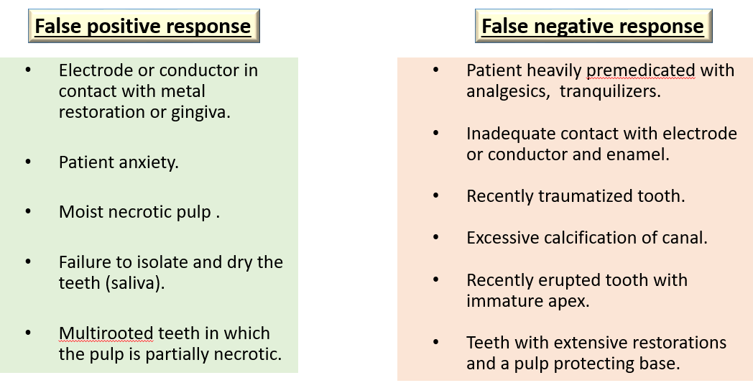

fig 4: False positive and false negative response of EPT

- ANESTHETIC TESTING
- Done when other tests are unable to identify the involved tooth.
- Infiltration/ intraligamentary injection is used.
- First, inject to the most posterior tooth in the suspected area, anesthetize the next tooth mesial to it, provided pain persists.^{1,3}

- TEST CAVITY: done if other diagnostic procedures have failed.
- Test cavity is made through DEJ of unanaesthetized tooth. Any sensitivity/ pain is suggestive of presence of viable nerve fibres.¹⁰
- TRANSILLUMINATION TEST:

PRINCIPLE: caries, calculus, restorative material, sound tooth structure, inflammatory exudates and healthy periodontium have different indices of light transmission.
USES to diagnose crown & root fracture- light from fiber-optic placed at right angles to the fracture line, part of tooth that is proximal to light source will absorb the light and will glow and the area that is beyond the fracture will be grey in comparison.^{1,15}
- GP POINT TRACING WITH RADIOGRAPH:
- Gutta percha localizes the lesion around the specific tooth.
- Helps to locate the source of infection i.e. the sinus tract is traced by inserting a GP point through the stoma.
- After tracing the sinus tract, the gutta percha is noticed to be directed to the root of infection.
- LASER DOPPLER FLOWMETRY
It is a procedure accustomed to evaluate the blood flow in microvascular systems. A diode projecting an infrared light beam across the crown and pulp chamber of a tooth is used and the infrared light beam gets scattered as it passes across the pulp tissue.

Principle: The Doppler principle affirms that the light beam gets frequency-shifted by moving cells (red blood cells) but remain unshifted when it passes across static tissues. When the light enters the tooth, it gets absorbed by the RBC’s that leads to a shift in the frequency of the scattered light which is detected with help of a photodetector. This principle ascertains the presence of blood flow within the pulp tissue.
ADVANTAGES
- Reflects vascularity of pulp.
- Noninvasive procedure.
- Provides accurate reading in case of recently erupted teeth or traumatized teeth.
- Effectively monitor revascularization of replanted teeth.
DISADVANTAGES
- Systemic medication may alter blood flow in the pulp.
- Gingival blood vessels can give false reading.
- Need custom fabricated jig to hold sensor.
- Expensive.^{2,12,16}
- PULSE OXIMETRY: a noninvasive method to evaluate the oxygen saturation levels of circulating arterial blood. Pulse oximeter sensor consists of:
- Two LED (light emitting diodes), one to transmit red light (660 nm) and another to transmit infrared light (940 nm).
- Photo detector is kept on opposite side of vascular bed.
- Investigated tooth is sandwiched between a photoelectric detector and an LED of red or infrared lights (fig 5).
- It measures the oxygen pressure of erythrocytes.
fig 5: Pulse oximeter parts

ADVANTAGES
- Effectively detects pulpal blood flow.
- Useful in traumatic injuries.
- Easy to reproduce readings.
- Pulpal circulation is evaluated independent of gingival circulation.
DISADVANTAGES
- Low specificity with calcified coronal pulp.
- Pulp is insulated by enamel & dentin, difficult to detect pulsations by the probe.
- Background absorption native to venous blood & tissue constituents.^{17,18}
- DUAL WAVELENGTH SPECTROPHOTOMETRY: designed to measures oxygenation changes in capillary bed (rather than in the supply vessels) and does not depend on a pulsatile blood flow. It detects the presence/ absence of oxygenated blood at 760 and 850nm.¹⁹

- TOOTH SURFACE TEMPERATURE CHANGES: different diagnostic procedures used for temperature measurement of human teeth has been discussed with the use of thermistors, Hughes Probeye Camera, Infrared thermo-graphic imaging and Liquid Crystal testing.¹²

RECENT TRENDS:
- Digital subtraction radiography: is considered as a valuable tool to detect extremely small bone changes during or after root canal treatment with more accuracy. Introduced by Zeides Plantes and is almost twice as sensitive in the analysis of bone formation or resorption as conventional radiography.
Uses:
- detection of lesion interproximal caries
- to view the progression of caries
- evaluation of bony changes or repair.

- CBCT: Cone beam computed tomography imaging in Endodontics require phenomenal detail and resolution to recognize the intricacies of root canal system along with periodontium.
Uses:
- To detect radiographic signs of periapical pathosis in case of nonspecific signs and symptoms and plain film imaging is indecisive.
- In surgeries to assess the proximity of root apices to important anatomical landmarks (i.e. multi-rooted teeth & complex anatomy).
- Assessment of the bucco-palatal extent of both internal and external root resorptions can only be accurately determined with CBCT.
- Aid in diagnosis of odontogenic/ non-odontogenic pain when clinical and traditional radiographic parameters are not clear.
- To assess traumatic dental injuries and/or management of dento-alveolar trauma, which may not be fully appreciated with traditional radiographs.
- To appreciate anatomically complex root canal system prior to endodontic management like dens invaginatus, obliterated canals.
- To detect secondary bone changes in case of vertical root fractures, cracked tooth syndrome, untreated canals and/or previous treatment complications like perforation, coronal microleakage.
- Appreciated when direct/indirect pulp capping or pulpotomy is being planned in extensively carious teeth.
Advantages:
- Increased accuracy.
- Higher resolution.
- Less scan time.
- Low radiation dose.
- Elimination of anatomic noise.
Limitations:
Presence of metallic restorations (e.g. amalgam, metal post-core, crowns, implants or even gutta-percha) can significantly leads to radiographic artefact compromising the details of pathosis associated with root canal and relevant structures.^{20,21}

- Computed axial tomography scanners: especially used
- to determine buccolingual as well as mesiodistal widths of teeth
- to detect the presence/ absence of root canal fillings and metal posts.
- CONE BEAM COMPUTED VOLUMETRIC TOMOGRAPHY:
CBCT uses a computer program with cone-shaped beam instead of fan beam and provide a 3D volume image in single 360° rotations.

- ULTRASOUND: A noninvasive procedure which uses a pulsed ultrasound beam having very high frequency (7.5–20 MHz) to fabricate a high-resolution image of more superficial structures. Color Doppler principle allows detection of blood flow.²²
Ultrasound Doppler or Color Power Doppler
Color Power Doppler flowmetry in ultrasound detect the presence as well as direction of the blood flow within the tissue of interest. The intensity of Doppler signal is represented by the changes in real time on a graph i.e. Doppler and is shown in the form of color spots on the gray scale image i.e. color.
+ve Doppler shifts (red): blood is moving toward the transducer.
-ve Doppler shift (blue): blood is moving in opposite direction.

In Ultrasound Doppler, different Doppler graphic waveforms and sounds also aid in differentiating vital vs non-vital teeth.
-Vital teeth: 'pulsating' waveform and characteristic sound.
-Root canal filled teeth: linear nonpulsed waveform without pulsating sound.
Advantages:
- High resolution.
- 3D images of the inner macrostructure of the tooth.
- Can differentially diagnose periapical granulomas and cystic lesions.
- Helps in monitoring the healing of periapical lesions treated by nonsurgical endodontics.²³
- FIBEROPTIC FLUORESCENT SPECTROMETRY:
Foreman reported that teeth having vital pulps will fluoresce normally and the teeth having necrotic or no pulp will not fluoresce when exposed to UV light.
- The differences in fluorescence spectra of healthy and decayed dentin can be appreciated due to loss of mineralized tissue components and increased organic content and water in decayed versus healthy dentin.
- Also the emission pattern for enamel is unique and can be differentiated from healthy and decayed dentin patterns hence, establishing a basis for differentiating between tissue categories.²⁴

CONCLUSION: with the advent of newer diagnostic techniques, the diagnosis of exact pulpal status (vital or necrotic) has become a quicker, easier and precise task. However, the results of newer diagnostic tests cannot be counted on individually, but, they should be combined with other diagnostic tests (patient history, clinical examination, pulse oximetry, LDF, radiovisiography) to arrive at a correct final diagnosis

REFERENCES
- Hargreaves M. Kenneth and Cohen Stephen. Diagnosis. Tenth edition; China: Eslevier:2011. Chapter:1 Diagnosis.1-39.
- Chandra S and Gopikrishna V. Grossman’s Endodontic Practice.13th edition; New Delhi, India: Wolters Kluwer 2014.Chapter: 3 Clinical Diagnostic Methods.53-78.
- Ingle I. John, Bakland K. Leif and Baumgartner J. Craig. sixth edition:Hamilton: BC Decker Inc:2008. Chapter14 Diagnosis of Endodontic Disease. 520-553.
- Roberson T, Heymann H, Swift ED. Sturdevant’s Art and Science of Operative Dentistry. Elsevier Health Sciences. 5th edition. Philadelphia. 2006.Cariology: The Lesion, Etiology, Prevention, and Control.65-134.
- Greenwood M. Essentials of medical history-taking in dental patients. Dental Update. 2015;42(4):308-315.
- Armitage GC. Diagnosis of periodontal diseases. J. Periodontol. 2003;74(8):1237-1247.
- Mathew S, Thangavel B, Mathew CA, Kailasam S, Kumaravadivel K and Das A. Diagnosis of cracked tooth syndrome. J Pharm Bioallied Sci. 2012;4(Suppl 2):S242-S244.
- Banerji S, Mehta SB and Millar BJ. Cracked tooth syndrome. Part 1: aetiology and diagnosis.Br. Dent. J. 2010;208(10):459-463.
- Jafarzadeh H and Abbott PV. Review of pulp sensibility tests. Part I: general information and thermal tests. Int. Endod. J. 2010;43(9):738-762.
- Chen E and Abbott PV. Dental pulp testing: a review.Int. J. Dent. 2009; 2009:1-12.
- Rickoff B, Trowbridge H, Baker J, Fuss Z and Bender IB. Effects of thermal vitality tests on human dental pulp. J. Endod. 1988;14(10):482-485.
- Gopikrishna V, Pradeep G and Venkateshbabu N. Assessment of pulp vitality: a review. Int. J. Paediatr. Dent. 2009;19(1):3-15.
- Lin J and Chandler NP. Electric pulp testing: a review. Int. Endod. J. 2008;41(5):365-374.
- Jafarzadeh H and Abbott PV. Review of pulp sensibility tests. Part ΙΙ: electric pulp tests and test cavities. Int. Endod. J. 2010;43(11):945-958.
- Marinova-Takorova M, Panov V and Anastasova R. Effectiveness of near-infrared transillumination in early caries diagnosis. Biotechnol. Biotechnol. Equip. 2016;30(6):1207-1211.
- Obeid AN, Barnett NJ, Dougherty G and Ward G. A critical review of laser Doppler flowmetry. J. Med. Eng. Technol. 1990;14(5):178-181.
- Almudever-Garcia A et al. Pulse oximetry as a diagnostic tool to determine pulp vitality: A systematic review. Applied Sciences. 2021;11(6):2747-2762.
- Gopikrishna V, Tinagupta K and Kandaswamy D. Evaluation of efficacy of a new custom-made pulse oximeter dental probe in comparison with the electrical and thermal tests for assessing pulp vitality. J. Endod. 2007 Apr 1;33(4):411-414.
- Chandi JK, Rajapandy S, Jahan N and Gill S. Advances in Endodontics: A Brief Review. J. MAR Dent Sci.2021:3(3):1-13.
- Patel S, Brown J, Pimentel T, Kelly RD, Abella F and Durack C. Cone beam computed tomography in Endodontics–a review of the literature. Int. Endod. J. 2019;52(8):1138-1152.
- Patel S, Brown J, Semper M, Abella F and Mannocci F. European Society of Endodontology position statement: Use of cone beam computed tomography in Endodontics: European Society of Endodontology (ESE) developed by. Int. Endod. J. 2019 ;52(12):1675-1678.
- Jain V, Kumar BP, Krishna TS, Parakh S, Kiran PH and Tiwari A. Recent Advances in Endodontic Diagnosis: A Review. Int. J. Prev. Clin. Dent. Res. 2017;4(4):300-303.
- Tyagi SP, Sinha DJ, Verma R and Singh UP. New vistas in endodontic diagnosis. Saudi Endod J. 2012;2(2):85-90.
- Deepak BS, Subash TS, Narmatha VJ, Anamika T, Snehil TK and Nandini DB. Imaging techniques in endodontics: an overview. J Clin Imaging Sci. 2012;2(1):1-8.

