IMPLEMENTATION OF DIGITIZATION IN P&O CLINIC PROCEDURE; E-PRD

Author details-
1.Soubhagya Samantaray,BPO
Department of Prosthetics and Orthotics
NIRTAR, Odisha
Mail id-soubhagya989@gmail.com
Phone no-9692405114
1. Sushree Sangita Nayak,PhD Scholar
Lecturer
Department of Prosthetics and Orthotics
NIRTAR, Odisha
Mail id-lollybpo@gmail.com
Phone no-9438117407

Abstract
Background: Digitization in prosthetic and orthopedic clinics is the systematic application of informatics, informatics and technology in public health practice, research and learning. It is an emerging concept defined as the systematic collection of electronically generated or computerized health information about a specific patient or population. It is a record in digital form that can theoretically be shared between different health units.
Objective: To create new treatment models and a sense of awareness among people about prosthetics and orthotics, keep pace with the fast advancing competitive world, improve services provided to the patient and increase internal collaboration.
Method: This website is a platform in which admin can collect, analyze record, summaries data and create content for other users. Mainly three groups of people can be the potential users for this website. As this is an application based upon healthcare services the first and foremost user can be (1) Patients, (2) Healthcare professionals and (3) Depository Manager. For running our website we used a server named XAMMP, in which our database is stored. XAMPP is a free and open source multi-purpose web server solution package developed by Apache Friends, which mainly consists of Apache HTTP Server, MariaDB database and script interpreters written in PHP and Perl programming languages. XAMPP and WordPress work as back-end software that can be used with front-end software like a browser ie. Google Chrome, Internet Explorer, etc.
Results: It empowers patient in self-management of chronic illness via collaboration between patient and rehabilitation professional. This creates general awareness among the population and the collected data can be used for survey and research.
Conclusion: The implementation of digitization in prosthetics and orthotics has marked a transformative leap forward in patient care and to the ease of access at their fingertip. The ability to customize and integrate advanced functionalities has opened a new era of opportunities and possibilities.
Introduction
The digitization process began in 1679 when computers were introduced. Gottfried Wilhelm Leibniz developed the very first binary system, creating a significant footprint in the world of digitization. The digital revolution became truly global during this period, even after it revolutionized society in the developed world in the 1990s, and in the 2000s, the digital revolution spread to the masses in developing countries. This marked the beginning of the era of digitization. An era in human history characterized by the transition from traditional industry to an economy based on information and communication technology. In July 2015, the Government of India launched the "Digital India" initiative to improve network infrastructure and increase citizens' access to the Internet, enabling the country to develop digitally. The initiative includes three main goals: to create a secure and stable digital infrastructure, to provide digital services, to ensure internet access for every citizen. Digitalization is included in all areas of society and the world to keep up with the rapidly changing, revolutionary world and technological development. It revolutionized communication and commerce and has a profound effect on almost every aspect of modern life. It has a wide range of applications from small industry to government. and non-governmental. for the very limited use of organizations in domestic tasks. The digitization process has successfully taken over the following industries; they are manufacturing, transportation, hospitality/tourism, healthcare, financial services, education, energy, media and retail. As digitization entered healthcare, it slowly crept into the rehabilitation sector at the end of the 20th century. Digital techniques make it possible to convert traditional forms of data storage, such as paper and photographs, into binary code (ones and zeros) for computer storage. Document digitization is a must in this digital age, people share files on digital platforms instead of physical papers. By digitization, we simply mean converting all of your patient data (old and new) from tangible to digital. All written or printed documents are digitized using document management solutions. Digitization in prosthetic and orthopedic clinics is the systematic application of informatics, informatics and technology in public health practice, research and learning. It is an emerging concept defined as the systematic collection of electronically generated or computerized health information about a specific patient or population. It is a disk in digital format that can theoretically be shared in different healthcare environments. The term digitization is often used when different forms of information such as object, text, audio, image or sound are converted into a single binary code, and the advantage of digitization is the speed and accuracy with which this type of information can be produced. transmitted without degradation compared to analog data. The digitization of treatment thus enables treatment outside the confines of a healthcare or rehabilitation facility and into the confines of one's own home. The future of digital healthcare in India looks very strong and vibrant.
Use of Blockchain
Digitalization of P&O clinic procedure can be achieved through blockchain application. With its ability to reduce costs, protect patient data and improve the overall experience for patients and healthcare professionals, blockchain is a powerful solution to a number of ongoing healthcare challenges. Blockchain is a decentralized and public digital ledger that records transactions across multiple computers so that no record can be changed retroactively without changing the blocks later. The blockchain is verified and linked to the previous 'block' to form a long chain. The blockchain architecture ensures that data is not processed in any centralized location, making it accessible and accountable to all network users. This decentralized system prevents a single attack by strengthening and securing the system. Blockchain provides an excellent platform for traditional companies to develop and compete for modern and creative business models. It facilitates better control over health information and patient care, minimizing duplication of care and follow-up, saving time and resources for doctors and patients.
Benefits of Blockchain
- Encrypts data for data integrity.
- Protects patient information with secure standards.
- Creates ownership through transparency and enables consistency.
- Lowers transaction cost.
- Provides real time updates of shared data.
- Ensures distributed and secure access.
- Guarantees system efficiency and removes vulnerable points.

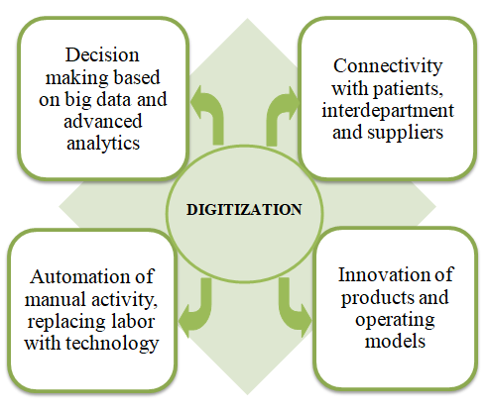
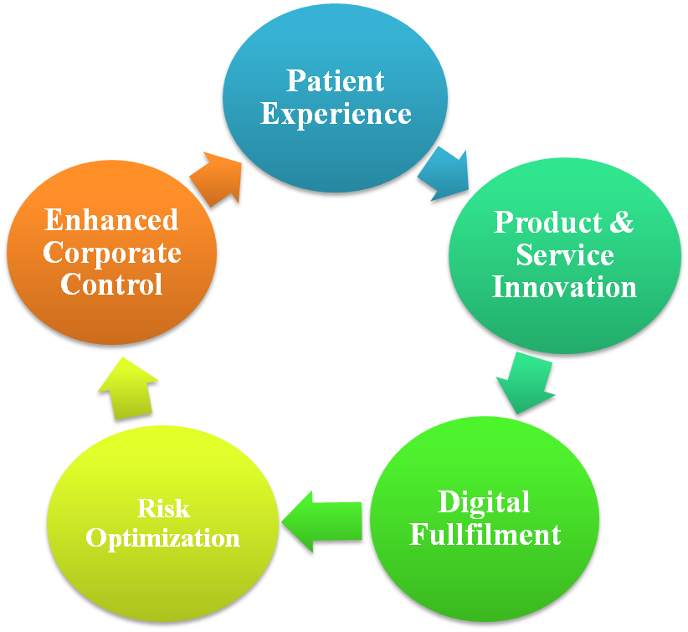

Need of Blockchain in Healthcare
Today there is a need for quality healthcare facilities supported by advanced and newer technologies. This is where Blockchain would play a crucial role in transforming the healthcare industry. The landscape of the health care system is changing to a patient-centered approach that focuses on two main things: accessible services and adequate health resources at any time. In addition, better research and shared knowledge of public welfare will improve the treatment of various communities. Some of the leading blockchain healthcare companies are BrustIQ, WholeCare, Nebula Genomics, Medicalchain, Gem, MedRec, Patientory. .
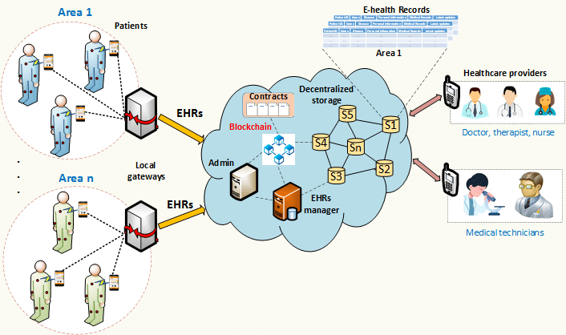

Digitization of p & o clinic procedure is required as
Messages can be lost in case of theft. • Loss of medical evidence in a fire. • Medical reports such as X-rays and MRIs can deteriorate over time. • The absence of these necessary documents can lead to the destruction of the treatment. • Paper maps or records are not interactive or intuitively designed. • Printed reminders and warnings can be easily ignored. • Not all physically written medical records can be read live. • Information cannot be exchanged for written documents. • Organization or disaster in the office can cause data loss. • Misplaced or lost reports can ruin a case if certain important documents are missing. • Patients do not always have all the required documents with them. • Once the assessment is complete, records are always kept for future reference.
Aim and Objective
To digitalize the P&O clinic procedure with the prime objective of:
- Improving services provided to the patient.
- Increasing internal collaboration.
- Optimizing processes and increasing efficiency.
- Becoming more agile and providing easy access to patient about the disease and treatment plan.
- Creating new treatment models and a sense of awareness among people about prosthetics and orthotics.
- Complying with data security.
- Keeping pace with the fast advancing competitive world.
Methodology
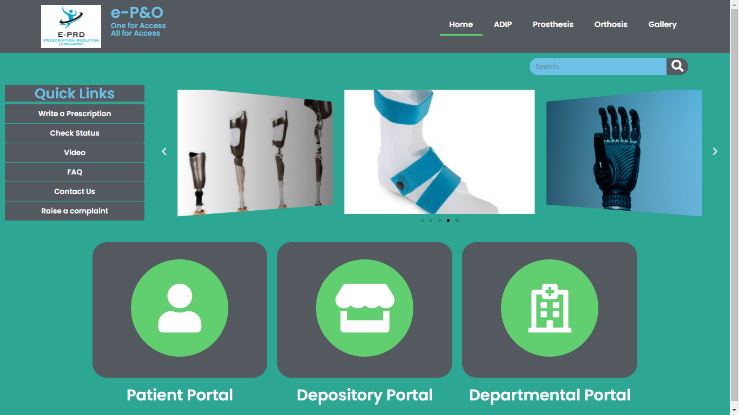
This website is a platform in which admin can collect, analyze, record, summaries data and create content for other users. Mainly three groups of people can be the potential users for this website. As this is an application based upon healthcare services and the first and foremost user can be (1) Patients, (2) Healthcare professionals and (3) Depository Manager. For running our website we used a server named XAMMP, in which our database is stored. We have selected WordPress as a content management system through which contents such as media file, photo and videos, articles, forms, table etc are managed. XAMPP and WordPress serves as a backend software which could be accessed by a frontend software such as web browser i.e. Google chrome, internet explorer etc.

Patient portal
Patient portal serves as an interface for interaction of the patient with the platform. The patient solely can assess the information and data by simply entering their registration details. They can upload documents, view/download prescription and invoice, track the status of appliance, raise complaint and give feedback.
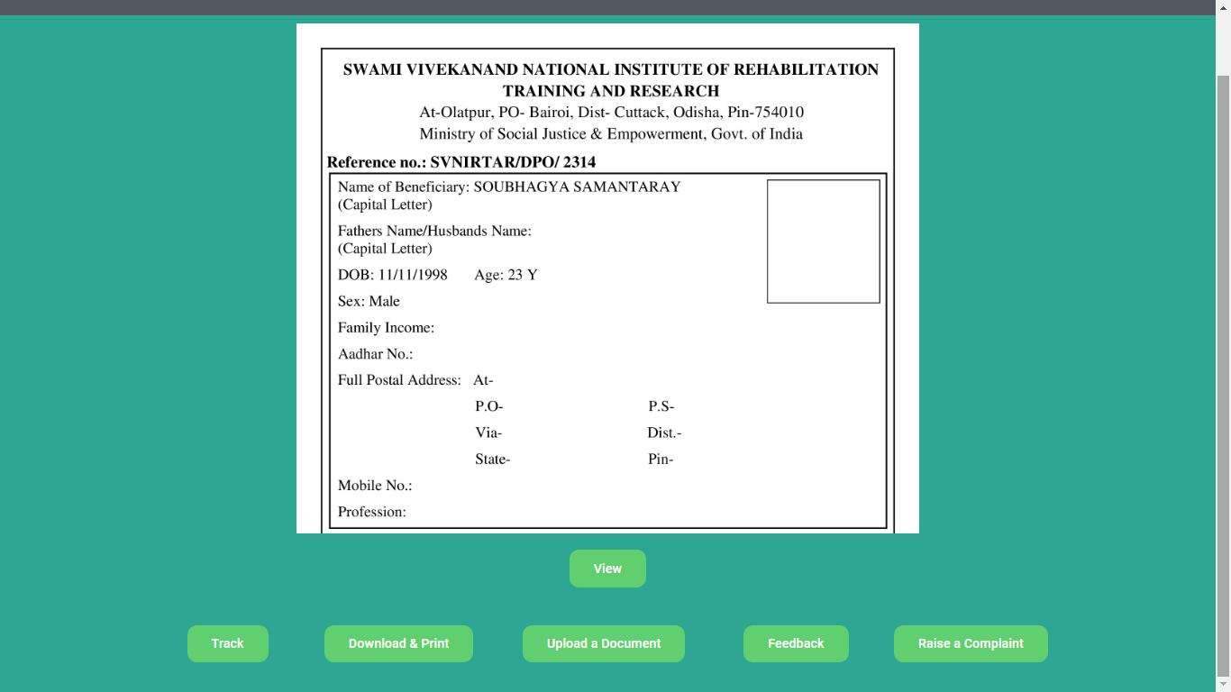

Depository portal
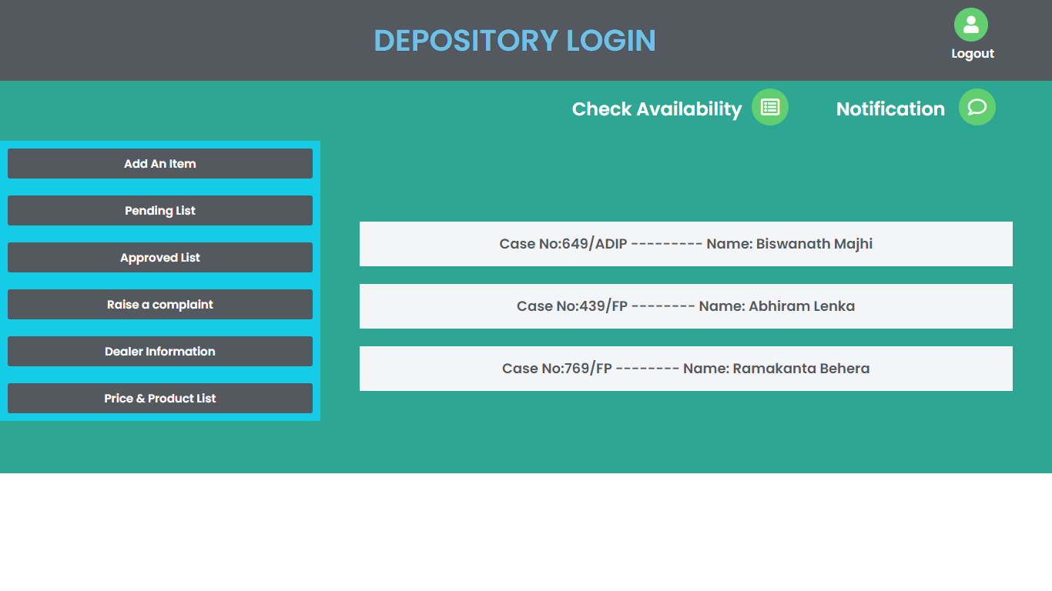
This portal is accessed by the store manager, who keeps a precise look on the availability of raw material, components, etc. The manager is responsible for approving or disapproving the requisition, checking the pending list, ordering items and raising a complaint against the damaged product provided. This portal serves as the medium for performing all these activities through a single window. Receiving and storing are the key considerations in the materials management.

Departmental portal
The rehabilitation professionals along with some other service providers in collaboration with the accounts department have access to his portal. This portal houses a wide range of services in a single window which is assessable to multiple users at a time. The generation of workorder number has a crucial role to play prior to prosthetic and orthotic fabrication. The workorder number helps in inter and intra departmental services to run smoothly and for record keeping of the patients. The professionals have the right to edit or add any information related to the case. This portal serves the professionals not only to prescribe and record data digitally but also to update and view a case in future, which may be a principal tool for research and development.

Tools used in digitization
- INFO BUTTONS
• Contact specific links from the information system to another resource. Provide relevant contextual information. Significantly increase the share of network data at this maintenance point.
- IT PROVISION ON ORDER (CPOE)
• Enables the creation of provider orders electronically either in a rehabilitation center or in an outpatient setting. Eliminates handwriting misinterpretations.
- CLINICAL DECISION SUPPORT (CDS)
Provides intelligently filtered clinical and patient related information. Improve patient care. CPOE and CDS often work in tandem to ensure appropriate patient care.
PERSONAL HEALTH INFORMATION (PHR)
- Allows the patient to track their personal health information. Provides educational materials on self-management of chronic diseases.
- Enables rehabilitation information to be forwarded to a remote service provider for consultation. The frequency of appointments required for the patient can be determined. Improves the quality of care.
- Reduce costs by avoiding costs.
- CLINICAL DATA REPOSITORY (CDR)
- The database that stores all the health information of the electronic health records.

Results
The implementation of digitization in prosthetics and orthotics clinic procedure has brought about significant improvements and advancements in patient care, workflow efficiency and overall outcomes. Below are some benefits of incorporating digitization:
Access from anywhere, anytime. •
Ability to use records simultaneously by several people. •
Makes your records backed up and protected forever. •
Money is saved by using the electronic patient card; not only the cost of paper and folders, but also the cost of labor and space. •
Application of uniform classification and indexing methods for searching documents.
• Quick access to records can be a lifesaver if the answers are there in an emergency and those questions need to be answered in the emergency decision-making process.
• Alerts the rehabilitation specialist to health services or related studies.
• Helps track the patient's previous rehabilitation or medical history and treatment.
• Better coordination and sharing of information.
• No data loss.
• Early intervention.
• serves one platform for all programs
.Despite these positive results, it is essential to acknowledge that challenges may arise during the process; the related issues may need to be addressed to ensure smooth transition and optimum utilization of digital tools.
- Loss of revenue due to expensive software and computer purchase and their maintenance expense.
- Dependent upon reliable operating source for smooth functioning.
- Data security is the biggest threat in the process of digitization.
- Slow learning curve in persons acquainted to older methods.

Discussion
Digitalization is dramatically changing the way rehabilitation specialists and other doctors practice. Implement more readable records that will benefit multiple practitioners. CDR and RHIO (Regional Health Information Organization) act as a bridge that enables teamwork in patient care and protects the population from disease outbreaks. Digitization has many advantages such as availability of information, easy and immediate communication, etc. However, it also has disadvantages such as dependence on unreliable sources, risk of hacking and misuse of information. Technology dominates almost every aspect of our lives. Today, we are witnessing a growing shift towards digitization as it makes life much more comfortable and convenient. Digitization is bringing a new revolution to the healthcare sector. The transformation of the "Indian healthcare system" has already begun. While the government is increasingly encouraging digitization with initiatives like DIGITAL INDIA and AADHAR, the private sector has launched several mobile apps, telemedicine, tools and innovation centers across the country. That is why India urgently needs to be a part of the digital revolution in healthcare.
Conclusion
The implementation of digitization in prosthetics and orthotics clinic procedure has fundamentally reshaped the way we live, work and interact. It’s potential for creating efficiencies, fostering innovation and improving lives is unparalleled. It has led to improved outcomes, increased accessibility and greater patient satisfaction. As we move forward, it is crucial to strike a balance between embracing technological advancements and addressing the ethical, social, and environmental implications they entail. It is crucial for the healthcare industry to adopt digitization fully, fostering continued innovation and enhancing the lives of differently able. By doing so, we can harness the full potential of digitization to build a brighter and more sustainable future for all.

References
- O&P clinical and business forms, American Orthotic and Prosthetic Association.
- Atlas of Amputations and Limb Deficiencies: Surgical, Prosthetic and Rehabilitation Principles.
- Atlas of Orthotics: Biomechanical Principles and Application.
- www.svnirtar.nic.in
- https://svnirtar-opac.l2c2.co.in
- www.guidemytreatment.com
- www.medtech.com/ind/
- https://socialjustice.nic.in
- www.rehabcouncil.nic.in
- www.opai.org.in
- www.sciencedirect.com
- journals.uic.edu
- www.researchgate.net

