Internet of Things and Cellular Networks (5G) – An Expedition to Human Mobility in
Smart Cities

¹Sashikanth Reddy Avula
Department of Master of Computer Applications
Nitte Meenakshi Institute of Technology
Bengaluru, India
askr1985@gmail.com

³Navaneeth A V
Department of Master of Computer Applications
Nitte Meenakshi Institute of Technology
Bengaluru, India
avnavaneeth25@gmail.com

²Sreekanth Rallapalli
Department of Master of Computer Applications
Nitte Meenakshi Institute of Technology
Bengaluru, India
rsreekanth1@yahoo.com

⁴Vidya Sagar S D
Department of Master of Computer Applications
Nitte Meenakshi Institute of Technology
Bengaluru, India
vidyasagarsd@gmail.com

ABSTRACT

Advances in mobile and Internet of Things (IoT) technologies are leading to rethinking how smart cities are designed and managed, tackling many of the challenges faced in the human society. Regions using age awareness can use related technologies to improve mobility and increase productivity for citizens. However, with the rapid development of smart terminals and infrastructure and the growth of various applications, even existing networks may not meet the expectations of fast-moving people. Therefore, they face many challenges for which different models and projects are in demand so far. Therefore, artificial intelligence (AI) has been adopted as a new direction for smart mobile network design and optimization. The aim of this project is to identify the problems of mobile phones related to the Internet of Things and artificial intelligence, to inform the wisdom movement of people and to discuss some solutions to these problems. Finally, based on this discussion, we present future directions for human intelligence research.
Keywords: Smart cities, Mobile Networks, Human Intelligence, Artificial Intelligence, Internet of Things.
- INTRODUCTION

With the rise of the digital age, technology has become an indispensable part of our lives, from work to the movement of people. The digital world affects people positively and creates new trends in technology. An important step following this trend is an ecosystem of services and smart applications based on the interconnection of different devices, that is, the use of the cyber-physical environment (CPE) to join the physical world with the digital world. In other words, the collaboration of artificial intelligence (AI), Internet of Things (IoT) and new technologies enable the digital transformation of people [1].
As society continues to digitize, the increasing speed of IoT has become a natural phenomenon. In fact, the true value of IoT comes from the information provided by existing devices and sensors. Data aggregation improves the prediction of product health and the quality and completeness of data. Therefore, the activities of the data aggregation process cause an increase in the number of connected users due to the trust in the process and the efficiency and potential of IoT smart applications. Therefore, so that the large demand of the equipment interface does not affect the performance, simultaneous connection and response time to user request, reduce the delay in the end use and use of sensors, the requirements such as: spectral efficiency, signalling efficiency should be considered. , high data and security. This means that new wireless communication must be used to overcome this transition. In other words, today's technology like 5G has to solve many problems to provide better quality and connectivity for mobile users [2].
In recent years, mobile power generation technology, including wireless communication, has been continuously developed [3]. All of them have had an impact on the "mobile community" or Internet of Things over the past 50 years. For example, 1G came when salespeople were equipped with phones in their cars so they could make calls while traveling. We started to send messages to each other with Short Message Service (SMS) in 2G and fit mobile phones into people's pockets. Conversely, 3G mobile phones are not limited to certain areas, they can be used everywhere.
Using 4G to provide interoperability across multiple networks. Finally, the purpose of 5G is to expand and adapt to users [4]. With the development of ubiquitous wireless mobile networks and systems, different needs such as the movement of people towards smart city services can be met with the convenience of the network. Wherever we live or whatever we want to achieve, a high-speed, reliable and powerful wireless network is the first step towards creating human services. This is the backbone of all potential smart human mobile apps. Examples of these applications are geotagged posts from social networks [5]; trajectories from mobile GPS [6]; and information about mobile phones and communication between phones [7]. Such a large amount of digital data has supported many achievements in human behavior such as orbital data mining [8] and statistical model reporting [9]. Additionally, data from these apps provide indications of population movement when people in the same place increase or move less (or more) than normal.
These measurements open new avenues for understanding human mobility. Although mobile data is ubiquitous, it has its biases and limitations. In general, data streams for people living in semi-urban or urban areas may be more representative than those living in rural areas. The most popular reports from big data providers show physical distance (mobility) metrics, but their underlying data is representative and the totals used are often not readily available. This lack of transparency makes it difficult to understand the representativeness and limitations of these materials before they are used as models.
The main principle is to determine the characteristics of different data and their results so that the signs of human movement can be better compared and interpreted more easily. On the other hand, the information can also enable people to carry out the prediction task, which is the prediction of the next location, the prediction of the crowd, and the creation of the matches [10]. Data currently drives the design of deep learning (DL) solutions [11,12]. They can work on a more predictable workforce. Additionally, they can extract relevant features from large heterogeneous data, easy-to-confuse data points (census data and weather data), and data movement (orbits and flows). On the other hand, deep learning can capture nonlinear spatio-temporal relationships and relationships in data, thanks to several recurrent neural network (RNN) algorithms. Although this study focuses on the use of deep learning, it also includes other popular prediction methods. For example, the gravity model and spatial equilibrium model are used to predict changes.
One of the advantages of the smart city is that no matter how technology develops and develops, there is always the opportunity to improve and reach a level that has not yet been reached. As we've seen, the Internet of Things has made an impact on people, making it more connected. Technology is now more than ever, anytime, anywhere, wireless networks cover vast areas, and artificial intelligence is increasingly becoming a human companion for prediction and guidance. However, we see that they all have limitations and problems in the development of human mobility services. While many studies have addressed and explored the benefits of this technology for human mobility, most of these studies have addressed the issues alone. Therefore, this article is widely used to bring these differences together, to understand at what level we use this technology in the analysis of movement behavior, and to point out ways that could lead to new human evolution.
In this article, we discuss the importance of IoT, AI and wireless networking technologies for the success of mobile applications for smart people. Therefore, we analyze the critical requirements of smart human mobility and tap into the opportunities created by the evolution of mobile connectivity and IoT architecture. In addition, this study focuses on investigating the level of help of new technologies, IoT architectures and mobile technologies in tracking people. Finally, we discuss the future directions of new technologies to present new solutions of human intelligence.

- HUMAN MOBILITY RESEARCH IN EVOLUTION MOBILE NETWORK

The scientific value of observing human mobility has long been applied in a variety of disciplines. This value is growing in parallel with the evolution of mobile network infrastructure. In fact, the ability of a device to communicate with others and its massive adoption by people demonstrated interconnectedness. Moreover, people stopped being merely passive objects where they operate, but rather agents who make choices about where to spend their time and who modify those places through their presence and activities. Therefore, we should highlight the evolution of mobile communication infrastructures in human mobility research.

2.1 Human Mobility Research from 1G to 4G:

Cell phone tracking has been an expanding research topic over the past few years as many techniques have become technologically advanced and efficient. Additionally, it has some advantages over other human computational methods such as overhead cameras, thermal sensors, and laser beams. While smartphone search tools are now available for many searches, this is not always the case. Therefore, Table 1 lists the metrics used to model the movement of people and the growth of movement.

Table 1. Characteristics of the human mobility metrics in Mobile Networks.
Mobile Networks | Movement- Based | Link- Based | Network- Based | Spatial- Based | Temporal- Based | Social- Based
1G |  |  | ✓
2G |  | ✓ | ✓ | ✓
3G | ✓ | ✓ | ✓ | ✓ | ✓ | ✓
4G | ✓ | ✓ | ✓ | ✓ | ✓ | ✓
5G | ✓ | ✓ | ✓ | ✓ | ✓ | ✓

The first generation (1G) is designed to communicate with mobile phones through a network of distributed transceivers. Their designs, begun in 1974 and completed in 1984, are based on Amplified Telephone Service (AMPS) and Total Access Communications System (TACS) technologies. The 1G network only allows phone calls, has reliability and signal interference issues, and has little protection against hackers. They also open a short discussion limited to a few people for business. These network parameters are controlled by a better understanding of motion patterns. Therefore, the management of the mobile network infrastructure takes into account various network-related metrics such as data loss rate, transmission or energy consumption. However, more infrastructure is required to drive the transition from 1G to 2G [3].
Next generation 2G mobile phones support General Packet Radio Service (GPRS), similar to the Global Standard for Mobile Communications (GSM), with some improvements for higher data requirements and improved data for GSM Evolution (EGPRS). EGPRS is the evolution and development of 2G and 2.5G GPRS networks between 1990 and 2003. In the 2G mobile phone era, some important functions such as short message service (SMS), picture messages, voice or picture messages (MMS) have been included, and the use of various technologies to improve the connection language of users, multiple instant messaging access. (TDMA), Code Division Multiple Access (CDMA), and Frequency Division Multiple Access (FDMA). In this mobile phone, triangulation of all parts of the mobile can be used to collect location and low-level events such as phone updates and calls from the network. These location algorithms make 2G more relevant for determining human movement based on multiple anonymous data sources.
From 2003 to 2008, 3G provided services that could carry both non-voice data (for example, e-mail exchange, file download or instant messaging) and voice. This process is a simple evolution method for 2G systems. Some 3G standards including Universal Mobile Telecommunications System (UMTS) (3GSM) (developed by the Third Generation Partnership Project (3GPP), High Speed Most of the ports are in the form of UMTS-based 3G networks - works fine.
This development allows for more data transfer among other communications such as Broadband Code Division Multiple Access (W-CDMA), Freedom of Movement Multimedia Access (FOMA), Universal Access Network (GAN/UMA), High Speed ​​Uplink Link Package. Access (G-HSUPA) and Time Division Synchronous Code Division Multiple Access (TD-SCDMA). This cell provides data for investigating human behavior patterns in cyberspace and human movement patterns in the physical world. Additionally, 3G spatio-temporal information connects cyberspace with the physical world, helping to examine their interconnections with urban workplaces. In other words, through 3G data, we can explore how people behave in cyberspace and the physical world, and analyze people's behavior in social context, etc. We can understand more about people's behavior by relating it to
With the development of technology and smart phones, the speed of 3G networks is rapidly becoming insufficient.
While any mobile phone can use a Wi-Fi hotspot and connect to the internet via a dongle on a computer, 4G makes data transfer very fast. Around 2010, 4G was split into two groups, 4G and 4G LTE (LTE for short). Voice calls are even better with 4G because data is sent in clear packets thanks to Vertical Frequency Division Multiplexing or Multiple Access (OFDM / OFDMA) technology. In this generation, operators collect a wealth of spatio-temporal data that enables location analysis for a variety of applications, such as determining how users move in a region (for example, in human movement)., most visited sites), mobile phone users' contact information, GPS or Wi-Fi data from mobile hotspots, mobile app data to us (like Twitter, Facebook or Uber), etc. Among other things, it opens the door to monetizing people's movement data by selling location intelligence insights to third parties.

2.2 5G Mobile Network to Explore Human Mobility

5G opens a new era in mobile communication technology. This new communication standard combines different flows between terminals and other technologies which access via different wireless technologies at the same time. Although 1G, 2G, 3G, and 4G have played an important role so far, 5G is able to really connect the entire world without limits. Therefore, this broad and fast digital connection provides a platform for every academy and industry to boost innovation projects in human mobility.

2..2.1 Components of 5G Physical Infrastructure

The market-oriented 5G network architecture is designed to meet different mobile markets. It uses network function virtualization (NFV) and software-defined networking (SDN) to extend cloud access, critical communications, transportation, and physical infrastructure support. Cloud computing is an efficient and flexible solution to support various 5G services. In addition, he is familiar with the core technology of end-to-end network slicing (E2ENS) through the sharing of network functions and the need to distribute onboard link services. The network payload consists of SDN controllers and routing nodes. The SDN controller creates a unique data transmission based on the network topology and business needs. The network architecture also manages network resources and enables end-to-end automatic slicing (E2EAS).
As shown in Figure 1, E2ENS is key to the evolution and support of 5G multi-services. The physical infrastructure of the SDN and NFV-based 5G network architecture consists of facilities and three DC layers: central office DC (CODC), local DC (LDC), and regional DC (RDC). The site supports 5G, LTE, Wi-Fi, etc. It takes various types and delivers cloud RAN real-time (RT) operations in the form of pico, micro and macro base stations. However, these tasks are real-time, high-performance, require computing power and involve specialized hardware. In contrast, a three-tier cloud DC provides storage and computing services. CODC is closest to the base station side. The second layer is LDC and the top layer is RDC. All cloud data centers are interconnected by transport network infrastructure.
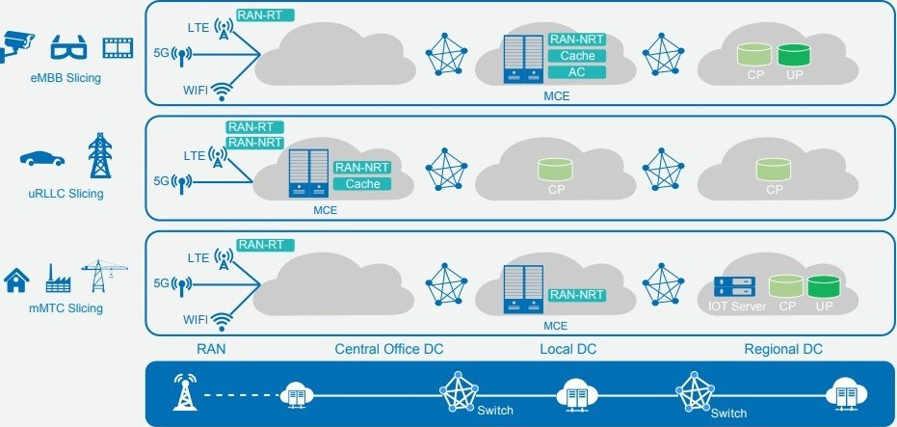

Figure 1. Physical infrastructure of the 5G network architecture

2.2.2 Open Challenges and Human Mobility Research Directions

5G technology is already being used. We can now estimate the revenue and costs associated with the Human Mobility Research use case. We rely on equipment to support many important sites. In the configuration performed in the core network (CN), an SDN device must be optimized to transmit and restore intent, provide better support, increase capacity and human sprawl. movement. . Also, faster and more efficient CN delivery can only be achieved using artificial intelligence techniques such as machine learning. By efficiency we mean here that the CN signal offers efficient and reduced transmission, operation and other measures cost.
5G works differently than human setups. Users can access different products such as services or links to different products. For example, to help meet the mobility needs of different 5G networks and avoid a one-size-fits-all approach, it would be helpful to have independent input for each connection. In addition, the implementation of this protocol can provide better communication management and quality of service (QoS) settings for 5G networks.
The principle of Device-to-Device (D2D) is to analyze the characteristics of people's movement patterns, individual pathways and different aspects of human mobility, including in real-life D2D communication. For example, 3GPP Release-13 supports communication with devices in a group, thus resulting in the D2D group. Therefore, the strategy of transferring from CP/DP data can improve the performance of network equipment in the group. The right policy still remains popular in 5G and B5G networks, given the continuation of CP-DP operation of the existing D2D framework, as well as the presence of D2D communication between users and devices, and other situations.
User mobility or network load is the failure to establish a learning connection to prepare the best strategy for human mobility for 5G and B5G networks. In addition, these parallel networks distribute traffic throughout the network, reducing congestion problems. Note that Network Functions Virtualization (NFV) and Software Defined Networking (SDN) simplify network operations by facilitating rapid changes as users move around the network. In addition, these migration services for 5G will improve QoS when users move to another national mobile network (PLMN) and allow people to migrate to edge cloud services as they move.

- EMERGING TECHNOLOGIES IN HUMAN MOBILITY

While mobility and the Internet of Things are nothing new for business and education, mobile devices are becoming more commonplace and IoT uses devices at the edge of the network to generate more traffic on the business network base. . To cope with the increase in traffic requires investment in connectivity. Higher demand for better connectivity is driving progress in new communication technologies. Therefore, we must address the impact of human mobility and the Internet of Things on mobile phones and explain how companies and education can prepare networks for the growth of human travel and the Internet of Things.

3.1 The Impact of Human Mobility and IoT on Mobile Networks

It is undeniable that the Internet of Things and mobile networks in human travel research are scientific events that encourage many problems encountered in life to produce solutions to many things. However, we need to be aware of the mobility and IoT challenges and solutions presented by new technologies, devices and applications.
First, the continued increase in mobile phone usage means there is greater demand for available network bandwidth. The challenge is to create a phone-ready network that ensures that all devices, indoors and outdoors, have enough resources, even when connected wirelessly. As hackers become more sophisticated and the number of malicious content increases, it becomes increasingly difficult to manage these devices and secure these endpoints.
Creating security policies for all devices on each user's network can be complex and difficult to implement. Mobile security should be the top priority for mobility research to prepare for the future network. But the Internet of Things has proven to be a disruptive technology that connects almost everything from microwaves to alarms to the Internet, transforming people, collecting research data and making life easier for users' lifestyle and work. However, the problem for mobility researchers is that end-user IoT services are designed with little attention to business networks, especially when it comes to cybersecurity. In addition, infrastructure must be adapted to take full advantage of the IoT while maintaining secure and efficient operations.
Given all this, network performance is a major concern. In most cases, data is collected from endpoints and sent to a home server or data center for processing, whereas in IoT this is useless when dealing with large volumes of data. The amount of data flow can be huge, which puts a lot of pressure on the network infrastructure. Therefore, the foundation of mobile phones must be reconsidered to improve performance and security while supporting disruptive technologies such as the Internet of Things.

3.2 Integration of Emerging IoT Communication Technologies

As with all technologies, the Internet of Things and human mobility present many challenges to overcome when it comes to wireless wide area networks (WWANs). To solve this problem, low-power local area network (LPWAN) has become a popular low-cost wireless communication technology. Sigfox, LoRa and 3GPP are three LPWAN technologies competing for large information domains, such as Extended Coverage GSM (EC-GSM), Long Term Evolution of Machines (LTE-M), and Narrowband Internet of Things (NB-IoT). Scale IoT deployments. Thus, LPWAN and WLAN are changing the IoT landscape.
Since human mobility in the environment requires the mobility of similar or different devices on LPWAN technology, enabling mobility is about ensuring that data is transmitted as required during transit. In other words, the challenge of using IoT in human mobility research is based on the recognition that effective communication between devices is essential for effective communication. They need to be able to communicate their business as people move around. Thus, human mobility in this context is defined as the movement of gateways (GWs) between different technologies and workers. Therefore, it is expected that the device can support multiple technologies to realize the delivery time of human voice data.
In Figure 2, we compare LPWAN technology with several generations of mobile phones based on 6 indicators: coverage, spectrum bandwidth, number of stations, power consumption, access cost and latency. Both are rated from 0 to 5; It is clear which technique works best for which job. For each metric, the technology with the highest value is assigned a value of 5. There are two lines of different colors on the map, one representing technology; others represent technology. Six measures means six measures. While mobile phones require high ratings, base station configurations, and high power consumption, criteria such as coverage, reach, and latency are the main traffic drivers for LPWAN applications. However, range, power consumption, cost and battery life are different features and LPWAN solutions may require significant trade-offs. They also support multiple devices with different expectations in a heterogeneous environment. Therefore, LPWAN solutions can be adapted to the user's mobility.
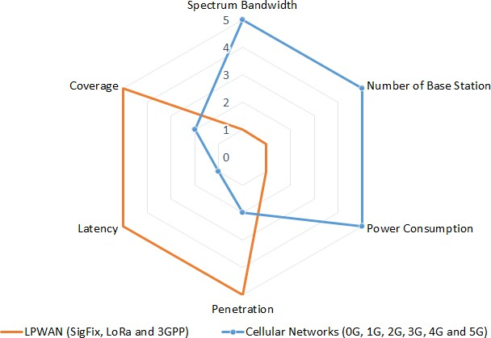

Figure 2: Qualitative perspective analysis between emerging technologies and traditional cellular

As we said, LoRa, Sigfox and 3GPP (EC-GSM, LTE-M and NB-IoT) are the main competitors in the LPWAN space. The ultimate goal of our technology is the same: Mobile users get their technology for IoT deployment in cities and countries wherever wide area networks (LPWANs) have no electricity. Although the business models and technologies behind Sigfox, LoRa Alliance, Sigfox and 3GPP are very different, they all use unlicensed communications technology. In Table 2 we present the features and functions of LoRa, Sigfox and 3GPP.
LoRa or LoRaWAN network is an open ecosystem with private security that provides two-way communication with a focus on capacity, efficiency and optimization of movement. They provide high quality and high quality design, including regular platforms. In addition, the LoRa Alliance improves commerce and life worldwide. For example, explore the sources of these networks to monitor the fuel tanks used by the supply companies. The filling levels and other important data of these tanks are sent to the LoRaWAN network.

Table 2. Overview of LPWAN technologies: LoRa, Sigfox, and 3GPP
Parameter LoRa | SigFox | EC-GSM | LTE-M | NB-IoT
Range <15 Km | <50 Km | <15 Km | <11 Km | <15 Km
Max peak 50 kbps | 100 bps | 74 kbps | 1 Mbps | 250 Kbps
Maximum 157 dB | 153 dB | 164 dB | 160 dB | 164 dB
Coupling loss <500 KHz  Bandwidth  Radio Spread Technology Spectrum | 100 KHz  Ultra Narrow Band | 200 KHz  TDMA/  FDMA | 1.08 MHz  OFDM | 180 KHz  OFDM
Autonomy >10 Years | >10 Years | >10 Years | >10 Years | >10 Years
Standardization LoRa-  Alliance | SigFox Company | 3GPP | 3GPP | 3GPP

Although Sigfox's website business model is unique due to its top-notch approach. Some of the features of this network include cloud servers, endpoint software and data backup. Despite all of the company's technologies, companies like STMicroElectronics, Atmel, and Texas Instruments have developed Sigfox radio to take advantage of its open market for end-of-content and cost-effective IoT and machine-to-machine (M2M) application. However, due to the company's special agreement with business owners, only one Sigfox can be shipped to the area if they cooperate.
Finally, 3GPP is another new technology that defines 5G standards. Now, it has many groups, EC-GSM, LTE-M and NB-IoT, each has a specific region. EC-GSM offers greater security, privacy and data integrity compared to GSM/EDGE and lower cost compared to GSM/GPRS. It can be used by the software to provide comprehensive services and faster updates required for the mobile phone's features. LTE-M is another part of the 3GPP architecture. It reuses existing LTE stations and supports features such as multicast, more data, location and different mobility metrics. In contrast, NB-IoT costs less than LTE-M. It's easy to improve mobility, reduce bandwidth and data speeds, and add process optimization. Improved service by improving streaming location, consumption and latency with recent updates. All these groups contribute actively to the goal of many efforts to support the development of new services and the use of human mobility.

- CELLULAR NETWORKS TECHNOLOGIES

According to the previous sections, the 5G generation has changed the way mobile communication communicates with similar features. It is designed and optimized for large-scale spectrum, local offloading, advanced encoding and modulation, and leverages small-cell wireless technologies (eg LoRa, SigFox, and 3GPP) to improve human coverage. However, this coverage area is not the same as other generation mobile phones. Therefore, we need to compare previous generation wireless technologies to better understand the coverage of 5G with the new technology and to allow for a comprehensive study of human mobility.

4.1 Coverage Human Mobility Comparison

The main feature of 5G technology is the increase in the quality of service when the mobile phone is used by many devices or devices. Also, these features are well suited for IoT applications. Both of these advantages can be easily used in crowded areas. Therefore, movement researchers should focus their research on crowded events and other gatherings such as concerts, stadiums and arenas. For example, thousands of workers work each week in large office buildings such as the Empire State Building in the United States or the 54-story Mori Tower in Tokyo's Roppongi district. As home Internet access from mobile phones becomes more commonplace, in many rural households, these 5G developments go beyond mobile phones and tablets. However, as shown in Figure 3, this is not always due to a limited number of different phones.
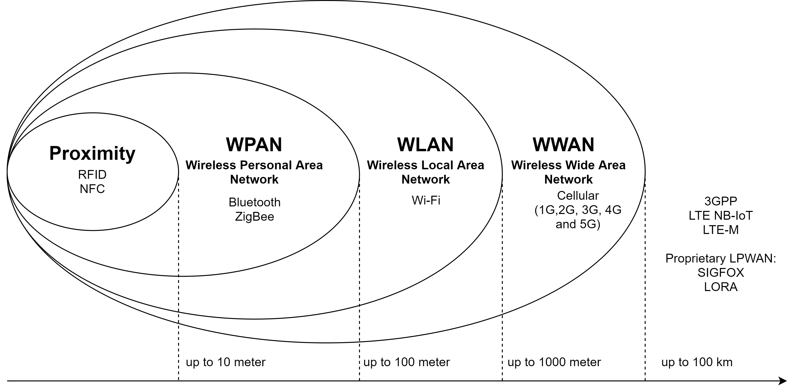
Few applications use outdoor sensors and use RFID technology. RFID is an automatic identification and data capture device to identify non-linear objects and read more, this function predicts bus stops, bus passengers and provides additional buses in heavy traffic areas where cars are required. Another strategy for indoor location tracking widely used in human mobility is based on RFID. With this process, a closed track is planned for walking for the visually impaired. It determines the user's position based on Bayesian decision theory by considering the signal received from the RFID reader as a detection vector. However, since the information of most of the tags is still very far away, the position error is large. Therefore, there is a need for other WPAN technologies that cover large areas: Bluetooth and Zigbee.
Figure 3. Wireless Landscape
Bluetooth Low Energy (BLE) has the advantages of small size, low cost, low power consumption and high security. A lot of recent research has been devoted to the enrollment process based on this process. In addition to exchanging information between devices, BLE offers new opportunities to explore space. In [24], researchers investigated how BLE beacons can be used in indoor conditions and human movement accuracy. In the external environment, Zigbee promises a lower cost compared to BLE. It also offers low power consumption and low data rates for short range wireless personal area networks (WPANs). In [25], the authors analyze existing privacy solutions focusing on cultural processes and analyze them in the context of human movement and find the closest mobile phone by local area. One of the disadvantages of using WPAN is working in a limited space or space around the user. Research-based mobility can use wireless local area networks (WLANs) to overcome this limitation.

WLAN has become the switch of the indoor environment. It meets the increasing demand for on-site services with the connectivity of all locations and the use of the Internet of Things. It is also important to determine the accuracy of the information at home. For example, to solve all these problems ref. [26] used a Wi-Fi system data-driven approach to simulate flows of indoor residents at various spatial locations and extract passenger flows from smartphones. On the other hand, many applications in outdoor environments such as city planning, transmission and traffic modeling use data collected from WLANs to understand the movement of people. This communication system has allowed researchers to see that people's movements in the external environment are regular and predictable. However, it has its limitations and requires a wireless access point. Then WLAN can cover a larger area using mobile communication technology.

1G, 2G, 3G, 4G LTE and 5G for indoor and outdoor human mobility Researchers are interested in important regulations such as greater mobility due to interoperability across multiple networks, product usage and physical tracking information. Here are some of the more widely accepted QoS metrics. They also enable the integration of devices and connections without high speed. Therefore, these mobile phones contribute more to the achievement of intelligent human mobile services and researchers introduced technologies such as data analysis dimension (AI/ML). In turn, new technologies (for example, LoRa, SigFox and 3GPP) further confirm the mention of the program.

4.2 User Mobility and Data Rate

All the methods mentioned in Chapter 4 collect information about the user's journey with each movement (ie, standing or walking). Figure 4 shows that the x-axis represents the data rate supported by different mobile phone models and the y-axis represents the user's mobility. Also, in a visual comparison, we can see that all technologies support high-speed connections. From 1G to recent 5G, users in fixed and mobile mode provide more data, better data can be obtained in wi-fi, but only passengers are served.
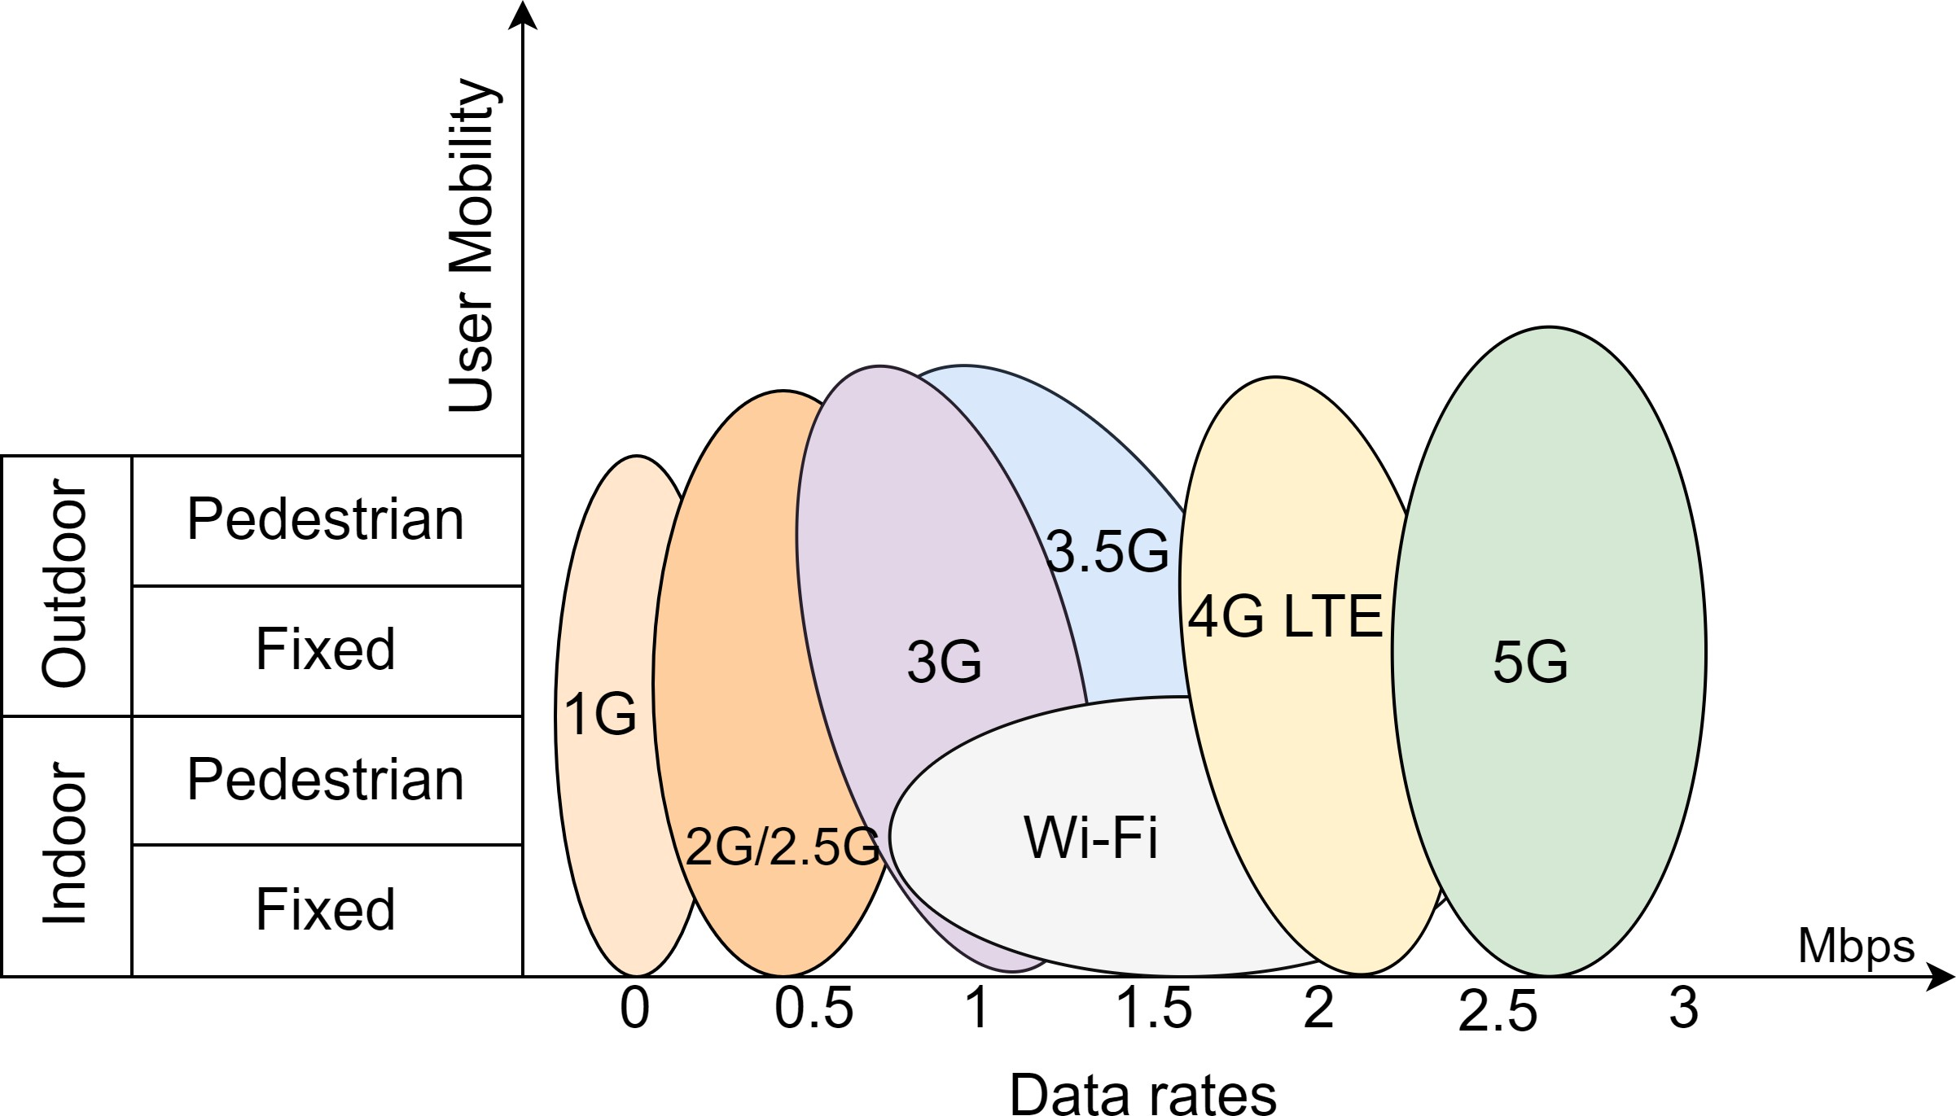
Figure 4. User Mobility versus data rate

However, some challenges remain with regard to mobile devices and IoT, mainly related to greater data, accessibility, mobility and reliability. The business of this technology seems to be evolving and improving just like the previous generation. So no matter how successful they are, they will be beneficial to the business. Users will have to step-by-step upgrade their equipment or purchase equipment that can be used with communication technology, resulting in many financial changes to their business and support businesses every decade. However, experience in the world of communication shows that the success of each new generation will be achieved more slowly than its commercial success.

- CONCLUSION

The rapidly emerging concept of mobile communication paves the way to the goal of intelligent human connection with various smart devices, Internet of Things and artificial intelligence. First, this article explores the rationale for this concept and presents contemporary research to monitor and analyze social network topology, spatial distribution and individual mobility in cities and regions, remote or rural areas. In addition, we use the human movement data and measurements method to gain a deeper understanding of the relationship between these factors and the spatio-temporal distribution in geographic location.
Human movement data and signals apply to many applications. The results of these human social applications should inspire ideas for understanding and predicting human behavior, creating new smart applications and improving existing systems. They should also better understand the information published by individuals, improve the editing process, and improve the connectivity of information technologies such as wireless connectivity. For example, in better predicting human movement, we need to consider not only artificial intelligence models, but also networked networks to receive data. Network dynamics can be key to documenting human interaction with various devices. Thus understanding of human dynamics leads to new interesting information for wireless networks in geospatial fields.
In addition to the great benefits of IoT, artificial intelligence, and networking, this document also presents some challenges (such as security, trust, and big data) and their solutions. In addition, this article examines the best potential of mobile technologies from 1G to 5G, as the Internet of Things has emerged as a continuous network to stimulate new human needs. In fact, it provides details on the role of 5G cellular networks in the advancement of the Internet of Things and human mobility. Additionally, this study discusses some of the problems and solutions related to this mobile age.
Also discussed new technologies such as LoRaWAN, Sigfox and 3GPP with high performance, low cost, wide coverage and narrow bandwidth. These LPWAN solutions are a powerful way to help people navigate. They provide a good framework and context for using the exchange. This article analyzes the gaps and evaluates the suitability of LPWAN implementation for user mobility. It also refers to various solutions such as EC-GSM, LTE-M and NB-IoT, and solutions for developing or adapting these technologies.
We also discuss some analyzes of the contribution of human mobility to mobile phone use. The upcoming 5G cellular technology should power all new applications, as its main benefits are improved performance and increased capacity in the user's mobile phone space. Hybrid networking solutions that combine personal area network (PAN), local area network (LAN), wireless wide area network (WWAN) and LPWAN in the future.
The theoretical contributions of this study form the latest scientific and technological basis for human mobility in smart cities. The available literature shows that many projects (with or without intelligence) are trying to increase the intelligence of human mobility in cities. These projects are designed using communication technologies, signs of human movement in the city and the most appropriate artificial intelligence algorithms. While increasing research in the field of human mobility leads to improvements in human intelligence, smart cities are exposed to different technological and scientific products, unaware that technological solutions exist. Therefore, in this study, it will be easier to develop and use the concept of human mobility so that the concept of smart city and human mobility are compatible. The next step in this research manifests itself in adapting these indicators, ideas and models in a cutting-edge approach to create smart people's mobility plans for each city.

- REFERENCES
- Aquilani, B.; Piccarozzi, M.; Abbate, T.; Codini, A. The role of open innovation and value co-creation in the challenging transition from industry 4.0 to society 5.0: Toward a theoretical framework. Sustainability 2020, 12, 8943.
- Zikria, Y.B.; Kim, S.W.; Afzal, M.K.; Wang, H.; Rehmani, M.H. 5G mobile services and scenarios: Challenges and solutions. Sustainability 2018, 10, 3626.
- Benisha, M.; Prabu, R.T.; Bai, T. Evolution of mobile generation technology. Int. J. Recent Technol. Eng. 2019, 7, 449–454.
- Strategy, A. This Report Outlines the Influence of 5G; Technical Report; 2021. Available online: https://www.accenture.com/_acnmedia/PDF-144/Accenture-5G-WP-EU-Feb26.pdf (accessed on 9 June 2021).
- Menfors, M.; Fernstedt, F. Geotagging in Social Media-Exploring the Privacy Paradox. Ph.D. Thesis, University of Borås, Borås, Sweden, 2015.
- Subedi, S.; Pyun, J.Y. A survey of smartphone-based indoor positioning system using RF-based wireless technologies. Sensors 2020, 20, 7230.
- Rong, B.; Han, S.; Kadoch, M.; Chen, X.; Jara, A. Integration of 5G Networks and Internet of Things for Future Smart City. Hindawi 2020.
- Zheng, Y. Trajectory Data Mining: An Overview. ACM Trans. Intell. Syst. Technol. 2015, 6, 1–41.
- Yong, N.; Ni, S.; Shen, S.; Chen, P.; Ji, X. Uncovering stable and occasional human mobility patterns: A case study of the Beijing subway. Phys. A Stat. Mech. Appl. 2018, 492, 28–38.
- Wu, R.; Luo, G.; Shao, J.; Tian, L.; Peng, C. Location prediction on trajectory data: A review. Big Data Min. Anal. 2018.
- Pamuluri, H.R. Predicting User Mobility Using Deep Learning Methods; Dept. Computer Science & Engineering, Blekinge Institute of Technology: Karlskrona, Sweden, 2020.
- Abbasi, M.; Shahraki, A.; Taherkordi, A. Deep Learning for Network Traffic Monitoring and Analysis (NTMA): A Survey. Comput. Commun. 2021.
- Ande, R.; Adebisi, B.; Hammoudeh, M.; Saleem, J. Internet of Things: Evolution and technologies from a security perspective. Sustain. Cities Soc. 2020, 54.
- Pravir, C.; Gianluca, F.; Stefano, L.; Stefano, L. Mobile Network and BroadBand Coverage Map; JRC103081; European Commission: Ispra, Italy, 2016.
- Sánchez-Corcuera, R.; Nuñez-Marcos, A.; Sesma-Solance, J.; Bilbao-Jayo, A.; Mulero, R.; Zulaika, U.; Azkune, G.; Almeida, A. Smart cities survey: Technologies, application domains and challenges for the cities of the future. Int. J. Distrib. Sens. Netw. 2019.
- Kadar, C.; Pletikosa, I. Mining large-scale human mobility data for long-term crime prediction. EPJ Data Sci. 2018, 7, 1–27.
- Hasija, S.; Shen, Z.J.M.; Teo, C.P. Smart city operations: Modeling challenges and opportunities. Manuf. Serv. Oper. Manag. 2020, 22, 203–213
- Zhao, C.; Zeng, A.; Yeung, C.H. Characteristics of human mobility patterns revealed by high-frequency cell-phone position data. Epj Data Sci. 2021, 10, 1–14.
- Archer, C.L.; Cervone, G.; Golbazi, M.; Al Fahel, N.; Hultquist, C. Changes in air quality and human mobility in the U.S. during the COVID-19 pandemic. Bull. Atmos. Sci. Technol. 2020.
- Wang, A.; Zhang, A.; Chan, E.H.W.; Shi, W.; Zhou, X.; Liu, Z. A Review of Human Mobility Research Based on Big Data and Its Implication for Smart City Development. ISPRS Int. J. Geo-Inf. 2020, 10, 13.
- Karsten, J. 5G Technologies will Power a Greener Future for Cities; Brookings Institution; 2016. Available online: https://www.brookings.edu/blog/techtank/2016/11/30/5g-technologies-will-power-a-greener-future-for-cities/ (accessed on 9 June 2021).
- Asmael, N.; Waheed, M. Demand estimation of bus as a public transport based on gravity model. In Proceedings of the MATEC Web of Conferences 2017, Sharm el-Shiekh, Egypt, 3–6 October 2017; Volume 162.
- Farid, Z.; Nordin, R.; Ismail, M. Recent Advances in Wireless Indoor Localization Techniques and System. J. Comput. Netw. Commun. 2013.
- Sindian, S.; Khalil, A.; Samhat, A.E.; Crussière, M.; Hélard, J.F. Resource allocation in high data rate mesh WPAN: A survey paper. Wirel. Pers. Commun. 2014, 74, 909–932.
- Shubina, V.; Holcer, S.; Gould, M.; Lohan, E.S. Survey of decentralized solutions with mobile devices for user location tracking, proximity detection, and contact tracing in the covid-19 era. Data 2020, 5, 87.
- Trivedi, A.; Silverstein, K.; Strubell, E.; Shenoy, P. WiFiMod: Transformer-based Indoor Human Mobility Modeling using Passive Sensing. arXiv 2021, arxiv:2104.09835
- Heo, S.; Lim, C.C.; Bell, M.L. Relationships between local green space and human mobility patterns during COVID-19 for Maryland and California, USA. Sustainability 2020, 12, 9401.

