Nuclear Physics, Unraveling the Mysteries of the Atom

Advances in nuclear physics, Exploring the fundamental of matter and energy
Author: Umar Mushtaq , Zubair Nazir .
Affiliated Department: Department of Mathematics, Jammu & Kashmir Institute Of Mathematical Sciences, Campus Amar Singh College, Srinagar, India.
Abstract
Nuclear physics is a branch of physics that explores the behaviour, configuration, and properties of atomic nuclei. This research paper aims to provide a comprehensive overview of nuclear physics, including its historical background, fundamental theories, current advancements, and practical applications. It delves into concepts such as nuclear decay, nuclear reactions, and nuclear energy, while also exploring the cutting-edge research carried out in this field. Nuclear physics has played a pivotal role in our understanding of the universe, leading to breakthroughs in medicine, energy generation, and elemental composition. This paper underscores the significance of nuclear physics and its impact on various scientific disciplines.

Keywords: Branch, ‎explores, ‎comprehensive, ‎overview, ‎advancements, ‎practical, ‎applications, ‎delves, and ‎concepts.
^{Introduction}
Nuclear physics is deeply embedded in our exploration to understand the essential building blocks of matter and the forces that govern their interactions. It analyses the nucleus of an atom, where more than 99.9% of its mass is concentrated, and examines the behaviour of protons, neutrons, and other subatomic particles within it. With evolutions in experimental techniques and theoretical models, our understanding of nuclear physics has significantly expanded in recent years. This paper sheds light on the notable advancements in this discipline and how they contribute to our knowledge of matter and energy.
Nuclear Structure: Overview of nuclear physics: Nuclear physics is a scientific discipline that studies the structure of nuclei, their formation and equilibrium. It mainly focuses on understanding the fundamental nuclear forces in nature and the complex interactions between neutrons and protons.
Nuclear Physics is the division of physics that deals with the pattern of the atomic nucleus and its interactions.
Historical development of nuclear physics
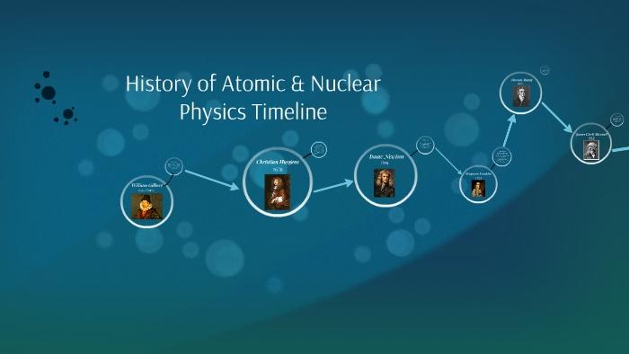
The history of nuclear physics as a discipline distinct from atomic physics, starts with the discovery of radioactivity by Henri Becquerel in 1896, made while investigating phosphorescence in uranium salts. About, in 1917, Ernest Rutherford became the first person to create an artificial nuclear reaction in laboratories at the University of Manchester. Rutherford, a British physicist probed atoms with alpha particles. He is known as the “father of nuclear physics”. He was awarded the Nobel Prize for his contribution to the structure of the atom in 1908.
Importance of nuclear physics in different scientific domain
Discoveries in nuclear physics have led to entreaty in many fields. This includes nuclear power, nuclear weapons, nuclear medicine and magnetic resonance imaging, industrial and agricultural sectors, ion implantation in particle engineering, and radiocarbon dating in geology and archaeology. Nuclear physics is ubiquitous in our lives. Detecting pollution in our households, testing and treating cancer, and monitoring shipments for contraband . The ways that nuclear physics and the methods it has generated make a difference in our safety, health, and security. Many of today’s most important evolutions in medicine, materials, energy, security, climatology, and dozens of other sciences emanate from the wellspring of basic research and development in nuclear physics.
Fundamental Theory Of Nuclear Physics
Atomic nucleus and its constituents, the nucleus of an atom is the focal locale of an atom where most of the mass is concentrated. Through the dispersing of alpha particles explored by Rutherford, we discovered that the nucleus of an atom contains a more significant part of the mass of the atom. Numerically, the nucleus of an atom possesses almost 10-14 times the volume of the atom yet contains 99.99% of the atomic mass. The nucleus of an atom is small to the point that if you extended an atom to occupy a room, the nucleus of an atom would at present be no bigger than a pinhead.
The mass of an atom is concentrated in a very small central segment of the atom which is called the atomic nucleus. The atomic nucleus is made up of electrically positive protons and electrically neutral neutrons. Surrounding the atomic nucleus are the electrically negative electrons. The masses and charges of these three fundamental constituents of atoms.
Particle Charge Mass
Electron -1 0
Proton +1 1
Neutron 0 1

The chemical nature of an atom, that is, the chemical properties of a specific element, is determined by the number of protons in the nucleus. This number of protons is called the atomic number. The mass of the atom, its atomic mass, relies upon both the number of protons and the number of neutrons present in the nucleus, remember that the mass of an electron is so small that it is completely ignored to establish the atomic mass. For many of the chemical elements, there are several known isotopes. Isotopes are atoms with different atomic masses which have the same atomic number. The atoms of various isotopes are atoms of the same chemical element, they differ in the number of neutrons in the nucleus.
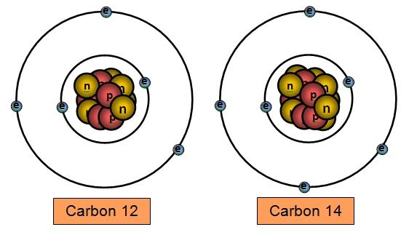
Physicists sometimes find it necessary to specify the atomic mass of an isotope. This is done by writing the atomic mass as a superscript preceding the atomic letter symbol, like carbon [14C].
Atoms of the same chemical element all have essentially the same chemical properties and reactivity but they do not always have the same mass because, although the number of protons in the nucleus is the same for all atoms of the same element, the number of neutrons is not. The number of electrons also may vary, but only if the atom ionizes, and in any case, the relative mass of the electron is much less than that of a proton or neutron. The loss or gain of electrons is often ignored. However, the mass of the neutron is large enough that for any element a difference of one neutron is significant. As a consequence, the molar masses of the different isotopes of an element are significantly different. Most elements as they occur naturally on earth are mixtures of several isotopes.
Strong Forces And Nuclear Stability
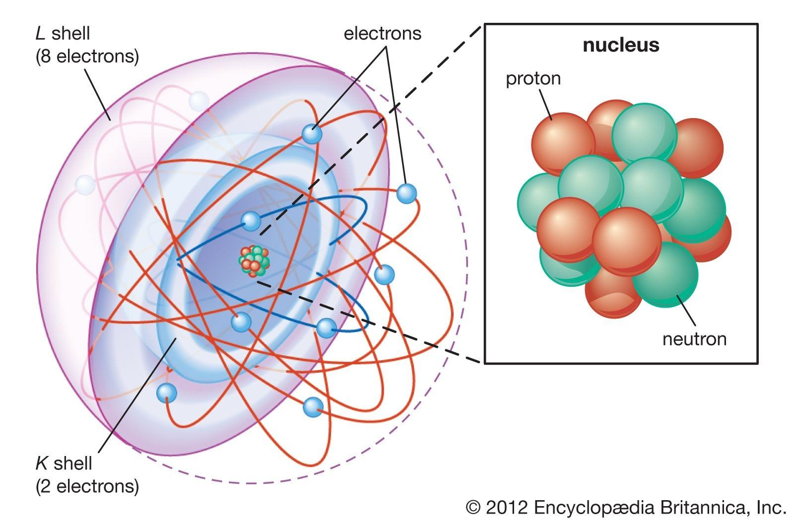
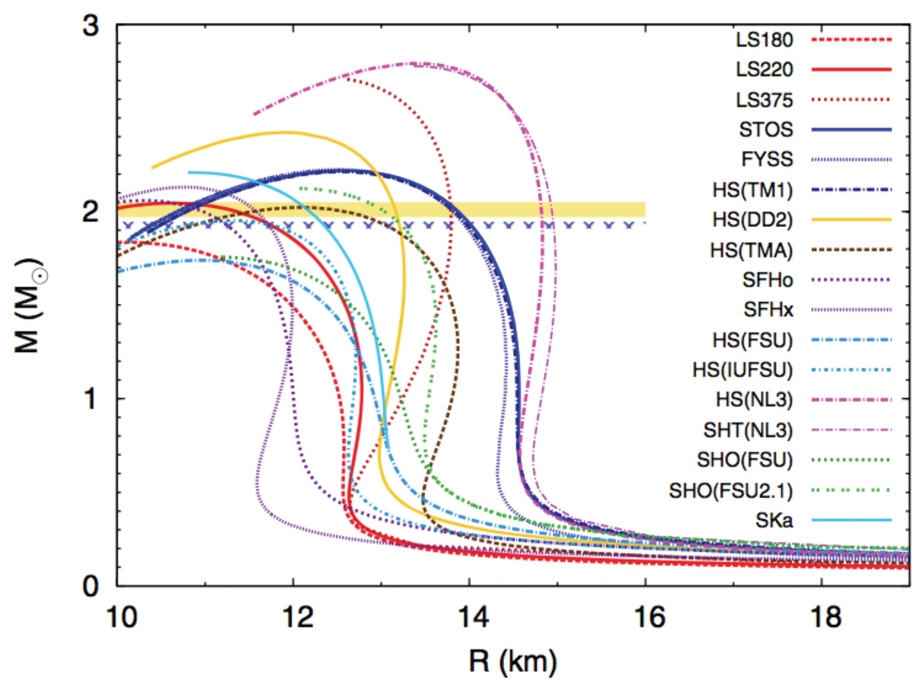
Each nucleon is enthralled to other nucleons by the strong nuclear force. Stable nuclei generally have even numbers of both protons and neutrons and a neutron-to-proton ratio of at least 1:1. Nuclei that contain mystic numbers of protons and neutrons are often especially. Neutrons are vital for stabilising the nucleus. If the attractive force between nucleons is less than the electrostatic repulsion then it makes the nucleus unstable and results in decay. It defines the equilibrium of an isotope of the elements. Nucleons with high binding energy are more stable. The strong nuclear force pulled positively and negatively charged quarks together to form positively charged protons and neutrally charged neutrons. The strong nuclear force also binds protons and neutrons in the nucleus of atoms. The weak nuclear force enabled complex atoms to form through nuclear fusion.
^{Nuclear Decay}
Nuclear decay is the process by which an unstable atomic nucleus loses its energy by emitting radiation. For example, the decay chain that begins with Uranium-238 culminates in Lead-206, after forming intermediates such as Uranium-234, Thorium-230, Radium-226, and Radon-222. Also called the decay series. Each series has its unique decay chain. The decay products within the chain are always radioactive.
^{Formula}
^{A= - dN/dt}

^{A} ⁼ ^{total activity}
^{N} ⁼ ^{number of particles}
^{t} ⁼ ^{time}
Depending on the particle emitted and the change in mass and atomic number, the decay is called alpha, beta, and gamma decay.
^{Alpha Decay:}
Alpha decay is a nuclear decay process where an unstable nucleus changes to another element by shooting out a particle composed of two protons and two neutrons. This ejected particle is known as an alpha particle and is simply a helium nucleus. Alpha particles have a relatively large mass and a positive charge.
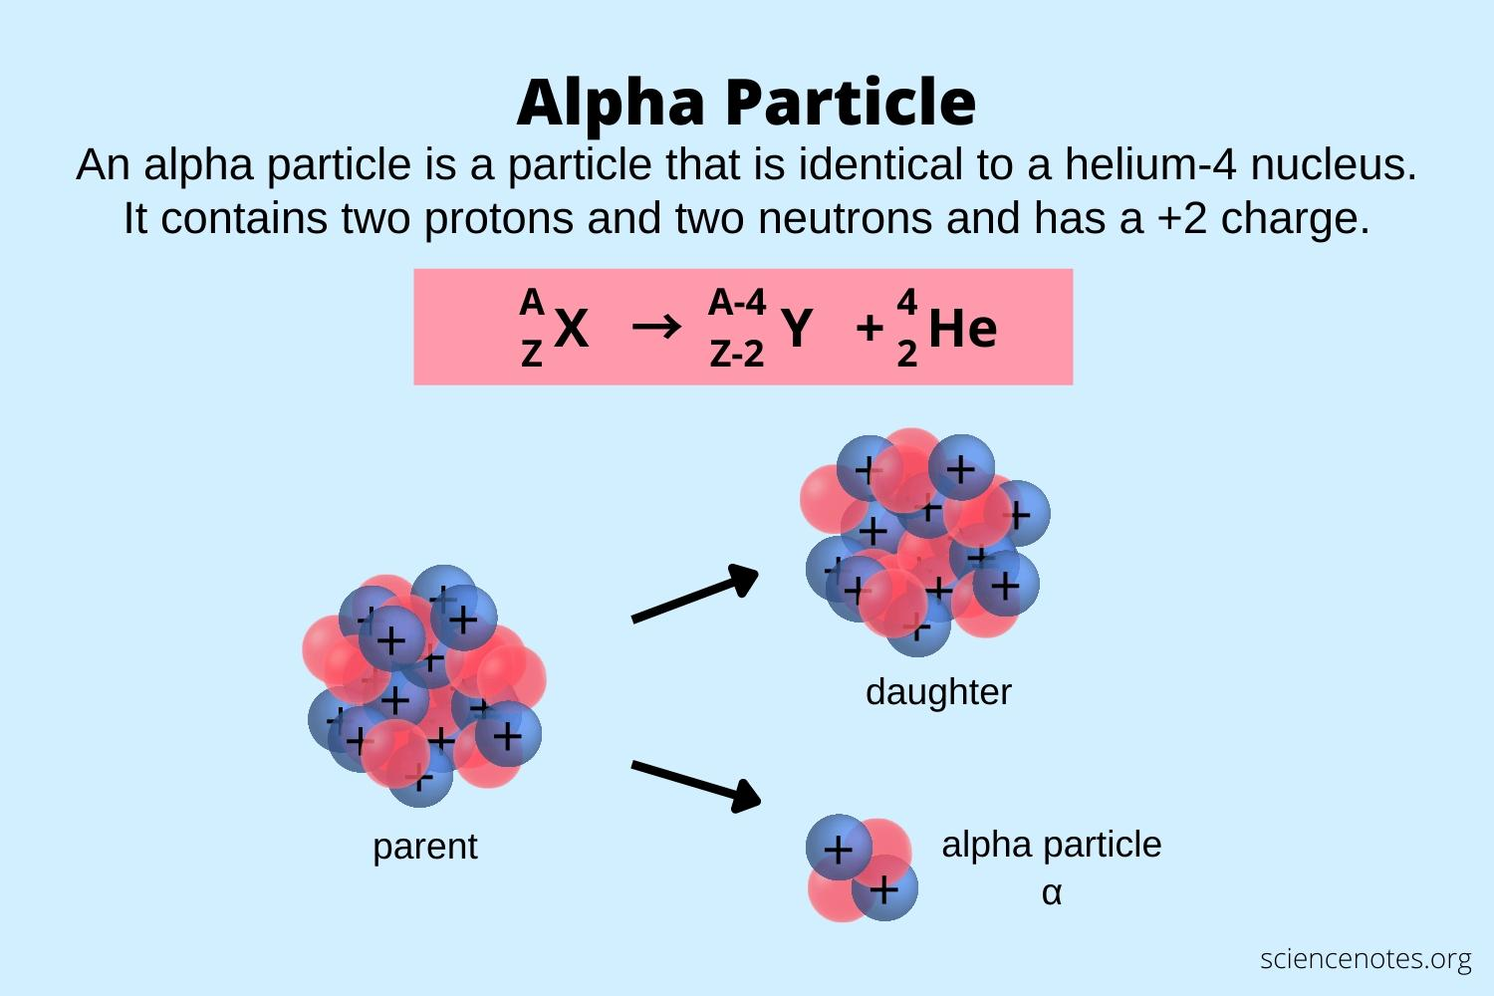
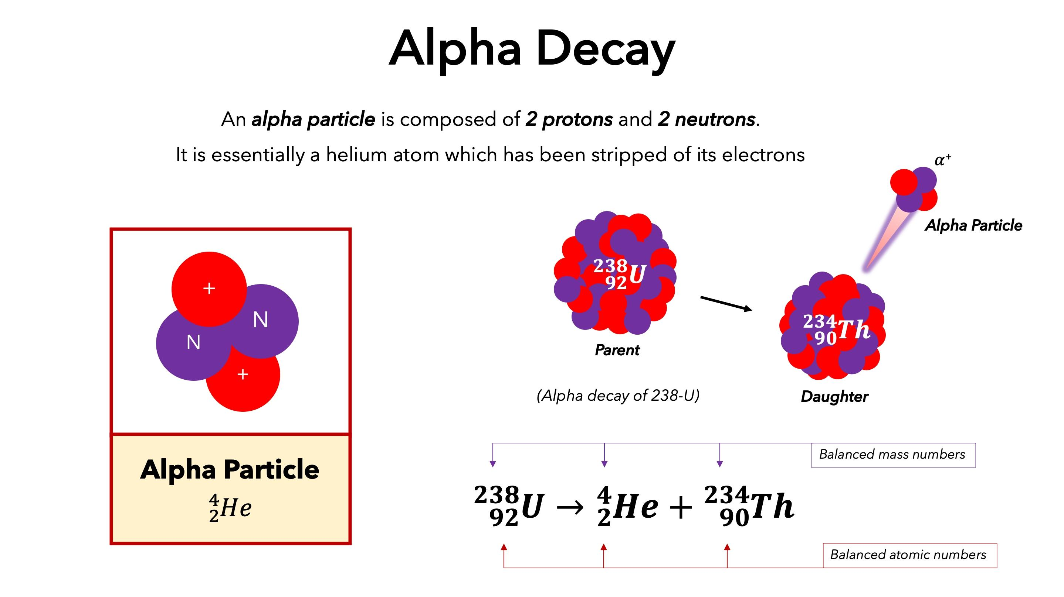

^{Beta Decay}
Beta decay is a radioactive decay in which a beta ray is emitted from an atomic nucleus. During beta decay, the proton in the nucleus is converted into a neutron and vice versa. If a proton is converted to a neutron, it is known as β+ decay. Similarly, if a neutron is converted to a proton, it is known as β– decay.
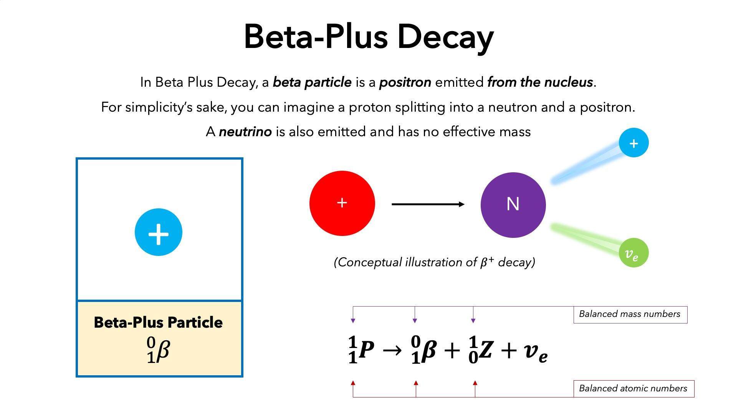
^{Gamma Decay}
In gamma decay, a nucleus changes from a higher energy state to a lower energy state through the emission of electromagnetic radiation (photons). The number of protons (and neutrons) in the nucleus does not change in this process, so the parent and daughter atoms are the same chemical element.

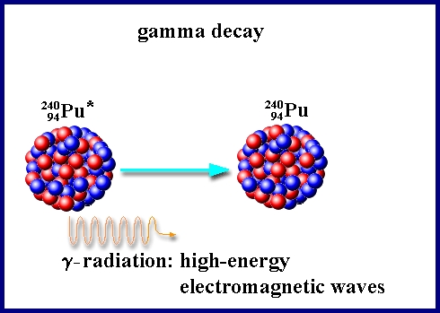
^{⁰γ₀ → Gamma Ray Symbol}
^{⁶⁰Co₂₇ → ⁶⁰Ni₂₈ + ⁰e₋₁ + 2⁰γ₀}
^{Gamma Emission}
Nuclear Reactions And Cross-sections
A nuclear reaction is a process in which two atomic nuclei or subatomic particles interact to produce one or more new particles or gamma rays. Thus, a nuclear reaction must cause a transformation of at least one nuclide to another. Sometimes if a nucleus interacts with another nucleus or particle without changing the nature of any nuclide, the process is referred to as a nuclear scattering rather than a nuclear reaction. Perhaps the most notable nuclear reactions are the nuclear fusion reactions of light. Another example is natural nuclear reactions also occur in the interaction between cosmic rays and matter.
The most notable man-controlled nuclear reaction is the fission reaction which occurs in nuclear reactors.
Nuclear cross-section, the nuclear cross-section of a nucleus is used to describe the probability that a nuclear reaction will occur. The nuclear cross section can be quantified physically in terms of "characteristic area" where a larger area means a larger probability of interaction. In nuclear or subatomic particle physics, the probability that a given atomic nucleus or subatomic particle will exhibit a specific reaction (for example, absorption, scattering, or fission) about a particular species of incident particle. The cross-section is expressed in terms of area, and its numerical value is chosen so that, if the bombarding particle hits a circular area of this size perpendicular to its path and centred at the target nucleus or particle, the given reaction occurs, and, if it misses the area, the reaction does not occur. The reaction cross-section is usually not the same as the geometric cross-sectional area of the target nucleus or particle. The unit of reaction cross section is the barn (equal to 10−24 square cm). Values of cross sections depend on the energy of the bombarding particle and the kind of reaction. Boron, for example, when bombarded by neutrons travelling 1,000,000 cm per second (22,500 miles per hour), has a cross-section for the neutron-capture reaction of about 120 barns, and boron’s cross-section increases to about 1,200 barns for neutrons travelling at 100,000 cm per second.
Nuclear Shell Model And Quantum Mechanics
The shell model clarifies how much energy is required to move nucleons from one orbit to another and how the quantum numbers change. One of the most successful and simple to understand is the shell model. In this model, the protons and neutrons occupy separate systems of shells, analogous to the shells in which electrons are found outside the nucleus. Each of the models is based on a plausible analogy that correlates a large abundance of information enabling revelations of the properties of nuclei.
^{Nuclear Energy}
Nuclear energy is a form of energy released from the nucleus, the core of atoms, made up of protons and neutrons. This source of energy can be produced in two ways, fission when nuclei of atoms split into several parts or fusion when nuclei fuse.
Nuclear energy delivers more uses than providing carbon-free electricity. Nuclear powers space exploration provides water through desalination, is used to sterilise medical equipment and supplies radioisotopes for treating cancer.
Astrophysical Nuclear Reactions
Describing the methods in stars during cosmic times, nuclear reactions re-arrange the nucleons that were left behind from the Big Bang (in the form of isotopes of hydrogen and helium, and traces of lithium, beryllium, and boron) to other isotopes and elements as we find them today. Nuclear astrophysics is the study of the origin of the chemical elements, and the study of how stars shine, evolve and ultimately die.
^{Fission And Fusion Reactions}
Fission and fusion are two physical processes that produce vast amounts of energy from atoms.
^{Fission}
Fission occurs when a neutron hits a larger atom, forcing it to excite and split into two smaller atoms also known as fission products. Additional neutrons are also released that can initiate a chain reaction.
When each atom splits, a huge amount of energy is released.
Uranium and plutonium are most commonly used for fission reactions in nuclear power reactors because they are easy to initiate and control.
The energy released by fission in these reactors heats water into steam. The steam is used to spin a turbine to produce carbon-free electricity.
^{Fusion}
Fusion occurs when two atoms slam together to form a heavier atom, like when two hydrogen atoms fuse to form one helium atom.
This is the same process that powers the sun and creates huge amounts of energy several times greater than fission. It also doesn’t produce highly radioactive fission products.
Fusion reactions are being studied by scientists, but are difficult to sustain for long periods because of the tremendous amount of pressure and temperature needed to join the nuclei together.
Advanced Research and Technology
Radioactive ion beams and rare Isotope production, radioactive ion beams can provide analysis alternatives not available with ordinary ion beams. In particular, radioactive beams allow investigation of nuclear reactions important to the stellar burning and nucleosynthesis which occur in high temperature and/or consistent environments in stars. In this Isotope each has distinct properties. They exist for distinct amounts of time, from a portion of a second to a few billion years, and they release different types of radiation and different amounts of energy.
Nuclear Astrophysics and Stellar Evolution
The process of atomic nuclei is characterized by the arrangement of protons and neutrons and their associated energies. The nuclear shell model, based on the principles of quantum mechanics, provides a comprehensive framework to explain the observed patterns of nuclear properties. Recent studies have focused on the development of new theoretical models and experimental techniques to explore the properties of exotic nuclei that lie beyond the stable isotopes. The discovery of new occult volumes and the emergence of new nuclear shapes have challenged our traditional understanding of nuclear structure.
Applications of Nuclear Physics
Medical imaging and radiation therapy
The goal of radiation therapy is to deliver a huge amount of radiation to the tumour or target region to improve local control of disease and a low dose to normal soft tissues to limit side effects. The use of ionizing radiation for cancer treatment has undergone incredible development during the past hundred years. The advancement of medical imaging has been critical in helping to achieve this change. The invention of computed tomography (CT) was pivotal in the development of treatment planning. Despite some disadvantages, CT remains the only three-dimensional imaging modality used for dose calculation. Newer image modalities, such as magnetic resonance (MR) imaging and positron emission tomography (PET), are also used secondarily in the treatment-planning process.
In the late nineteenth century, three discoveries regarding ionizing radiation were instrumental in the development of radiation therapy
⁽¹⁾ November 8, 1895: X-rays discovered by Wilhelm Conrad
^{Roentgen (1845–1923),}
⁽²⁾ March 1, 1896: Radioactivity discovered by Henri Becquerel (1852–1908),
⁽³⁾ December 26, 1898: Radium was discovered by Madame Curie (Maria Sktodowska) (1867–1934).
Radiocarbon Dating And Archaeology
In 1949, American chemist Willard Libby, who worked on the development of the atomic bomb, published the first set of radiocarbon dates. His radiocarbon dating technique is the most important development in absolute dating in archaeology and remains the main tool for dating the past 50,000 years.
Radiocarbon (14C) dating is an isotopic or nuclear decay method of inferring the age of organic materials. The technique provides a common chronometric time scale of worldwide applicability on a routine basis in the age range from about 300 calendar years to between 40,000 and 50,000 years. With isotopic enrichment and larger sample sizes, ages up to 75,000 years have been measured (Taylor 1987, 2001)
Radiocarbon measurements can be obtained on a wide spectrum of carbon
Nuclear Forensics And Nonproliferation
Nuclear Security aims at the prevention and detection of and response to, theft, sabotage, unauthorized access, illegal transfer or other malicious acts involving nuclear material. Nuclear Forensics is a key element of nuclear security. Nuclear Forensics is defined as a methodology that aims at re-establishing the history of nuclear material of unknown origin. It is based on indicators that arise from known relationships between material characteristics and process history. Thus, nuclear forensics analysis includes the characterization of the material and its correlation with production history. Nuclear forensics is a key technical capability that utilizes signatures inherent to nuclear and radioactive materials to provide information about pre-and post-detonation events (i.e., the spectrum of nuclear security events under investigation).
Materials Science And Nuclear Waste Management
Nuclear waste management involves minimising all forms of radioactive waste, categorising it and determining appropriate disposal methods in line with Best Available Techniques (BAT). Radioactive waste is typically classified as either low-level (LLW), intermediate-level (ILW), or high-level (HLW), dependent, primarily, on its level of radioactivity.
Challenges and Future Perspectives
Limitations and safety concerns
Nuclear reactions affect the alteration of atomic nuclei through processes such as radioactive decay, nuclear capture, and particle-induced reactions. Understanding these reactions is crucial for various applications, including energy production, material synthesis, and medical treatments. Recent research has investigated the mechanisms and dynamics of nuclear reactions at both low and high energies. The development of advanced detectors and accelerators has allowed for precise measurements and detailed studies of reaction cross-sections and resonance phenomena.
Fusion Energy Development And Sustainability
Nuclear fission and fusion are processes that release vast amounts of energy by breaking or combining atomic nuclei, respectively. Studies on nuclear fission have made significant progress in understanding the complex dynamics and the potential for energy release. The analysis of spontaneous fission and the discovery of new isotopes with unique fission properties have enhanced our knowledge in this field. Furthermore, exploration on nuclear fusion has shown promising results, with experimental advancements in controlled fusion devices, such as tokamaks and stellarators, providing a pathway towards sustainable energy production.
Nuclear Physics In The Context Of Quantum Computing
The advancements in nuclear physics have revolutionized our understanding of matter and energy. The exploration of nuclear structure, reactions, and fission/fusion processes has led to a deeper understanding of the atomic nucleus's intricate nature. These advancements have not only contributed to theoretical knowledge but have also yielded practical applications in areas such as energy production, medicine, and astrophysics. As research in this field continues to thrive, we can anticipate further breakthroughs in unlocking the mysteries of the atomic nucleus and its associated phenomena. The developments in nuclear physics have found numerous applications in various fields. Nuclear energy, despite its challenges, remains a significant source of electricity generation globally. The advancements in accelerator technology have facilitated the production of isotopes for medical diagnostics and cancer treatment. Additionally, nuclear physics plays a vital role in studying astrophysical phenomena, such as nucleosynthesis and stellar evolution, through the use of laboratory measurements and theoretical models.
Recap Of Key Findings And Contributions Of Nuclear Physics
Nuclear physics provides information about the structure of nuclei that can be obtained from high-energy electron scattering experiments. The results of these experiments show that the density of nuclear matter is roughly the same at the centre of all nuclei. As nuclear physics is the study of the structure of nuclei their formation, stability, and decay. It aims to understand the fundamental nuclear forces in nature, their symmetries, and the resulting complex interactions between protons and neutrons in nuclei and among quarks inside hadrons, including the proton.

Future Directions And Potential Applications
A future direction is usually more suitable for theoretical or exploratory examination, where you want to suggest new questions, hypotheses, or areas for further investigation in nuclear physics.
Importance Of Continued Research In Nuclear Physics
By presenting a comprehensive review of nuclear physics, this research paper aims to foster a deeper understanding of the field's theoretical foundations, technological advancements, and applications. While emphasizing the importance of nuclear physics in shaping our understanding of the universe, it also highlights the ethical and safety considerations associated with nuclear energy and weaponry. By exploring the challenges and prospects, this paper anticipates further advancements and discoveries that will continue to shape the field of nuclear physics in the years to come.
- _{References}
- R. E. Pollock and D. L. Morton, “Principles of surgical oncology,” in Cancer Medicine, D. W. Kufe and R. E. Pollock, Eds., B. C. Decker, Hamilton, Ontario, Canada, 2000.
- V. T. De Vita Jr. And E. Chu, “A history of cancer chemotherapy,” Cancer Research, vol. 68, no. 21, pp. 8643–8653, 2008.
- F. M. Khan, “Clinical radiation generators,” in The Physics of Radiation Therapy, Lippincott Williams & Wilkins, Philadelphia, Pa, USA, 2010.
- K. U. Hunter and A. Eisbruch, “Advances in imaging: target delineation,” Cancer Journal, vol. 17, no. 3, pp. 151–154, 2011.
- CURRIE, L.A. 2004. The remarkable metrological history of radiocarbon dating. Journal of Research of the National Institute of Standards and Technology 109: 185-217.
- Anspaugh, L. R., Catlin, R. J., Goldman, M., The Global Impact of the Chernobyl Reactor Accident, Science 242, Dec 16, 1988, p1513
- Becker, Edwin D., High Resolution NMR, Academic Press, 1969.
- Beiser, Perspectives of Modern Physics, Sec 5.3. Reference for alpha scattering geometry
- Blatt, Frank J, Modern Physics, McGraw Hill, 1992. Mossbauer effect, Ch 15. Rutherford scattering, Ch 14.
- Booth, C. N. And Combley, F. H., Nuclear Physics 303, http://www.shef.ac.uk/uni/academic/N-Q/phys/teaching/phy303/phy303-3.html External link
- Cowan, George A., A Natural Fission Reactor, Scientific American 235, July 1976, p 36.
- Dalrymple, G. Brent, The Age of the Earth, Stanford University Press, 1991.
- Das, Ashok and Ferbel, Thomas, Introduction to Nuclear and Particle Physics, Wiley, 1994.
- Evans, Robley D., The Atomic Nucleus, McGraw-Hill, 1955.
- Jelley, N. A., Fundamentals of Nuclear Physics, Cambridge University Press, 1990.
- Krane, Kenneth S., Introductory Nuclear Physics, Wiley, 1987.
- Levin,Harold L., The Earth Through Time, 2nd Ed,, Philadelphia:Saunders College Publishing, 1983. Discussion of radioactive dating processes.
- Mulligan, Joseph F., Practical Physics: The Production and Conservation of Energy, McGraw-Hill, 1980.
- Nave, C. R. And Nave, B. C., Physics for the Health Sciences, 3rd Ed, W. B. Saunders, 1985.

