CHAPTER NAME
FINANCIAL RISK MANAGEMENT AND DERIVATIVES
Chapter submitted by-
Mr. Pratham Joshi
Kolkata, West Bengal

FINANCIAL RISK MANAGEMENT AND USE OF DERIVATIVES

Overview of Financial Risk Management-
Financial Risk Management –
Involves understanding & managing the financial risks faced by the organisation. It refers to the process of identifying, assessing, and managing potential risks that can impact an organization's financial well-being. It involves the implementation of strategies and practices to mitigate or minimize the negative consequences of these risks, while maximizing opportunities for growth and profitability.
The significance of financial risk management lies in its ability to protect an organization from unexpected events or circumstances that can jeopardize its financial stability and viability. By proactively identifying and addressing risks, organizations can safeguard their assets, optimize their financial performance, and maintain investor confidence. Effective risk management enables businesses to make informed decisions, allocate resources efficiently, and navigate through uncertain economic conditions.

Types of Financial Risks:
- Market risk: including interest rate risk, foreign exchange risk, and commodity price risk
- Credit risk: assessing the likelihood of default by borrowers or counterparties
- Liquidity risk: managing the availability of funds to meet financial obligations
- Operational risk: identifying and mitigating risks arising from internal processes, systems, or human error
- Regulatory risk: understanding and complying with legal and regulatory requirements
-Interest rate risk - Risk of possible losses due to the changes in interest rates
- Exchange rate risk - Risk of possible losses due to the changes in exchange rates
-Commodity price risk - Risk of possible losses due to the changes in commodity prices

3. Principles and Methodologies of Financial Risk Management:

- Risk identification: recognizing potential risks and their sources
- Risk assessment: evaluating the impact and likelihood of risks
- Risk mitigation: implementing strategies to reduce or transfer risks
- Risk monitoring: continuously monitoring and reviewing risks
Qualifying fianancial risk
- Standard Deviation (SD)-Reflects the volatility of an investment. Often used to measure turn
stock or a stock portfolio - Le., higher the SD/volatility, higher the risk, higher the expected return
-Coefficient of Variation - Measure of the relative risk of investments. Determines how much
volatility (risk) is being assumed in comparison to the expected return from investment
Coefficient of Variation= Standard Deviation/Expected Return
Note- Lower the Coefficient of Variation, the better is the risk-return tradeoff for an investment
- Regression analysis - Analysis of how one variable (e.g., cash flow) is affected by changes in
various factors/variables which influence it
-Value-at-Risk (VaR) analysis - Maximum likely loss on an investment/portfolio/derivative at a particular probability level (or, confidence level) over a holding period
-Scenario analysis (Sensitivity tests, or "what if?" analysis) - Involves a financial model with a set of "what if" scenarios. e.g .What if" the S&P 500 crashes by 15%?

Capital Asset Pricing Model (CAPM)-
CAPM is a widely used financial model that helps investors and analysts determine the expected return on an investment based on its systematic risk. It provides a framework for understanding the relationship between risk and return in the context of an investment portfolio.
CAPM = Risk-Free Rate + Beta × (Market Return - Risk-Free Rate)
Where ,
Risk-Free Rate-an absolutely risk-free rate, usually consider the rate of G-Secs.
Beta(β) –measure of the volatility—or systematic risk of a security or portfolio compared to the market as a whole (usually the S&P 500).
Market Return-return which the financial market is offering, usually the return of benchmark index.
Limitations –
-Beta often based on several unrealistic assumptions
-Beta and expected market return are based on historical data and may not be reflective of the future
-Risk-free rates are volatile (and change regularly)

Alpha- measures abnormal/excess return of an investment over expected return.

4. Managing financial risks :
Managing financial risks help protect cash flows and reduce earnings volatility. May
contribute to a lower cost of capital, increase access to financing and help achieve financial
objectives.
Techniques =>
- Hedging: using derivatives to protect against adverse price movements
- Diversification: spreading investments across different asset classes or sectors
- Insurance: transferring risks to insurance companies
- Capital management: maintaining adequate capital buffers to absorb potential losses

5. Best Practices in Financial Risk Management:

- Establishing a risk management framework
- Developing risk appetite and tolerance levels
- Regularly assessing and updating risk management policies and procedures
- Integrating risk management into decision-making processes
- Encouraging a risk-aware culture within the organization

USE OF DERIVATIVE AND HEDGING –
The use of derivatives and hedging is an integral part of financial risk management. These tools are employed by organizations to mitigate the impact of potential adverse price movements, manage market risks, and protect against financial losses. The Capital Asset Pricing Model (CAPM) is a widely used framework that incorporates derivatives and hedging strategies to assess and manage investment risk.

Derivatives:
Derivatives are financial instruments whose value is derived from an underlying asset, such as stocks, bonds, commodities, or currencies. They provide organizations with the ability to hedge against price fluctuations, speculate on future price movements, and manage their exposure to various risks. Mostly used for Translation (accounting) risk occurs when financial statements need to be translated or converted from one currency to another
• Transaction risk results from gains or losses that occur because a transaction will be
denominated (received or paid) in a foreign currency
✓ Gain or loss goes to the balance sheet as other comprehensive income
✓ To minimize this effect, many companies will enter into derivatives hedging contracts include futures contracts, options, swaps, and forward contracts-

→ Options - Allow, but do not require, the holder to buy (call) or sell (put) a specific or
standard commodity or instrument, at a specified price during a specified period of time
(American option) or at a specified date (European option)

→Forwards Negotiated contracts (which are customized by the parties) to purchase and
sell a specific quantity of a financial instrument, foreign currency, or commodity at a
price specified at origination of the contract, with delivery and payment at a specified
future date

→ Futures-Forward-based standardized contracts (which are traded on an exchange) to
take delivery of a specified financial instrument, foreign currency, or commodity at a
specified future date or during a specified period generally at the then-market price.
Futures contracts are traded on organized exchanges and are subject to margin requirements.
→ Long position - Right & obligation to buy in the future
→ Short position - Right & obligation to sell in the future

Currency swaps-Forward-based contracts in which two parties agree to exchange an
obligation to pay cash flows in one currency for an obligation to pay in another currency

→ Money market hedge-E.g., borrow money in foreign currency (say, yen) when an
agreement to receive the foreign currency in the future is executed. This strategy
immediately converts the yen to US $. Then, when the yen are collected from the sale,
the loan can be repaid, resulting in no foreign exchange loss or gain

Hedging:
Hedging is the practice of using derivatives or other financial instruments to offset or reduce the risk of adverse price movements in an underlying asset. It involves taking an opposite position in the derivative instrument to protect against potential losses in the value of the asset. Hedging strategies are employed to manage market risks, including interest rate risk, foreign exchange risk, commodity price risk, and credit risk.
Lets take a example-
Scenario: ABC Corporation is a manufacturer that relies heavily on a specific commodity, copper, for its production. The price of copper is subject to significant fluctuations in the market, which can impact ABC Corporation's profitability. To mitigate the risk of rising copper prices, ABC Corporation decides to implement a derivative hedging strategy using copper futures contracts.

Identify the Risk:
ABC Corporation anticipates that the price of copper will increase in the future. This would result in higher production costs and potentially reduce their profit margins.

Determine the Hedge Ratio:
ABC Corporation analyzes historical data and market trends to determine the correlation between the price of copper and copper futures/options contracts. They find that, on average, the price of copper futures moves in tandem with the spot price of copper. Based on this analysis, they decide to use a 1:1 hedge ratio, meaning they will hedge their exposure to copper prices by entering into futures contracts for an equivalent amount of copper.

Implement the Hedge:
ABC Corporation decides to enter into copper futures contracts to hedge their exposure. They sell (short) copper futures contracts equivalent to the amount of copper they expect to purchase in the future. By doing so, they lock in a predetermined price for the purchase of copper, protecting themselves against potential price increases.

Monitor and Adjust:
As time passes, ABC Corporation closely monitors the price of copper and the value of their futures contracts. If the price of copper starts to rise, the value of their futures contracts will increase, offsetting the higher cost of purchasing copper. Conversely, if the price of copper decreases, the value of their futures contracts may decline, but they will benefit from lower purchase prices.

Close out the Hedge:
When the time comes to purchase the actual copper for production, ABC Corporation closes out their futures contracts by buying an equivalent amount of copper futures contracts. The gains or losses from the futures contracts will offset the changes in the price of copper, effectively hedging their exposure.
By implementing this derivative hedging strategy, ABC Corporation has protected themselves from potential losses caused by rising copper prices. They have effectively locked in a predetermined price for the purchase of copper, ensuring stability in their production costs and safeguarding their profit margins.

Option Contracts and its use in Hedging-

The buyer of an option pays a premium to the seller for this right. Options can be used for hedging and speculation.
Key features of options include:
1. Call and Put Options: Call options give the holder the right to buy the underlying asset, while put options give the holder the right to sell the underlying asset.
Call-option - Right (not obligation) to buy in the future
Put-option - Right (not obligation) to sell in the future

2. Strike Price: The strike price is the predetermined price at which the underlying asset can be bought or sold. It is specified in the option contract.

3. Expiration Date: Options have a limited lifespan and expire on a specific date. After the expiration date, the option becomes worthless.

4. Premium: The premium is the price paid by the buyer to the seller for the right to buy or sell the underlying asset. It is determined by various factors, including the price of the underlying asset, time to expiration, volatility, and interest rates.

Options Greeks-
Options Greeks are a set of risk measures that help investors and traders assess the sensitivity of options prices to various factors. These risk measures are derived from mathematical models and provide insights into how changes in different variables can impact the value of an options contract. The main options Greeks are:

1. Delta (Δ): Delta measures the sensitivity of an option's price to changes in the price of the underlying asset. It indicates the expected change in the option price for a $1 change in the underlying asset's price. Delta ranges from 0 to 1 for call options and from -1 to 0 for put options. For example, a call option with a delta of 0.6 would be expected to increase by $0.60 if the underlying asset's price rises by $1.

2. Gamma (Γ): Gamma measures the rate of change of an option's delta in relation to changes in the price of the underlying asset. It reflects the convexity of an option's price curve. Gamma is highest when an option is at-the-money and decreases as the option moves further in or out of the money. A higher gamma implies greater sensitivity to changes in the underlying asset's price.

3. Theta (Θ): Theta measures the rate of change in the option price with respect to time. It quantifies the time decay of an option's value as it approaches its expiration date. Theta is typically negative, reflecting the diminishing value of an option as time passes. It indicates the expected change in an option's price per day, assuming all other factors remain constant.

4. Vega (V): Vega measures the sensitivity of an option's price to changes in implied volatility. It represents the expected change in an option's price for a 1% change in implied volatility. Vega is particularly relevant for options traders and investors who want to assess the impact of changes in market volatility on their option positions.

5. Rho (ρ): Rho measures the sensitivity of an option's price to changes in interest rates. It indicates the expected change in an option's price for a 1% change in interest rates. Rho is more relevant for options on interest rate-sensitive assets, such as bonds, rather than equity options.

6. Implied volatility( IV)- value of the volatility of the underlying instrument

7. Open interest (OI)- total number of outstanding derivative contracts for an underlying asset.

Understanding the options Greeks helps traders and investors make informed decisions about their options strategies. By analyzing these risk measures, they can assess the potential impact of changes in the underlying asset's price, time decay, implied volatility, and interest rates on their options positions. This knowledge allows for better risk management and the ability to adjust strategies to align with market conditions.

Options provide flexibility for investors and can be used for risk management purposes, such as hedging against price movements, as well as for speculative purposes to profit from anticipated price movements.

What is an option chain-
An option chain often called an options matrix, is a list of all potential options contracts for a particular security. Within a particular maturity period, it displays all listed puts and calls, as well as their expiration dates, strike prices, and volume and pricing information for a single underlying asset.

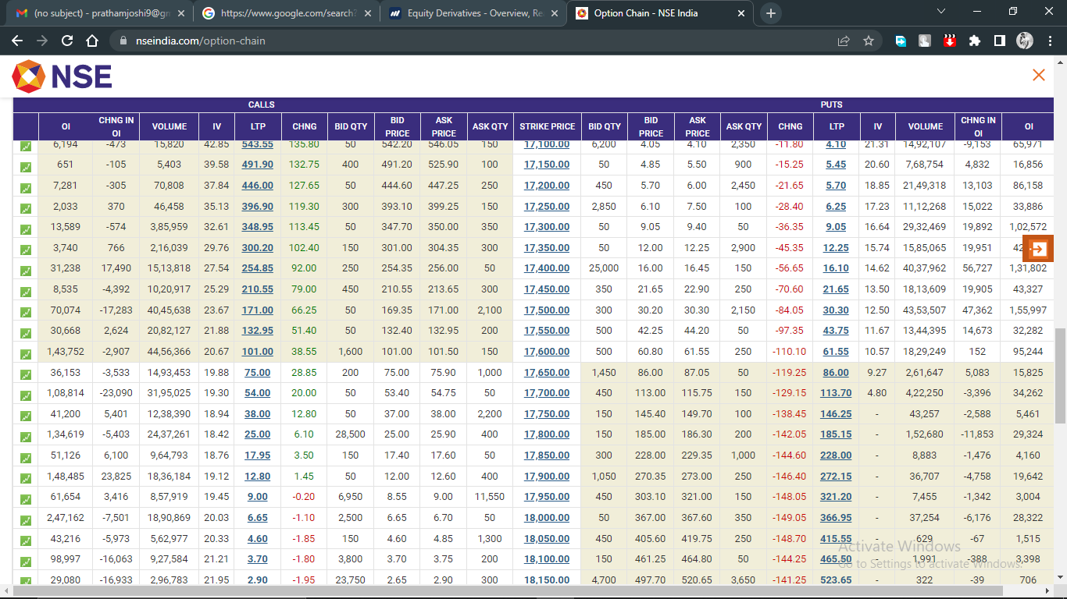

Hedging using options

We have discussed about futures hedging earlier. Now let us see how one can take hedging positions using options.

Taking above example into consideration, we can hedge our long position in ABC Ltd by buying put option of ATM strike price. Suppose, 100 put is trading at Rs 3 and the lot size is again 1000. So, the total cost of hedging here is Rs 3000 (3*1000) and the Break Even Point for this option trade is 97 (100-3) i.e. Strike Price-Premium paid. In this case, maximum risk is the premium amount organisation will paid. Even though stock corrects 10% from current level, you may lose Rs 3,000 only.
We have just elaborated couple of illustrations on how organisations can use to limit their downside as markets can be unpredictable at times. Hedging is just like a vaccine shot that works against a virus. Hence, organisations should always opt for hedging as and when required.

Overall Use of derivatives in risk management-
Risk is a situation where actual outcome may deviate from expected outcome. Risk is categorized into two forms such as internal risk and external risk. Risk management refers to the process of understanding, mitigation and sharing of risk. This is not about to see what will happen in future, instead it deals to work out in advance what might happen. Therefore, it is called as proactive management rather than reactive. Risk management plays a key role in the financial industry and an integral part of it. Markets and risk management practices grow with the progress of business. The growth of the business and market expansion pose challenges for managing the risk. As a result, financial instruments evolved to manage the risks which are known as financial derivatives. There are different forms of contract but most common forms include futures, forwards, options and swaps. Exchange traded derivatives are those which are traded through stock exchange. On the other hand, over the counter derivatives are those financial instruments whose terms and conditions are settled between two parties through negotiation. Although, the core purpose of derivatives are to control the certain level of risks but they are also utilized for the purpose of speculative activities by taking more risk in order to increase the return. Therefore, whether activity is trade base or over the counter, firms are in position to mitigate their risk with the help of financial derivatives. So, it is not hard to say that financial derivatives play a key role in emerging markets. There are various approaches to estimate the risk but in this paper, VaR has been used to measure the risk. Financial derivative is a tool used by the companies to manage the risk. In simple word, it is used to hedge the risk which is being faced by the company. There are two important functions which are played by the financial derivatives namely hedging and speculation. Hedge instruments are used with an attempt to reduce the risk level attached with the underlying transactions. Hedgers protect their assets or liabilities from the adverse change by entering into derivative contract. Speculation presumes the financial risk with the prediction of gain from market fluctuations. Therefore, financial derivative play key role for managing risk. The efficient use of financial derivatives reduces risk level and increases rate of return. Thus, it is improving the financial health of business and climate.

