Role and Regulation of Plants Phenolics in heat Stress Tolerance: An Overview
Ragini Bhardwaj¹, Jafar K. Lone¹, Sapna Lngyan¹
¹Division of Germplasm Evaluation, ICAR-National Bureau of Plant Genetic Resources, New Delhi-110012, India.
1. Introduction
Plants undergo a variety of unfavorable environmental conditions collectively known as abiotic stresses, which occur due to ever-changing and unfavorable atmospheric circumstances for their growth and development (Zhu et al., 2016). These stresses include challenges related to water availability (drought and flooding), heavy metal exposure, salinity, nutrient imbalances, extreme temperatures (chilling and heat), varying light levels (high and low), radiation (UV-B and UV-A), ozone, sulfur dioxide, mechanical forces, and other less frequent stress factors (Pereira, 2016). Because plants are firmly rooted in their growth environment, they must adapt to these fluctuating conditions caused by abiotic stresses. Among these challenges, temperature fluctuations are particularly detrimental to plant growth and development. In response to these abiotic stressors, plants synthesize a range of defensive compounds, with plant phenolic compounds playing a pivotal role (Parvaiz & Satyawati, 2008; Akula & Ravishankar, 2011). An adaptive mechanism employed by plants in the face of these unfavorable conditions involves the accumulation of phenolic compounds in their tissues (Pereira, 2016; Lattanzio, 2013). These phenolic compounds significantly increase in plants under stress, contributing to their survival (Lattanzio, 2013; Sharma et al., 2019).
Plants produce a diverse array of chemicals categorized as primary and secondary metabolites. Primary metabolites such as sugars, fatty acids, amino acids, and nucleic acids are indispensable for plant growth and are universally present in plants (Fiehn, 2002; Wu and Chappell, 2008). In contrast, secondary metabolites exhibit greater diversity in terms of structure and function. While not directly essential for basic plant metabolism, these compounds are vital for the plants' survival within their environment. Plant phenolics, or polyphenols, represent a prevalent group of secondary metabolites with significant physiological and morphological significance. These aromatic compounds, containing one or more hydroxyl groups, originate from pathways like the shikimate/phenylpropanoid or polyketide acetate/malonate pathways, resulting in the formation of both monomeric and polymeric phenols and polyphenols (Randhir et al., 2004). Plant phenolics exert substantial influence on plant growth, development, and reproduction. They also act as defensive agents against abiotic stressors such as high light, low temperatures, UV-B radiation, heavy metals, and nutrient deficiencies (Lattanzio, 2013). Moreover, they provide protection against pathogens and predators (Bravo, 1998), contribute to the color and sensory attributes of fruits and vegetables (Alasalvar et al., 2001), and possess important properties like anti-allergenic, antimicrobial, and antioxidant activities (Balasundram et al., 2006).
With the growing demand for food and the urgency to counteract crop losses due to climate change, including global warming, there is an imperative need to formulate strategies for enhancing crop productivity (Ainsworth & Ort, 2010). During times of stress, plants curtail their growth and shift their primary metabolic focus towards synthesizing secondary metabolites. This entails precise regulation of gene expression levels, influenced by factors like ontogeny and the circadian clock mechanism. These regulatory mechanisms are orchestrated by transcription factors responsible for managing growth and the accumulation of various secondary metabolites in plants (Ornston & Yeh, 1979; Wink, 1999; Lehfeldt et al., 2000; Tauber et al., 2000; Broun, 2005; Nascimento & Fett-Neto, 2010). The transport and buildup of secondary metabolites govern defense and developmental processes in plants based on factors such as developmental stage, tissue or organ type, and specific stress conditions. Among the multitude of plant metabolites, phenolic compounds are natural secondary metabolites synthesized through pathways such as the pentose phosphate, shikimate, and phenylpropanoid pathways (Balasundram et al., 2006; Cheynier et al., 2013; Heleno et al., 2015). These pathways give rise to either monomeric phenolic compounds like flavonoids, phenolic acids, and phenylpropanoids, or polymeric phenolic compounds such as tannins, lignins, lignans, and melanins. Due to their distinct roles in plant growth and defense, phenolic compounds exhibit substantial structural diversity. While certain phenolic compounds are common across various plant species, others are specific to particular plant types. These phenolic compounds not only contribute to regulating diverse physiological functions during plant growth and development but also play a pivotal role in plant defense mechanisms (Kumar et al., 2020).
2. Biosynthesis of plant phenols
Within plants, the synthesis of phenolic compounds initiates from the precursor molecules phenylalanine and shikimic acid, facilitated through the shikimic acid pathway (depicted in Figure 1). This pathway commences with erythrose-4-phosphate and phosphoenolpyruvate (PEP), both originating from distinct metabolic routes, namely the pentose phosphate pathway (PPP) and glycolysis. The primary step involves the transformation of glucose within the PPP into glucose-6-phosphate, which is subsequently converted into ribulose-5-phosphate through the irreversible enzymatic action of glucose-6-phosphate dehydrogenase (G6PDH). The progression of the PPP generates erythrose-4-phosphate as an intermediary product. Likewise, glycolysis produces phosphoenolpyruvate, which then combines with erythrose-4-phosphate. This integrated pathway guides these metabolites through the phenylpropanoid pathway and ultimately into the shikimic acid pathway, culminating in the production of phenolic compounds, with the conversion of phenylalanine being a pivotal steps (as illustrated in Figure 1).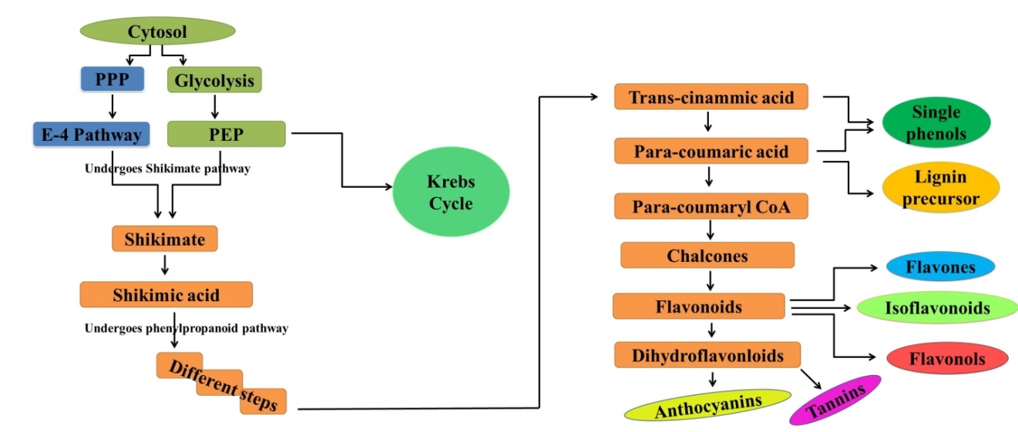
Fig.1: Integration of all three major pathways in the biosynthesis of Phenols includes: phenyl propanoid pathway, Pentose phosphate pathway, and Shikimate pathway in plants/crops

3. Classification of plant phenolics
Phenolic compounds exhibit a structural framework comprising an aromatic ring decorated with one or multiple hydroxyl groups, spanning from uncomplicated phenolic molecules to extensively polymerized substances. This gives rise to remarkable structural variations, often denoting them as polyphenols (Bravo, 1998). Many phenolic compounds naturally manifest as combinations with mono- and polysaccharides, incorporating one or several phenolic units. Additionally, they can adopt functional modifications such as esters and methyl esters (Harborne, 1989; Harborne et al., 1999; Shahidi and Naczk, 1995). Although phenolics form an extensive and diverse array of chemical compounds, they can be categorized using various criteria. For instance, Al-Mamari, 2021 briefly described the classification based on the carbon count within the molecule (Table 1) as follows:
Table 1: classification of plant phenolics (Al-Mamari, 2021)

Structure | Class | No. of atoms
C6 | Simple Phenols, benzoquinones6 | 6
C6-C1 | Phenolic acids and related compounds | 7
C6-C2 | Acethophenones, phenyl acetic acids | 8
C6-C3 | HCAs, phenylpropanoids (coumarin, isocoumarin, chromones, chromenes) | 9
C6-C4 | Napthoquinones | 10
C6-C1-C6 | Xanthones | 13
C6-C2-C6 | Stilbenes, anthroquinones | 14
C6-C3-C6 | Flavonoids, isoflavonoids | 15
 | Betacyanins | 18
(C6-C3)2 | Lignans, neolignans | 18
(C6-C3-C6)3 | Biflavonloids | 30
(C6-C3)n | Lignin
(C6)n | Melanin | N
(C6-C3-C6)n | Condensed tannins (proanthocyanins falvolans)

The classification of plant phenolics is determined by various factors, including the number of hydroxyl groups, chemical composition, and structural attributes. This categorization is based on: Number of Hydroxyl Groups: Phenolic compounds can be divided into different categories based on the number of hydroxyl (OH) groups they possess. This includes 1-, 2-, and polyatomic phenols. If a phenolic compound contains multiple OH-groups within its aromatic ring, it is classified as a polyphenol. Chemical Composition: Phenolic compounds can also be classified based on their chemical composition into mono-, di-, oligo-, and polyphenols. Substituents and Aromatic Rings: Another classification approach takes into account the substitutes present in the carbon skeleton, the number of aromatic rings, and the carbon atoms in the side chain. According to this principle, phenolic compounds are grouped into four main categories: Phenolics with One Aromatic Ring: This category encompasses a variety of compounds, including simple phenols (C6), phenols with one (C6-C1), two (C6-C2), or three (C6-C3) attached carbon atoms. Phenolics with Two Aromatic Rings: This group includes compounds such as benzoquinones and xanthones (C6-C1-C6) with two aromatic rings linked by one carbon atom, stilbenes (C6-C2-C6) linked by two carbon atoms, and flavonoids (C6-C3-C6) containing three carbon atoms. Flavonoids are further subdivided based on the structure of the propane unit and the attachment point of side chain B into flavonoids in the strict sense, isoflavonoids, and neoflavonoids. Quinones: This subgroup consists of compounds with quinone structures. Polymers: This category comprises polymers formed by the linkage of phenolic compounds. Polyphenolics represent a diverse array of over 8,000 distinct compounds identified to date. Consequently, the terminology and classification of polyphenols can be intricate and perplexing. Despite their similar chemical structures, certain distinctive differences set them apart. Based on these variations, polyphenols can be divided into two primary classes: flavonoids and non-flavonoids, such as tannins.

4. Phenolics and plant growth
Plants employ secondary metabolites to interact with their environment, and within this group, polyphenols assume essential functions. These compounds contribute to diverse processes, including the transmission of signals from roots to shoots and the mobilization of nutrients. Phenolic compounds, which are widely distributed in the plant kingdom, play pivotal roles in metabolic and physiological activities (Boudet et al., 2007; Kumar et al., 2019). They exert influence over growth-related physiological functions like seed germination, cell division, and the synthesis of photosynthetic pigments (Tanase et al., 2019). The versatility of phenolic compounds extends to applications such as bioremediation, allelopathy, promoting plant growth, and serving as antioxidants in food additives (Bujor et al., 2015). When subjected to stress, plants consistently accumulate phenolic compounds, which act as a defense mechanism against various abiotic stressors (Cheynier et al., 2013). These compounds are instrumental in enhancing plant tolerance and adaptability under less-than-optimal conditions (Andersen et al., 2003), with many of them possessing antioxidant properties (Hasanuzzaman et al., 2013) that bolster plant performance during stressful periods.
The interaction between plants and their environment through secondary metabolites, including polyphenols, extends to vital processes like signal transduction from roots to shoots and the mobilization of nutrients. Phenolic compounds present in root exudates actively modify the characteristics of the rhizosphere. These compounds are transformed by soil microbes, contributing to nitrogen (N) mineralization and humus formation (Sakamoto et al., 2000). Furthermore, phenolics play a role in improving nutrient uptake through mechanisms such as metallic ion chelation, enhanced absorption sites, soil porosity, and expedited mobilization of essential elements like calcium (Ca), magnesium (Mg), potassium (K), zinc (Zn), iron (Fe), and manganese (Mn) (Balla et al., 2009). Recent research conducted by Rehman et al. highlighted the increase in phenolic and organic acid contents in wheat root exudates upon zinc (Zn) application and treatment with plant growth-promoting rhizobacteria (PGPR), leading to enhanced nutrient mobilization and uptake (Hoque et al., 2020; Oh et al., 2009).
In the context of legumes, phenolic compounds aid in nitrogen fixation by releasing secondary metabolites that inhibit auxin transport, thereby facilitating cell division during nodulation (Lo-Piero et al., 2005). Operating as physiological regulators and chemical messengers, plant phenolics impact the catabolism or synthesis of indole-3-acetic acid (IAA), consequently affecting growth and development (Christie et al., 1994). Notably, flavonoids play a key role in pollen development, with even minimal amounts of flavonolaglycones restoring mature pollen fertility during pollination (Rivero et al., 2001; Kasuga et al., 2008). However, some phenolics like trans-cinnamic acid, coumarin, p-hydroxybenzoic acid, and benzoic acid, when excessively accumulated, can hinder germination and seedling growth due to enzyme disruption and impaired cell division (Weidner et al., 2009). Conversely, elevated levels of phenolic acids can have positive effects on seed germination, as demonstrated in a recent study (Isshiki et al., 2014). Extracts rich in polyphenols derived from spruce bark stimulate germination rates in Lycopersicon esculentum while concurrently inhibiting root elongation (Rana et al., 2016). Phenolics impact seed tegument porosity, facilitating water absorption and germination (Commisso et al., 2016). They also enhance photosynthetic activity and pigment synthesis in maize and sunflower (Chalker-Scott & Fuchigami, 2018). The polyphenols are synthesized in plants under both optimal and challenging conditions, exerting pivotal roles in development encompassing signal transduction, cell division, hormonal regulation, photosynthetic activity, germination, and reproduction. The increased synthesis of polyphenols under abiotic stress conditions contributes to plants' adaptability in demanding environments.
5. Plant defense against temperature stress
Plants employ intricate strategies to defend against temperature stress, which involves a complex sequence of responses. Both elevated and reduced temperatures disrupt photosynthetic metabolism and trigger the production of reactive oxygen species, leading to cellular damage (Asada, 2006; Hasanuzzaman et al., 2013). . In response, plants accumulate osmoprotective compounds like soluble sugars, proline, and glycine betaine, which provide defense against oxidative injury (Sakamoto & Murata, 2000). Moreover, plants synthesize antioxidant enzymes and molecules to counteract oxidative stress (Balla et al., 2009). The buildup of antioxidant metabolites, including phenolics, terpenes, and alkaloids, during temperature stress enhances the plant's ability to cope with these adversities (Hoque et al., 2020; Oh et al., 2009; Lo-Piero et al., 2005; Christie et al., 1994). The enzyme phenylalanine ammonia lyase becomes more active during temperature stress, resulting in the accumulation of phenolic compounds within plant cells. Notably, Rivero et al., (2001) observed significant increases in soluble phenolics in watermelon and tomato under heat and cold stress conditions. Kasuga et al., (2008) proposed that the accumulation of phenolics induced by cold stress contributes to lowering the freezing point, maintaining water potential, and safeguarding against cell damage.
Exposure to cold treatment was observed by Weidner et al. (2009) to result in increased levels of tannins and soluble phenolics in grapevine roots. Amarowicz et al. (2010) reported heightened concentrations of gallic acid, ferulic acid, and caffeic acid in grapevines subjected to cold stress. In the context of freezing cold stress, Isshiki et al. (2014) documented the accumulation of farinose flavonoids in the above-ground parts of primula. Rana and Bhushan (2016) proposed that temperature stress triggers the synthesis of phenolic compounds, thereby enhancing plants' capacity to endure cold stress. Commisso et al. (2016) put forward the notion that phenolic compounds play a protective role against reactive oxygen species, safeguarding the microfilament cytoskeleton. Chalker-Scott and Fuchigami (2018) underscored the significance of phenolic compound accumulation in fortifying cellular resilience and stress tolerance by incorporating into cell walls as suberin or lignin. The predominant phenols expressed during defense against temperature stress are depicted in Figure 2.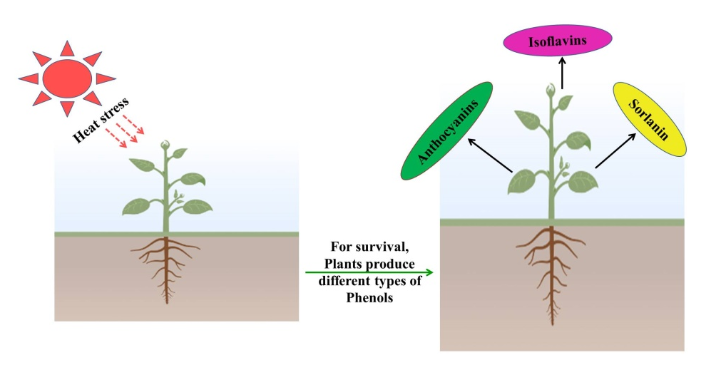
Fig. 2: High temperature stress induces synthesis of phenolic compounds in plants
Each plant species possesses a specific optimal temperature range crucial for its growth and development. Even a slight deviation from this optimal range can detrimentally impact the plant's growth potential. Such temperature fluctuations induce physiological, biochemical, and molecular changes within plants, forcing them to adapt and maintain cellular homeostasis in adverse environments. Both high and low temperatures create stressful conditions for plants, collectively referred to as temperature stress. The temperature range considered ideal for one species might be stressful for another. Hence, a temperature range below which a plant's regular growth and development processes are hindered can be classified as low temperature stress.
Temperature exceeding the optimal range creates stressful conditions for plant survival and growth. An estimated 17% yield loss is projected for every degree increase in temperature above the average growing season temperature (Lobell and Asner, 2003). Heat stress leads to diminished seed germination, reduced photosynthesis, alterations in plant phenology, oxidative stress, decreased seed quality, and ultimately reduced crop yield. Elevated temperatures result in reduced enzyme activity and less functional proteins. At higher temperatures, the plant's photosynthetic machinery becomes inhibited, giving rise to the production of reactive oxygen species (ROS), which subsequently harm plant structures. Both high and low temperatures trigger the generation of cellular ROS, causing damage to various components including the photosynthetic machinery (Asada, 2006; Hasanuzzaman et al., 2013). Furthermore, temperature stress disrupts water potential gradients, leading to dehydration stress. To counteract dehydration stress arising from temperature fluctuations, plants accumulate primary metabolites as osmoprotectants, including proline, glycine betaine, and soluble sugars. These compounds maintain cell water balance and offer buffering capacity to the cell's redox potential (Fig. 3) (Sakamoto and Murata, 2000). Plants also activate antioxidative defense mechanisms against ROS. This defense network encompasses diverse antioxidative enzymes and antioxidants that scavenge ROS, affording protection against their harmful effects (Balla et al., 2009).
In response to stress, plants redirect their primary metabolism toward secondary metabolism, synthesizing high-molecular-weight secondary plant compounds known as secondary metabolites (Selmar and Kleinwächter, 2013). These secondary metabolites encompass terpenes, phenolics, and alkaloids. Accumulation of these secondary metabolites during temperature stress enhances the plant's capacity for stress tolerance (Table 2).

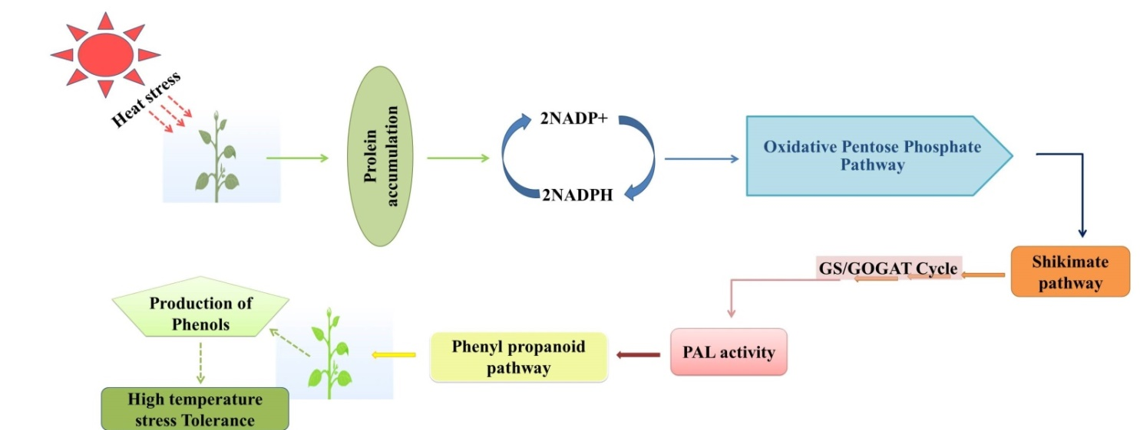
Fig. 3: Mechanism of heats stress tolerance through phenolic production in plants/crops

Table 2: Phenolics as plant protective companion against high temperature stress
Phenoliccompound | Plant/crop | Modeofaction/signalling | Reference
Total solublephenols | Tomato(Lycopersiconesculentum) and watermelon (Citrulluslanatus) | Totalsolublephenolsgetaccumulatedundertemperature stressesthroughtheinductionoftheirbiosynthesisandtheirreducedoxidation | Rivero et al.(2001)
Kaempferol, 3-O-  glucoside, naringenin,  naringeninchalcone, quercetin-  3-hexoside | Tomato  (Solanum  lycopersicon) | Phenolic compounds get accumulated under heat stress and help the plant to protect  from oxidative damage | Martinez  et al. (2016)
Coumaric acid,caffeic acid and  anthocyanins | Carrot (Daucus  carota L.) | The phenolic metabolites Protected microfilaments cytoskeletons from reactive oxygen species generated during heat episodes, and plants showed less heat damage under  carrot cell culture | Commisso  et al. (2016)
Chicoric acid and  chlorogenic acid,  quercetin-3-O-  glucoside and  luteolin-7-O-  glucoside | Lettuce  (Lactuca  sativa L.) | Mild heat stress increased the phenolic content of lettuce. Chilling  stress induces the synthesis of PAL, L-GalDH and g-TMT but not the heat stress, while GalDH was consistently  increased under both the stresses | Oh et al.  (2009)

6. Significance and a way forward
Plant phenolics stand out as the most prevalent and widespread secondary metabolites, constituting an extensive repository of natural chemical diversity encompassing an immense array of compounds and enzymes. These compounds operate through a diverse spectrum of mechanisms, encompassing gene regulation, metabolite transport, and enzyme interactions. In response to adverse environmental stresses, such as wounding, pathogen attacks, mineral deficiencies, and temperature fluctuations, plants accumulate phenolic compounds within their tissues as a form of adaptive response. The phenylpropanoid pathway stands as one of the most extensively studied secondary metabolism routes in plants. In challenging growth conditions, the accumulation of phenolic compounds often corresponds with heightened plant tolerance, as depicted in Figure 4. Abiotic stresses also activate cellular signaling, leading to the transcriptional up-regulation of the phenylpropanoid pathway. This increased resistance aligns with the manifold functions of polyphenols in plants, primarily encompassing their ability to scavenge reactive oxygen species (ROS) and the potential of certain polyphenol classes to shield plants from excessive light, such as flavonoids countering UV light and anthocyanins shielding against visible light. Furthermore, polyphenols may undertake additional ecological roles during abiotic stress, potentially functioning as infochemicals for neighboring plants (Fig. 4).

Fig. 4: Significance of phenolic compound in plants/crops
Despite the extensive body of research in this area, further exploration is imperative. For instance, delving into the specialized roles of polyphenols in response to specific abiotic stresses remains a priority. Moreover, elucidating the intricate mechanisms that orchestrate the transition from primary metabolism to the heightened expression of the phenylpropanoid pathway is an avenue that requires further investigation.
7. References
Ainsworth, E. A., & Ort, D. R. (2010). How do we improve crop production in a warming world?. Plant physiology, 154(2), 526-530.
Akula, R., & Ravishankar, G. A. (2011). Influence of abiotic stress signals on secondary metabolites in plants. Plant signaling & behavior, 6(11), 1720-1731.
Alasalvar, C., Grigor, J. M., Zhang, D., Quantick, P. C., & Shahidi, F. (2001). Comparison of volatiles, phenolics, sugars, antioxidant vitamins, and sensory quality of different colored carrot varieties. Journal of agricultural and food chemistry, 49(3), 1410-1416.
Al Mamari, H. H. (2021). Phenolic compounds: Classification, chemistry, and updated techniques of analysis and synthesis. Phenolic Compounds: Chemistry, Synthesis, Diversity, Non-Conventional Industrial, Pharmaceutical and Therapeutic Applications, 73-94.
Amarowicz, R., Weidner, S., Wójtowicz, I., Karmac, M., Kosinska, A., & Rybarczyk, A. (2010). Influence of low-temperature stress on changes in the composition of grapevine leaf phenolic compounds and their antioxidant properties. Functional Plant Science and Biotechnology, 4, 90-96.
Andersen, C. P. (2003). Source–sink balance and carbon allocation below ground in plants exposed to ozone. New phytologist, 157(2), 213-228.
Asada, K. (2006). Production and scavenging of reactive oxygen species in chloroplasts and their functions. Plant physiology, 141(2), 391-396.
Balasundram, N., Sundram, K. and Samman, S. (2006). Phenolic compounds in plants and agriindustrial by-products: Antioxidant activity, occurrence, and potential uses. Food Chemistry 99, 191-203.
Balla, K., Bencze, S., Janda, T., & Veisz, O. (2009). Analysis of heat stress tolerance in winter wheat. Acta Agronomica Hungarica, 57(4), 437-444.
Boudet, A. M. (2007). Evolution and current status of research in phenolic compounds. Phytochemistry, 68(22-24), 2722-2735.
Bravo, L. (1998). Polyphenols: chemistry, dietary sources, metabolism, and nutritional significance. Nutrition reviews, 56(11), 317-333.
Broun, P. (2005). Transcriptional control of flavonoid biosynthesis: a complex network of conserved regulators involved in multiple aspects of differentiation in Arabidopsis. Current opinion in plant biology, 8(3), 272-279
Bujor, O. C., Talmaciu, I. A., Volf, I., & Popa, V. I. (2015). Biorefining to recover aromatic compounds with biological properties. TAPPI J, 14(3), 187-193.
Chalker-Scott, L., & Fuchigami, L. H. (2018). The role of phenolic compounds in plant stress responses. In Low temperature stress physiology in crops (67-80). CRC press.
Cheynier, V., Comte, G., Davies, K. M., Lattanzio, V., & Martens, S. (2013). Plant: recent advances on their biosynthesis, genetics, and ecophysiology. Plant physiology and biochemistry, 72, 1-20
Christie, P. J., Alfenito, M. R., & Walbot, V. (1994). Impact of low-temperature stress on general phenylpropanoid and anthocyanin pathways: enhancement of transcript abundance and anthocyanin pigmentation in maize seedlings. Planta, 194, 541-549.
Commisso, M., Toffali, K., Strazzer, P., Stocchero, M., Ceoldo, S., Baldan, B., ... & Guzzo, F. (2016). Impact of phenylpropanoid compounds on heat stress tolerance in carrot cell cultures. Frontiers in Plant Science, 7, 1439.
Fiehn, O. (2002). Metabolomics –the link between genotypes and phenotypes. Plant Molecular Biology 48, 155–171.
Harborne, J.B. (1989). General procedures and measurement of total phenolics. In: Methods in Plant Biochemistry: Volume 1 Plant Phenolics. Academic Press, London, pp. 128.
Harborne, J.B., Baxter, H., Moss, G.P. (Eds.) (1999). Phytochemical Dictionary: Handbook of Bioactive Compounds from Plants. seconded Taylor & Francis, London.
Hasanuzzaman, M., Nahar, K., Alam, M. M., Roychowdhury, R., & Fujita, M. (2013). Physiological, biochemical, and molecular mechanisms of heat stress tolerance in plants. International journal of molecular sciences, 14(5), 9643-9684.
Heleno, S. A., Martins, A., Queiroz, M. J. R., & Ferreira, I. C. (2015). Bioactivity of phenolic acids: Metabolites versus parent compounds: A review. Food chemistry, 173501-513
Hoque, T. S., Sohag, A. A. M., Burritt, D. J., & Hossain, M. A. (2020). Salicylic acid-mediated salt stress tolerance in plants. Plant Phenolics in Sustainable Agriculture: Volume 1, 1-38.
Isshiki R, Galis I, Tanakamaru S. Farinose flavonoids are associated with high freezing tolerance in fairy primrose (Primulamalacoides) plants. Journal of Integrative Plant Biology. 2014;56(2):181-188
Kasuga, J., Hashidoko, Y., Nishioka, A., Yoshiba, M., Arakawa, K., & Fujikawa, S. (2008). Deep supercooling xylem parenchyma cells of katsura tree (Cercidiphyllum japonicum) contain flavonol glycosides exhibiting high anti‐ice nucleation activity. Plant, cell & environment, 31(9), 1335-1348
Kumar, S., Abedin, M. M., Singh, A. K., & Das, S. (2020). Role of phenolic compounds in plant-defensive mechanisms. Plant Phenolics in Sustainable Agriculture: Volume 1, 517-532.
Kumar, V., Sharma, A., Kohli, S. K., Bali, S., Sharma, M., Kumar, R., ... & Thukral, A. K. (2019). Differential distribution of polyphenols in plants using multivariate techniques. Biotechnology Research and Innovation, 3(1), 1-21.
Lattanzio V. (2013). Phenolic compounds: Introduction In: Ramawat K.G., Mérillon J.M. editors. Natural Products: Phytochemistry, Botany and Metabolism of Akaloids, Phenolics and Terpenes. (Berlin/Heidelberg, Germany: Springer; ) pp. 1543–1580. doi: 10.1007/978-3-642-22144-6_57
Lattanzio, V. (2013). Phenolic compounds: introduction 50. Nat. Prod, 1543-1580
Lehfeldt, C., Shirley, A. M., Meyer, K., Ruegger, M. O., Cusumano, J. C., Viitanen, P. V., ... & Chapple, C. (2000). Cloning of the SNG1 gene of Arabidopsis reveals a role for a serine carboxypeptidase-like protein as an acyltransferase in secondary metabolism. The Plant Cell, 12(8), 1295-1306.
Lo Piero, A. R., Puglisi, I., Rapisarda, P., & Petrone, G. (2005). Anthocyanins accumulation and related gene expression in red orange fruit induced by low temperature storage. Journal of agricultural and food chemistry, 53(23), 9083-9088.
Lobell and Asner 2003 Lobell, D. B., & Asner, G. P. (2003). Climate and management contributions to recent trends in US agricultural yields. Science, 299 (5609), 1032-1032.
Martinez, V., Mestre, T. C., Rubio, F., Girones-Vilaplana, A., Moreno, D. A., Mittler, R., & Rivero, R. M. (2016). Accumulation of flavonols over hydroxycinnamic acids favors oxidative damage protection under abiotic stress. Frontiers in plant science, 7, 838.
Nascimento, N. C. D., & Fett-Neto, A. G. (2010). Plant secondary metabolism and challenges in modifying its operation: an overview. Plant secondary metabolism engineering: methods and applications, 1-13
Oh, M. M., Carey, E. E., & Rajashekar, C. B. (2009). Environmental stresses induce health-promoting phytochemicals in lettuce. Plant Physiology and Biochemistry, 47(7), 578-583.
Ornston, L. N., & Yeh, W. K. (1979). Origins of metabolic diversity: evolutionary divergence by sequence repetition. Proceedings of the National Academy of Sciences, 76(8), 3996-4000
Parvaiz, A., & Satyawati, S. (2008). Salt stress and phyto-biochemical responses of plants-a review. Plant soil and environment, 54(3), 89.
Pereira, A. (2016). Plant abiotic stress challenges from the changing environment. Frontiers in plant science, 7, 1123
Rana, S., & Bhushan, S. (2016). Apple phenolics as nutraceuticals: Assessment, analysis and application. Journal of food science and technology, 53, 1727-1738.
Randhir, R., & Shetty, K. (2004). Microwave-induced stimulation of L-DOPA, phenolics and antioxidant activity in fava bean (Vicia faba) for Parkinson’s diet. Process Biochemistry, 39(11), 1775-1784.
Rivero, R. M., Ruiz, J. M., Garcıa, P. C., Lopez-Lefebre, L. R., Sánchez, E., & Romero, L. (2001). Resistance to cold and heat stress: accumulation of phenolic compounds in tomato and watermelon plants. Plant science, 160(2), 315-321
Sakamoto, A., & Murata, N. (2000). Genetic engineering of glycinebetaine synthesis in plants: current status and implications for enhancement of stress tolerance. Journal of Experimental Botany, 51(342), 81-88
Selmar and Kleinwächter 2013 Selmar, D., & Kleinwächter, M. (2013). Stress enhances the synthesis of secondary plant products: the impact of stress-related over-reduction on the accumulation of natural products. Plant and Cell Physiology, 54(6), 817-826.
Shahidi, F., &Naczk, M. (1995). Food phenolics.Technomic Pub. Co. Inc. Lancaster, PA. 31-38
Sharma, A., Shahzad, B., Rehman, A., Bhardwaj, R., Landi, M., & Zheng, B. (2019). Response of phenylpropanoid pathway and the role of polyphenols in plants under abiotic stress. Molecules, 24(13), 2452.
Tanase, C., Bujor, O. C., & Popa, V. I. (2019). Phenolic natural compounds and their influence on physiological processes in plants. In Polyphenols in plants (45-58). Academic Press.
Tauber, E., Last, K. S., Olive, P. J., & Kyriacou, C. P. (2004). Clock gene evolution and functional divergence. Journal of Biological Rhythms, 19(5), 445-458.
Weidner, S., Karolak, M., Karamac, M., Kosinska, A., & Amarowicz, R. (2009) . Phenolic compounds and properties of antioxidants in grapevine roots [Vitis vinifera L.] under drought stress followed by recovery. Acta Societatis Botanicorum Poloniae, 78(2), , 97-103
Wink, M. (Ed.). (1999). Biochemistry of plant secondary metabolism (Vol. 2). CRC Press
Wu, S., & Chappell, J. (2008). Metabolic engineering of natural products in plants; tools of the trade and challenges for the future. Current Opinion in Biotechnology, 19(2), 145-152.
Zhu, J. K. (2016). Abiotic stress signaling and responses in plants. Cell, 167(2), 313-324

