Chapter 1: Introduction of various organized and non-organized parts of the plants used in clinical application
Rahul Maurya, Thirupataiah Boini, Lakshminarayana Misro, Thulasi Radhakrishnan, Rohit KS and Rajeesh VR
National Ayurveda Research Institute for Panchakarma, CCRAS, Ministry of AYUSH, Government of India, Cheruthuruthy, Thrissur, Kerala, 679 531.
1. Introduction
  - Overview of Plant Anatomy

Plant anatomy is the foundational study of the structure and organization of plant tissues, organs, and cells, elucidating plant forms' intricate complexity and diversity. This discipline explores the hierarchical arrangement of plant parts, encompassing roots, stems, leaves, flowers, and fruits. At the cellular level, plant anatomy delves into cell types, tissues, and their specific functions, revealing the diverse adaptations in plants for its survival and growth. Understanding plant anatomy involves examining the spatial arrangement of cells, tissues, and vascular systems uncovering how plants transport nutrients, water, and photosynthetic products throughout their structures. This detailed comprehension of plant anatomy not only aids in identifying and classifying different plant species but also provides valuable insights into their ecological adaptations and significance in various industries, agriculture, medicine, and environmental conservation.

  - Importance of Understanding Plant Parts

Comprehending organized (roots, stems, leaves) and unorganized (resins, latex, etc.) plant parts is paramount in traditional medicine and food product development, offering a rich repository of natural resources for therapeutic remedies and culinary innovations. Organized plant parts, such as roots containing active compounds like ginsenosides in Panax ginseng, have been integral in traditional medicine for enhancing vitality and immunity. Stems like turmeric's rhizomes, rich in curcuminoids, exhibit anti-inflammatory and antioxidant properties in medicinal preparations. Leaves, exemplified by the menthol in peppermint leaves, are valued for their digestive and soothing effects. Andrographis paniculata (kalmegh) is known for its anti-inflammatory properties,. Boerhavia diffusa (root), Rauwolfia Serpentina (root), and Elaeocarpus ganitrus (fruit) exhibit antihypertension activity and Embelia ribes, Piper longum (Long pepper) fruit and are used in the treatment of CNS disorders,. Conversely, unorganized parts like resin from Boswellia serrata possess anti-inflammatory properties utilized in joint health supplementssome other examples of plant and its clinical application shown in Figure 1., while latex from Hevea brasiliensis is the source of natural rubber and is explored for its potential medical applications. In food products, gums like Gum Arabic derived from Acacia species function as stabilizers in confectionery, while essential oils extracted from plants such as lavender and thyme add distinct flavours and aromas to culinary creations. Understanding these organized and unorganized plant parts not only upholds traditional medicinal practices but also catalyzes the development of diverse, functional food products harnessing their health benefits and sensory attributes.
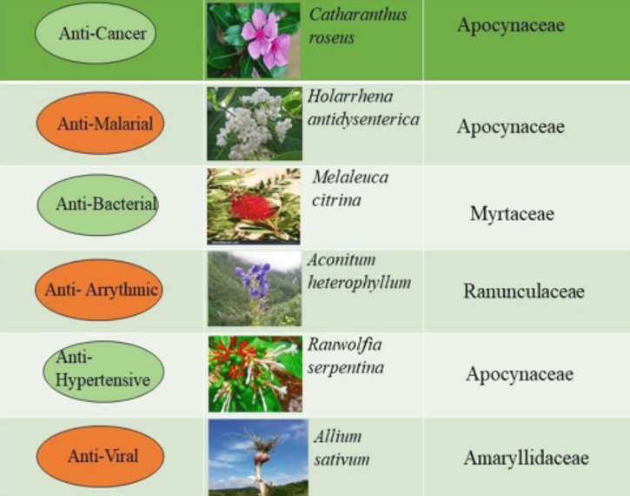
Figure 1. Different plants and its clinical application
1.3 Objective of the chapter
The objective is to comprehensively explore and elucidate the classification, structural attributes, and multifaceted applications of organized and unorganized plant parts within herbal medicine and food product development. This chapter aims to explore the distinct properties, bioactive compounds, and traditional uses of organized plant parts like roots, stems, and leaves, as well as highlighting their significance in herbal remedies and medicinal formulations. In addition, this chapter also investigates the diverse roles and applications of unorganized plant parts, such as resins and latex, in both herbal medicine and food products. The chapter aims to provide insights into these plant parts' specific bioactive components, traditional uses, and modern applications, emphasizing their contributions to herbal medicine's therapeutic potential and enhancing nutritional value, flavours, and preservation in food products.
2. Classification of Organized Plant Parts
2.1 Roots
Roots exhibit various structural adaptations based on their roles and environments. For example, Taproots in plants like carrots and radishes, characterized by a central primary root with smaller lateral roots. However, Fibrous Roots in grasses and monocot plants form a dense network of fine roots without a central primary root and Adventitious Roots arise from stems or leaves, providing support to the plants like ivy or aiding in respiration in plants like mangroves. Roots serve multifaceted functions crucial for plant survival, such as providing stability and anchoring the plant in the soil. Absorbing water, minerals, and nutrients essential for growth. Storing reserve food materials like starch, as seen in tuberous roots. Roots exhibit adaptations such as root hairs to enhance surface area and mycorrhizal associations for enhanced nutrient absorption. Roots play vital role in food and medicine. Some common examples are Carrots (Daucus carota), rich in vitamins and antioxidants, Ginseng (Panax ginseng) is used in traditional medicine for its purported health benefits, including boosting immunity and improving vitality. Radish (Raphanus sativus) is consumed as a vegetable and has potential medicinal properties due to its high fiber and vitamin C content, and Dandelion (Taraxacum officinale) has been used traditionally for its purported diuretic and detoxifying properties in herbal medicine.
Understanding structural diversity and functionalities of roots is crucial not only for agricultural practices, crop growth, and soil health but also for harnessing their medicinal properties in traditional and modern herbal medicine systems. Roots provide a rich source of nutrients and bioactive compounds with various health benefits.
2.2 Stems
Stems exhibit diverse structures and adaptations, such as Herbaceous Stems; soft, non-woody stems found in annual plants. Woody Stems; hard and lignified stems found in trees and shrubs, providing the structural support and durability. Modified stems are specialized stems, such as runners in strawberries or rhizomes in ginger, designed for functions like reproduction or storage of nutrients. Stems serve several essential functions in plant physiology. It provides structural support for leaves, flowers, and reproductive structures, aiding the plant's growth and orientation towards light. Facilitating the movement of water, nutrients, and photosynthetic products between roots and leaves through the vascular system (xylem and phloem). Storing water, carbohydrates, and nutrients is often seen in succulent stems or tubers. Stems offer various applications in herbal medicine and food products due to their diverse properties and various constituents, such as Mint Stems (Mentha spp.) used in herbal medicine for their essential oils, offering digestive and calming effects. Stem Tubers (Potatoes) are a significant food source, rich in carbohydrates and essential nutrients. Cinnamon (Cinnamomum verum) bark, considered part of the stem, is used in herbal medicine for its antibacterial and anti-inflammatory properties. Lemongrass (Cymbopogon citratus) is used in herbal teas and culinary dishes for its citrusy flavour and potential medicinal benefits.
Structural diversity, physiological roles, and chemical composition of stems contribute significantly to herbal medicine by providing bioactive compounds with therapeutic properties. Moreover, certain stems serve as valuable ingredients in food products, offering distinctive flavours, nutrients, and functional properties essential for culinary purposes and product formulations shown in table 1.
Table1. Biomedical application of the stem, bark and tuber of selective medicine plants
S.No | Plant parts | Family | Therapeutic use
1 | Abelmoschus manihot stem | Malvaceae | Anti-inflammation
2 | Thespesia populnea bark | Malvaceae | Alzheimer’s disease
3 | Senna auriculata bark | Fabaceae | Diabetes, pharyngitis, and ophthalmic diseases
4 | Berberis asiatica stem | Berberidaceae | Antimicrobial properties
5 | Cyperus rotundus tuber | Cyperaceae | Wound healing

2.3 Leaves
Leaf anatomy and morphology, characterized by intricate structures like the blade, petiole, veins, and specialized cells such as stomata and chloroplasts, play a pivotal role in the medicinal and nutritional realms. In herbal medicine, leaves harbour a wealth of bioactive compounds that contribute to their therapeutic significance. Various plant’s leaves, such as Eucalyptus, Neem, and Moringa, contain compounds with antiviral, antibacterial, or anti-inflammatory properties, making them integral components in traditional remedies addressing diverse health conditions. Moreover, leaves are substantial sources of nutrition, offering an array of vitamins, minerals, and antioxidants essential for human health. Varieties like spinach, kale, and curry leaves exemplify this, providing iron, vitamins A and C, calcium, and other vital nutrients, supporting overall well-being and dietary requirements. Understanding the intricate anatomy of leaves unveils their medicinal compounds and nutritional content, enabling their incorporation into herbal medicine formulations and dietary strategies, contributing significantly to holistic health practices and culinary applications shown in Table 2.
Table 2. Biomedical application of leaves of selective medicinal plants
S.No | Plant -leaf | Family | Therapeutic use | Ref.
1 | Papaya (Carica papaya) | Caricaceae | anticancer, anti-inflammatory, antidiabetic and antiviral activities
2 | Brahmi (Bacopa monneri) | Scrophulariaceae | neurological disorders
3 | Neem (Azadirachta indica) | Meliaceae | antimicrobial properties
4 | Moovila (Pseudarthria viscida) | Fabaceae | antidiabetic
5 | Aloe vera (Aloe barbadensis) | Liliaceae | wound healing and anti-inflammatory

3. Unorganized Plant Parts: Resins, Latex, and More
3.1 Resins
Resins, renowned for their diverse composition and remarkable properties, are versatile substances utilized across multiple industries, artistic endeavours, and health-related applications. Comprised of a blend of organic compounds, including terpenes and phenolic compounds, resins exhibit adhesive, insulating, and waterproofing qualities. Industrially, resins play a pivotal role as raw materials in various sectors. Moreover, the resinous secretion of lac insects, known as shellac, is a valuable ingredient in varnishes and protective coatings for tablet. Medicinally, resins like frankincense and myrrh have historical significance and continue to be explored for their potential anti-inflammatory and antimicrobial properties, utilized in traditional remedies and aromatherapy. While typically not consumed directly, resins are occasionally used as flavouring agents, contributing to the aromatic profile of certain cuisines. The diverse composition and versatile characteristics of resins underscore their indispensability across industries, arts, potential medicinal applications, and the broader spectrum of human activities, showcasing their multifaceted significance and utility (Figure 2).

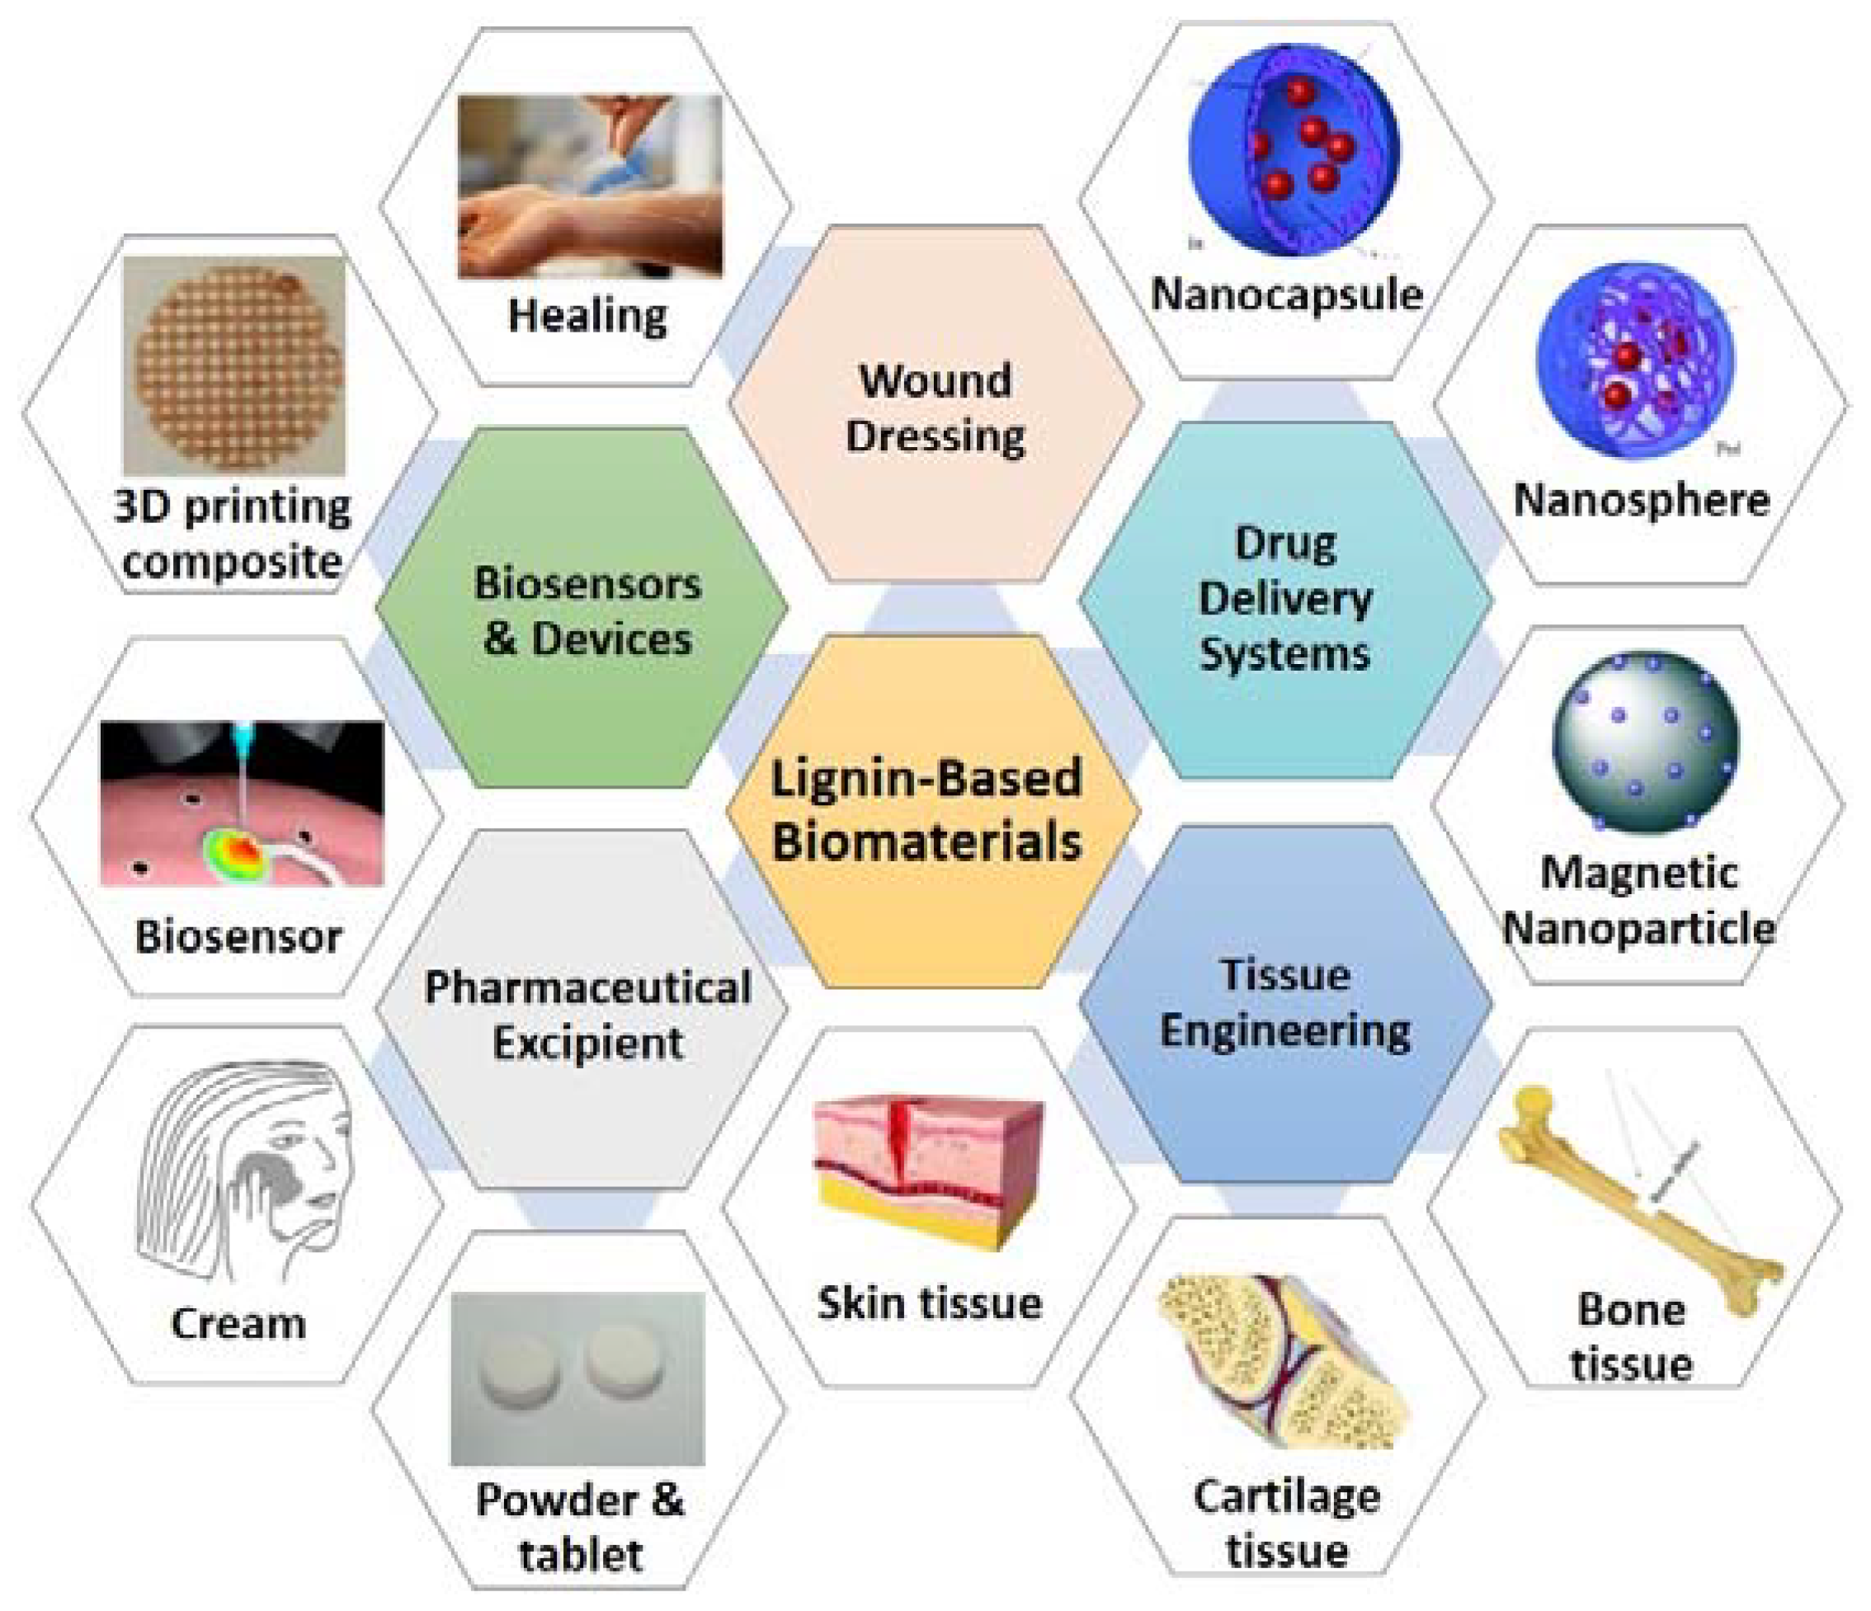
Figure 2. Application of lignin-based resin in the field of biomedical and material science
3.2 Latex
Latex, recognized for its complex structure and production process, is a valuable natural material with diverse applications across industries, medicine, and biology. Structurally, latex is produced in laticifer cells found in various plants, particularly in species like Hevea brasiliensis, which produce latex in rubber production. Its unique chemical composition, predominantly comprising polymers like polyisoprene, contributes to its elasticity and durability, making it crucial in manufacturing rubber products such as gloves, tires, and medical devices. Additionally, Figure 3 shows, latex's versatility extends to medical and biological uses, which are utilized in healthcare products like latex gloves and catheters due to its impermeability and elasticity.
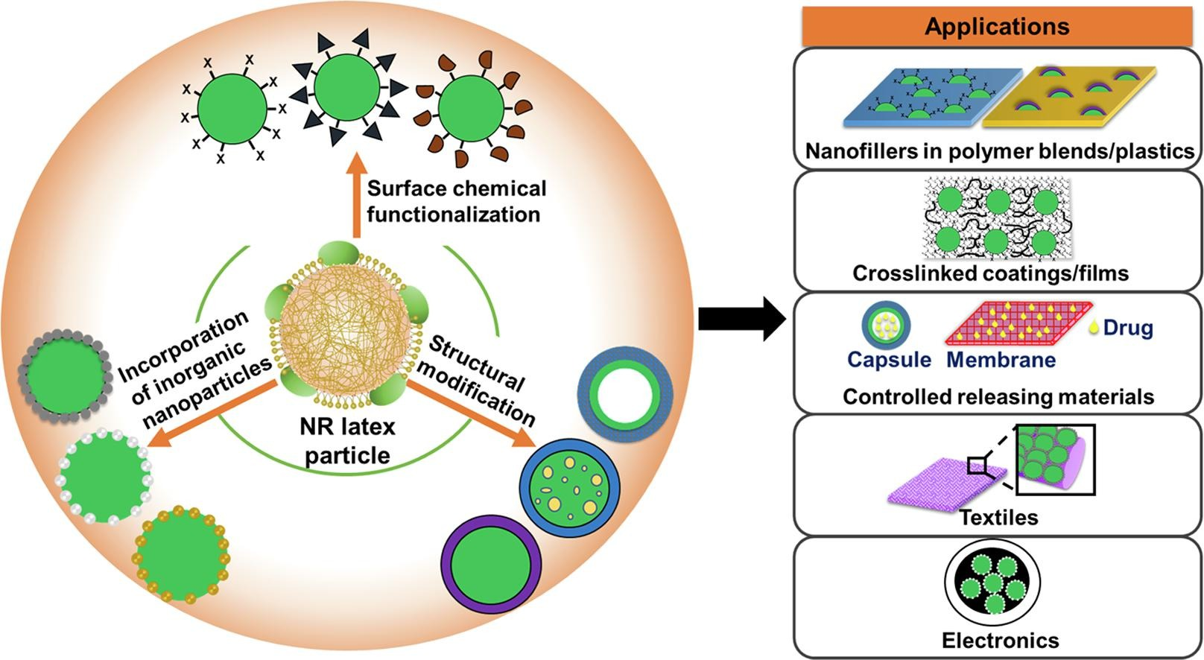
Figure 3. Natural rubber latex's versatility in the field of medical, biological and applied science
Moving to other plant-based compounds, gums like Gum Arabic, tannins, and essential oils exhibit distinctive characteristics and functions. Gum Arabic, sourced from Acacia trees, stabilises food and pharmaceutical industries due to its emulsifying properties. Tannins, found in various plants like tea leaves and oak bark, are known for their astringent properties, used in tanning leather and traditional medicine as antidiarrheals and wound healers. Essential oils, extracted from plants such as lavender and tea tree, possess aromatic and therapeutic properties, utilized in cosmetics, aromatherapy, and medicinal applications like treating skin conditions or alleviating stress. Their diverse functionalities and commercial applications are shown in Figure 4, highlighting their significance across multiple sectors, including food, pharmaceuticals, cosmetics, and healthcare, contributing to their widespread utilization and value in various industries.
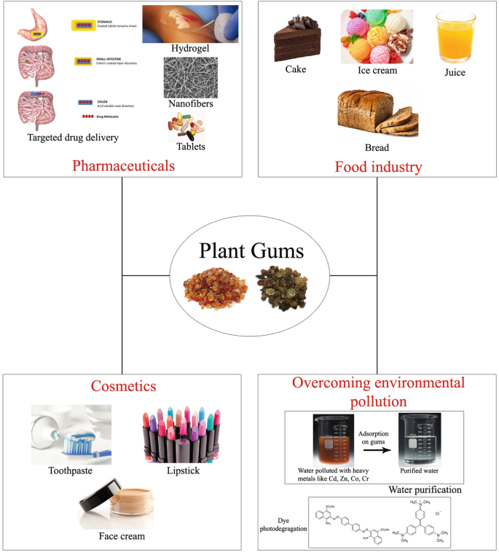
Figure 4. Application of plant gums
4. Comparative Analysis of Organized vs. Unorganized Parts
4.1 Structural Variances and Functions
Organized plant parts, such as roots, stems, and leaves, showcase distinct structural variances tailored to specific functions are vital for plant growth and survival. Roots exhibit diverse structures—taproots or fibrous roots—suitable for anchorage, nutrient absorption, and storage. Stems from herbaceous to woody provide support, transport water and nutrients, and store reserves like carbohydrates. Leaves optimize surface area for photosynthesis and gas exchange with their characteristic blade and veins. Conversely, unorganized plant parts lack defined structures. Resins, for instance, are amorphous compounds serving as protective substances, while latex, a fluid material, lacks a structured arrangement but contributes to the elasticity and resilience of plants. The contrasting structures between organized and unorganized parts underscore how the former possess specialized configurations tailored for specific functions, while the latter often lack organized structures yet exhibit unique properties serving diverse purposes.
4.2 Ecological Significance and Adaptations
Organized plant parts and unorganized substances exhibit diverse adaptations which are crucial for plant survival and ecological interactions in ecological contexts. Organized parts contribute significantly to a plant's interaction with its environment. Roots aid in soil anchorage, preventing erosion, while stems facilitate light capture and support for photosynthesis. Leaves, through their morphology, optimize light absorption and gas exchange. Unorganized parts, like resins and latex, showcase adaptations that often deter herbivory or prevent microbial infections. These substances might serve as deterrents against predators or pests, helping plants survive and thrive in various ecosystems. The ecological significance lies in the multifaceted adaptations of these parts, aiding plants in various environmental conditions and interactions.
4.3 Utilization Potential in Different Industries
Due to their unique properties and functionalities, both organized and unorganized plant parts offer immense potential for utilization across diverse industries. Organized parts find applications in agriculture, timber, pharmaceuticals, and textiles. Roots provide stability to crops and are used in traditional medicine. Stems are valuable sources of wood for construction and fiber for textiles. Leaves contribute to medicinal formulations and as food sources. Unorganized parts, like resins and latex, find applications in industries such as adhesive and rubber production. Resins are raw materials in varnishes and adhesives, while latex is integral in rubber manufacturing. The utilization potential lies in harnessing the diverse properties of these plant parts, catering to different industry needs and contributing significantly to various sectors, ranging from manufacturing to healthcare and beyond.
5. Challenges and Future Perspectives
5.1 Conservation Challenges
Organized and unorganized plant parts face significant conservation challenges due to various factors, including habitat destruction, overexploitation, climate change, and deforestation. When harvested without sustainable practices, organized parts like roots, stems, and leaves can lead to habitat degradation and loss of biodiversity. Unorganized parts such as resins and latex face similar threats, especially when sourced from vulnerable plant species. Overexploitation for commercial purposes and inadequate conservation measures pose a risk to these resources. The conservation challenge lies in developing sustainable harvesting practices, promoting biodiversity conservation, and implementing effective management strategies to preserve these plant parts for future generations.
5.2 Harnessing Potential for Sustainable Applications
The future perspectives for organized and unorganized plant parts revolve around harnessing their potential for sustainable applications across various industries. Sustainably utilizing these parts is crucial to minimize environmental impact and ensure long-term availability. Sustainable practices involve responsible harvesting, cultivation, and processing methods that do not compromise ecosystem integrity. For instance, selective harvesting methods and reforestation efforts in forestry can aid in preserving timber and stem resources. Sustainable tapping methods for latex or resin extraction from trees can promote regeneration and minimize ecological damage. Additionally, exploring innovative technologies and eco-friendly practices can enhance the utilization potential of these plant parts while minimizing environmental footprints
5.3 Advancements in Plant Biotechnology
Advancements in plant biotechnology offer promising avenues for the sustainable utilization and conservation of organized and unorganized plant parts. Biotechnological approaches, such as tissue culture, genetic modification, and metabolic engineering, can potentially enhance the production and extraction of bioactive compounds from these plant parts. Improved cultivation techniques could reduce pressure on wild populations, including plant tissue culture for mass propagation or genetic modification for increased yield and resilience. Furthermore, biotechnological innovations might enable the synthesis of bioactive compounds found in these plant parts through microbial fermentation or bioprocessing, offering sustainable alternatives while reducing reliance on wild harvesting. Embracing advancements in plant biotechnology presents an opportunity to address conservation concerns, enhance sustainable utilization, and meet growing demands for these valuable plant resources.

6. Conclusion
In summary, exploring organized (such as roots, stems, leaves) and unorganized (including resins, latex, etc.) plant parts reveals a wealth of diversity, structural complexities, and functional significance within the botanical realm. Organized parts exhibit specialized structures tailored for distinct functions crucial to plant growth and survival, while unorganized parts, lacking defined structures, showcase unique properties that cater to various applications. Both categories of plant parts play pivotal roles in medicinal practices and food product development, offering a rich repository of bioactive compounds, nutrients, and functional properties that contribute significantly to human health and diverse industrial sectors. Understanding organized and unorganized plant parts is paramount for diverse applications in medicine and food. Organized parts, such as roots with medicinal compounds like ginsenosides or stems providing structural support and nutrients, contribute significantly to herbal medicine and dietary sources. Meanwhile, unorganized parts like resins with protective properties or latex used in rubber production showcase industrial significance. This comprehension allows for harnessing these parts in traditional remedies, pharmaceuticals, culinary creations, and various industries, enriching product formulations and addressing health needs. The future directions for organized and unorganized plant parts entail sustainable utilization, conservation efforts, and advancements in research and biotechnology. These resources involve responsible harvesting practices, conservation strategies, and eco-friendly utilization methods to preserve biodiversity and ecosystem integrity. Furthermore, advancements in plant biotechnology offer promising avenues for sustainable production, innovative cultivation, and extraction methods. Future research endeavours should focus on exploring biotechnological solutions, enhancing cultivation techniques, and developing sustainable utilization practices that ensure the continued availability of these valuable plant resources for medicinal, nutritional, and industrial applications, thus paving the way for more sustainable and diversified utilization of plant parts in various sectors.
References

Lopez FB, Barclay GF, Badal S. Plant anatomy and physiology. InPharmacognosy 2024 (pp. 29-48). Academic Press.
Uralovich KS, Toshmamatovich TU, Kubayevich KF, Sapaev IB, Saylaubaevna SS, Beknazarova ZF, Khurramov A. A primary factor in sustainable development and environmental sustainability is environmental education. Caspian Journal of Environmental Sciences. 2023;21(4):965-75.
Hong H, Baatar D, Hwang SG. Anticancer activities of ginsenosides, the main active components of ginseng. Evidence-Based Complementary and Alternative Medicine. 2021 Oct;2021.
Lima EP, Gonçalves OH, Ames FQ, Castro-Hoshino LV, Leimann FV, Cuman RK, Comar JF, Bersani-Amado CA. Anti-inflammatory and antioxidant activity of nanoencapsulated curcuminoids extracted from Curcuma longa L. in a model of cutaneous inflammation. Inflammation. 2021 Apr;44:604-16.
Rahul M, Boini T, Lakshminarayana M, Radhakrishnan T, Sudayadas RK. Approaches to Improve Solubility, Stability and the Clinical Potential of Andrographolide: A Review. Journal of Young Pharmacists. 2022;14(1):15.
Maurya R, Thirupataiah B, Misro L, Thulasi R. Effect of the Solvent Polarity and Temperature in the Isolation of Pure Andrographolide from Andrographis paniculata. The Scientific Temper. 2022 Dec 12;13(02):243-56.
Maurya R, Boini T, Misro L, Radhakrishnan T. In-silico Studies of Boerhavia diffusa (Purnarnava) Phytoconstituents as ACE II Inhibitor: Strategies to Combat COVID-19 and Associated Diseases. Natural Product Sciences. 2023 Jun;29(2):104-37.
Maurya R, Boini T, Misro L, Radhakrishnan T, Singh R. Review on Pharmacognostic, Phytochemical and Pharmacological Characteristics of Medicinal Plants which can be used to Design a Novel Ayurvedic Formulation to Treat Hypertension in Multidimensional Approaches. Current Hypertension Reviews. 2023 Aug 1;19(2):67-78.
Thirupataiah Boini, Rahul Maurya, Lakshminarayana Misro, Thulasi Radhakrishnan, 2023. Extraction and identification of bioactive compound embelin from embelia ribes fruits. Journal of medical pharmaceutical and allied sciences, V 12 - I 1, Pages - 5571 – 5581
Rahul Kumar Maurya, Thirupataiah B, Lakshminarayana Misro, Thulasi R, Rohit K S, Gaurav Pandey, Sarita Kushwaha. Validation of UV Spectroscopic Method for the Standardization of Jwarhara Kwatha Churna. Vigyan Prakash 20 (3), 37-48
Mishra SU, Bishnoi RS, Maurya RA, Jain DE. Boswellia Serrata ROXB.–a Bioactive Herb with Various Pharmacological Activities. Asian J. Pharm. Clin. Res. 2020 Nov 7;13(11):33-9.
Choudhary S, Zehra A, Mukarram M, Wani KI, Naeem M, Hakeem KR, Aftab T. Potential uses of bioactive compounds of medicinal plants and their mode of action in several human diseases. Medicinal and Aromatic Plants: Healthcare and Industrial Applications. 2021:143-58.
Char CD. Carrots (Daucus carota L.). Fruit and Vegetable Phytochemicals: Chemistry and Human Health, 2nd Edition. 2017 Oct 11:969-78.
Coleman CI, Hebert JH, Reddy P. The effects of Panax ginseng on quality of life. Journal of clinical pharmacy and therapeutics. 2003 Feb;28(1):5-15.
Gamba M, Asllanaj E, Raguindin PF, Glisic M, Franco OH, Minder B, Bussler W, Metzger B, Kern H, Muka T. Nutritional and phytochemical characterization of radish (Raphanus sativus): A systematic review. Trends in Food Science & Technology. 2021 Jul 1;113:205-18.
González-Castejón M, Visioli F, Rodriguez-Casado A. Diverse biological activities of dandelion. Nutrition reviews. 2012 Sep 1;70(9):534-47.
Silva H. A descriptive overview of the medical uses given to Mentha aromatic herbs throughout history. Biology. 2020 Dec 21;9(12):484.
Gogoi R, Sarma N, Loying R, Pandey SK, Begum T, Lal M. A comparative analysis of bark and leaf essential oil and their chemical composition, antioxidant, anti-inflammatory, antimicrobial activities and genotoxicity of North East Indian Cinnamomum zeylanicum Blume. The Natural Products Journal. 2021 Feb 1;11(1):74-84.
Sahore K, Rani S. A Review on Medicinal Importance, Pharmacological Activity and Toxicology of Nutraceuticals. J Pharm Innov. 2019;8(2):441-9.
Majewska E, Kozlowska M, Gruszczynska-Sekowska E, Kowalska D, Tarnowska K. Lemongrass (Cymbopogon citratus) essential oil: extraction, composition, bioactivity and uses for food preservation-a review. Polish Journal of Food and Nutrition Sciences. 2019;69(4).
Murugan Prasathkumar, Salim Anisha, Chenthamara Dhrisya, Robert Becky, Subramaniam Sadhasivam, Therapeutic and pharmacological efficacy of selective Indian medicinal plants – A review, Phytomedicine Plus, 2021 :1(2):100029.
Rai S, Singh U, Bains VK, Srivastava R. Application and availability of indigenous, commercially available medicines in periodontology. Asian Journal of Oral Health and Allied Sciences. 2023 Aug 14;13.
Singh SP, Kumar S, Mathan SV, Tomar MS, Singh RK, Verma PK, Kumar A, Kumar S, Singh RP, Acharya A. Therapeutic application of Carica papaya leaf extract in the management of human diseases. DARU Journal of Pharmaceutical Sciences. 2020 Dec;28:735-44.
Banerjee S, Anand U, Ghosh S, Ray D, Ray P, Nandy S, Deshmukh GD, Tripathi V, Dey A. Bacosides from Bacopa monnieri extract: An overview of the effects on neurological disorders. Phytotherapy Research. 2021 Oct;35(10):5668-79.
Subapriya R, Nagini S. Medicinal properties of neem leaves: a review. Current Medicinal Chemistry-Anti-Cancer Agents. 2005 Mar 1;5(2):149-56.
Kuppusamy R, Shirwaikar A, Sam KG, Kaitheri SK. Antidiabetic activity of Pseudarthria viscida aqueous root extract in neonatal streptozotocin-induced NIDDM rats. Revista Brasileira de Farmacognosia. 2012;22:1079-84.
Maan AA, Nazir A, Khan MK, Ahmad T, Zia R, Murid M, Abrar M. The therapeutic properties and applications of Aloe vera: A review. Journal of Herbal Medicine. 2018 Jun 1;12:1-0.
Cao B, Wei XC, Xu XR, Zhang HZ, Luo CH, Feng B, Xu RC, Zhao SY, Du XJ, Han L, Zhang DK. Seeing the unseen of the combination of two natural resins, frankincense and myrrh: Changes in chemical constituents and pharmacological activities. Molecules. 2019 Aug 24;24(17):3076.
Nan N, Hu W, Wang J. Lignin-based porous biomaterials for medical and pharmaceutical applications. Biomedicines. 2022 Mar 23;10(4):747.
Nair KP, Nair KP. Rubber (Hevea brasiliensis). Tree Crops: Harvesting Cash from the World's Important Cash Crops. 2021:287-332.
Wichaita W, Promlok D, Sudjaipraparat N, Sripraphot S, Suteewong T, Tangboriboonrat P. A concise review on design and control of structured natural rubber latex particles as engineering nanocomposites. European Polymer Journal. 2021 Oct 5;159:110740.
Chen K, Zhang M, Mujumdar AS, Wang M. Quinoa protein isolate-gum Arabic coacervates cross-linked with sodium tripolyphosphate: Characterization, environmental stability, and Sichuan pepper essential oil microencapsulation. Food Chemistry. 2023 Mar 15;404:134536.
Dagli N, Dagli R, Mahmoud RS, Baroudi K. Essential oils, their therapeutic properties, and implication in dentistry: A review. Journal of International Society of Preventive & Community Dentistry. 2015 Sep;5(5):335.
Murthy HN. Chemical constituents and applications of gums, resins, and latexes of plant origin. Gums, resins and latexes of plant origin: chemistry, biological activities and uses. 2021 Dec 11:1-21.
Albert CH, Thuiller W, Yoccoz NG, Soudant A, Boucher F, Saccone P, Lavorel S. Intraspecific functional variability: extent, structure and sources of variation. Journal of Ecology. 2010 May;98(3):604-13.
Abarca LF, Klinkhamer PG, Choi YH. Plant latex, from ecological interests to bioactive chemical resources. Planta Medica. 2019 Aug;85(11/12):856-68.
Agrawal AA, Hastings AP. Plant defense by latex: Ecological genetics of inducibility in the milkweeds and a general review of mechanisms, evolution, and implications for agriculture. Journal of Chemical Ecology. 2019 Dec;45(11-12):1004-18.
Bergen JY, Davis BM. Principles of botany. Ginn; 1906.
Heywood VH. Plant conservation in the Anthropocene–challenges and future prospects. Plant diversity. 2017 Dec 1;39(6):314-30.
Singh H. Prospects and challenges for harnessing opportunities in medicinal plants sector in India. Law Env't & Dev. J.. 2006;2:196.
Gahlawat SK, Salar RK, Siwach P, Duhan JS, Kumar S, Kaur P, editors. Plant biotechnology: recent advancements and developments. Singapore:: Springer; 2017 May 31.

