Approaches of Stock Market Prediction using Artificial Intelligence- A Review on Recent Findings
Ghanshyam Rathod¹ , Pappu Kumar Rai² , Hamid Shaikh³
¹GH Raisoni College of Engineering and Management,Pune, India
Email: ghanshyam.rathod@raisoni.net
¹GH Raisoni College of Engineering and Management, Pune, India
Email: pappu.rai@raisoni.net
¹GH Raisoni College of Engineering and Management, Pune, India
Email: hamid.shaikh@raisoni.net

Abstract: In recent times, there has been unprecedented development in the field of artificial intelligence. The developments in agriculture, health sector, stock market and financing, IOT and many more due to artificial intelligence have given new insights for research and analysis. Stock market as a dynamic field of study interests the data scientists more frequently because predicting the stock market price is key to investors. The basic structure of stock market is nonlinear and the investors search for methods which will earn them more capital. Therefore, there is need for risk free predictive analysis. This can be done by using machine algorithms on historical stock market data. Both supervised and unsupervised learning models have been able to accurately predict the stock market prices. In this paper we have surveyed some of the important works, that have been done in recent past to efficiently and reliably predict the stock market prices with less risk factors associated. We have also discussed some algorithms that have been used to make the predictions.
- Introduction
As a part of the process of economic liberalization, the stock market has been assigned an important place in financing the Indian corporate sectors. [1] Besides Mobilizing resources from investment directly from the investors, providing liquidity for the investors directly from the investors, providing liquidity for the investors and monitoring and liquidity company managements are the principal function of stock markets. [2] The main attraction of the stock markets is that they provide entrepreneurs and governments a means of mobilizing resources directly from the investors, and to the investors they offer liquidity. It has also been suggested that liquid markets improve the allocation of resources and enhance prospects of long-term economic growth [3].] Stock markets are also expected to play a major role in disciplining company's managements. In India, Equity market development received emphasis since the very Equity market development received emphasis since the very first phase of liberalization in the early eights. Additional emphasis followed after the liberalization process got depended and widened in 1991 as development of capital market was made an integral part reconstructing strategy. today Indian markets confirms to international standards both in term of structure and in term of operating efficiency.

- Review of literature
Aditya Srinivas et al, [4] in their study attempts to establish a relationship between major economic indicators and stock market behaviour. It also analyses the stock market reactions to changes in the economic climate. The factors considered are in inflation, money supply, growth in GDP, fiscal deficits and credits deposits ratio. To find trend in stock market we can see index of 100 top companies. The study shows that stock market movements are largely influenced by broad money supply, inflation and c/d ratio and fiscal deficits apart from political stability.
Varughese and Thomas [5] reviewed Fundamental Analysis and Technical Analysis to analyse the worthiness of the individual securities needed to be acquired for portfolio construction. Technical Analysis detects the most appropriate time to buy or sell the stock. It aims to avoid the pitfalls of wrong timing in the investment decisions. He also stated that the modern portfolio literature suggests'beta'value Pas the most acceptable measure of risk of scrip. The securities having low P should be selected for constructing a portfolio in order to minimize the risks.
Ranganathan M. & Madhumahi R [6] found that BSE sensitivity and national indices did not follow random walk by using correlation analysis on monthly stock returns data over the period January 1981 to December 1992
Anju Bala [7]] reviewed the existence and measurement of risk involved in investing in corporate securities of shares and debentures. He commended that risk is usually determined, based on the likely variance of returns. It is more difficult to compare 80 risks within the same class of investments. He is of the opinion that the investors accept the risk measurement made by the credit rating agencies, but it was questioned after the Asian crisis. He concluded his article by commenting that risk is not measurable.
Juhi Ahuja[8] emphasized the need for risk management in the securities market with particular emphasis on the price risk. He commented that the securities market is a 'vicious animal' and there is more than a fair chance that far from improving, the situation could deteriorate.
Arun Jeth Malani [9] examine the interdependence of the three major stock markets in south Asia stock market indices namely India (NSE-Nifty) Taiwan (Taiex) and Singapore (STI) by employing bivariate and multivariate co integration analysis to model the linkages among the stock markets, no co -integration was found for the entire period (daily data from January 1994 to November 2002). They concluded that there is no long run equilibrium
Avijith Banerjee [10] presents a review of Indian Capital Market & its structure. In last decade or so, it has been observed that there has been a paradigm shift in Indian capital market. The application of many reforms & developments in Indian capital market has made the Indian capital market comparable with the international capital markets. Now, the market features a developed regulatory mechanism and a modern market infrastructure with growing market capitalization, market liquidity, and mobilization of resources. The emergence of Private Corporate Debt market is also a good innovation replacing the banking mode of corporate.
Madhusoodan [11] concentrated on the capital market integration in developing Asia during the period 1970 to 1994 taking into variables such as net capitals. He observed that capital market integration in Asian developing countries in the 1990 s was a consequence of broad-based economic reforms, especially in the trade and sectors, which is the critical reason for economic crises which followed the increased capital market integration in the 1970s in many countries will not be repeated in the 1990s. He concluded that deepening and strengthening the process of economic liberalization in the Asian developing countries is essential for minimizing the risks and maximizing the benefits from stock markets. Table 1 presents the evaluation measures of the proposed techniques and the performance matrices used to evaluate the prediction models.
Table1. Performance metrics of models used in the literature
Sr. no | Year of publication | Titles | Methods | Accuracy | Precision | Limitations
1 | 2016 | Indian Capital Market - Impact of FII on Indian Stock Market | ANN | 93 | 90 | Inflation , GDP these are not good factors for prediction of stock market
2 | 2015 | Role of Foreign Institutional Investors on Indian Capital Market | RNN | 92 | 90 | Training of RNN is very difficult task
3 | 2014 | Investment Analysis and Portfolio Management | Linear Regression | 91 | 89 | The P/E ratio is single factor not sufficient for prediction of stock
4 | 2013 | Indian Stock Market - Review of Literature | SVM | 90 | 90 | SVM works for private company only . it does not work well with Public Company
5 | 2012 | Indian Capital Market: An Overview with Its Growth | LSTM | 89 | 89 | It is More complicated model . It requires more training data
6 | 1999 | Risky Business | Linear Regression | 88 | 88 | This model is not always work . when bad news come suddenly stock price change
7 | 1998 | A Glimpse of Portfolio Management | Granger Casualty | 87 | 89 | Sometime it provide unreliable data
8 | 1998 | Persistence in the Indian Stock Market Returns: An application of Variance Ratio Test | Augmented Dickey Fuller (ADF) Test | 86 | 87 | It does not provide accurate result always
- Popular Algorithms for Stock Market Prediction
This section discusses the various algorithms used in stock market prediction in detail.
3.1 Recurrent Neural Networks
Recurrent neural networks (RNN) are a class of neural networks that is powerful for modeling sequence data such as time series or natural language. I have used it in predicting stock prices. The logic behind this is that because it has a special memory that keeps previously computed data for a long time and it will remember the price after a particular sequence and the model will gain experience based on that pattern. Schematically, RNN layer uses a for loop to iterate over the time steps of a sequence, while maintaining an internal state that encodes information about the time steps it has seen so far. RNN can retain sequence patterns only for a short time so RNN can look at previous samples when forecasting the stock market for a special time period thus, we move to LSTM that can remember patterns in Long- and Short-Term memory.
3.2 LSTM
LSTM is a popular deep learning technique in RNN for time series prediction. LSTM is used for both classification and regression problems not only for the stock market prediction but the rainfall runoff modelling, anomaly detection, mobile traffic prediction. Although standard RNN is superior to traditional networks in preserving the information, it is not effective in learning long-term dependencies due to the vanishing gradient problem. LSTM uses memory cells to overcome the issue of vanishing gradients. It consists of an input layer, a hidden layer, a cell state, and an output layer. Cell's primary duty is to identify values over arbitrary time intervals and the task of controlling the information flow into the cell and out of it belongs to the gates.
A specific kind of RNN called LSTM has a wide range of applications, including document categorization, time series analysis, and voice and speech recognition. In contrast to feed forward networks, RNN predictions are reliant on prior estimates [12]. LSTM uses designated gates for forgetting old information and learning new information to solve problems.
The result of bidirectional LSTM could forecast the future of market [13]. LSTM with automatic encoder and LSTM with an embedded layer utilize give better stock market estimation [14]. Hybrid method of LSTM and Genetic algorithm (GA) result indicates that this method is outperformed the benchmark model. Forecasting LSTM model and over fitting prevention LSTM module results over fitting prevention LSTM module make more accurate results [15].
3.3 Decision Tree
Decision tree algorithms can be used to examine past financial data and spot trends that can help investors make better choices. For instance, a decision tree algorithm can examine stock market data and forecast whether the value of a stock would rise or fall.
It is very popular supervised learning strategy used for both regression and classification problems and it also very simple to read and that it can solve issues with a variety of outputs a common drawback is the construction of overly complicated trees that lead to over fitting and here its objective is to forecast a target using simple decision rules created from the dataset and relevant attributes [16].

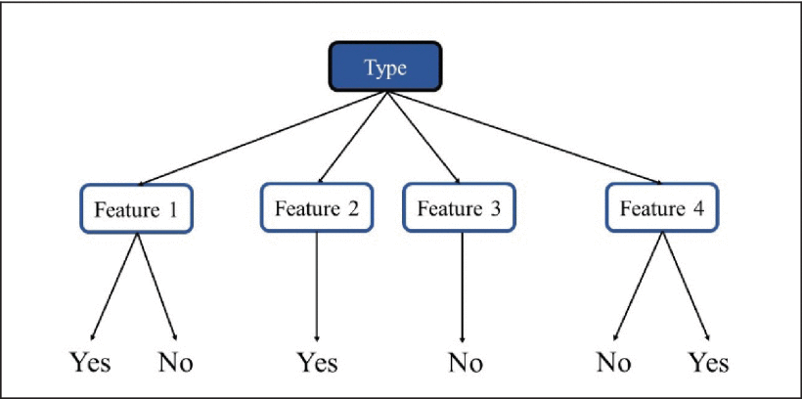

Figure 1. Decision Tree Algorithm
3.4 Random Forest
Random Forests are used for classification, regression, and the creation of decision trees. RFs correct the habit of over fitting decision trees to the training set and random forest model is created using a large number of decision trees.
The algorithm also employs three random ideas: randomly choosing training data when creating trees, randomly selecting specific subsets of variables when dividing nodes, and using only a small fraction of all variables to split each node in each basic decision tree.
During the training phase of a random forest, each fundamental tree gains knowledge from a random sampling of the dataset.
XGBoost and Random Forest methods for the classification problem to forecast the stock increase or decrease based on previous values [17].
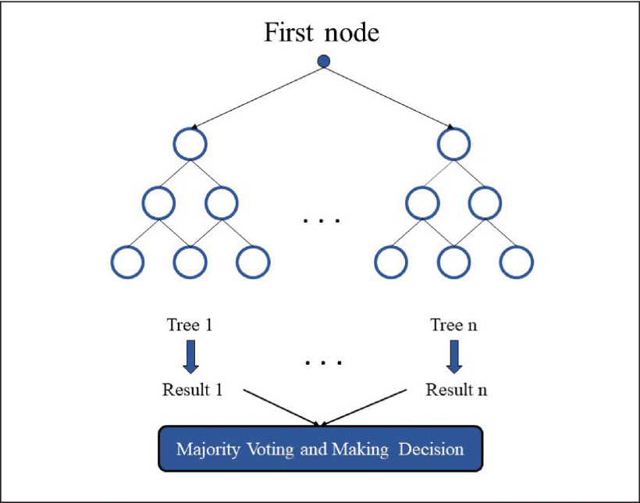
Compared the performance of AdaBoost, Random Forest and kernel factory versus single models involving SVM, KNN, Logistic Regression and ANN. They predict European company’s prices for one-year ahead. The final results showed that Random Forest outperformed among all models [18].

Figure 2. Random Forest Algorithm
- Conclusion
The main job of stock markets is to get money from investors directly, to provide liquidity for investors directly, to provide liquidity for investors, and to keep an eye on and handle the liquidity of companies. The best thing about the stock market is that it gives businesses and governments a way to get money directly from investors. For investors, the stock market provides liquidity. Some people have also said that liquid markets help allocate resources better and improve the chances of long-term economic growth .
5. References
[1] Aditya Srinivas, (2016), “Indian Capital Market - Impact of FII on Indian Stock Market‟, Indian Journal of Science and Technology, Vol. 9, Issue 15, ISSN (Print) : 0974-6846 ISSN (Online) : 0974-5645
[2] Varughese and Thomas, (2015), “Role of Foreign Institutional Investors on Indian Capital Market‟, GE-International Journal of Management Research, Vol. 3, Issue 4, Impact Factor 4.316 ISSN: (2321-1709)
[3] Avijith Banerjee,(1998) "A Glimpse of Portfolio Management", The Management Accountant, Monthly Vol. 39, No.10, October 1998, p.774
[4] Aditya Srinivas, (2016), “Indian Capital Market - Impact of FII on Indian Stock Market‟, Indian Journal of Science and Technology, Vol. 9, Issue 15, ISSN (Print) : 0974-6846 ISSN (Online) : 0974-5645
[5] Varughese and Thomas, (2015), “Role of Foreign Institutional Investors on Indian Capital Market‟, GE-International Journal of Management Research, Vol. 3, Issue 4, Impact Factor 4.316 ISSN: (2321-1709)
[6] Ranganathan M. & Madhumahi R., (2014), “Investment Analysis and Portfolio Management‟, Pearson Education (India) Ltd., New Delhi
[7] Anju bala (2013), Indian Stock Market - Review of Literature, TRANS Asian Journal of Marketing & Management Research Vol.2 Issue 7, July 2013, ISSN 2279-0667.
[8] Juhi Ahuja (2012), “Indian Capital Market: An Overview with Its Growth” VSRD International Journal of Business & Management Research Vol. 2 (7), pp. 386-399.
[9] Arun Jeth Malani, ,(1999) "Risky Business", The Economics Times, Daily, Vol. 39, No. 119, July 1 st , 1999, p.12
[10] Avijith Banerjee,(1998) "A Glimpse of Portfolio Management", The Management Accountant, Monthly Vol. 39, No.10, October 1998, p.774.
[11] Aditya Srinivas, (2016), “Indian Capital Market - Impact of FII on Indian Stock Market‟, Indian Journal of Science and Technology, Vol. 9, Issue 15, ISSN (Print) : 0974-6846 ISSN (Online) : 0974-5645
[12] H. Maqsood, I. Mehmood, M. Maqsood, M. Yasir, S. Afzal, F. Aadil, et al., "A local and global event sentiment based efficient stock exchange forecasting using deep learning", Int. J. Inf. Manage., vol. 50, pp. 432-451, Feb. 2020
[13] Y. Baek and H. Y. Kim, "ModAugNet: A new forecasting framework for stock market index value with an overfitting prevention LSTM module and a prediction LSTM module", Expert Syst. Appl., vol. 113, pp. 457-480, Dec. 2018.
[14] Kelotra A and P. Pandey, "Stock market prediction using optimized deep-convLSTM model", Big Data, vol. 8, no. 1, pp. 5-24, 2020.
[15] G. Rekha, D. Bhanu Sravanthi, S. Ramasubbareddy and K. Govinda, "Prediction of stock market using neural network strategies", J. Comput. Theor. Nanoscience, vol. 16, no. 5, pp. 2333-2336, May 2019
[16] M. Nabipour, P. Nayyeri, H. Jabani, A. Mosavi and E. Salwana, "Deep learning for Stock Market Prediction", Entropy, vol. 22, no. 8, pp. 840, Aug. 2020.
[17] S. Basak, S. Kar, S. Saha, L. Khaidem and S. R. Dey, "Predicting the direction of stock market prices using tree-based classifiers", North Amer. J. Econ. Finance, vol. 47, pp. 552-567, Jan. 2019.
[18] M. Ballings, D. Van den Poel, N. Hespeels and R. Gryp, "Evaluating multiple classifiers for stock price direction prediction", Expert Syst. Appl., vol. 42, no. 20, pp. 7046-7056, Nov. 2015.

