Casting Design and Simulation of Bearing Block using Auto CAST Software for Defect Minimization with Experimental Validation
Avinash R. Narwade¹, Dr. Siddharth K. Undirwade²
¹Assistant Professor, Dept. of Mechanical and Automation Engineering, P.E.S. College of Engineering, Aurangabad, M.S., India
²Professor Mechanical & Dean IQAC, P.E.S. College of Engineering, Aurangabad, M.S., India

¹Email: narwadear@gmail.comMob No.: 8408966555

Abstract:
This paper represents an extension of my previous work titled "Feeder Design and Analysis Using Casting Simulation Software" by A. R. Narwade et al. (2014). In the earlier study, we explored how solidification simulation could assist in identifying casting defects and lead to improved casting quality by optimizing feeder size. The solidification process in casting is inherently complex, making simulations essential in the industry before actual production. The aim is to minimize defects like shrinkage cavities and porosity by designing an effective feeding system that ensures directional solidification during casting.
In this paper, we present a comprehensive methodology that encompasses simulation and optimization using Auto CAST software, which relies on the Vector Gradient Method. We employ the Canies method to calculate feeder size, and the feeder diameter is optimized through iterative trial and error. The Canies curve, differentiating between sound and unsound casting, is also employed. Subsequently, the Auto CAST software simulates how casting engineers make decisions regarding the casting process, including parting lines, cores, mold boxes, feeders, gating systems, and mold layouts. It analyzes each decision to provide suggestions for enhancing quality while reducing tooling and manufacturing costs. Finally, the simulated results are compared with experimental trials to validate the approach.
Introduction:
Casting represents a manufacturing technique in which a liquid material is typically poured into a mold that holds a desired hollow shape. Subsequently, the material is allowed to solidify, resulting in the formation of a solid part, commonly referred to as a casting. This casting is then extracted or removed from the mold to conclude the process. Despite having a history of approximately 600 years, metal casting continues to encounter various challenges, including issues related to quality, limited production capacity, and high material and energy consumption. These challenges persist because the casting process is inherently complex.
Top of Form
Choudhari et al. (2012) conducted research that highlighted the significance of considering manufacturability during part design to address various casting defects, such as shrinkage porosity, that may persist despite adjustments to tooling and process parameters. Casting solidification simulation emerges as a valuable tool in this context, as it enables the prediction and preemptive resolution of potential issues before finalizing the product design. This approach is instrumental in achieving high yield while maintaining the desired quality standards. Given the susceptibility of castings to various defects, their elimination becomes imperative. One effective method involves incorporating a riser into the casting, which functions as a molten metal reservoir. Optimizing the dimensions of the riser ensures that the metal inside solidifies at a later stage, thereby aiding in the elimination of defects from the casting.
Top of Form
2 Literature Review
Numerous research studies have delved into casting simulation employing various casting simulation software tools. Prabhakara Rao et al. [1] conducted simulations to analyze mold filling, enhance casting yield, and optimize gating system design and mold filling. Ravi B. et al. [2] focused on computer-aided casting design and simulation, offering improved insights for optimizing feeder and gating design in casting. Rabindra Behera et al. [3] emphasized the application of computer-aided methodologies and casting simulation in foundries to streamline casting development, minimizing bottlenecks and non-value-added time by reducing the need for shop floor trial castings.
S. Sulaiman and A.M.S. Hamouda [4] discussed the process of casting solidification simulation, providing an example to assist foundry engineers and industrial metallurgists in optimizing design parameters and identifying hot spot regions through time-temperature contours. B. Ravi et al. [5] underscored the importance of correctly optimizing casting design, including feeding and gating, to ensure defect-free castings, and they demonstrated how automated design, intelligent simulation, and castability assessments contribute to this.
Sham Asunder et al. [6] delved into the steps involved in simulating casting processes and highlighted precautions for addressing possible sources of errors. They stressed the significance of experience and tool usage to instill confidence in casting simulation. With technology advancements and meticulous modeling, it's feasible to predict casting defects before actual production, and they provided case studies using ADSTEFAN software.
A. Reis and Z. Xu [7] explored shrinkage defects in aluminum castings and proposed a 3D modeling-based model for explicitly calculating defects resulting from insufficient feeding flow. They compared their numerical results with experimental data to validate their approach.
Ravi and Srinivasan [8] developed a novel method for identifying hot spots and simulating feeding paths in three-dimensional casting models, relying on determining the direction of the largest thermal gradient within the casting.
Dr. B. Ravi [9] delved into casting simulation and optimization, highlighting the benefits, bottlenecks (both technical and resource-related), and best practices for overcoming these challenges.
Sulaiman S. and Hamouda A.M.S. [10] created a simulation model for a three in-gate mold, monitoring temperature changes in the casting and sand over time. They compared predicted results with experimental data and reported good agreement between the two.
3 Methodology
Three sections comprised the entire study: numerical simulation, experimental trial validation, and casting design calculations for bearing blocks.
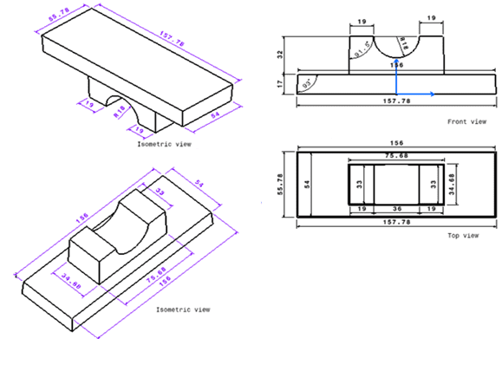
Fig.1.Wood pattern with allowances for bearing block
According to the needs of the foundry, silica sand is employed as the mold material and LM6 is the casting material used in the simulation research. The design calculations begin with the pattern allowances, then move on to the gating system and, lastly, the feeder design. Fig. 1 depicts the wood pattern with bearing block tolerances.
4 Numerical simulation using Auto CAST software:
4.1 Simulation is carried out for feeder diameter of 74 mm as follows:
One of the most crucial aspects of creating a casting process is developing the feeding system. A fraction of fresh molten metal should be injected to compensate for the volume shrinkage that occurs when molten metal solidifies in the mold cavity due to the difference in density between the liquid and solid states of metal. However, porosity defects like cavities and other empty regions arise because fresh molten metal cannot be given to an isolated non-solidified metal that is totally surrounded by solidified metal. One of the most severe and frequent casting flaws is a shrinkage cavity, which is the cavity that results from this process. A feeder's job is to provide thermal gradients that allow for controlled progressive directional solidification, where shrinkage happens in the feeder region. Finding the hot point in the casting is crucial for feeder design. A hot spot is a localized temperature maximum that efficiently feeds surrounding casting regions. To guarantee flawless casting, the hot point needs to be inside the feeder.
Fig.2 a. Feeder region or hot spots in castingFig. 2 b. Location of feeder

Fig. 2 illustrates the final solidification zones within the casting, specifically highlighting the hottest areas. Achieving this involves the activation of the Hot Spot function, which computes and visualizes these final solidifying regions. The feed module provides tools for designing and enhancing feeders and feed aids to attain the desired quality and high yield. The simulation encompasses the casting solidification process, presenting results through cooling animations, feed metal pathways, and the distribution of shrinkage porosity.
The feeder design can undergo automatic optimization guided by user-defined constraints. In this context, Fig. 2(a) showcases the identification of the last solidifying region within the casting or the casting's hotspots. Additionally, Fig. 2(b) features a green dot pinpointing the feeder's location.
The simulation trial revealed that the feeders with diameters of 48 mm and 37 mm were undersized. To determine the appropriate feeder size, a heuristic approach based on experience-driven techniques for feeder design was employed. Consequently, simulations were conducted for various diameter values starting from 48 mm and progressing upward until the hotspots were entirely accommodated within the feeder. The simulation results indicated that a feeder with a diameter of 74 mm yielded satisfactory outcomes. In this case, the simulation demonstrated that the hotspots completely migrated inside the feeder, rendering any feeding aid unnecessary, as illustrated in Fig. 3.

Fig. 3. Shifted position of hotspot with 74 mm diameter

Two main results are produced in Solidification function as follow:
- Cooling Simulation: progressive solidification (casting surface to interior).
- Feed metal paths: directional solidification (thin to thicker regions)
This helps in verifying and optimizing the design of feeders which gives the good quality of casting with high yield.

Fig.4. Cooling simulation in 3D
Feed metal flows microscopically along the feed paths from regions that solidify later, to regions that solidify earlier (along highest temperature gradients) to compensate the solidification shrinkage. Ideally, feed paths should end inside a feeder as shown in the Fig.5.

Fig.5.Feed metal paths in a cross-section
5. Experimental Analysis of casting:
5.1 Pattern making and mould box Preparation:
The preparation of the wooden pattern with different allowances for shrinkage, draft, machining, etc. was the first stage of the experimental analysis. The next stage involved creating hardwood templates for the pouring basin, sprue base well, sprue, runner, and ingates based on the aluminum casting's design dimensions. The rigging system with pattern is depicted in Fig. 6. Bentonite was combined with silica sand at a 10:1 ratio. It is a characteristic of bentonite to hold moisture. In addition, it serves as a binder, keeping the sand securely in place when the pattern is removed from the mold box. A standard-sized mold box of 300 x 300 x 160 mm was utilized. According to Figure 7, the mold cavity was divided into two sections: the drag portion was lower and the cope part was above. Silica was employed in the mold, and the casting material was the aluminum alloy LM6. It was about 800 and 900 0C when the molten metal was poured into the mold.

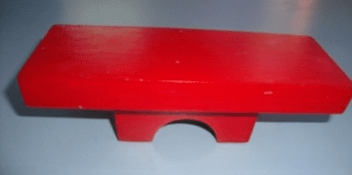

Pattern | Riser
 | 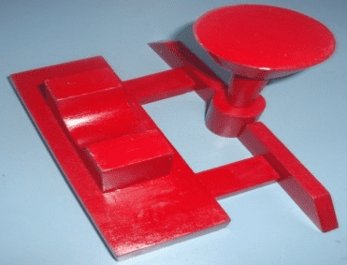
Pattern with runner, ingates. | Pattern with pouring basin, sprue, sprue, base well
Fig.6. Rigging System with pattern

Cope | Drag
Fig.7. Mould box

6. Results and discussion:
The Canies design approach was utilized to calculate the necessary diameter for the feeder. Trial and error was also used to optimize the feeder's diameter. In order to move the hotspot inside the feeder, the 48mm feeder diameter that was theoretically calculated was insufficient. The use of feeding aids as an exothermic sleeve has been attempted once more. However, the results have still not been adequate. The simulation testing revealed that the feeder was not the right size. The heuristic approach, which is based on experience-based techniques for feeder design, is then used to determine the feeder's size.Consequently, simulations have been run for a range of values starting at 48 mm and continuing until the hotspot fully enters the feeder. The 74 mm diameter feeder has yielded satisfactory results. Simulations for this diameter of feeder showed that hotspots moved all the way through the feeder without the need for feeding assistance.
These simulation results compared with experimental trial as follows:
First trial was carried out without riser as shown in fig.8. The hotspots shown at the center was as per AutoCAST simulation software.
 | 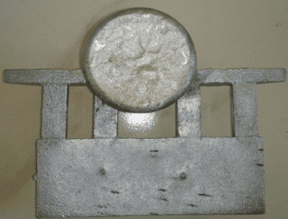
Casting simulation by AutoCAST | Casting without Riser
Fig.8.Simulation results with experimental trial

The next trial was done with 48mm riser diameter as shown in fig.9, as per the simulation trial we found hotspots in the casting. So, to check the simulation results with experimental trial we cut the casting in middle section and we don’t found the defects in the casting as shown, but we found some surface defects on the final casting.
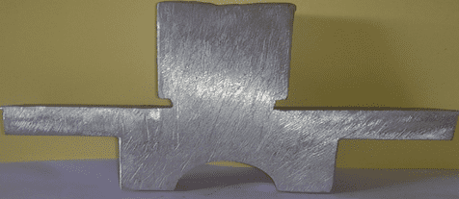
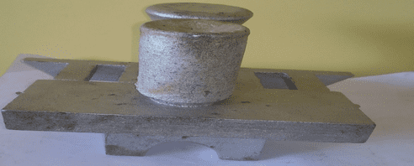
Fig.9. Experimental results for 48 mm Riser.

Lastly we carried out with 74mm riser diameter as shown in fig.10, and after that we cut the casting from center and we found no shrinkages defects in the casting. The casting was defect free. This gave result as per the casting simulation trial.
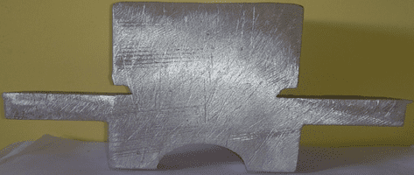
Fig.10. Simulation results with experimental trial for 74 mm Riser.
The optimum volume of riser (v_{r}) and the volume of casting (v_{c}) and the freezing ratio are tabulated in table no.1

Freezing ratio(X) = (SA_{c}/V_{c}) / (SA_{r}/V_{r})
= 0.318 D, where SA_{c}= surface area for casting and SA_{r}= surface area for Riser

Y = V_{r} /V_{c} = 3.73x10^-6 D3

Table.1. Values for sound and unsound casting

Diameter of feeder(D) | X | Y | Results
48 mm | 1.52 | 0.412 | Unsound casting
74mm | 2.35 | 1.5 | Sound casting
The above table shows the values for freezing ratio and value for V_{r} /V_{c}ratio to indicate the sound and unsound casting for given diameter of feeder. The graph is plotted below as shown in fig.

Fig.11.Caine’s curve for sound and unsound casting
From the above graph it is concluded that the feeder with 74mm diameter gives sound casting. The experimental results were also validated by using nondestructive testing. The radiographic test was carried out for final casting of 48 mm feeder diameter with sleeve and 74 mm feeder diameter. Both the test confirmed that there exist no internal defects (shrinkage porosity) in the casting. With manual inspection it has been observed that the casting with 48 mm diameter has surface defects as shown in fig. but, it has been also observed that the casting with 74 mm feeder diameter was free from surface defects.

Conclusion:
This study demonstrates that solidification simulation plays a crucial role in directly identifying and minimizing shrinkage porosity defects, ultimately leading to higher casting quality with appropriately sized feeders. Through successive simulation trials, it has been determined that a feeder with a diameter of 74 mm is sufficient to completely relocate the entire hotspot from the casting to the feeder. This research highlights the significant potential of simulation in optimizing riser dimensions and enhancing the feeding efficiency of the casting process. The simulation results for a 74 mm diameter feeder were compared with Caine's graph for sound and unsound casting, confirming sound casting quality for the 74 mm diameter. Therefore, it is recommended to design with a larger feeder, as the hotspot has been completely shifted into the feeder without the need for any feeding aids (sleeve). This also indicates that the casting is free from shrinkage defects.
In the heuristic approach, simulations were conducted using different feeder dimensions to achieve a defect-free casting. This approach proves valuable as it avoids the high costs associated with conducting actual foundry trials. It underscores the importance of adopting simulation-based practices in the present time, leading to significant savings in terms of cost, materials, time, and energy.
References
[1] P. Prabhakara Rao G.Chakaraverthi “application of casting simulation”. International journal of thermal technologies, Vol.1, No.1 (dec-2011).
[2] Ravi, B. and Durgesh Joshi, “Feedability Analysis and Optimization Driven by Casting Simulation,” Indian Foundry Journal, 53(6), 71-78, 2007.
[3] Rabindra Behera, “Solidification behavior and detection of Hotspots in Aluminum Alloy castings: Computer Aided Analysis and experimental validation,” IJAER Volume 1, No 4, 2011.
[4] S. Sulaiman, A.M.S. “Hamouda, Numerical simulation of casting solidification in permanent metallic molds”, Journal of Materials Processing Technology 29-33, 2006.
[5] B Ravi, “Computer- aided Design and Analysis for Zero Defects”, International Conference on Aluminum, ALUCAST, 2000
[6] Sham asunder S., “To believe or not to believe Results of casting simulation software,” ALUCAST, pp. 62-67, 2012.
[7] A. Reis, Z. Xu, “modeling feeding flow related shrinkage defects in aluminum castings” Journal of Manufacturing process, 14, 1-7, 2012
[8] B. Ravi and M. N. Srinivasan, “Casting solidification analysis by modulus vector method,” Int. J. Cast metals Res., 1996.
[9] Dr. B. Ravi, “casting simulation and optimization: benefits, bottlenecks, best practices” Technical Paper for Indian Foundry Journal, 2008.
[10] S. Sulaiman, A.M.S. Hamouda Modeling and experimental investigation of solidiﬁcation process in sand casting Journal of Materials Processing Technology, 155–156, 2004.

