STUDY OF BARYON ASYMMETRY WITH TBM NEUTRINO MASS MATRIX AND HYBRID TEXTURES MATRIX
RupamKalita
rupkalitaphy@gmail.com
Department of Physics, PDUAM Amjonga, Goalpara, Assam, India 783124
In the context of a model that combines the type I and type II seesaw mechanisms, we investigate two different kinds of neutrino mass matrices that enable the production of tiny neutrino masses. The goal of this work is to examine how leptogenesis contributes to the matter-antimatter asymmetry's origin. The first mass matrix is of the tri-bimaximal (TBM) type, which consistently produces a reactor mixing angle that is non-zero, and is based on the type I seesaw mechanism. Next, we study the type II seesaw mass matrix with the goal of introducing perturbations from the TBM mixing pattern and matching the neutrino parameter best-fit values when type I and type II seesaw mechanisms are taken into account together. The type II seesaw matrix is handled by us as a hybrid textures matrix. We explore the roles of hybrid texturing mass matrices and TBM in shedding light on how neutrino CP phases affect the universe's baryon asymmetry.

- INTRODUCTION
Neutrino masses and their significant mixing have emerged as one of the key observed phenomena in recent years [1–5]. Particle physics' Standard Model is unable to provide an explanation. In addition to predicting neutrino parameters more precisely than earlier estimates, a number of neutrino oscillation experiments, including T2K[6], Double ChooZ[7], Daya-Bay[8], and RENO[9], have also projected that the reactor mixing angle, ¬θ_13, will not be zero. The most current global fit value for the 3σ range of neutrino oscillation parameters is given by [10] and [11]. Since the neutrino oscillation experiments only measure two mass squared differences, the lightest neutrino mass, which is still a free parameter, can be constrained using the upper bound on the sum of absolute neutrino masses from cosmology∑▒m_i < 0.12eV[12].Other than the neutrino mass hierarchy problem, nothing new has been found in the current neutrino experiments about the nature of the neutrino mass. Several new experiments have recently been proposed to solve these challenges, and the India-based Neutrino Observatory (INO) has put forward some ideas to address some of these concerns.

The Seesaw mechanism stands as the prevailing Beyond the Standard Model (BSM) framework for elucidating the source of minuscule neutrino masses, and it encompasses three main categories: type I [13], type II [14], and type III. These mechanisms all involve the incorporation of additional heavy fermionic or scalar fields into the Standard Model (SM). In addition to addressing neutrino mass and mixing, it's worth noting that the SM is unable to account for the observed matter-antimatter imbalance. According to the most recent findings from the Planck experiment [12], this imbalance can be expressed in terms of the baryon-to-photon ratio as follows.
Y_{B}$≅(6.065±0.090)×{10}^{-10}$

In the current study, we examine leptogenesis as the sole mechanism responsible for the baryon asymmetry of the universe. Previous research has examined [15–18] the potential to produce non-zeroθ_13 and, in certain instances, the Dirac CP phase δ, by examining a BSM framework that incorporates both type I and type II seesaw mechanisms that contribute to neutrino masses.

The structure of this document is as follows. The TBM mixing matrix and the hybrid textures matrix are covered in section II. We outline the numerical analysis used in this case in section III, and we wrap up in section IV.

- TBM mixing + Hybrid Textures

In this study, we take type By considering the seesaw mass matrix as a TBM type mixing, I can approximate the observation of neutrino mixing as $θ_{12}≅35.3°, θ_{23}=45°$ and $θ_{13}=0$. The type II seesaw term can provide the necessary correction to the neutrino mass matrix of TBM type to yield θ_13 that is not zero but still tiny. The leptonic mixing matrix of Pontecorvo-Maki-Nakagawa-Sakata (PMNS) is associated with the diagonalizing
Matrices of neutrino and charged lepton mass matrices $U_{ν},{ U}_{l}$ respectively, as

$$U_{PMNS}={U_{l}}^{+}U_{ν}$$

In this work we consider hybrid texture neutrino mass matrix as the origin of type I seesaw. There are six categories of hybrid texture matrix which make it 39 matrices. We choose only 6 out of 39 hybrid texture matrices in our work which is closely agreed with experimental values. Following are the structure of hybrid texture neutrino matrix we have used in our work.

A1: $\left(\begin{matrix}0 & 1 & 1 \\ 1 & a & b \\ 1 & b & 1\end{matrix}\right)$, B1: $\left(\begin{matrix}a & 0 & b \\ 0 & 1 & 1 \\ b & 1 & 1\end{matrix}\right)$ , C1: $\left(\begin{matrix}a & b & 0 \\ b & 1 & 1 \\ 0 & 1 & 1\end{matrix}\right)$, D1: $\left(\begin{matrix}a & b & 1 \\ b & 1 & 0 \\ 1 & 0 & 1\end{matrix}\right)$

E1: $\left(\begin{matrix}a & b & 1 \\ b & 0 & 1 \\ 1 & 1 & 1\end{matrix}\right)$, F1: $\left(\begin{matrix}a & b & 1 \\ b & 1 & 1 \\ 1 & 1 & 0\end{matrix}\right)$

We formulate the neutrino mass matrix as follows, taking into account the type II seesaw term as the hybrid texture matrix that is required as a correction to TBM mixing.

$M_{ν}=M_{I}+M_{II}=U_{TBM}{M_{I}}^{diag}{U_{TBM}}^{T}$+ A1 hybrid texture

Where$M_{I}$is type I seesaw and $M_{II}$is the type II seesaw neutrino mass matrices respectively. Since the diagonalizing matrix of$M_{ν}$ is $U_{PMNS}$and that of type I mass matrix$M_{I}$is $U_{TBM}$the above equation can be written as

$$U_{PMNS}{m_{ν}}^{diag}{U_{PMNS}}^{T}=U_{TBM}{M_{I}}^{diag}{U_{TBM}}^{T}+A1 hybrid texture$$

We parametrize the diagonal type I mass matrix as follows in order to change the relative strength of type I and type II seesaw terms:${M_{I}}^{diag}=Z{m_{ν}}^{diag},$. Where Z is a parameter which determine the contribution of type I seesaw.
The diagonal mass matrix of the light neutrinos for normal mass hierarchy can be expressed as
$${m_{ν}}^{diag}=diag(m_{1}, \sqrt{{m_{1}}^{2}+Δ{m_{21}}^{2}}, \sqrt{{m_{1}}^{2}+Δ{m_{31}}^{2}})$$
whereas for inverted mass hierarchy it can be written as
${m_{ν}}^{diag}=diag(\sqrt{{m_{3}}^{2}+Δ{m_{23}}^{2}-Δ{m_{21}}^{2}}, \sqrt{{m_{3}}^{2}+Δ{m_{23}}^{2}}$, $m_{3}$)

- Numerical Analysis

As explained in section II, we first formulate the type I seesaw mass matrix by expressing it in terms of U_TBM and Z to start our research. We then go on to calculate the normal and inverted neutrino masses, which may be stated as a function of the mass squared differences and the lightest neutrino mass. In the type I mass matrix, the parameters that we have access to are the neutrino mass with the lowest mass, Z, and the parameters that are contained in the hybrid texture mass matrix.
Employing the best-fit values for the three mixing angles and two mass squared differences, we proceed to assess the neutrino mass matrix with considerations for the lightest neutrino mass, the numerical factor Z, and the free parameters denoted as 'a' and 'b'. Our next step involves the computation of the baryon asymmetry, and this process aligns with established methodologies previously employed in certain earlier studies [16-18]. As a result, the leptogenesis formula has not been duplicated here. To write here, we will treat the type I seesaw as a TBM type
matrix.$=U_{TBM}{M_{I}}^{diag}{U_{TBM}}^{T}$. In this work we consider only A1 form of hybrid texture matrix given above. Summary of work model is given in table below.

The expressions detailing the baryon asymmetry for various flavor regimes can be found in [15-18], as well as in our prior study [17]. Hence, we refrain from reiterating them here. Our selection involves setting the numerical factor Z at values of 0.50, 0.70, and 0.90. This encompasses scenarios where type II dominates, type I and type II seesaw mechanisms contribute equally, and type I seesaw is predominant, respectively.
We investigate two possible values of the lightest neutrino mass in our work. A quasi-degenerate spectrum is produced by the other, whereas one corresponds to a completely hierarchical light neutrino spectrum. We select the greatest value for the lightest neutrino in order to guarantee compliance with the Planck limit on the sum of absolute neutrino masses. For the regular hierarchy, this value is roughly 0.07 eV, and for the inverted hierarchy, it is 0.065 eV. The lowest value used for both tiers is 10^(-6) eV.
In our investigation, we specifically consider a lightest neutrino mass value that falls between the upper and lower limits set by the Planck constraint. In this work, our chosen value for the lightest neutrino mass is 0.001 eV. We investigate the baryon asymmetry of the Universe under three distinct scenarios, as previously discussed.

Model | Type I seesaw contribution | Type II seesaw contribution
A1 texture with NH | 50% | 50%
A1 texture with NH | 70% | 30%
A1 texture with NH | 90% | 10%
A1 texture with IH | 50% | 50%
A1 texture with IH | 70% | 30%
A1 texture with IH | 90% | 10%
%
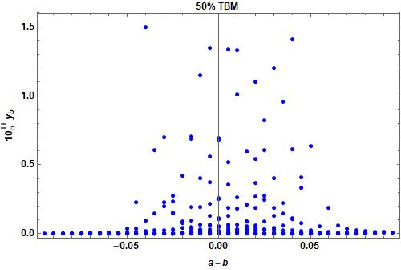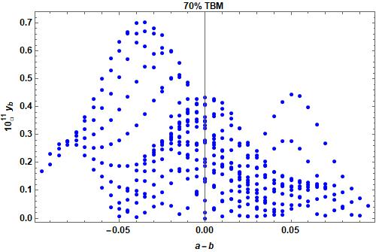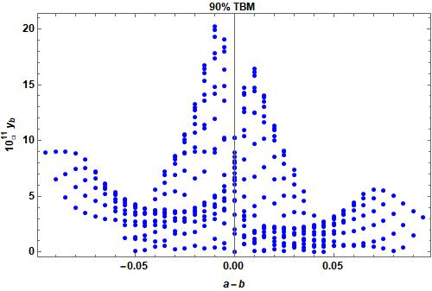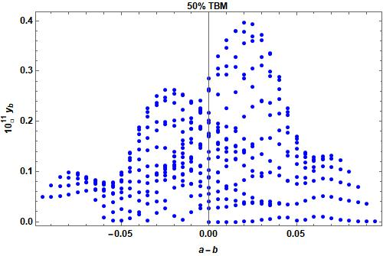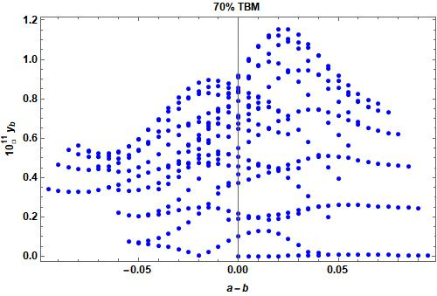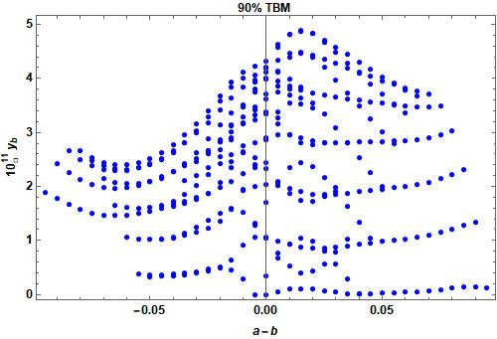

Fig1:Baryon asymmetry with the variation of parameter a-b

- Results and Conclusion

Without accounting for pure type I or pure type II seesaw, we assume numerical component Z to be 0.50, 0.70, and 0.90 in this work, which corresponds to 50% type I contribution, 70% type I –and 30% type II contribution, and 90% type I contribution, respectively. We consider the Type II seesaw mass matrix, as reported by [17–20]. In this effort, we just employed the hybrid textures' A1 structure. Next, we include the type I and type II seesaw contributions in the calculation of the baryon imbalance resulting from the lightest right-handed neutrino decay via leptogenesis.. We impose accurate baryon asymmetry constraints on the Dirac and two Majorana phases using certain values of leptonic CP phases. Figure 1 illustrates the permitted parameter space regions for the two flavor regimes of leptogenesis with respect to the three leptonic phases. Figure 1 only displays a small number of leptogenesis plots. From the above figures we observe in most of the cases close values are obtained. If we take more contributions from type I seesaw matrix that will give us more accurate result. The above results of baryon asymmetry constraint the values of parameters a and b in hybrid texture and we can make specified hybrid texture neutrino model based on above results. We can also give a specific value of lightest neutrino mass from above results. In future work we will try to study all the different hybrid model of neutrino mass matrix. We will try to choose the value of different lightest neutrino mass in future along with hybrid texture matrix to get correct baryon asymmetry and neutrino parameters. In this work we have not consider Majorana phases but we will try to study Majorana effects in future.

The ongoing investigations of neutrino less double beta decay may provide insight into the nature of neutrino masses. It will be an exciting field of future research to further constrain the Majorana CP phases by computing other observables, like the lifetime of neutrinoless double beta decay, by incorporating contributions from multiple seesaw mechanisms operating at the TeV scale or above and then computing the experimental constraints.

Acknowledgement

I would like to thank Dr. Debasish Borah from IIT Guwahati for useful discussion regarding this work and also my deep gratitude towards Dr. Mrinal Kumar Das from Tezpur University for giving some valuable time to discuss about this work.

References

- S. Fukuda, et al. “Constraints on neutrino oscillations using 1258 days of super-kamokande solar neutrino data”. Phys. Rev. Lett. 86, 5656-5660 (2001).

- Q.R.Ahmad, et al. “Direct evidence for neutrino flavor transformation from neutral current interactions in SNO,” Phys. Rev. Lett. 89, 011301 (2002).
- Ahmed, Q. R. Ahmad, et al. “Measurement f day and night neutrino energy spectra at SNO,”Phys. Rev. Lett. 89, 011302 (2002).
- J.N. Bahcall, et al. “Solar modes and solar neutrino oscillations,” New J. Phys. 6, 63 (2004).
- K. Nakamuraet al. “ Review of particle physics,” Nucl. and part. Phys 37, 075021 (2010).
- K. Abe, et al. “Indication of electron neutrino appearance from an accelerator produced off-axis muon neutrino beam”, Phys. Rev. Lett. 107, 041801 (2011).
- Y. Abe, et al. “ Indication for the disappearance of reactor electron antineutrinos in the double chooz experiment,” Phys. Rev. Lett. 108, 13180 (2012).
- F.P. An, et al. “Observation of electron antineutrino disappearance in the daya bay experiment,” Phys. Rev. Lett. 108, 171803 (2012) .
- J.K.Ahn, et al. “Observation of reactor electron antineutrino disappearance in the RENO Experiment,”Phys. Rev. Lett. 108, 191802 (2012) .
- P.F. de Salas, P.F., et al.. “Status of neutrino oscillations 2018,” Phys. Rev. D98, 030001( 2018).
- I. Esteban, et al., “ Global analysis of three flavor neutrino oscialltion,” JHEP 01 106 (2019).
- N. Aghanim, et al. “Planck 2018 results. VI.” HEP 01, 106 (2019).
- , R.N. Mohapatra, et al.“ Neutrino mass and spontaneous parity violation ,” Phys. Rev. Lett 44, 912(1980).
- D.Borah, et al. “ Derivations from tribimaximal neutrino mixing using type II seesaw,” Nucl. Phys. B876, 575 (2013).
- R. N. Mohapatra and W. Rodejohann, Phys. Lett. B 644, 59 (2007).
- R. Kalita, D. Borah and M.K. Das , Nucl. Phys. B894, 307 (2015).
- S. Kaneko, H. Sawanaka and M. Tanimoto, JHEP 0508, 073 (2005);
- S. Dev, S. Verma and S. Gupta, Phys. Lett. B687, 53 (2010);
- S. Goswami, S. Khan and A. Watanabe, Phys. Lett.B693, 249 (2010).
- R. Kalita and D. Borah, Int. J. Mod. Phys. A31, 1650008 (2016).

