Perspectives of Ventricular assist device (VAD) in heart failure patients
Mr. Murthi S, Department of Perfusion Technology
School of Allied Health Sciences, Vinayaka Mission’s Research Foundation – DU
AVMC & H, Puducherry, India

ABSTRACT
Congestive heart failure is a major cause of mortality and morbidity around the world. Heart failure affects more than 64 million people around the world. Despite many medical therapies available for heart failures like heart transplant ventricular assist devices offers an alternative when the heart transplant is limited by donor availability. And it also provides both pulsatile flow and non-pulsatile flow and depending upon the choice of temporary or permanent supportive device. The advancement in VAD helps in extended support, overall patient outcomes This article describes the ventricular assist device and pump types, components, indications, complication, hemodynamic criteria and evolution and current trends
Keyword: Ventricular assist device, pulsatile and non-pulsatile flow indications, complication,
- INTRODUCTION
Cardiopulmonary Assist Device A mechanical pump called a ventricular assist device (VAD) is surgically implanted into one or both ventricles of the heart to improve or replace ventricular function. It is intended to assist cardiac function in persons with heart failure either partially (either the right "RVAD" or left "LVAD" ventricle) or entirely (both at once, "BiVAD").[1] VADs are implanted as a substitute for heart transplantation (called destination therapy, a patient who will never receive a heart transplant), a bridge to transplantation, a bridge to recovery, or both. [2]

- WORKING PRINCIPLE
The heart's workload is decreased by using a ventricular assist device to help pump blood from the lower chamber (ventricle) to the body or the lungs. This maintains adequate systemic perfusion while reducing myocardial oxygen demand. The improvement in myocardial oxygenation is caused by the rise in systemic perfusion.[3] Ventricular recovery is aided by the improvement in myocardial oxygen supply and decrease in myocardial oxygen demand.[4]
- Components
An inflow tube that transports blood from the heart, an outflow tube that returns blood to the ascending aorta or the major pulmonary artery, and other basic components make up a ventricular assist device. Driveline (a cord that runs through the skin and holds the device's power and control wires while connecting it to a portable, external driver), A portable driver with a control unit that keeps track of the VAD's operations a power source (which may be housed inside a small bedside monitor, carried on one's shoulder, or wrapped around the waist). [5]
- Pump flow types
Pulsatile and non-pulsatile (continuous flow) pumps are the two primary groups into which the pumps utilized in ventricular assist devices fall. Pumps with Pulsatile Flow: The majority of extracorporeal pulsatile devices have valves, an air chamber with a compressor-operated membrane, and a blood chamber. Blood enters by an inflow cannula, fills the blood chamber, and is subsequently expelled into the systemic circulation via an outflow cannula by a pneumatic pump that collapses the blood chamber by pumping air at a high pressure into it. As the ventricle empties into the blood chamber during native ventricular systole, pulsatile devices consecutively fill and empty. Pulsatile Flow Pumps imitate the heart's normal rhythmic pounding. The patients will therefore have measured blood pressure and palpable pulses. [6] [7]
- CLINICAL APPLICATION
Depending on the therapeutic objectives of circulatory support and the length of the treatment, ventricular assist devices can be applied in a variety of situations. They can be used both temporarily and permanently. The following conditions are indicators: end stage cardiomyopathy, after cardiotomy cardiogenic shock, destination therapy, bridge to transplantation, and bridge to decision [8].
- CLINICAL COMPLICATION
Right ventricular failure, sepsis, device thrombosis, cable malfunction, mechanical device failure, neurologic impairment, and infection are the most frequent problems associated with VAD implants.[9]

- CURRENT TRENDS AND EVOLUTION
First-generation pulsatile pumps (Novacor® and HeartMate VE®) gave way to second- and third-generation continuous flow LVAD technologies.[10] The architecture of second-generation pumps is axial, and a turbine system creates a parallel flow to the rotating axis. Compared to heart mate I, heart mate II is substantially smaller and has a higher survival rate. [11] The third-generation LVAD, the last group, is the most popular. At the ENDURANCE study, HeartWare® (HVAD) with the hybrid centrifugal flow was not inferior to HeartMate II®, making the exchange practicable.[12] Long-term morbidity and mortality between the two centrifugal DT-LVAD devices were not evaluated in clinical trials. However, certain descriptive data indicated that HeartMate III® had fewer problems and mortality than HeartWare® [13].
Nevertheless, HeartMate III® signaled a revolution in medicine. It is a totally magnetically levitated robust LVAD that improves hemocompatibility by reducing bloodstream friction and presenting broader route gaps. Overall heart mate III is not improved in overall survival rate than heart mate II but heart mate III lower rates of gastrointestinal bleeding as well as aortic insufficiency. [14]
Even though there were no changes in the incidence of right heart failure, arrhythmia, or infections, hemocompatibility-related events (bleeding, stroke, and device thrombosis) occurred at reduced rates in the HeartMate III® group.[15] But if biventricular assistance is required, negative effects are far more common, with bleeding and infection occurring on more than [16] Despite the use of HeartMate III, there was only one reported case of both and 25%, respectively. [17] Long-term morbidity and mortality between the two centrifugal DT-LVAD devices were not evaluated in clinical trials. Nevertheless, some illustrative data revealed fewer. HeartMate III® has fewer side effects and lower fatality rates than HeartWare® [18]. Perhaps there will be another choice in the near future.

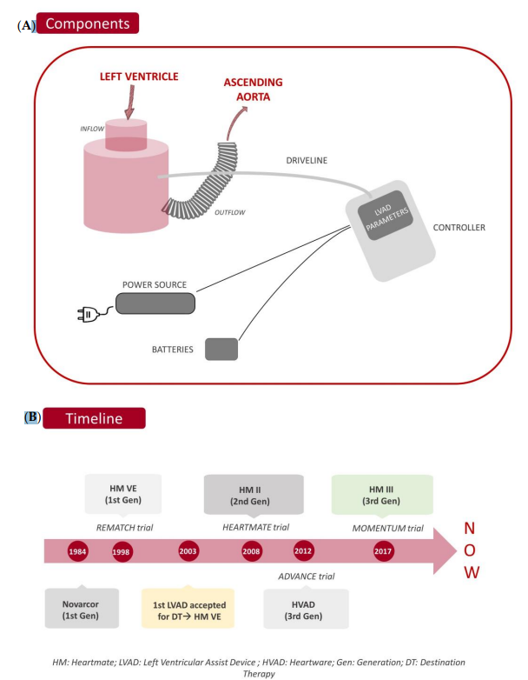

Figure 1: Components and timeline of VAD

- CONCLUSION
In the care of severe heart failure patients who are ineligible for transplantation, mechanical circulatory support is a highly sensible alternative that increases their functional ability. Implantable pumps increased exponentially in terms of event-free survival as they became more sophisticated. Additionally, highly specialized non-transplant LVAD centres came to be. At two and five years, the predicted survival rate is currently greater than 70% and 50%, respectively.
However, meticulous preimplant patient selection determines the short- and medium-term prognosis. Evaluation of the baseline situation is crucial, paying close attention to factors including frailty, the psychosocial environment, renal function, hemodynamic indicators that can assist determine prognosis and RVF, and ultimately, the surgical strategy used for the heart. A multidisciplinary shared decision process is particularly pertinent in these cases, particularly in patients who have several conditions and under uncertain circumstances.

REFERENCE
- Writing Group Members, Lloyd-Jones D, Adams RJ, Brown TM, Carnethon M, Dai S, De Simone G, Ferguson TB, Ford E, Furie K, Gillespie C. Heart disease and stroke statistics—2010 update: a report from the American Heart Association. Circulation. 2010 Feb 23;121(7):e46-215.
- Maybaum S, Mancini D, Xydas S, Starling RC, Aaronson K, Pagani FD, Miller LW, Margulies K, McRee S, Frazier OH, Torre-Amione G. Cardiac improvement during mechanical circulatory support: a prospective multicenter study of the LVAD Working Group. Circulation. 2007 May 15;115(19):2497-505.
- Slaughter MS, Pagani FD, Rogers JG, Miller LW, Sun B, Russell SD, Starling RC, Chen L, Boyle AJ, Chillcott S, Adamson RM. Clinical management of continuous-flow left ventricular assist devices in advanced heart failure. The Journal of heart and lung transplantation. 2010 Apr 1;29(4):S1-39.
- Swetz KM, Freeman MR, Mueller PS, Park SJ. Clinical management of continuous-flow left ventricular assist devices in advanced heart failure. The Journal of Heart and Lung Transplantation. 2010 Sep 1;29(9):1081.
- Goldstein DJ. Worldwide experience with the MicroMed DeBakey ventricular assist device® as a bridge to transplantation. Circulation. 2003 Sep 9;108(10_suppl_1):II-272.
- Miller LW, Pagani FD, Russell SD, John R, Boyle AJ, Aaronson KD, Conte JV, Naka Y, Mancini D, Delgado RM, MacGillivray TE. Use of a continuous-flow device in patients awaiting heart transplantation. New England Journal of Medicine. 2007 Aug 30;357(9):885-96.
- Klotz S, Stypmann J, Welp H, Schmid C, Drees G, Rukosujew A, Scheld HH. Does continuous flow left ventricular assist device technology have a positive impact on outcome pretransplant and posttransplant?. The Annals of thoracic surgery. 2006 Nov 1;82(5):1774-8.
- Thalmann M, Schima H, Wieselthaler G, Wolner E. Physiology of continuous blood flow in recipients of rotary cardiac assist devices. The Journal of heart and lung transplantation. 2005 Mar 1;24(3):237-45..
- Haft J, Armstrong W, Dyke DB, Aaronson KD, Koelling TM, Farrar DJ, Pagani FD. Hemodynamic and exercise performance with pulsatile and continuous-flow left ventricular assist devices. Circulation. 2007 Sep 11;116(11_supplement):I-8
- Starling RC, Estep JD, Horstmanshof DA, Milano CA, Stehlik J, Shah KB, Bruckner BA, Lee S, Long JW, Selzman CH, Kasirajan V. Risk assessment and comparative effectiveness of left ventricular assist device and medical management in ambulatory heart failure patients: the ROADMAP study 2-year results. JACC: Heart Failure. 2017 Jul;5(7):518-27
- Cassina AM. Dispositivos de asistencia ventricular de tipo axial. Cirugía cardiovascular. 2009 Apr 1;16(2):131-7.
- Slaughter MS, Rogers JG, Milano CA, Russell SD, Conte JV, Feldman D, Sun B, Tatooles AJ, Delgado III RM, Long JW, Wozniak TC. Advanced heart failure treated with continuous-flow left ventricular assist device. New England Journal of Medicine. 2009 Dec 3;361(23):2241-51.
- Wasilewski G, Kędziora A, Wiśniowska-Śmiałek S, Tomsia P, Kaleta M, Wierzbicki K. Outcomes in Patients with HeartMate3 Versus HeartWare Ventricular Assist Device Implanted as Destination Therapy. InTransplantation Proceedings 2022 May 1 (Vol. 54, No. 4, pp. 1049-1053). Elsevier.
- Mehra MR, Uriel N, Naka Y, Cleveland Jr JC, Yuzefpolskaya M, Salerno CT, Walsh MN, Milano CA, Patel CB, Hutchins SW, Ransom J. A fully magnetically levitated left ventricular assist device. New England Journal of Medicine. 2019 Apr 25;380(17):1618-27.
- Mehra MR, Goldstein DJ, Cleveland JC, Cowger JA, Hall S, Salerno CT, Naka Y, Horstmanshof D, Chuang J, Wang A, Uriel N. Five-year outcomes in patients with fully magnetically levitated vs axial-flow left ventricular assist devices in the MOMENTUM 3 randomized trial. JAMA. 2022 Sep 27;328(12):1233-42.
- Marasco S, Simon AR, Tsui S, Schramm R, Eifert S, Hagl CM, Paç M, Kervan Ü, Fiane AE, Wagner FM, Garbade J. International experience using a durable, centrifugal-flow ventricular assist device for biventricular support. The Journal of Heart and Lung Transplantation. 2020 Dec 1;39(12):1372-9.
- Wasilewski G, Kędziora A, Wiśniowska-Śmiałek S, Tomsia P, Kaleta M, Wierzbicki K. Outcomes in Patients with HeartMate3 Versus HeartWare Ventricular Assist Device Implanted as Destination Therapy. InTransplantation Proceedings 2022 May 1 (Vol. 54, No. 4, pp. 1049-1053). Elsevier.
- Allen SR, Slaughter MS, Ahmed MM, Bartoli CR, Dhingra R, Egnaczyk GF, Gulati SK, Kiernan MS, Mahr C, Meyer DM, Motomura T. COMPETENCE Trial: The EVAHEART 2 continuous flow left ventricular assist device. The Journal of Heart and Lung Transplantation. 2023 Jan 1;42(1):33-9.

