Synthesis and Properties Single-crystal MnO₂ nanorods

K.Premkumar, Dr. P. Prabu
Assistant Professor, PG & Research Department of Physics.
E.G.S.Pillay Arts and Science College, Nagapattinam. – 611002,Tamilnadu.
Email:mklspkumar@gmail.com
Abstract
Single-crystal MnO₂ nanorods were prepared by hydrothermal reaction of
single KMnO4 under acidic conditions. The nanorods have a diameter of
30–70 nm and a length up to 2 μm. The formation mechanism for the
MnO2 nanorods was investigated. Electrochemical properties of the MnO2
nanomaterials prepared for different hydrothermal times were characterized
by galvanostatic charge/discharge tests and cyclic voltammetry (CV) studies.
The results indicate that the MnO2 nanorods prepared for 5 and 8 h show fine
capacitive behaviour with high specific capacitances of 71.1 and 70.9 F g-1,

Introduction
one-dimensional (1D) nanostructures, including nanowires, nanorods and nanotubes, have attracted increas- ing attention due to their superior optical, electrical, catalytic and magnetic properties, which can be extensively explored as fundamental building blocks for nanoscale science and tech- nology. Therefore, much effort has been devoted to the fabrication of various 1D nanomaterials with alterable morphology, phase and distinctive performances.
MnO₂ has many kinds of polymorphs, such as α, β,γ and δ-type according to different linkage ways of its basic MnO₆ octahedral units. MnO₂ has wide applications such as redox catalysts, molecular/ion sieves and electrode materials in batteries or capacitors. Recently, increasing interest has been focused on the fabrication of 1D MnO₂ nanostructures. Various 1D MnO₂ nanomaterials, such as α-MnO₂ nanorods/nanowires, β-MnO₂ nanorods/nanotubes, γ -MnO₂ nanowires/nanotubes and δ-MnO₂ nanofibres have been successfully prepared by oxidation of Mn²⁺ or reduction of KMnO₄. In addition, single-crystal MnO₂ nanowires of α, β and γ -type have also been conveniently prepared by simple hydrothermal treatment of commercial γ -MnO₂ particles in water or ammonia solution. Further, it is found that these 1D MnO₂ nanomaterials show finer electrochemical properties than their bulk counterparts, which can be adopted as promising electrode materials in Zn–MnO₂ batteries, Li– MnO₂ cells and electrochemical capacitors, etc
In this paper, we report the preparation of single-crystal α-MnO₂ nanorods by direct hydrothermal decomposition of single KMnO₄ under acidic conditions involving no templates or surfactants. The formation mechanism of such nanorods was studied by tracing their growth process at different reaction stages. Electrochemical properties of the as-prepared nanorods as electrode materials in electrochemical capacitors were also investigated with galvanostatic charge/discharge tests and cyclic voltammetry (CV) studies. The results show that these MnO₂ nanorods display ideal capacitive behaviour, in which the MnO₂ nanomaterials prepared for 5 and 8 h have high specific capacitances of 71.1 and 70.9 F g⁻¹, respectively.

Experimental methods
All the chemical reagents were analytical grade and used without further purification. All the hydrothermal reactions were performed in a 36 ml Teflon-lined stainless steel autoclave under autogenous pressure. In a typical synthesis, 2 mmol KMnO₄ and 1 ml concentrated H₂SO₄ were added to 23 ml distilled water under stirring to form a solution, which was then loaded into the autoclave, sealed and heated in an oven at 150 ◦C for 12 h. After the reaction was complete, the autoclave was taken out and naturally cooled to room temperature. The resulting brown-black precipitates were filtered off, washed with distilled water several times to remove excess ions, and finally dried at 120 ◦C in air overnight.
X-ray powder diffraction (XRD) was taken on a Rigaku- D-Max rA 12 kW Diffractometer with Cu Kα radiation (λ 0.154 06 nm) at an operation voltage and current of 40 kV and 300 mA, respectively. The Fourier transform infrared (FT-IR) spectrum was recorded on a US Nicolet-5DX Fourier-IR spectrometer with KBr pellets. Transmission electron micrographs (TEM), selected area electron diffraction (SAED) and high-resolution transmission electron micrographs (HRTEM) were obtained from a Hitachi H-800 transmission electron microscope and a JEOL-3010 high-resolution transmission electron microscope, respectively. Chemical composition of the as-obtained materials was analysed by an inductively coupled plasma emission spectrograph (ICP-ES). Average oxidation state of Mn in the final products was determined by chemical titration with sodium thiosulfate as described elsewhere
The electrodes used for the electrochemical measurements were prepared by mixing the as-prepared MnO₂ samples, acetylene black and PTFE latex with a mass ratio of 80:10:10 to form a slurry. The slurry was dried at 120 ◦C, and then filled into a Ni mesh, which was then roll pressed and dried again. The capacitor was assembled with the MnO₂ positive electrode and MnO₂ negative electrode, separated by a polypropylene separator. The masses of the positive-electrode and the negative-electrode active materials are kept the sameGalvanostatic charge/discharge tests of the MnO₂ capac- itors were performed using a Land battery test system in a two-electrode system, in which MnO₂ electrodes were used as the positive electrode and the negative electrode. All the tests were performed between 0 and 1.0 V at a specific current of 300 mA g⁻¹ in a 0.5 M Na₂SO₄ electrolyte at room temper- ature. Discharge specific capacitances of the capacitors were calculated according to the formula C It/m∆V (where I is the discharge current, t is the discharge time, ∆V is the differ- ence in discharge voltage and m is the total mass of active ma- terials of the two electrodes). Cyclic voltammetry (CV) stud- ies were carried out on a CHI-660 electrochemical workstation with a three-electrode configuration, in which a MnO₂ elec- trode was used as the working electrode, Pt wire as the counter and a saturated calomel electrode (SCE) as the reference. CV tests were done between 0.2 and 1.0 V in a 0.5 M Na₂SO₄ electrolyte at different scan rates of 5, 10 and 20 mV s⁻¹, re- spectively.
=
−

Results and discussion
Figure 1 shows the XRD pattern of the resultant MnO₂ product. All the peaks can be indexed to the pure tetragonal phase of α-MnO₂ (JCPDS No. 44-0141) with lattice constants of a 0.982 nm and c 0.286 nm. No peaks for other types of manganese oxides are observed, indicating that the as-prepared products are phase-pure α-MnO₂ nanorods. The sharp diffraction peaks reveal that the products are well crystalline. In addition, it is worth noting that the relative intensity of the (110) peak (51.0%) is much stronger than that of the standard JCPDS card (37.0%). Likewise, the relative intensity of the (220) peak (7.5%) is 1.5 times of the value from the standard JCPDS card. However, the relative intensities of other diffraction peaks are basically comparable to those of the standard JCPDS card. Thus, these MnO₂ nanorods might have a preferential growth along the [001] direction
= =

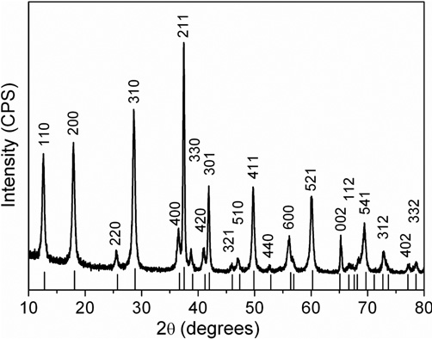
Figure 1. Typical XRD pattern of the as-prepared MnO₂ products.

Figure 2(a) gives a panoramic TEM image of the as- obtained α-MnO₂ samples. It is found that all the MnO₂ samples are composed of nanorods with diameters 30–70 nm and lengths up to 2 μm. Figure 2(b) shows a representative TEM micrograph of a single nanorod with uniform diameter. As indexed in the SAED pattern taken from this rod (inset image of figure 2(b)), a series of dots arrayed in a single line and perpendicular to the rod can be seen clearly, implying that it is a single-crystal rod. The HRTEM image of part of an individual rod demonstrates that the nanorod has uniform lattice fringes as shown in figure 2(c). The lattice spacing is calculated to be 0.69 nm (figure 2(d)), which corresponds to the (110) plane of α-MnO₂.
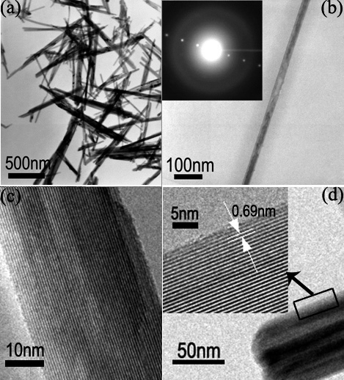
Figure 2. ((a), (b)) TEM images of the as-prepared α-MnO₂ nanorods; the inset shows the corresponding SAED pattern. ((c), (d)) HRTEM images of the α-MnO₂ nanorods.

Figure 3 shows the FT-IR spectrum of the resulting nanorods. The bands at around 3416.6 and 1642.3 cm⁻¹ correspond to the O–H vibrating mode of traces of absorbed water. The bands at about 709.9, 528.6 and 470.3 cm⁻¹ that are below 750 cm⁻¹ can be attributed to the Mn–O vibrations of MnO₆ octahedra in α-MnO₂ nanorods. The relatively simple FT-IR pattern is ascribed to the highly structural symmetry of α-MnO₂ nanorods. The IR analysis here is consistent with the results reported in the literature.
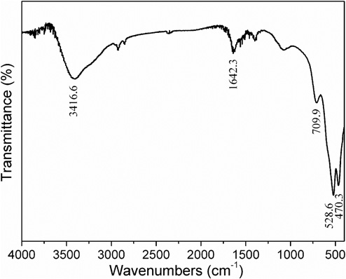
Figure 3. FT-IR spectrum of the as-synthesized α-MnO₂ nanorods.
The production yield of MnO₂ is repeatedly above 95% based on Mn in our experiments. The molar ratio of K/Mn in the MnO₂ products is about 0.15 determined by ICP-ES analysis. The average oxidation state of Mn in the products is 3.84 according to the chemical titration analysis.
In our synthesis of MnO₂ nanorods, the source materials were merely KMnO₄; no templates or surfactants were used. To investigate the formation process of α-MnO₂ nanorods, a series of samples were prepared by hydrothermal reaction for different times. Figure 4 shows the XRD patterns of the samples hydrothermally prepared for 1.5, 5, 8 and 12 h, respectively. Clearly, the main reflection peaks of the products prepared for 1.5 h can be indexable to the α-MnO₂ phase. In addition, a small amount of Mn₇O₁₃ 5H₂O (JCPDS No. 23- 1239) can also be observed. When the hydrothermal time is increased to 5 h, the products are composed of single- phase α-MnO₂, and no peaks for other manganese oxides are detected any more. Meanwhile, the diffraction peaks become narrower and sharper along with the prolongation of hydrothermal time, indicating the crystallinity of the products enhances with increased reaction time. TEM micrographs of the products hydrothermally synthesized at different times are shown in figure 5. Figures 5(a)–(c) show the TEM images of the samples hydrothermally prepared for 1.5 h. We can see that the products are composed of flower-like nanoarchitectures and some aggregates of nanorods. In addition, few individual nanorods are also detected. The SAED pattern taken from an individual nanorod (inset image of figure 5(c)) demonstrates that it is a single crystal, though it is not very uniform in diameter. When the hydrothermal reaction was prolonged to 5 h, the products are all composed of nanorods, and no flower-like aggregates are detected, as shown in figures 5(d) and (e). Besides, some nanorods have congregated and stacked together. Figure 5(f) shows the TEM image of the products obtained after hydrothermal reaction for 8 h. It is evident that the products exhibit fine rodlike morphology with the prolongation of the hydrothermal treatment
·
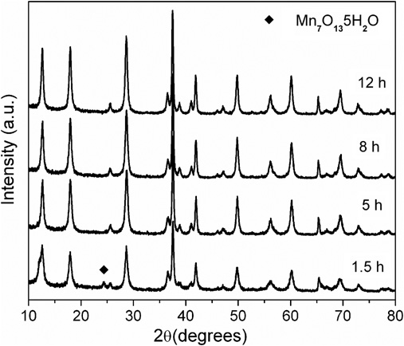

Figure 4. XRD patterns of the manganese oxides prepared at different hydrothermal times.
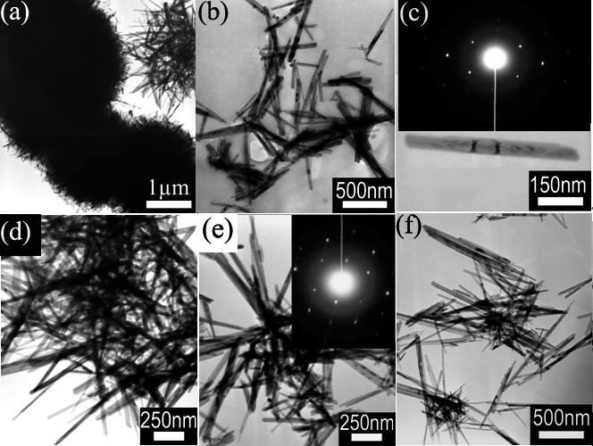
Figure 5. TEM images and SAED patterns of the resulting manganese oxides prepared at different hydrothermal times. ((a)–(c)) 1.5 h; ((d), (e)) 5 h; (f) 8 h.

Based on the above experimental results, the formation mechanism of these nanorods is deduced as follows. Firstly, KMnO₄ is generally unstable in acidic conditions, which would decompose into MnO₂ and O₂. This decomposition reaction would be accelerated considerably under a sealed hydrothermal environment, resulting in a large quantity of MnO₂ colloids. Next, the produced MnO₂ colloids tended to form some larger agglomerates due to their relatively high concentration and surface energies. Meantime, minor colloids might grow into a few small nanorods because of their 1D growth habits under the specific experimental conditions. As the reaction proceeded, the reaction rate would be slowed down due to the decrease of the reactants. After the KMnO₄ was consumed completely, the whole system would thus tend to be thermodynamically stable. Subsequently, a dissolution–recrystallization process should be involved. That is, the amorphous and poorly crystalline components in the agglomerates would dissolve again and grow into nanorods. This process obeyed the well-known ‘Ostwald ripening process’, in which the larger nanorods grew at the cost of the small ones because of their energy differences. The growth process of the α-MnO₂ nanorods presented here is somewhat different from those reported in the literature

Conclusion
In conclusion, single-crystal α-MnO₂ nanorods were prepared via a facile hydrothermal approach involving no templates and surfactants. Based on our experimental results, a dissolution–recrystallization followed by an ‘Ostwald ripening process’ should be responsible for the formation of nanorods. Electrochemical studies indicate that the MnO₂ materials show ideal capacitive behaviour, in which the MnO₂ samples prepared after 5 and 8 h have high specific capacitances of 71.1 and 70.9 F g⁻¹, respectively. This simple synthetic approach may provide a convenient route for the fabrication of α-MnO₂ nanorods with alterable particle size and other cation-doped MnO₂ 1D nanomaterials on a large scale. Further, these MnO₂ nanorods may find potential applications in catalysis and electrochemical power sources.

References

  - CapewellSG,HefterG,MayPM.Potentiometricinvestigationoftheweakassociation ofsodiumandcarbonateionsat25ºC.JournalofSolutionChemistry1998;27:865-877.
  - Benjamin MM. Water Chemistry. New York: McGraw-Hill;2001.
  - Broecker WS, Peng TS. Tracers in the Sea. New York: Lamont-Doherty Geological Observatory;1982.
  - Bonucci E. Biological calcification. Berlin: Springer-Verlag;2007.
  - CowanJ,WeintrittD.Waterformedscaledeposits.Houston:GulfPubl.Co.;1976.
  - Allwood AC, Walter MR, Kamber BS, Marshall CP, Burch IW. Stromatolite reef from the Early Archaean era of Australia. Nature 2006; 441:714-718.
  - Sánchez Navas A, Martín Algarra A. Genesis of apatite in phosphate stromatolites. European Journal of Mineralogy 2001; 13:361-376.
  - Allen CC, Albert FG, Chafetz HS, Combie J, Graham CR, Kieft TL et al. Microscopic physicalbiomarkersincarbonatehotsprings:implicationsinthesearchforlifeonMars. Icarus 2000; 147:49-67.
  - McKay DS, Thomas-Keptra KL, Romanek CS, Gibson Jr EK, Vali H. Evaluating the evidence for past life on Mars. Science 1996; 274:2123-2124.
  - Allwood AC, Walter MR, Kamber BS, Marshall CP, Burch IW. Stromatolite reef from the Early Archaean era of Australia. Nature 2006; 441:714-718.

  - Chivas AR, Torgersen T, Polach HA. Growth rates and Holocene development of stromatolites from Shark Bay, Western Australia. Australian Journal of Earth Science 1990; 37,113-121.
  - Walter MR, Golubic S, Preiss WV. Recent stromatolites from hydromagnesite and aragonite depositing lakes near the Coorong Lagoon, South Australia. Journal of Sedimentary Research 1973; 43:1021-1030.
  - Rivadeneyra MA, Martín-Algarra A, Sánchez-Román M, Sánchez-Navas A, Martín- Ramos D. Amorphous Ca-phosphate precursors for Ca-carbonate biomineralsmedi‐ated by Chromohalobactermarismortui. The ISME Journal 2010; 4:922-932.
  - Buczybnski C, Chafetz HS. Habit of bacterially induced precipitates of calcium carbonate and the influence of medium viscosity on mineralogy. Journal of Sedimen‐taryPetrolology 1991; 61,226-233.
  - Ehrlich HL. Geomicrobiology (4th edn.). New York: Marcel Dekker;2002.
  - Sánchez-Navas A, Martín-Algarra A, Rivadeneyra MA, Melchor S, Martín RamosJD. Crystal-Growth Behavior in Ca−Mg Carbonate Bacterial Spherulites. Crystal Growth and Design 2009; 9:2690-2699.
  - SunagawaI.MorpholgyofCrystals.Tokyo:TerraScientificPublishingCompany;1987.
  - Checa González A, Sánchez-Navas A, Rodríguez-Navarro A. Crystal growth in the foliatedaragoniteofmonoplacophorans(Mollusca).CrystalGrowthandDesign2009; 9:4574-4580.
  - Martín-Ramos J.D., Díaz-Hernández J.L., Cambeses A., Scarrow J.H.,López-Galindo
A. Pathways for Quantitative Analysis by X-Ray Diffraction. In: Aydinalp C. (ed.) An Introduction to the Study of Mineralogy. Rijeka: InTech; 2012. http://www.intechop‐ en.com/articles/show/title/pathways-for-quantitative-analysis-by-x-ray-diffraction (accessed 20 July 2012).
  - Vali H, Koster HM. Expanding behaviour, structural disorder, regular and random irregular interstratification of 2–1 layer-silicates studied by high-resolution images of transmission electron-microscopy. Clay Minerals 1986; 21:827-859.Jarvis I. Sedimentology, geochemistry and origin of phosphatic chalks: the Upper Cretaceous deposits of NW Europe. Sedimentology 1992; 39:55-97.
  - De Vrind-de-Jong E.W., de Vrind J.P.M. Algal deposition of carbonates and silicates. In.BanfieldJ.F.,NealsonK.H.(eds.)Geomicrobiology:InteractionsbetweenMicrobes and Minerals. Reviews in Mineralogy: Mineralogical Society of America; 1997. p267-307.
  - Landis WJ, Hodgens KJ, Arena J, Song MJ, McEwen BF. Structural RelationsBetween Collagen and Mineral in Bone as Determined by High Voltage Electron Microscopic Tomography. Microscopy Research and Technology 1996; 33:192-202.
  - ZivV,SabanayI,AradT,TraubW,WeinerS.Transitionalstructuresinlamellarbone. Microscopy Research and Technology 1996; 33:203-213.
  - Garvie LAG, Graven AG, Brydson R. Use of electron-energy loss near-edge fine structure in the study of minerals. American Mineralogist 1994; 79:411-425.
  - Cölfen H, Antonietti M. Mesocrystals: Inorganic Superstructures Made by Highly ParallelCrystallizationandControlledAlignment.AngewandteChemieInternational Edition 2005; 44:5576-5591.
  - GrassmannO,NederRB,PutnisA,LöbmannP.Biomimeticcontrolofcrystalassembly bygrowthinanorganichydrogelnetwork.AmericanMineralogist2003;88:647-652.
  - Putnis A, Prieto M, Fernández-Díaz L. Fluid supersaturation and crystallization in porous media. Geological Magazine 1995; 132:1-13.
  - GránásyL,PusztaiT,TegzeG,WarrenJA,DouglasJF.Growthandformofspherulites. Physical Review E 2005; 72 (011605):1-15.
  - AlivisatosAP.Nanocrystals:buildingblocksformodernmaterialsdesign.Endeavour 1997; 21(2):56-60.
  - Sánchez-Navas A, Martín-Algarra A, Nieto F. Bacterially-mediated authigenesis of clays in phosphate stromatolites. Sedimentology 1998; 45:519-533.
  - Henderson P. Inorganic geochemistry. Oxford: Pergamon Press;1986.
  - Goldsmith JR, Graf DL. Lattice constants and composition of the calciummagnesium carbonates. American Mineralogist 1961; 46:453-457.
  - Bader RFW, Preston HJT. A critique of Pauli repulsions and molecular geometry. Canadian Journal of Chemistry 1966; 44:1131-1145.
  - BaderRFW.Paulirepulsionsexistonlyintheeyeofthebeholder.ChemistryEuropean Journal 2006; 12:2896-2901.

