SURVEILLANCE SYSTEM FOR ELDERLY PEOPLE

Dr. Tejashwini N

Department of Computer science and Engineering,

Sai Vidya Institute of Technology, Bangalore, Karnataka, India
tejashwini.n@saividya.ac.in

Abstract—One of the most serious issues endanger- ing the lives of old people is human fall. Elderly peo- ple who fall by accident could suffer various permanent prob- lems or even deaths. In this study, we propose a fall detec- tion system using surveillance camera is used to detect falls based on a real-time method of identifying senior fall behaviour. This system is based on Deep Learning classification using a Convolutional Neural Network used for image classification and with an improved YOLOv5 utilized for object detection, using the standard datasets called COCO, which stands for Common Objects in Context, along with IoT used for alerting the related persons through SMS and phone system and a buzzer system that the elderly can use manually if there is
medical requirement or to suggest no emer- gency. This method allows for the real-time identification of el- derly falls, allowing for quick and efficient treatment. The testing findings indicate that the algorithm’s average accu- racy across all categories is 97.2
Index Terms—component, formatting, style, styling, insert
- INTRODUCTION
Falls are one of the major health dangers that older people face, and they are also the most important symptom of serious illnesses. According to domestic research, falls are now the second-leading cause of fatal accidents and unintentional injuries. They are also the main cause of injury-related death for persons over 65 [1]. According to medical studies, if prompt, appropriate treatment is received after a fall, the chance of death can be decreased and the elderly’s survival rate can be raised [2]. Therefore, an effective and practical fall detection system for the elderly is required. It should be built using cutting-edge science and technology, and should be able to detect and identify fall behaviors early on and send warnings to reduce injuries from falls as well as enhance the quality of life for elderly people who live alone. We require a comprehensive detection and confirmation programme due to the rarity of falls in order to guarantee that they will occur on a regular basis. The fall detection (FD) alarm system is now a key research area in telemedicine and assistive technology
since it allows for quick response for fallers. Through the use of deep learning computer vision algorithms, we can accurately identify the incidence of a fall using a basic home security camera. Additionally, this alert system might lessen caretakers’ and the elderly’s mental stress. Our technology can alert caretakers in real time over the network when elderly residents in nursing homes exhibit fall-prone behavior. some research involving wearable sensors. To detect falls, some sensors measure the amount of acceleration. These techniques are used by the majority of commercial systems, and they have some benefits in terms of embedded systems’ low cost and low power consumption. However, the level of accuracy is limited and charging or carrying the sensor around the waist is inconvenient. So there are technological challenges with this strategy. Some experiments employ sensors to detect falls using eyesight. Utilize surveillance cameras to analyze video and evaluate human behavior. With a vision sensor, you can see with greater accuracy in some circumstances, but in others (such occlusion and light variations), the recognition accuracy might not be sufficient. Well-trained data sets are used to train machine learning models in effective fall detection systems. Unfortunately, it is difficult to gather enough data sets us- ing sensors or sensor locations with different characteristics. Additionally, the knowledge gained through machine learning has only been applicable to tasks in the same industry. The performance of the FD system may be hampered by the mis- match between several domains. Therefore, proposed a deep learning and motion feature-based fall detection method. This technique combined the deep characteristics retrieved by CNN with the human motion features to determine whether a fall had taken place. It employed the you only look once version (YOLO) to identify human targets, employ an appropriate algorithm to guarantee the system’s robustness, and apply auxiliary detection techniques to prevent missed detection for fall recognition. As a result, the plan will be able to reduce the costs associated with social and health difficulties affecting
- LITERATURE REVIEW
- Based on machine learning: The primary objective of this study is to use video streaming to identify falls in seniors by reducing noise in the frames that were obtained from a data collection of falling videos. In addition, employing foreground detection or background subtraction to recognize that the moving object is a human and removing the shadow to detect only the moving object without a shadow. Additionally, the suggested technique extracts two key features—aspect ratio (AR) and fall angle (FA)—to detect a fall. By applying cross validation and the features that had been retrieved, the suggested system can determine whether or not the person in the video is falling. The suggested falling detecting system, based on the classification technique Linear Discriminant Analysis (LDA), has surpassed both support SVMs and K- nearest neighbor (KNN) classification algorithms were used to detect falling objects with a 96.59
- Using Deep Learning: An overview of current develop- ments in fall detection systems based on deep learning is provided in this paper. The reviewed systems have been di- vided into CNN-based, LSTM-based, and auto-encoder-based categories. For creating fall detection systems, CNN has been used in the vast majority of related works. Among the systems we reviewed, 3D CNN or CNN with 10-fold cross-validation performed the best. There are two main categories of hardware technology: sensor-based systems and vision-based systems. The assessed fall detection systems were designed to quickly alert a nearby nurse or member of the support/medical staff when an older person has fallen using the best deep learning techniques.
- Based on Improved YOLOv5s Network: This work proposes an enhanced YOLOv5s algorithm to enhance the behavioral safety of the elderly, especially the elderly living alone. The ACB convolution block is used in the Backbone network to replace the existing basic convolution, which enhances the capability of feature extraction. The residual structure is enhanced by the spatial attention mechanism module, which causes the network to pay closer attention to feature position information and improves its localization capabilities. This work proposes an enhanced YOLOv5s al- gorithm to enhance the behavioral safety of the elderly, especially the elderly living alone. The ACB convolution block is used in the Backbone network to replace the existing basic convolution, which enhances the capability of feature extraction. The residual structure is enhanced by the spatial attention mechanism module, which causes the network to pay closer attention to feature position information and improves its localization capabilities. D) Using IOT and mobile based application devices: This study has provided a thorough analy- sis of IoT systems for senior fall detection monitoring systems in indoor settings. The majority of studies indicate that older residents of nursing homes and aged care facilities have a need for a fall identification system. The main conclusions from the aforementioned literature study indicate how to interface with wearable sensors and put together a user-friendly framework
the older population. In the study, the perception of three sets of falls—falls forward, fall in reverse, and sidelong fall—as well as three types of ADLs—walking, mounting stairs, and sitting—were examined. Additionally, this study’s comparison analysis shows that fall detection results are superior to those of other studies of a similar sort. High levels of average accuracy, precision, sensitivity, and specificity are included in the benefit. Additionally, by providing information regarding the type of fall and the location of the old person’s dwelling, the emergency alert message system service enables effective and fast action on decision-making on the part of careers and medical experts. The planned real-time health monitoring system for senior citizens residing in nursing homes will send information to careers so they may assess the health status of elderly patients. The fall identification framework used in this study offers a platform for interacting with wearable sensors and putting together a fantastic home framework. Furthermore, setting up an observation framework that can be used in an outside place as opposed to just a residential space is seen to be beneficial.
E) Microsoft Kinect sensor-based fall detection system: A Microsoft Kinect sensor-based fall detection system for older individuals has been developed. The human body’s velocity and width to height ratio have a significant impact on fall detection. when there is a fall occurrence and WHR suddenly rises. Using a GSM module, this technology offers instant medical aid. Therefore, it is beneficial to decrease the death of older adults and the likelihood of serious injuries. Because it uses real-time data rather than a database, the system is very dependable and robust.

- METHODOLOGY

This section describes the proposed SURVEILLANCE SYSTEM FOR ELDERLY PEOPLE. This paper’s fall detec- tion system is built with a camera. Without requiring human participation, this device can monitor a room by being im- planted into walls or ceilings. Furthermore, wearing equipment is not mandatory for those being watched at home. The system is therefore capable of continuous monitoring. It is critical to note that this system is designed for home dwellers who are living alone because if there are other occupants at home and one of them trips and falls, the other can call for assistance. Based on deep learning algorithms, the system keeps track of who is present in a space and checks to see whether someone has fallen. A fall is detected, an alert in the form of call or message is sent to the concerned people. This system also detects the difference between a man sleeping or lying on the bed or any surface and a fall of an elderly person using image classification based on provided dataset. Technologies used in this system are deep learning for software part and IOT for the hardware part.

- Deep Learning:

Video capturing: The visual scene is captured at various sampling rates. Each and every frame is processed and checked (where a person is present) pre-processing of the image is done by the processor. Pre-pressing refers to giving color format (RGB or gray sale format), resize ratio, and reducing image resolution to a much smaller scale, this is because the object detection method can consume more CPU power and it lags a little bit. Load-trained model: Once preprocessing of the image is finished, the processor loads the trained model. Here, your (you only look once) algorithm is used, which is trained for detecting a person so that particular model file will be loaded The image that the user or admin gives will be bent to the trained model. This model checks in a given frame whether a person is present or not, if the person is identified then the representation of an object belonging to a class person is drawn using the bounding box values. which is known as the bounding box of an object. Object detection and clarification: After the object detection, we have to classify the object, here the object class is a person. Draw a bounding box of an object: Once classified, finally the bounding box for a particular object (person) is drawn. from where, in this particular column, which particular row, to where X and Y values are going. X and Y values are needed to plot the bounding box. This is done from a visualization point of view. Check the activity and classify: Checking for the activity (whether the person is standing or fallen) is necessary. Trigger Action: For the case of fall down scenario, the height and width difference is checked and evaluated (height decreases and width increases) if this happens an action is created or triggered. Output: Action can be SMS alert, call alert and email alert, which is viewed as the resulting output.
- IOT: The system uses IOT part to trigger the call or SMS which is sent to the concerned people. Here we use Arduino UNO or NANO microcontroller and a program in C++ is written into it, to trigger the call or SMS actions. Using GSM (Global System for Mobile Communication) module which is connected to Arduino, reads the request if the fall is detected and triggers the action via call or SMS, which is sent to the provided number. A button which can be used manually by the elderly for emergency purpose is also implemented in this system. A button has two states, a pressed and a released state. When the button is pressed, there is a time delay to reach the released state, this is termed as debounce value. The time delay is measured using timer and the debounce value is used to determine whether the button is pressed once or twice. If the button is pressed once it indicates that the elderly has some emergency situation and the same will be notified to the concerned people which needs to be addressed immediately. Likewise, if the button is pressed twice by the elderly person, it indicates that the person is okay and there is no need for the assistance by the family members.
- Algorithms Used:
- YOLO:
YOLO which means You Only Look once is a state of art, real time object detection system. YOLO algorithm is used for object detection. It is a pre trained model. YOLO comes under Convolutional Neural Networks. Object detection not only predicts the objects but also finds the location in terms of bounding boxes. Since YOLO is a pre trained model, it is trained for 80 objects by using standard dataset called COCO (Common Object in Context). YOLO algorithm gives good accuracy when compared to SSD (Single Shot detection) and also it tracks the object and not loose bounding box value. To understand this algorithm, it is necessary to establish what is actually being predicted. Here we aim to predict the class of an object, and localize bounding box to determine where the object is present exactly, in which row and column it is present in image. In YOLO algorithm it takes image frames as input and output: height, width, row, column, class to draw bounding box. It also determines class probability. Probability that there is an object in bounding box. Most of the bounding boxes will not contain object. Therefore, class probability is predicted so that it serves to remove low object probability. Only the object with highest class probability is considered which is called as Non max Suppression. Every time we get output we generally get back the value. Non max suppression is used to remove the errors like overlapping of bounding boxes.
- CNN:
Each layer in a CNN applies a different set of filters, typically hundreds or thousands of them, and combines the results, feeding the output into the next layer in the network. During training, a CNN automatically learns the values for these filters. In the context of image classification, our CNN may learn to: Detect edges from raw pixel data in the first layer. Use these edges to detect shapes (i.e., “blobs”) in the second layer. Use these shapes to detect higher-level features such as facial structures, parts of a car, etc.in the highest layers of the network. The last layer in a CNN uses these higher- level features to make predictions regarding the Contents of the image. In terms of deep learning, an (image) convolution is an element-wise multiplication of two matrices followed by a sum. 1. Take two matrices (which both have the same dimensions). 2. Multiply them, element-by-element (i.e., not the dot product, just a simple multiplication). 3. Sum the elements together.
- VGG
VGG16 is a convolution neural net (CNN) architecture.
Most unique thing about VGG16 is that instead of having a large number of hyper-parameter they focused on having convolution layers of 3x3 filter with a stride 1 and always used same padding and maxpool layer of 2x2 filter of stride
- It follows this arrangement of convolution and max pool layers consistently throughout the whole architecture. In the end it has 2 FC (fully connected layers) followed by a softmax for output. The 16 in VGG16 refers to it has 16 layers that

have weights. This network is a pretty large network and it has about 138 million (approx.) parameters.

- RESULT AND DISCUSSION

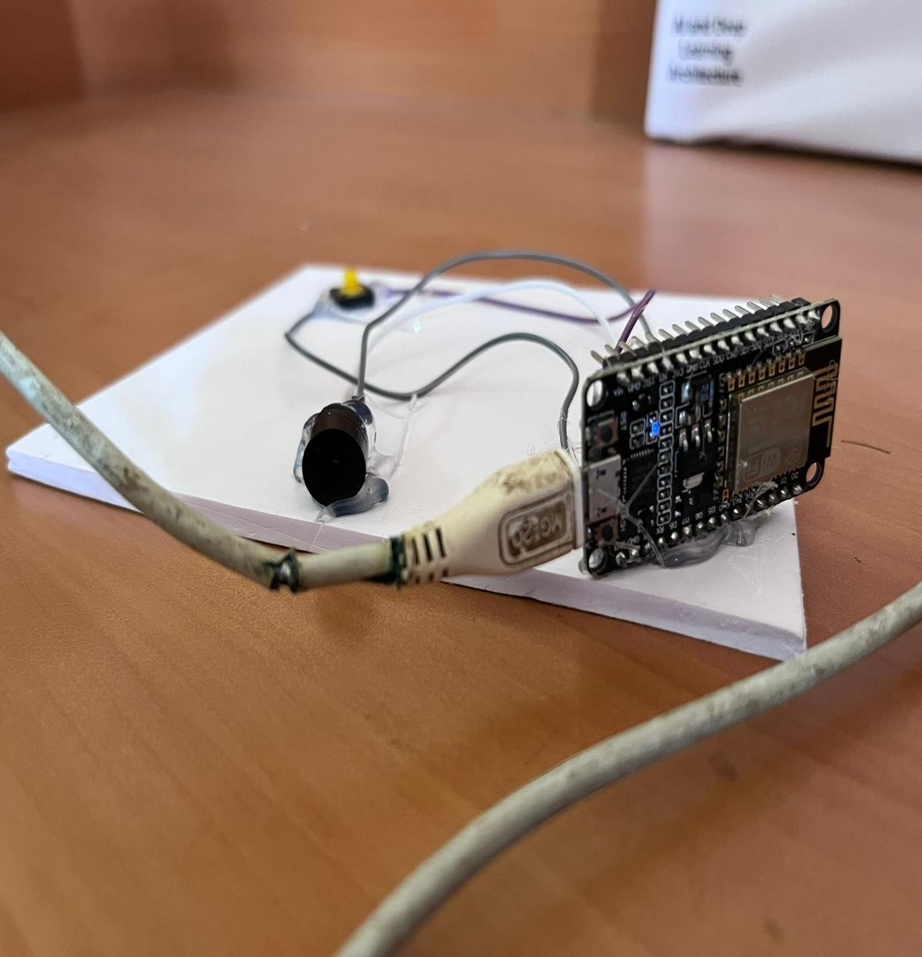

Figure 1: Fall detected scenario Figure 2: Buzzer implementation

Figure 3:SMS sent to concerned family member/neighbor

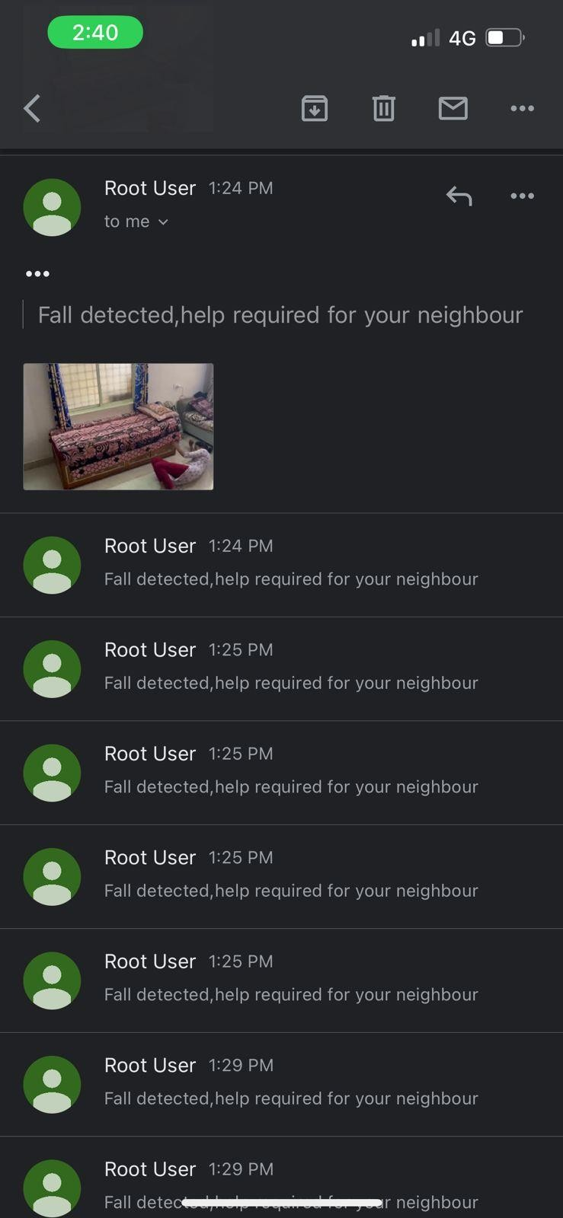

Figure 4: Email sent to concerned family member/neighbor

- CONCLUSION
In this paper, we proposed a fall detection system that uses a surveillance camera and deep learning algorithms to detect real-time fall scenarios in older persons. Deep learning algorithms for object (person) detection like YOLO v5 is used, and the model is pre-trained using the COCO dataset and based on the provided dataset, the CNN algorithm for image classification is used to distinguish between an old person falling and a man sleeping or lying on a bed or other surface. In addition to predicting the objects, object detection also determines their location in terms of bounding boxes. The YOLO algorithm uses video image frames as its input and outputs bounding boxes for objects in the form of height, width, row, column, and class. Additionally, it establishes the object’s class probability. It is only possible to consider the object with the highest class probability, which is known as non-max suppression. This system uses IoT to trigger the call or SMS to relevant parties using GSM module connected to a microcontroller, in fall case scenario. This system also includes a button that the elderly can press manually to declare no emer- gency or state that they need medical attention. As a result, the suggested algorithms can detect senior people’s fall behavior with accuracy. Implementation of this system is user-friendly. Because we employ cameras instead of complicated gear, that the elderly person could easily use and he can be easily tracked by his family members.

- FUTURE WORK
  - Develop a more robust and accurate fall detection algo- rithm using advanced deep learning techniques such as con- volutional neural networks (CNNs), recurrent neural networks (RNNs), or long short-term memory (LSTM) networks.
  - Implement and test the fall detection system on a larger and more diverse dataset to evaluate its performance and generalizability.
  - Evaluate the system’s effectiveness in real-world scenarios by conducting user studies with elderly people and collecting feedback to improve the system’s usability and acceptance.
  - Investigate the potential of integrating other sensing modalities such as audio, temperature, or pressure sensors to enhance the accuracy and reliability of the fall detection system.
  - Explore the use of edge computing and cloud computing to improve the system’s efficiency and scalability.
  - Develop a user-friendly mobile application to alert care- givers or emergency services in case of a fall and provide real-time monitoring of the elderly person’s activities.
  - Address privacy and security concerns by implementing appropriate measures to protect users’ sensitive data and prevent unauthorized access to the system.

- ACKNOWLEDGEMENT

I would like to express our deep sincere feelings of gratitude to our institution, Sai Vidya Institute of Technology, for providing an opportunity to build this system. I also express my sincere gratitude to Management, Sai Vidya Institute of Technology, Bengaluru, for their support.
I am thankful to Dr. Shantakumar B Patil, Professor and HOD, Department of Computer Science and Engineering, Sai Vidya Institute of Technology, Bengaluru, for his constant support.
REFERENCES
- A. Purushothaman, “Fall detection system using Artificial Neural Net- work”, in 2nd International Conference on Inventive Communication and Computational Technologies(ICICCT 2018), Hotel Arcadia, Coim- batore, 2018.
- Fall Detection Based on RetinaNet and MobileNet Convolutional Neural Networks, Hadir Abdo; Khaled M. Amin; Ahmad M. Hamad IEEE, 2020.
- T. Tri, H. Truong, and T. Khanh, “Automatic Fall Detection using Smartphone Acceleration Sensor,” Int. J. Adv. Comput. Sci. Appl., vol. 7, no. 12, pp. 123–129, 2016
- W. Lie, A. T. Le and G. Lin, ”Human fall-down event detection based on 2D skeletons and deep learning approach,” 2018 International Workshop on Advanced Image Technology (IWAIT), Chiang Mai, 2018, pp. 1-4, doi: 10.1109/IWAIT.2018.8369778. IEEE 2018
- Khan, M. and H. A. Habib. “Video Analytic for Fall Detection from Shape Features and Motion Gradients.” (2009). WCECS 2009
- Y. M. Chen, Z. F. Liu, X. D. Li, and Y. X. Huang, „„The aging trend of Chinese population and the prediction of aging population in 2015–2050,‟‟ Chin. J. Social Med., vol. 35, no. 5, pp. 480–483, 2018.
- M. Zhao, M. Yu, and S. K. Zhu, „„The prevalence of falls in the elderly in the community and the progress of prevention,‟‟ Injury Med., vol. 7, no. 1, pp. 61–66, 2018.
- Y. Chen, R. Du, K. Luo, and Y. Xiao, „„Fall detection system based on realti pose estimation and SVM,‟‟ in Proc. IEEE 2nd Int. Conf. Big Data, Artif. Intell. Internet Things Eng. (ICBAIE), Mar. 2021, pp. 990–993.
- C. Mao, „„Research Progress of intervention for fear of falling in the aged at home and abroad,‟‟ Chin. J. Modern Nursing, vol. 24, no. 7, pp. 865–868, 2018.
- F. F. Liu, „„Research on detection and recognition of indoor falling behavior based on video surveillance,‟‟ Shan Dong Univ., Jinan, China, Tech. Rep.,2016.

